Assignment 16.1

Problem Statement :-

Given a list of numbers - List[Int] (1, 2, 3, 4, 5, 6, 7, 8, 9, 10)

- find the sum of all numbers

- find the total elements in the list

- calculate the average of the numbers in the list

- find the sum of all the even numbers in the list

- find the total number of elements in the list divisible by both 5 and 3

Solution:-

List of Numbers is :-

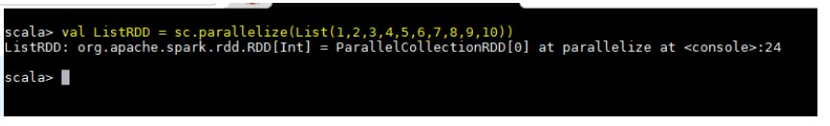

**Sum of all numbers**



**Total elements in the list**

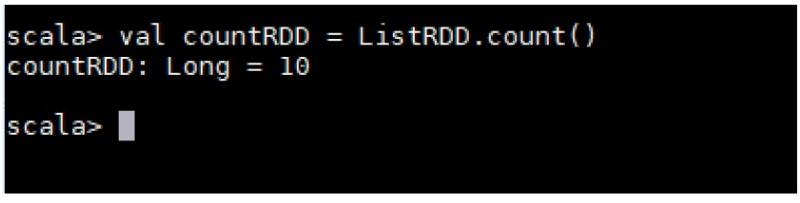

**Average of the numbers in the list**

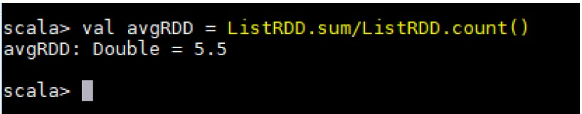

**Sum of all the even numbers in the list**

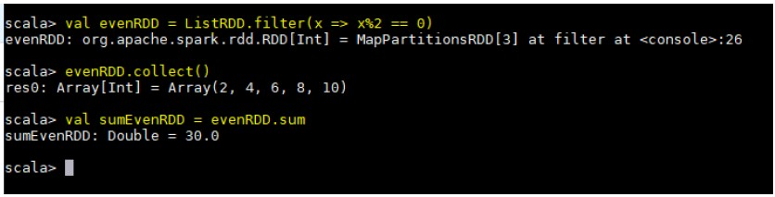

**Total number of elements in the list divisible by both 5 and 3**

