**HBase Architecture**

HBase is composed of three types of servers in a master slave type of architecture.

• Region servers serve data for reads and writes.

• HBase Master process handles the Region assignment, DDL (create, delete tables) operations

• Zookeeper maintains a live cluster state.

• The Hadoop DataNode stores the data that the Region Server is managing.

• All HBase data is stored in HDFS files.

• The NameNode maintains metadata information for all the physical data blocks that comprise the files.

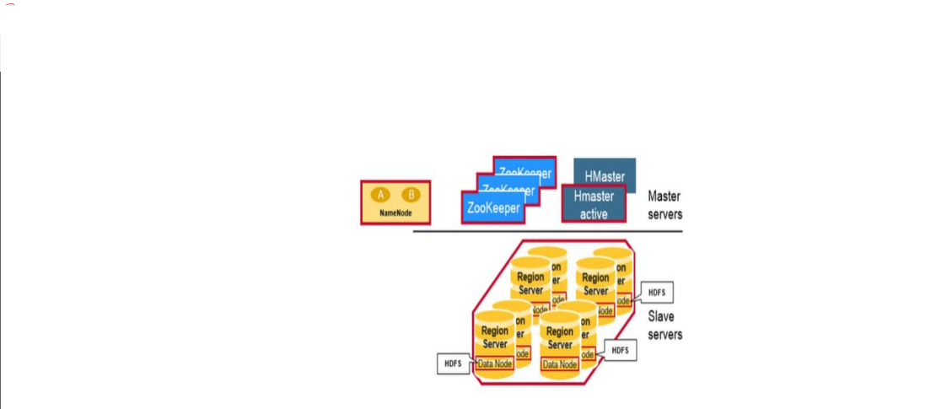

• HBase Tables are divided horizontally by row key range into “Regions.”

• A region contains all rows in the table between the region’s start key and end key.

• Regions are assigned to the nodes in the cluster, called “Region Servers,” and these serve data for reads and writes.

• A region server can serve about 1,000 regions.

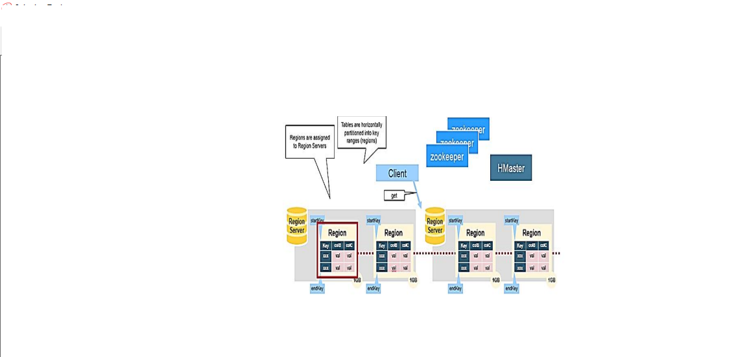

**H Master**

Region assignment, DDL (create, delete tables) operations are handled by the HBase

Master.

A master is responsible for:

• Coordinating the region servers

• Assigning regions on startup

• Re-assigning regions for recovery or load balancing

• Monitoring all RegionServer instances in the cluster (listens for notifications from

zookeeper)

Admin functions

• Interface for creating, deleting, updating tables

