**AFT**

Contents

Overview: 2

Test Templet Generic Headers: 3

SN: 3

CMD 3

PERM_01 to PERM_03 3

ITERATIONS: 3

EXPECTED: 3

OBSERVED: 3

RESULT: 3

TIME_STAMP: 3

DURATION: 3

REMARK: 3

Basic Windows Commands: 3

WIN_DELAY: 3

WIN_TEST_CONFIG 4

WIN_CONNECT: 4

WIN_SEND_BLE: 4

User defined DUT command: 4

DUT_ENROLL_MAC: 4

DUT_FLASH: 4

DUT_CRED: 4

User defined AFT command: 4

AFT_RELAY: 4

AFT_ADC: 4

AFT_SWITCH: 4

AFT_DIO: 4

AFT_FLASH: 4

Test templet Considerations: 4

Script Consideration: 5

# Overview:

Automatic function teste is combination of Script , AFT Hardware and test sequence to

* Automate BLE device user Interaction functionality.
* To simulate external event to test device (DUT) like Switch press , UART communication frames
* To read response from device UART, Read LED or Diooutput , Read internal system variable (configurations)
* To populate test template with test output and interpret the test result as PASS OR FAIL.
* Example with Bluetooth on PC controlling AFT and Device under test (DUT)

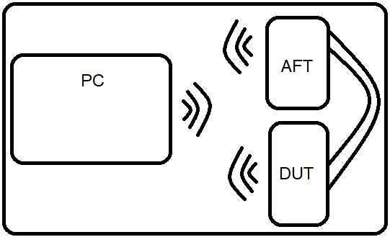

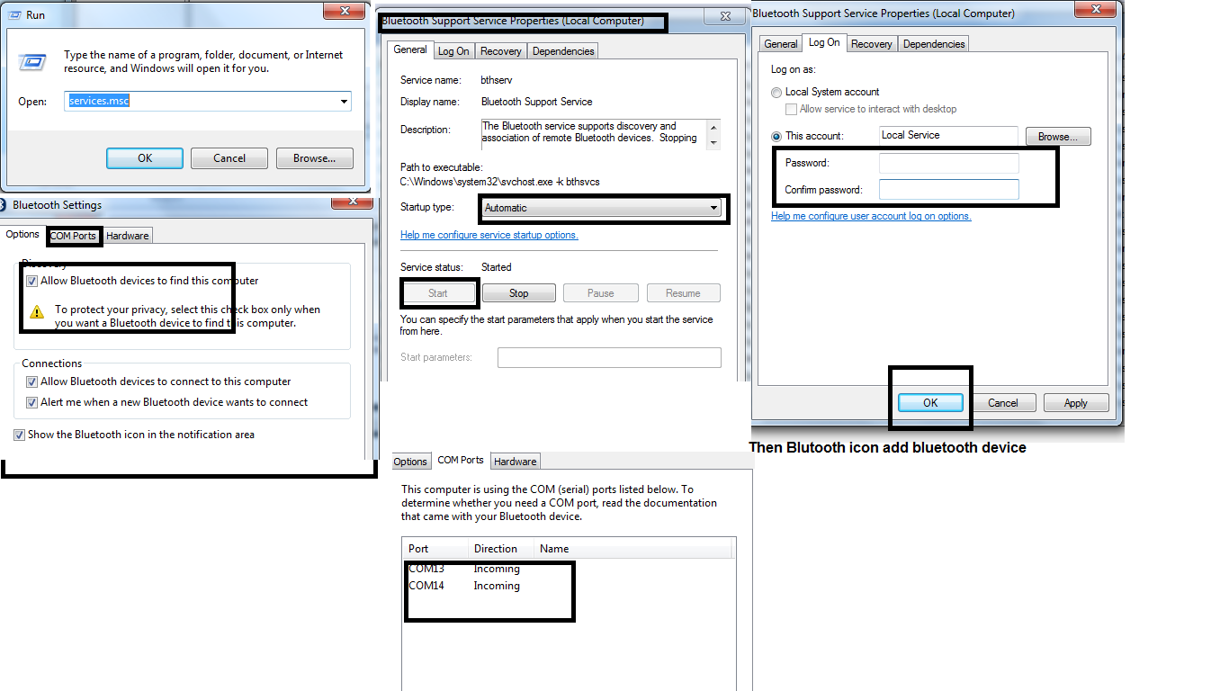

# **Test Templet Generic Headers**:

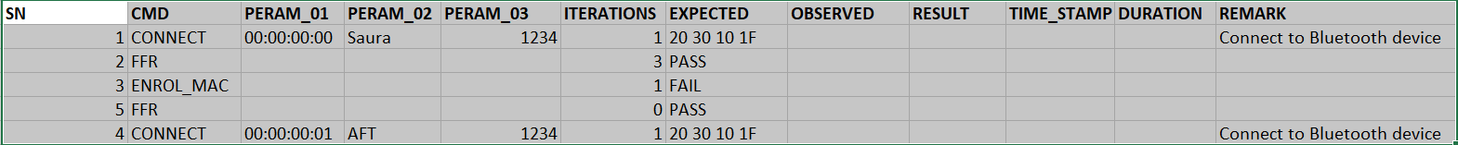

SN: Test Case Number , Not used in script.

CMD : its command which is to be executed and should be included in the script.

If command is not found in the script test case is marked fail.

PERM_01 to PERM_03 : are parameter expected by command

ITERATIONS: Number of times Command need to be executed , value 0 means that command is skipped

1 means command is executed for 1 time

EXPECTED: is expended result from command , it can have generic PASS or FAIL or other data type return by specific command

OBSERVED:Output from Command is populated hear.

RESULT:If EXPECTED and OBSERVED matches PASS is populated else Fail is populated.

If ITERATIONS value is > 1 and at least one is failed, then Failed is populated with faild count.

I.e. FAIL_2 means out of N cycle test failed for 2 times

TIME_STAMP:Basically time at which test is started

DURATION:duration for which test is run

REMARK:Basic info about command , Not used in script.

# **Basic Windows Commands**:

WIN_DELAY:Provide delay between test sequence

**PERM_01**: Delay value in seconds

i.e: 0.01 is 10ms delay

1 is 1 second delay

WIN_TEST_CONFIG**:**This is basically test environment configuration tag.

**PERM_01 :**

FALSE/NULL : Run all test cases

TRUE : stop test is any test fails

WIN_CONNECT:

Connects to respective BLE device , disconnects previous device if already connected

WIN_SEND_BLE:

Send raw data to BLE device which is connected

# **User defined DUT command:**

These commands are configurable by user. This commands use , AFT and Windows commands together to accomplish system test functionality.

And can be added in script.

DUT_FDR :

DUT_ENROLL_MAC:

DUT_FLASH:

DUT_CRED:

# **User defined AFT command:**

This Commands are AFT specific below are for AFT Ver 1 (which have 4 basic I/O peripherals)

AFT_RELAY:

AFT_ADC:

AFT_SWITCH:

AFT_DIO:

AFT_FLASH:

# **Test templet Considerations**:

* Tag names are Fixed and should not be modified.
* Tags can be moved to any positions.
* New tags can be added with script update.

# **Script Consideration:**

AFT.py is the script which processes user command as per the test templet

Custom test specific test templet to be provided by user.

User need to update new command functionality inAFT.py