command line arguments, fileoperators, read and filters

- Write a Bash script that accepts a filename as the first command-line argument.
Check whether an argument is provided.
Check whether the file exists using a file operator.
If the file exists, display the first 5 lines using head.
Otherwise, display an appropriate error message.
File Type and Permission Checker

#!/bin/bash
if [ $# -eq 0 ]; then
echo "Please provide a filename."
exit 1
fi
if [ -e "$1" ]; then
echo "First 5 lines of $1:"
head -n 5 "$1"
else
echo "File does not exist."
fi
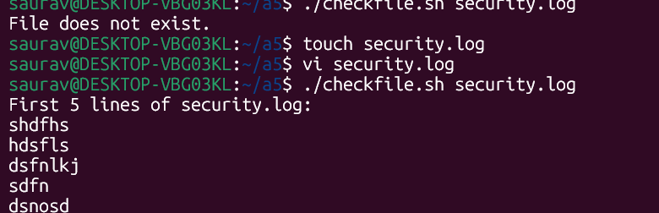
- Write a Bash script that accepts a path as a command-line argument and determines whether it is:
a regular file,
a directory,
readable,
writable, and
executable.
Display suitable messages using file operators such as -f, -d, -r, -w, and -x.
#!/bin/bash

if [ $# -eq 0 ]; then
echo "Error: Please provide a path."
exit 1
fi

path="$1"

if [ -f "$path" ]; then
echo "$path is a regular file."
fi

if [ -d "$path" ]; then
echo "$path is a directory."
fi

if [ -r "$path" ]; then
echo "$path is readable."
else
echo "$path is not readable."
fi

if [ -w "$path" ]; then
echo "$path is writable."
else
echo "$path is not writable."
fi

if [ -x "$path" ]; then
echo "$path is executable."
else
echo "$path is not executable."
fi
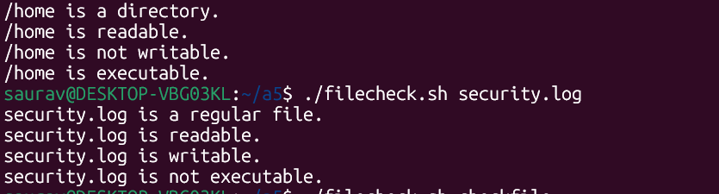
- Write a Bash script that accepts a log file as a command-line argument and searches for the words:
failed, denied, unauthorized, and error.
#!/bin/bash
if [ $# -eq 0 ]; then
echo "Error: Please provide a log file."
exit 1
fi

if [ ! -f "$1" ]; then
echo "Error: File does not exist."
exit 1
fi

echo "Matching records:"
grep -iE "failed|denied|unauthorized|error" "$1"

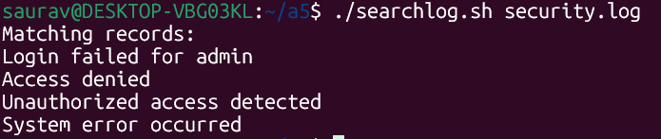

- Write a Bash script that accepts a filename and checks whether:
the file exists,
it is a regular file,
it is empty or non-empty.
If it is non-empty, display the first 5 lines.

#!/bin/bash
if [ $# -eq 0 ]; then
echo "Please provide a filename."
exit 1
fi

file="$1"

if [ ! -e "$file" ]; then
echo "File does not exist."
exit 1
fi

echo "File exists."

if [ ! -f "$file" ]; then
echo "It is not a regular file."
exit 1
fi

echo "It is a regular file."

if [ -s "$file" ]; then
echo "File is non-empty."
echo "First 5 lines:"
head -n 5 "$file"
else
echo "File is empty."
fi
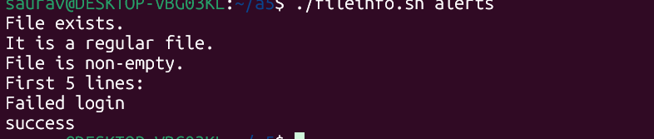
- Write a Bash script named investigate.sh that accepts a log file as a command-line argument.
The script must first verify that the file exists and is readable. Then ask the investigator to enter a search term.
Display the first 5 matching records and report the total number of matching records.

#!/bin/bash
if [ $# -eq 0 ]; then
echo "Error: Please provide a log file."
exit 1
fi

logfile="$1"

if [ ! -e "$logfile" ]; then
echo "Error: File does not exist."
exit 1
fi
if [ ! -r "$logfile" ]; then
echo "Error: File is not readable."
exit 1
fi

read -p "Enter search term: " term

count=$(grep -i "$term" "$logfile" | wc -l)

echo
echo "First 5 matching records:"
grep -i "$term" "$logfile" | head -n 5

echo
echo "Total matching records: $count"
