Part A — User and System Investigation

- Determine the username of the account you are currently using.
whoami

- Display your UID, primary GID, and supplementary groups.
id

- Display all users currently logged in to the system.
who

- Determine what activities the currently logged-in users are performing.
w

- Examine /etc/passwd and identify the following information for your current account:
Username
UID
GID
Home directory
Login shell

wc -l /etc/passwd

- Determine how many user-account entries are present in /etc/passwd.
wc -l /etc/passwd

- Display only the username and UID fields from /etc/passwd.
cut -d: -f1,3 /etc/passwd

- Find all accounts whose UID is 0. Explain the security significance of UID 0.
awk -F: '$3 == 0 {print $1, $3}' /etc/passwd
O/P: root 0

Security significance: UID 0 represents the root/superuser account. So unauthorized accounts with UID 0 are major security risk.
A UID 0 has very high privileges that are:
- Read or modify protected files
- Change system configurations
- Create/delete users
- Start/stop system services
- Access resources restricted to normal users

- Compare /etc/passwd and /etc/shadow. Why are password hashes stored in /etc/shadow instead of /etc/passwd?

etc/passwd
- Contains usernames, uid,gid, home directories and shells
- Readable by normal users
/etc/shadow
- Contains password hash and password-aging information
- Readable only by root/authorized processes
/etc/passwd needs to be readable by many system programs because it contains basic account information. If password hashes are stored there, any local user who can read the file can get the hashes and attempt offline password cracking. Moving password hashes to /etc/shadow gives them restricted permissions, reducing the risk of unauthorized access.

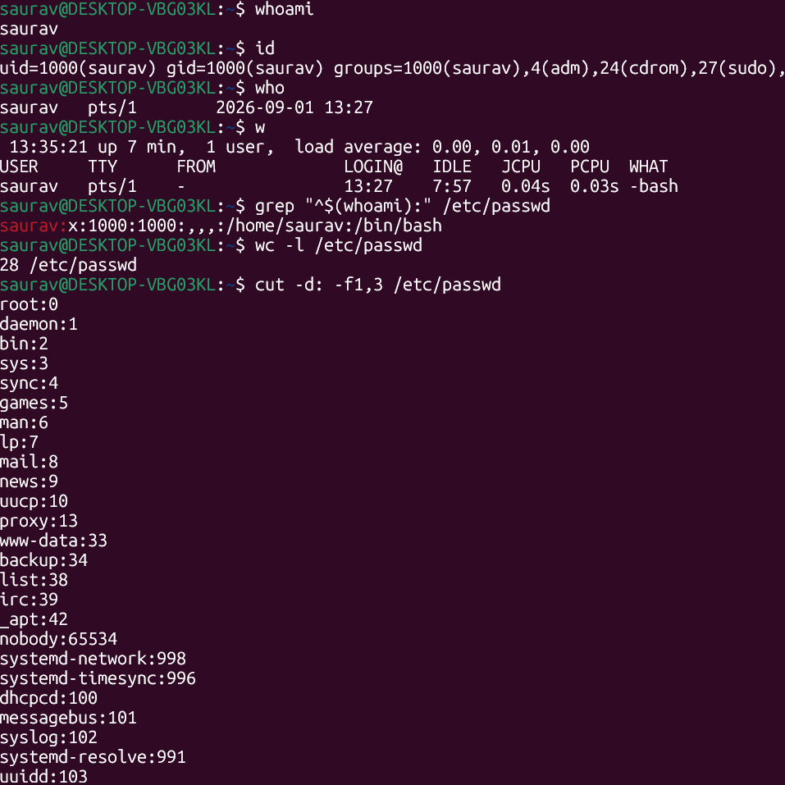

Part B — Creating and Verifying Users

- Create the following users and ensure that a home directory is created for each:alice, bob, Charlie
sudo useradd -m alice

- Verify that all three accounts have been added to /etc/passwd.
grep -E '^(alice|bob|charlie):' /etc/passwd

- Determine the UID assigned to each newly created user.
id alice

- Determine the home directory and default shell assigned to alice.
getent passwd alice | cut -d: -f6,7
- Inspect /home and verify that the required home directories were created.
ls -l /home

- Set passwords for all three accounts.
sudo passwd charlie

- Switch from your current account to alice using a login shell. Verify the change using an appropriate command, and then return to your original account.
su - alice
whoami
pwd
exit

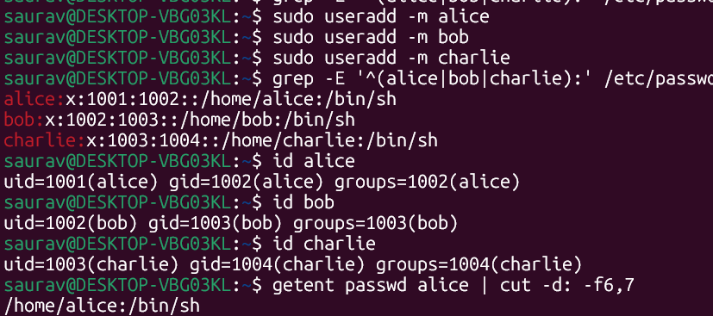
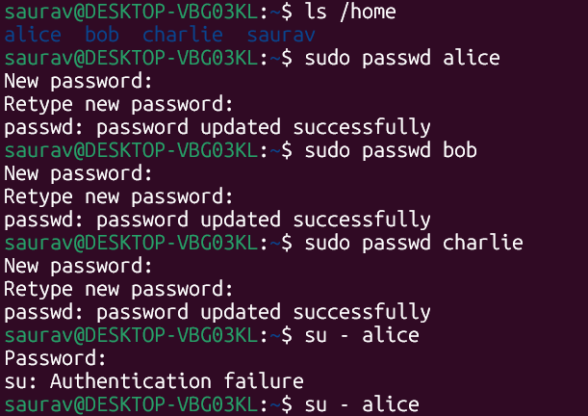

Part C — Group Management and Access Control
- Create two groups:security and developers
sudo groupadd security

- Add alice and charlie to the security group.
sudo usermod -aG security alice

- Add bob to the developers group.
sudo usermod -aG developers bob

- Without switching accounts, verify the group membership of all three users.
groups alice
groups bob

- Display the entries corresponding to security and developers from /etc/group.
grep -E '^(security|developers):' /etc/group

- Add bob to the security group without removing him from the developers group.
sudo usermod -aG developers bob

- Verify that bob now belongs to both groups.

