ASSIGNMENT 2_LOS_THEORY

- Compare Permissions on Regular Files and Directories
Default Permissions | User | Group | Others
File | read,write | read | read
Directory | read,write, execute | write, execute | execute

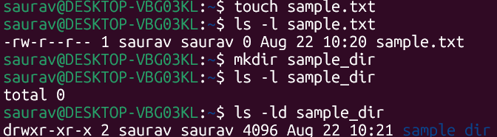

- Apply each of the following permissions using chmod. Perform the specified operations and record your observations.

- Read: cat sample.txt
- Write: echo “writing” > sample.txt
- Change permission: chmod 000 sample.txt

* Execute permission allowed only for executable files for sample.txt it is invalid

Permission | Regular File (sample.txt) – Test | Observation
400 (r--) | Try to read and modify the file | - read - allowed  - write - when tried to modify shows ‘readonly’
200 (-w-) | Try to read and modify the file | - read - not allowed  - write - possible using echo >sample.txt and using vi not able to write
100 (--x) | Try to read and execute the file | - read - denied  - write – denied (allowed only for executable files)
500 (r-x) | Try to read and modify the file | - read- allowed  - write- Permission denied  - execute- allowed(but invalid)
600 (rw-) | Try to read and modify the file | - read- allowed  - write- allowed  - execute- not allowed
700 (rwx) | Try to read, modify, and execute the file | - read and write allowed

- DIRECTORY
    - r = list
    - w = create/delete/rename entries
    - x = enter/traverse the directory

Permission | Directory (sample_dir) – Test | Observation
400 (r--) | Try to list and enter the directory | - dr-------- 2 sa sa 4096 Aug 22 10:23 sample_dir  - list: ls: cannot access 'sample_dir/file1.txt': Permission denied  file1.txt  - enter: denied
200 (-w-) | Try to list, enter, and create a file | - list: denied  - enter: denied  - create: denied
100 (--x) | Try to list and enter the directory | - list: denied  - enter: denied
500 (r-x) | Try to list and enter the directory | - list: denied  - enter: allowed and can access the files
600 (rw-) | Try to list, enter, and create a file | - list: denied  - enter: denied  - create: denied  ls -l sample_dir  ls: cannot access 'sample_dir/file1.txt': Permission denied  total 0  -????????? ? ? ? ? ? file1.txt
700 (rwx) | Try to list, enter, create, and delete files | All allowed

- Questions

- What does read (r) permission allow you to do with a regular file?
Allows read/view content of the file.
- What does read (r) permission allow you to do with a directory?
List the names of the files and directories.
- What does write (w) permission mean for a regular file?
Modify, overwrite, or write data to the file.

- What does write (w) permission mean for a directory?
Create, delete, and rename files or directories inside it.

- What does execute (x) permission mean for a regular file?
Allows the file to be executed as a program/script, provided it is a valid executable or script.

- Why is execute (x) permission important for accessing a directory?
Enter/traverse the directory and access items inside it.

- Which permission combination allows the owner to fully access a regular file
rwx (700)

- Which permission combination allows the owner to fully access a directory??
rwx (700)

- Based on your observations, explain why the same r, w, and x permissions behave differently for a regular file and a directory.
File contains data and directory contains entries like filea , directories. Therefore, the permissions have different meanings.
- File: r means reading contents, w means modifying contents and x means execute/run scripts or files.
- Directory: r means listing entries, w means creating/deleting entries, and x means entering or traversing the directory.

