2_LOS_LAB
Topic Name:
The main aim of this lab session is to provide hands-on experience on
- Getting Help
- Basic Commands
- Navigation
- File System
- Simple shell script
- Globbing
- Extended Globbing
- Filters -I (head,tail,wc)

- Getting Help

Task | Command Name | Syntax | Example | Screenshots
To get manual page for the known command | man | man <command> | man grep | 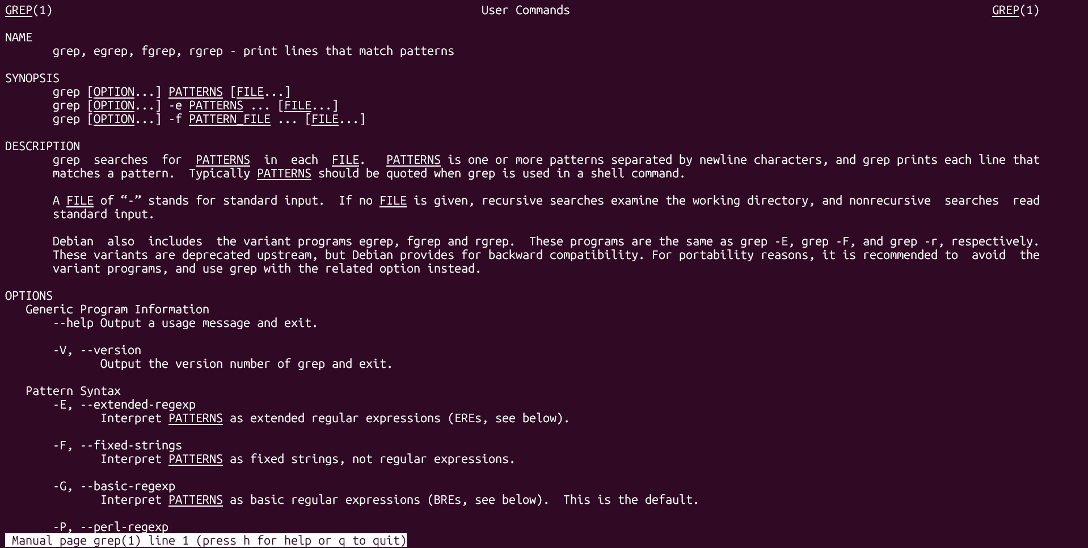
To get manual page for the unknown command | man | man command  or  apropos keyword | man -k network | 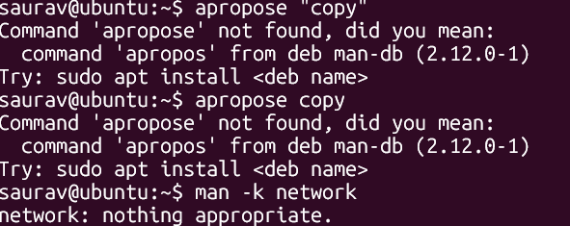
To know the source file binary | which | which cmd | which ls
To know the path of the command | whereis | whereis <cmd> | whereis bash
To know the command is external or internal | type | type cmd | type ls | 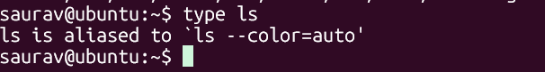
To get help for the internal command | help | help -cmd | help | 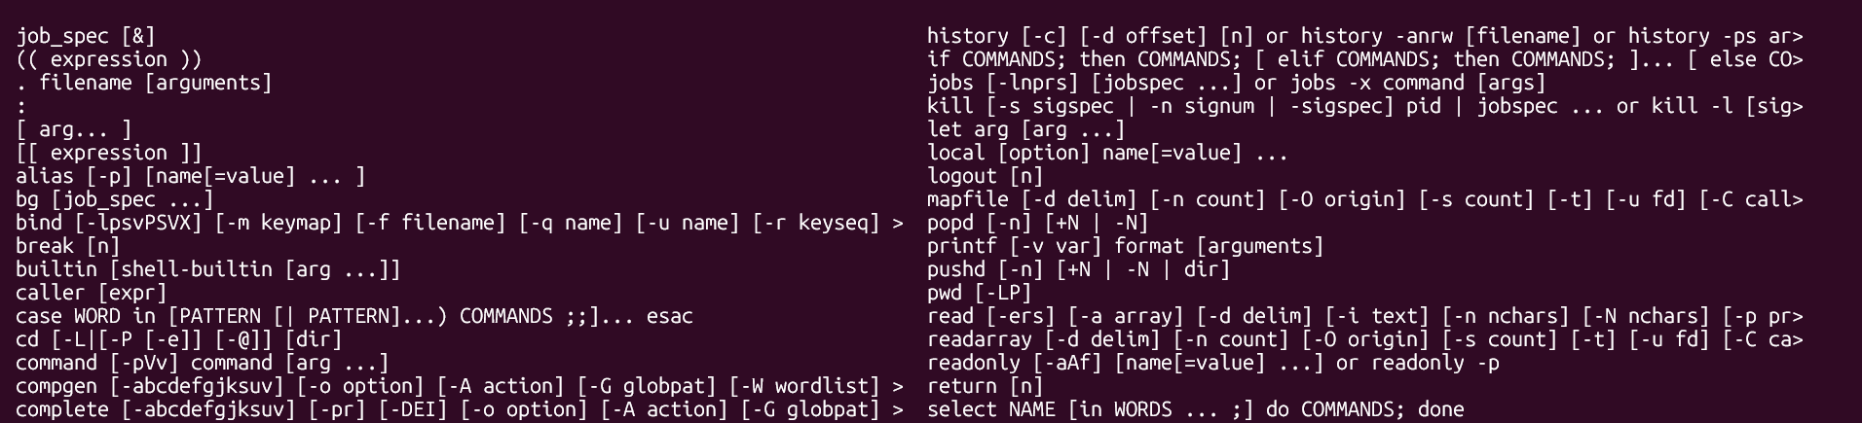
To list out bash commands | compgen | compgen command | compgen -b | 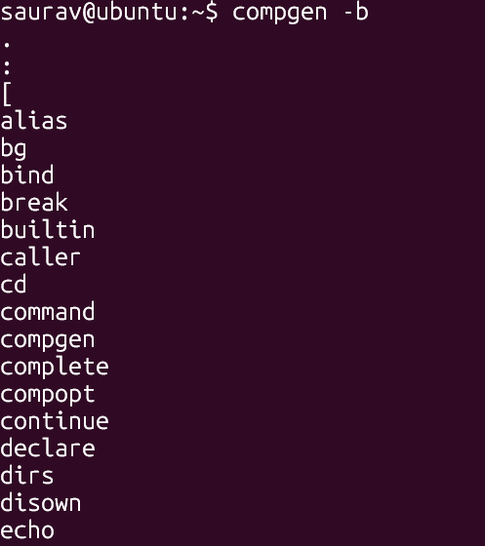
To know the usage of the command | --help | cmd --help | cd --help | 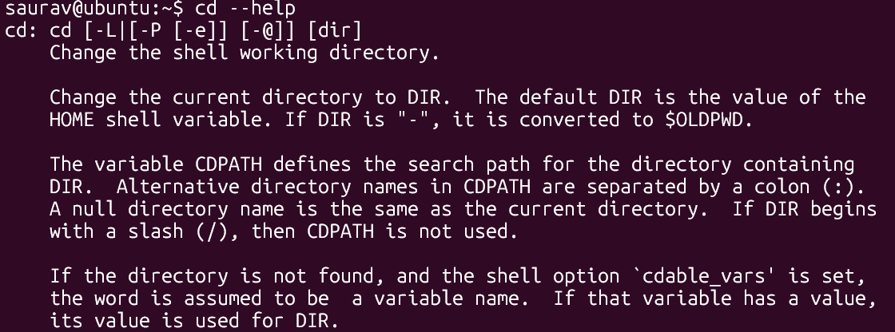

- Basic Commands
Task | Command Name | Syntax | Example | Screenshots
To know today’s date | date | date | date | 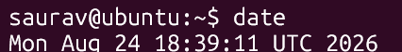
To print calendar | cal | cal | cal | 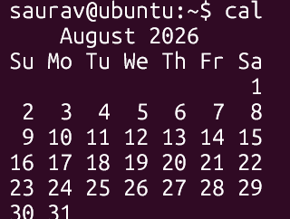
To print kernel version | uname | uname -r | uname -r | 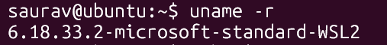
To print default shell |  |  |  | 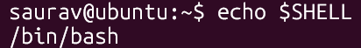
To print currently logged in user | whoami | whoami | whoami | 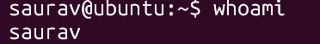
To create shortcut for command | alias | alias shortname='command' | alias ll='ls -l' | 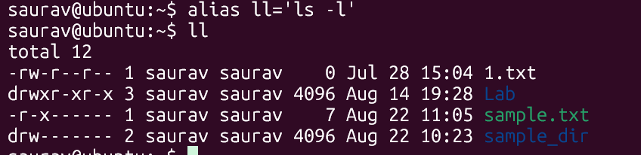
To delete shortcut | unalias | unalias shortnane | unalias ll | 
To change the timestamp of the file | touch | touch sample.txt | touch sample.txt | 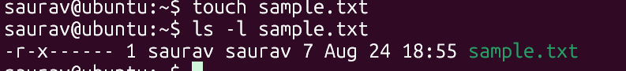
To clear the screen | clear | clear | clear | 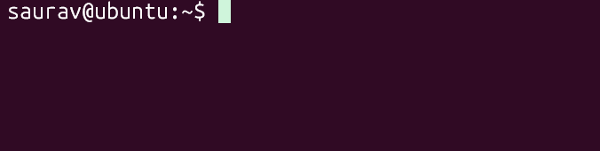
To create empty files | touch | touch filename | touch sample.txt | 
To know disk usage | du | du -sh | du -sh | 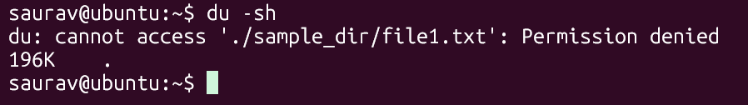
To know free space in the system | df | df -h | df -h | 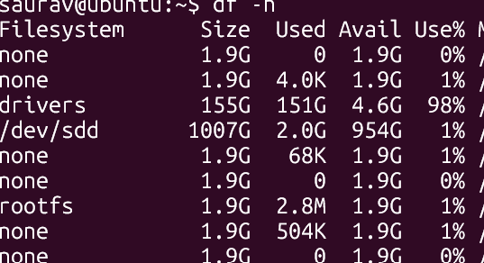
To know about the Linux release | lsb_release | lsb_release -a | lsb_release -a | 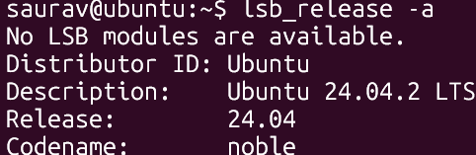
To show login history | last | last | last | 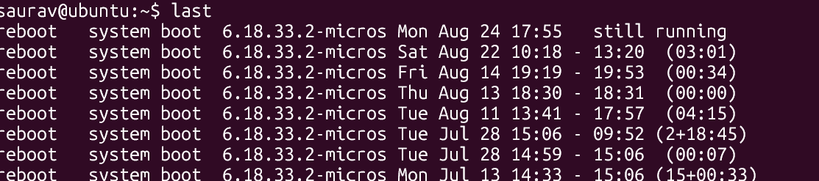
To check the current user privileges | sudo -l | sudo -l | sudo l | 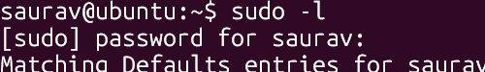
To find about the Linux release | cat | cat command | cat /etc/os-release | 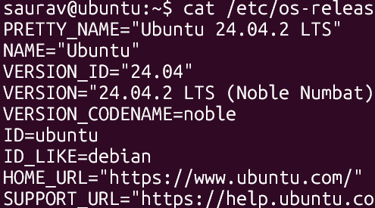
To check system uptime | uptime | uptime | uptime
To shutdown | sudo | sudo shutdown | sudo shutdown now
To restart | sudo | sudo reboot | sudo reboot

- Navigation
Task | Command | Syntax | Screenshots
To navigate home directory | cd | cd ~ | 
To navigate to the parent directory | cd | cd .. | 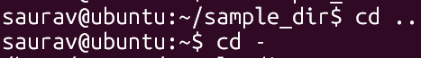
To navigate to the child directory | cd | cd sample_dir | 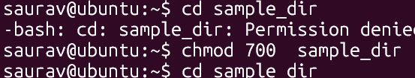
Alternate command to cd | pushd | pushd sample_dir | 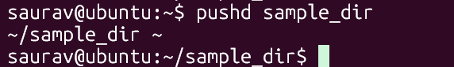
To go back to the previous directory | cd | cd – | 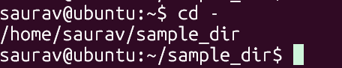
To go to the root directory | cd | cd /

- File System
Task | Syntax | Command
How to identify the file system | df -T  or  lsblk -f | 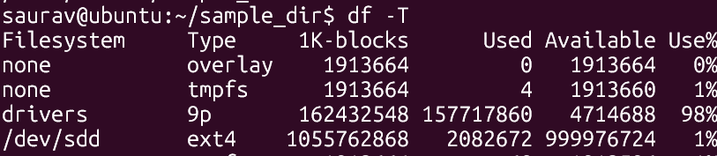

- Globbing
Create a dedicated practice directory containing sample files such as:
index.html, login.html, admin.htm, report.txt, access.log, error.log, user1.txt, user2.log, file123, backup1.html, backup2.txt
Use globbing patterns wherever possible, rather than specifying filenames individually.
- List all files ending in .html.
ls *.html
- List all files other than .html files using extended globbing.
ls !(*.html)
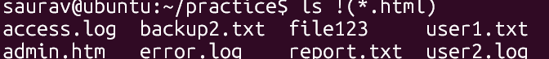
- List filenames containing at least one numeric digit.
Ls *[0-9]*
- List files whose names begin with user followed by a single digit.
Ls user[0-9].*

- List files ending in either .txt or .log using a single extended glob pattern.
Ls *.@(txt|log)
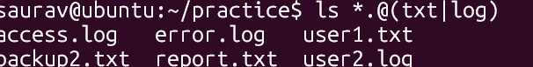
- List files that do not end in .txt or .log.
ls *.!(txt|log)
- List files beginning with either access or error using extended globbing.
Ls +(access|error).*
- List .html files whose filenames contain a numeric digit.
Ls *[0-9]*.html

- Extended Globbing

- Assume a directory contains:
access.log, error.log, auth.log, auth.log.1, auth.log.2, system.log, notes.txt
Write an extended glob pattern that selects only access.log, error.log, and auth.log.
ls +(access|error|auth).log
Select all files except notes.txt.
Ls !(notes.txt)
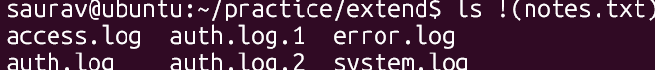
Select files named either auth.log.1 or auth.log.2 using pattern matching rather than writing both complete filenames separately.
ls auth.log.[12]
ls auth.log.{1,2}
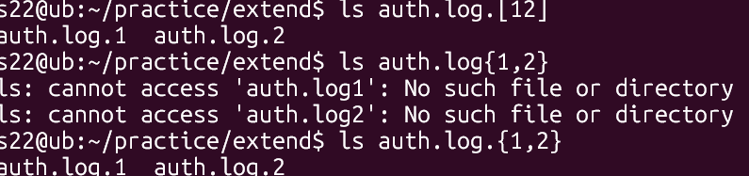
- Given the files:
malware1.log malware2.log malwareA.log malware_report.txt normal.log
construct a glob pattern that identifies .log files whose names start with malware and contain a numeric character.
ls malware[0-9].log
- Given:
failed_login.log, successful_login.log, login_backup.log, login.txt, firewall.log
use extended globbing to select .log files containing either failed_login or successful_login.
ls @(failed_login|successful_login).log
Construct a pattern that lists all .log files except firewall.log.
Ls !(firewall).log
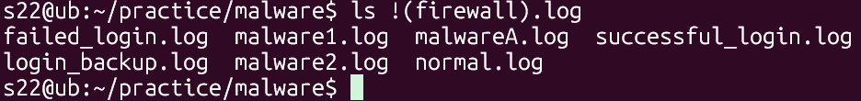

- Filters
- Display the first 10 entries of login.log.
head -n login.log
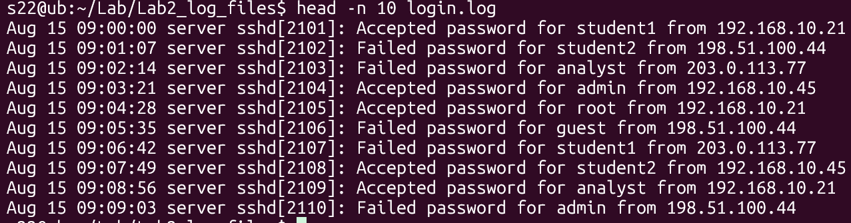
- Display the first 5 entries of access.log.
head -n 5 access.log
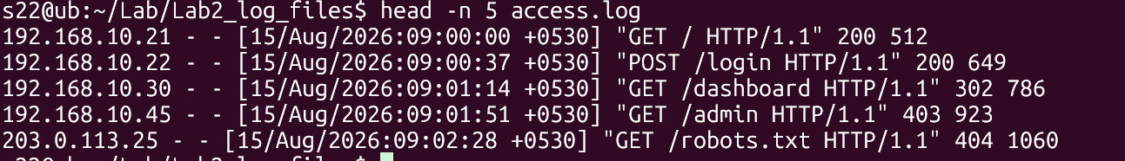
- Display the first 15 security events from security.log.
Head -n 15 security.log
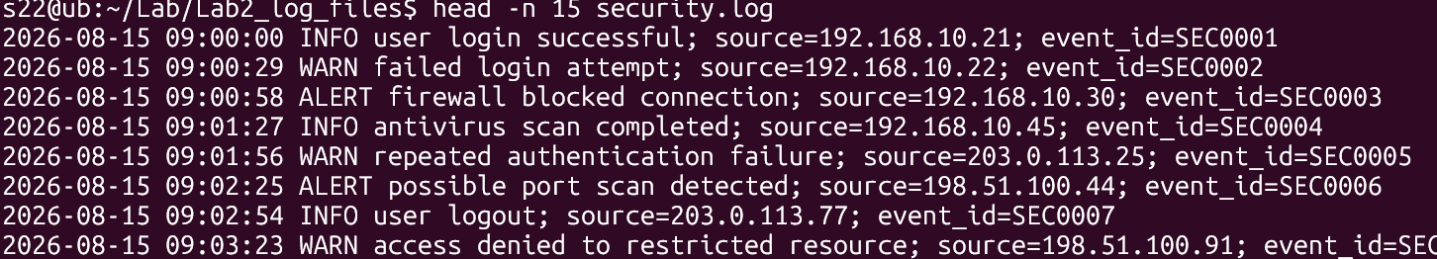
- Display the first 20 events recorded in incident.log.
head -n 20 incident.log
[screen shots shows few entries for all similar outputs]
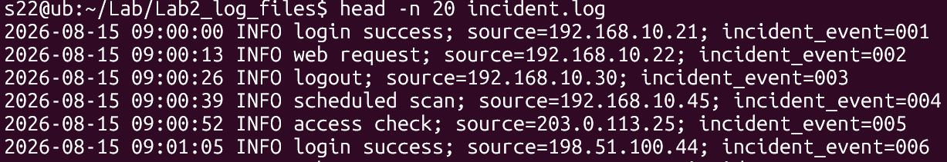
- Display only the first entry in login.log.
Head -n 1 login.log

- Display the first 25 web requests recorded in access.log.
head -n 25 access.log
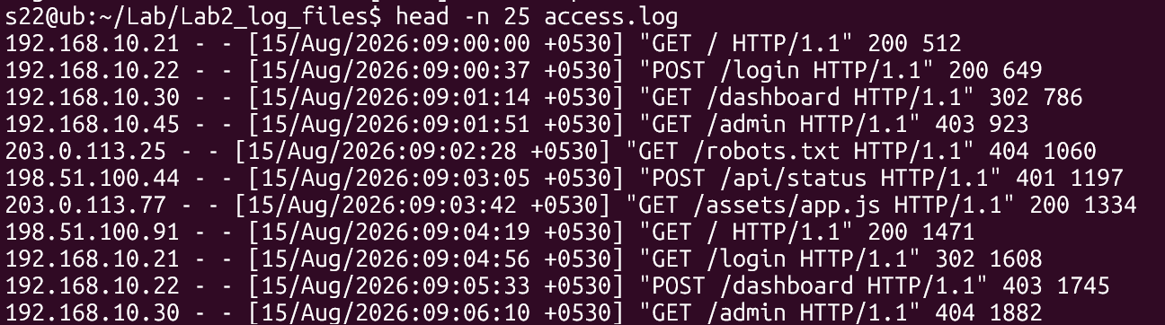

- Display the last 10 entries of login.log.
Tail -n 10 login.log

- Display the last 5 entries of access.log.
Tail -n 5 access.log
- Display the 20 most recent security events from security.log.
Tail -n 20 security.log
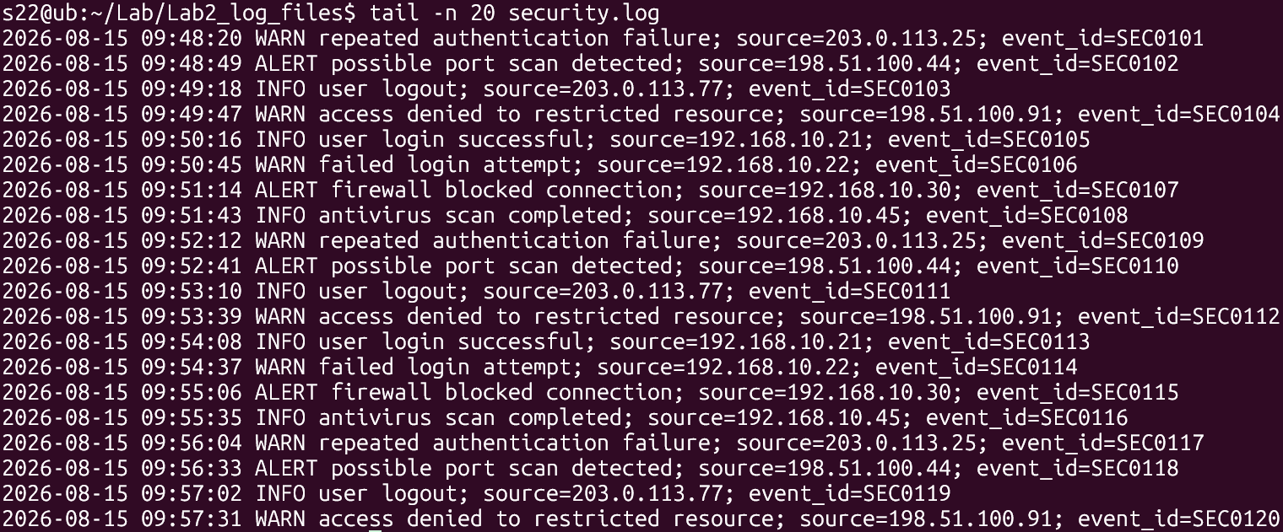
- Display the 25 most recent events from incident.log.
tail -n 25 incident.log
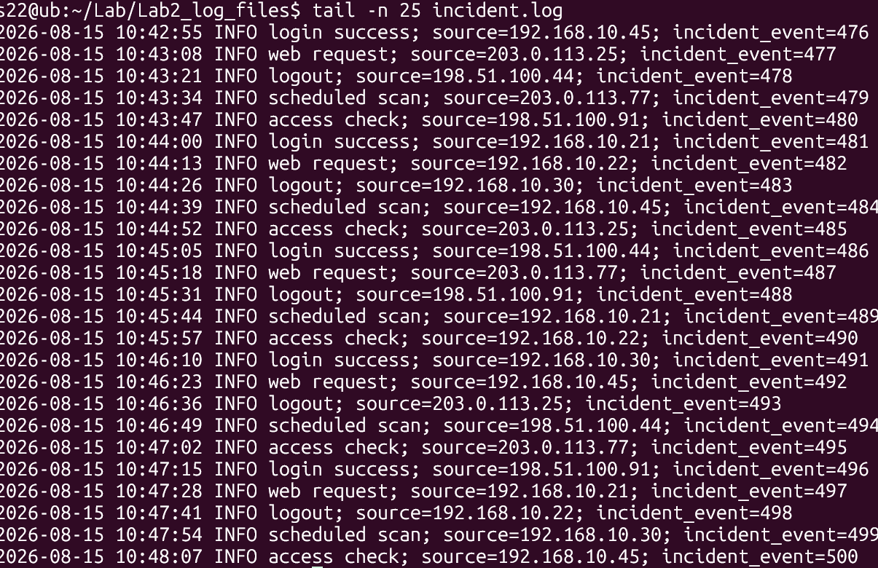
- Display only the last entry in security.log.
tail -n 1 security.log
- Display the last 50 events recorded in incident.log.
tail -n 50 incident.log
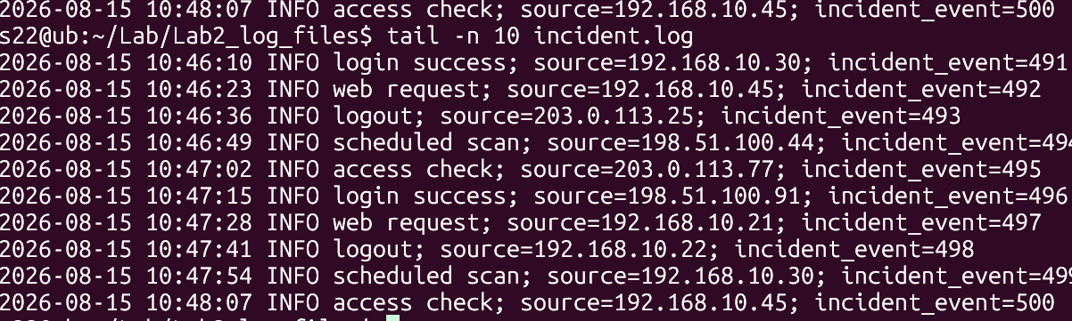
- Display the contents of login.log starting from line 41 until the end of the file.
tail -n +41 login.log
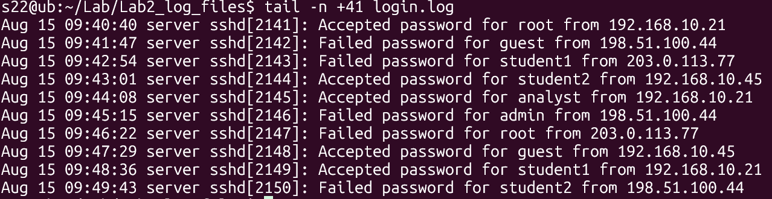
- Display the contents of security.log starting from line 101 until the end of the file.
tail -n +101 security.log
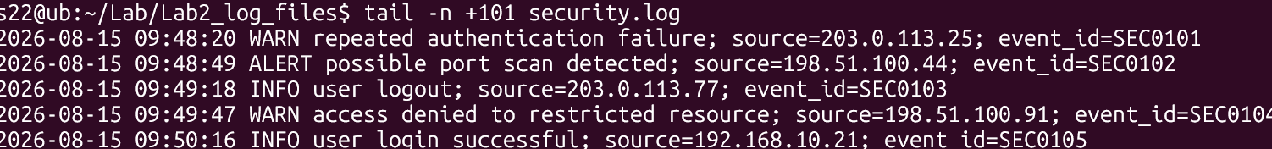
- Find the total number of lines in login.log.
wc -l login.log

- Find the total number of lines in access.log.
wc -l access.log
- Find the total number of security events in security.log.
- wc -l security.log (will work for this log as it contains 1 line logs)
if it has multiple lines I will count the word “event_id” using grep
- grep -c 'event_id=' security.log
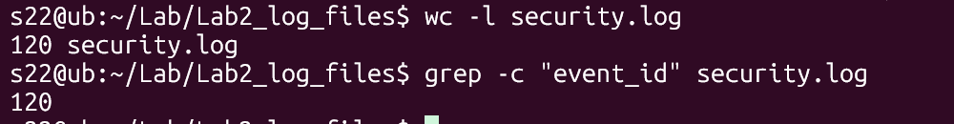

- Determine the total number of events recorded in incident.log.
grep -c “incident_event” incident.log
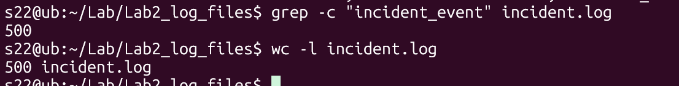

- Count the number of words in login.log.
wc -w login.log 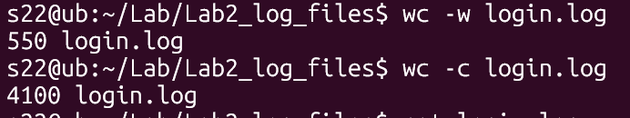
- Count the number of bytes in security.log.
wc -c security.log
- Display the line, word, and byte counts of access.log.
wc -l -w -c access.log
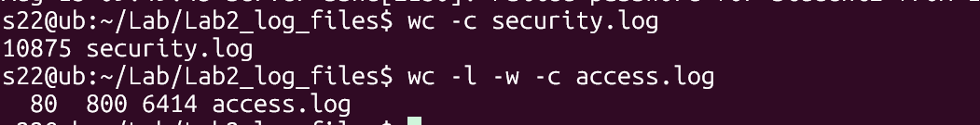
- Find the line counts of all four .log files using a single wc command.
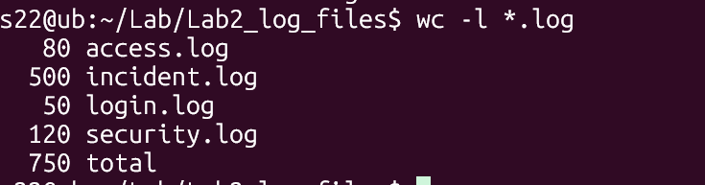
- Display the first 20 entries of login.log and, from those entries, display only the last 5.
head -n 20 login.log| tail -n 5
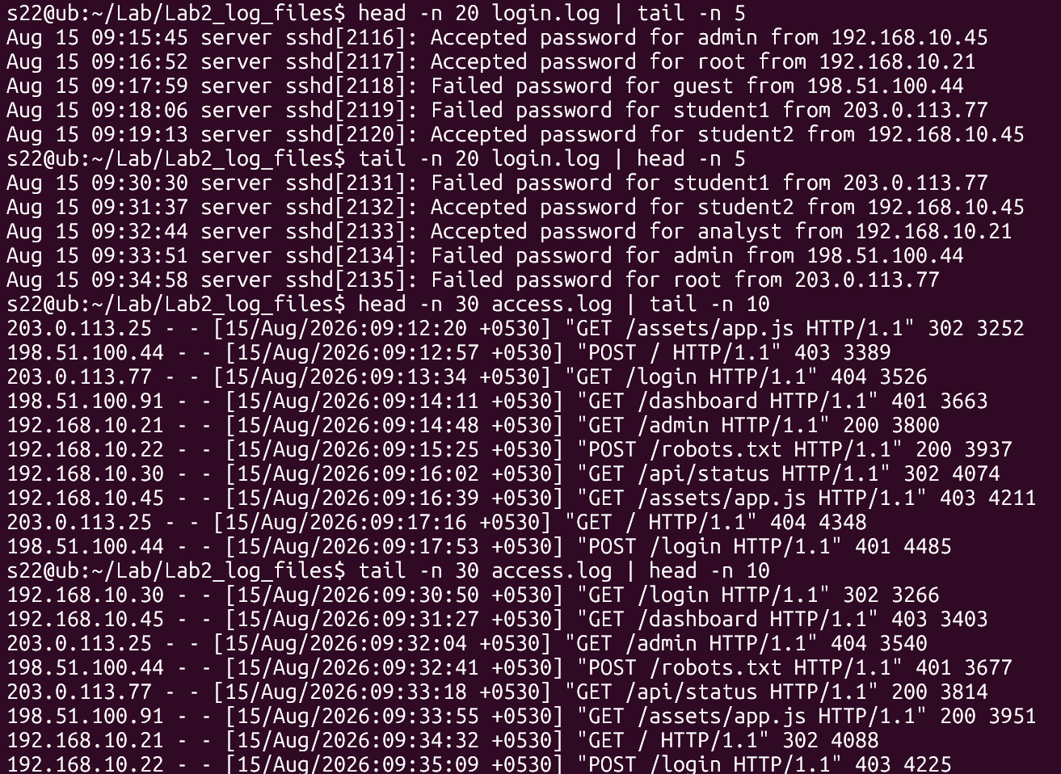
- Display the last 20 entries of login.log and, from those entries, display only the first 5.
tail -n 20 login.log| head -n 5
- Display the first 30 entries of access.log and then display only the last 10 entries from that output.
head -n 30 access.log| tail -n 10

- Display the last 30 entries of access.log and then display only the first 10 entries.
tail -n 30 access.log|head -n 10
- Display the first 50 events from security.log and then display the last 10 events from those 50.
grep 'event_id=' security.log|head -n 50 | tail -n 10
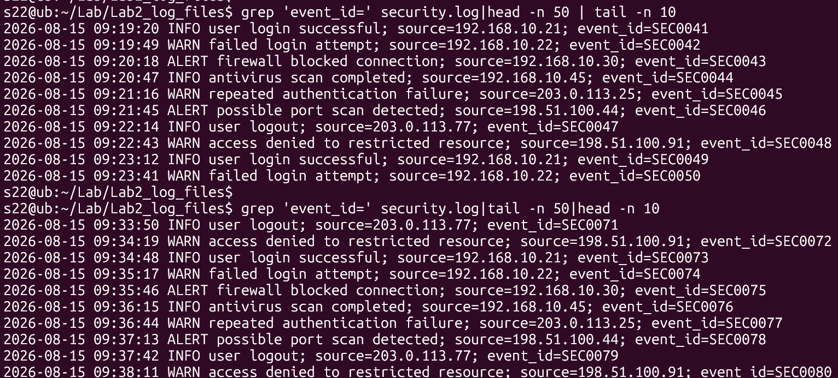
- Display the last 50 events from security.log and then display the first 10 events from those 50.
grep 'event_id=' security.log|tail -n 50|head -n 10
- Display entries from line 11 to line 20 of login.log.
head -n 20 login.log|tail -n 10
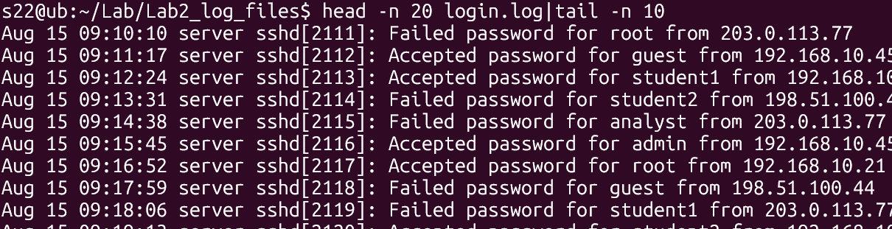
- Display entries from line 21 to line 30 of login.log.
head -n +21 login.log|head -n 10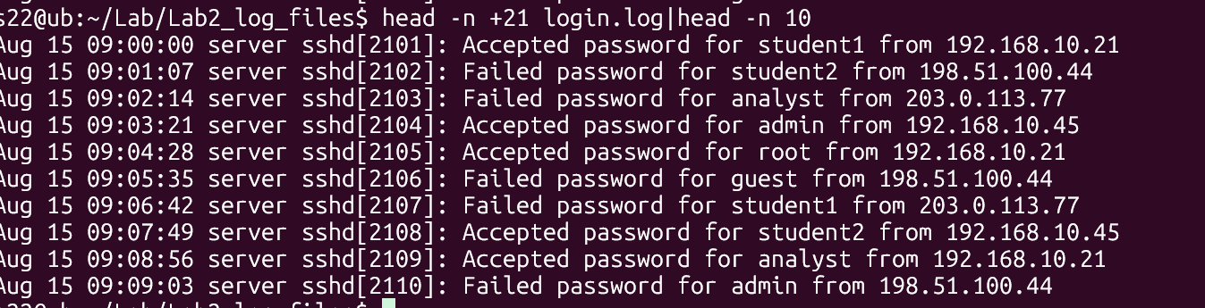

- Display entries from line 11 to line 20 of access.log.
head -n +11 access.log|head -n 10
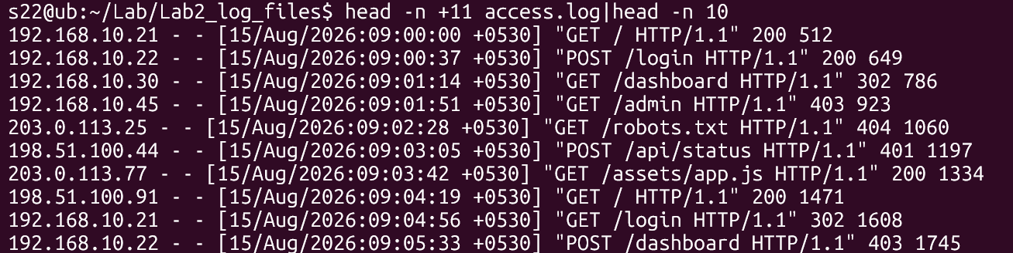

- Display entries from line 31 to line 40 of access.log.
head -n +31 access.log|head -n 10
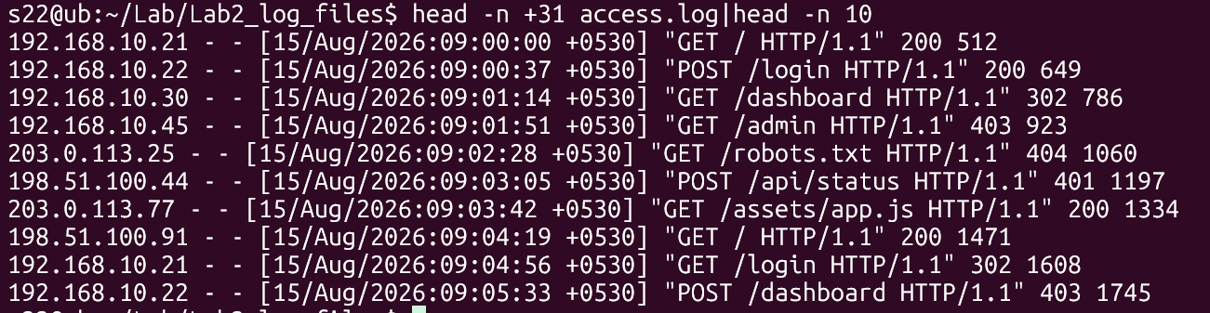

- Display security events from line 21 to line 30 of security.log.
head -n +21 security.log|head -n 10

- Display security events from line 51 to line 60 of security.log.
head -n +51 access.log|head -n 10
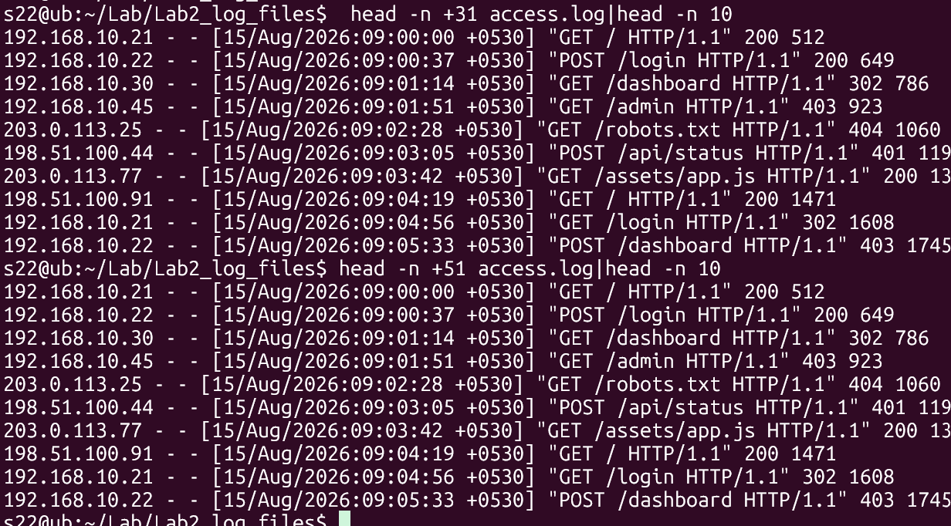

- Display incident events from line 101 to line 110 of incident.log.
- Display incident events from line 201 to line 220 of incident.log.

ii) head -n +101 incident.log|head -n 10
jj) head -n +201 incident.log|head -n 20
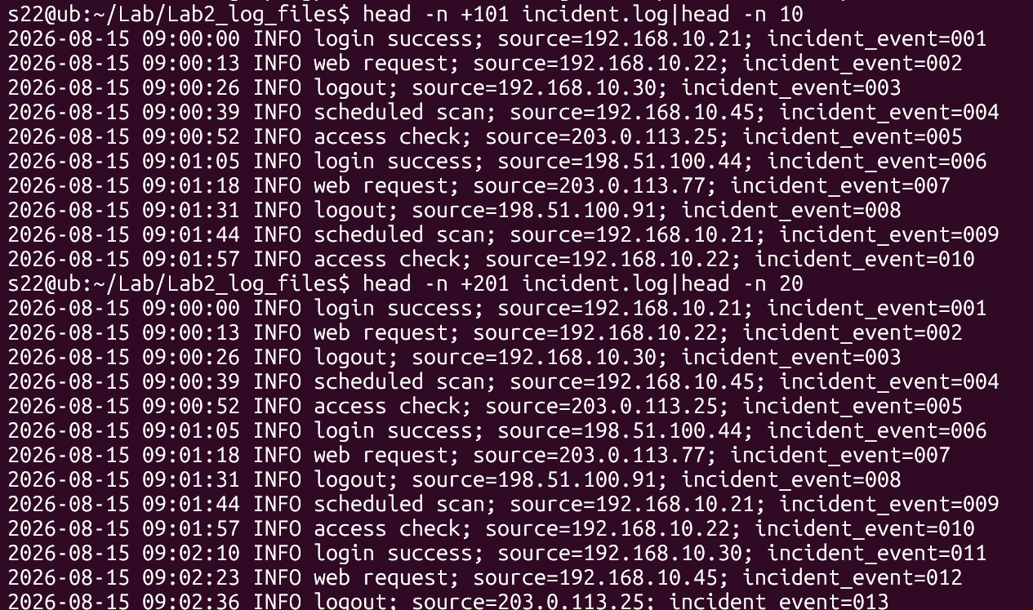

- Display incident events from line 491 to line 500.
head -n +491 incident.log|head -n 10
- Take the first 20 entries of login.log and count how many lines are displayed.
- Take the last 15 entries of access.log and count how many lines are displayed.
- Take the first 50 entries of security.log and count the number of words in those entries.
- Take the last 25 entries of security.log and count the number of lines.
ll) head -n 20 login.log|wc -l
mm) tail -n 15 access.log|wc -l
nn) grep 'event_id=' security.log|tail -n 50|wc -l
oo) grep 'event_id=' security.log|tail -n 25 | wc -l
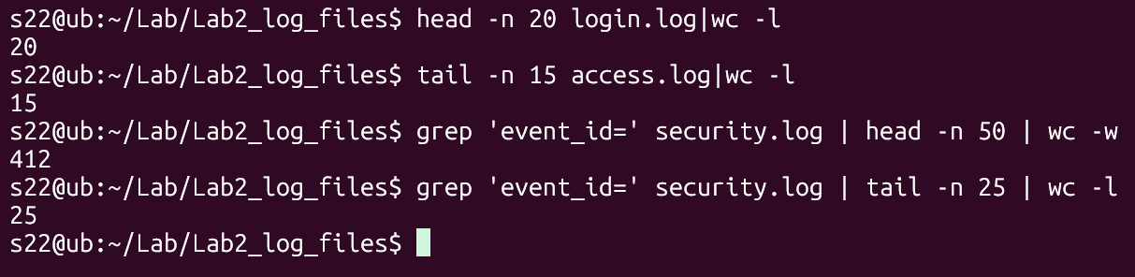

- Extract lines 21–30 from login.log and count the number of extracted lines.
head -n 30 login.log | tail -n 10 | wc -l
- Extract lines 51–60 from access.log and count the number of extracted lines.
head -n 60 access.log|tail -n 10|wc -l
- Extract events 101–150 from incident.log and count how many events are displayed.
head -n 100 incident.log | tail -n 20 | wc -l
- Display the first 100 events from incident.log, take the last 20 events from that output, and count the number of lines.
head -n 100 incident.log|tail -n 20|wc -l
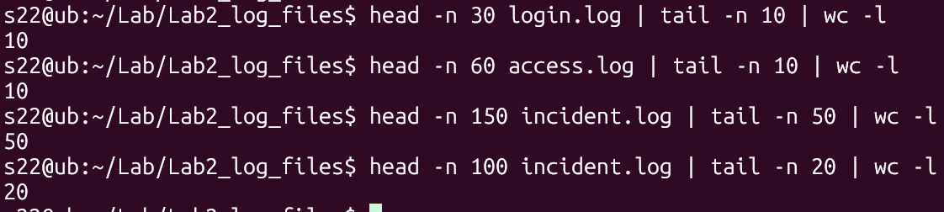

“All our dreams can come true if we have the courage to pursue them.”
                - Walt Disney

