Day-2: File Ownership and Access Control

Topics: chown, chgrp, ownership + permissions

Part A — Ownership Investigation (10 Minutes)

- Create a directory named ownership_lab.
Inside it, create:

- incident_report.txt

Owner- msis
Group- msis
Owner permissions-rw-
Group permissions- rw-
Others permission r--

- network.log

Owner- msis
Group- msis
Owner permissions-rw-
Group permissions- rw-
Others permission r--

- credentials.txt

Owner- msis
Group- msis
Owner permissions- rw-
Group permissions- rw-
Others permission r--

Display the detailed information for these files.

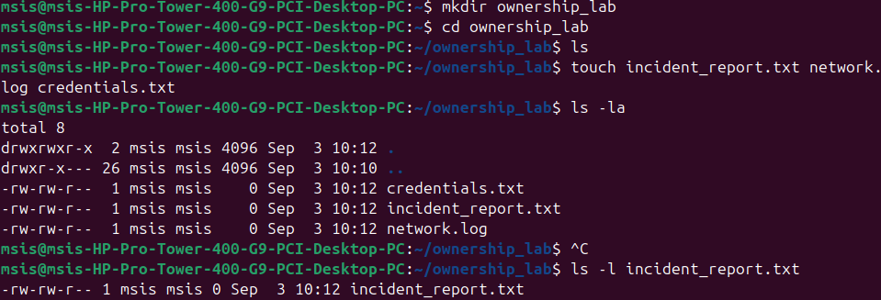
- Determine the UID and GID of the current user.
Id

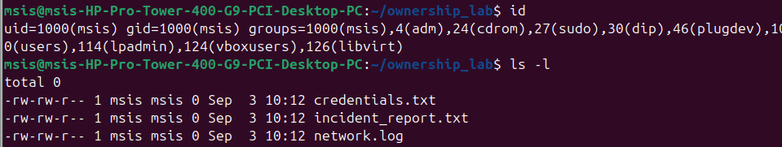
- Compare the UID/GID information with the ownership displayed for the newly created files.
Current user process has UID 1000(msis). When the files are created they are automatically stamped with UID. So owner column displays msis having rw-
Group is msis GID(1000) so group column shows msis with rw-

Others can read these files but cannot modify

- Explain the difference between file ownership and file permissions.
Ownership indicates which user account and which group account these files belong to.
(msis and msis)
Permissions- rw-rw-r-- defines what the accounts can do

Part B — chown: Changing Ownership (15 Minutes)
- Change the owner of incident_report.txt to alice.
- Change the owner of network.log to bob.
- Change the owner of credentials.txt to charlie.
Verify each change.

Sudo useradd -m alice
sudo chown bob incident_report.txt
ls -l

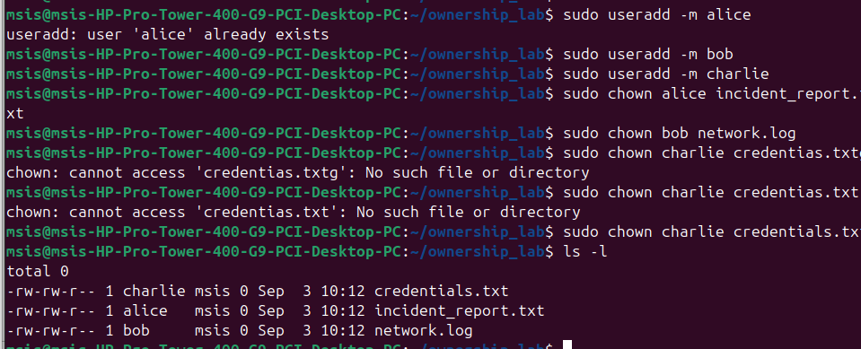
- Try changing the owner of a file to another user without using sudo. Record the result.
- Explain why an ordinary user is generally not permitted to transfer file ownership to another user.

Linux restricts regular users from changing the file ownership (chown restrictions) for major security reasons:
Disk Quota Evasion: If users could change file ownership freely, a user running out of storage space could "gift" large, heavy files to another user's account. This would fake-clear their own storage quota while unfairly consuming someone else's space allocation.

Malicious File Plants: Prevents attackers from assigning harmful files to administrators to gain high-level system control.

Trashing the Audit Trail: Prevents users from swapping ownership to hide their actions and break system tracking.

- Using a single command, configure:
incident_report.txt
Owner : alice
Group : security
Verify the resulting ownership.

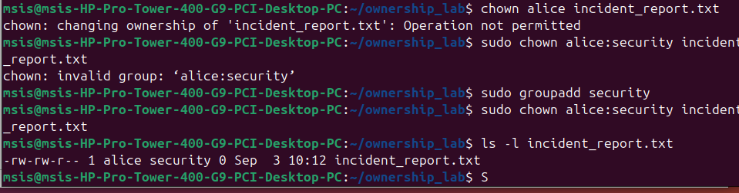
Part C — chgrp: Changing Group Ownership (15 Minutes)
- Change the group ownership of network.log to developers.
sudo groupadd developers
sudo chgrp developers network.log

- Change the group ownership of credentials.txt to security.
sudo chgrp security credentials.txt

- Verify the changes.
Ls -l

- Display the group memberships of alice, bob, and charlie.
groups alice
groups bob
groups charlie
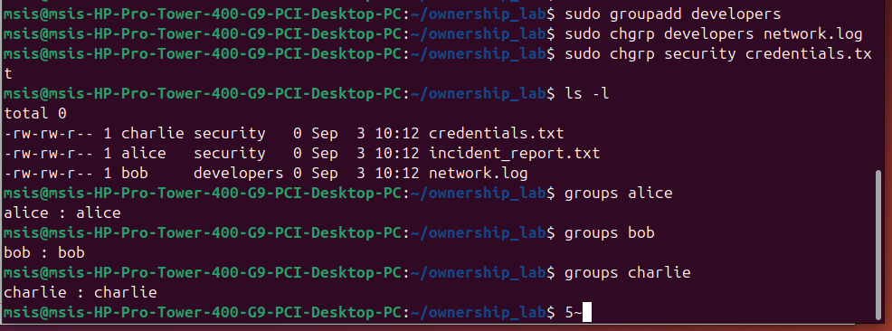
- Log in as alice and create a file named alice_report.txt.
sudo su - alice

- Attempt to change the group of alice_report.txt to security.
chgrp security alice_report.txt
not permitted
- Attempt to change its group to developers.
chgrp developers alice_report.txt
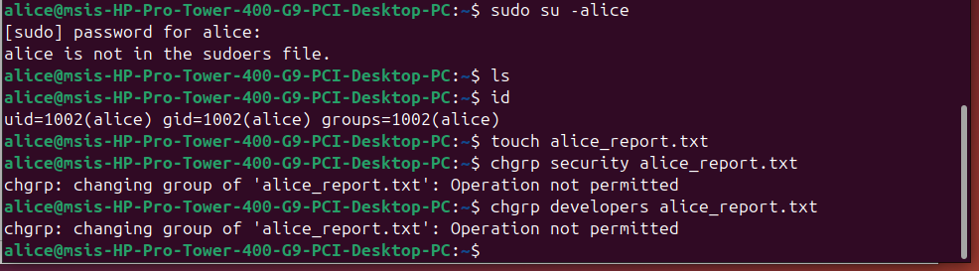
- Compare the results.
Both operations failed saying Operation not permitted error
Because a regular user can only change group permissions of file to that theya are member of. Alice is not a member of sucurity or developers so not allowed.

- Explain how a user's group membership affects their ability to change the group ownership of a file they own.

User's group membership defines which group they can assign to a file they own through the following strict rules. A regular user can only change a file's group ownership to a group that they currently belong to. Even the owner of a file cannot assign it to a group like security or developers if he are not an active member of that group.
Only the root user can change a file's group to any group on the system without all membership.

Part D — Ownership + Permission Investigation (20 Minutes)

- Configure:

-rw-r----- alice security incident_report.txt
Identify what operations are available to:
alice- rw-
charlie- r--
bob- no access

sudo chown alice:security incident_report.txt
sudo chmod 640 incident_report.txt

- A user who belongs to neither security nor the file owner charlie belongs to security. Test whether Charlie can:
Read incident_report.txt
Modify incident_report.txt
Delete incident_report.txt

chmod o+x /home/msis
chmod o+x /home/msis/ownership_lab
sudo su – charlie
cat incident_report.txt

read- allowed
modify – failed

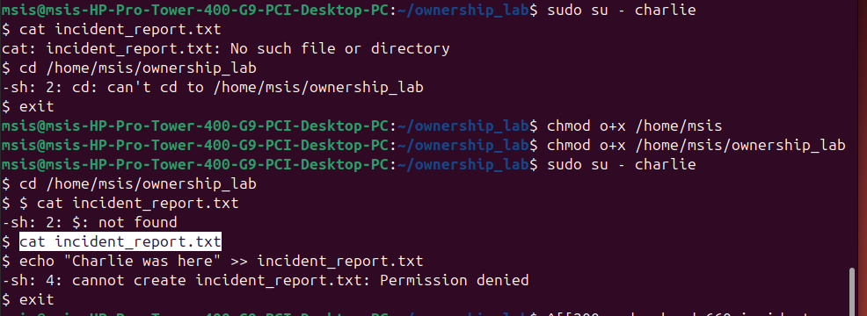
Record the result of each operation.

Change the permissions to:
-rw-rw----

read- allowed
write- allowed
delete- denied

Repeat the test as charlie.
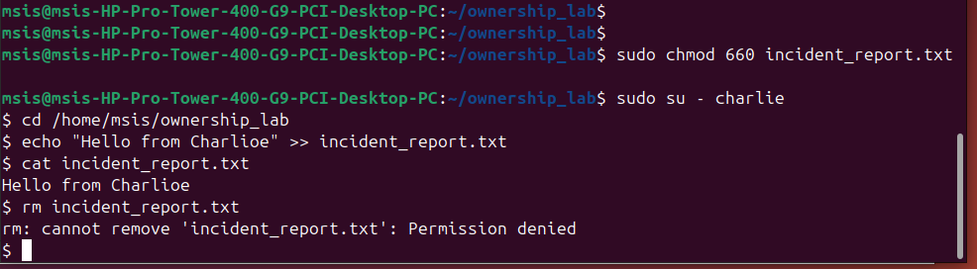
- Explain why Charlie's access changed even though the owner and group of the file did not change.
Because Linux separates identity (who owns the file) from permissions (what those owners can do).
The file owner stayed as alice and the file group stayed as security. Charlie's identity as a member of the security group also did not change.
When I ran sudo chmod 660, it altered the rules of security group upgraded their access mask from (r--) to (rw-).

- Remove bob from the security group.
sudo gpasswd -d bob security

- Without changing the file's ownership or permissions, test Bob's access again.
$ sudo su - bob
$ cd /home/msis/ownership_lab
$ cat incident_report.txt
cat: incident_report.txt: Permission denied
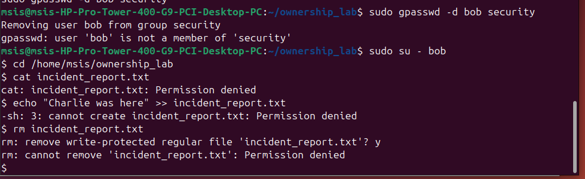
- Explain why Bob's effective permissions changed.
Before removal BOB belonged to security group. It stopped evaluating further and granted him the Group permissions layer (rw-).
After removal of bob from the security group, Linux checked his identity and saw he was not the owner (alice) and no longer in the group (security). As a result, the system dropped him into the Others category.

Refer: https://towardsdev.com/ownership-groups-in-linux-chown-chgrp-a2ae60b53083

"Practice isn't the thing you do once you're good. It's the thing you do that makes you good." — Malcolm Gladwell

