4_LAB_THEORY

Hard link vs. soft link

Part A — Create the links
- Create a directory named link_lab and navigate to it.

- Create a file named security.txt containing the following text:
Linux File System Security Lab
Confidential Security Report

- Create:
a hard link named security_hard.txt
a symbolic link named security_soft.txt

ln security.txt security_hard.txt
ln -s security.txt security_soft.txt

- List all three files using a command that displays their inode numbers.
ls -li
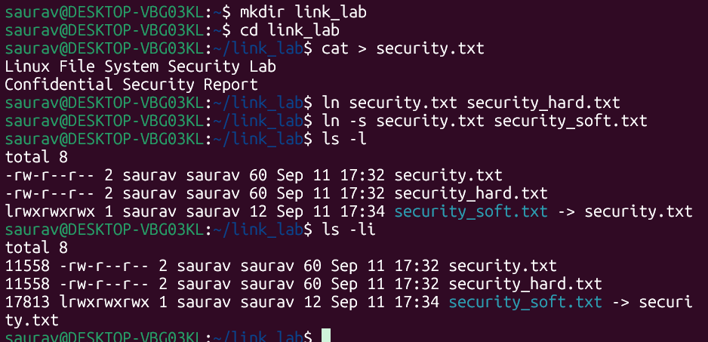
- Record the inode numbers of:
security.txt | 11558
security_hard.txt | 11518
security_soft.txt | 17813

- What difference do you observe?
security.txt and security_hard.txt share the same inode number. So hard link is not a separate file it is simply an additional directory entry (filename) pointing to the same inode. security_soft.txt has its own distinct inode. A symbolic link is a completely separate small file whose own content is just the text of the path it points to ("security.txt").

Part B — Examine File Metadata

- Use ls -l to examine the three files. Identify the file type of each file from the first character of the permission field.
security.txt | (-)regular file
security_hard.txt | (-) regular
security_soft.txt | (l) symbolic link

- Compare the link count of the original file, hard link, and symbolic link. Explain the observed values.

The link count field shows many filenames (hard links) point to the same inode. Creating security_hard.txt added a second name to inode 11518, so its link count became 2 and both filenames has same value and the link count belongs to the inode, not to any single filename. The symbolic link has its separate inode (17813), and since only one filename (security_soft.txt) points to that inode, its link count is 1.

- Use the stat command on all three files and record the following information:

stat $ stat security.txt security_hard.txt security_soft.txt
Parameter | Original | Hard Link | Soft Link
Inode number | 11558 | 11558 | 17813
File type | regular | regular | symbolic link
Size | 60 | 60 | 12
Link count | 2 | 2 | 1
Permissions | 0644/ -rw-r--r-- | 0644/ -rw-r--r-- | 0777/lrwxrwxrwx

- Compare the file sizes of the original file, hard link, and symbolic link. Why might the size of the symbolic link differ from the original file?
The size shown for a symbolic link is not the size of the target's data it is the number of characters in the pathname the link stores. The link stores the string "security.txt", which is exactly 12 characters, so its size is 12 bytes, unrelated to the 60-byte content of the original file. A hard link always shows the identical size to the original because it is the same file.

Part C — Investigate readlink
- Execute readlink on security_soft.txt. What information is displayed?
readlink security_soft.txt

readlink on the symbolic link prints the stored target path "security.txt" that the link contains.

- Execute readlink on security_hard.txt. What do you observe?

readlink security_hard.txt
readlink on the hard link produces no output because it is not a symbolic link it has no stored target path to display. readlink only has meaning for files whose type is 'l' (symbolic link).

- Based on your observations, explain why readlink works differently for hard links and symbolic links.

A symbolic link is a distinct file type that stores a path string as its content. readlink's job is to read and print that string. A hard link is an ordinary directory entry pointing at the same inode as the original file; from the filesystem's point of view there is nothing to resolve, so readlink correctly reports that the file is not a symbolic link.

- Use:
readlink -f security_soft.txt

- What does the -f option reveal?
The -f option fully resolves the link following the chain if needed and prints the absolute, canonical path of the final target file, rather than just the raw relative string stored inside the link.
Part D — Content Modification
- Append the following line to security.txt:
Unauthorized login detecte
- Display the contents using all three filenames.
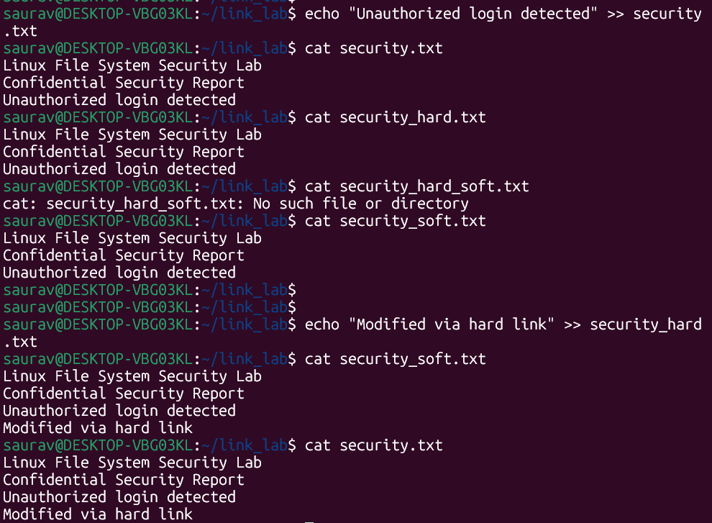
- Is the newly added content visible through both links? Explain why.
Yes. security_hard.txt shows it because it is the same inode/data as security.txt There is only one copy of the data on disk. security_soft.txt shows it because the operating system follows the symlink to security.txt and reads that same data. The symlink itself was never changed

- Modify the file using security_hard.txt. Check the contents through security.txt and security_soft.txt. What do you observe?
The change made in security_hard.txt instantly appears in security.txt and security_soft.txt. This confirms that all three filenames are different ways of reaching the same data editing any one of them edits the one and only copy of the file.

Part E — Rename Experiment
- Rename:
security.txt to: incident.txt
- Try accessing the content through security_hard.txt. Does it still work?
mv security.txt incident.txt

Works and shows full content.

- Try accessing the content through security_soft.txt. Does it still work?

Broken - Shows [No such file or directory]

- Use readlink security_soft.txt after renaming the original file. What path is still stored in the symbolic link?
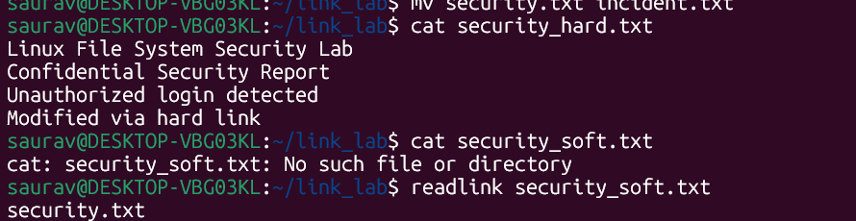

"security.txt" original string. Renaming the target does not update the symlink automatically.
- Explain why renaming the original file affects the symbolic link differently from the hard link.
A hard link does not store a filename, it points directly to the inode number, and inode numbers never change when a file is renamed, so the hard link keeps working no matter what the file is called. A symbolic link, however, stores the target's pathname as plain text. Once security.txt is renamed to incident.txt, that path no longer exists, so the kernel cannot resolve the symlink and every access through security_soft.txt fails, even though the underlying data (incident.txt) is completely intact.

Part F — Deletion Experiment

- Recreate the links if necessary and then perform the following.
stat -c "Inode:%i Links:%h Name:%n" security.txt security_hard.txt security_soft.txt

- Delete the original file.
rm security.txt

- Check whether security_hard.txt can still be accessed.
Yes. Only the link count dropped from 2 to 1, since only one filename (security_hard.txt) now points to inode

- Check whether security_soft.txt can still be accessed.
Not accessible. ls -l still lists the symlink itself (it is a real, separate file) and still shows the arrow to "security.txt", and readlink still prints that stored path but the target no longer exists, so any attempt to read/open it fails.

- Use ls -l and readlink to investigate the symbolic link after deleting its target.

- What is a dangling/broken symbolic link?
A symbolic link whose stored target path no longer refers to an existing file (because the target was deleted/renamed/moved). The link file itself still exists on disk and can still be listed with ls, but attempting to open, read, or cd into it returns a "No such file or directory" error.

- Does deleting the original filename immediately delete the underlying data when a hard link exists? Justify your answer using the link count and inode.
No. rm does not delete data directly it only removes a directory entry (a name) and decrements the inode's link count by one. The kernel only frees the inode and its data blocks once the link count reaches zero and no process still has the file open. Deleting security.txt only reduced the link count from 2 to 1 (as shown by stat); because security_hard.txt still points to the same inode, the data remains fully readable. If security_hard.txt were also deleted, the link count would fall to 0 and the space would then be reclaimed by the filesystem.
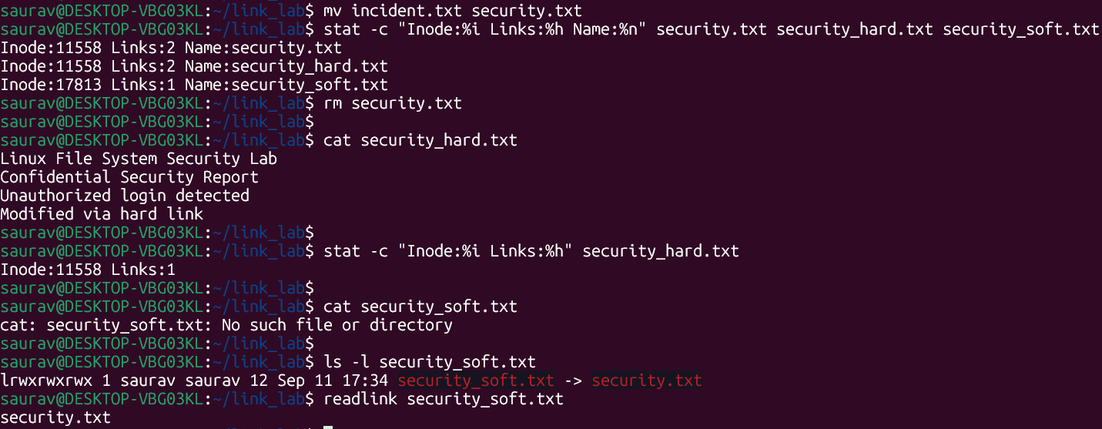

Part G — Directory and Filesystem Behaviour
- Create a directory named evidence. Attempt to create a hard link to this directory. Record the result.
$ mkdir evidence
$ link_lab$ ln evidence_hard
ln: failed to access 'evidence_hard': No such file or directory
Reason: Hard links to directories are blocked by the kernel/ln to prevent filesystem loops (a directory containing a hard link to one of its own ancestors would break tools like find, fsck and rm -r, which rely on the directory tree being a strict hierarchy with no cycles).
- Create a symbolic link named evidence_link pointing to the evidence directory. Was the operation successful?
Successful. Symbolic links to directories are supported.
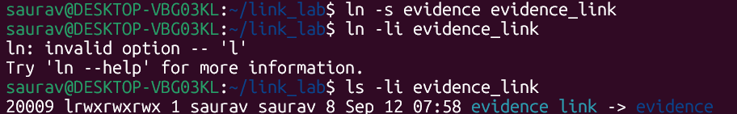

- Based on your experiment, compare hard and symbolic links with respect to directory linking.
Hard links to directories are not allowed (with the built-in exception of the '.' entry every directory has to itself), because the filesystem must remain a tree, not a graph with cycles. Symbolic links to directories are fully allowed because a symlink is just a pointer/shortcut, not a second directory entry sharing the same inode, it introduces no structural cycle.

- If multiple filesystems/mount points are available in the laboratory environment, attempt to create:
- a hard link across filesystems
A hard link cannot cross filesystems/mount points because the hard link must refer to an inode on the same filesystem.

- a symbolic link across filesystems
Succeeds without any restriction. A symlink only stores a path string as text; it does not depend on inode numbers at all, so it can point to a target on any filesystem, or even to a target that does not exist yet.

Final Comparison
Based only on your experimental observations, complete the following table:
Parameter | Hard Link | Symbolic Link
Inode number | Same as original file | Unique
File type | ‘-‘ regular | ‘l’ symbolic link
Link count | Increases shared count (>=2) | 1
File size | same (60) | Length of the target path string (18)
Stores target pathname? | no -points to inode directly | Yes
readlink output | None | Prints stored target path
Effect of modifying target | Change instantly visible (same data) | Change instantly visible (link followed)
Effect of renaming target | Unaffected - still works | Breaks - path no longer resolves
Effect of deleting target | Data survives if link count > 0 | Becomes a dangling/broken link
Can become a dangling or broken link? | No | Yes
Directory linking | Not allowed (prevents cycles) | Allowed
Cross-filesystem linking | Not allowed (EXDEV error) | Allowed

sort
Suppose alerts.txt contains:

192.168.1.10 admin 5
10.0.0.8 root 12
172.16.0.5 guest 2
10.0.0.20 admin 8

Format:

IP-address username failed attempts

- Sort according to failed attempts
~/link_lab$ sort -k3,3n alert.txt
172.16.0.5 guest 2
192.168.1.10 admin 5
10.0.0.20 admin 8
      - root 12

- Sort a list of suspicious IP addresses alphabetically.
$ awk '{print $1}' alerts.txt | sort
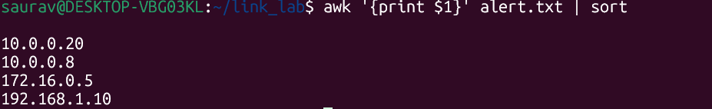
- Display only unique suspicious IP addresses using sort.
:~/link_lab$ awk '{print $1}' alert.txt | sort -u

10.0.0.20
10.0.0.8
172.16.0.5
192.168.1.10
- Sort a list of detected port numbers numerically.
sort -n ports.txt
- Display port numbers in descending numerical order.
sort -nr ports.txt
- Sort usernames without considering uppercase/lowercase differences.
sort -f users.txt

- From a failed-login log, count how many times each IP address occurs and display the most frequent IP first.

sort alert.txt | uniq -c | sort -nr
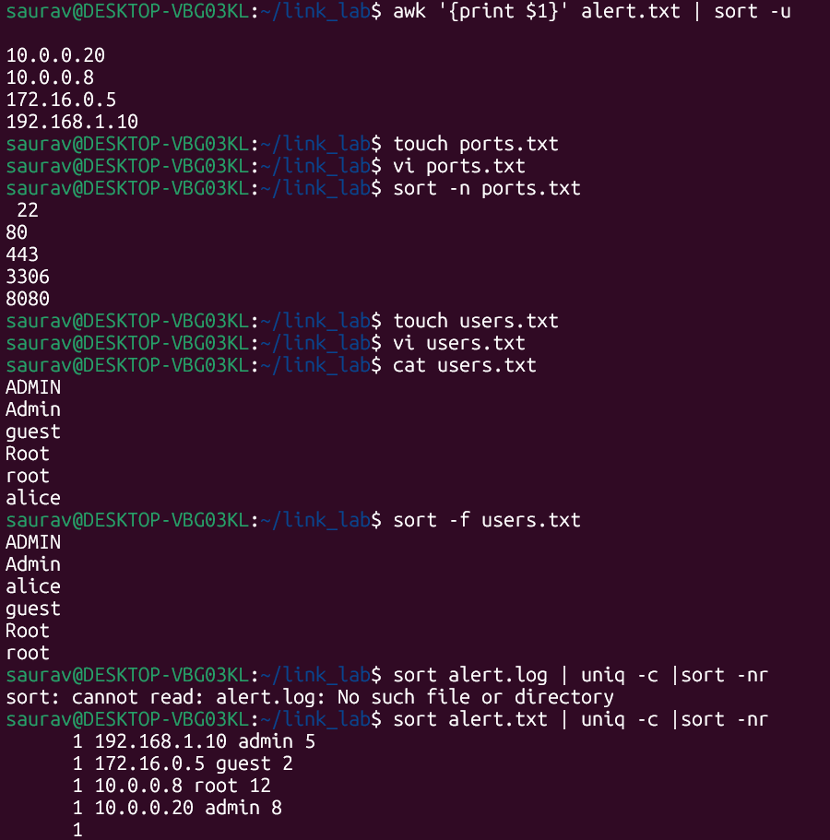
- Given IP,username,failed_attempts, sort records based on the number of failed attempts.

sort -k3,3n alert.txt

- Sort a CSV vulnerability report based on severity score.
sort -t',' -k3,3n vulnerability.csv

- Extract IP addresses using grep, then use sort and uniq to identify unique IP addresses.
grep -oE '([0-9]{1,3}\.){3}[0-9]{1,3}' failed_login.log | sort | uniq

- Create a pipeline that displays the top 5 IP addresses responsible for the most failed login attempts.
grep -i "FAILED LOGIN" failed_login.log | grep -oE '([0-9]{1,3}\.){3}[0-9]{1,3}' | sort | uniq -c | sort -nr | head -5
