Proposal:

Online loan management system

Chapter 1:

1. Introduction of system:

The system is named as an Online loan management system. This system will be design in order to maintain the data of the loan customers specifically. This will keep the records about the customers who have taken loan from a bank. So, I will be developing PHP based software which will help the customers and bank. This system will reduce manual data entry and will provide great efficiency.

1. Background of the system:
2. Justification of project:

Here I have proposed this system because with the help of this system people can easily take loan from the bank and data of the loan customers can be backed. It will also decrease the amount of time taken to write customer’s details and other modules. This system will also be helpful in terms of reducing manual data entry and will provide great efficiency. The user interface of the system will be very friendly and can be easily used by anyone. Therefore, in order to help the bank and the customers I will be developing this project.

1. Overview of the project:

Here the system will have two main interfaces. One will be for customers and other will be for the user (admin) which will manage all the bank account. Admin will be one who will verify the customer. There will be only one account of admin and other all will be of customers or users. Admin can add or delete the account of users. The admin will have to keep the loan details. Like for example how many instalments has been paid by the user and how many are left, how many installments were not paid by the customer in the past etc. when will the loan be over and what kind of loan is taken by the customer.

Chapter 2:

Scope:

1. Amis of the project:

* To reduce the manual data entry and provide great efficiency.
* To develop the software in minimum cost and provide all the features.
* To reduce the time taken to write the customers details and other modules.
* To help the user work with bank and their branches.
* To notify the user (sending SMS) about the loan payment according to their duration.

1. Objectives of the project:

* To make the user interface of the system very friendly so that it can be used by anyone.
* To record the loan customer details in systematically way.
* Backing up the data so that it will never be lost.
* Notifying the user about the loan payment through SMS.

1. Features to be included
2. Data of the customer to be stored in online server.
3. Payment collection of the customer.
4. Notifying the customers who takes loan.
5. Overview of scope:

Overview scope of project means imitations of project or in order words what is the boundary of the project or who can use this system. Online loan management can only be the user who have knowledge about the computer. Little knowledge related to computer can also be helpful.

Chapter 3:

1. Development methodology:

Development methodology is used to structure, plan and control the process of developing an information system. There are many ways to develop the software and some of them are agile, crystal method, dynamic systems development model, extreme programming, feature driven development, joint application development, lean development, rapid application development, rational unified process, Scrum, SDLC and waterfall.

Above all these methods I am going to use waterfall aka traditional method because waterfall method is one of the easiest ways to develop a project as development of project is done by following steps within the rule of waterfall development. It also allows departmentalization and managerial control. In this method deadlines are set for each stage of development and product can be proceed through the development process. This process leads to deliver the project on time as everything will be planned. And also as this project is not team project, waterfall method will be beneficial for me to do the project.

Down below is the diagram of waterfall diagram:

System Analysis

System design

Implementation

Testing

Maintenance

Fig: waterfall diagram

1. Design pattern:

Design pattern helps to develop better design architecture. It helps decrease the necessity of refactoring. it basically helps in solving the code of the project in the certain context. It makes the code easy to debug. Here for this project I will be using MVC pattern (Model View Controller). In this design pattern if one of the parts gets affected, it doesn’t affect the other parts. MVC will be used over other design pattern as the code is reusable in the other sections and classes. MCV pattern is divided into three parts:

1. Model: Model basically contains the code of the project. It must allow access for the data to be viewed, or collected and written to, and is the bridge between the View component and the Controller component in the overall pattern. The Model must act as a gatekeeper to the data itself, asking no questions but accepting all requests which comes its way.
2. View: The View is the part of the system where the HTML is generated and displayed. It shows the interface of the system. It shows the display of the system.
3. Controller:

Here down below is the MVC pattern diagram:

Model

Updates

Manipulates

View

Controller

Sees Uses

Chapter 4

Scheduling:

1. Work breakdown structure:

Work breakdown structure in project means breaking down of a project into smaller components. It is a key project deliverable that organizes the team’s work into manageable sections. The breaking down of the project helps to make the project more understandable and also helps in reducing complexity.

Online loan management system

Project Management

coding

Testing

documentation

Analysis

Design

Risk management

Requirement gathering

presentation

Black block testing

Database coding

Structural model

WBS

Final report

White box testing

GUI coding

Behavioral model

Use case

Configuration management

Database

design

UI design

Analysis

specification

Architecture

Proposal

submission

1. Milestone:

Milestone is tool used in project to set the deadline for the specific system. Here down below I have set certain date for each work to complete my work. This will help me to complete the project on time. As this project is not a team work this deadline will be beneficial for me to complete the project.

|  |  |  |
| --- | --- | --- |
| S. N | Milestone | date |
|  | Proposal | 1st July,2019 |
|  | Analysis | 20th September,2019 |
|  | Design | 29th august,2019 |
|  | Implementation | 11th oct,2019 |
|  | Testing | 30th September,2019 |
|  | Documentation | 11th oct,2019 |

1. Gantt chart

Chapter 5:

1. Risk management:

Risk management is the identification, evaluation and prioritization of risk followed by coordinated and economical application of resources to minimize, monitor and control the probability or impact of unfortunate events or to maximize the realization of opportunities. No system is perfect in this world, it certainly contains some defects. The system might get infected or may get harm. It may be affected by the natural disaster, employee theft, system failure, human error etc.

Impact = likelihood * consequence is the formula to calculate and evaluate risk factors.

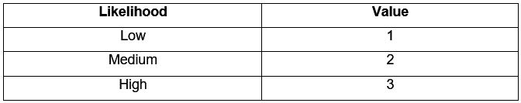

*Risk likelihood and values*

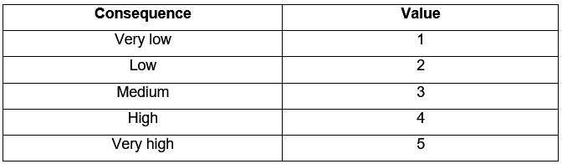

*Risk Consequence and Values*

Here down below is some of the risk that will affect my project with their impact and actions:

|  |  |  |  |  |
| --- | --- | --- | --- | --- |
| Risks | Likelihood | Consequence | Impact | Action |
| Employee theft | 3 | 4 | 12 | Data loss |
| System failure | 2 | 5 | 10 | Can cause data loss |
| Natural disaster | 2 | 2 | 4 | May impact on the scheduling |
| Human error | 1 | 2 | 2 | May be in scheduling |
| Hardware failure | 1 | 4 | 4 | Backup of customer data should be kept. |

Chapter 6:

Configuration:

For the configuration management of the system I have created folder in D drive to backup my data and also for backing up of the data online I have store my project in git-hub.

