**Proposal:**

**Online loan management system**

**Table of content:**

1. Introduction of system....................................................................................................................2
   1. background of system..........................................................................................................2
   2. Justification of project..............................................................................................................2
   3. Problem of statement..............................................................................................................3
   4. Overview of project..............................................................................................................3
2. Scope ..........................................................................................................................................3

2.1 aims of project......................................................................................................................3

2.2 objectives of project......................................................................................................4

2.3 features of project.............................................................................................................4

2.4 overview of scope....................................................................................................................4

1. Development methodology .....................................................................................................5

3.1 waterfall........................................................................................................................5

3.1 design pattern........................................................................................................................6

3.1 system artitecture...................................................................................................................7

1. Secluding .................................................................................................................8

4.1 WBS.......................................................................................................................8

3.1 milestone........................................................................................................................9

3.1 description of milestone......................................................................................................10

1. Risk management.........................................................................................................12
2. Configuration.......................................................................................................................13
3. Conclusion ........................................................................................................................14
4. References .......................................................................................................................15

Figure 1. Waterfall diagram....................................................................................................5

Figure 2. MVC pattern...........................................................................................................6

Figure 3. three tier architecture..............................................................................................7

Figure 4. WBS structure .......................................................................................................8

Figure 5. Gantt chart...........................................................................................................11

Figure 6. Configuration.................................................................................................. 14

**Chapter 1:**

1. **Introduction of system:**

* The system is named as an Online loan management system. This system will be design in order to maintain the data of the loan customers specifically. This will keep the records about the customers who have taken loan from a bank. So, I will be developing PHP based software which will help the customers and bank. This system will reduce manual data entry and will provide great efficiency.

1. **Background of the system:**

* Filling up the form while taking loan from the bank, people find it difficult. Many educated people also find It difficult to fill up form as they may not understand the requirements asked by the bank. And the loan customer data can’t also be kept in paper in the bank, it might get lost. Manual data entry doesn’t provide great efficiency. So, in order to reduce manual data entry, I will create this project. Also, it will provide confidentiality to the data of customers.

Thus, the main goal of this project is to provide all the features to bank and the user and also reducing the time taken to write the customer details and provide great efficiency.

1. **Justification of project:**

* Here I have proposed this system because with the help of this system people can easily take loan from the bank and data of the loan customers can be backed. It will also decrease the amount of time taken to write customer’s details and other modules. This system will also be helpful in terms of reducing manual data entry and will provide great efficiency. The user interface of the system will be very friendly and can be easily used by anyone. Therefore, in order to help the bank and the customers I will be developing this project.

**Problem statement:**

* It is necessary that every application should be efficient, it should be able to store and manipulate the data easily. Many banks have issues regarding storing data of loan customer as they record the data manually and also calling them notifying them regarding the loan payment. Therefore, this system will help the bank and user regarding their loan and payment.

1. **Overview of the project:**

* Here the system will have two main interfaces. One will be for customers and other will be for the user (admin) which will manage all the bank account. Admin will be one who will verify the customer. There will be only one account of admin and other all will be of customers or users. Admin can add or delete the account of users. The admin will have to keep the loan details. Like for example how many instalments has been paid by the user and how many are left, how many installments were not paid by the customer in the past etc. when will the loan be over and what kind of loan is taken by the customer.

**Chapter 2:**

**Scope**:

1. **Amis of the project:**

* To reduce the manual data entry and provide great efficiency.
* To develop the software in minimum cost and provide all the features.
* To reduce the time taken to write the customers details and other modules.
* To help the user work with bank and their branches.
* To notify the user (sending SMS) about the loan payment according to their duration.

1. **Objectives of the project:**

* To make the user interface of the system very friendly so that it can be used by anyone.
* To record the loan customer details in systematically way.
* Backing up the data so that it will never be lost.
* Notifying the user about the loan payment through SMS.
* Data of the customer will be kept confidential.
* To keep the website secure and functional.

1. **Features to be included**
2. Data of the customer to be stored systematically.
3. Recording payment collection of the customer.
4. Sending SMS to the customers who takes loan.
5. Log in of admin.
6. Adding new customer (Registration).
7. Providing receipt after each payment by customer.
8. Backing up the data in online server as well as in local drive of computer.
9. Sending SMS to the customer regarding the payment of the loan.
10. Recording all the details about the user who takes loan.
11. Confidentiality of data will be maintained.
12. **Overview of scope:**

* Overview scope of project means imitations of project or in order words what is the boundary of the project or who can use this system. Online loan management can only be the user who have knowledge about the computer. Little knowledge related to computer can also be helpful.

**Chapter 3:**

1. **Development methodology:**

* Development methodology is used to structure, plan and control the process of developing an information system. There are many ways to develop the software and some of them are agile, crystal method, dynamic systems development model, extreme programming, feature driven development, joint application development, lean development, rapid application development, rational unified process, Scrum, SDLC and waterfall.

Above all these methods I am going to use waterfall aka traditional method because waterfall method is one of the easiest ways to develop a project as development of project is done by following steps within the rule of waterfall development. It also allows departmentalization and managerial control. In this method deadlines are set for each stage of development and product can be proceed through the development process. This process leads to deliver the project on time as everything will be planned. And also, as this project is not team project, waterfall method will be beneficial for me to do the project.

Down below is the diagram of waterfall diagram:

System Analysis

System design

Implementation

Testing

Maintenance

*Fig1: waterfall diagram*

1. **Design pattern:**

* Design pattern helps to develop better design architecture. It helps decrease the necessity of refactoring. it basically helps in solving the code of the project in the certain context. It makes the code easy to debug. Here for this project I will be using MVC pattern (Model View Controller). In this design pattern if one of the parts gets affected, it doesn’t affect the other parts. MVC will be used over other design pattern as the code is reusable in the other sections and classes. MCV pattern is divided into three parts:

1. Model: Model basically contains the code of the project. It must allow access for the data to be viewed, or collected and written to, and is the bridge between the View component and the Controller component in the overall pattern. The Model must act as a gatekeeper to the data itself, asking no questions but accepting all requests which comes its way.
2. View: The View is the part of the system where the HTML is generated and displayed. It shows the interface of the system. It shows the display of the system.
3. Controller: Basically, the controller handles or manages the model and view connection. People interact with view as view means the interface which people uses. User interacts with view and which in turn raises URL request, this request will be handled by controller.

Here down below is the MVC pattern diagram:

Model

Updates

Manipulates

View

Controller

Sees Uses

*Fig2: Model View Controller*

1. **System Architecture:**

* For this project I will be using 3 tier system architecture. System architecture means the conceptual model that defines the structure, behavior and more views of a system. It is done to know the structural, behavior and more views of a system. It is a formal description and representation of a system. Here for this I will be using 3-tier architecture as it more flexible and the application is faster. And the three tiers are;

1. Presentation tier: this tier contains the top-level displays related to services available on the website. This tier basically communicates with the other tier by sending the result to other in tier in network
2. Application tier: this tier is the middle tier, logic tier. Application tier is pulled from the presentation tier. It controls the application function.
3. Data tier: Data related to the customer who have taken loan is stored over here.

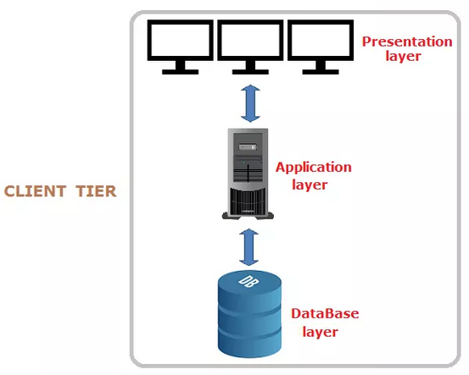

*fig3: three tier architecture*

**Chapter 4**

**Scheduling:**

1. **Work breakdown structure:**

* Work breakdown structure in project means breaking down of a project into smaller components. It is a key project deliverable that organizes the team’s work into manageable sections. The breaking down of the project helps to make the project more understandable and also helps in reducing complexity.

Here down below figure indicate the WBS of my project. The figure explains that after completing proposal I will be looking forward to analysis where I will be gathering information related to my project and then I will be drawing diagram like use case and class diagram. After than design will come where I will make the interface design, structural model, behavior model and also database design. Then comes coding part where database coding and system coding will be done. And finally testing as system may contain many bugs and Implementation of system is done.

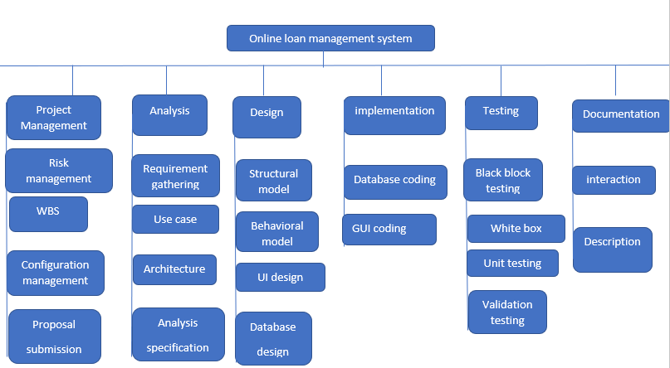

*Fig4: WBS structure*

1. **Milestone:**

* Milestone is tool used in project to set the deadline for the specific system. Here down below I have set certain date for each work to complete my work. This will help me to complete the project on time. As this project is not a team work this deadline will be beneficial for me to complete the project.

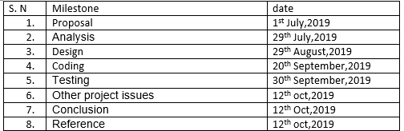

Here down below are the project stages and for the projects date are allocated so that it becomes easy for me to complete all the task. Milestone helps in better time management and it ultimately leads to deliver the project on time.

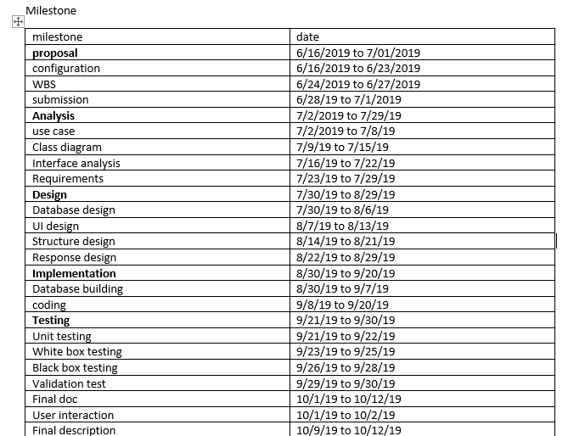

1. **Description of milestone:**

* Here is the time estimation in which I will be completing my project so that I can complete my project on the time of deadline.

**Project management (16 days)**

* Proposal submission (5 days)
* Risk management (2 days)
* WBS (6 days)
* Configuration management (3 days)

**Analysis (28 days)**

* Requirement analysis (8 days)
* Use-case (5 days)
* Architecture (class diagram) (8 days)
* Analysis Specification (4 days)

**Design (30 days)**

* Structural design (9 days)
* Behavioral design (8 days)
* UI design (6 days)
* Database design (7 days)

**Implementation (22 days)**

* Building database (10 days)
* Coding (12 days)

**Testing (10 days)**

* Black box testing (3 days)
* White box testing (3 days)
* Unit testing (2days)
* Validation test (2 days)

1. **Gantt chart**

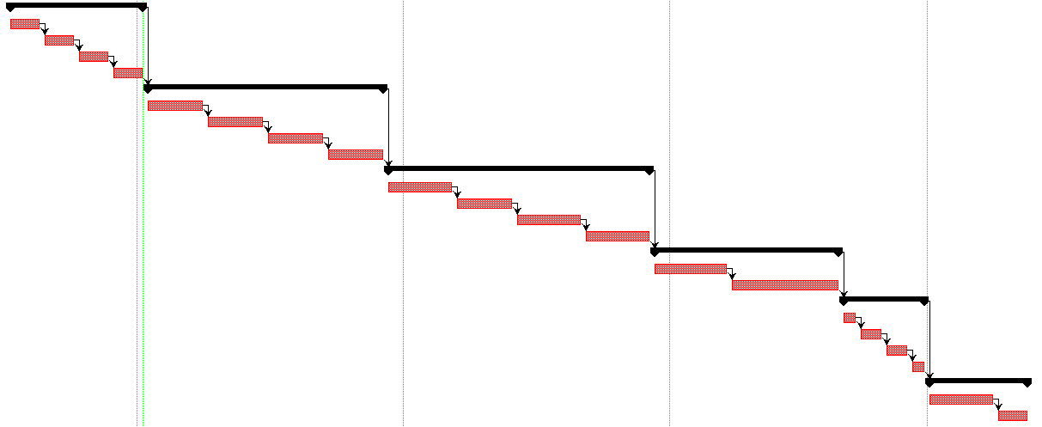

*Fig5: Gantt chart*

1. **Secluding:**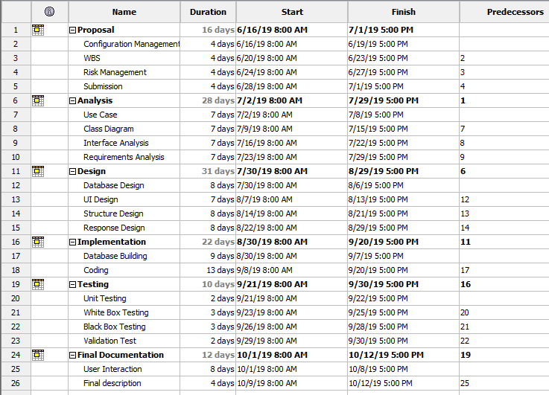

*Fig: Secluding time*

**Chapter 5:**

1. **Risk management:**

* Risk management is the identification, evaluation and prioritization of risk followed by coordinated and economical application of resources to minimize, monitor and control the probability or impact of unfortunate events or to maximize the realization of opportunities. No system is perfect in this world, it certainly contains some defects. The system might get infected or may get harm. It may be affected by the natural disaster, employee theft, system failure, human error etc.

Impact = likelihood * consequence is the formula to calculate and evaluate risk factors.

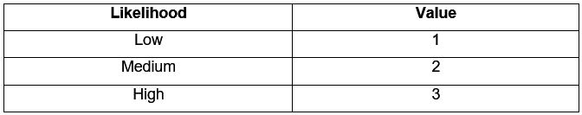

*Risk likelihood and values*

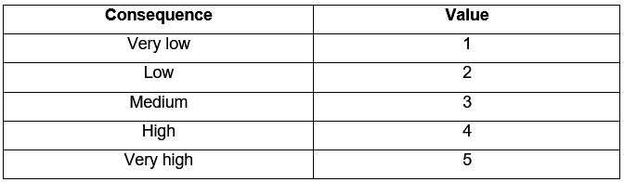

*Risk Consequence and Values*

Here down below is some of the risk that will affect my project with their impact and actions:

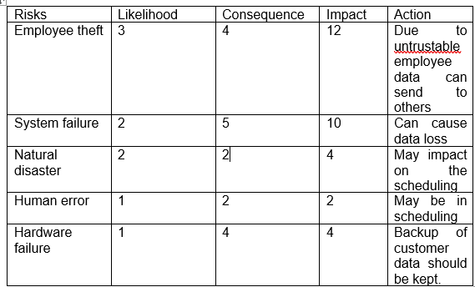*Risk and action*

**Chapter 6: Configuration:**

* The software configuration management system controls the basic components such as software objects, program code, test data, test output, design documents and user manuals. It is basically done as it helps in managing the data.

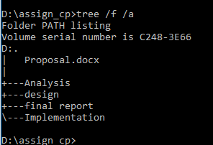

*Fig5: saved file in drive*

I have created a GitHub account named saurab906 to store my data within which sub folders are also created. Here down below is the figure that shows how the data of my project are stored in git-hub account.

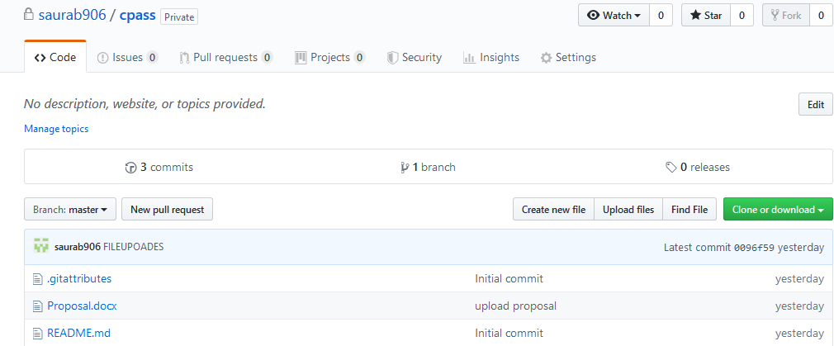

*Fig6: GitHub drive*

For configuration management there is release management which means the process of managing, planning scheduling and controlling a software build through different stages including deployment and testing.

Version control management is known as revision control which manages the changes of documents, computer programs, large website and other information.

**Conclusion:**

* Therefore, in this way the overview of the project which contains introduction and the justification of the project is explained in this project as well as scope limitation and methodology is defined in this project. With the help of WBS the task is decomposed into subtask which makes the project easy to do and also the time allocation part is done for each task so that project can be completed on time.

And finally, online loan management system outcome is here. It is software which helps the user to work with bank easily. It reduces the amount of manual data entry and gives greater efficiency. The User Interface of it is very friendly and can be easily used by anyone. It also decreases the amount of time taken to write customer’s details and other modules.

**References/bibliography:**

1. Scribd, 2018. Scope limitation, definition [Online]

Available at: https://www.scribd.com/presentation/349056812/RESEARCH-PAPER-SCOPE-LIMITATIONS-Reporting

1. Techopedia, 3 tier system architecture[online]

Available at: <https://www.techopedia.com/definition/24649/three-tier-architecture>

1. Wikipedia, waterfall diagram, definition [Online]

Available at: <https://en.wikipedia.org/wiki/Waterfall_chart>

1. Site-point, MVC pattern, defining and diagram2019[online]

Available at: <https://www.sitepoint.com/the-mvc-pattern-and-php-1/>

1. WBS, definition ad diagram,2019 [online]

Available at: <https://www.workbreakdownstructure.com/>

1. Wrike, Risk management ,2019[online]

Available at: https://www.projectmanager.com/blog/risk-management-process-steps

1. Wikipedia, configuration management, definition[online]

Available at: https://en.wikipedia.org/wiki/Configuration management