**Chapter 5: Testing**

* Software testing is a set of processes that is done to aim to know the quality of a computer software. It ensures the compliance of a software product. Testing of a software is done basically to know the quality, performance and reliability of a product. It helps to find the errors, gaps or missing requirement in relation to the actual requirements of the software. In simple words software testing means verification of application under test.

There are different types of testing with which the software can be tested like unit testing, integration testing, system testing, sanity testing, smoke testing, interface testing, regression testing, beta/acceptance testing e. t. c and for testing mine software I have used black testing and unit testing.

Types of testing:

1. **Black box testing**
2. **Unit testing**

* **Black box testing:** black box testing is a software testing where internal structure or design or implementation of a item is tested.it is also known as Behavioral testing. These tests can be functional ore non functional though mainly it is functional. This testing is done to know whether the software functions properly or not.it ensures the functionality of a software. This testing helps to know the user what the software is supposed to do and what happens after the success of one.it is like prototype testing.
* **Reasons for doing black box testing:**

1. It ensures the functionality of a software.
2. Tests the design or implementation of an item.
3. Shows behavior or performance errors.
4. Shows interface errors.

Here down below are the black box testing the I have performed to test my system:

1.

|  |  |  |  |  |  |
| --- | --- | --- | --- | --- | --- |
| Tester ID | Case name | Test strategy | Expected result | Actual result | Remarks |
| 1 | Login form | Black box testing | Dashboard or Home is expected to be open. | Opens Home form or dashboard | Succeed. |

* **After admin login with his/her email and password, dashboard opens where admin can view all the customer:**

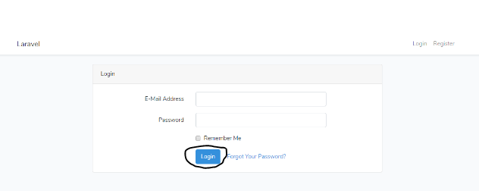

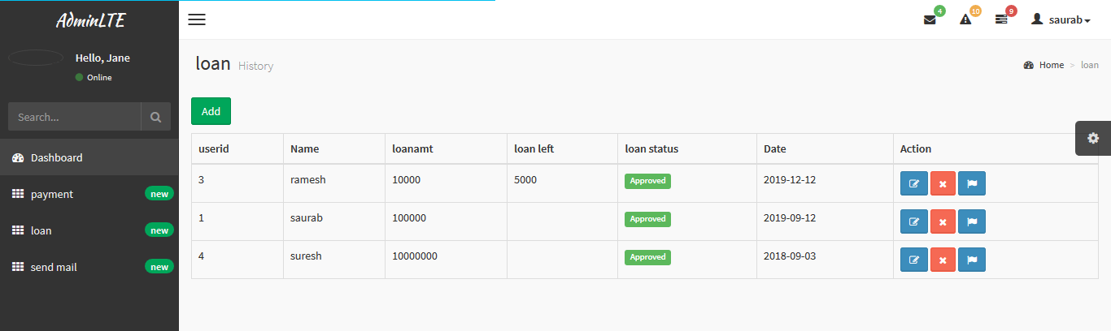

**2.**

|  |  |  |  |  |  |
| --- | --- | --- | --- | --- | --- |
| Tester ID | Case name | Test strategy | Expected result | Actual result | Remarks |
| 2 | Customer  Login form | Black box testing | Dashboard or Home is expected to be open. | Opens Home form or dashboard | Succeed. |

* **After Customer logins a dashboard open where he/she can view his/her records only.**   
  

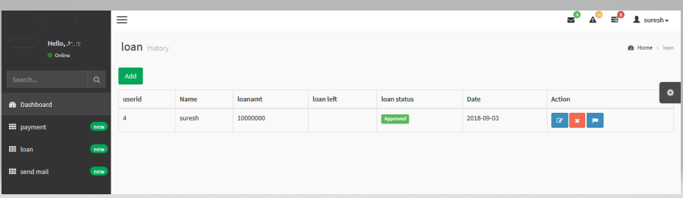

**3.**

|  |  |  |  |  |  |
| --- | --- | --- | --- | --- | --- |
| Tester ID | Case name | Test strategy | Expected result | Actual result | Remarks |
| 3 | Logout | Black box testing | Login form appears | Opens login form | Succeed. |

**When logout button is clicked login form appears:**

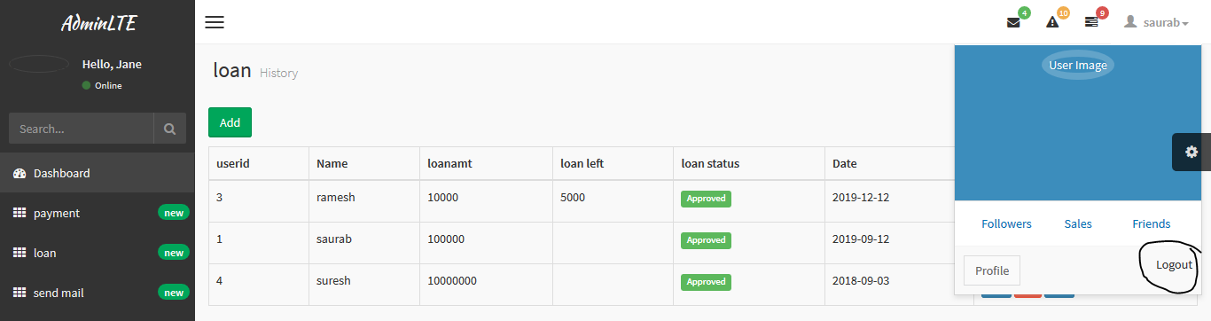

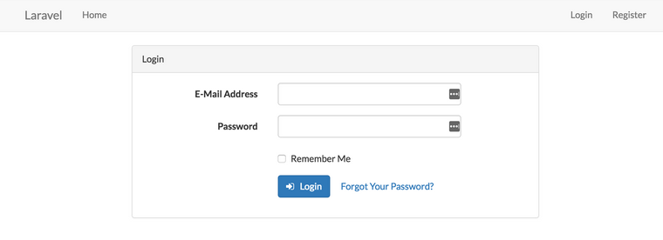

4.

|  |  |  |  |  |  |
| --- | --- | --- | --- | --- | --- |
| Tester ID | Case name | Test strategy | Expected result | Actual result | Remarks |
| 4 | Registration | Black box testing | Registration form appears | Opens registration form | Succeed. |

* **When registration button is clicked, registration form opens:**

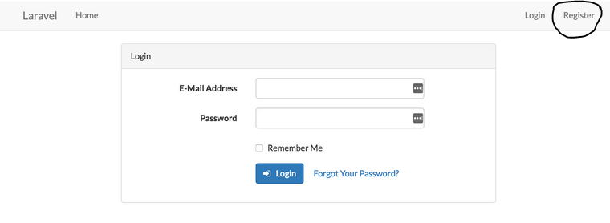

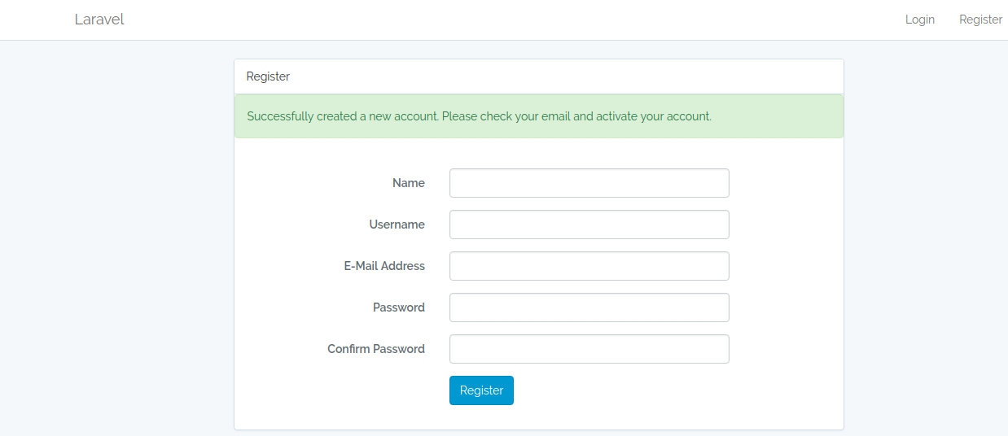

**5.**

|  |  |  |  |  |  |
| --- | --- | --- | --- | --- | --- |
| Tester ID | Case name | Test strategy | Expected result | Actual result | Remarks |
| 5 | Loan | Black box testing | loan form appears | Opens loan form | Succeed. |

* **When loan button is clicked by admin, he/she can view the users who have taken loan.**

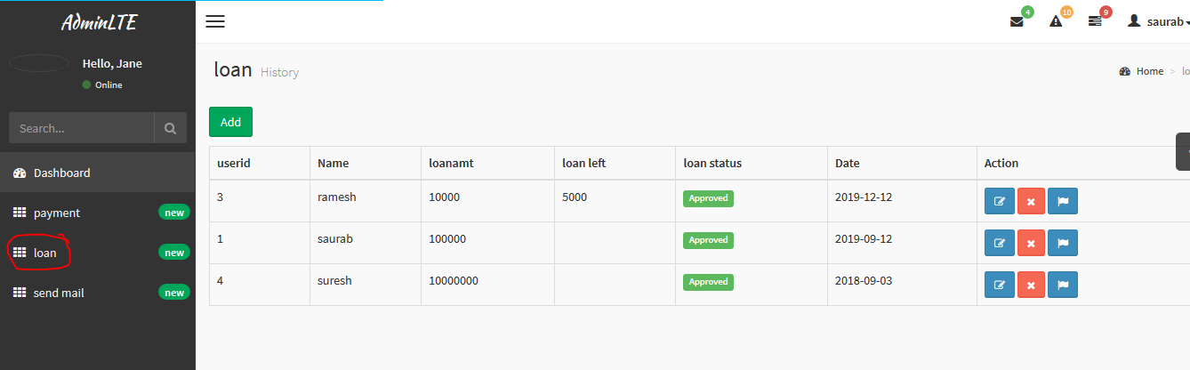

**6.**

|  |  |  |  |  |  |
| --- | --- | --- | --- | --- | --- |
| Tester ID | Case name | Test strategy | Expected result | Actual result | Remarks |
| 6 | Add loan | Black box testing | Loan add form appears | Opens loan add form | Succeed. |

* **When add loan is clicked, loan form opens:**

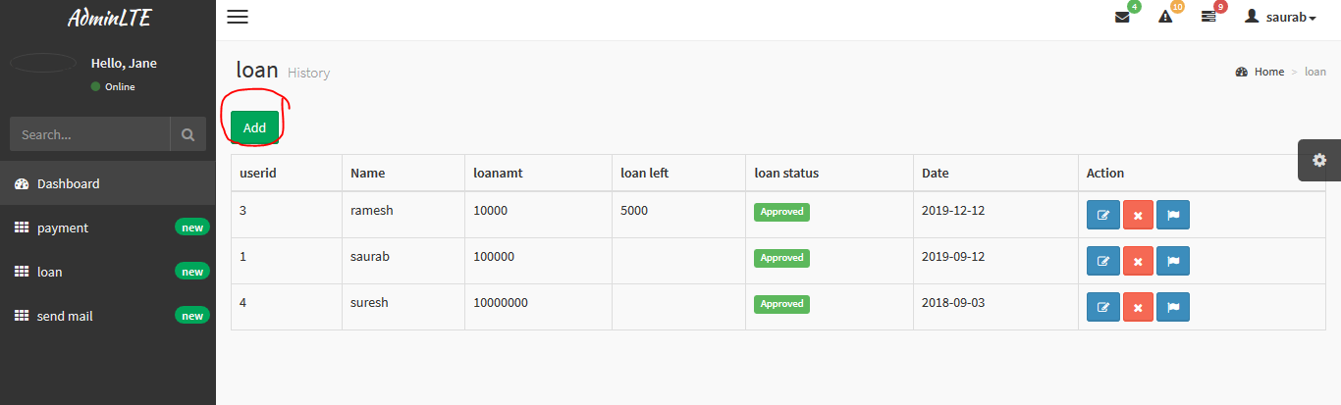

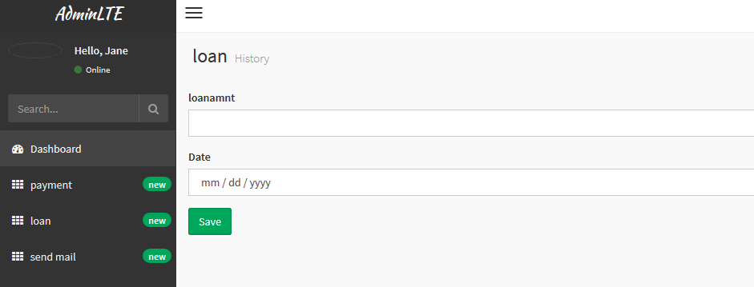

**7.**

|  |  |  |  |  |  |
| --- | --- | --- | --- | --- | --- |
| Tester ID | Case name | Test strategy | Expected result | Actual result | Remarks |
| 7 | Payment | Black box testing | payment form appears | Opens payment add form | Succeed. |

* **When payment button is clicked, payment form opens:**

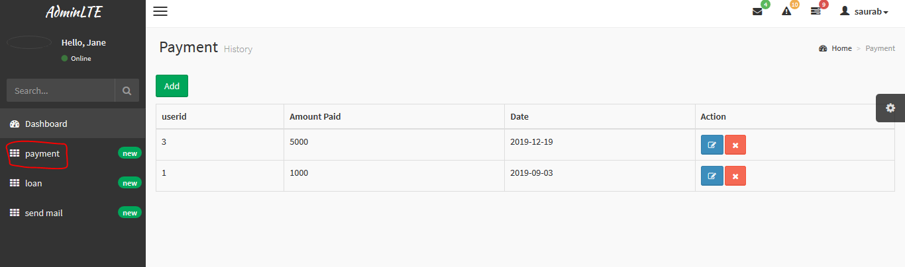

**8.**

|  |  |  |  |  |  |
| --- | --- | --- | --- | --- | --- |
| Tester ID | Case name | Test strategy | Expected result | Actual result | Remarks |
| 8 | Add Payment | Black box testing | Add payment form appears | Opens add payment add form | Succeed. |

* **When Add payment button is clicked, add payment forms open where user can pay their loan amount.**

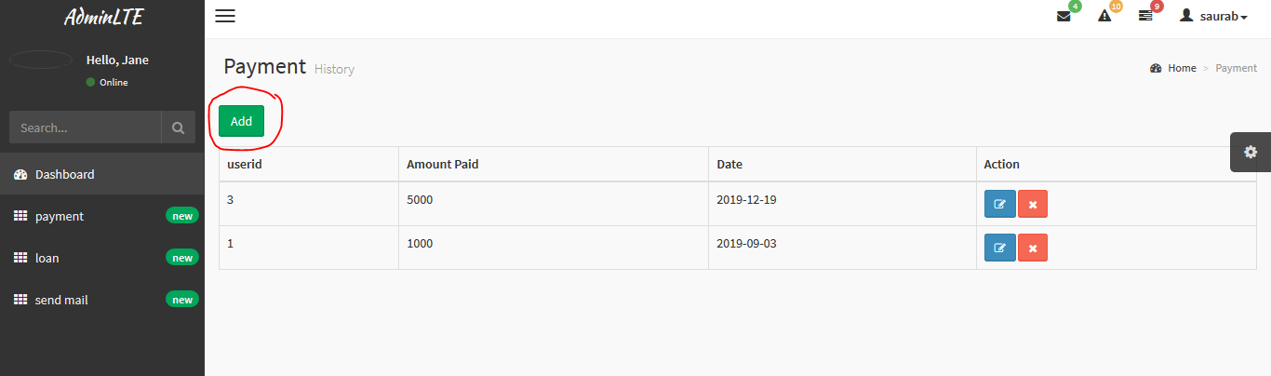

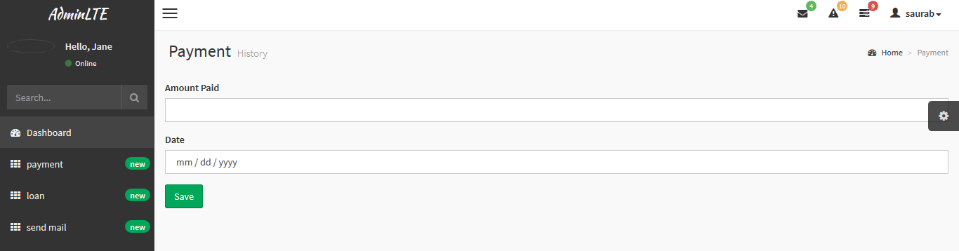

**9.**

|  |  |  |  |  |  |
| --- | --- | --- | --- | --- | --- |
| Tester ID | Case name | Test strategy | Expected result | Actual result | Remarks |
| 9 | Email | Black box testing | Email form appears | Opens email form | Succeed. |

* **When send email button is clicked, email form appears where admin sends reminder of loan payment:**

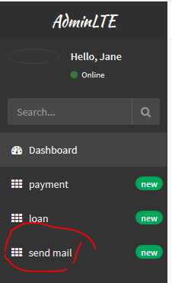

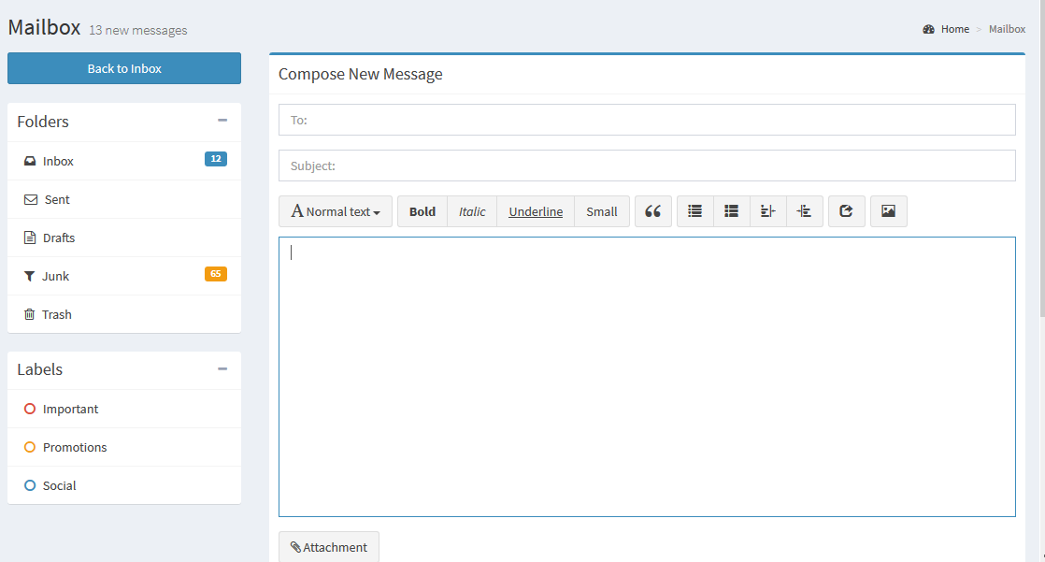

10

|  |  |  |  |  |  |
| --- | --- | --- | --- | --- | --- |
| Tester ID | Case name | Test strategy | Expected result | Actual result | Remarks |
| 10 | Email message | Black box testing | Email message appears | Opens email message form | Succeed. |

* **When mail icon is clicked admin can view all emails send to him by the customers.**

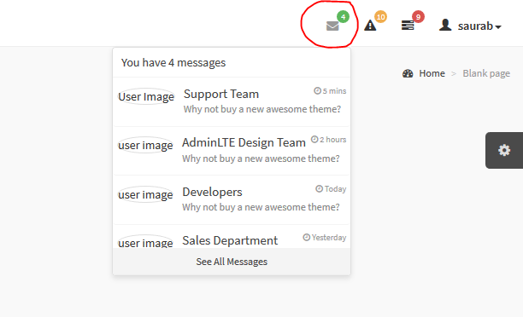

**11**

|  |  |  |  |  |  |
| --- | --- | --- | --- | --- | --- |
| Tester ID | Case name | Test strategy | Expected result | Actual result | Remarks |
| 11 | Notification message | Black box testing | Notification message appears | Opens notification message form | Succeed. |

* **When notification icon is clicked admin can be notified what is going on.**

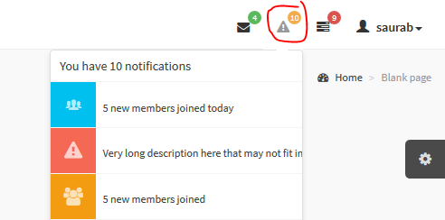

1**2.**

|  |  |  |  |  |  |
| --- | --- | --- | --- | --- | --- |
| Tester ID | Case name | Test strategy | Expected result | Actual result | Remarks |
| 12 | Loan delete | Black box testing | Loan amount deletes | Deletes user loan amount | Succeed. |

* **When admin clicks on delete button the loan amount of user gets deleted.**

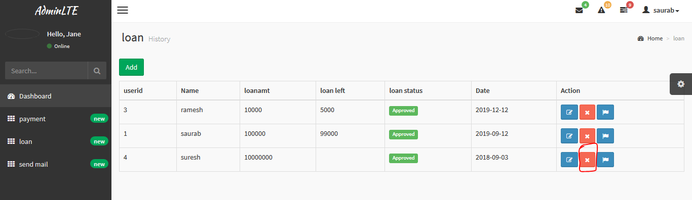

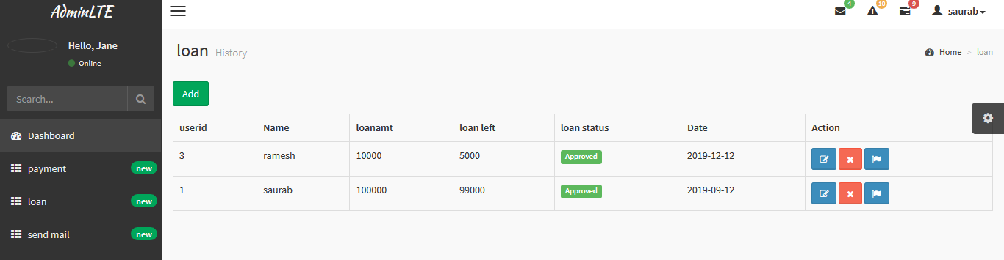

**13**

|  |  |  |  |  |  |
| --- | --- | --- | --- | --- | --- |
| Tester ID | Case name | Test strategy | Expected result | Actual result | Remarks |
| 13 | Flag | Black box testing | Approved sign comes | Approves displays | Succeed. |

* **When admin flag button is clicked, approved symbol displays:**

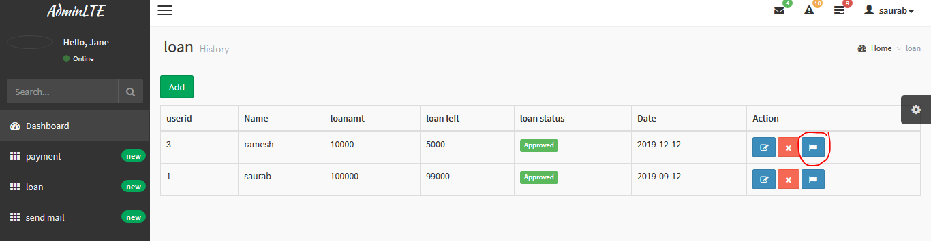

**14**

|  |  |  |  |  |  |
| --- | --- | --- | --- | --- | --- |
| Tester ID | Case name | Test strategy | Expected result | Actual result | Remarks |
| 14 | Payment Edit | Black box testing | Payment edit form appears | Opens edit form | Succeed. |

* **When customer click on payment button to pay their loan interest, payment form opens.**

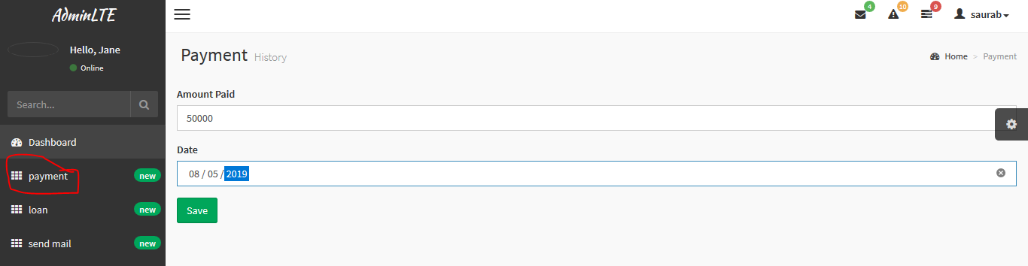

**15.**

|  |  |  |  |  |  |
| --- | --- | --- | --- | --- | --- |
| Tester ID | Case name | Test strategy | Expected result | Actual result | Remarks |
| 15 | Setting | Black box testing | Options bar appears | Opens options side bar | Succeed. |

* **When option side bar is clicked, options bar displays.**

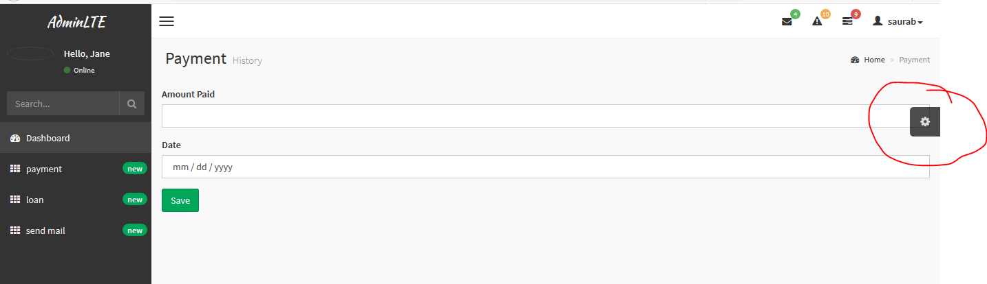

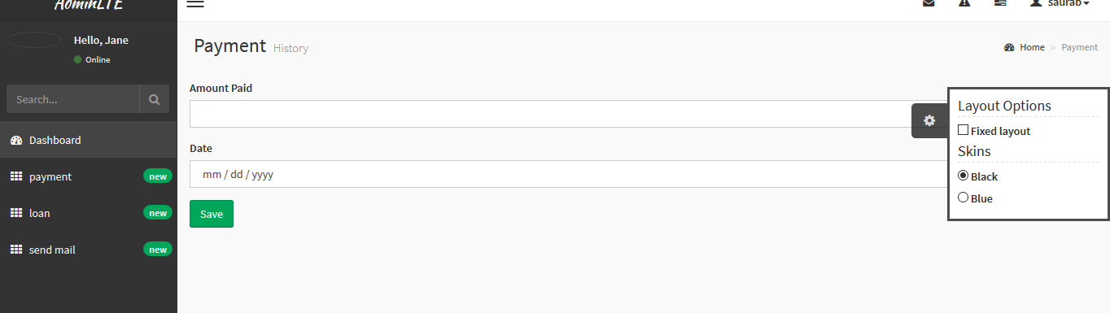

**16.**

|  |  |  |  |  |  |
| --- | --- | --- | --- | --- | --- |
| Tester ID | Case name | Test strategy | Expected result | Actual result | Remarks |
| 16 | Profile | Black box testing | User profile opens | Opens user profile | Succeed. |

* **When user profile is clicked, the payment and loan taken by the user is displayed.**

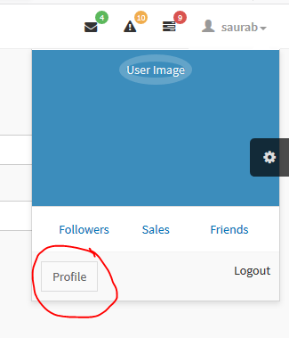

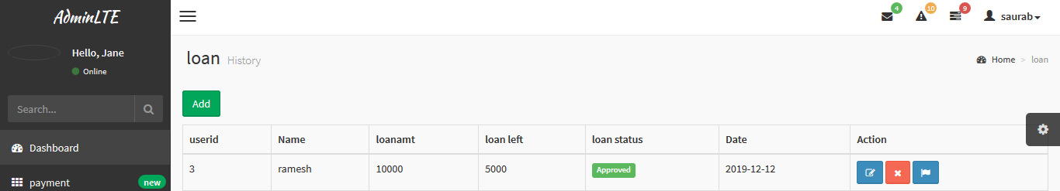

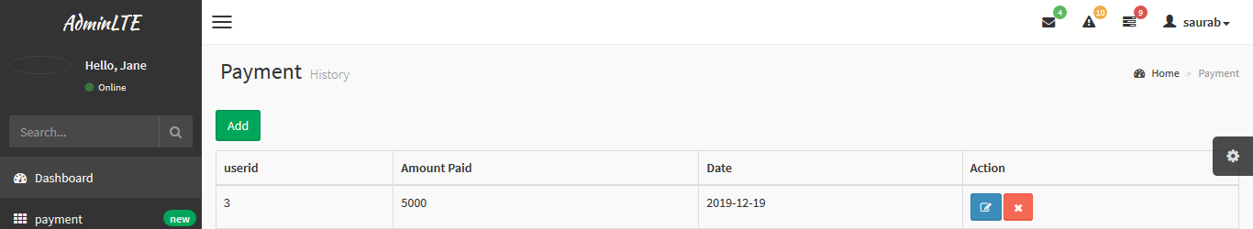

17.

|  |  |  |  |  |  |
| --- | --- | --- | --- | --- | --- |
| Tester ID | Case name | Test strategy | Expected result | Actual result | Remarks |
| 17 | Admin bar | Black box testing | Admin  Setting opens | Opens admin setting | Succeed. |

* **When admin side bar is clicked, it opens the options**

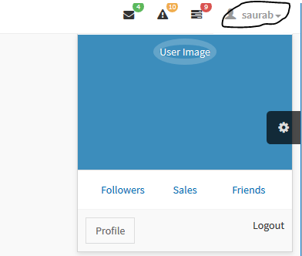

18.

|  |  |  |  |  |  |
| --- | --- | --- | --- | --- | --- |
| Tester ID | Case name | Test strategy | Expected result | Actual result | Remarks |
| 18 | Payment edit | Black box testing | Edit form opens | Opens payment edit form | Succeed. |

* **When payment edit button is clicked,it opens edit form.**

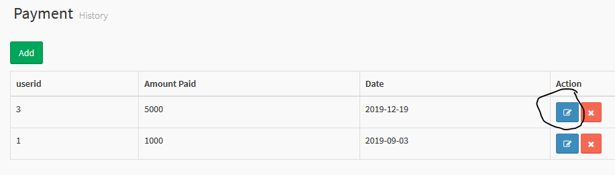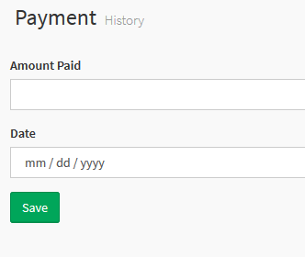

**19.**

|  |  |  |  |  |  |
| --- | --- | --- | --- | --- | --- |
| Tester ID | Case name | Test strategy | Expected result | Actual result | Remarks |
| 19 | Payment delete | Black box testing | delete payment | Deletes payment | Succeed. |

* **When payment delete button is clicked it deletes the data.**

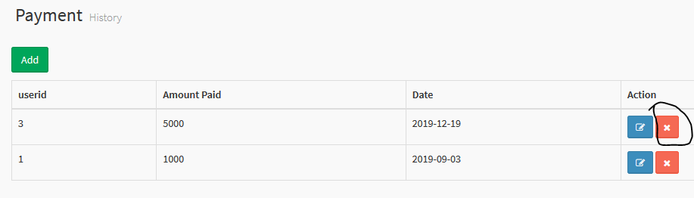

**20.**

|  |  |  |  |  |  |
| --- | --- | --- | --- | --- | --- |
| Tester ID | Case name | Test strategy | Expected result | Actual result | Remarks |
| 20 | Loan edit | Black box testing | Loan edit opens | Opens loan form | Succeed. |

* **When edit button is clicked loan edit form opens**

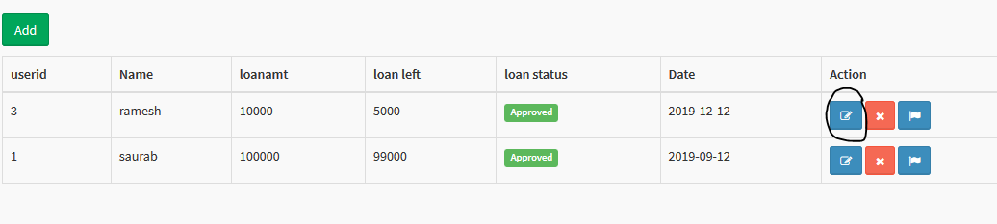

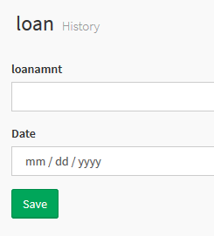

* **Unit testing**: unit testing is software testing where each and every individual units or components of a software are tested. Basically, it is done to test each unit of the software. Its main purpose to validate each unit of the software performed as designed. Every components of the software are tested.
* **Reasons to do unit testing:**

1. Ensures that each and every unit of the software works properly.
2. Facilitates changes & simples’ integration
3. Ensures quality of code.
4. Find software bugs early.

Here down below are the unit testing that I have performed for my software:

1. Loan amount test:

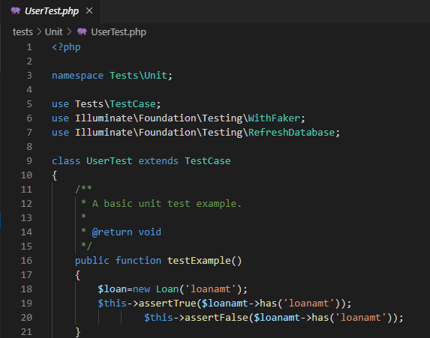

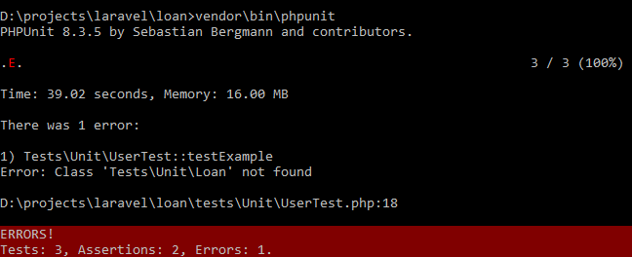

**2**.loan date:

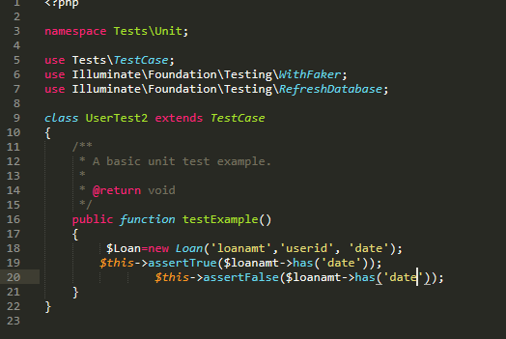

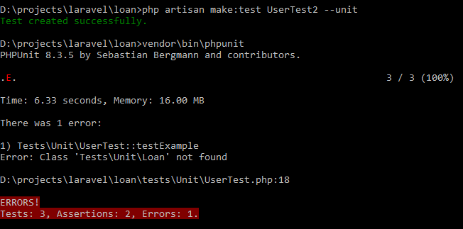

1. loan userid

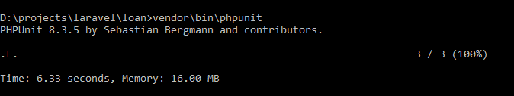



**4**.payment

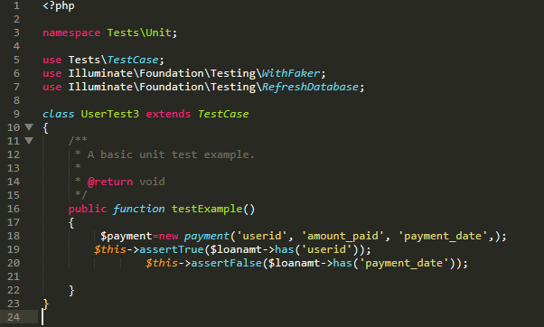

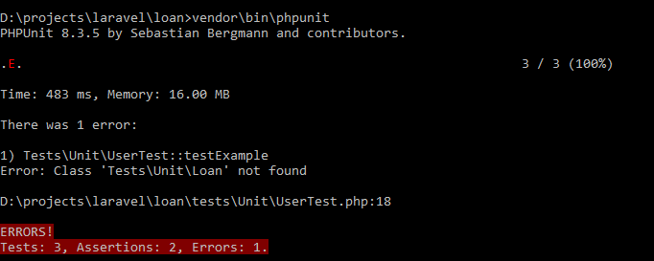

5.

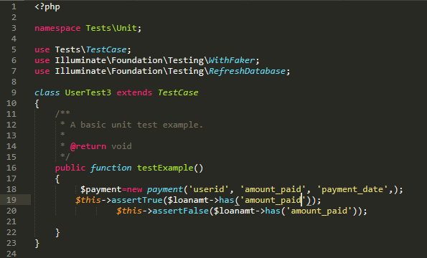

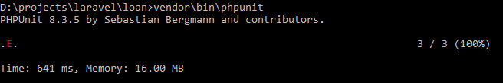



**6.**payment userid

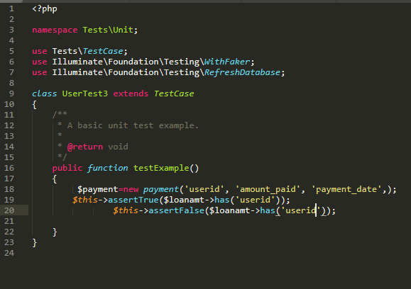





**7**. login

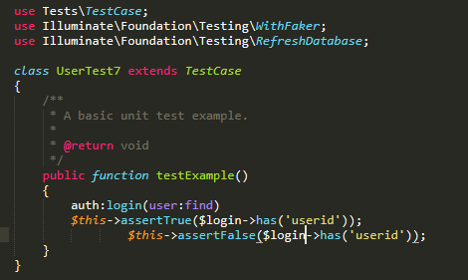





**8**.registration

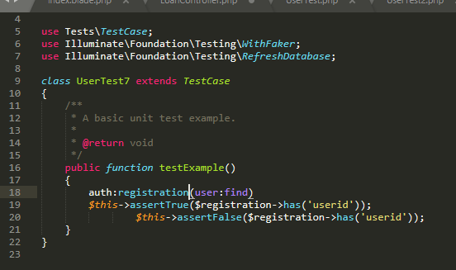





**9**.registration details

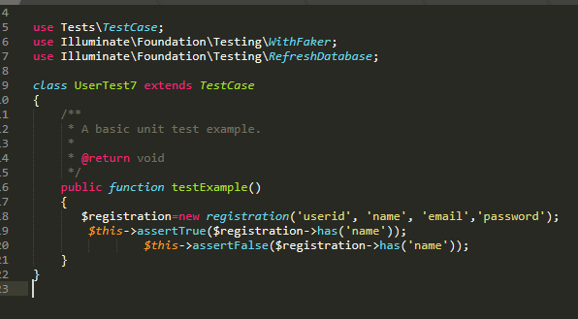





**10**.Registration email

