WIPRO CAPSTONE PROJECT REPORT

Name | Saurabh Agrawal
Superset ID | 5448178
Organization | Wipro
Project Type | Capstone Project
Project Name | Automation Testing using Selenium PyTest Framework
 | Automation Testing using Behave BDD Framework
Domain | E-Commerce
Module Title | Myntra Shopping Automation

SYNOPSIS
The Wipro Capstone Project focuses on automating the Myntra E-Commerce website using Selenium WebDriver with Python PyTest framework and Behave BDD framework.
The automation validates:
Product Search
Kids Section Navigation
Product Details Verification
Add To Bag Workflow
Cart Validation
Brand Filter Validation
Login Validation
Complete End-to-End Shopping Flow
The framework is developed using the Page Object Model (POM) architecture for better maintainability and reusability.
Screenshots, logs, Allure reports, and reusable utility components are integrated for execution tracking and debugging.
The project includes:
End-to-End Testing
Positive Testing
Negative Testing
Data-Driven Testing
BDD Automation Testing

PROJECT DESCRIPTION
The automation framework validates complete Myntra shopping workflows including:
Homepage Verification
Kids Section Navigation
Product Search
Product Page Validation
Product Size Selection
Add To Bag Validation
Cart Verification
Quantity Update
Donation Selection
Place Order Workflow
Login Validation
The project is implemented using:
Selenium WebDriver
Python
PyTest Framework
Behave BDD Framework
Allure Reporting
Page Object Model (POM)
Separate Page Classes are implemented for:
Kids Page
Cart Page
Login Page
Filter Page
Base Page
The framework supports reusable automation utilities including:
Logging Utility
Screenshot Utility
Config Reader
Excel Data Reader

SELENIUM PYTEST FRAMEWORK

TEST STRATEGY
The project uses Selenium WebDriver with Python PyTest framework for automation testing. The framework supports:
End-to-End Testing
Positive Testing
Negative Testing
Data-Driven Testing
Tools Used:
Selenium WebDriver
PyTest
Allure Reports
Logging Module

TEST ENVIRONMENT

Operating System | Windows 11
IDE | PyCharm Unified Product
Browser | Google Chrome (or) Edge
Framework | Selenium WebDriver + PyTest
Design Pattern | Page Object Model (POM)
Reporting Tool | Allure Reports

FRAMEWORK ARCHITECTURE
MyntraAutomation
├── config
├── logs
├── pages
├── reports
│ ├── allure-results
│ └── allure-report
│
├── screenshots
├── testdata
├── tests
├── utils
├── conftest.py
├── pytest.ini
└── requirements.txt

TEST EXECUTION
The automation suite includes:
1 End-to-End Test Case
4 Positive Test Cases
2 Negative Test Cases

SELENIUM TEST CASE SUMMARY
S.No | Test Type | Test Scenario | Expected Result | Status
1 | End-to-End | Product Selected and added to bag | User successfully reaches flight details page | Passed
2 | Positive | Product Search Validation | Product Search Validation Successfully | Passed
3 | Positive | Add To Bag Validation | Add To Bag Validation Successfully | Passed
4 | Positive | Brand Filter Validation | Brand Filter Validation Successfully | Passed
5 | Positive | Login Validation | Login Validation Successfully | Passed
6 | Negative | Invalid Login Validation | Invalid Login Validation Error Successfully | Passed
7 | Negative | Invalid Product Search | Invalid Product Search Error Successfully | Passed

END-TO-END FLOW VALIDATION
The End-to-End automation validates:
Homepage Navigation
Kids Section Navigation
Product Search
Product Details Validation
Add To Bag Workflow
Cart Validation
Quantity Update
Donation Selection
Place Order Workflow
Login Validation
OTP Validation
POSITIVE TEST CASES
Positive Test Case 1 – Product Search Validation
Verifies successful product search
Opens product details page
Validates product availability
Positive Test Case 2 – Add To Bag Validation
Selects product size
Adds product to shopping bag
Verifies cart badge update
Positive Test Case 3 – Brand Filter Validation
Applies H&M brand filter
Verifies filter application successfully
Positive Test Case 4 – Login Validation
Validates login workflow
Verifies OTP page navigation

NEGATIVE TEST CASES

Negative Test Case 1 – Invalid Login Validation
Enters invalid mobile number
Verifies error validation message
Negative Test Case 2 – Invalid Product Search
Searches invalid product
Verifies “No Products Found” validation

ALLURE REPORTS
Integrated Allure Reports with PyTest
Generates professional execution reports
Displays passed and failed test status
Captures screenshots during execution
Maintains execution history
Displays step-by-step execution flow
Helps debugging and tracking failures
Provides detailed execution summary
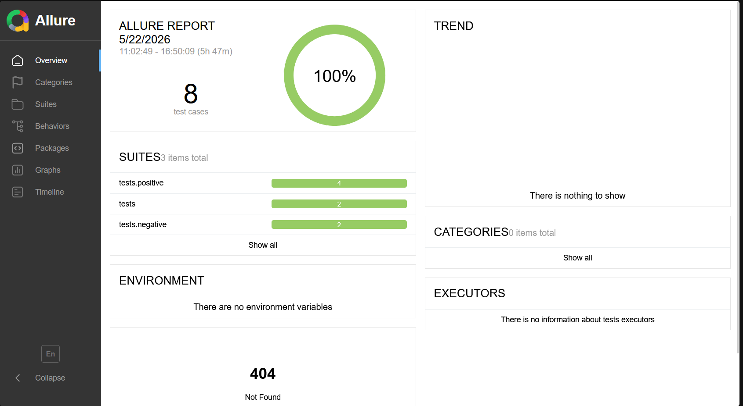

TEST OUTPUTS
The framework captures screenshots during:
Homepage Verification
Product Search
Product Page Validation
Cart Verification
Login Validation
Detailed execution logs are generated using Python logging framework.
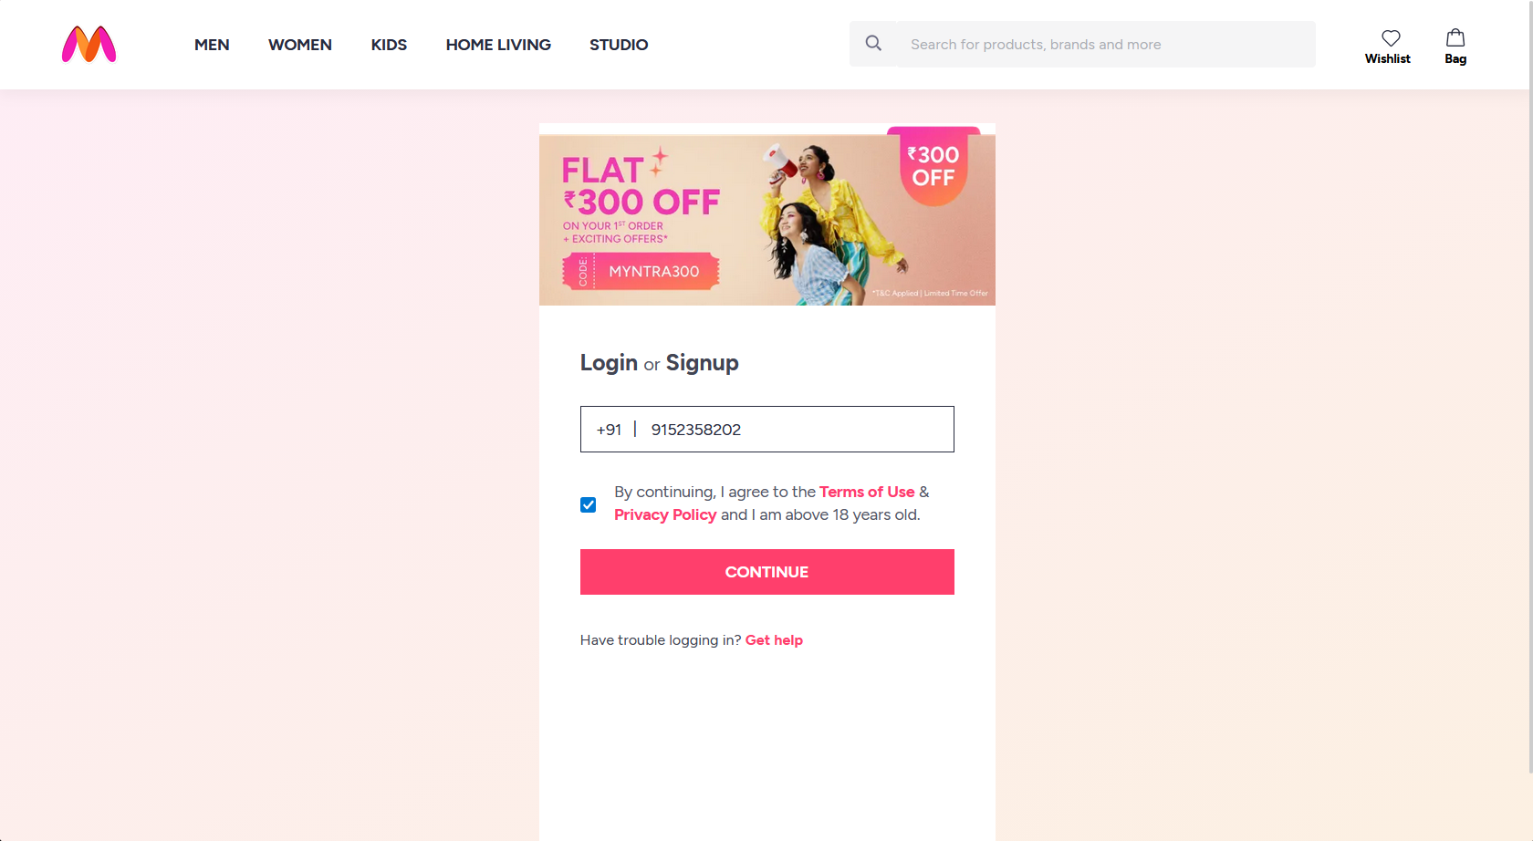
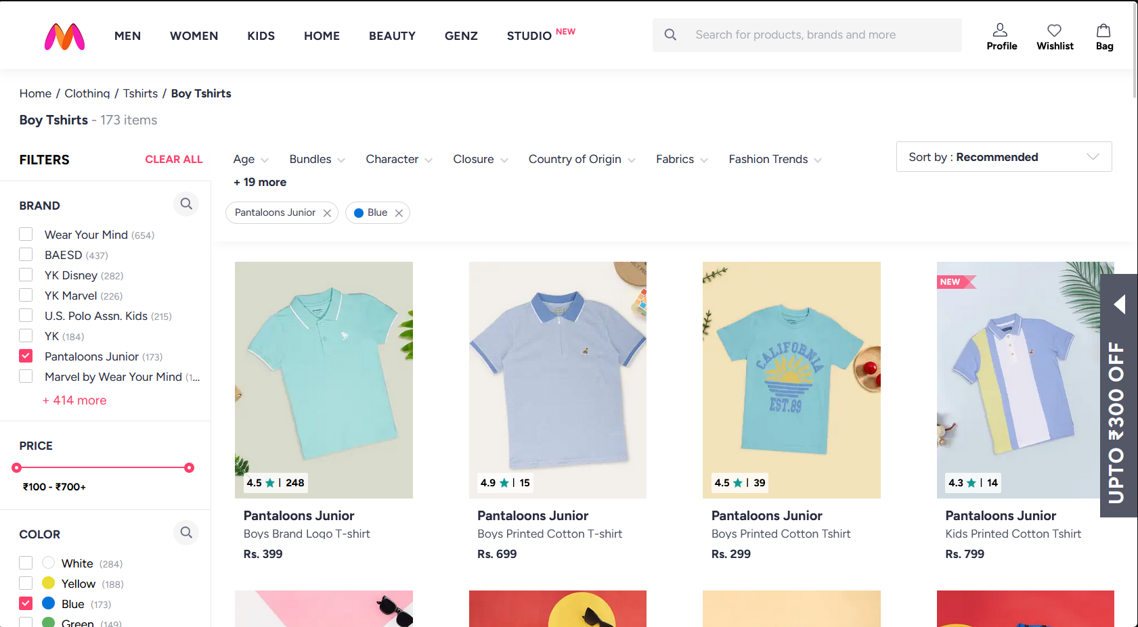

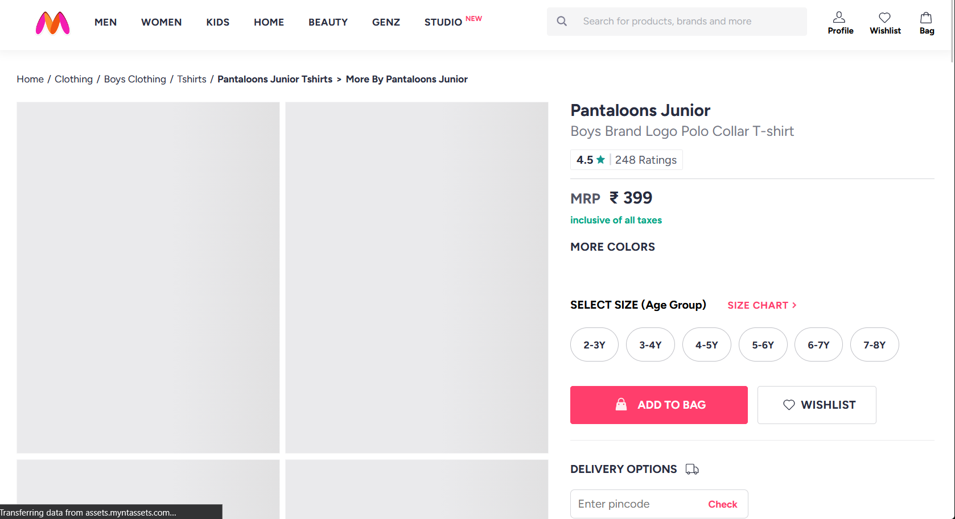
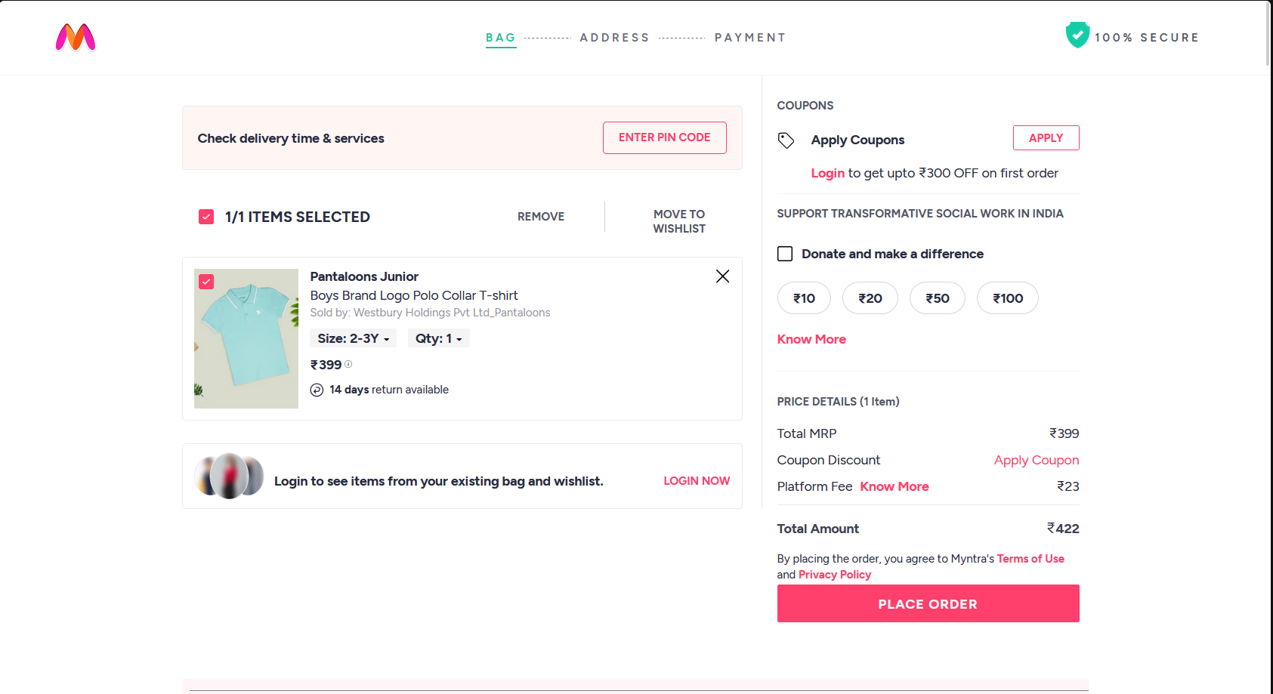
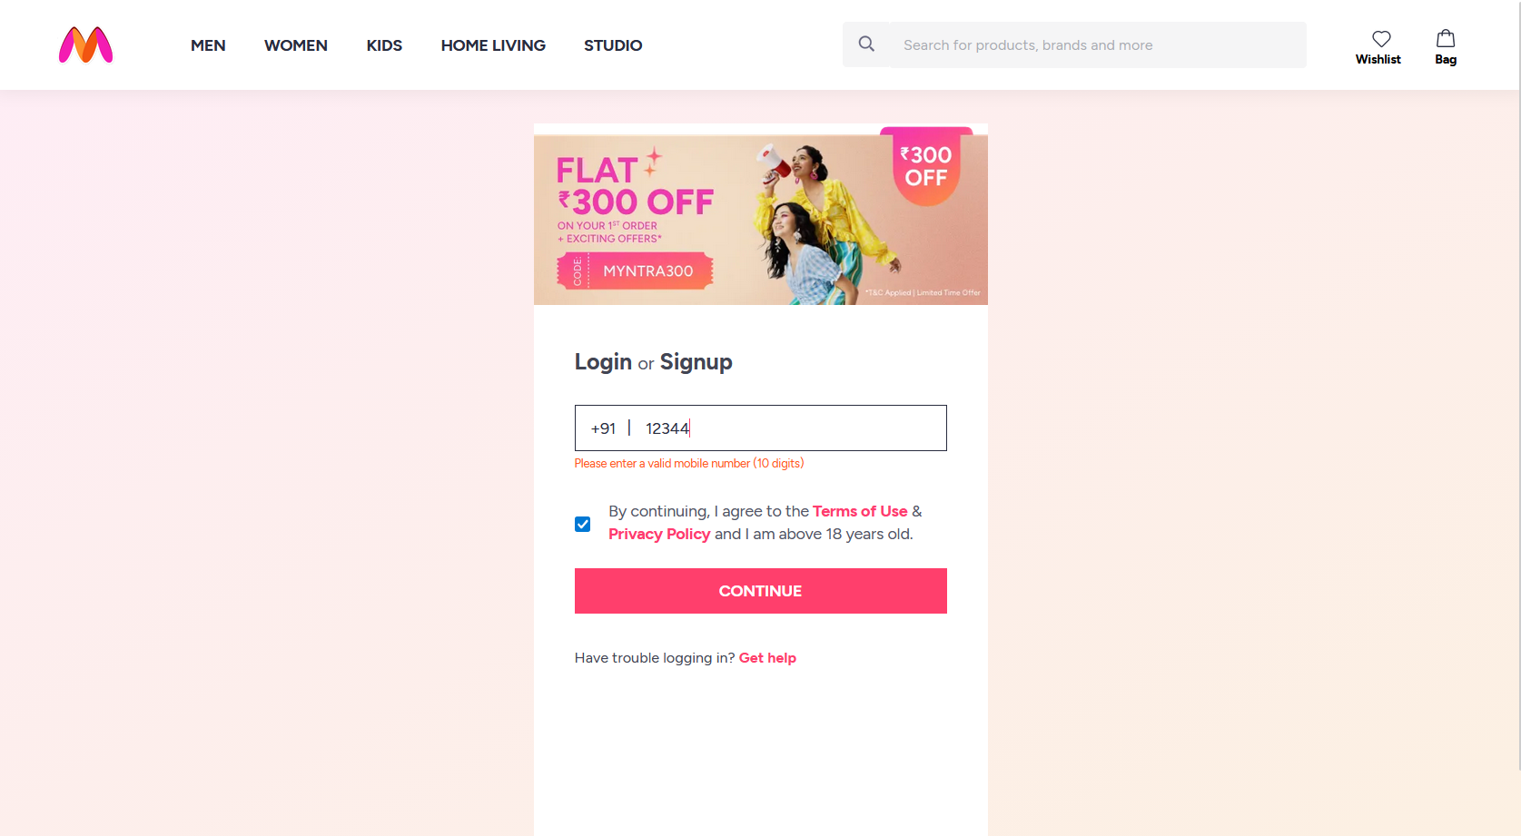
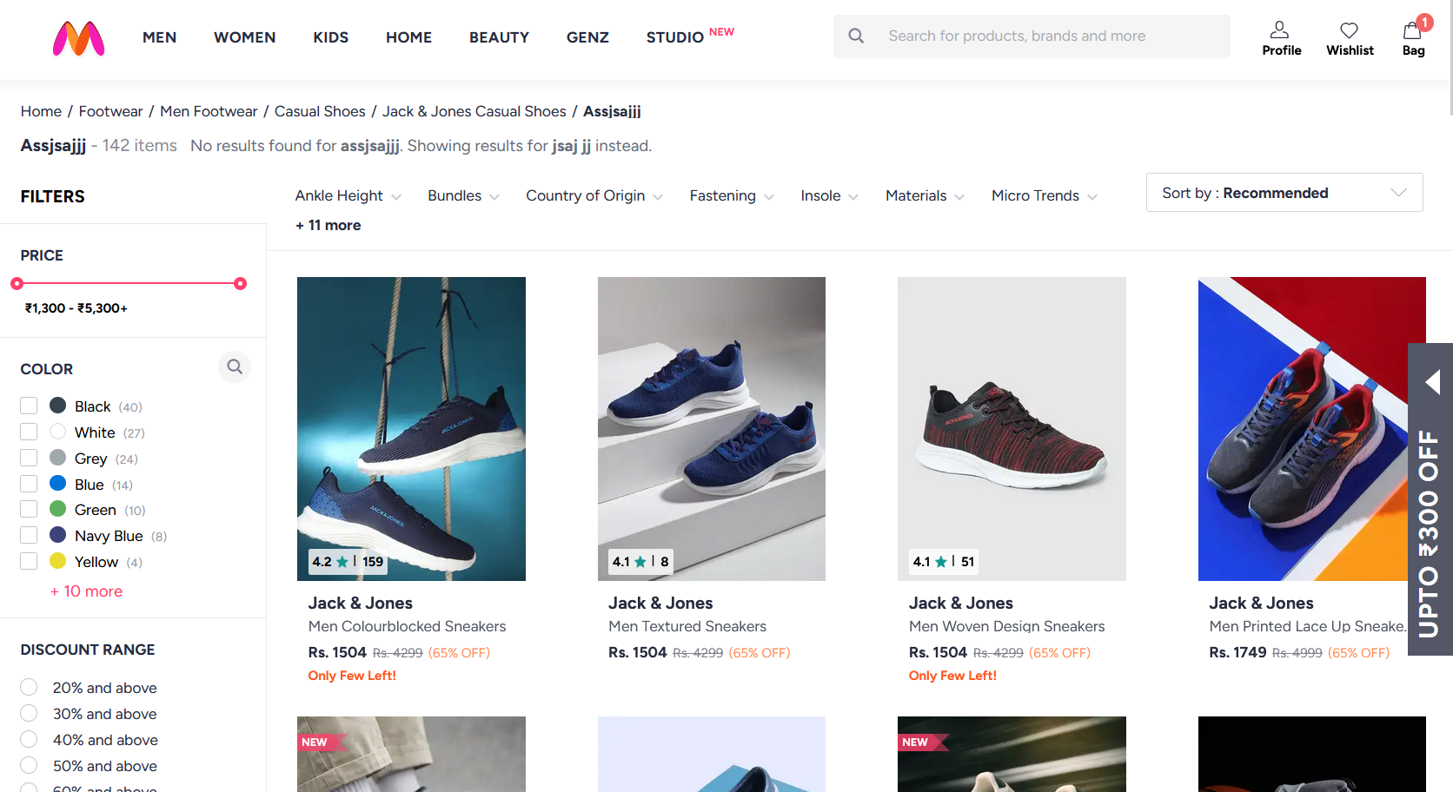

TEST REPORT
Total Tests Executed: 7
Tests Passed: 7
Tests Failed: 0
Automation Accuracy: 100%

CONCLUSION

The Selenium PyTest and Behave BDD automation framework successfully validates the Myntra E-Commerce application using real-world automation testing practices.
The framework demonstrates:
Scalable Architecture
Reusable Components
Professional Reporting
Reliable Automation Testing
Page Object Model Design
Data-Driven Testing
BDD Implementation
The project successfully automates critical Myntra shopping workflows with professional execution reporting, screenshot evidence, and detailed execution logs.
Overall, the project demonstrates a complete real-world automation testing framework for E-Commerce application testing.

SELENIUM BDD FRAMEWORK

TEST STRATEGY
The project uses Selenium WebDriver with Python Behave BDD framework for automation testing.End-to-End Testing
Positive Testing
Negative Testing
Data-Driven Testing
Behavior-Driven Development (BDD)
Tools Used:
Selenium WebDriver
PyTest
Allure Reports
Logging Module

TEST ENVIRONMENT
Operating System | Windows 11
IDE | PyCharm Unified Product
Browser | Google Chrome (or) Edge
Framework | Selenium WebDriver + Behave
Design Pattern | Page Object Model (POM)
Reporting Tool | Allure Reports
Test Approach | Behavior Driven Development

FRAMEWORK ARCHITECTURE
MyntraAutomation
├── config
├── features
│ ├── end_to_end.feature
│ ├── test_cases.feature
│ ├── environment.py
│ └── steps
│ ├── end_to_end.steps
│ └── test_cases.steps
├── reports
│ ├── allure-results
│ └── allure-report
├── screenshots
├── testdata
├── logs
├── utils
├── behave.ini
├── runtest.bat
└── requirements.txt

TEST EXECUTION
The automation suite includes:
1 End-to-End Test Scenario
4 Positive Test Scenarios
2 Negative Test Scenarios
The End-to-End scenario validates the complete Myntra shopping workflow from homepage navigation until OTP verification.
SELENIUM TEST CASE SUMMARY
S.No | Test Type | Test Scenario | Expected Result | Status
1 | End-to-End | Complete Shopping Workflow | User successfully completed shopping flow until the login page | Passed
2 | Positive | Add product to bag | Product added successfully into cart | Passed
3 | Positive | Brand Filter Validation | Filter applied successfully | Passed
4 | Positive | Filter Details Validation | Product detail page loaded successfully | Passed
5 | Positive | Valid Login Validation | OTP page displayed successfully | Passed
6 | Negative | Invalid Product Search | Error message displayed successfully | Passed
7 | Negative | Invalid Login Validation | Proper error displayed for invalidation mobile number | Passed

END-TO-END FLOW VALIDATION
The End-to-End automation validates the complete business workflow including:
Homepag Navigation
• Kids Section Navigation
• Product Search
• Product Selection
• Product Details Validation
• Product Size Selection
• Add To Bag Validation
• Shopping Cart Validation
• Quantity Update Validation
• Donation Selection
• Place Order Navigation
• Login Redirection Validation
• OTP Verification Validation
POSITIVE TEST SCENARIOS
Positive Test Scenario 1 – Add Product To Bag
Validates successful product search
• Validates product page opening
• Selects product size
• Adds product successfully into shopping bag
• Verifies cart update successfully

Positive Test Scenario 2 – Brand Filter Validation
Validates product search functionality
• Applies H&M brand filter
• Verifies successful filter application
• Ensures filtered products display correctly
Positive Test Scenario 3 – Product Details Validation
Validates successful product search
• Opens first available product
• Verifies product details page successfully
• Ensures product title validation
Positive Test Scenario 4 – Valid Login Validation
Opens Myntra login popup
• Enters valid mobile number
• Accepts consent checkbox
• Clicks continue button
• Verifies OTP page display successfully
NEGATIVE TEST SCENARIOS
Negative Test Scenario 1 – Invalid Login Validation
Enters invalid mobile number
• Validates login error handling
• Verifies display of validation error message
• Ensures invalid mobile number restriction
Negative Test Scenario 2 – Invalid Product Search
Searches invalid product keyword
• Validates no products found handling
• Verifies empty search result validation
• Ensures unsupported product handling
BDD IMPLEMENTATION
The framework follows Behavior Driven Development using:
Feature Files
• Step Definition Files
• Gherkin Syntax
• Given-When-Then Structure
• Scenario Outlines
• Tags Based Execution

ALLURE REPORTS
Integrated Allure Reports with Behave BDD
Generates professional execution reports
Displays passed and failed scenario status
Captures screenshots during execution
Maintains execution history
Displays step-by-step scenario execution flow
Helps debugging and tracking failuresProvides detailed execution summary
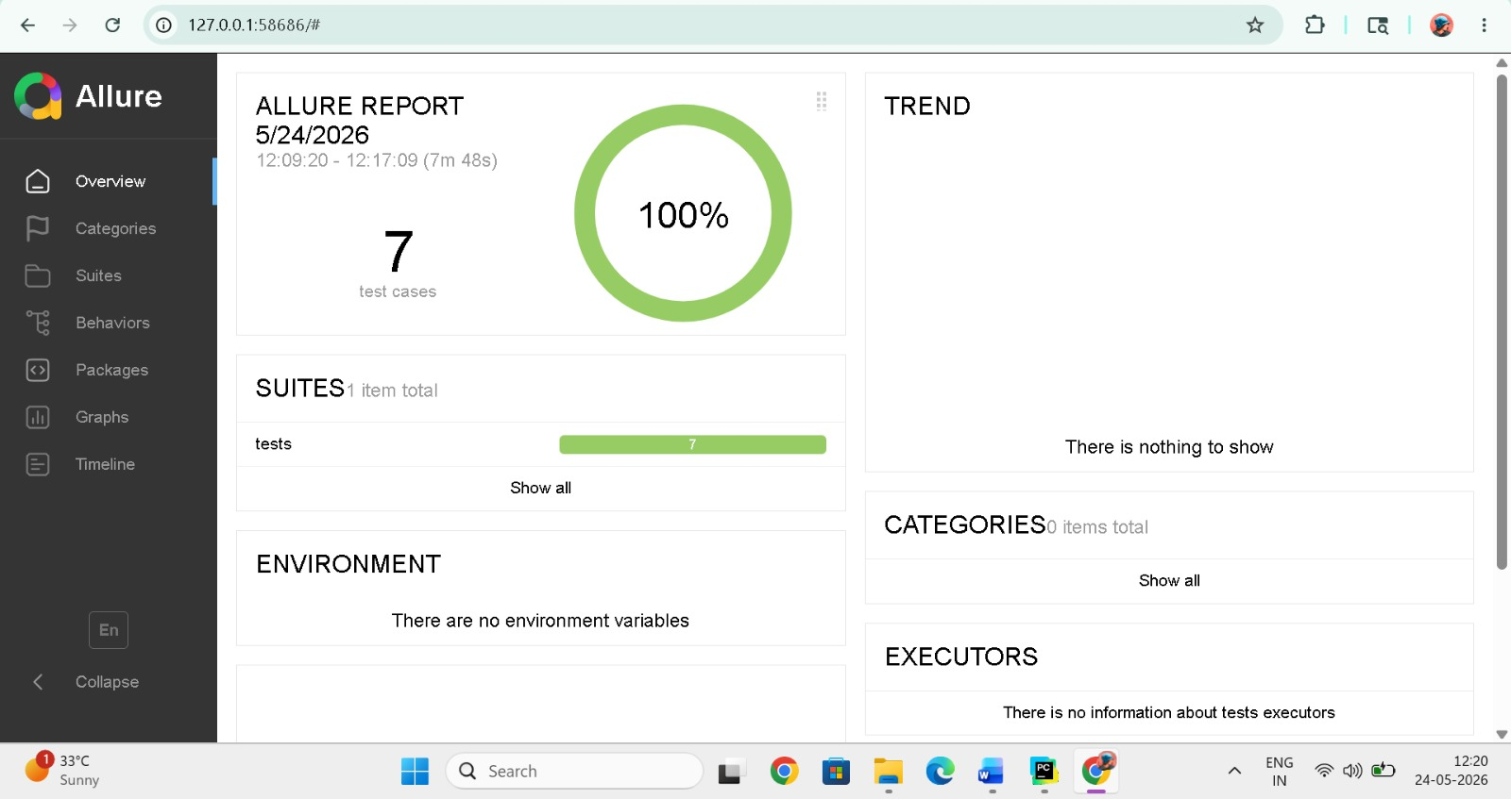

TEST OUTPUTS
The framework automatically captures screenshots during important execution stages including HomeePage Verification , product search , product details , add to bag , cart page verification , logiin pop validation , OTP verification page
Detailed execution logs are generated using Python logging framework for debugging and execution tracking.

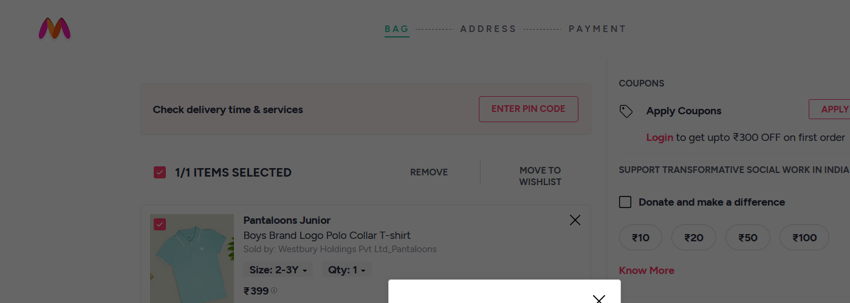
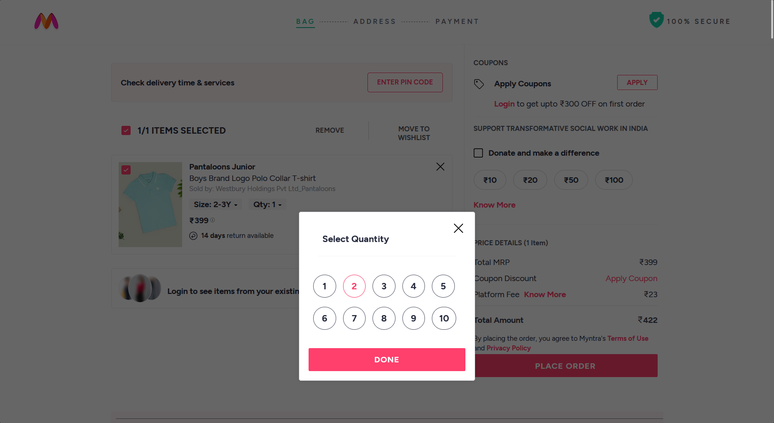





TEST REPORT
Total Scenarios Executed: 7
Scenarios Passed: 7
Scenarios Failed: 0
Automation Accuracy: 100%

CONCLUSION
The Selenium Behave BDD automation framework successfully validates the Myntra E-Commerce application using Behavior Driven Development methodology.
The framework is implemented using:
Selenium WebDriver
• Behave BDD Framework
• Gherkin Feature Files
• Step Definition Files
• Page Object Model (POM)
• Allure Reporting
• Data-Driven Testing
The framework validates complete business workflows including:
Homepage Navigation
•Product Search
• Brand Filter Validation
• Product Details Validation
• Add To Cart Validation
• Shopping Cart Validation
• Login Validation
• OTP Verification
The implementation of Feature Files and Given-When-Then structure improves readability, maintainability and collaboration between technical and non-technical users.
The framework also includes:
Professional Allure Reports
• Screenshot Evidence
• Detailed Execution Logs
• Positive and Negative Testing
• Reusable Automation Components
• Config Driven Execution
All scenarios executed successfully with accurate validations and detailed reporting.

