**Problem Statement 2**

**CREATE SCHEMA `**Shopping cart for a Book Store**’ ;**

1. **Create Database ShopingCart**

QUERY:- CREATE DATABASE SHOPINGCART;

QUERY:- USE SHOPINGCART;

1. **Creating Books Table**

CREATE TABLE `Books` (

`Book_Id` INT NOT NULL,

`Book_Name` VARCHAR(50) NOT NULL,

`Author` VARCHAR(50) NOT NULL,

`Price` INT NOT NULL,

PRIMARY KEY (`Book_Id`));

1. **Creating Order_Details Table**

CREATE TABLE `order_details` (

`Order_Id` INT NOT NULL,

`Book_Id` VARCHAR(50) NOT NULL,

`Cust_Name` VARCHAR(50) NOT NULL,

`Phone_No` VARCHAR(50) NOT NULL,

`Address` VARCHAR(50) NOT NULL,

`Order_Date` VARCHAR(50) NOT NULL,

`Quantity` VARCHAR(50) NOT NULL,

PRIMARY KEY (`Order_Id`));

1. **Creating Users Table**

CREATE TABLE `shoppingcart`.`users` (

`first_name` VARCHAR(45) NOT NULL,

`address` VARCHAR(45) NOT NULL,

`email` VARCHAR(45) NOT NULL,

`user_name` VARCHAR(45) NOT NULL,

`password` VARCHAR(45) NOT NULL,

`registration_date` VARCHAR(45) NOT NULL,

PRIMARY KEY (`first_name`));

OUTPUT:-

**Show Tables**

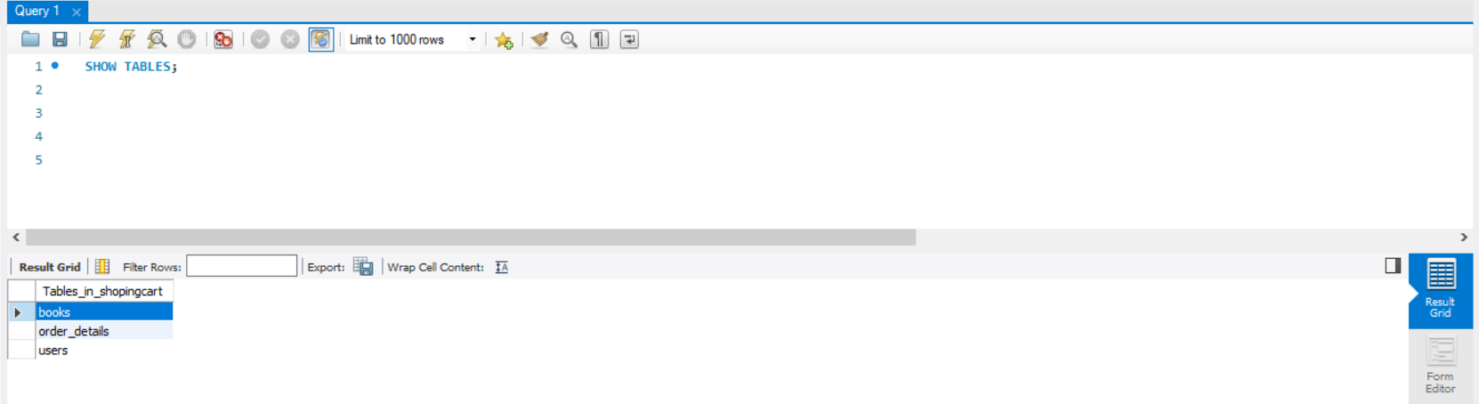

**Books**

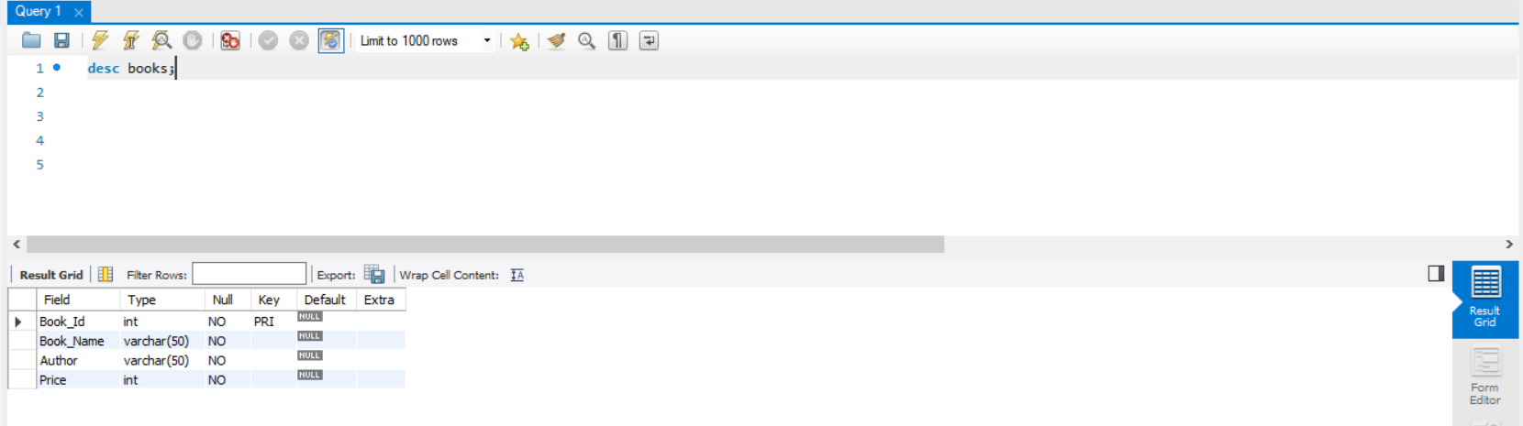

**Order_Details**

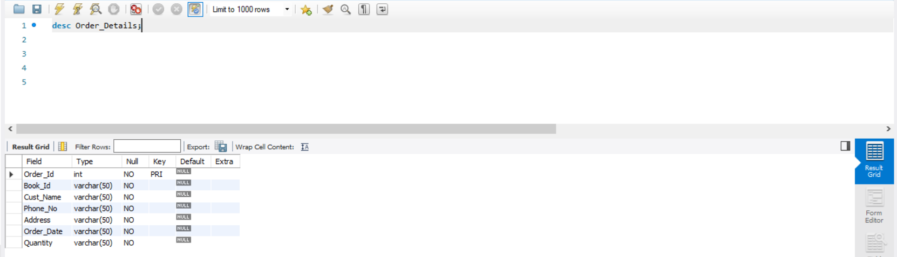

**Users**

