**Software Requirement Specification**

**1. Introduction**

            1.1 Purpose

            1.2 Intended Audience

1.3 Intended Use

            1.4 Scope

1.5 Project Objective

1.6 Problem Statement

**2. Overall Description**

           2.1 User Needs / Sprints and Task

2.2 Users of SRS

**3. System Features and Requirements**

            3.1 Functional Requirements

            3.2 Non-functional Requirements

            3.3 UML

            3.4 System Requirements

1. **Introduction**

Ming’s Dinner will function the platform to offer service centers to restaurant management and its customers. Ming’s Dinner is a system which will help restaurant to optimized and control over their restaurants.

Airline Reservation System aims to automate the flight operations and ticketing / seat booking and

confirmation sytem of an Airline company. The software is providing options for viewing different

flights available within a different timings for a specific day.

Airline Reservation System aims to automate the flight operations and ticketing / seat booking and

confirmation sytem of an Airline company. The software is providing options for viewing different

flights available within a different timings for a specific day.

Airline Reservation System aims to automate the flight operations and ticketing / seat booking and

confirmation sytem of an Airline company. The software is providing options for viewing different

flights available within a different timings for a specific day.

* 1. **Purpose**

The purpose of this project is to enable restaurants automate its operations and digital presence in the online world. That provide customers within facility to able to book order smoothly.

That provide customers within facility to

able to book ticket smoothly

* 1. **Intended Audience**

The intended audience for this document consists of requirements engineers, software developers, designers, testers and project manager.

* 1. **Intended use**

The use of this project is to automate restaurants operations such as order booking ,enquiry about dishes and to check availability of food.

* 1. **Scope**

The Ming’s Dinner website is an application stored in the user server. The purpose of the website is to make digital presence of restaurants in online world. Get order from customer via online mode.

* 1. **Project Objective**

Build a responsive website for a restaurant where users can read the details of the restaurant.’.

* 1. **Problem Statements**

You are a web developer at a service-based web development company called Kite Technologies. The company has been approached by a client who wants to build a website for their restaurant named Ming’s Diner. The website should provide the users a brief overview of the restaurant and its bestsellers, its address, as well as an option to contact the restaurant. During sprint planning, you agree to lead this project and develop the website.

1. **Overall Description**
   1. **User Needs (Story)**

* **Sprints**
* **Sprint 1:**
* Building the website using HTML
* Adding Bootstrap to the website.
* Start Date: 04/03/2022 End Date: 06/03/2022
* **Sprint 2:**
* Adding a landing page, a navbar, a CTA button, a grid, and a footer A master list of places for source and destination.
* Adding a contact form for users to contact the restaurant
* Start Date: 07/03/2022 End Date: 09/03/2022
* **Sprint 3:**
* The website should provide the users a brief overview of the restaurant and its bestsellers, its address.
* Option to contact the restaurant.
* Start Date: 10/03/2022 End Date: 11/03/2022
* Product Release(Deadline):12 /03/2022
  1. **Users of SRS**
* Development team (1 members)
* Testing team (1 members)
* Client (NA)

1. **System Features and Requirements**
   1. **Functional Requirements**

This section provides requirement overview of the system. Various functional modules that can be implemented by the system will be –

* **Functional Modules**
* Login Module
* Contact US Module
* Display Bestseller
* Display Reviews
* Menus & Events
  1. **Non-functional requirements :-**
* Performance – for example Response Time, Throughput, Utilization, Static Volumetric
* Scalability
* Reliability
* Maintainability
* Security
* Usability
  1. **UML and Flowchart**
     1. **Use-Case Diagram**

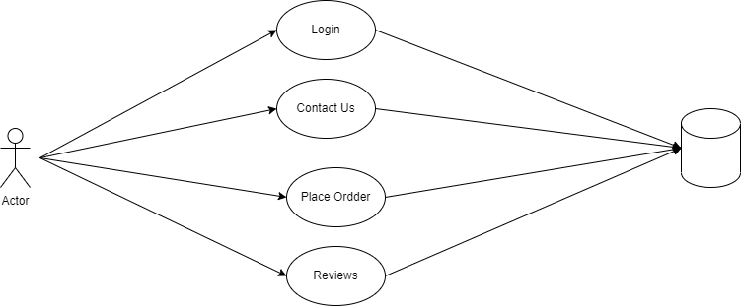

* 1. **System Requirements**
     1. **Software Requirements –**

Operating System : Windows XP or above, Linux, MAC.

Front-End : HTML5, CSS3, JavaScript , jQuery, Bootstrap.

Backend : NA

Tools : Visual Studio Code

Used Java Concepts :

* HTML5
* CSS3
* JavaScript
* jQuery
* Bootstrap

Git URL : https://github.com/saurabh-939/Phase_2_Final_Project.git

3.4.2 **Hardware Requirements –**

CPU:- Dual core or higher

RAM:- 2GB RAM or higher,

Hard-disk- 256 GB or higher