1. **Project Objective**

As a developer, write a program using JavaScript to decide the budget of a specific team.

1. **Problem Statements**

As a developer, you are assigned to a project. You need to develop a website where program managers of a specific team will add details of professional deals they want to have with vendors. The finance team will check expenses of those teams and will decide their annual budget.

1. **User Needs (Story)**

* **Sprints**
* **Sprint 1:**
* Add Expenses
* Delete Expenses
* Show Expenses
* Calculate Expenses
* Start Date: 06/03/2022 End Date: 07/03/2022
* Product Release(Deadline):08 /03/2022
  1. **Users of SRS**
* Development team (1 members)
* Testing team (1 members)
* Client (NA)

1. **System Features and Requirements**

* **Functional Requirements**

This section provides requirement overview of the system. Various functional modules that can be implemented by the system will be –

* **Functional Modules**
* Add Expenses
* Delete Expenses
* Show all Expenses
* Calculate Budget
* **Non-functional requirements :-**
* Performance – for example Response Time, Throughput, Utilization, Static Volumetric
* Scalability
* Reliability
* Maintainability
* Security
* Usability

**4.1) UML and Flowchart**

* + 1. **Use-Case Diagram**

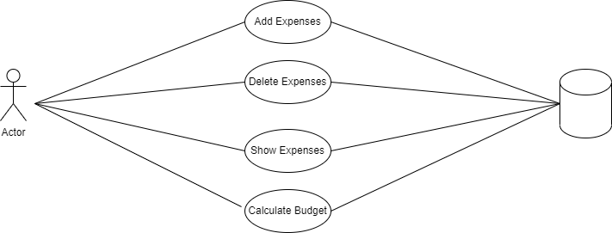

**4.2) System Requirements**

* + 1. **Software Requirements –**

Operating System : Windows XP or above, Linux, MAC.

Front-End : HTML5, JavaScript ,

Backend : NA

Tools : Visual Studio Code

Used JavaScript Concepts :

* Functions
* Prototypes
* Primitives
* IIFEs,
* promises,
* async, and webpack

Git URL : https://github.com/saurabh-939/Phase-4-Projects.git

**4.2.2 Hardware Requirements –**

CPU:- Dual core or higher

RAM:- 2GB RAM or higher,

Hard-disk- 256 GB or higher