**A**

**MINI PROJECT REPORT**

**on**

**Virtual Drum-Kit**

**Submitted in partial fulfillment for the completion of BE-III Semester**

**In INFORMATION TECHNOLOGY**

**By**

**Saurabh Challawar (160118737113)**

**And**

**D.Susheel Kumar(160118737117)**

**Under the guidance of**

**Mr.Rajesh Khannan Assistant Professor, Dept. of IT, CBIT.**



**DEPARTMENT OF INFORMATION TECHNOLOGY CHAITANYA BHARATHI INSTITUTE OF TECHNOLOGY (A)**

**(Affiliated to Osmania University; Accredited by NBA(AICTE) and NAAC(UGC), ISO Certified 9001:2015)**

**GANDIPET, HYDERABAD – 500 075**

**Website:** [**www.cbit.ac.in**](http://www.cbit.ac.in/)

**2019-2020**

**CHAITANYA BHARATHI INSTITUTE OF TECHNOLOGY (A)**

DEPARTMENT OF INFORMATION TECHNOLOGY



**CERTIFICATE**

This is to certify that the project work entitled “**Virtual Drum-Kit**” submitted to **CHAITANYA BHARATHI INSTITUTE OF TECHNOLOGY,** in partial fulfillment of the requirements for the award of the completion of 3rd  semester of B.E in Information Technology, during the academic year 2019-2020, is a record of original work done by **Saurabh Challawar (160118737113), D.Susheel Kumar(160118737117)** during the period of study in Department of IT, CBIT, HYDERABAD, under our supervision and guidance.

**Project Guide Head of the Department**

**Mr.Rajesh Khannan Dr.Suresh Pabboju**

Asst. Professor, Dept. of IT, Professor, Dept. of IT, CBIT, Hyderabad. CBIT, Hyderabad.

# ACKNOWLEDGEMENT

We would like to express our heartfelt gratitude to Mr.Rajesh Khanan, our project guide, for his invaluable guidance and constant support, along with his capable instruction and persistent encouragement.

We are grateful to our Head of Department, Dr.Suresh Pabboju, for his steady support and for the provision of every resource required for the completion of this project.

We would like to take this opportunity to thank our Principal, Dr.P.Ravinder Reddy, as well as the management of the institute, for having designed an excellent learning atmosphere.

Our thanks are due to all member of the staff and our lab assistants for providing me with the help required to carry out the groundwork of this project.

# ABSTRACT

It is said that air drumming provides the same level of satisfaction to the user as drumming on a physical drum set does. Knowing this, why should everyone have to own a drum set to start drumming?

We know that the drum-kits are heavy and is not possible to always carry a musical instrument like drums.Musicians find it hard to transport drum-kits for practice sessions or even for musical events because it is hard to carry and transport drum-kits to different places.It is also time consuming to setup a drum-kit.This project is developed by using c++ language.

This project will help produce sounds of a drum-kit using a keyboard.It will be programmed using C++.Further this program can be used in sound pads or other hardware products to produce sounds of a drum-kit after configuration.This will make it easier for musician to carry it to different locations for practises or performances.

The goals of the system are:

* To make drum-kit portable.
* To make setup easy.
* To a drum kit available at anytime and any place.

# CONTENTS

|  |  |  |  |
| --- | --- | --- | --- |
| **Chapter** | **Chapter Description** | | **Page** |
|  | **Certificate** | | **ii** |
|  | **Acknowledgement**  **Abstract** | | **iii**  **iv** |
|  | **List Of Figures** | | **vi** |
|  | **List Of Tables** | | **vii** |
| **1** | **Introduction** | | **1** |
|  | **1.1**  **1.2** | Motivation  Objectives of the project | 1  2 |
| **2** | **Existing System** | | **3** |
|  | 2.1 | Virtual Drummer | 3 |
| **3** | **Proposed System** | | **5** |
|  | 3.1  3.2  3.3 | Problem Statement  Methodology  Flow Chart | 5  5  6 |
| **4** | **Software And Hardware Requirements** | | **7** |
| **5** | **Result And Screenshots** | | **9** |
| **6** | **Conclusion** | | **11** |
| **7** | **Future Scope** | | **12** |
| **8** | **Bibliography** | | **13** |

**List of Figures**

|  |  |  |
| --- | --- | --- |
| **Figure number**  **1.1**  **2.1**  **4.1**  **5.1**  **5.2** | **Figure Description** Virtual Drum Kit Interface **Virtual Drummer Website**  **Virtual Drum Kit was programmed on the above system,**  **Home Page of the Virtual Drum Kit**  **Virtual Drum Kit is being operated.** | **Page**  **2**  **4**  **8**  **9**  **10** |
|  |  |  |
|  |  |  |
|  |  |  |
|  |  |  |
|  |  |  |
|  |  |  |
|  |  |  |
|  |  |  |
|  |  |  |

**List Of Tables**

|  |  |  |
| --- | --- | --- |
| **Table Number**  **2.1**  **4.1** | **Table Description** Information about Virtual Drummer **Software and hardware requirements** | **Page**  **3**  **7** |

1. **Introduction**

A **drum kit** — also called a **drum set**, **trap set** (an abbreviation of the word, "contraption"),[ or simply **drums** — is a collection of [drums](https://en.wikipedia.org/wiki/Drum) and other [percussion instruments](https://en.wikipedia.org/wiki/Percussion_instrument), typically [cymbals](https://en.wikipedia.org/wiki/Cymbal), which are set up on stands to be played by a single player, with [drumsticks](https://en.wikipedia.org/wiki/Drum_stick) held in both hands, and the feet operating pedals that control the [hi-hat cymbal](https://en.wikipedia.org/wiki/Hi-hat_cymbal) and the beater for the [bass drum](https://en.wikipedia.org/wiki/Bass_drum). A drum kit consists of a mix of drums (categorized classically as [membranophones](https://en.wikipedia.org/wiki/Membranophones), [Hornbostel-Sachs](https://en.wikipedia.org/wiki/Hornbostel-Sachs" \o "Hornbostel-Sachs) high-level classification 2) and [idiophones](https://en.wikipedia.org/wiki/Idiophones) – most significantly cymbals, but can also include the [woodblock](https://en.wikipedia.org/wiki/Woodblock_(instrument)) and [cowbell](https://en.wikipedia.org/wiki/Cowbell_(instrument)) (classified as Hornbostel-Sachs high-level classification 1). In the 2000s, some kits also include [electronic instruments](https://en.wikipedia.org/wiki/Electronic_instrument) (Hornbostel-Sachs classification 53). Also, both hybrid (mixing acoustic instruments and [electronic drums](https://en.wikipedia.org/wiki/Electronic_drum)) and entirely electronic kits are used.

A standard modern kit (for a right-handed player), as used in [popular music](https://en.wikipedia.org/wiki/Popular_music) and taught in music schools,contains:

* A [snare drum](https://en.wikipedia.org/wiki/Snare_drum), mounted on a [stand](https://en.wikipedia.org/wiki/Snare_drum_stand), placed between the player's knees and played with [drum sticks](https://en.wikipedia.org/wiki/Drum_stick) (which may include [rutes](https://en.wikipedia.org/wiki/Rute_(music)" \o "Rute (music)) or [brushes](https://en.wikipedia.org/wiki/Brushes_(percussion))).
* A [bass drum](https://en.wikipedia.org/wiki/Bass_drum), played by a [pedal](https://en.wikipedia.org/wiki/Bass_drum_pedal) operated by the right foot, which moves a felt-covered beater.
* One or more [toms](https://en.wikipedia.org/wiki/Tom_drum), played with sticks or brushes (usually three toms: rack tom 1 and 2, and floor tom).
* A [hi-hat](https://en.wikipedia.org/wiki/Hi-hat) (two cymbals mounted on a stand), played with the sticks, opened and closed with left foot pedal (it can also produce sound with the foot alone).
* One or more [cymbals](https://en.wikipedia.org/wiki/Cymbal), mounted on stands, played with the sticks.

1.1 Motivation

We know that the drum-kits are heavy and is not possible to always carry a musical instrument like drums.Musicians find it hard to transport drum-kits for practice sessions or even shows because it is hard to carry and transport drum-kits to different places.It is also time consuming to setup a drum-kit.

This project will help produce sounds of a drum-kit using a keyboard.It will be programmed using C++.Further this program can be used in sound pads or other hardware products to produce sounds of a drum-kit after configuration.This will make it easier for musician to carry it to different locations for practises or performances.

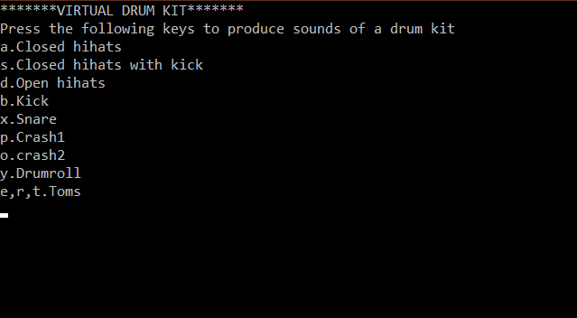

## Fig. 1.1:Virtual Drum Kit Interface

## 1.2 Objective of the Project

## To develop a system for musicians to play/practice drums without actually having a drum kit.

## To make it portable, since a real drum kit is large and heavy for musicians to carry everywhere they go.

## To give musicians more sound options.

## To provide the users a system which works without internet connectivity.

## To make mass people familiar with virtual musical instruments.

# 2. Existing System

# 2.1 Virtual Drummer

UJAM is a cloud-based service enabling everyone, musician or not to produce great sounding music and share it with their friends and the world. UJAM aims to be the go-to place to create music easy, fast and from everywhere UJAMs core technology augments simple user input such a singing or whistling into fully-fledged, studio-quality songs by interpreting melody, composing chords, arranging song form and rendering the result with professionally produced musical styles. Long-term, UJAM can be integrated and embedded with other services on any platform and aims to become a go-to-place for all music-lovers for creating and sharing their music. UJAM was founded in April 2009 by music technology pioneer Peter Gorges, Hip Hop producer Pharrell Williams and film composer Hans Zimmer. They soon added General Manager Axel Hensen and Chief Inventor Paul Kellett to the founders team. UJAMs investors are the founders, Sequoia Capitalâ€™s special limited partner Mark Kvamme as well as Hasso Plattner Ventures, a venture capital fund initiated by SAPs famous founder.

# Table 2.1: Information about Virtual Drummer

| Start up Name | Virtual Drummer |
| --- | --- |
| Headquarter | Bremen-vegesack, Bremen, Germany |
| Founder | Peter Gorges |
| Sector | Cloud computing,Music. |
| Founded | 2010 |
| Parent Organization | Ujam |

# 

# C:\Users\VENKATESH CHALLAWAR\Pictures\Screenshots\Screenshot (13).png

**Fig 2.1: Virtual Drummer Website**

**3. Proposed System**

**3.1 Problem statement**

We know that the drum-kits are heavy and is not possible to always carry a musical instrument like drums.Musicians find it hard to transport drum-kits for practice sessions or even shows because it is hard to carry and transport drum-kits to different places.It is also time consuming to setup a drum-kit.

**3.2 Methodology**

The following methodology applied for the developing the programme for online ticket booking.

* Programming language C++ is used.
* A linker (-lwinmm) is used.
* A series of IF statements are used for the selection of various sound options of a drum kit in a while loop.
* PlaySound function is used to play the audio files (sounds of a drum kit) .
* The **PlaySound** module is a cross platform module that can play audio files. This doesn't have any dependencies.
* getche() function is used so that the ***Enter*** key is required during the execution of the program.
* Certain keys in the keyboard are assigned to different sounds in a drum kit.

**3.3 Flow chart of the project is shown below**

Key is entered without using the ***Enter*** key.

Sound associated to the key which is entered is produced.

Display of the sound options in a drum kit.

Certain keys on the keyboard(alphabet) are assigned to a sound

User can play the Virtual Drum Kit

.

**4. Software and Hardware Requirements**

A software requirements specification (SRS) is a description of a software system to be developed. Used appropriately, software requirements specifications can help prevent software project failure. The software requirements specification document lists sufficient and necessary requirements for the project development.

Computer hardware is a collective term used to describe any of the physical components of an analog or digital computer .the term hardware distinguishes the tangible aspects of a computing device from software, which consists of written instructions that tell physical components what to do.

**Table 4.1: Software and hardware requirements**

|  |  |  |
| --- | --- | --- |
| **S.No** | **Description** | **Requirement** |
|  | Operating system | Windows 7 and above |
|  | Programming language | C++ |
|  | Software | Dev c++ |
|  | processor | Intel Core™ i3 |
|  | Ram | 1 GB or more |
|  | Disc space | 20 GB or more |

Virtual Drum Kit was programmed on the system with the specfications metioned below in the picture:

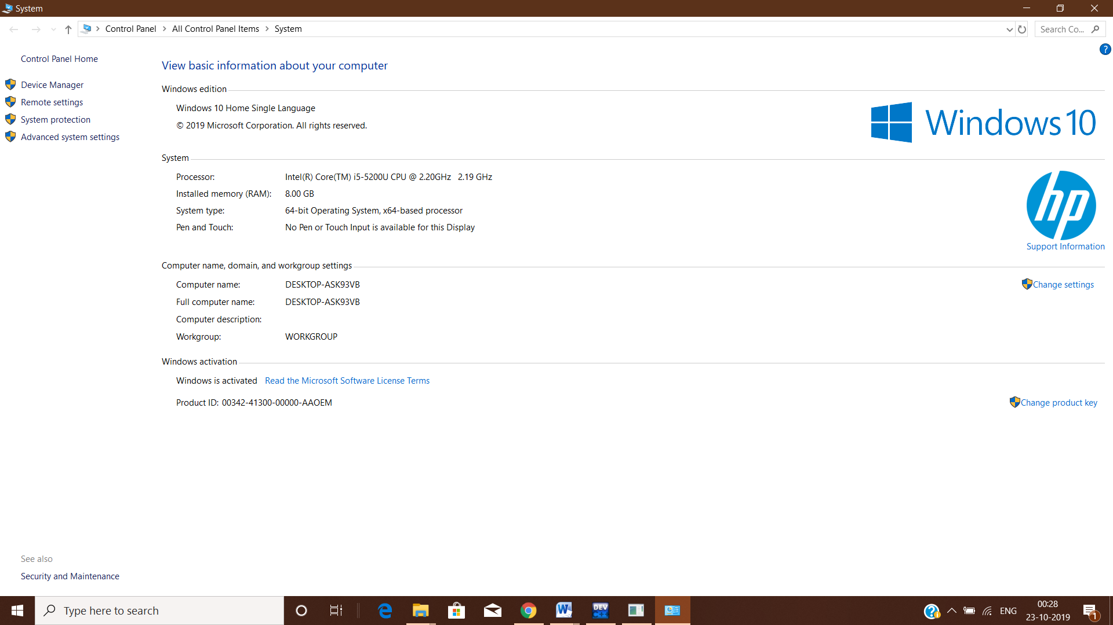

**Fig 4.1: Virtual Drum Kit was programmed on the above system,**

**5. Results and Screenshots**

Once programme is executed, the User is presented with the console page as shown in the Fig 5.1. He/she selects the options given the screen.Keys of the computer keyboard are assoiciated with sound of a standard drum kit.

Key (a):Closed hihats

Key(s):Closed hihats with kick

Key(d):Open hihats

Key(b):Kick

Key(x):Snare

Key(p):Crash 1

Key(o):Crash 2

Keys(e,r,t):Toms

Key(y):Drumroll

Key(z):Exit.

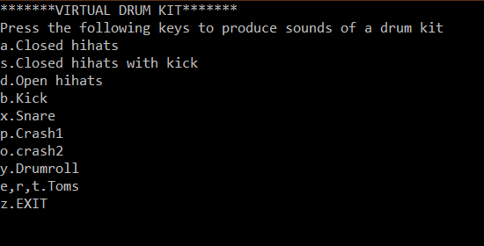

**Fig 5.1: Home Page of the Virtual Drum Kit**

With the selection of option a, a closed Hihat is played.

With the selection of option s, a closed Hihat with kick is played.

With the selection of option d, an open Hihat is played.

With the selection of option b,a Kick is played,

With the selection of option x, a Snare is played.

With the selection of option p or o, Crash is played.

With the selection of option y , a drumroll is played.

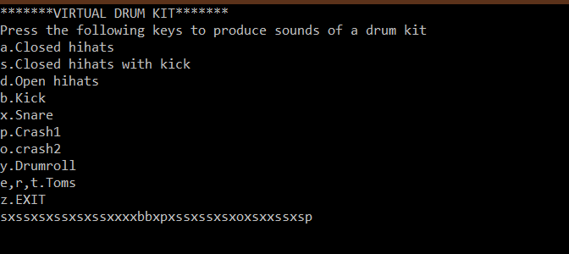

**Fig 5.2: Virtual Drum Kit is being operated.**

**6. Conclusion**

We know that the drum-kits are heavy and is not possible to always carry a musical instrument like drums.Musicians find it hard to transport drum-kits for practice sessions or even for musical events because it is hard to carry and transport drum-kits to different places.It is also time consuming to setup a drum-kit.This project is developed by using c++ language.

This project will help produce sounds of a drum-kit using a keyboard.Further this program can be used in sound pads or other hardware products to produce sounds of a drum-kit after configuration.This will make it easier for musician to carry it to different locations for practises or performances.

* To make drum-kit portable.
* To make setup easy.
* To a drum kit available at anytime and any place.

1. **Future Scope**

* This program can be used in a web application.
* This program can be used in sound pads after configurations.
* Sound pads are nothing but percussion keys replacing the keys of the computer keyboard.
* These sounds pads could made available at a very affordable price.

**Bibliography**

* www.greeksforgreeks.com
* www.udemy.com
* www.quoara.com
* Wikipedia
* Youtube