Object-Oriented Principles in Two Languages: A Ride Sharing System in C++ and Smalltalk

Saurabh Dahale
Department of Information Technology, University of the Cumberlands
MSCS-632-M30, Advanced Programming Languages
November 7, 2026

Object-Oriented Principles in Two Languages: A Ride Sharing System in C++ and Smalltalk
The same ride sharing system was implemented twice, once in C++ and once in GNU Smalltalk, under a specification fixing the classes, fare rules and exact output text written before either program. A script builds and runs both and compares the results, identical line for line apart from one section C++ cannot produce, so every remaining difference is the language. Both define a Ride base class, two subclasses that price differently, a Driver owning a private ride list, and a Rider recording requests. Source: https://github.com/saurabh-dahale/Ride-Sharing-System.

Encapsulation
C++ makes encapsulation a decision. Driver declares assignedRides private, so the collection changes only through addRide and is read only through getDriverInfo. Removing that one keyword would expose the field and nothing would object. The protection is checked before the program exists. Uncommenting the direct access in main produces a compile error naming the member and where it was declared private.
Smalltalk removes the decision. Instance variables are private to the object by construction and no public option exists (Goldberg & Robson, 1983), so Driver's state is unreachable from outside whether or not the author thought about it. Enforcement arrives later. Sending assignedRides to a driver with no accessor is accepted when the file loads and fails only on execution, raising MessageNotUnderstood. Sebesta (2019) frames this as when errors are detected rather than whether a language can express the constraint. Smalltalk guarantees more by default and reports violations later, C++ guarantees only what is declared and reports violations first. That check is the section C++ cannot print, because the equivalent line never compiles.

Inheritance
C++ derives StandardRide and PremiumRide publicly from Ride, whose data members are protected rather than private so a subclass fare() reads distance directly while outside code cannot. Declaring fare() pure virtual makes Ride abstract and instantiating it is a compile error. Smalltalk expresses the same hierarchy with Ride subclass: StandardRide, but abstractness is a convention, and Ride implements fare as self subclassResponsibility, which raises only when a missing override is reached. The languages also differ in what a class is. The fare constants in Smalltalk are class-side methods, because a class is itself an object that responds to messages, and subclasses inherit them. C++ has no equivalent, so the same constants are static members.

Polymorphism
Both programs store four rides in one collection and call fare and rideDetails without testing the type. In C++ the collection is a vector of shared pointers to Ride and each call reaches the override for the object's actual class through the virtual table. The binding happens at run time, but what the vector may hold is fixed at compile time. Smalltalk places no such bound. An OrderedCollection accepts any object and a message is dispatched by looking up the selector in the receiver's class at send time, so the elements need not share a superclass. Any object answering fare and rideDetails would work in the same loop.
One structure is identical in both. rideDetails is defined once in Ride and never overridden, yet behaves differently per subclass because it calls the two overridden methods. That is the Template Method pattern (Gamma et al., 1994), and it works the same way under virtual dispatch and message sending.

References
Gamma, E., Helm, R., Johnson, R., & Vlissides, J. (1994). Design patterns: Elements of reusable object-oriented software. Addison-Wesley.
Goldberg, A., & Robson, D. (1983). Smalltalk-80: The language and its implementation. Addison-Wesley.
Sebesta, R. W. (2019). Concepts of programming languages (12th ed.). Pearson.

Appendix: Sample Output and Source
Figure 1
C++ Build and Run
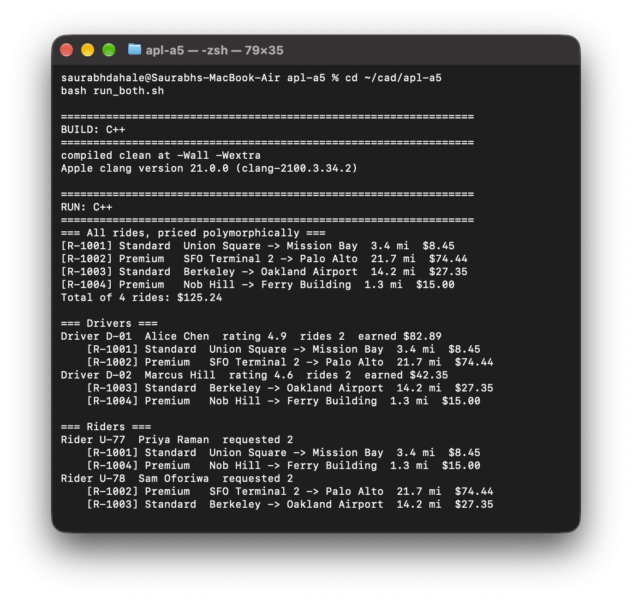
Note. The program compiles clean at -Wall -Wextra under Apple clang. The four rides are priced through the same loop, which never asks what kind of ride it holds.
Figure 2
GNU Smalltalk Run
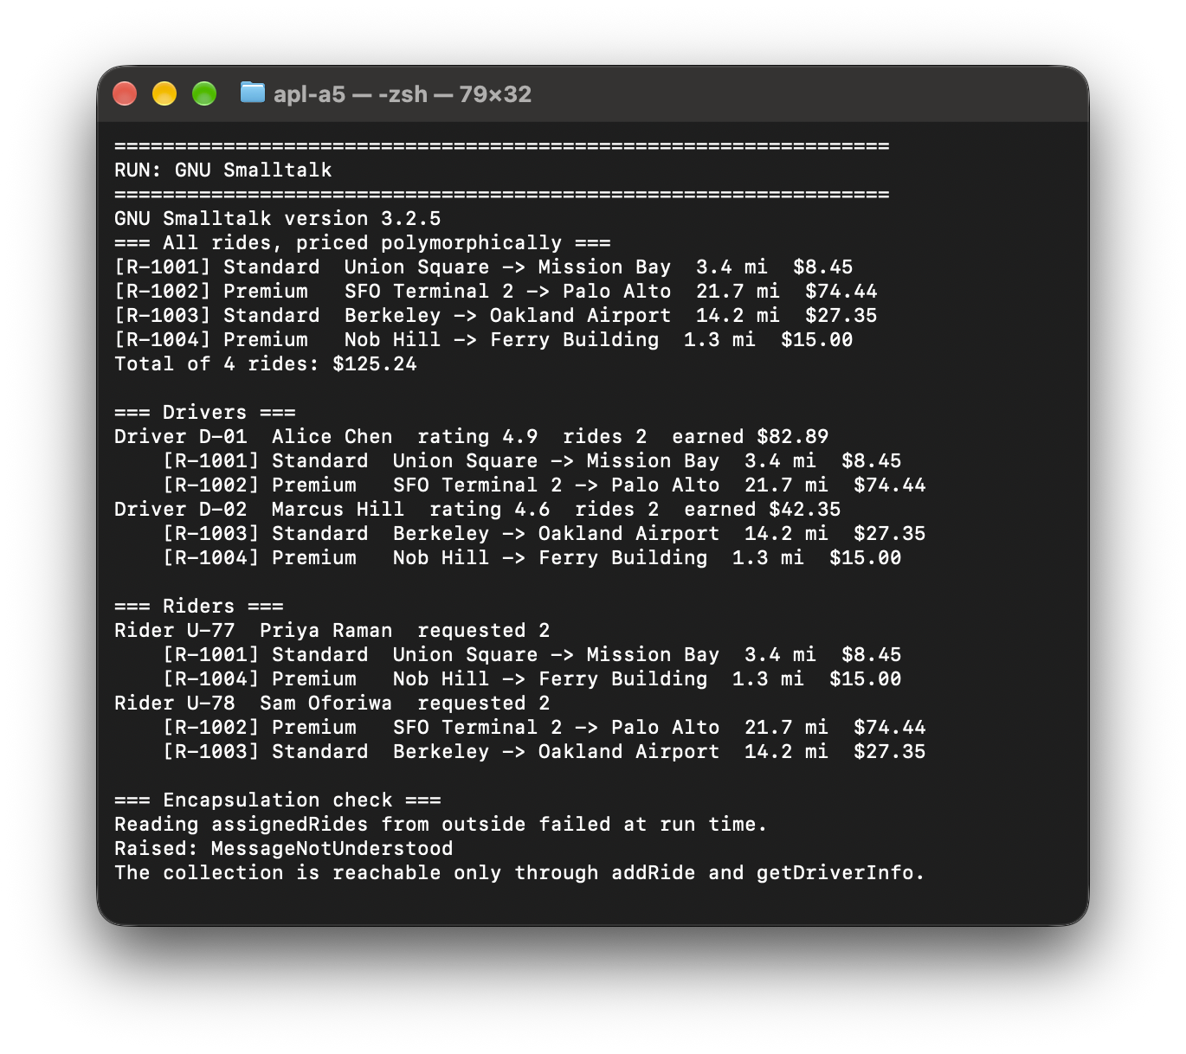
Note. The same three sections, identical to the C++ output. The fourth section has no C++ counterpart. Reading a driver's ride collection from outside raises MessageNotUnderstood at run time, where the equivalent C++ line is rejected by the compiler.
Figure 3
Comparison of the Two Outputs
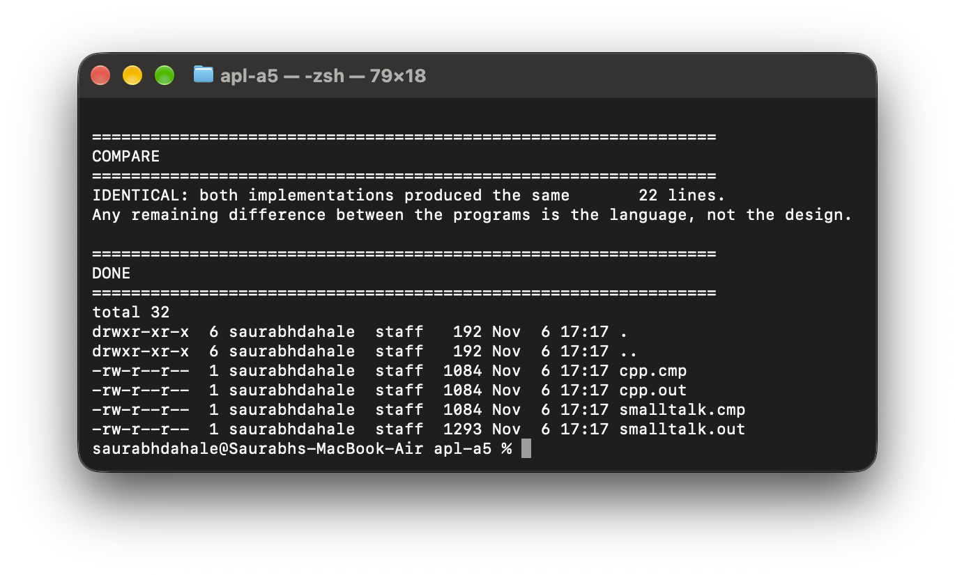
Note. The script strips the Smalltalk-only section and diffs the rest. All 22 lines match.
Figure 4
Smalltalk Ride Class
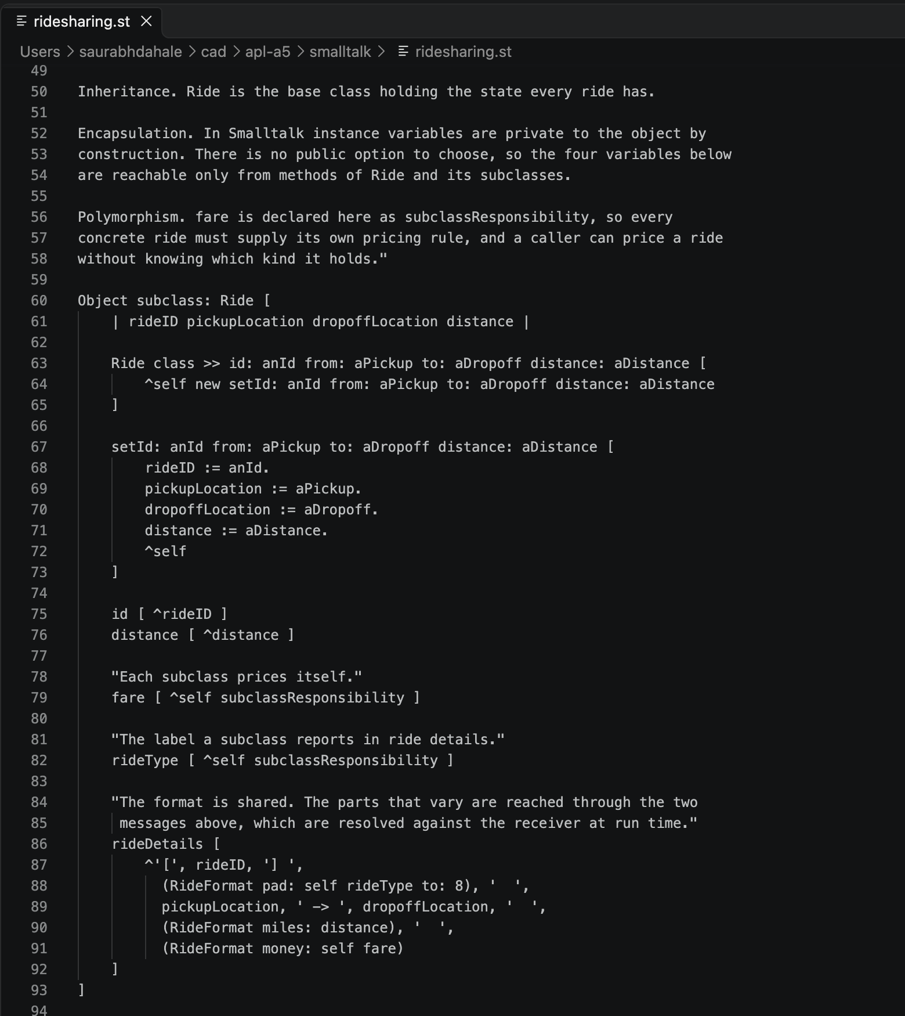
Note. fare and rideType are declared subclassResponsibility, so each subclass must supply them. rideDetails is defined once and calls both, which is where the polymorphic behavior enters.
Figure 5
C++ Driver Class
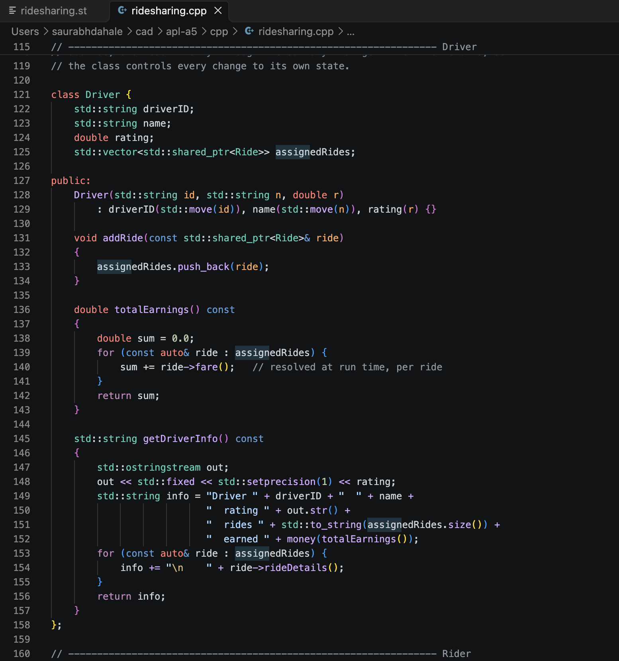
Note. assignedRides is declared before the public label, so it is private. Every read and write goes through addRide, totalEarnings and getDriverInfo.

