**Decision Tree for Salary Estimation**

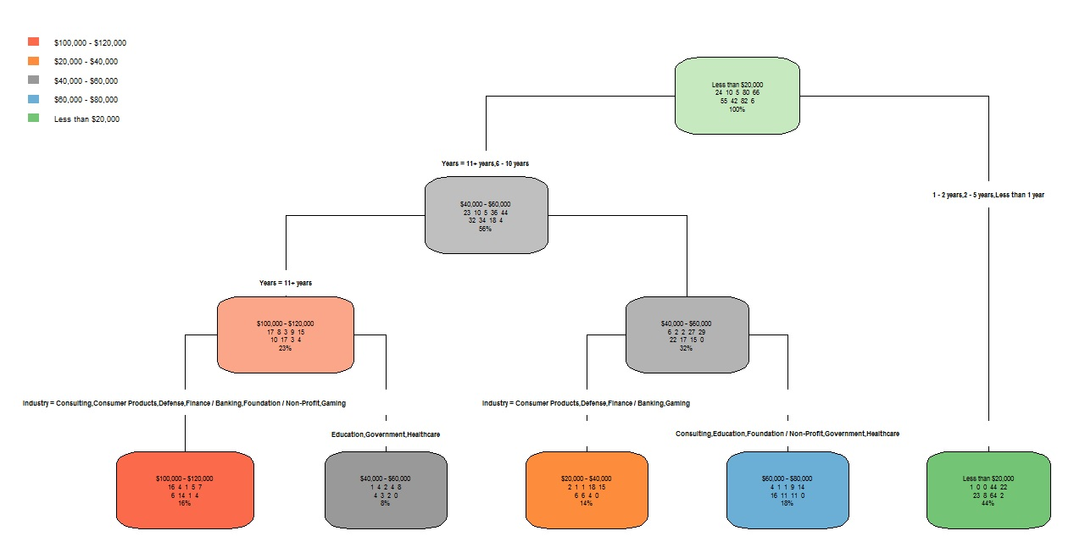

**Inferences derived from the above model are as follows**

1. Years of experience acts as primary differentiator for classification.
2. For less than 5 years of experience, the model predicts salary lesser than 20,000 $ irrespective of industry.
3. Finance, consulting, etc are more rewarding in salary than Education, Healthcare, and Government.

**Confusion Matrix for decision tree**

­­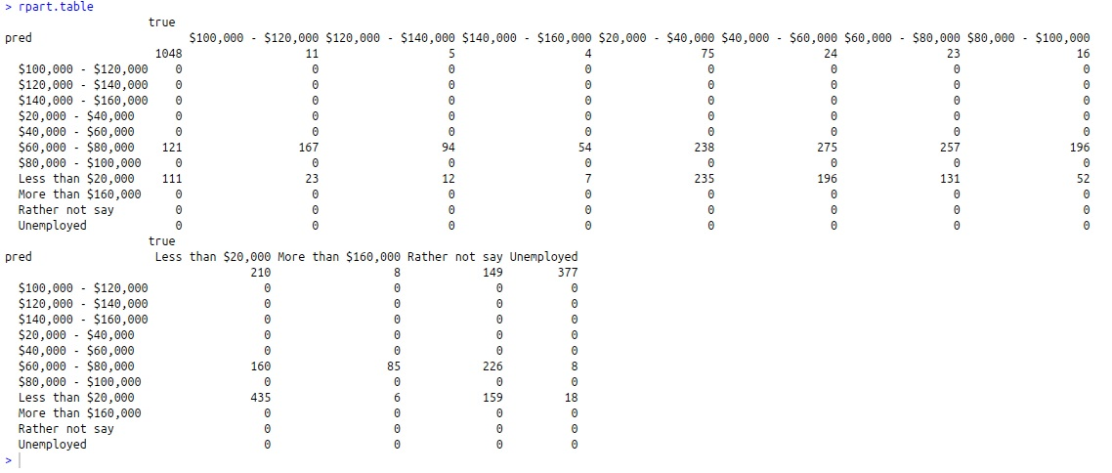

**Confusion Matrix for SVM**

