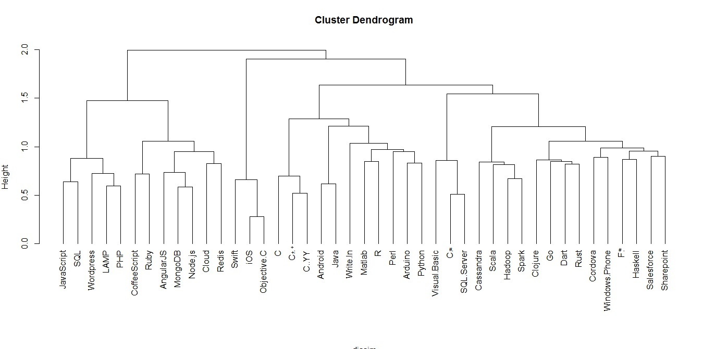

This plot does clustering on columns. The noteworthy points are as follows:-

* People working on iOS are a lot likely to work on Objective C.
* MongoDB and Node.js share their likeability.
* C# and SQL Server study go hand in hand.

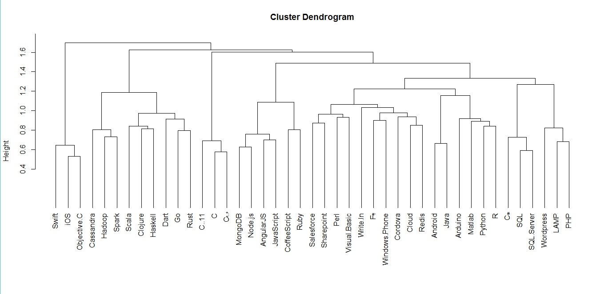

This plot shows the future technology similarities. Noteworthy points are as follows-

* People want to learn related technologies- R and Python; SQL and SQL Server; Android and Java.
* iOS and Objective C share similar responses from people.

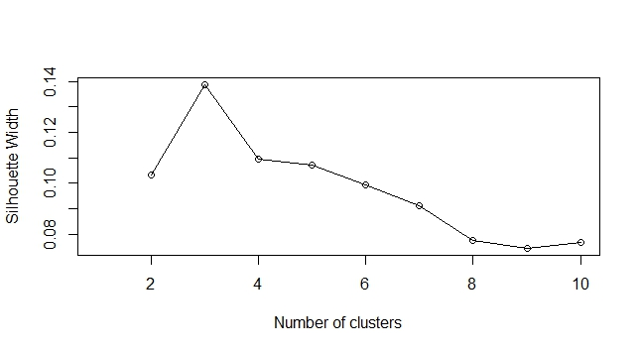

This plot shows that 3 clusters will yield best clustering. Greatest variance across clusters and least within.

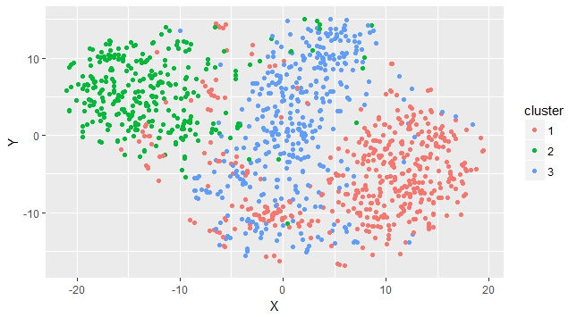

This cluster is yielded as an outcome of clustering exercise based on k-means clustering with 3 clusters.  
Medoids- 30, 363, 607

Most Similar- 268, 2

Most Dissimilar- 375, 111