**LICENSE NUMBER PLATE RECOGNITION AND IDENTIFICATION USING MATLAB**

A Project Report

Submitted in Partial Fulfillment of the Requirement

for the Award of the Degree of

BACHELOR OF TECHNOLOGY

(ELECTRONICS AND COMMUNICATION ENGINEERING)

TO

VEER MADHO SINGH BHANDARI UTTARAKHAND TECHNICAL UNIVERSITY DEHRADUN



Submitted by

1. Saurabh Tamta(190050102047) 2. Mohit Singh Bohra(190050102030)



**UNDER THE GUIDANCE OF**

**Mr. Anoop Raghuvanshi**

**(Assistant Professor)**

**DEPARTMENT OF ELECTRONICS AND COMMUNICATION ENGINEERING**

**BIRLA INSTITUTE OF APPLIED SCIENCES, BHIMTAL**

**JUNE, 2023**

DECLARATION

## I Saurabh Tamta and Mohit Singh Bohra bearing university roll numbers 190050102047 and 190050102030 respectively, students of B. TECH, Electronics and Communication Engineering Department hereby declare that we own the full responsibility for the information, results etc. provided in this Project titled “License Number Plate Recognition and Identification using MATLAB”, submitted to Veer Madho Singh Bhandari Uttarakhand Technical University, Dehradun for the award of B. TECH (ECE) degree. We have taken care in all respect to honor the intellectual property right and have acknowledged the contribution of others for using them in this academic purpose. We further declare that in case of any violation of intellectual property or copyright, we as the candidates will be fully responsible for the same. Our supervisor, HOD and the Institute should not be held responsible for any full or partial violation of copyright if found at any stage of my degree.

### Date:

### Place: BIAS Bhimtal Students name:

Saurabh Tamta &

Mohit Singh Bohra

CERTIFICATE

Certified that the thesis titled “*License Number Plate Recognition and Identification* using MATLAB” submitted by **Saurabh Tamta & Mohit Singh Bohra,** University Roll No’s**. 190050102047 & 190050102030 respectively,** in the partial fulfilment of the requirements for the award of the degree of B. TECH (Electronics & Communication Engineering) of **Veer Madho Singh Bhandari Uttarakhand Technical University, Dehradun**, is a record of student’s own work carried under my supervision and guidance. To the best of our knowledge, this thesis has not been submitted to UKTU University or to any other university or institute for award of any degree. It is further understood that by this certificate the undersigned do not endorse or approve any statement made, opinion expressed or conclusion drawn therein but approve the thesis only for the purpose for which it is submitted.

### 

|  |  |  |
| --- | --- | --- |
| **Mr. Anoop Raghuvanshi**  Assistant Prof. |  | **H.O.D.**  Mr. Anil Kumar Chaurasia  HOD, ECE Dept. |

**Acknowledgement**

We wish to express our sincere gratitude to our supervisor **Mr. Anoop Raghuvanshi** Assistant Professor, BIAS, Bhimtal for his valuable guidance, constant inspirations and helpful suggestions for carrying out this thesis work.

We also wish to express our sincere thanks and deep sense of gratitude to our Head of Department **Mr. Anil Kumar Chaurasia (Department of Electronics and Communication Engineering)**, BIAS for his constant inspirations and helpful suggestions throughout the course of this Project work.

We would like to thank **Staff and faculty members** of Electronics and Communication Engineering department for their support throughout this work.

We also wish to express our sincere thanks to **Dr. B.K. Singh,** Director, Birla Institute of Applied Sciences, Bhimtal, Uttarakhand for his guidance.

Last but not the least, we thank our family and friends, who have always been a constant source of encouragement in every aspect of my life.

Saurabh Tamta

(Roll no. 190050102047)

Mohit Singh Bohra

(Roll no. 190050102030)

**Abstract**

The License Number Plate Recognition and Identification system is based on image processing technology. It is one of the necessary systems designed to detect the vehicle number plate. In today’s world with the increasing number of vehicle day by day it’s not possible to manually keep a record of the entire vehicle. With the development of this system, it becomes easy to keep a record and use it whenever required. The main objective here is to design an efficient automatic vehicle identification system by using vehicle number plate. The system first would capture the vehicles image as soon as the vehicle reaches the security checking area. The captured images are then extracted by using the segmentation process. Optical character recognition is used to identify the characters. The obtained data is then compared with the data stored in their database. The system is implemented and simulated on MATLAB and performance is tested on real images. This type of system is widely used in Traffic control areas, tolling, parking area etc. This system is mainly designed for the purpose of security system.

Keywords: Number Plate Recognition, Gray Processing, Image Acquisition, Image Binarization, Template Matching.

**Table of Content**

**S.No. Content Page**

1. Declaration ii

2. Certificate iii

3. Acknowledgement iv

4. Abstract v

5. Table of Contents vi

6. Overview of Project vii

6.1 Introduction vii

6.2 Objective ix

7. Technology behind the Project xii

8. Literature survey xv

9. Methodology xvii

9.1 Software Model xvii

9.2 Work flow Process xviii

9.3 Hardware Interconnections xxii

11. Application and Future Scope xxiii

12. References xxiv

**OVERVIEW OF PROJECT**

**Introduction**

Number plates are used for identification of vehicles all over the nations. Vehicles are identifying either manually or automatically. Automatic vehicle identification is an image processing technique of identify vehicles by their number plates. Automatic vehicle identification systems are used for the purpose of effective traffic control and security applications such as access control to restricted areas and tracking of wanted vehicles. Number plate recognition (NPR) is easier method for Vehicle identification. NPR system for Indian license plate is difficult compared to the foreign license plate as there is no standard followed for the aspect ratio of license plate. The identification task is challenging because of the nature of the light. Experimentation of number plate detection has been conducted from many years; it is still a challenging task. Number plate detection system investigates an input image to identify some local patches containing license plates. Since, a plate can exist anywhere in an image with various sizes, it is infeasible to check every pixel of the image to locate it. In parking, number plates are used to calculate duration of the parking. When a vehicle enters an input gate, number plate is automatically recognized and stored in database. In NPR system spectral analysis approach is used were acquiring the image, extract the region of interest, character segmentation using SVM feature extraction techniques. The advantage of this approach is success full recognition of a moving vehicle. It is difficult to detect the boundary of the Number plate from the input car images in outdoors scene due to color of characters of the number plate and Background of the Number plate the gradients of the original image are adopted to detect candidate number plate regions. There are also algorithms which are based on a combination of morphological operation, segmentation and Canny edge detectors. License plate location algorithm consist of steps like as Edge Detection, Morphological operation like dilation and erosion, Smoothing, segmentation of characters and recognition of plate characters are described.

• A digital image differs from a photo in that the values are all discrete.  
• Usually, they take on only integer values.  
• A digital image can be considered as a large array of discrete dots, each of which has a brightness associated with it. These dots are called picture elements, or more simply pixels.  
• The pixels surrounding a given pixel constitute its neighborhood A neighborhood can be characterized by its shape in the same way as a matrix: we can speak of a 3x3 neighborhood, or of a 5x7 neighborhood.

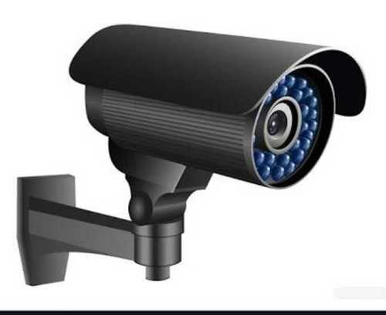

Captured image of the Vehicle Number plate

Segmentation and Recognition of Plate Characters

Display vehicle Number

Fig 1. Image acquisition and identification

Aspects of Image Processing Image Enhancement: Processing an image so that the result is more suitable for a particular application. (Sharpening or deblurring an out of focus image, highlighting edges, improving image contrast, or brightening an image, removing noise) Image Restoration: This may be considered as reversing the damage done to an image by a known cause. (Removing of blur caused by linear motion, removal of optical distortions) Image Segmentation: This involves subdividing an image into constituent parts, or isolating certain aspects of an image. (Finding lines, circles, or particular shapes in an image, in an aerial photograph, identifying cars, trees, buildings, or roads.

The growing affluence of urban India has made the ownership of vehicles a necessity. This has resulted in an unexpected civic problem - that of traffic control and vehicle identification. Parking areas have become overstressed due to the growing numbers of vehicles on the roads today. The Automatic Number Plate Recognition System (ANPR) plays an important role in addressing these issues as its application ranges from parking admission to monitoring urban traffic and to tracking automobile thefts. There are numerous ANPR systems available today which are based on different methodologies. In this paper, we attempt to review the various techniques and their usage. The ANPR system has been implemented using template Matching and its accuracy was found to be 80.8% for Indian number plates.

**Objective**

The project presented here can be used to detect a vehicle’s number plate from the images stored in a database through an input camera device. That is, it aims at detecting the license plate of a vehicle and then extracting the information regarding that vehicle using MATLAB software.

The purpose of motor vehicle registration by a government authority is to establish a link between the vehicle and its owner or user. The registration number is generally alphanumeric and it uniquely identifies the vehicle within the issuing authority’s database. These number plates can be of different colours, fonts, and sizes depending upon the country and their rules.

This project can be used in the following areas:

1. Analysis of city traffic during peak hours
2. Automation of weigh-in-motion systems
3. Enhanced vehicle theft prevention
4. Effective enforcement of traffic rules
5. Flexible and automatic vehicle entry and exit from a car parking area
6. Car parking management system
7. Improved security for the car parking operators

Further, this project can be used for vehicle license plate detection at interstate borders, airports, and harbours. The elements considered in this project include the following:

***Number plate detection.*** Both front and back number plates of a vehicle are considered for detection.

***Text extraction from the detected number plate.***It can extract the text of only one vehicle number plate at a time.

With the increasing number of vehicles in today’s world it’s not possible to manually keep a track of the entire vehicle. There need to be a man standing 24*7 to note down the number. It’s a time-consuming process and require manpower. Furthermore, the data stored manually is not readable after a long time. So, to overcome all these limitations here we tried to develop a system which would automatically detect the number plate and store it in its database. Later on, when the information is required one can get it and use it.

The primary objective of this project is to develop a license plate reader and automatic gate system using MATLAB, an Arduino Uno SMD R3 board, a camera, an ultrasonic sensor, and a servo motor. The system aims to achieve the following objectives:

1. License Plate Recognition: Develop an algorithm to capture images of vehicle license plates and process them using MATLAB to extract the text information from the plates. The objective is to accurately recognize and extract the alphanumeric characters present on the license plates.
2. Car Detection: Utilize an ultrasonic sensor to detect the presence of a vehicle within a specified range. When a car enters the range of the ultrasonic sensor, the system triggers the camera to capture an image of the license plate for further processing.
3. Database Integration: Integrate a database system with the MATLAB code to store and manage a collection of recognized license plate data. The system will compare the extracted text from the license plate with the database records to determine whether the vehicle is authorized or unauthorized.
4. Gate Control: Implement a control mechanism using an Arduino Uno SMD R3 board and a servo motor to operate an automatic gate. When a recognized license plate matches an entry in the database, the system will send a signal to the servo motor to open the gate, allowing the authorized vehicle to pass through. If the license plate is not recognized or does not match any database entries, the gate remains closed.
5. System Integration: Ensure seamless communication and coordination between the hardware components (camera, ultrasonic sensor, Arduino board, servo motor) and the software components (MATLAB code, database integration). Achieve real-time functionality, where the system can capture, process, and analyze license plate data promptly, allowing for efficient gate control.
6. Accuracy and Reliability: Strive to achieve a high level of accuracy in license plate recognition and database matching to minimize false positives and false negatives. The system should demonstrate reliability in consistently detecting vehicles, recognizing license plates, and controlling the gate based on the authorization status.
7. Ease of Use and Scalability: Design the system in a user-friendly manner, allowing easy setup, configuration, and maintenance. Ensure the system is scalable, enabling the addition of more cameras, sensors, or gates to expand its functionality and coverage.

The successful completion of these objectives will result in a functional license plate reader and automatic gate system that enhances security and access control while providing convenience and efficiency for authorized vehicles.

**Technology behind the Project**

**Software used**

**1. MATLAB: MATLAB** is a programming platform designed specifically for engineers and scientists to analyze and design systems and products that transform our world. The heart of MATLAB is the MATLAB language, a matrix-based language allowing the most natural expression of computational mathematics. Image Processing Toolbox™ provides a comprehensive set of reference-standard algorithms and workflow apps for image processing, analysis, visualization, and algorithm development. You can perform image segmentation, image enhancement, noise reduction, geometric transformations, and image registration using deep learning and traditional image processing techniques. The toolbox supports processing of 2D, 3D, and arbitrarily large images.

2. **MySQL**: MySQL is an open-source relational database management system. As with other relational databases, MySQL stores data in tables made up of rows and columns. Users can define, manipulate, control, and query data using Structured Query Language, more commonly known as SQL. A flexible and powerful program, MySQL is the most popular open-source database system in the world. As part of the widely-used LAMP technology stack (which consists of a Linux-based operating system, the Apache web server, a MySQL database, and PHP for processing), it’s used to store and retrieve data in a wide variety of popular applications, websites, and services.

* **Connector ODBC:** MySQL Connector/ODBC provides both driver-manager based and native interfaces to the MySQL database, with full support for MySQL functionality, including stored procedures, transactions and full Unicode compliance. In the project it was used to establish a connection between MySQL and MATLAB.

**Hardware used**

**1. Camera:** Surveillance cameras, or security cameras, are video cameras used for the purpose of observing an area. They are often connected to a recording device or IP network, and may be watched by a security guard or law enforcement officer.It is used in the project as an input source for capturing the license plate photo.

2. **Motor and gate**: An electric motor is an electrical machine that converts electrical energy into mechanical energy. Most electric motors operate through the interaction between the motor's magnetic field and electric current in a wire winding to generate force in the form of torque applied on the motor's shaft. A Motor will be used for opening and closing of gate.

* **Micro Servo Motor SG90:** Here in the Project, we have used Micro/Mini SG90 Servo motor with 180-degree rotation.
* The ATmega328 chip i.e., a micro-controller which comes with Arduino uno, helps us in controlling the motor.
* Servo code hardware or library can be used to control this servo motor.
* Specifications - Operating Voltage (VDC):3.0 ~ 7.2 | Operating Speed @4.8V:0.12sec/60° | Operating Speed @6.6V:0.1sec/60° | Stall Torque @ 4.8V (Kg-Cm):1.2 | Operating Temperature (°C): -30 to 60|

3. **Ultrasonic sensor:** FMCW method MW and Ultrasonic sensor enables to detect vehicle approach and presence. Point to point photo beam which is designed for reliable vehicle detection. Measuring difference of earth magnetic field enable to detect vehicle presence.

* **HC-SR04 DC 5V Ultrasonic sensor:** The HC-SR04 Ultrasonic Distance Sensor provides very short (2CM) to long-range (4M) detection and ranging. The HC-SR04 sensor provides precise and stable non-contact distance measurements from about 2cm to 4 meters with very high accuracy. It can be easily interfaced to any microcontroller.

4. **Arduino Uno R3 SMD:** The Arduino Uno is an open-source microcontroller board based on the Microchip ATmega328P microcontroller and developed by Arduino.cc and initially released in 2010. The board is equipped with sets of digital and analog input/output (I/O) pins that may be interfaced to various expansion boards (shields) and other circuits. The board has 14 digital I/O pins (six capable of PWM output), 6 analog I/O pins, and is programmable with the Arduino IDE (Integrated Development Environment), via a type B USB cable. It can be powered by a USB cable or a barrel connector that accepts voltages between 7 and 20 volts, such as a rectangular 9-volt battery. It is similar to the Arduino Nano and Leonardo. The hardware reference design is distributed under a Creative Commons Attribution Share-Alike 2.5 license and is available on the Arduino website. Layout and production files for some versions of the hardware are also available. The word "uno" means "one" in Italian and was chosen to mark a major redesign of the Arduino hardware and software. The Uno board was the successor of the Duemilanove release and was the 9th version in a series of USB-based Arduino boards. Version 1.0 of the Arduino IDE for the Arduino Uno board has now evolved to newer releases. The ATmega328 on the board comes preprogrammed with a bootloader that allows uploading new code to it without the use of an external hardware programmer. While the Uno communicates using the original STK500 protocol, it differs from all preceding boards in that it does not use a FTDI USB-to-UART serial chip. Instead, it uses the Atmega16U2 (Atmega8U2 up to version R2) programmed as a USB-to-serial converter.

* ICSP pin - The In-Circuit Serial Programming pin allows the user to program using the firmware of the Arduino board.
* Power LED Indicator- The ON status of LED shows the power is activated. When the power is OFF, the LED will not light up.
* Digital I/O pins- The digital pins have the value HIGH or LOW. The pins numbered from D0 to D13 are digital pins.
* TX and RX LED's- The successful flow of data is represented by the lighting of these LED's.
* AREF- The Analog Reference (AREF) pin is used to feed a reference voltage to the Arduino UNO board from the external power supply.
* Reset button- It is used to add a Reset button to the connection.
* USB- It allows the board to connect to the computer. It is essential for the programming of the Arduino UNO board.
* Crystal Oscillator- The Crystal oscillator has a frequency of 16MHz, which makes the Arduino UNO a powerful board.
* Voltage Regulator- The voltage regulator converts the input voltage to 5V.
* GND- Ground pins. The ground pin acts as a pin with zero voltage.
* Vin- It is the input voltage.
* Analog Pins- The pins numbered from A0 to A5 are analog pins. The function of Analog pins is to read the analog sensor used in the connection. It can also act as GPIO (General Purpose Input Output) pins.

**Literature Survey**

**Recognition Of Vehicle Number Plate Using MATLAB Ami Kumar Parida, SH Mayuri, Pallabi Nayk, Nidhi Bharti.**

Automatic video analysis from traffic surveillance cameras is a fast-emerging field based on computer vision techniques. It is a key technology to public safety, intelligent transport system (ITS) and for efficient management of traffic. We define video analytics as computer-vision-based surveillance algorithms and systems to extract contextual information from video. Currently most reliable approach is through the recognition of number plates, i.e., automatic number plate recognition (ANPR), which is also known as automatic license plate recognition (ALPR), or radio frequency transponders. We are proposing two methods for extraction of license plates and comparing it with other existing methods. The Extracted license plates are segmented into individual characters by using a region-based method. The recognition scheme combines adaptive iterative thresholding with a template matching algorithm.

**Vehicle Number Plate Detection using MATLAB** **Narendra Singh Tamar, Prakhar Sachan,** **Pranav Mittal, Shivani Agarwal**

The VPR (Vehicle Number plate Recognition) system is based on image processing technology. It is one of the necessary systems designed to detect the vehicle number plate. In today’s world with the increasing number of vehicle day by day it’s not possible to manually keep a record of the entire vehicle. With the development of this system, it becomes easy to keep a record and use it whenever required. The main objective here is to design an efficient automatic vehicle identification system by using vehicle number plate. The system first would capture the vehicles image as soon as the vehicle reaches the security checking area. The captured images are then extracted by using the segmentation process. Optical character recognition is used to identify the characters. The obtained data is then compared with the data stored in their database. The system is implemented and  
simulated on MATLAB and performance is tested on real images. This type of system is  
widely used in Traffic control areas, tolling, parking area etc. This system is mainly  
designed for the purpose of security system.

**Automatic Vehicle Number Plate Recognition System using Matlab Bhawna Tiwari, Archana Sharma, Malti Gautam Singh, Bhawana Rathi**

Automatic number plate recognition is a mass surveillance method that uses optical  
character recognition on images to read the number plates on vehicles. Existing closed-  
circuit television or road-rule enforcement cameras, or specifically designed systems  
can be used for the task. This system is very helpful for traffic police to find the details of  
a car violating the traffic rules. Its applications also include Automatic toll collection system and car parking systems.[1] In high security areas where parking space is reserved for VIP vehicle owners only, the parking gate will be opened after number recognition. In areas where parking space is allotted to a particular vehicle, wrong vehicle parked can be recognized. ANPR can be used to store the images captured by the cameras and the text  
from the number plate. Systems use infrared lighting to allow the camera to take the  
picture at any time of day. A powerful flash can also be included in cameras, to both  
illuminate the picture and make the offender aware of his mistake. Due to plate variation  
from place-to-place ANPR technology tends to be region specific.

**Methodology**

**Software model**

The first and the most important part in this process is the software model. The software model uses the image processing technology. The programs are implemented in MATLAB. The algorithm is divided into following parts: Capture image, Pre-processing, Plate region extraction, Segmentation of character in the extracted number plate, Character recognition, Comparison with database and Indicate result. The flow chart of license plate recognition system implementation in this work is shown in the following figure. There are various steps in this approach and these are implementation in MATLAB.

Input Captured Image

Pre-Processing

Plate Region Extraction

Segmentation of Character

Character Recognition

Display of Recognized Character

Fig.2: Flow diagram of NPD (Number Plate Detection)

**WORK FLOW PROCESS**

**Capture of Image:**

The first step is the capture of image. The image is captured by electronic device. This phase deals with acquiring an image by an acquisition method. In the proposed system, we used a 120x160 resolution digital camera or 3.2-megapixel cameras to acquire the input image. The input image is 120 x160 or 1200 x 1600 pixels. The image captured is stored in JPEG format. Later on, it is converted in to gray scale image in MATLAB.

**Pre-processing:** The next step after capturing the image is the preprocessing of the image. When the image is captured, there is lot of disturbances and noises present in the image for which the image can’t be used properly. So, in this step the noises from the image are required to be cleared to obtain an accurate result.

**a. Gray Processing:** this step involves the conversion of image in to gray levels. Color images are converted in to gray image. According to the R, G, B value in the image, it calculates the value of gray value, and obtains the gray image at the same time.

**b. Median Filtering:** media filtering is the step to remove the noises from the image. Gray level cannot remove the noises. So, to make image free from noise media filtering is used.

**Plate region extraction:** The most important stage is the extraction of number plate from eroded image significantly. The extraction can be done by using image segmentation method. There are numerous image segmentation methods available in various literatures. In most of the methods image binarization is used.

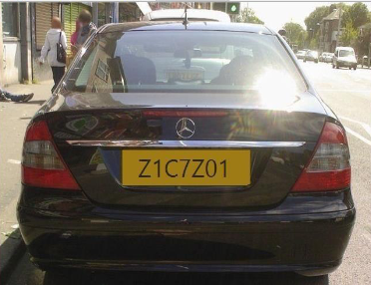

Fig 3: License plate image

The inputs to the system were the images of vehicles captured by a camera. RGB to gray-scale conversion is adopted, in order to facilitate the plate extraction, and increase the processing speed. Color image (RGB) acquired by a digital camera is converted to gray-scale image based on the RGB to gray-scale conversion technique. Image captured from the camera is first converted to the gray scale image. The basic step in recognition of vehicle number plate is to detect the plate size. In general number plates are rectangular in shape. Hence, we have to detect the edges of the rectangular plate. Mathematical morphology will be used to detect that region. We use here Sobel operator to calculate the threshold value. Using Sobel edge detector, we used to high light regions with a high edge magnitude and high edge variance are identified. The binary gradient mask shows lines of high contrast in the image. These lines do not quite delineate the outline of the object of interest. Compared to the original image, you can see gaps in the lines surrounding the object in the gradient mask. These linear gaps will disappear if the Sobel image is dilated using linear structuring elements.

Structuring element is represented as matrices. Structuring element is a characteristic of certain structure and features to measure the shape of an image and is used to carry out other image processing operations, which we can create with the strel function in MATLAB. The binary gradient mask is dilated using the vertical structuring element followed by the horizontal structuring element. MATLAB toolbox function provide a function imfill (BW, ‟holes”) that fills holes in the binarized image called BW. The set of background pixels are known as hole that cannot be reached by filling the background from the edge of the image. Figure 6f shows after remove lower than 100 pixels connected components fills the holes. The dilated gradient mask shows the outline of the region quite nicely, but there are still holes in the interior of the region. To fill these holes, we use the imfill function in MATLAB.

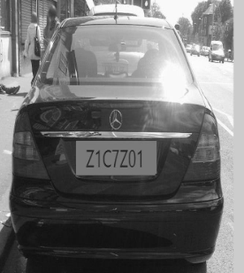

Fig 4: Gray-scale converted image.

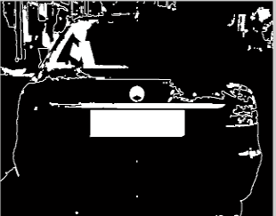

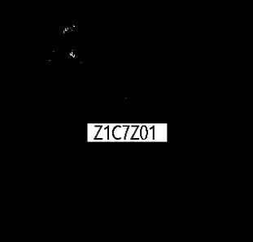

Fig 5: Binary images

The region of interest has been successfully segmented, but it is not the only object that has been found. Any objects that are connected to the border of the image can be removed using the imclearborder MATLAB function. The connectivity in the function was set to 4 or 8 to remove diagonal connections. We fill the hole to locate the plate region. Now omitting the lower pixel components to gets the actual plate. Finally, in order to make the segmented object look natural, we smoothing the object by eroding the image twice with a diamond, disk, line structuring element. We create the diamond structuring element using the strel function. Multiply the Segmented Image with gray scale image, we get the only number plate area in a vehicle image with characters and numbers present on it

**Character segmentation:** In this step get the o/p of extracted number plate using labeling components, and then separate each character and split the each and every character in the number plate image by using split and also find the length of the number plate, then find the correlation and database if both the value is same means it will generate the value 0-9 and A - Z, and finally convert the value to string and display it in edit box, and also store the character in some text file in this code. Following figure shows the segmented characters.

The character recognition is now used to compare each individual character with the character stored in the database. OCR uses the correlation method to match the characters. And if both the character matches then it displays the authorized otherwise it will display the unauthorized.

**Some of Possible Difficulties**  
• Broken number plate.  
• Blurry images.  
• Number plate not within the legal specification.  
• Low resolution of the characters.  
• Poor maintenance of the vehicle plate. Similarity between certain characters, namely, O and D; 5 and S; 8 and B, E; O and 0 etc.

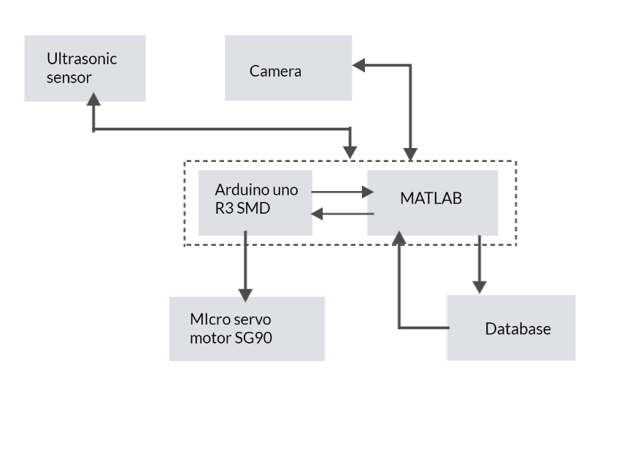

Fig 6: Block Diagram

**Hardware interconnections**

To establish the necessary connections between the hardware components, the following interconnections were made:

1. Camera Connections:

* The camera was connected to a computer or embedded system via a USB interface. This connection allowed for image acquisition and processing using MATLAB.
* The USB cable from the camera was plugged into an available USB port on the computer or embedded system.

2. Ultrasonic Sensor Connections:

* The HC-SR04 ultrasonic sensor was connected to the Arduino Uno board for distance measurement and car detection.
* The VCC (power) pin of the sensor was connected to the 5V pin on the Arduino board.
* The GND (ground) pin of the sensor was connected to the GND pin on the Arduino board.
* The Trig (trigger) pin of the sensor was connected to a digital input/output pin (e.g., pin 2) on the Arduino board.
* The Echo (echo) pin of the sensor was connected to another digital input/output pin (e.g., pin 3) on the Arduino board.

3. Servo Motor Connections:

* The servo motor was connected to the Arduino Uno board for gate control.
* The power supply wire (usually red) of the servo motor was connected to the 5V pin on the Arduino board or an external power supply if required.
* The ground wire (usually black or brown) of the servo motor was connected to the GND pin on the Arduino board.
* The signal wire (usually yellow or white) of the servo motor was connected to a PWM pin (e.g., pin 9) on the Arduino board.

**Applications and Future Scope**

The future scope is that the automated vehicle recognition system plays a serious role in detection threats to defense conjointly it will improve the protection associated with the women’s as they'll simply notice the quantity plate before victimization cab or alternative services. The system strength may be increase if a bright and sharp camera is employed. The government ought to take some interest in developing this technique as this technique is money-saving and eco-friendly if applied effectively in varied areas.

• **Parking** : The NPR is used to automatically enter prepaid members and calculate parking fee for non-members  
• **Access Control** : A gate automatically opens for authorized members in a secured area, thus replacing or assisting the security guard.  
• **Tolling** : The car number is used to calculate the travel fee in a toll-road or used to double check the ticket.  
• **Border Security** : The car number is registered in the entry or exits to the country and used to monitor the border crossings.  
• **Traffic Control** : The vehicles can be directed to different lanes according to their entry permits. The system reduces the traffic congestions and number of attendants.  
• **Airport Parking**: In order to reduce ticket frauds or mistakes, the NPR unit is used to capture the number plate & image of the car.

**REFERENCES**

[1] Loumos, V.; Kayafas, E., ”License plate recognition from still images and video sequences: A survey” IEEE Transactions on Intelligent Transportation Systems, volume 9, issue 3, pages 377-391, September 2008.

[2] Shen Zheng Wang & His-Jian Lee “Detection and Recognition of License Plate Characters with Different Appearances”, IEEE Intelligent Transportation Systems, Proceedings 2003 , vol.2 , Page(s): 979 – 984.

[3] Wisam Al Faqheri and Syamsiah Mashohor, "A Real-Time Malaysian Automatic License Plate Recognition (M-ALPR) using Hybrid Fuzzy”, IJCSNS International Journal of Computer Science and Network Security, VOL.9 No.2, February 2009.