Hellooooooo.....

AJAX

AJAX = Asynchronous JavaScript and XML.

AJAX is a technique for creating fast and dynamic web pages.

AJAX allows web pages to be updated asynchronously by exchanging small amounts of data with the server behind the scenes. This means that it is possible to update parts of a web page, without reloading the whole page.

Classic web pages, (which do not use AJAX) must reload the entire page if the content should change.

Examples of applications using AJAX: Google Maps, Gmail, Youtube, and Facebook tabs.

How AJAX Works

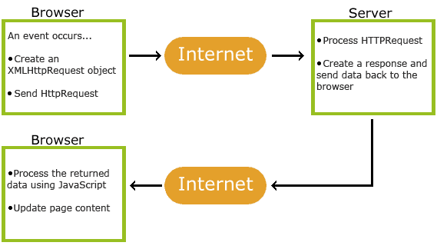

AJAX is Based on Internet Standards

AJAX is based on internet standards, and uses a combination of:

* XMLHttpRequest object (to exchange data asynchronously with a server)
* JavaScript/DOM (to display/interact with the information)
* CSS (to style the data)
* XML (often used as the format for transferring data)

AJAX applications are browser and platform-independent.

The XMLHttpRequest object is used to exchange data with a server behind the scenes. This means that it is possible to update parts of a web page, without reloading the whole page.

Syntax:

*variable*=new XMLHttpRequest();

To send a request to a server, we use the open() and send() methods of the XMLHttpRequest object:

xmlhttp.open("GET","ajax_info.txt",true);  
xmlhttp.send();

|  |  |
| --- | --- |
| open(*method,url,async*) | Specifies the type of request, the URL, and if the request should be handled  asynchronously or not. *method*: the type of request: GET or POST *url*: the location of the file on the server *async*: true (asynchronous) or false (synchronous) |
| send(*string*) | Sends the request off to the server.  *string*: Only used for POST requests |

Two commonly used methods for a request-response between a client and server are: GET and POST.

* **GET** - Requests data from a specified resource
* **POST** - Submits data to be processed to a specified resource

GET is basically used for just getting (retrieving) some data from the server. **Note:** The GET method may return cached data.

POST can also be used to get some data from the server. However, the POST method NEVER caches data, and is often used to send data along with the request.

## The $.ajax() Function:

The jQuery’s [$.ajax()](http://api.jquery.com/jquery.ajax/) function is used to perform an asynchronous HTTP request. It was added to the library a long time ago, existing since version 1.0. The $.ajax() function is what every function discussed in the previously mentioned article calls behind the scene using a preset configuration. The signatures of this function are shown below:

**$.ajax(url[, options])**

**$.ajax([options])**

The url parameter is a string containing the URL you want to reach with the Ajax call, while options is an object literal containing the configuration for the Ajax request. In its first form, this function performs an Ajax request using the url parameter and the options specified in options. In the second form, the URL is specified in the options parameter, or can be omitted in which case the request is made to the current page.