PPT GENERATOR INSTRUCTIONS — DO NOT TURN THIS PAGE INTO A SLIDE
Purpose: Convert each following “BRIEFING PAGE — SLIDE NN” into exactly one 16:9 PowerPoint slide, preserving the slide order. Use the ON-SLIDE COPY as the authoritative visible content. “Presenter notes” and this instruction page must not appear on slides.
GLOBAL VISUAL SYSTEM
- Canvas: widescreen 16:9. Technical academic presentation; clean, restrained, high contrast.
- Palette: midnight navy #0B132B, deep blue #1C2541, teal #2A9D8F / cyan #5BC0BE, white/off-white background, amber #F4A261 for caveats. Use red only for failure/caution.
- Typography: Aptos, Arial, or Inter. Slide title 28–34 pt; body 18–22 pt; code 13–16 pt; source footers 9–11 pt. Keep body text readable and avoid shrinking to fit.
- Use precise engineering diagrams: 7 compute-slice positions, 8 memory-slice positions, legal MIG profile footprints, a scheduler flow, and rollout branches. No decorative space imagery, random GPU stock photos, or invented data.
- When charts are embedded in this brief, use the exact chart asset and preserve its axes, units, legend, and captions. Do not redraw it in a way that alters values.
- Use citations [1]–[3] on relevant slides and full references near the end. Keep assumptions and limitations visible. Never claim exact replication, hardware deployment, statistical significance, or superiority unless stated explicitly in the slide copy.
- Treat single backticks around identifiers/formulas as inline-code formatting delimiters: render the enclosed text in monospace if appropriate, but do not show literal backtick characters on the slide.
- Slides 28–29 are optional appendix/technical backup slides. Keep them after the reference slide, and do not remove the main results or limitations slides.
NON-NEGOTIABLE PROJECT FRAMING
This is a Python simulation study of MIG profile placement. It is not a physical GPU benchmark, a deployed cluster scheduler, or an exact reproduction of the paper’s unpublished executable implementation.

The document is intentionally detailed: it tells the generator what text to place, what diagrams/charts to create, what evidence belongs on each slide, and what must stay in speaker notes rather than visible slide text.

BRIEFING PAGE — SLIDE 01
Fragmentation-Aware Scheduling for Multi-Tenant MIG-Based GPU Clouds
ON-SLIDE COPY — USE THIS AS THE VISIBLE SLIDE CONTENT
Auditing Minimum Fragmentation Increment (MFI) and evaluating bounded lookahead under synthetic workloads
Cloud Computing Research Project
Saurabh Kumar | IIT (BHU), Varanasi | October 2026
Core question: Can limited lookahead increase future job acceptance enough to justify its extra scheduling cost?

VISUAL AND LAYOUT INSTRUCTIONS
Use a minimalist cover. Show one conceptual GPU split into seven compute positions and eight memory positions, with a few valid MIG profile blocks. Keep the title dominant; no generic GPU photo.
PRESENTER NOTES — DO NOT RENDER ON THE SLIDE
Open by describing the work as a simulation-based research extension. The published MFI method is the foundation; this project audits implementation assumptions and evaluates whether fixed/adaptive lookahead is worthwhile.
Source footer: [1] MFI paper; [2] NVIDIA MIG documentation.

BRIEFING PAGE — SLIDE 02
Project in One Minute
ON-SLIDE COPY — USE THIS AS THE VISIBLE SLIDE CONTENT
- Problem: legal MIG placement depends on compute, memory, and index constraints—not only total free capacity.
- Baseline: MFI chooses the feasible placement with the smallest immediate increase in fragmentation score.
- Extension tested: fixed and adaptive finite-horizon lookahead estimate how many later jobs each placement may admit.
- Method: an event-driven Python simulator, synthetic profile distributions, matched traces, paired acceptance analysis, and decision-latency measurement.
- Current conclusion: score semantics materially change placement choices; lookahead has not shown a consistent, reliable acceptance gain in the current small study.
The goal is a defensible evaluation—not to assume the new algorithm is better.

VISUAL AND LAYOUT INSTRUCTIONS
Use a 4-step flow: MIG constraints → MFI baseline → score-aware lookahead → paired experiments. Put the current conclusion in a single restrained highlight, not a decorative badge.
PRESENTER NOTES — DO NOT RENDER ON THE SLIDE
Set expectations early: MFI is prior work, while the project contribution is the implementation audit and evaluation of the proposed extension. “No reliable gain established” is a meaningful research outcome, not a failure.
Source footer: [1]

BRIEFING PAGE — SLIDE 03
Why GPU Scheduling Is Difficult in Multi-Tenant Clouds
ON-SLIDE COPY — USE THIS AS THE VISIBLE SLIDE CONTENT
- Cloud users request different fractions of a GPU; a single fixed-size allocation can waste expensive capacity.
- NVIDIA MIG partitions supported GPUs into isolated GPU Instances with dedicated compute and memory resources.
- MIG profiles are discrete and constrained: only documented size combinations and legal placement indices may be used.
- A scheduler must decide both which GPU to use and where the profile can fit on that GPU.
- A placement that looks efficient now can block future requests and lower cluster-wide job acceptance.
Aggregate free capacity is necessary but not sufficient for placement feasibility.

VISUAL AND LAYOUT INSTRUCTIONS
Two-column slide: left shows “job requests” arriving with profile sizes; right shows the same physical GPU after different profile placements. Add a small label “hardware-level isolation; discrete profiles.”
PRESENTER NOTES — DO NOT RENDER ON THE SLIDE
Explain that the scheduling problem is online: future workload types and durations are not known exactly when the current request arrives. MIG reduces interference but also constrains placement flexibility.
Source footer: [1, Section III; 2]

BRIEFING PAGE — SLIDE 04
MIG Profile Model Used by the Simulator
ON-SLIDE COPY — USE THIS AS THE VISIBLE SLIDE CONTENT
The simulator follows the A100-80GB profile/placement table used by the MFI paper. Compute and memory occupancy are tracked independently.
Profile | Compute slices | Memory slices | Legal start indices
7g.80gb | 7 | 8 | 0
4g.40gb | 4 | 4 | 0
3g.40gb | 3 | 4 | 0, 4
2g.20gb | 2 | 2 | 0, 2, 4
1g.20gb | 1 | 2 | 0, 2, 4, 6
1g.10gb | 1 | 1 | 0, 1, 2, 3, 4, 5, 6

Important: `1g.20gb` uses 1 compute slice but 2 memory slices; `3g.40gb` uses 3 compute slices but 4 memory slices.
These are model inputs from the paper’s A100 profile table—not live queries to an NVIDIA driver.
VISUAL AND LAYOUT INSTRUCTIONS
Use a clean table on the left and a two-row slice strip on the right. Label compute positions 0–6 and memory positions 0–7. Visually distinguish the compute and memory footprints; do not imply a 1:1 slice count.
PRESENTER NOTES — DO NOT RENDER ON THE SLIDE
This detail matters because some profiles have different compute and memory footprints. The simulator validates both dimensions and the legal placement-start set.
Source footer: [1, Table I; 2]

BRIEFING PAGE — SLIDE 05
Fragmentation: Enough Free Slices, but No Legal Placement
ON-SLIDE COPY — USE THIS AS THE VISIBLE SLIDE CONTENT
- A requested profile is fragmented-out on a GPU when enough aggregate compute and memory remain, but every legal placement is blocked.
- The blocking can come from occupied compute positions, occupied memory positions, or both.
- Fragmentation is profile-specific: a GPU may still accept `1g.10gb` while rejecting `3g.40gb`.
- Arrival and completion events can create these patterns over time; without migration, existing jobs remain where they were placed.
Scheduler objective: avoid placements that unnecessarily destroy future feasible configurations.

VISUAL AND LAYOUT INSTRUCTIONS
Draw two GPUs with compute and memory occupancy strips. Highlight a requested 3g.40gb legal footprint blocked at each of its legal starts on GPU A, and an available legal start on GPU B. Include a small note “example schematic, not measured output.”
PRESENTER NOTES — DO NOT RENDER ON THE SLIDE
Use the diagram to explain why first-fit or a simple best-fit resource count can fail even when aggregate free resources appear sufficient. The key constraint is legal index/footprint feasibility.
Source footer: [1, Figure 3 and Section V-A]

BRIEFING PAGE — SLIDE 06
Research Question and Evaluation Objectives
ON-SLIDE COPY — USE THIS AS THE VISIBLE SLIDE CONTENT
Research question: Can finite-horizon lookahead improve future job acceptance over greedy MFI—and is any gain worth the additional decision latency?

Objectives
- Implement a transparent profile/placement simulator with separate compute and memory constraints.
- Establish a reliable MFI baseline and compare score interpretations against a numeric example in the source paper.
- Separate paper-path BF-BI/WF-BI behavior from stronger global-feasible alternatives.
- Evaluate fixed and adaptive lookahead on identical synthetic workloads; report acceptance and decision cost together.
- State clearly where source details are ambiguous and where results are only exploratory.
Hypothesis to test—not a claim: selective lookahead may improve admission decisions when greedy MFI has near-tied candidates, while spending less computation than fixed search.
VISUAL AND LAYOUT INSTRUCTIONS
Use a central research question with four objective boxes beneath: MODEL, CONFORMANCE, COMPARISON, EVIDENCE. Avoid putting “novel” or “optimal” in the title.
PRESENTER NOTES — DO NOT RENDER ON THE SLIDE
Emphasize that the engineering objective is more jobs accepted, but this project currently uses acceptance as a primary proxy and must also measure decision cost. Fairness, SLOs and energy are outside the current objective.
Source footer: Project research protocol; [1

BRIEFING PAGE — SLIDE 07
Published Foundation: Minimum Fragmentation Increment (MFI)
ON-SLIDE COPY — USE THIS AS THE VISIBLE SLIDE CONTENT
Reference: Zambianco, Fasol & Doriguzzi-Corin, “An Online Fragmentation-Aware GPU Scheduler for Multi-Tenant MIG-based Clouds” (arXiv:2511.18906, 2025).
- Proposes a fragmentation score that counts blocked legal MIG-profile placements, weighted by the profile’s memory-slice count.
- MFI evaluates hypothetical placements and picks the one that minimizes the change in fragmentation score.
- Paper evaluation: a synthetic 100-GPU A100 cluster, four profile distributions, and 500 independent simulations per distribution.
- Reported baselines include First Fit (FF), Round Robin (RR), Best Fit–Best Index (BF-BI), and Worst Fit–Best Index (WF-BI).
Our work uses the paper as the algorithmic foundation; the simulator and experiments are paper-guided operationalizations, not exact replication.

VISUAL AND LAYOUT INSTRUCTIONS
Left: citation and published method. Right: a simple MFI loop graphic “enumerate → dry-run → ΔF → choose argmin.” Include a small label “published method ≠ this project’s extension.”
PRESENTER NOTES — DO NOT RENDER ON THE SLIDE
Do not attribute the project’s lookahead algorithm to the original authors. The source paper establishes MFI and its baseline comparisons; our lookahead evaluation is an extension/hypothesis implemented in this repository.
Source footer: [1]

BRIEFING PAGE — SLIDE 08
System Model and Simulator Architecture
ON-SLIDE COPY — USE THIS AS THE VISIBLE SLIDE CONTENT
- Input job: arrival time, requested MIG profile, and duration.
- GPU state: 7 compute positions, 8 memory positions, occupied-by arrays, legal starts, and active-job metadata.
- Arrival handler: builds an online scheduling context, calls the selected policy, then accepts/allocates or rejects the job.
- Completion handler: releases the job’s occupied positions and adds its observed duration to history.
- Lookahead may use past profile counts and completed-duration history; it is not given the true future job trace or active jobs’ true completion times.
- Outputs: acceptance, compute/memory utilization, active GPUs, fragmentation diagnostics, decisions, rollout/fallback counts, and decision latency.
This is discrete-event simulation in Python; no physical MIG GPU, CUDA workload, Kubernetes cluster, or cloud deployment is involved.

VISUAL AND LAYOUT INSTRUCTIONS
Create a left-to-right pipeline: synthetic trace → event-driven simulator → scheduler policy → GPU state update/reject → metrics and CSVs. Put past-only context above the lookahead block and cross out “future ground truth”.
PRESENTER NOTES — DO NOT RENDER ON THE SLIDE
Explain the information boundary. If the scheduler could see the actual next job or the exact completion time of a running job, it would be evaluating an oracle rather than an online scheduler.
Source footer: Repository: src/mig_scheduler/simulator.py, context.py, state.py

BRIEFING PAGE — SLIDE 09
Synthetic Workload Distributions
ON-SLIDE COPY — USE THIS AS THE VISIBLE SLIDE CONTENT
Each job requests one of six profiles. Four categorical distributions create different placement pressures.
Profile | Uniform | Skew-small | Skew-big | Bimodal
7g.80gb | 0.167 | 0.05 | 0.30 | 0.30
4g.40gb | 0.167 | 0.10 | 0.25 | 0.15
3g.40gb | 0.167 | 0.10 | 0.20 | 0.05
2g.20gb | 0.167 | 0.20 | 0.10 | 0.05
1g.20gb | 0.167 | 0.25 | 0.10 | 0.15
1g.10gb | 0.167 | 0.30 | 0.05 | 0.30

- Uniform: all profiles equally likely.
- Skew-small: many small requests may block large profiles.
- Skew-big: large requests have fewer placement options.
- Bimodal: large and small requests dominate together.
VISUAL AND LAYOUT INSTRUCTIONS
Use a compact probability table plus four small distribution icons or mini bars. Values must total 1 within rounding. Label these as probabilities of requested profile—not resource-utilization percentages.
PRESENTER NOTES — DO NOT RENDER ON THE SLIDE
These distributions originate in the MFI paper’s experimental protocol. Workload traces are synthetically generated and then paired: every policy sees the same trace for a given replicate.
Source footer: [1, Table II; src/mig_scheduler/workloads.py]

BRIEFING PAGE — SLIDE 10
Policies Compared: From Simple Placement to MFI
ON-SLIDE COPY — USE THIS AS THE VISIBLE SLIDE CONTENT
Policy family | Decision logic | Role in this project
First Fit (FF) | First available GPU/start under its order | Simple placement baseline
Round Robin (RR) | Spread requests across GPUs | Load-balancing baseline
Paper-path BF-BI / WF-BI | Choose GPU by residual capacity, then Best Index | MIG-aware paper baselines
MFI all-starts | Choose feasible placement minimizing ΔF under all-starts score | Prior score interpretation
MFI free-anchor | Same argmin rule with anchor-filtered score | Figure-3-conformance candidate
Global-feasible BF/WF | Rank all feasible GPU/start pairs globally | Separate alternative heuristics; not paper-path

The score mode and the baseline-selection semantics are explicit experimental factors—not hidden implementation details.
VISUAL AND LAYOUT INSTRUCTIONS
Group policies by color: basic heuristics, paper-path MIG-aware baselines, MFI modes, and global-feasible alternatives. Avoid presenting all baselines as equivalent “MFI variants.”
PRESENTER NOTES — DO NOT RENDER ON THE SLIDE
This slide prepares the audience for the M12 audit: a global search that always scans all feasible placements can be stronger than a GPU-first algorithm and therefore must not be labeled as the same baseline.
Source footer: Repository: src/mig_scheduler/paper_baselines.py, mfi_score_variants.py; [1

BRIEFING PAGE — SLIDE 11
How MFI Selects a Placement
ON-SLIDE COPY — USE THIS AS THE VISIBLE SLIDE CONTENT
Fragmentation score (project operationalization):
F(g) = Σ over profiles p with enough free compute AND memory [ mₚ × Nblockedₚ(g) ]
mₚ = profile memory-slice count. Nblockedₚ(g) = number of blocked legal starts counted by the selected score mode.
For each feasible current placement a = (GPU g, legal start i):
ΔF(g, i) = F(state after placing p at i) − F(current state)
Choose a* = argmin over feasible (g, i) of ΔF(g, i). If no legal feasible placement exists, reject the job.

The score is a heuristic for future placement flexibility; it is not a direct percentage of wasted GPU capacity.
VISUAL AND LAYOUT INSTRUCTIONS
Put the ΔF expression in the largest type. Beneath it show “current state → hypothetical placement → recompute F → calculate ΔF → choose minimum.” Include a side note that compute and memory feasibility are gated separately.
PRESENTER NOTES — DO NOT RENDER ON THE SLIDE
MFI is greedy because it considers the immediate change in fragmentation score, not a full future trace. For every candidate the simulator dry-runs a placement, scores the resulting state, and compares ΔF values.
Source footer: [1, Algorithm 1 and Algorithm 2; src/mig_scheduler/fragmentation.py]

BRIEFING PAGE — SLIDE 12
M12 Audit: Reconstructing the Paper’s Figure 3 Scores
ON-SLIDE COPY — USE THIS AS THE VISIBLE SLIDE CONTENT
Reconstructed GPU state | Compute occupancy | Paper score | Free-anchor score | All-starts score
GPU 1: 1g.10gb@2, 1g.10gb@3 | 2 / 7 = 28.6% ≈ 30% | 8 | 8 | 14
GPU 2: 2g.20gb@2, 1g.10gb@5 | 3 / 7 = 42.9% ≈ 43% | 16 | 16 | 23

- `all_legal_starts` counts every blocked legal start when aggregate compute and memory are sufficient.
- `free_anchor_starts` skips starts whose anchor index is already occupied in either resource dimension, then checks the complete footprint.
- The free-anchor interpretation matches the two reported numeric values for these reconstructed states.
Conformance clue, not proof of exact code equivalence: anchor filtering is not stated explicitly in the paper’s pseudocode, and the original executable implementation is not part of this project.

VISUAL AND LAYOUT INSTRUCTIONS
Use two miniature GPU occupancy diagrams and a score comparison table. Make the paper values 8 and 16 visually comparable to the free-anchor values; use amber to mark the remaining uncertainty.
PRESENTER NOTES — DO NOT RENDER ON THE SLIDE
Explain that the diagram does not print every occupied index in machine-readable form, so the states are reconstructed consistently with the figure and utilization labels. This is an implementation audit, not a claim to have recovered the authors’ source code.
Source footer: [1, Figure 3 and Algorithm 1; M12_FIGURE3_CONFORMANCE.md]

BRIEFING PAGE — SLIDE 13
M12 Audit: Correct Baseline Semantics
ON-SLIDE COPY — USE THIS AS THE VISIBLE SLIDE CONTENT
Paper-path BF-BI / WF-BI in the project:
- First choose one GPU among those with sufficient aggregate compute and memory.
- Then inspect legal starts on that selected GPU in the profile-specific Best Index preference order.
- If the selected GPU has no feasible legal start, reject—even if a different GPU could accept the request.
Residual score used to rank GPUs (explicit project assumption):
R(g, p) = (Cfree(g) − Cₚ) / 7 + (Mfree(g) − Mₚ) / 8
BF-BI minimizes R; WF-BI maximizes R. The paper does not specify a unique scalar formula for combining separate compute and memory residuals.
Global-feasible BF/WF are retained as separate stronger alternatives; they are not mislabeled as the paper-path baseline.

VISUAL AND LAYOUT INSTRUCTIONS
Use two parallel flow diagrams: (A) paper-path: choose GPU → choose index → accept/reject; (B) global-feasible: enumerate all legal cluster placements → choose best feasible pair. Highlight the difference in search scope.
PRESENTER NOTES — DO NOT RENDER ON THE SLIDE
This fixes a methodological confound. Earlier global feasible search could rescue a request by looking at another GPU after the selected GPU fails. The Figure 3 failure mechanism is precisely that selection of one GPU can result in rejection.
Source footer: M12_BASELINE_SEMANTICS.md; [1

BRIEFING PAGE — SLIDE 14
Fixed Lookahead: Evaluate Future Admission, Not Only Immediate Fragmentation
ON-SLIDE COPY — USE THIS AS THE VISIBLE SLIDE CONTENT
- Enumerate each feasible current placement a for the arriving job.
- Sample R future traces over horizon H: future profile requests, inter-arrival gaps, durations, and predicted residual lifetimes for active jobs.
- For every candidate, simulate the same rollout plans; place later jobs using the configured MFI score mode.
- Estimate V̂H(a) = (1/R) Σᵣ Yᵣ(a), where Yᵣ(a) is the number of future jobs admitted in rollout r.
- Choose the candidate with the largest estimated future acceptance; use lower immediate ΔF, GPU ID, and start index as tie-breakers.
M13 fixed-search parameters: horizon H = 2; 3 rollouts per feasible current-placement candidate.

The current job is not counted in Yᵣ(a), because all candidate placements being compared are already feasible for it.
VISUAL AND LAYOUT INSTRUCTIONS
Draw candidate actions branching into shared sampled future traces and merging into “mean future admissions.” Annotate “common random numbers: same rollouts for every candidate.”
PRESENTER NOTES — DO NOT RENDER ON THE SLIDE
This policy is a finite-horizon Monte Carlo lookahead. Because the candidate count can vary and each candidate gets multiple rollouts, total search work scales with candidates × rollouts × horizon.
Source footer: LOOKAHEAD_METHOD.md; src/mig_scheduler/schedulers.py

BRIEFING PAGE — SLIDE 15
Adaptive Lookahead: Spend Search Only When It Might Matter
ON-SLIDE COPY — USE THIS AS THE VISIBLE SLIDE CONTENT
1. Estimate profile probabilities from past arrivals:
q̂ₚ = (nₚ + η) / (N + Kη)
2. Heuristic profile-stability score from older vs. newer halves of history:
TV(q̂old, q̂new) = ½ Σₚ |q̂old,ₚ − q̂new,ₚ|; Rt = max(0, 1 − TV / θTV)
- Use greedy MFI if history is insufficient, the recent profile mix appears unstable, or the top MFI candidates are not close in ΔF.
- If lookahead is triggered, shortlist at most 5 candidate placements and evaluate rollout batches of 2–4 samples per candidate (M13: batch size 2, horizon 2).
- Stop early when a candidate appears separated from alternatives under paired rollout differences; otherwise stop at the maximum budget.
The stability score and approximate 95% Student-t stopping interval are heuristics—not calibrated probabilities or formal error guarantees.

VISUAL AND LAYOUT INSTRUCTIONS
Show a decision gate: enough history? → stable profile mix? → MFI near-tie? → bounded rollout search → early stop or greedy fallback. Put a dashed border around the “heuristic” parts.
PRESENTER NOTES — DO NOT RENDER ON THE SLIDE
The adaptive policy attempts to trade off search effort and decision quality. Its nominal interval should not be treated as a rigorous confidence guarantee: repeated interim checks, selecting the observed best candidate, discrete rollout outcomes, and multiple comparisons affect coverage.
Source footer: ADAPTIVE_LOOKAHEAD_METHOD.md; M13_SCORE_MODE_DESIGN.md

BRIEFING PAGE — SLIDE 16
Implementation: Explicit Score Mode Through the Entire Decision Path
ON-SLIDE COPY — USE THIS AS THE VISIBLE SLIDE CONTENT
The main M13 correctness change: current candidates, future rollouts, tie-breaking, and adaptive fallback must all use the same declared score mode.
before = fragmentation_score_variant(gpu, mode=self.score_mode)
for start in gpu.feasible_starts(profile):
compute, memory = gpu.hypothetical_occupancy(profile, start)
after = fragmentation_score_variant_from_occupancy(
compute, memory, mode=self.score_mode
)
delta = after - before
candidate = (delta, gpu.gpu_id, start, before, after)

Final candidate ordering is deterministic: minimize (ΔF, GPU ID, start index).
- `profiles.py` / `state.py`: profile geometry and occupancy.
- `fragmentation.py` / `mfi_score_variants.py`: score functions and greedy MFI.
- `schedulers.py` / `context.py` / `simulator.py`: fixed/adaptive search and online-information boundary.
- `workloads.py` / experiment scripts: trace generation, runs, CSVs, manifests, and plots.
VISUAL AND LAYOUT INSTRUCTIONS
Keep the code excerpt large and readable. On the right, show the modules as a small dependency map. Do not paste additional code that is not present in the repository.
PRESENTER NOTES — DO NOT RENDER ON THE SLIDE
M13 preserves all-starts for backward compatibility at the Python constructor level while exposing the CLI option. The CLI defaults to the free-anchor Figure-3-conformance candidate; tests guard against mismatched score modes between current placement and hypothetical rollout.
Source footer: src/mig_scheduler/mfi_score_variants.py; src/mig_scheduler/schedulers.py; CHANGELOG_M13.md

BRIEFING PAGE — SLIDE 17
How the Research Evolved: Milestones 1–13
ON-SLIDE COPY — USE THIS AS THE VISIBLE SLIDE CONTENT
Stage | What was built or audited | Why it matters
M1–M3 | Core profile/placement simulator, greedy MFI baseline, fixed lookahead prototype | Establish a runnable model and a testable extension
M4–M6 | Adaptive budget hypothesis, tiny-trace offline oracle, matched budget-frontier analysis | Test value-versus-cost and keep an optimal small-instance check
M7–M10 | Horizon and protocol audits, workload-dynamics sensitivity, load-basis review | Expose experimental assumptions before scaling claims
M11–M12 | Compute/memory score-gate audit, BF/WF ranking audit, Figure 3 conformance candidate, paper-path baseline semantics | Correctness and baseline labels become explicit
M13 | Score-aware fixed/adaptive lookahead with paired 4-GPU progressive and burst experiments | Current evidence for deciding whether lookahead is worth keeping

Repository includes source, tests, experiment manifests, per-job decisions, aggregate CSVs, plots, and decision memos.
VISUAL AND LAYOUT INSTRUCTIONS
Use a horizontal milestone timeline with five grouped stages; make M12 and M13 visually prominent. Do not list every individual commit as a research discovery.
PRESENTER NOTES — DO NOT RENDER ON THE SLIDE
This is a research engineering progression. Some milestones added auditability and experiment validity rather than a new algorithm, and that work is important because MFI has ambiguous details in the paper.
Source footer: Repository changelogs M6–M13

BRIEFING PAGE — SLIDE 18
M12 Result 1: Progressive Load on 100 Simulated GPUs
ON-SLIDE COPY — USE THIS AS THE VISIBLE SLIDE CONTENT
Design: 100 GPUs; four profile distributions; 5 repetitions per distribution; 8 policies; 160 policy runs. Load target 100% of cumulative offered demand, arrival gap 1.0. The chart reports mean acceptance at the 85% requested-demand checkpoint.
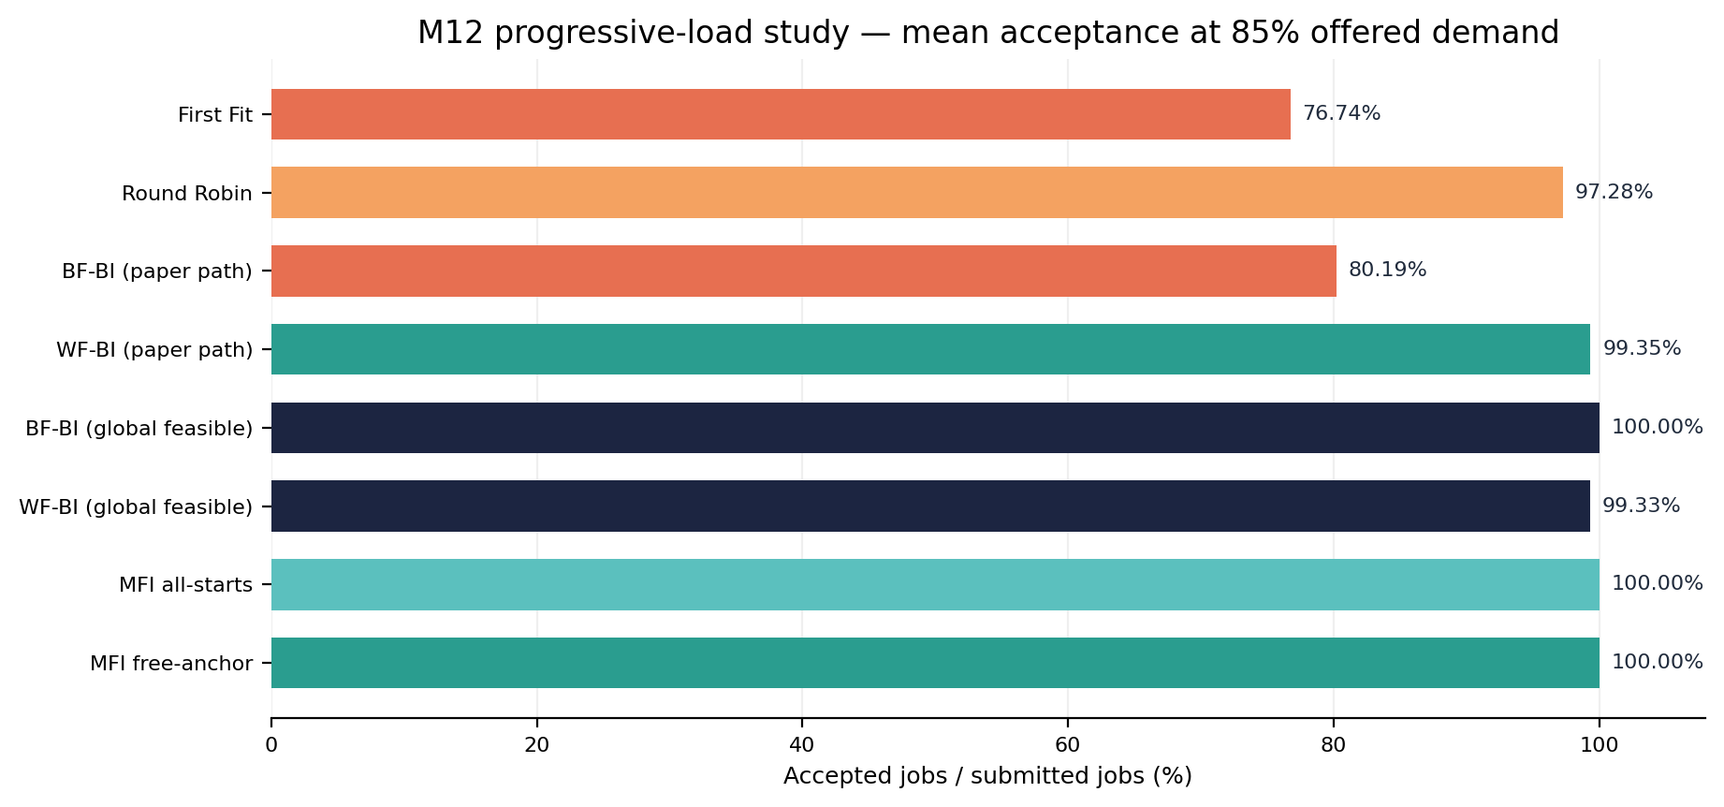
Values averaged across the 20 scenario × repetition cases at the requested 85% checkpoint.
- MFI all-starts and free-anchor each accepted 100.00% at this checkpoint in the current sample.
- Paper-path First Fit averaged 76.74%; Round Robin 97.28%; BF-BI 80.19%; WF-BI 99.35%.
- These results are paper-guided and exploratory: the source paper used 500 simulations per profile distribution; this study used 5.
VISUAL AND LAYOUT INSTRUCTIONS
Use the embedded horizontal bar chart as the main visual. Preserve the note that it is the exact 85% requested-demand checkpoint, not the final full-trace acceptance.
PRESENTER NOTES — DO NOT RENDER ON THE SLIDE
At this point, the MFI score-mode choice changed many placement decisions but did not change acceptance in the progressive sample at the tested checkpoint. Avoid using the result to claim MFI is universally optimal; the sample is small and synthetic.
Source footer: results/m12_figure3_baseline_study_100gpu_5rep/M12_EXPERIMENT_REPORT.md; [1

BRIEFING PAGE — SLIDE 19
M12 Result 2: Burst / High-Demand Stress Test
ON-SLIDE COPY — USE THIS AS THE VISIBLE SLIDE CONTENT
Design: 20 simulated GPUs; four profile distributions; 5 repetitions per distribution; 8 policies; 160 runs. Offered demand 150%; arrival gap 0.0, so positive-duration jobs arrive before any completion can free capacity.
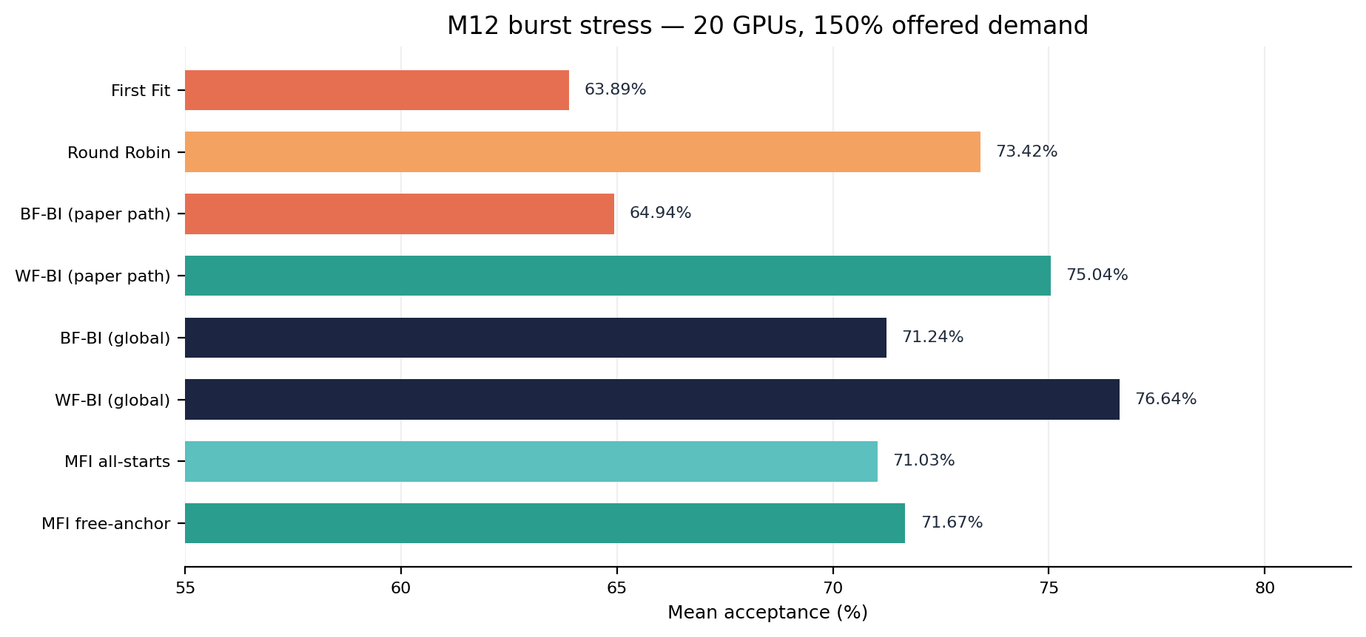
Mean full-trace acceptance averaged across four workload distributions.
- MFI all-starts: 71.03%; MFI free-anchor: 71.67% (+0.64 percentage points).
- Paired bootstrap interval for free-anchor minus all-starts: approximately −0.80 to +1.86 percentage points; it includes zero.
- This is a packing stress test, not realistic production arrival dynamics or a paper replication.
Observed difference ≠ established improvement.

VISUAL AND LAYOUT INSTRUCTIONS
Use the embedded chart and put the +0.64 pp difference with its interval directly beside the two MFI bars. Label arrival gap = 0.0 prominently.
PRESENTER NOTES — DO NOT RENDER ON THE SLIDE
The burst experiment creates more pressure to pack jobs because capacity cannot be reused through completions during the arrival sequence. The score modes may select different placements, but the uncertainty interval is too broad to establish a meaningful advantage.
Source footer: results/m12_burst_150pct_20gpu_5rep/M12_EXPERIMENT_REPORT.md

BRIEFING PAGE — SLIDE 20
M13 Experiment: Paired Evaluation of Score-Aware Lookahead
ON-SLIDE COPY — USE THIS AS THE VISIBLE SLIDE CONTENT
Design element | Setting
Simulator cluster | 4 A100-profile GPUs (abstract model)
Workload distributions | Uniform, skew-small, skew-big, bimodal
Replications | 3 per distribution in each of 2 regimes = 24 shared workload traces
Policy variants | 10 policies × 24 traces = 240 simulations
Progressive regime | 100% offered demand target; inter-arrival gap 0.25
Burst regime | 150% offered demand target; inter-arrival gap 0.0
Fixed lookahead | H = 2; 3 rollouts per feasible candidate
Adaptive lookahead | H = 2; 2–4 rollouts, batch size 2, ≤5 candidates

Every policy receives the identical workload trace within each paired case. Results are summarized by regime and profile distribution.
VISUAL AND LAYOUT INSTRUCTIONS
Show a compact matrix: 4 distributions × 3 repetitions × 2 regimes → 24 traces; then branch each trace into 10 policy runs → 240 simulations. Label “paired design.”
PRESENTER NOTES — DO NOT RENDER ON THE SLIDE
The experiment is much smaller than a full scale-up study. The purpose is to see whether score mode and lookahead policies behave differently and whether the results justify a larger held-out experiment.
Source footer: M13_EXPERIMENT_REPORT.md; m13_run_manifest.json

BRIEFING PAGE — SLIDE 21
M13 Results: Acceptance Does Not Show a Consistent Lookahead Win
ON-SLIDE COPY — USE THIS AS THE VISIBLE SLIDE CONTENT
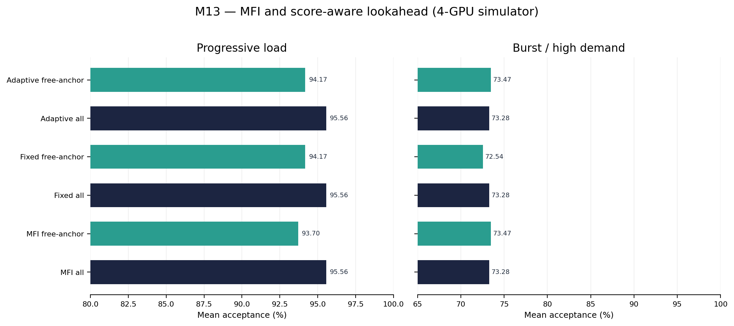
Mean accepted jobs / submitted jobs across 12 paired traces in each regime.
- Progressive: all-starts fixed/adaptive lookahead match all-starts MFI at 95.56%; free-anchor lookahead is 94.17% versus free-anchor MFI at 93.70%.
- Burst: all-starts fixed/adaptive match all-starts MFI at 73.28%; free-anchor adaptive matches free-anchor MFI at 73.47%.
- Free-anchor fixed lookahead is 72.54% in burst, 0.93 pp below free-anchor MFI.
- Paired acceptance intervals are based on only 12 workload traces per regime and remain exploratory.
Interpretation: no consistent, robust acceptance improvement is established by the current M13 sample.

VISUAL AND LAYOUT INSTRUCTIONS
Use the embedded two-panel chart; keep labels short and ensure the axis starts at a disclosed value. Place the bullets to the right if the generator can preserve legibility; otherwise make the chart the focus and move detail to speaker notes.
PRESENTER NOTES — DO NOT RENDER ON THE SLIDE
The positive progressive free-anchor differences are small and their paired intervals touch zero. The burst result changes direction for fixed free-anchor lookahead. The correct conclusion is inconclusive—not that lookahead never helps, and not that it has been proven to help.
Source footer: results/m13_score_aware_lookahead_4gpu_3rep/M13_EXPERIMENT_REPORT.md

BRIEFING PAGE — SLIDE 22
M13 Results: Decision Latency and Search Frequency
ON-SLIDE COPY — USE THIS AS THE VISIBLE SLIDE CONTENT
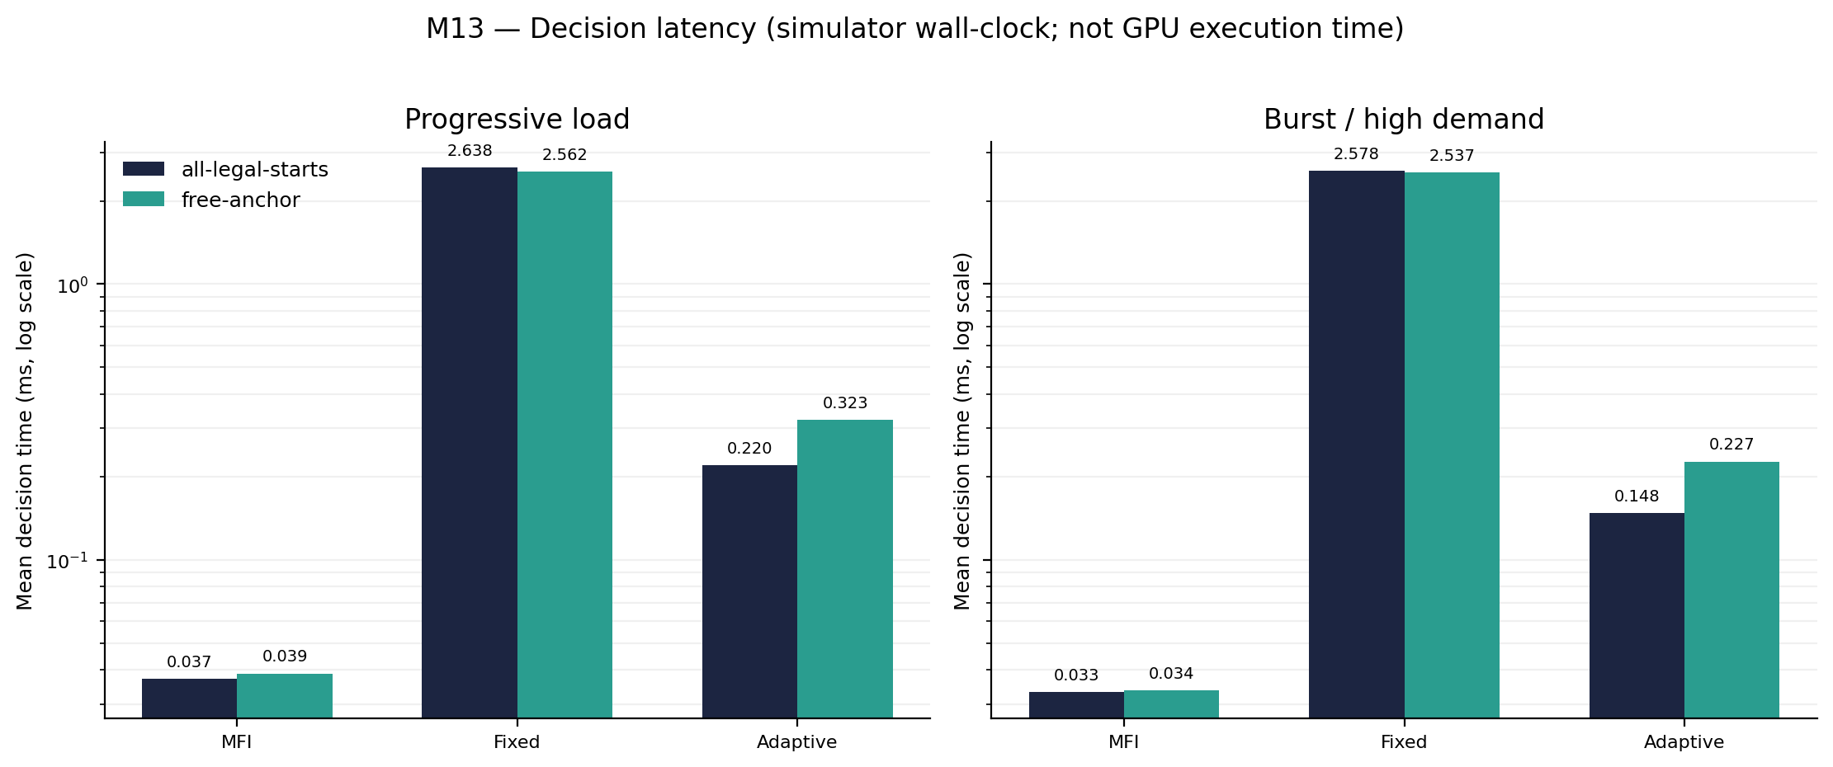
Mean decision time measured around the scheduler call in the Python simulator; log scale.
- Greedy MFI: approximately 0.033–0.039 ms per decision.
- Fixed lookahead: approximately 2.54–2.64 ms per decision—about 65–80× the MFI time in this experiment.
- Adaptive lookahead: approximately 0.148–0.323 ms—about 4–8× MFI, but it frequently falls back to greedy placement.
- Adaptive search averaged about 0.92–1.50 lookahead decisions per trace and roughly 6.83–9.17 fallback decisions per trace.
Runtime values are simulator wall-clock measurements, not GPU kernel time or a production scheduler latency guarantee.

VISUAL AND LAYOUT INSTRUCTIONS
The embedded chart uses a log-scale vertical axis. Keep values in milliseconds; do not reinterpret them as seconds or GPU compute time. Add a small note “machine/process dependent.”
PRESENTER NOTES — DO NOT RENDER ON THE SLIDE
The cost-benefit question is central: fixed lookahead is tens of times slower than MFI for no consistent admission improvement in this sample. Adaptive reduces the search budget but the gates often prevent lookahead from running; their thresholds require further calibration.
Source footer: M13_EXPERIMENT_REPORT.md; m13_policy_summary.csv

BRIEFING PAGE — SLIDE 23
M13 Audit: Score Semantics Change Many Decisions
ON-SLIDE COPY — USE THIS AS THE VISIBLE SLIDE CONTENT
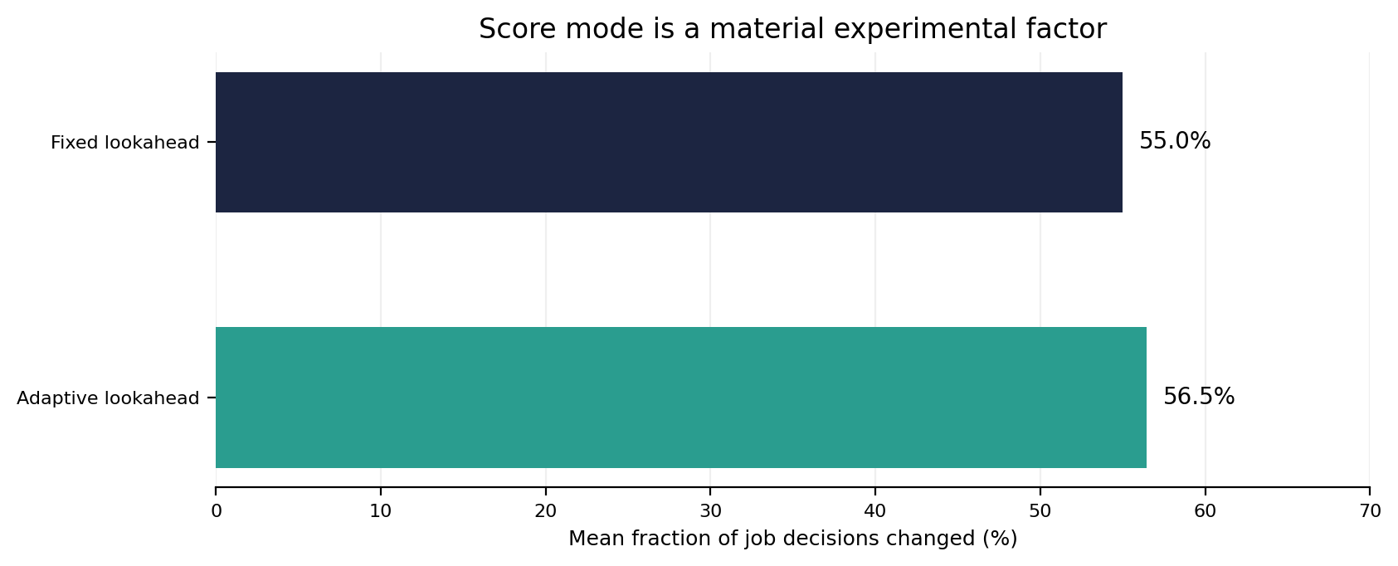
Mean within-trace fraction of per-job decision tuples changed when switching score mode.
- Fixed lookahead: the mean fraction of changed job decisions across the 24 matched traces was 55.0%.
- Adaptive lookahead: the mean fraction was 56.5%.
- A decision change means a different (status, GPU ID, start index) tuple; it does not necessarily change acceptance.
- M13 now threads one explicit score mode through current-candidate ranking, rollout placement, tie-breaking, and adaptive fallback.
Report the score mode with every result: `all_legal_starts` or `free_anchor_starts`.

VISUAL AND LAYOUT INSTRUCTIONS
Use the embedded sensitivity chart and a short definition of a changed decision. Keep “placement changed” visually separate from “job acceptance changed.”
PRESENTER NOTES — DO NOT RENDER ON THE SLIDE
The score-mode ambiguity is not cosmetic. Different fragmentation scores reorder candidates and future rollout placements. The Figure 3 conformance candidate is better constrained by the reported numerical values, but the paper does not make the exact anchor filtering explicit.
Source footer: m13_score_mode_decision_sensitivity.csv; M12_FIGURE3_CONFORMANCE.md

BRIEFING PAGE — SLIDE 24
Validation and Reproducibility
ON-SLIDE COPY — USE THIS AS THE VISIBLE SLIDE CONTENT
Automated tests: 107 passed.

- `python -m pytest -q` — full regression suite.
- `python scripts/validate_baseline.py` — profile model validation, memory-overlap regression, and MFI argmin consistency over 250 deterministic randomized states.
- These checks validate implementation consistency; they do not validate paper-level performance replication.
- Each experiment stores raw runs, per-job decisions, aggregate summaries, score-mode sensitivity, paired deltas, bootstrap intervals, and a run manifest.
- Main reproducibility instructions are in `M13_RUN_ME_FIRST.md`.
Python 3.11+ recommended. Install with `python -m pip install -e ".[test,analysis]"` from the repository root.
VISUAL AND LAYOUT INSTRUCTIONS
Use three compact boxes: TESTS, BASELINE CHECKS, EXPERIMENT ARTIFACTS. Show no success badges beyond the factual “107 passed.” Keep the limitation line visible.
PRESENTER NOTES — DO NOT RENDER ON THE SLIDE
Mention that deterministic regression tests protect the implementation against regressions, while stochastic scheduling results need statistical replication and external validation. Correct code does not imply that every modeled behavior matches live driver behavior.
Source footer: M13_RUN_ME_FIRST.md; scripts/validate_baseline.py

BRIEFING PAGE — SLIDE 25
Limitations, Threats to Validity, and Next Experiments
ON-SLIDE COPY — USE THIS AS THE VISIBLE SLIDE CONTENT
Limitation | Implication / next action
Simulation fidelity | Abstract profile/placement model; not driver-validated MIG emulation or hardware benchmark.
Synthetic workloads | No real tenant arrival/profile/duration dataset; repeat with trace-driven or calibrated distributions.
Small M13 sample | Only 3 repetitions per distribution/regime and 12 paired traces per regime; expand to ≥20–30 seeds.
Score ambiguity | Free-anchor matches two Figure 3 values for reconstructed states; original executable behavior remains unconfirmed.
Policy assumptions | BF/WF residual scalarization and adaptive stability/stop thresholds are explicit heuristics.
Objective scope | Acceptance only; fairness, SLOs, energy, migration, reconfiguration cost, and job priorities are not optimized.

Next step: run a preregistered, larger paired study with held-out test seeds and compare acceptance, latency, fallback rate, and variability together.
VISUAL AND LAYOUT INSTRUCTIONS
Use a “known limits → concrete next action” table. This is an academic strength slide: be explicit, not defensive. Do not hide low repetition counts in footnotes.
PRESENTER NOTES — DO NOT RENDER ON THE SLIDE
A larger study should separate tuning/calibration seeds from test seeds. If the acceptance gain remains negligible and latency cost remains high, the defensible decision may be to simplify or drop lookahead rather than force a novelty claim.
Source footer: M13_FINDINGS_AND_NEXT_DECISION.md; ADAPTIVE_LOOKAHEAD_METHOD.md

BRIEFING PAGE — SLIDE 26
Conclusion: What We Know Today
ON-SLIDE COPY — USE THIS AS THE VISIBLE SLIDE CONTENT
- MFI is a strong conceptual baseline for index-constrained MIG placement: it explicitly minimizes immediate increase in profile-specific fragmentation.
- The Figure 3 audit found that `free_anchor_starts` reproduces the reported scores 8 and 16 on reconstructed states; it is a conformance candidate, not confirmed source equivalence.
- The baseline audit separated GPU-first paper-path BF-BI/WF-BI from global-feasible alternatives.
- M13 made lookahead scoring consistent across current and simulated future placements and compared policies on paired workloads.
- Current M13 evidence does not establish a stable acceptance benefit, while fixed lookahead has a substantial decision-latency cost.
Decision: do not claim lookahead superiority yet. Expand the paired, held-out study first; keep both score modes explicitly reported.

VISUAL AND LAYOUT INSTRUCTIONS
Use five concise takeaways and a final research decision. Keep the “do not claim superiority yet” message clear and academically credible.
PRESENTER NOTES — DO NOT RENDER ON THE SLIDE
Close with the key lesson: accurate method semantics and experimental controls matter as much as algorithm design. The next milestone should test whether any observed gains survive more seeds and a wider set of workload dynamics.
Source footer: Repository M12–M13 reports

BRIEFING PAGE — SLIDE 27
References
ON-SLIDE COPY — USE THIS AS THE VISIBLE SLIDE CONTENT
[1] Marco Zambianco, Lorenzo Fasol, and Roberto Doriguzzi-Corin. “An Online Fragmentation-Aware GPU Scheduler for Multi-Tenant MIG-based Clouds.” arXiv:2511.18906, 2025. https://arxiv.org/abs/2511.18906
[2] NVIDIA. “Multi-Instance GPU User Guide” — Concepts, Supported MIG Profiles, and MIG Device Names. https://docs.nvidia.com/datacenter/tesla/mig-user-guide/
[3] Bekir Turkkan, Pavankumar Murali, Pavithra Harsha, Rohan Arora, Gerard Vanloo, and Chandra Narayanaswami. “Optimal Workload Placement on Multi-Instance GPUs.” arXiv:2409.06646, 2024. https://arxiv.org/abs/2409.06646
Project artifacts cited in this presentation
- `M12_FIGURE3_CONFORMANCE.md` and `M12_BASELINE_SEMANTICS.md` — score and baseline audits.
- `M13_SCORE_MODE_DESIGN.md`, `M13_EXPERIMENT_REPORT.md`, `M13_FINDINGS_AND_NEXT_DECISION.md` — implementation contract, experiment, and interpretation.
- Repository: `MIG_Scheduling_Milestone13` (Python source, tests, scripts, CSV results, run manifests, and plots).
VISUAL AND LAYOUT INSTRUCTIONS
Use a clean bibliographic slide with readable paper titles and short URLs. The full URLs can be hyperlink targets. No fabricated publication venue or DOI.
PRESENTER NOTES — DO NOT RENDER ON THE SLIDE
The primary source is the MFI paper. NVIDIA documentation supports the MIG terminology and profile model; Turkkan et al. is the source cited in the project for profile-specific Best Index ordering.
Source footer: External sources [1]–[3]; project files listed above.

BRIEFING PAGE — SLIDE 28 [OPTIONAL APPENDIX]
Appendix A — MFI Pseudocode and Feasibility Checks
ON-SLIDE COPY — USE THIS AS THE VISIBLE SLIDE CONTENT
INPUT: current cluster state S; arriving job requesting profile p
CANDIDATES ← empty list
for each GPU g:
if free_compute(g) < compute(p): continue
if free_memory(g) < memory(p): continue
F_before ← fragmentation_score(g, selected_mode)
for each legal start i of p:
if full compute/memory footprint at (g, i) overlaps an allocation: continue
S′ ← hypothetical placement of p at (g, i)
ΔF ← fragmentation_score(S′, selected_mode) − F_before
append (ΔF, GPU_ID(g), i) to CANDIDATES
if CANDIDATES is empty: reject job
else: choose lexicographic minimum (ΔF, GPU ID, start index) and allocate

Complexity: the paper describes the main decision cost as scaling with the number of GPUs, with profile/start enumeration bounded by the fixed hardware profile table.
Important model detail: the implementation checks compute and memory occupancy separately; it is not merely a scalar “free slice count” test.
VISUAL AND LAYOUT INSTRUCTIONS
Render pseudocode in a monospaced block. Use a side note with the two independent feasibility gates and a red “reject if no legal pair” line.
PRESENTER NOTES — DO NOT RENDER ON THE SLIDE
This is presentation pseudocode derived from the implementation and source algorithm—not a byte-for-byte quote. The tie-break by GPU/start ID makes results deterministic in the implementation.
Source footer: [1, Algorithm 2]; src/mig_scheduler/mfi_score_variants.py

BRIEFING PAGE — SLIDE 29 [OPTIONAL APPENDIX]
Appendix B — Reproduce the M13 Experiment
ON-SLIDE COPY — USE THIS AS THE VISIBLE SLIDE CONTENT
From the repository root (Python 3.11+ recommended):
python -m venv .venv
# Windows PowerShell
.venv\Scripts\Activate.ps1
# Linux/macOS: source .venv/bin/activate
python -m pip install -e ".[test,analysis]"
python -m pytest -q
python scripts/validate_baseline.py
python scripts/run_m13_score_aware_lookahead.py --gpus 4 --repetitions 3 --seed 20261026 --out results/m13_score_aware_lookahead_4gpu_3rep

Key outputs
- `m13_raw_runs.csv` — run-level outcomes.
- `m13_per_job_decisions.csv` — individual decisions and search diagnostics.
- `m13_policy_summary.csv` — acceptance, utilization, and runtime summary.
- `m13_paired_acceptance_vs_free_anchor_mfi.csv` — paired deltas and bootstrap intervals.
- `m13_score_mode_decision_sensitivity.csv` + `m13_run_manifest.json` — decision changes and exact configuration.
Use identical workload traces for all compared policies. Report the regime, score mode, seed/repetition count, acceptance, latency, and uncertainty together.

VISUAL AND LAYOUT INSTRUCTIONS
Use a terminal-style command panel at the top and a two-column list of outputs beneath. Make the seed and output path visible; do not substitute a different command.
PRESENTER NOTES — DO NOT RENDER ON THE SLIDE
The committed current experiment output corresponds to these parameters. Re-running on a different machine may produce slightly different wall-clock timings; the policy logic, workload seed and configuration are the key reproducibility items.
Source footer: M13_RUN_ME_FIRST.md

