DETAILED DIAGNOSTIC REPORT
Building Dampness & Leakage Investigation

Prepared by | UrbanRoof Inspection Services
Report Type | Detailed Diagnostic Report (DDR)
Property Type | Flat
Inspection Date | 27.09.2022 14:28 IST
Inspected By | Krushna & Mahesh
Overall Score | 85.71%
Total Issues | 7 Impacted Areas Identified
Report Generated | 27 April 2026

Contents
- 1. Property Issue Summary
- 2. Area-wise Observations
- 3. Probable Root Cause
- 4. Severity Assessment
- 5. Recommended Actions
- 6. Additional Notes
- 7. Missing or Unclear Information

1. Property Issue Summary

The inspection for a flat located in an 11-floor building was conducted on September 27, 2022, by Krushna and Mahesh. The property received an overall condition score of 85.71%, indicating it is generally in good condition. However, issues were identified across several areas, including the bedroom, common bathroom, hall, kitchen, master bedroom, and parking area. A total of seven issues were noted, with temperature differentials observed reaching up to 5.4°C, as detected by thermal imaging equipment. While the property appears structurally sound with no previous audits or repair work done, attention is required to address these specific concerns to maintain the living quality. Urgency is moderate, tending towards non-critical but needing timely resolution to prevent escalation.

2. Area-wise Observations

Area 1: Hall Skirting level Dampness
📊 17 thermal image(s) correlated to this area
Area 1: Hall Skirting level Dampness
In the Hall area, dampness has been visually observed at the skirting level. This appears as noticeable discoloration and potential water stains on the lower portion of the walls. Such damage is clearly documented in Photos 1 to 7. These images reveal indications of persistent moisture, which has caused the walls to develop mold and mildew patterns, especially noticeable near the floor.
The source of this moisture, identified on the Positive Side, is attributed to hollowness in the tiles of the Common Bathroom. This imperfection allows water to seep through, migrating from the bathroom into the adjacent Hall area and causing the skirting level dampness noted above. This source of water entry is documented in Photos 8 to 11.
Thermal imaging corroborates the presence of moisture. Temperature discrepancies between hotspots and cold spots ranged from 28.8°C to 20.6°C across different thermal images, such as RB02380X and RB02391X. The cold spots detected align with areas of suspected moisture accumulation, confirming the visual assessments. This thermal evidence supports the finding that moisture is indeed migrating from the bathroom to the hall, contributing to the noted damage.
Thermal Images:
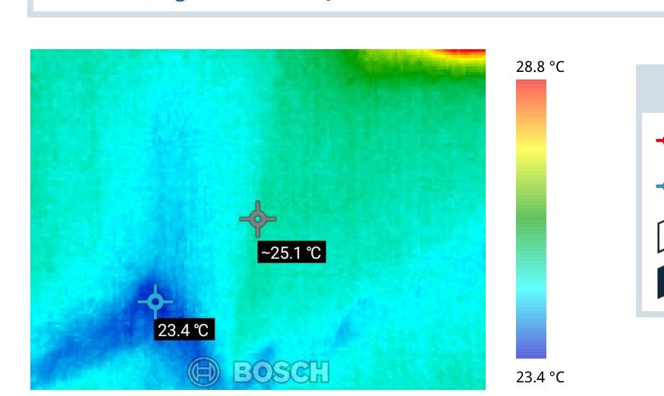 | 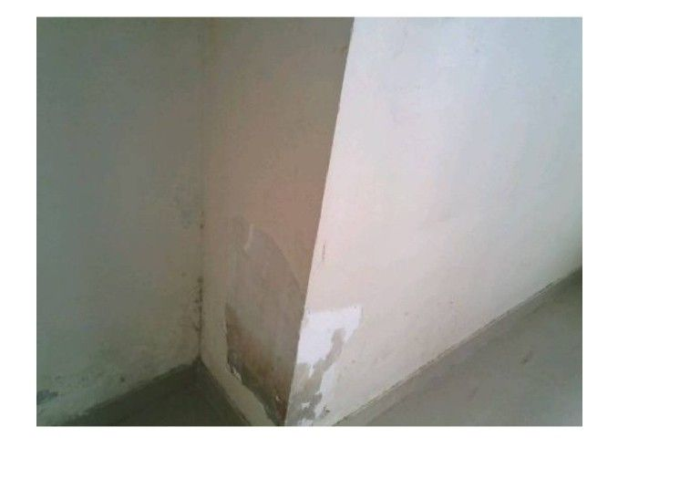
Thermal: RB02380X | Hotspot: 28.8°C | Coldspot: 23.4°C | Delta: 5.4°C | Correlation confidence: high

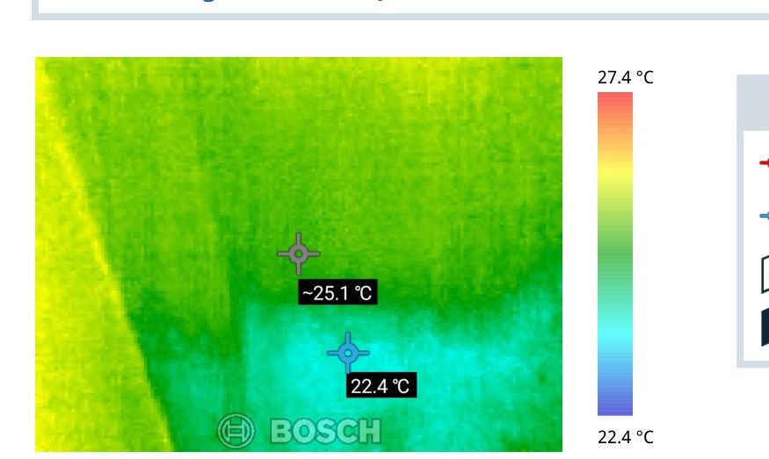 | 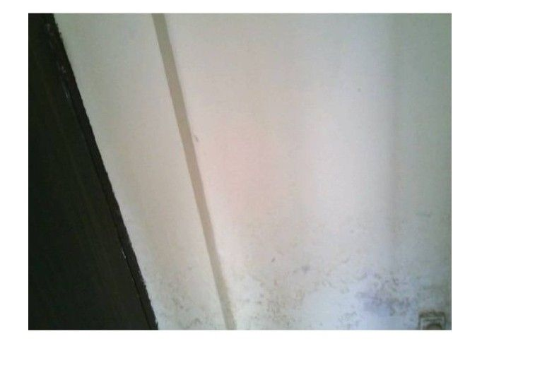
Thermal: RB02386X | Hotspot: 27.4°C | Coldspot: 22.4°C | Delta: 5.0°C | Correlation confidence: high

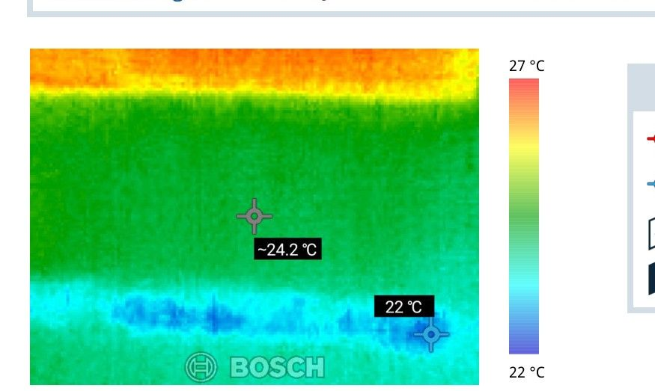 | 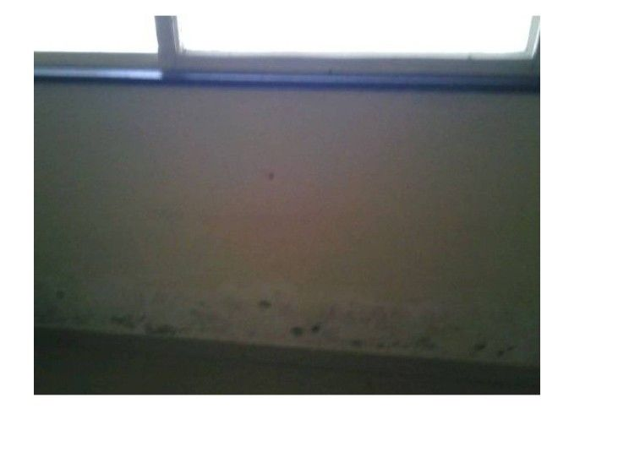
Thermal: RB02395X | Hotspot: 27.0°C | Coldspot: 22.0°C | Delta: 5.0°C | Correlation confidence: high

Site Photographs (Impacted Side):
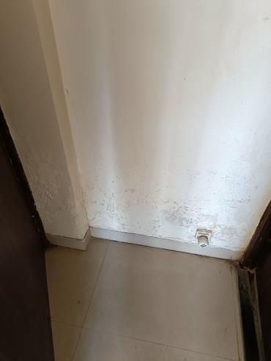 | 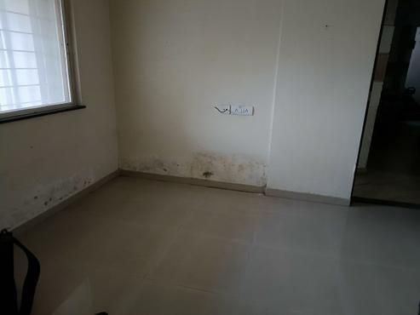
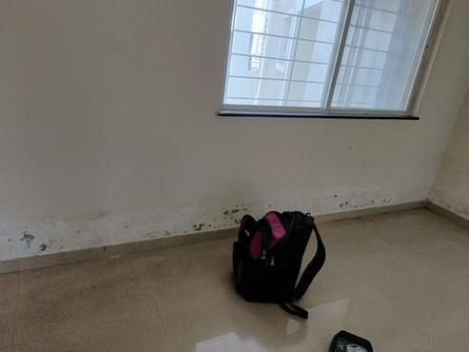 | 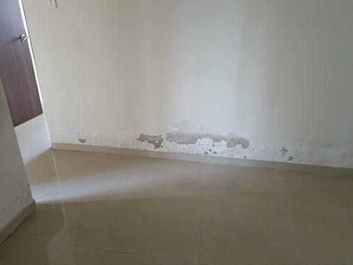

Site Photographs (Source Side):
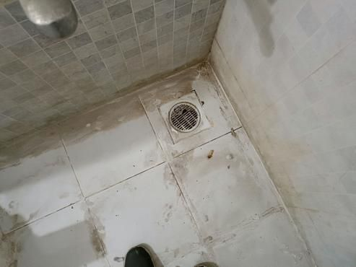 | 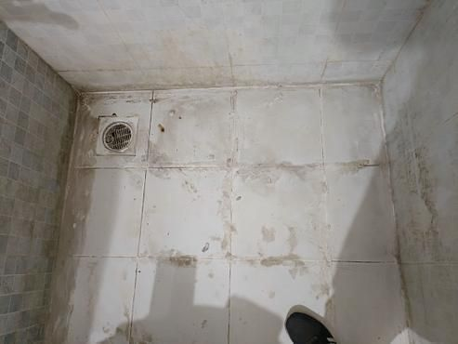
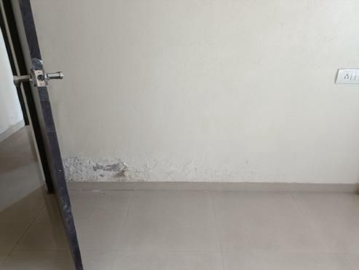

Area 2: Bedroom Skirting level Dampness
📊 9 thermal image(s) correlated to this area
Area 2: Bedroom Skirting Level Dampness
During the inspection, noticeable dampness was observed at the skirting level of the bedroom. This area exhibited signs of moisture damage, including discoloration and possible staining on the lower section of the walls. These physical symptoms suggest consistent exposure to moisture over time.
The source of this moisture was traced back to the common bathroom, where tile hollowness was identified. This defect allows water to seep through and migrate into the bedroom, causing the dampness observed at the skirting level. The connection between these defects is evident as the compromised tiles in the bathroom provide a pathway for water to reach the bedroom walls.
Thermal imaging provided further confirmation of moisture presence. The thermal data, with a cold spot consistently around 20.5°C to 21.5°C, highlighted a cooler zone indicative of dampness. This matches the physical damage seen in the inspected area. The source problem is documented in Photos 15 to 19, showing the defective bathroom tiles responsible for the moisture intrusion.
Thermal Images:
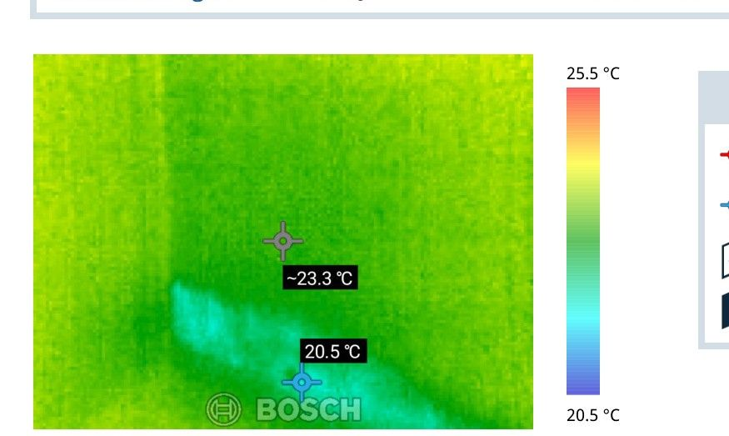 | 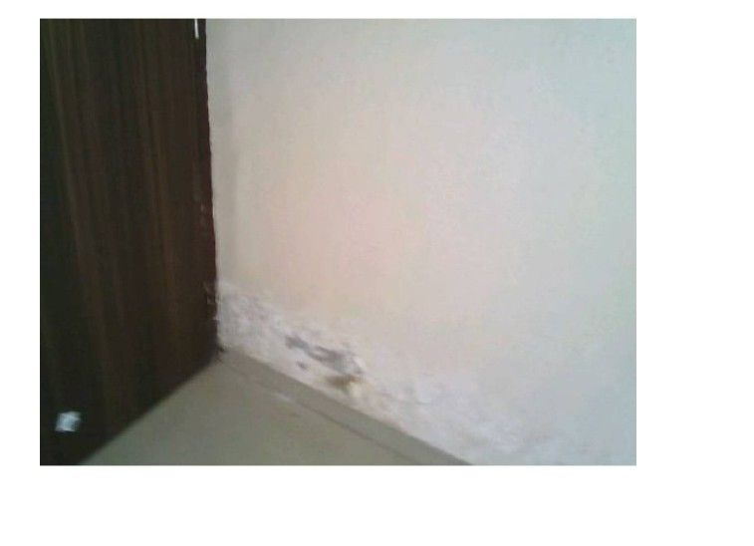
Thermal: RB02403X | Hotspot: 25.5°C | Coldspot: 20.5°C | Delta: 5.0°C | Correlation confidence: high

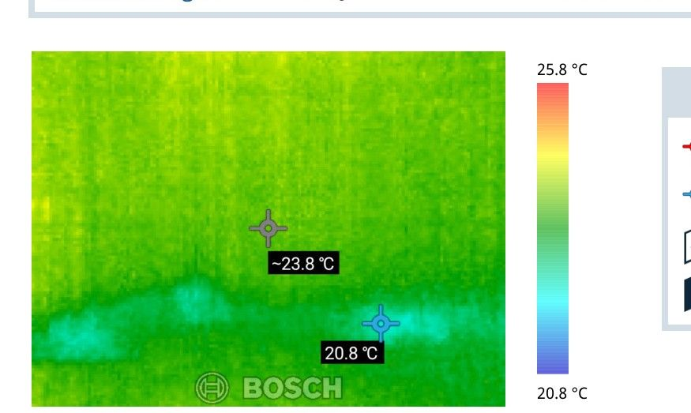 | 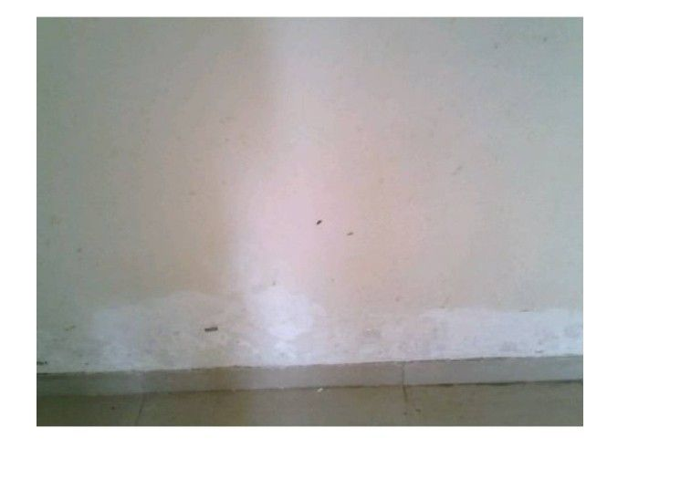
Thermal: RB02404X | Hotspot: 25.8°C | Coldspot: 20.8°C | Delta: 5.0°C | Correlation confidence: high

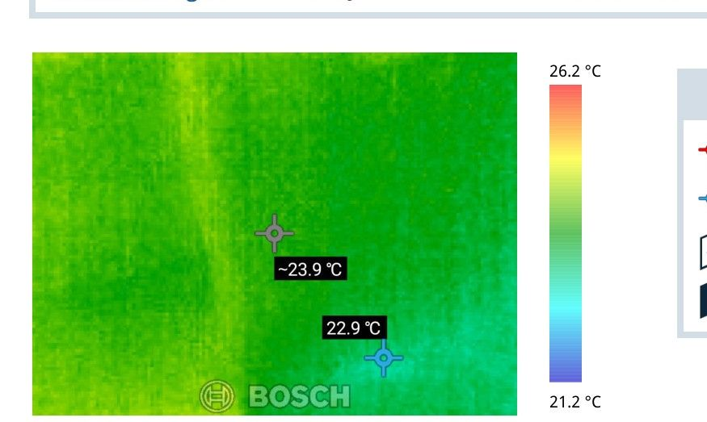 | 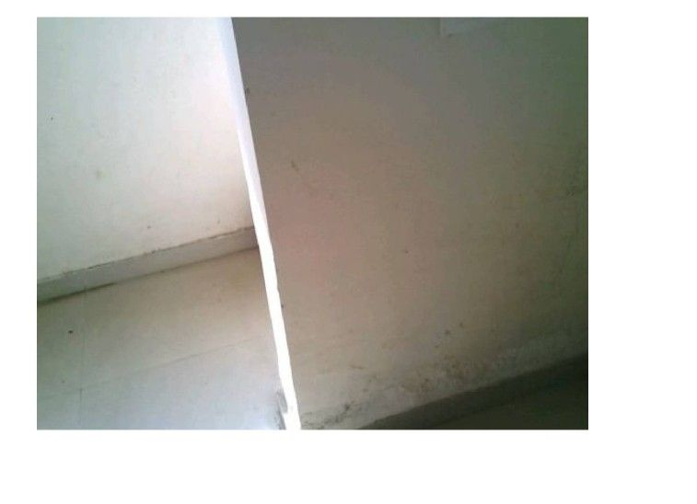
Thermal: RB02405X | Hotspot: 26.2°C | Coldspot: 21.2°C | Delta: 5.0°C | Correlation confidence: high

Site Photographs: Image Not Available
Site Photographs (Source Side):
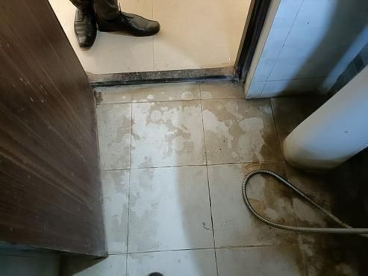 | 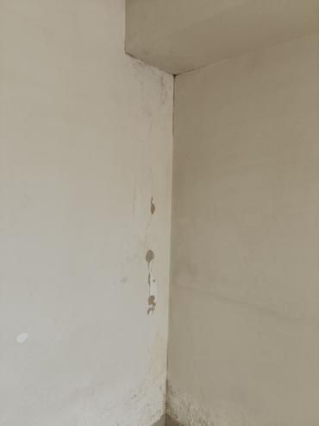
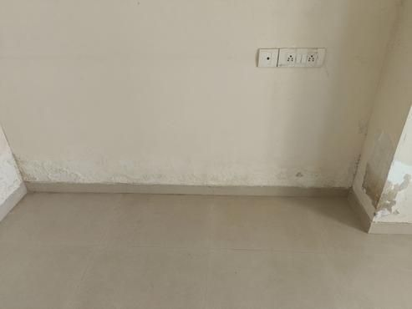

Area 3: Master bedroom Skirting level Dampness
📊 1 thermal image(s) correlated to this area
Area 3: Master bedroom Skirting Level Dampness
In the master bedroom, there is noticeable dampness at the skirting level. This issue is visually documented in Photos 20, 21, 22, 23, 24, and 25. The dampness indicates moisture ingress, likely resulting in potential staining and structural deterioration at the lower walls.
The source of this moisture appears to be from the master bathroom, where tile hollowness has been detected. This defect, documented in Photos 26, 27, 28, 29, and 30, is likely allowing water to seep through and cause the damp conditions observed in the bedroom. The gaps and dirt observed in tile joints and around the Nahani Trap supports this finding, along with loose plumbing joints.
Thermal imaging provided further evidence of moisture presence, with hotspots and cold spots recorded at 26.1°C and 21.1°C respectively, showing a temperature delta of 5.0°C. This data logically corresponds to the affected area in the bedroom, confirming the damp conditions. These observations highlight the need for correcting the tile issues in the bathroom to prevent further moisture migration.
Thermal Images:
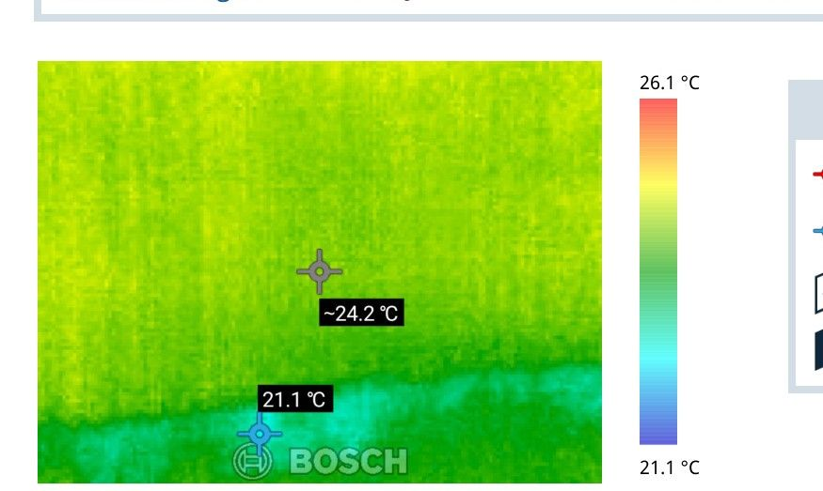 | 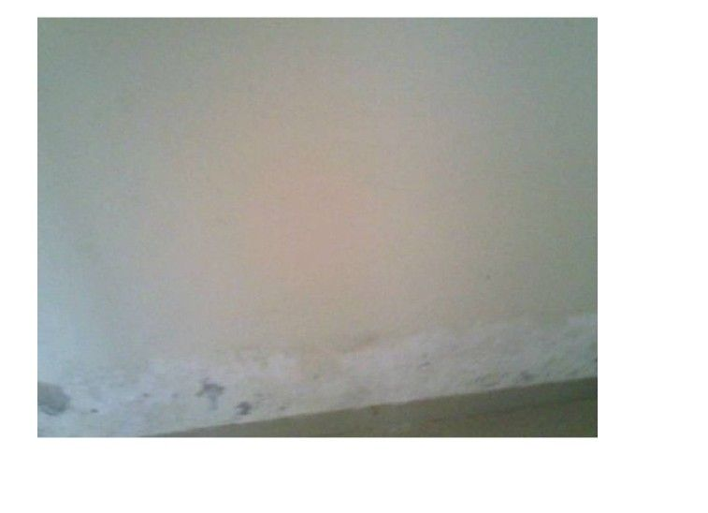
Thermal: RB02396X | Hotspot: 26.1°C | Coldspot: 21.1°C | Delta: 5.0°C | Correlation confidence: logical

Site Photographs (Impacted Side):
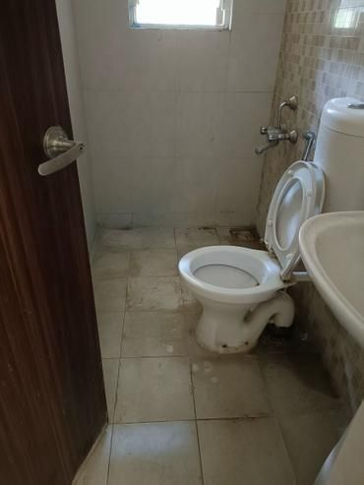 | 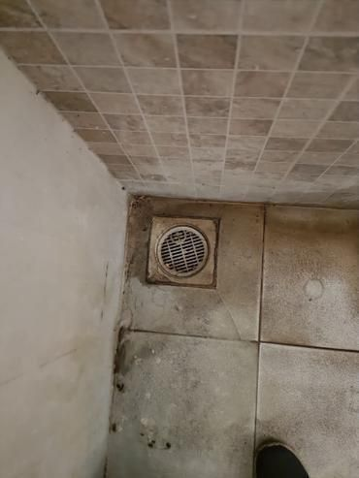
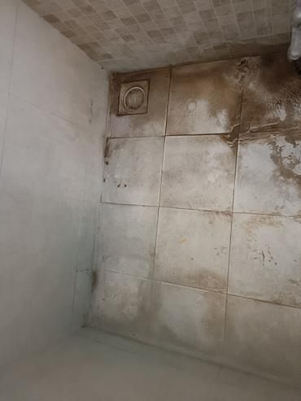 | 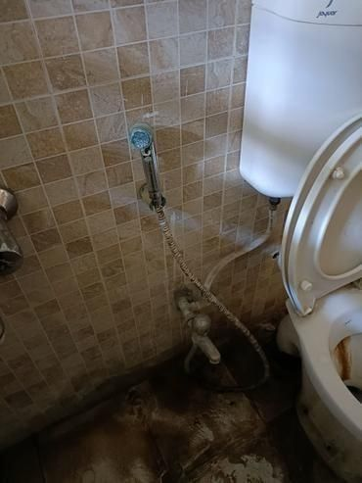

Site Photographs (Source Side):
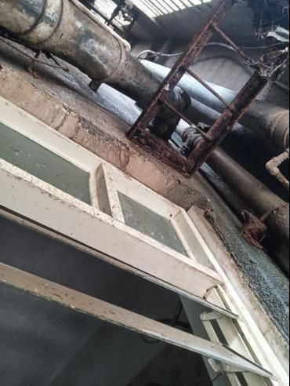 | 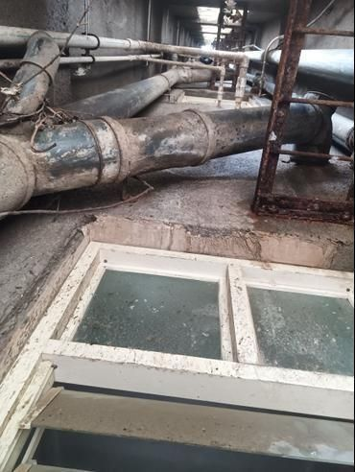
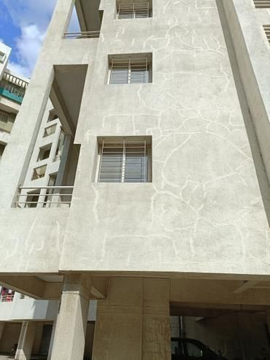

Area 4: Kitchen Skirting level Dampness
📊 3 thermal image(s) correlated to this area
Area 4: Kitchen Skirting Level Dampness
The inspection at the kitchen skirting level revealed visible dampness, which includes staining and moisture marks. There are no evident cracks, but the presence of dampness is clear from the discoloration observed along the skirting. This issue is documented in Photos 31 and 32.
The source of the moisture is traced to the master bedroom bathroom. There are defects such as gaps and blackish dirt in the tile joints and issues around the Nahani trap joints, causing water leakage. This round-the-clock leakage, primarily due to concealed plumbing, increases moisture transfer. Photos 33 to 37 provide evidence of these problems in the bathroom, confirming it as the source of the dampness seen in the kitchen.
A causal link exists between the positive side issue and the negative side symptom. The defects in the master bedroom bathroom allow moisture to migrate directly to the kitchen area, causing the visible dampness at the skirting level. Thermal imaging supports this observation, showing temperature variations with hotspots at 27.3°C and cold spots at 22.3°C, confirming moisture presence (Photo 32, Thermal image RB02385X). These variations in temperature align with the visual evidence, reinforcing the conclusion about moisture migration and its source.
Thermal Images:
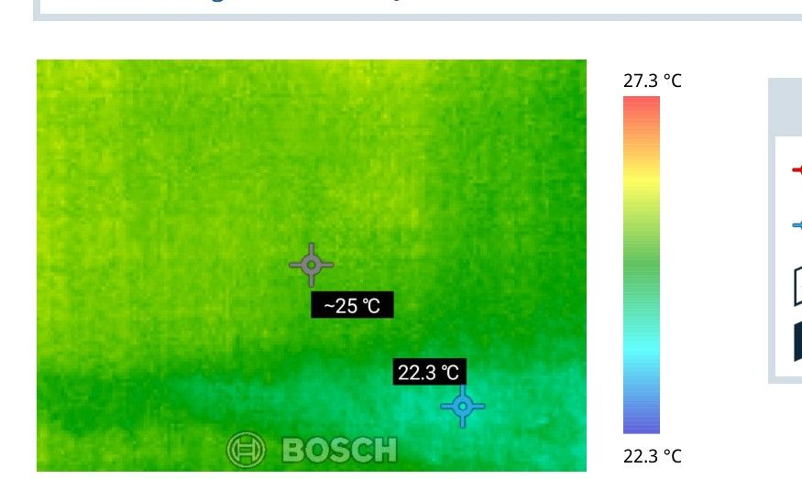 | 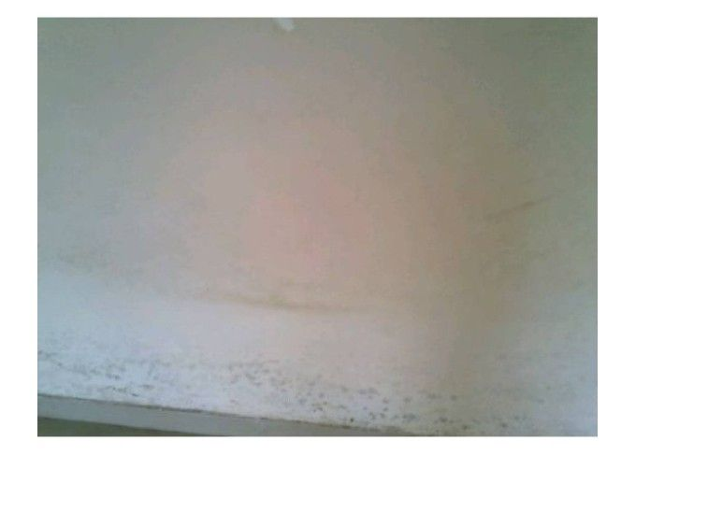
Thermal: RB02385X | Hotspot: 27.3°C | Coldspot: 22.3°C | Delta: 5.0°C | Correlation confidence: high

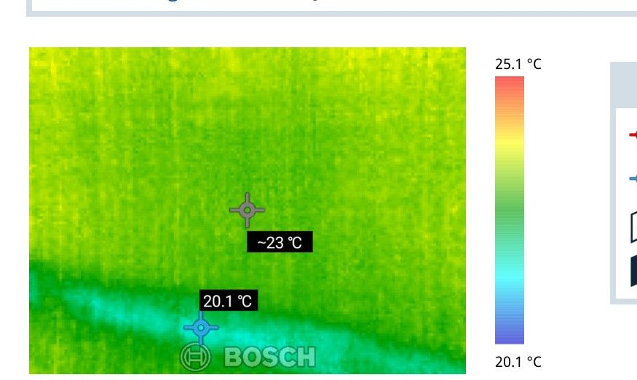 | 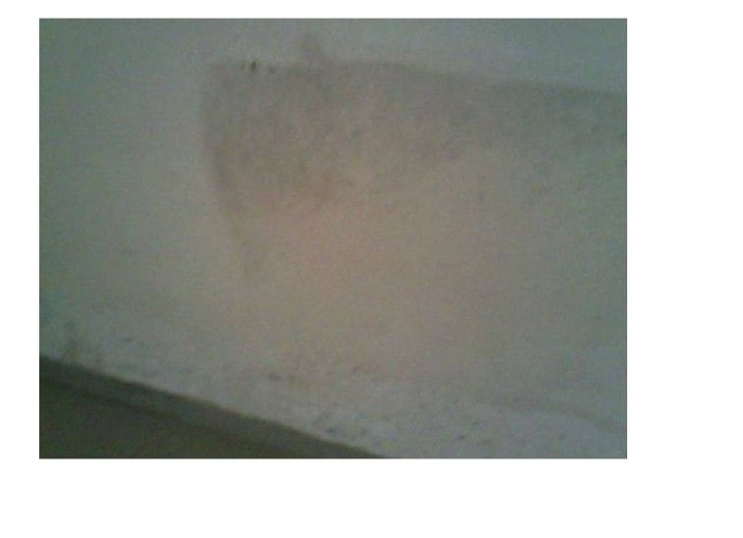
Thermal: RB02388X | Hotspot: 25.1°C | Coldspot: 20.1°C | Delta: 5.0°C | Correlation confidence: high

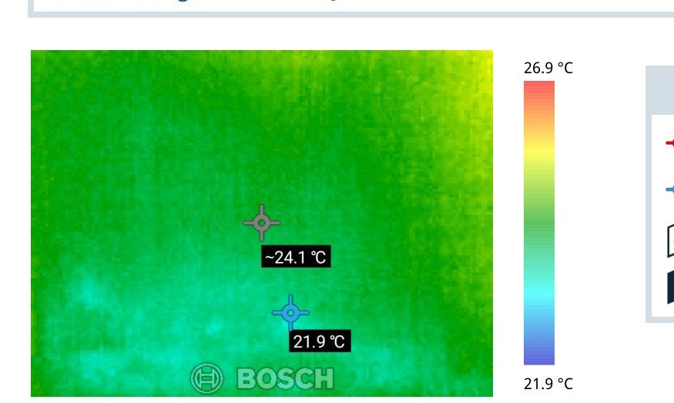 | 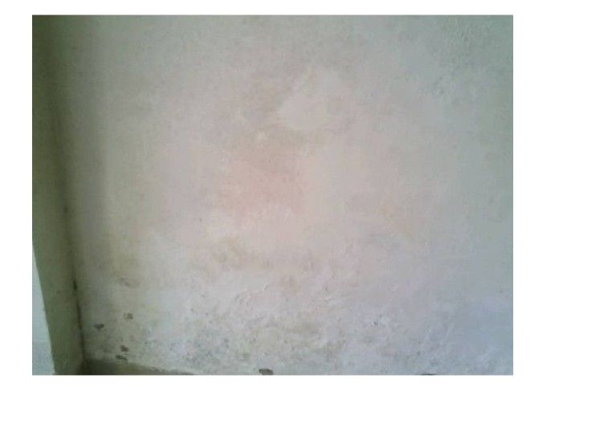
Thermal: RB02377X | Hotspot: 26.9°C | Coldspot: 21.9°C | Delta: 5.0°C | Correlation confidence: high

Site Photographs (Impacted Side):
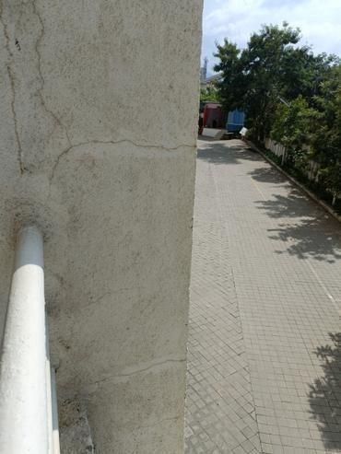 | 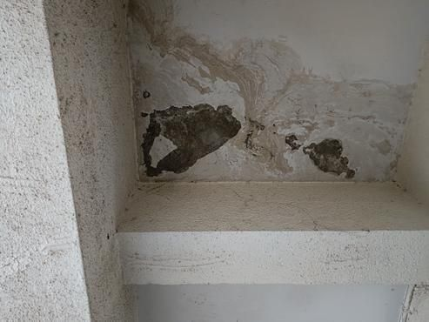

Site Photographs (Source Side):
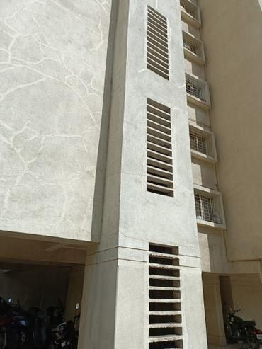 | 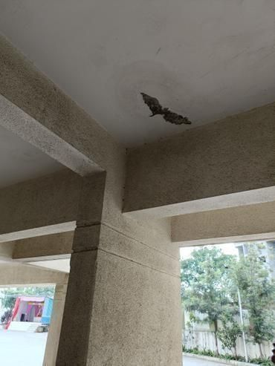
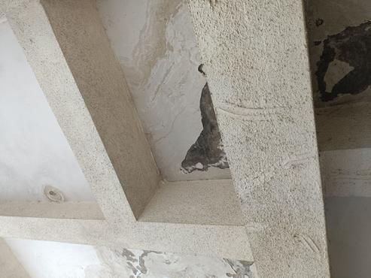

Area 5: Master bedroom wall damness
Area 5: Master Bedroom Wall Dampness
The master bedroom wall shows clear signs of dampness. This includes visible moisture marks and discoloration on the surface. The affected area, with dampness, is documented in Photos 38, 39, 40, and 41. This condition is likely to be negatively affecting the room's appearance and could potentially lead to other issues like mold growth if not addressed.
The source of the moisture is traced to a crack in the external wall and issues with the duct system. These defects are captured in Photos 42, 43, 44, 45, 46, 47, and 48. The cracks and duct problems on the external wall allow water to migrate through the structure and manifest as dampness on the master bedroom wall. This causal link is crucial to addressing the root cause of the dampness.
Thermal imaging data is not available for this area; therefore, no temperature variations or cold zones can be confirmed to further illustrate the presence of moisture. Steps should be taken to repair the external wall crack and address any duct issues to prevent ongoing moisture ingress and resolve the dampness in the master bedroom wall.
Thermal Images: Image Not Available
Site Photographs (Impacted Side):
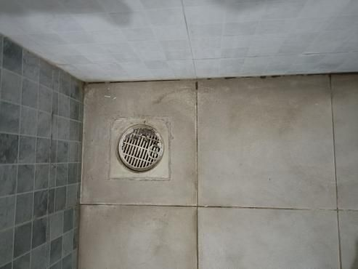 | 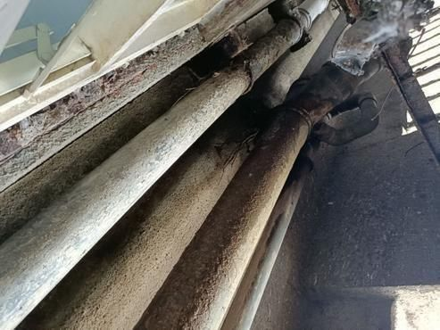
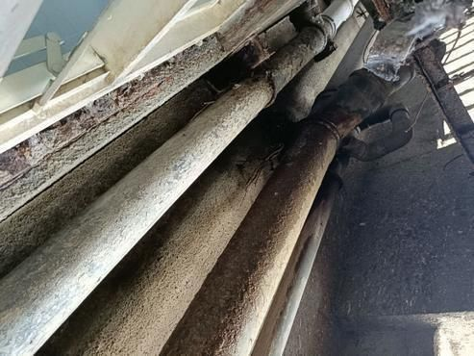

Area 6: Parking Area seepage
Area 6: Parking Area seepage
In the Parking Area, a noticeable issue of seepage was observed. This dampness is due to water infiltrating through affected areas, causing evident damage. The specific signs of damage in this area, such as damp patches, were documented in Photos 49 through 52. These images clearly show the extent of the seepage problem on the parking surfaces.
The source of this issue is traced back to the Common Bathroom, as observed problems with tile hollowness and a plumbing issue were discovered there. These defects, captured in Photos 53 to 57, demonstrate how tiles with gaps or blackish dirt in joints allow water to escape. Compounded by rust and looseness at plumbing joints, the bathroom's condition allows water to travel from there to the parking area below. This cause-and-effect relationship indicates that moisture from the bathroom migrates through structural channels and manifests as seepage where it is visually detected in the Parking Area.
No thermal images were taken for this area, so no temperature data is available to further substantiate the presence of moisture. The checklist findings confirm continuous leakage due to concealed plumbing issues, occurring at all times, affecting the Parking Area by enabling water migration from the bathroom without thermal verification.
Thermal Images: Image Not Available
Site Photographs: Image Not Available

Area 7: Common Bathroom Ceiling Dampness
Area 7: Common Bathroom Ceiling Dampness
Upon inspection, the ceiling of the common bathroom was found to be damp. This dampness, located on what we'll call the Negative Side, is visibly captured in Photo 58. The moisture has resulted in a consistent damp appearance on the ceiling but does not appear to have caused any notable structural damage such as cracks or staining at this moment.
The source of this problem, identified on the Positive Side, is due to an open tile joint in Flat no. 203. Photographic evidence, documented in Photos 59 through 64, highlights that the gaps and blackish dirt observed in the tile joints, along with gaps around the Nahani trap joints, are allowing moisture to seep through. Additionally, loose plumbing joints are contributing to consistent leakage, which occurs all the time, not just occasionally or under certain conditions.
There is a direct cause-and-effect relationship between the Positive Side and the Negative Side. Moisture from the open tile joints in Flat no. 203 migrates downwards, resulting in continuous dampness on the bathroom ceiling below. Although no thermal images were taken for this area, the combination of visible observations and the constant presence of leaks confirms the source of the dampness.
Thermal Images: Image Not Available
Site Photographs: Image Not Available

3. Probable Root Cause

The inspection data highlights several areas of moisture entry and resulting damage in different parts of the building. The primary root cause of the moisture entry appears to be related to the hollowness of tiles, particularly in bathroom areas, as well as external wall issues.
In multiple areas, such as the common bathroom in relation to the hall (Area 1) and bedroom (Area 2), the hollowness of the tiles acts as a point of moisture entry. This means that water can seep behind the tiles where it may remain undrained and subsequently infiltrate walls and floors. The thermal imaging supports this, showing consistent cold spots at the skirting level where moisture is visible as dampness.
In the master bathroom, the same tile hollowness (Area 3), contributes to skirting level dampness in the master bedroom. The water trapped behind hollow tiles travels through walls or floors, manifesting as damp patches at lower levels. Similarly, in Area 4, the dampness observed in the kitchen is linked to moisture escape from the master bedroom bathroom. This suggests water travels through structural floor gaps into adjoining areas.
For Area 5, the cracks in the external wall and issues with the ducts allow moisture ingress, which subsequently appears as dampness on the master bedroom wall. This pathway is critical, highlighting external wall vulnerabilities as sources of interior wall moisture.
Area 6, involving parking area seepage, ties back to issues in the common bathroom where tile hollowness and plumbing problems let water seep through and appear as leakage below. The cold zones at skirting levels further corroborate the presence of continuous moisture.
In Area 7, the ceiling dampness in the common bathroom results from gaps in tile joints in Flat 203 above, demonstrating a clear vertical moisture path from upper floors. The inadequate sealing of joints allows water to percolate through the ceiling into the bathroom below.
Additionally, secondary contributing factors include the lack of effective waterproofing and gaps in Nahani Trap joints, which could exacerbate moisture spread. While there are no broken tiles, the gaps and improper sealing are significant vulnerabilities that facilitate the uninterrupted movement of moisture. The general condition of the structure, flagging a moderate state, further suggests that systemic maintenance issues may contribute to ongoing moisture problems. This points to the need for addressing both immediate repair of visible flaws and long-term structural strengthening and waterproofing measures.

4. Severity Assessment

Certainly, here is the severity assessment based on the provided data:
---
**Area 1 - Hall Skirting level Dampness: High Severity**
Reason: 17 thermal images show consistent temperature differences with cold spots as low as 20.7°C and hotspots up to 28.8°C, indicating widespread dampness. Persistent dampness can lead to mold growth which poses health risks and damages structures. The consistency and extent of this issue necessitate prompt action to prevent further deterioration.
Immediate Attention: Yes
---
**Area 2 - Bedroom Skirting level Dampness: Medium Severity**
Reason: 9 thermal images reveal lower temperature differences with cold spots at 20.5°C and hotspots up to 26.2°C, suggesting significant but less severe dampness compared to Area 1. While action is required, the issue seems less extensive and more contained.
Immediate Attention: No, but should be addressed soon
---
**Area 3 - Master Bedroom Skirting level Dampness: Low Severity**
Reason: Only 1 thermal image is available, showing less data to clearly assess the severity. With insufficient evidence of significant dampness in this area, the issue appears minor.
Immediate Attention: No
---
**Area 4 - Kitchen Skirting level Dampness: Medium Severity**
Reason: 3 thermal images with cold spots down to 20.1°C indicate noticeable dampness that should be checked. The cooking environment could exacerbate the problem if left unattended.
Immediate Attention: No, but it should be monitored and addressed
---
Area 5 - Master Bedroom Wall Dampness: Not Evaluatable
Reason: No thermal data is available to support an assessment. The severity cannot be accurately determined, necessitating further investigation.
Immediate Attention: More data required for evaluation
---
Area 6 - Parking Area Seepage: Not Evaluatable
Reason: No thermal data is available. It's unclear how severe the dampness is in this area, requiring further investigation.
Immediate Attention: More data required for evaluation
---
**Area 7 - Common Bathroom Ceiling Dampness: High Severity**
Reason: Although no thermal data is provided, checklist flags indicate leakage related to plumbing issues, and gaps/black dirt in tile joints, which could lead to severe water damage over time, especially in high-moisture areas like bathrooms.
Immediate Attention: Yes
---
**Overall Property Severity Rating: Medium to High**
Reason: Multiple areas exhibit dampness, with some areas like the Hall and Common Bathroom requiring immediate attention. The checklist also raises issues with plumbing and internal leakage, suggesting a need for thorough maintenance to prevent worsening conditions.
---
Attention is recommended in the outlined high severity areas to mitigate further potential issues. Follow-up inspections could further substantiate these findings and provide a more comprehensive understanding.

5. Recommended Actions

Immediate Actions (to prevent further damage):
- Repair Bathroom Tile Hollowness and Seal Joints (Area 1, 2, 3, 4, 6):
- Action: Carefully remove and reattach hollow tiles in the Common Bathroom, Master Bathroom, and any other affected areas. Fully seal any gaps in tile joints, especially those noted around the Nahani Trap.
- Reason: Prevents water from seeping behind tiles, stopping moisture from spreading into walls and floors.
- Addresses: Hall, Bedroom, Kitchen, and Parking Area as these are affected by tile hollowness leading to skirting and ceiling dampness.
- Fix Common Bathroom Ceiling Leak (Area 7):
- Action: Seal the open tile joints in Flat 203 and repair the ceiling below to prevent leaks from the upper floor's bathroom.
- Reason: This will stop water from entering the ceiling, preventing damage to the Common Bathroom's structural and cosmetic condition.
- Addresses: Dampness and potential water damage in the Common Bathroom.
Short-term Repairs (within 1-3 months):
- Investigate and Repair External Wall Cracks and Duct Issues (Area 5):
- Action: Conduct a thorough inspection of the exterior walls and ducts of the Master Bedroom for cracks or gaps. Repair any identified issues to prevent further inward moisture ingress.
- Reason: Prevents external moisture from entering through walls, reducing dampness on the Master Bedroom wall.
- Addresses: Master Bedroom wall dampness due to external vulnerabilities.
- Monitor and Address Kitchen Dampness Issues (Area 4):
- Action: Closely monitor temperatures and humidity levels in the kitchen while inspecting any connection points to the Master Bathroom. Repair or replace cracked or hollow tiles permanently.
- Reason: Ensures any developing issues are caught early, preventing worsening conditions tied to kitchen usage.
- Addresses: Kitchen and indirectly supports the Master Bathroom.
Long-term Solutions (waterproofing, structural):
- Improve Waterproofing Measures Across Affected Areas:
- Action: Apply comprehensive waterproofing solutions in all bathrooms, kitchen, and critical skirting areas. Consider using advanced waterproof coatings on bathroom walls and floors.
- Reason: Provides a long-lasting barrier against moisture, drastically reducing entry points for water that could lead to future problems.
- Addresses: Prevents future tile hollowness issues and suppresses skirting dampness in all affected areas.
- Conduct Regular Structural Maintenance and Inspections:
- Action: Establish a routine structural maintenance schedule, ensuring the building's integrity and identifying signs of dampness or leakage early.
- Reason: Ongoing maintenance will preemptively address and resolve weaknesses in the building’s structure before they develop into serious issues.
- Addresses: Overall property health, ensuring persistent observance of potential problem areas like Hall, Bedrooms, Kitchen, and Parking Area.
Following these recommendations ensures immediate, mid-term, and future issues are managed effectively, supporting the building's integrity and its occupants' comfort and health.

6. Additional Notes

The inspection report highlights several critical areas where moisture is causing damage, mainly due to hollow tiles and issues with external walls. The severity of the problems varies across the property, with some areas experiencing significant dampness, leading to temperature variations captured in the thermal images.
In Area 1 - Hall Skirting level, the dampness severity is high. This is evidenced by 17 thermal images showing strong temperature differences, with colder areas down to 20.7°C and warmer spots reaching 28.8°C. The widespread uneven temperatures suggest significant moisture presence that requires immediate attention.
Systemic Issues Identified: The prevalence of hollow tiles in bathrooms is a recurring problem across multiple areas, leading to water penetration and damage. This suggests a potential systemic issue with tile installation or material quality that could affect other areas if not addressed.
Monitoring and Follow-up: While some areas are currently stable, monitoring areas with previous dampness signs, especially where tiles are involved, is recommended. Continued observation over the next several months can help catch any emerging issues early.
Safety Concerns: At this point, no immediate safety hazards are noted. However, if moisture issues persist, they could lead to structural concerns or mold growth, posing potential health risks over time.
Inspection Recommendations: Given the high severity in the hall skirting and recurring tile issues, a follow-up inspection is advisable in six months to reassess and ensure that remedial measures are effective. Addressing the hollow tile problem could significantly reduce moisture risks across the entire property.
Overall, it's crucial to address the highlighted issues promptly to prevent more severe damage in the future.

7. Missing or Unclear Information

- Property Age: Missing Information
- *Why it matters:* Understanding the property's age is crucial for assessing the wear and tear, necessary maintenance, and potential impact of structural issues.
- *Follow-up:* This information can likely be obtained with a follow-up inquiry to the property owner or local records.
- Customer Information: Marked as Not Available (Redacted)
- *Why it matters:* Customer contact details are essential for follow-up communication regarding the inspection report and any necessary actions.
- *Follow-up:* This can probably be acquired if permission to access the redacted information is granted, or directly from the property owner.
- Property Address: Marked as Not Available (Redacted)
- *Why it matters:* The property's address is required to accurately log the inspection data and any follow-up tasks that may need to be conducted on-site.
- *Follow-up:* As with customer details, this can likely be obtained through authorized access to the redacted information.
- Paint Manufacturer: Marked as "Not Sure"
- *Why it matters:* Knowing the paint manufacturer can help determine the paint's durability and identify any potential issues related to the material used.
- *Follow-up:* This detail might be verifiable by checking records or the physical product markings.
- Unmatched Thermal Images: None
- There are no missing photo correlations, as all thermal images have been successfully visually correlated. Therefore, there are no thermal images with low confidence or logical assignments.
- Standard Inspection Item (Previous Structural Audit)
- *Why it matters:* No previous structural audit was conducted, which means there is no baseline comparison for structural integrity from past inspections.
- *Follow-up:* Not directly obtainable from the current inspection but recommended for future reference.
- Standard Inspection Item (Previous Repair Work)
- *Why it matters:* There has been no previous repair work, which could inform current maintenance needs or reveal overlooked issues.
- *Follow-up:* Same as above, not obtainable from this inspection but advisable for future records.
All critical elements (such as thermal data) have been reported to match successfully with high confidence, making the thermal imaging aspect of the inspection thorough. However, more property and customer details would improve the completeness and usefulness of the inspection report.

