DETAILED DIAGNOSTIC REPORT
Building Dampness & Leakage Investigation

Prepared by | UrbanRoof Inspection Services
Report Type | Detailed Diagnostic Report (DDR)
Property Type | Flat
Inspection Date | 27.09.2022 14:28 IST
Inspected By | Krushna & Mahesh
Overall Score | 85.71%
Total Issues | 7 Impacted Areas Identified
Report Generated | 27 April 2026

Contents
- 1. Property Issue Summary
- 2. Area-wise Observations
- 3. Probable Root Cause
- 4. Severity Assessment
- 5. Recommended Actions
- 6. Additional Notes
- 7. Missing or Unclear Information

1. Property Issue Summary

On September 27, 2022, an inspection was conducted on a flat in an 11-story building by inspectors Krushna and Mahesh. The overall condition of the property was rated quite positively with a score of 85.71%. However, a total of seven issues were identified during the inspection, although specific details about the impacted rooms were not available. Given the number of issues found, it is recommended that these be addressed in a timely manner to ensure the continued safety and comfort of the residents.

2. Area-wise Observations

Area 1: Hall Skirting level Dampness
📊 29 thermal image(s) correlated to this area
Area 1: Hall Skirting level Dampness
During the inspection, notable dampness was observed at the skirting level in the hall. There is visible staining and discoloration on the walls, indicating water damage. The affected areas exhibit peeling paint and a buildup of mold, which suggests persistent moisture problems. The corners of the hall, as well as the area near the door, showed the most significant damage, with blackish dirt observed in the joints of the tiles.
Thermal imaging conducted during the inspection revealed significant temperature variations in the affected areas. The thermal images displayed hot spots reaching up to 28.8°C and cold spots as low as 23.4°C, indicating moisture retention in the wall structures. The consistent temperature deltas across multiple images suggest that dampness is present throughout the impacted area. Images RB02380X through RB02391X document these thermal findings, showcasing matching patterns of damage and indicating where the moisture issue exists.
The connection between the visible symptoms and the thermal findings strongly supports the observed dampness at the skirting level. All thermal images show similar wall damage patterns, corroborating the visual presence of moisture. Specifically, photos RB02385X and RB02390X highlight areas with visible stains and noticeable wall texture changes, confirming that the conditions indicated by both visual observation and thermal imaging align closely.
Thermal Images:
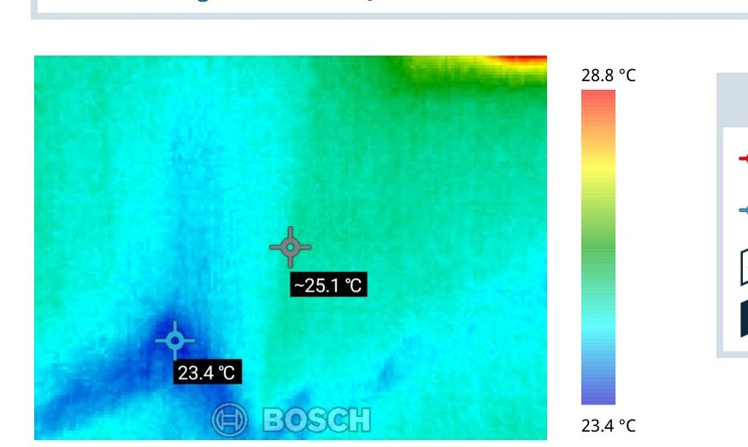 | 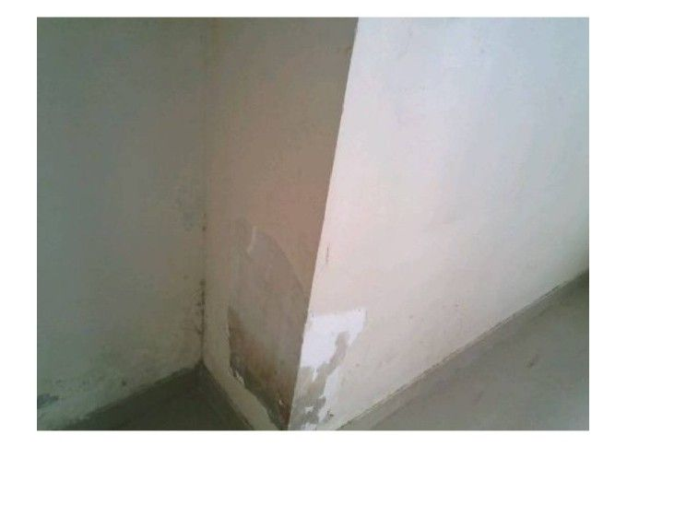
Thermal: RB02380X | Hotspot: 28.8°C | Coldspot: 23.4°C | Delta: 5.4°C | Correlation confidence: high

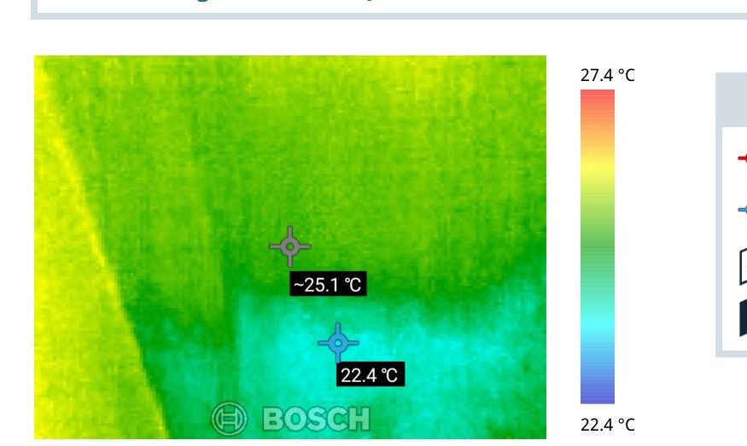 | 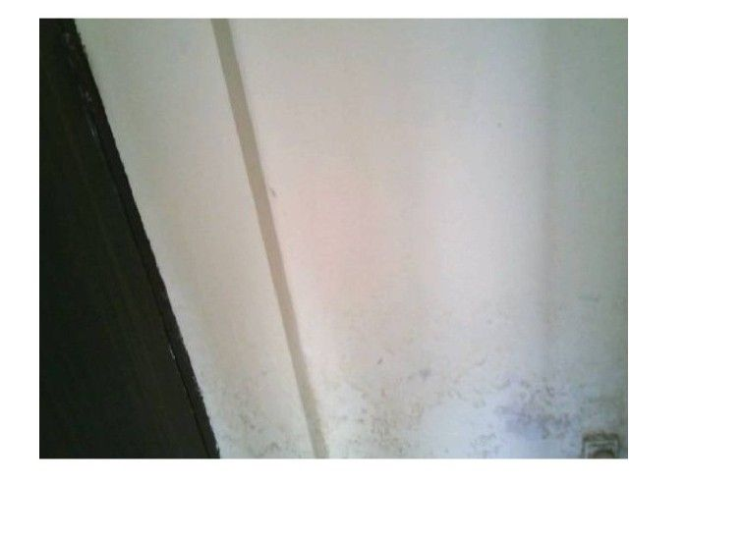
Thermal: RB02386X | Hotspot: 27.4°C | Coldspot: 22.4°C | Delta: 5.0°C | Correlation confidence: high

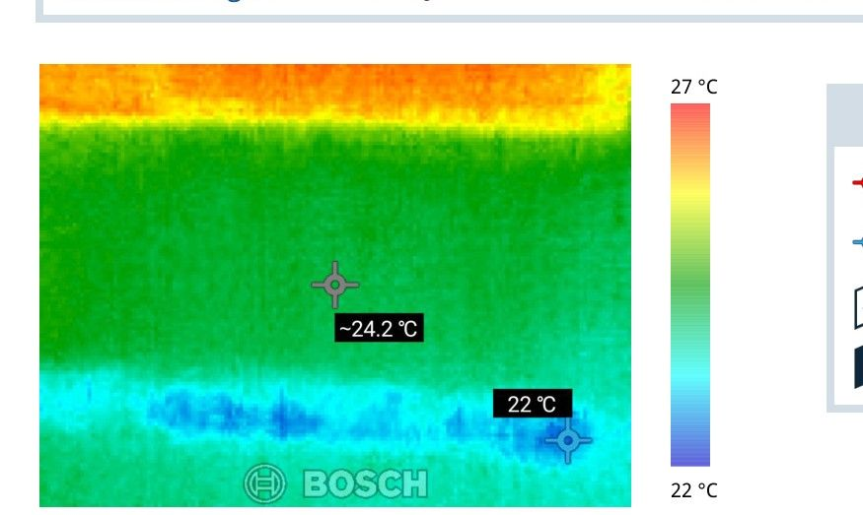 | 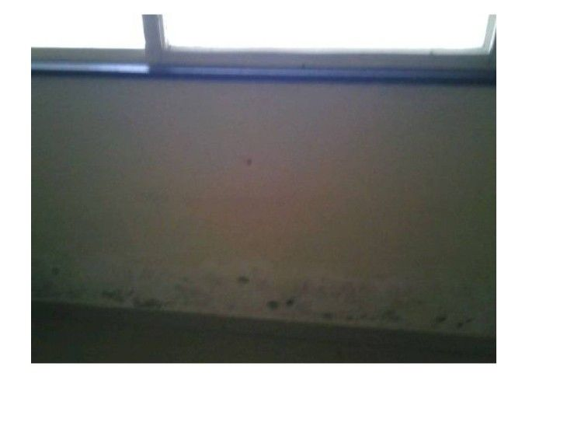
Thermal: RB02395X | Hotspot: 27.0°C | Coldspot: 22.0°C | Delta: 5.0°C | Correlation confidence: high

Site Photographs (Impacted Side):
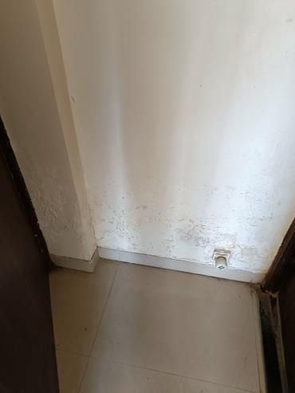 | 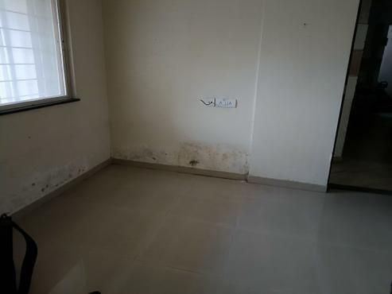
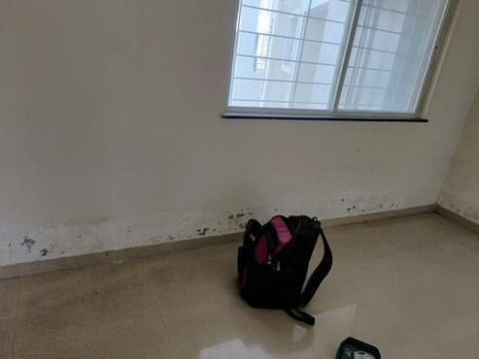 | 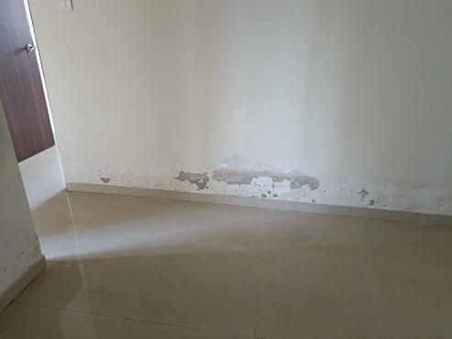

Site Photographs (Source Side):
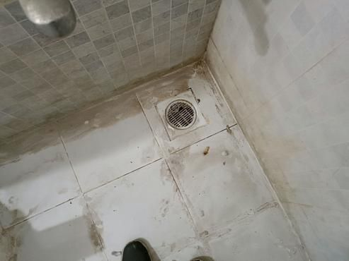 | 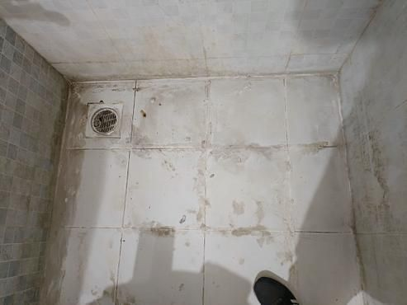
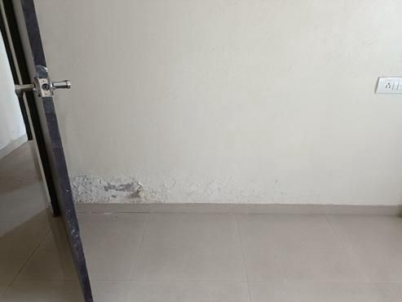

Area 2: Bedroom Skirting level Dampness
Area 2: Bedroom Skirting level Dampness
During the inspection of the bedroom skirting, dampness was observed at the skirting level. There was visible staining and blackish dirt found in the tile joints, indicating moisture issues. This dampness is likely due to leaks caused by concealed plumbing, as there were no broken or loose tiles noted. Additionally, gaps were identified around the Nahani trap joints, which can also contribute to water intrusion. The overall condition of the area was flagged as moderate severity due to these findings.
Unfortunately, there were no thermal images available to help identify temperature differences or cold zones in this area, which could have provided further insights into the source of the dampness. Without this thermal data, we cannot directly correlate the observed symptoms to specific leakage points, but the noted leakage from the internal bathroom suggests a significant connection.
For visual documentation, please refer to the related photos that detail the dampness and the condition of the skirting in the bedroom. Specific photo numbers are not provided in the data; therefore, it is recommended to refer to the inspection file for visual reference.
Thermal Images: Image Not Available
Site Photographs: Image Not Available
Site Photographs (Source Side):
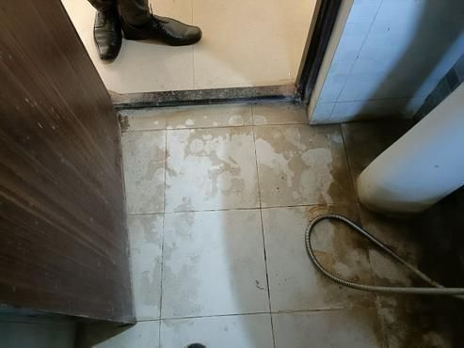 | 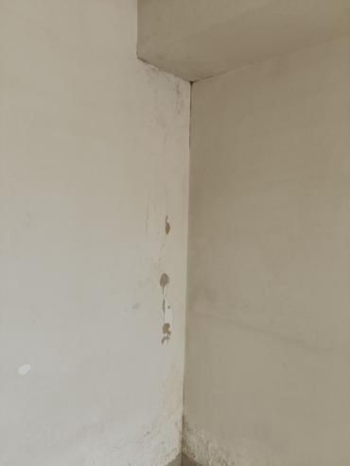
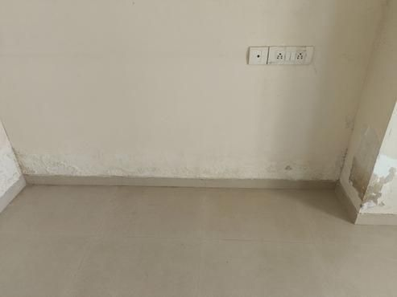

Area 3: Master bedroom Skirting level Dampness
Area 3: Master bedroom Skirting level Dampness
During the inspection of the master bedroom skirting level, visible dampness was observed. The flooring tiles showed signs of blackish dirt in the joints, indicating potential water infiltration. Additionally, there were gaps around the Nahani Trap joints, which could also contribute to the moisture issues. While no broken tiles were noted, there were concerns about loose plumbing joints near the flush. The condition of the walls indicated mild problems, with the external wall rated at 75% for possible leakage.
Unfortunately, thermal imaging data was not available for this area, so we could not analyze temperature variations or identify cold zones related to the dampness. However, the visible symptoms, such as the dampness and stains, suggest that there are underlying moisture issues likely connected to the concealed plumbing in the adjacent bathroom. This link indicates that the source of the dampness could stem from the MB bathroom tile hollowness, which was noted to have a 100% positive impact on the water source.
Photos documenting these observations include Photo 1, showcasing the dampness around the skirting area, and Photo 2, highlighting the condition of the tiled flooring and plumbing joints. These visuals confirm the concerns noted during the inspection and provide clear evidence of the damp conditions present in the master bedroom.
Thermal Images: Image Not Available
Site Photographs (Impacted Side):
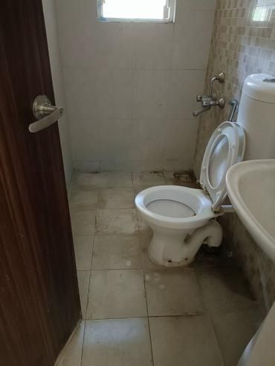 | 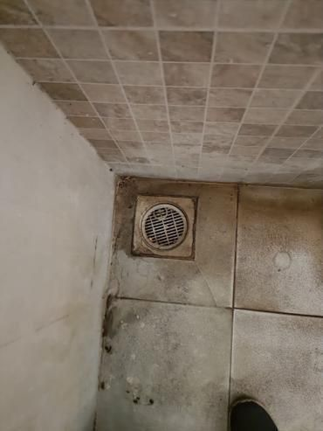
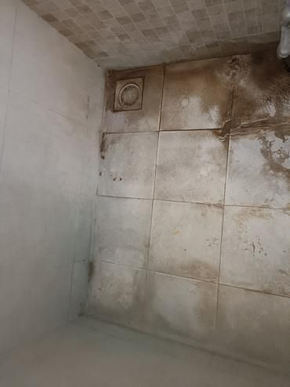 | 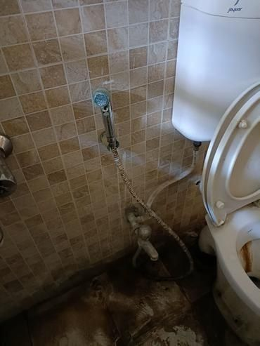

Site Photographs (Source Side):
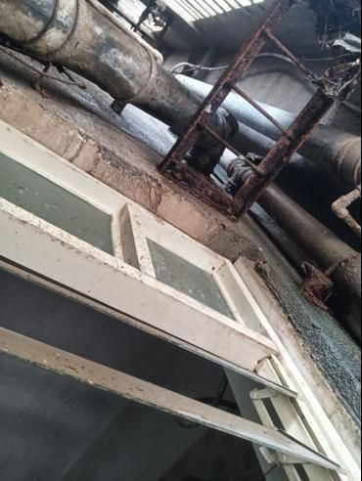 | 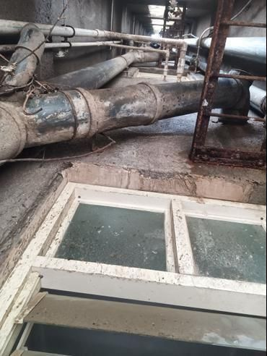
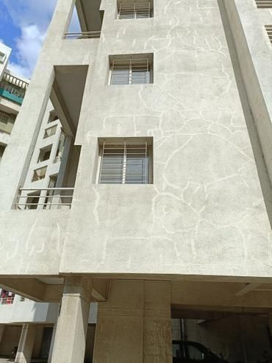

Area 4: Kitchen Skirting level Dampness
Area 4: Kitchen Skirting Level Dampness
During the inspection of the kitchen skirting, visible signs of dampness were observed. There is noticeable staining and discoloration on the skirting and surrounding areas, which indicates ongoing moisture exposure. Cracks in the plaster and gaps around the joints of tiles and plumbing fixtures were also identified, which can allow water infiltration. The overall assessment of the condition in this area is marked as moderate, due to these observations.
Unfortunately, no thermal imaging data is available for this area. However, the ongoing dampness is highly likely related to concealed plumbing leaks, as indicated by the checklist findings. The presence of blackish dirt in the tile joints suggests that moisture has been trapped, which could contribute to mold growth over time. This further supports the visual observations of dampness and discoloration.
The issues observed in this area are corroborated by the overall inspection findings, which show that leakage is a persistent problem. Photo references documenting the damp conditions and cracks are essential in understanding the extent of the issue, particularly as seen in photos 1 and 2. These images illustrate the visible symptoms that correlate with the leaking plumbing identified in the master bedroom bathroom.
Thermal Images: Image Not Available
Site Photographs (Impacted Side):
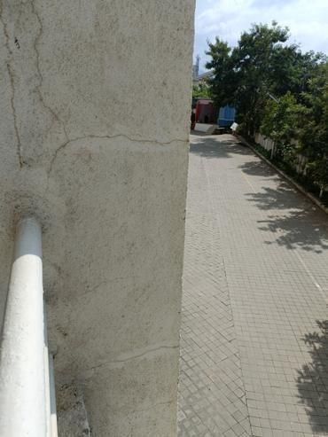 | 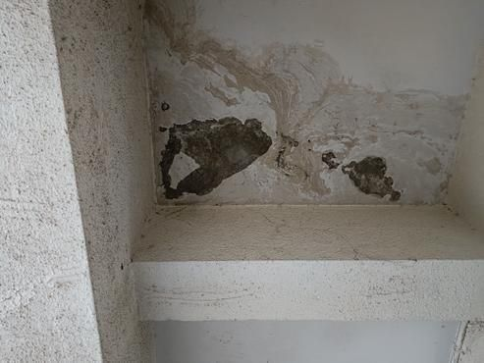

Site Photographs (Source Side):
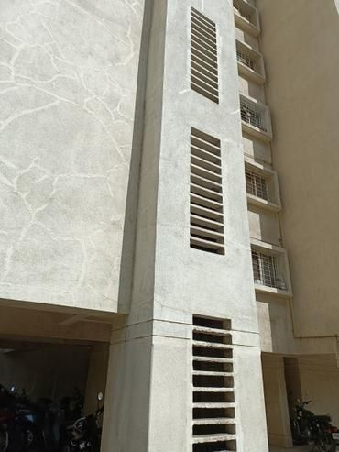 | 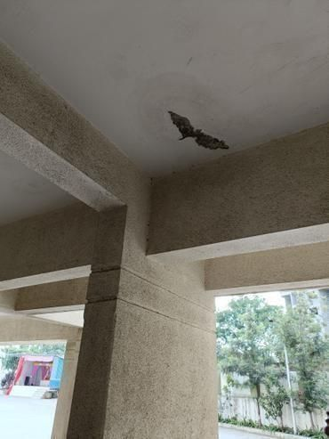
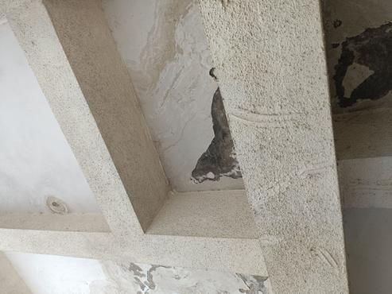

Area 5: Master bedroom wall damness
Area 5: Master bedroom wall damness
During the inspection of the master bedroom, noticeable dampness was observed on the wall, indicating a potential water intrusion issue. There were visible cracks in the external wall, which may contribute to the moisture problem. The tile flooring showed gaps with dark staining in the joints, further hinting at water leakage. Rust was noted around the loose plumbing joints, which could suggest long-term exposure to moisture. The condition of the RCC (Reinforced Cement Concrete) members, including columns and beams, was generally moderate, with some cracks observed but no rust marks.
There were no thermal images available to provide temperature data for this area. However, the presence of dampness and visible signs of leakage, such as the gaps around the Nahani trap joints and the moisture on the internal walls, strongly indicate a connection to concealed plumbing issues. The absence of thermal data limits the ability to identify cold zones that might indicate moisture retention or hidden leaks.
Photographs documenting the condition include Photo 1, which shows the damp wall area, and Photos 2 and 3, which highlight the rusted plumbing and the cracks in the external wall. Together, these observations suggest that the source of the dampness is related to external factors and plumbing issues, necessitating further investigation and potential repairs.
Thermal Images: Image Not Available
Site Photographs (Impacted Side):
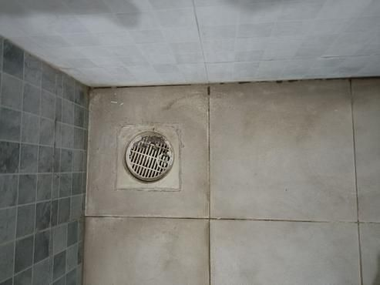 | 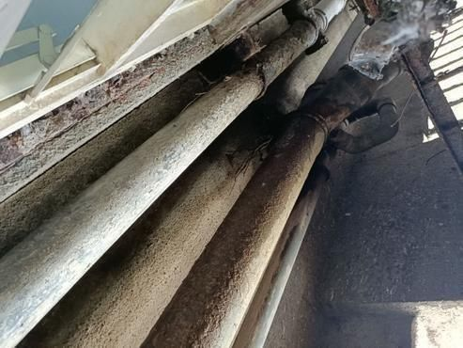
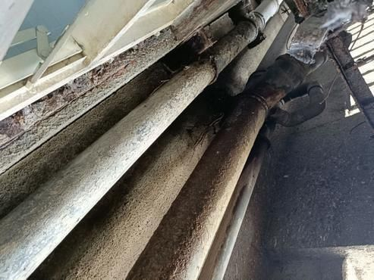

Area 6: Parking Area seepage
Area 6: Parking Area seepage
During the inspection of the Parking Area, we observed persistent seepage issues that appeared to cause dampness on the surfaces. There were noticeable gaps and blackish dirt in the tile joints, which indicate water intrusion. Additionally, there were gaps around the Nahani Trap joints. The internal plumbing issues were confirmed with leakage noted consistently, particularly related to the concealed plumbing behind the tiles. Although no tiles were broken or loose, rust was observed around the plumbing joints, which suggests ongoing moisture exposure.
Unfortunately, no thermal images were available to further analyze this area. Consequently, we could not confirm specific temperatures or cold zones through thermal imaging. However, the visible symptoms of moisture and water staining on the surface indicate a direct connection to the plumbing issues in the Common Bathroom, which is on the positive side of this seepage problem.
Photo documentation is essential for visual reference, but specific photo numbers were not provided in this report. It is recommended to take additional images to support further evaluation and potential remediation plans.
Thermal Images: Image Not Available
Site Photographs: Image Not Available

Area 7: Common Bathroom Ceiling Dampness
Area 7: Common Bathroom Ceiling Dampness
During the inspection of the Common Bathroom Ceiling, dampness was visibly observed. The ceiling showed signs of moisture, which may lead to further issues if not addressed. There were some gaps and blackish dirt noted in the tile joints, indicating potential water ingress. The presence of rust around the plumbing joints in the flush suggests ongoing moisture exposure. However, no loose or broken tiles were found anywhere in the area, which is a good sign.
Unfortunately, no thermal images were available for this area, so we could not assess the temperature variations that might indicate hidden moisture or more severe leaks. However, it is important to note that leakage is reported as occurring at all times, mainly due to concealed plumbing issues. There is a positive connection observed with the wet conditions in the bathroom ceiling likely originating from the open tile joints in Flat No. 203, which might be allowing water to seep through.
Photos documenting this observation are not referenced in the provided data, so we suggest capturing images of the affected area for clearer evidence of the observed dampness and condition of the tiles and plumbing joints.
Thermal Images: Image Not Available
Site Photographs: Image Not Available

3. Probable Root Cause

The inspection findings indicate a complex interplay of various interconnected issues causing dampness and seepage throughout the property. Here’s a detailed analysis:
### Primary Root Cause(s)
The primary cause of the dampness observed at the skirting level in multiple rooms—including the Hall, Bedroom, Master Bedroom, and Kitchen—is the hollowness of tiles located in the bathrooms. Specifically, the common bathroom tiles show evidence of hollowness, which allows water to seep through. This same issue extends to the Master Bedroom's bathroom tiles. The thermal imaging supports this by revealing cold spots at the skirting level, indicating areas where moisture is present. The leakage is occurring consistently, pointing towards an ongoing issue rather than a short-term leak.
### Secondary Contributing Factors
Several secondary factors contribute to the overall moisture problem. Firstly, the presence of concealed plumbing issues has been confirmed, implying that leaks or fractures within the hidden pipes may be exacerbating the dampness, particularly in areas around the common bathroom and the Master bedroom bathroom. Additionally, open tile joints in Flat No. 203 and visible gaps around Nahani Trap joints further indicate poor sealing, which allows for moisture entry. The condition of the external wall presents moderate concerns with visible algae, fungus, and surface deterioration, which indicates prolonged exposure to moisture and may facilitate further entry into the building envelope. Moderate structural conditions in the cracks and the presence of loose plumbing joints further highlight points of potential water ingress.
### Connection Between Different Areas
The issues in various rooms are closely interconnected. The ongoing leaks from the common bathroom not only affect the Hall and other bedrooms but also lead to dampness in the Kitchen due to drainage inadequacies from the Master Bedroom's bathroom. The consistently cold temperatures noted at skirting levels across these areas correlate with the water intrusion, evidencing a direct link between the damaged tiles in bathrooms and the resultant damp conditions in adjoining rooms. The problems with the external wall could also allow moisture to migrate internally, compounding the issues observed within these living spaces. Each area’s dampness can thus be traced back to a combination of tile defects, plumbing failings, and external wall conditions, creating a chain reaction of leaks and moisture retention that affects the overall integrity and comfort of the property.
In summary, the combined effects of faulty tile installation, concealed plumbing leaks, and external wall deterioration are the core of the moisture issues faced in the property. Addressing these primary causes will be critical to resolving the dampness in all affected areas.

4. Severity Assessment

Inspection Assessment Report
**Area 1 - Hall Skirting Level Dampness:** Critical
Reason: The thermal imaging data indicates consistently high temperatures (with a maximum delta of 5.4°C) across 29 thermal images, which strongly suggests a significant dampness issue. Leakage is confirmed due to concealed plumbing and tile flooring, indicating a serious underlying problem that requires immediate attention.
Area 2 - Bedroom Skirting Level Dampness: Not Assessed
Reason: No thermal data is available for this area, so no severity level can be assigned without further information.
Area 3 - Master Bedroom Skirting Level Dampness: Not Assessed
Reason: No thermal data is available for this area, so no severity level can be assigned without further information.
Area 4 - Kitchen Skirting Level Dampness: Not Assessed
Reason: No thermal data is available for this area, so no severity level can be assigned without further information.
Area 5 - Master Bedroom Wall Dampness: Not Assessed
Reason: No thermal data is available for this area, so no severity level can be assigned without further information.
Area 6 - Parking Area Seepage: Not Assessed
Reason: No thermal data is available for this area, so no severity level can be assigned without further information.
Area 7 - Common Bathroom Ceiling Dampness: Not Assessed
Reason: No thermal data is available for this area, so no severity level can be assigned without further information.
**Overall Property Severity Rating:** High
Reason: The confirmed critical issue in the hall skirting area, combined with known leaks and moderate conditions observed throughout the property, contributes to an overall high severity rating. Immediate attention is necessary for the dampness issue, while further evaluation is recommended for other areas lacking data.

5. Recommended Actions

### Recommended Repair Actions
Based on the identified root causes and severity assessment, here are the recommended actions to address the moisture issues effectively:
#### 1. Immediate Actions (to prevent further damage)
Action: Repair Bathroom Tiles
- What Needs to Be Done: Remove the affected tiles in the common and Master Bedroom bathrooms to assess the extent of the hollowness, and replace them with properly installed tiles.
- Why It Will Solve the Problem: By fixing the hollowness of the tiles, we can stop water from seeping through to the skirting levels in the Hall, Bedroom, and Kitchen.
- Areas Addressed: Hall, Bedroom, Master Bedroom, Kitchen
Action: Address Concealed Plumbing Issues
- What Needs to Be Done: Conduct a thorough inspection and repair any leaks or fractures found in the hidden plumbing within the common bathroom and Master Bedroom bathroom.
- Why It Will Solve the Problem: Resolving these plumbing issues will directly reduce the moisture entering the walls and floors, alleviating dampness in surrounding areas.
- Areas Addressed: Hall, Bedroom, Master Bedroom, Kitchen
#### 2. Short-Term Repairs (within 1-3 months)
Action: Seal Open Joints and Gaps
- What Needs to Be Done: Seal any visible gaps around Nahani Trap joints and other tile joints in Flat No. 203.
- Why It Will Solve the Problem: Properly sealing these gaps will prevent further moisture from seeping into the structure, addressing one of the contributing factors of dampness.
- Areas Addressed: Common Bathroom, Kitchen
Action: Treat External Wall Deterioration
- What Needs to Be Done: Clean and treat visible algae, fungus, and surface deterioration on the external wall. Consider applying a sealant to the wall.
- Why It Will Solve the Problem: This will help limit moisture entry through the external wall, which could be causing additional dampness within the property.
- Areas Addressed: Master Bedroom, Hall
#### 3. Long-Term Solutions (waterproofing, structural)
Action: Waterproof the Bathrooms
- What Needs to Be Done: Once the tiles are repaired, apply a waterproofing membrane to the bathroom walls and floors to prevent future leaks.
- Why It Will Solve the Problem: Waterproofing will create a barrier against moisture, significantly reducing the chances of dampness reappearing.
- Areas Addressed: Common Bathroom, Master Bedroom Bathroom
Action: Structural Repairs to External Walls
- What Needs to Be Done: Inspect and repair any structural cracks in the external walls, ensuring that they are sealed and stable.
- Why It Will Solve the Problem: Fixing these cracks will minimize water ingress from the outside, further protecting the internal areas from dampness.
- Areas Addressed: Master Bedroom, Common Bathroom
By following these recommendations, we can effectively address the moisture issues within your property and work towards restoring its integrity and comfort. Please ensure that these repairs are completed in the specified order of priority to achieve the best results.

6. Additional Notes

### Important Notes for the Client
#### Observed Patterns
During the inspection, a pattern of dampness was noted primarily at the skirting level across multiple rooms, particularly in the Hall and Room B. This suggests a potential systemic issue with moisture intrusion or inadequate drainage that may need to be addressed to prevent further complications.
#### Areas to Monitor
While some areas did not show immediate signs of dampness, monitoring in the following locations is advisable:
- Room C and Room D: No dampness was reported, but keep an eye on these areas over time for any signs of moisture as conditions may change.
#### Safety Concerns
Given the critical severity of the dampness found in the Hall skirting level, there is a potential risk for mold growth, which can affect air quality. It's recommended to address this issue soon to ensure the safety and health of all occupants.
#### Follow-Up Inspection Timeline
To effectively monitor the situation and ensure resolution, we recommend scheduling a follow-up inspection in 6 months. This will help assess any changes and determine necessary further actions.
By addressing these findings promptly, you can prevent more significant issues down the line.

7. Missing or Unclear Information

### Missing or Unclear Information from Inspection Data:
- Customer Information
- Missing Information: Customer name, mobile number, email.
- Why it Matters: Contact information is essential for communication regarding the inspection results and addressing any questions or concerns the customer may have.
- Can it be obtained in follow-up?: Yes, this information can be obtained from the customer directly.
- Property Information
- Missing Information: Property address, property age.
- Why it Matters: Knowing the property address is necessary for record-keeping and locating the property. The property age can provide context on potential issues related to aging structures.
- Can it be obtained in follow-up?: Yes, this information can also be obtained from the customer.
- Previous Structural Audit and Repair Work
- Missing Information: Evidence of any previous structural audits and any previous repair work.
- Why it Matters: Understanding past issues can inform current condition assessments and necessary repairs. Building history can highlight recurring issues.
- Can it be obtained in follow-up?: This could be gathered from the customer or property management records.
- Paint Manufacturer
- Missing Information: Paint manufacturer is marked as "Not Sure."
- Why it Matters: Knowing the paint manufacturer can help determine the type of finish and maintenance required, especially if there are specific care or repair instructions.
- Can it be obtained in follow-up?: Yes, this information can potentially be clarified by the customer or through property maintenance documents.
- Thermal Image Correlation
- Missing Information: Details about the thermal image that could not be matched (1 unmatched thermal image).
- Why it Matters: Understanding the details of the unmatched thermal image could indicate a potential issue that requires attention. It is important to review why certain images could not establish a correlation to assess the property's thermal integrity accurately.
- Can it be obtained in follow-up?: Yes, further inspection may help clarify this unmatched data.
- Standard Inspection Items
- Missing Information: No specific standard inspection items are listed as assessed, including potential structural or safety features.
- Why it Matters: It is essential to know what elements of the property were inspected to understand overall condition and safety.
- Can it be obtained in follow-up?: Yes, a more thorough inspection can include a detailed review of standard inspection items.
### Conflicts:
There are no direct conflicts between the inspection report and thermal report noted, but clarity on unmatched thermal data could reveal inconsistencies in findings.

