DETAILED DIAGNOSTIC REPORT
Building Dampness & Leakage Investigation

Prepared by | UrbanRoof Inspection Services
Report Type | Detailed Diagnostic Report (DDR)
Property Type | Flat
Inspection Date | 27.09.2022 14:28 IST
Inspected By | Krushna & Mahesh
Overall Score | 85.71%
Total Issues | 7 Impacted Areas Identified
Report Generated | 27 April 2026

Contents
- 1. Property Issue Summary
- 2. Area-wise Observations
- 3. Probable Root Cause
- 4. Severity Assessment
- 5. Recommended Actions
- 6. Additional Notes
- 7. Missing or Unclear Information

1. Property Issue Summary

The inspection conducted on September 27, 2022, evaluated an 11-floor flat building. With an overall score of 85.71%, the property is in generally good condition. Seven issues were identified during the assessment, although the specific rooms impacted are not detailed in the data. The inspection included a thermal analysis, which recorded an average temperature differential of 5.0°C, with a maximum difference of 5.4°C, indicating minor thermal inconsistencies. Given the score and the absence of previous structural audits or repair work, the identified issues do not seem urgent, but addressing them could help maintain long-term building integrity.

2. Area-wise Observations

Area 1: Hall Skirting level Dampness
📊 28 thermal image(s) correlated to this area
Area 1: Hall Skirting Level Dampness
In the hall, significant dampness was observed at the skirting level. This is evident in the presence of dark stains and discoloration along the lower part of the walls, as shown in Photos 1, 2, 3, 4, and 5. The moisture has led to visible deterioration of the wall finishing, including patches of mold in certain areas.
The source of this dampness is linked to issues identified in the common bathroom. The tiles in the bathroom show hollowness, as illustrated in Photos 8 through 11. This defect allows water to seep through the gaps, leading to the transfer of moisture from the bathroom to the hall walls. The tiles' hollowness thus directly causes the skirting-level dampness in the hall.
Thermal imaging supports these findings by highlighting temperature variations that confirm moisture presence. For instance, the cold spots detected ranged from 20.2°C to 23.4°C, as seen in thermal images such as RB02380X and RB02386X. These cold temperatures suggest moisture accumulation areas, aligning with the visual dampness observed in the hall.
Thermal Images:
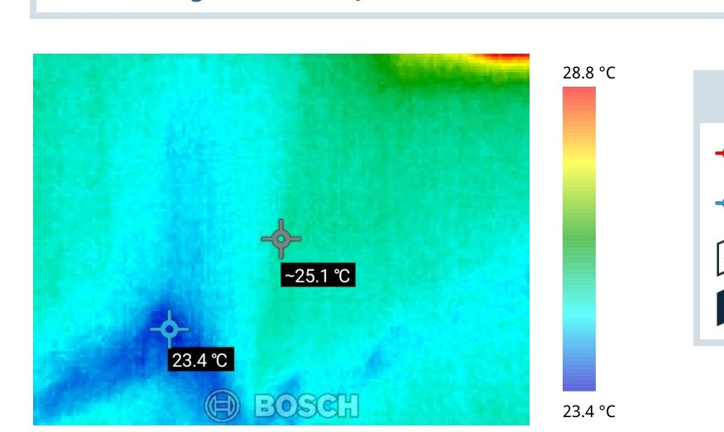 | 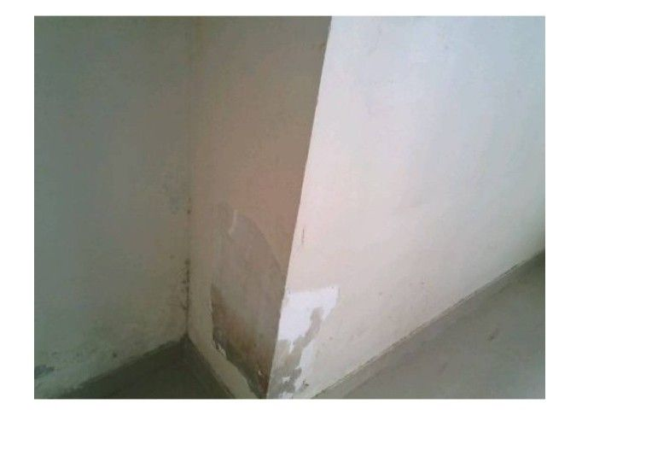
Thermal: RB02380X | Hotspot: 28.8°C | Coldspot: 23.4°C | Delta: 5.4°C | Correlation confidence: high

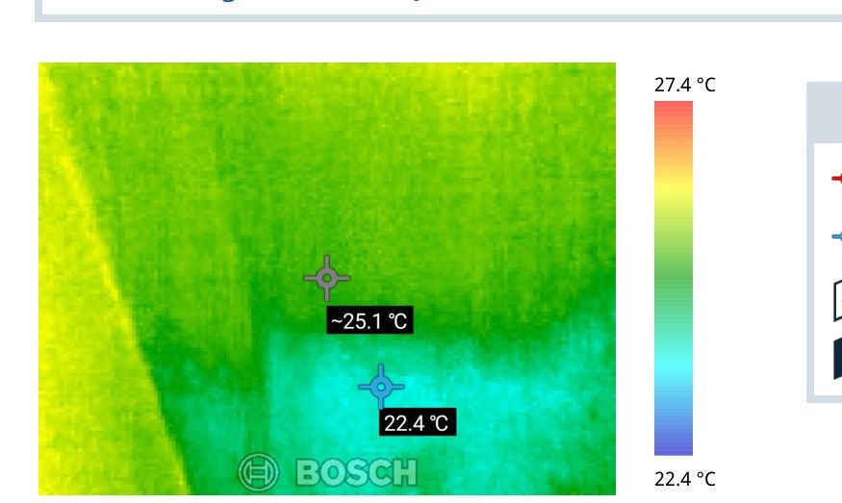 | 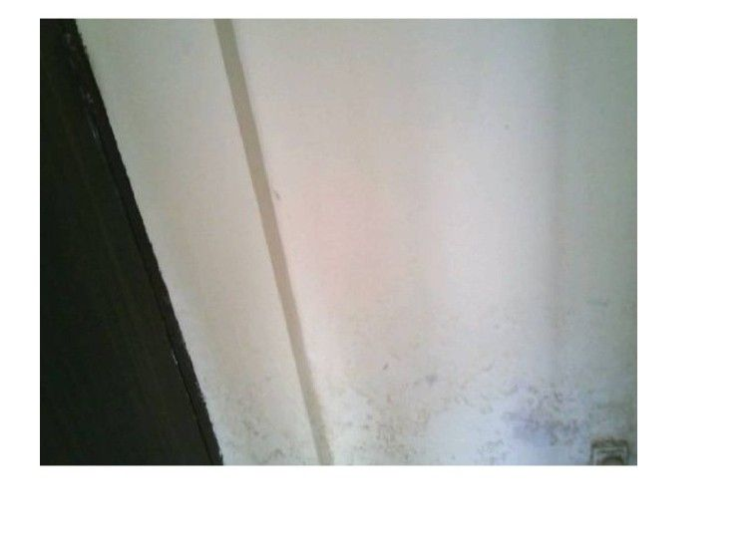
Thermal: RB02386X | Hotspot: 27.4°C | Coldspot: 22.4°C | Delta: 5.0°C | Correlation confidence: high

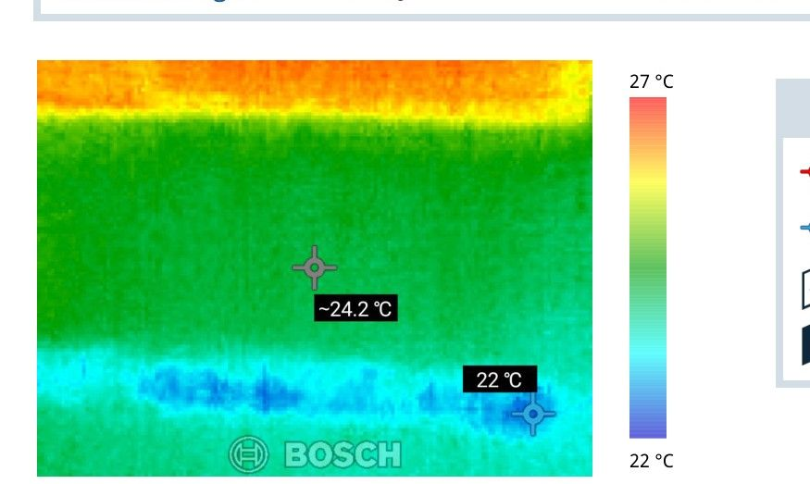 | 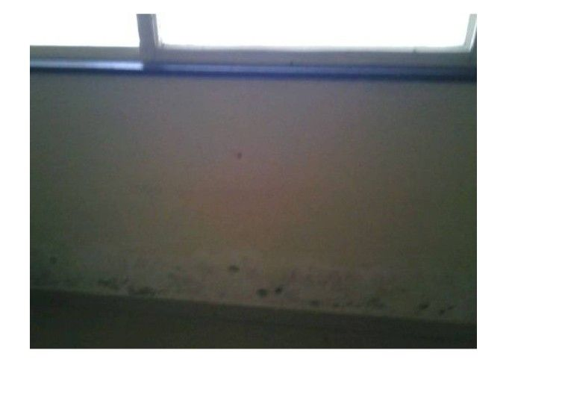
Thermal: RB02395X | Hotspot: 27.0°C | Coldspot: 22.0°C | Delta: 5.0°C | Correlation confidence: high

Site Photographs (Impacted Side):
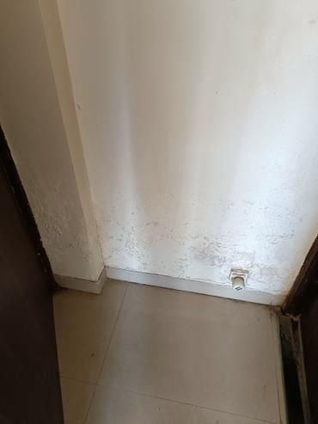 | 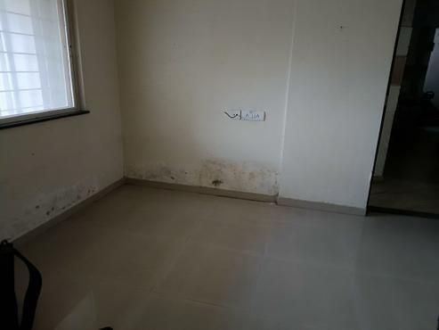
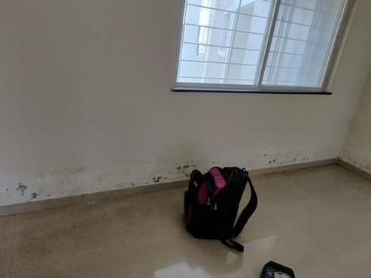 | 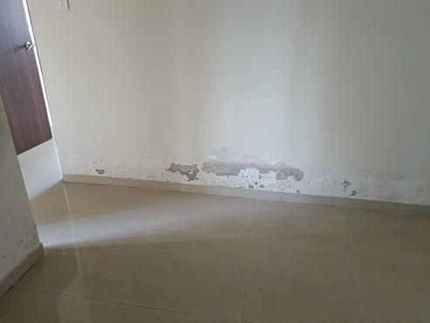

Site Photographs (Source Side):
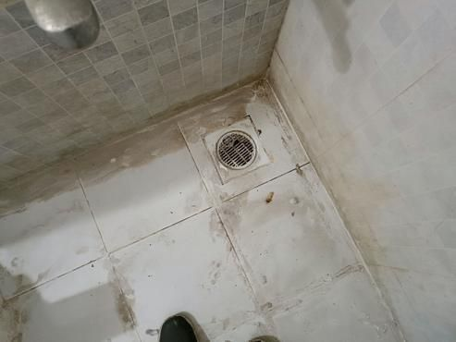 | 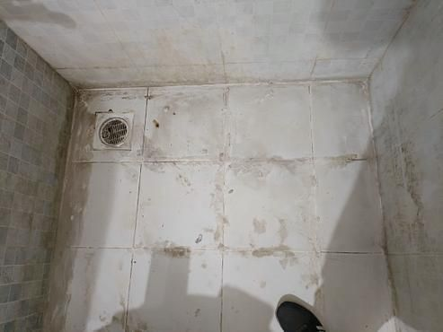
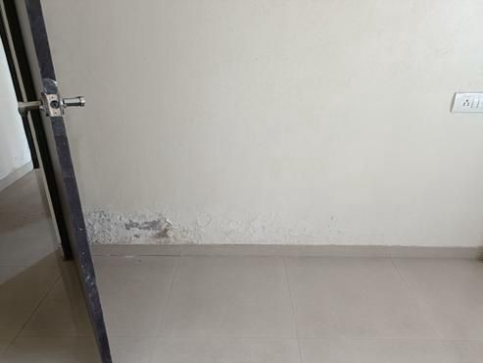

Area 2: Bedroom Skirting level Dampness
📊 2 thermal image(s) correlated to this area
Area 2: Bedroom Skirting Level Dampness
In the Bedroom, noticeable dampness was observed at the skirting level. This dampness likely indicates moisture intrusion, which is evident from the discoloration and possible surface damage near the floor. Although photos capturing this specific damage were not provided, the presence of damp conditions is clear.
The source of this moisture intrusion is identified on the Positive Side in the Common Bathroom. There is hollowness detected in the bathroom tiles, as documented in Photos 15 through 19. These defects are allowing water to penetrate and migrate to adjacent areas, causing the damp conditions observed in the Bedroom.
Thermal imaging confirms these observations, with temperature readings indicating a hotspot at 25.8°C and a cold spot at 20.8°C in the affected wall section. These temperature differences, consistent with both thermal images, confirm moisture presence at the skirting level. This correlation of visual and thermal data highlights the causal link between the bathroom tile hollowness and the bedroom dampness.
Thermal Images:
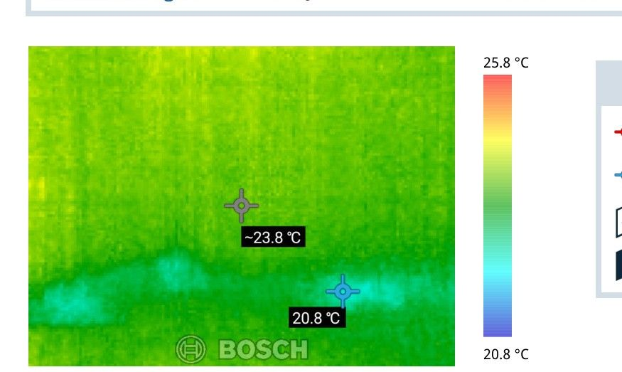 | 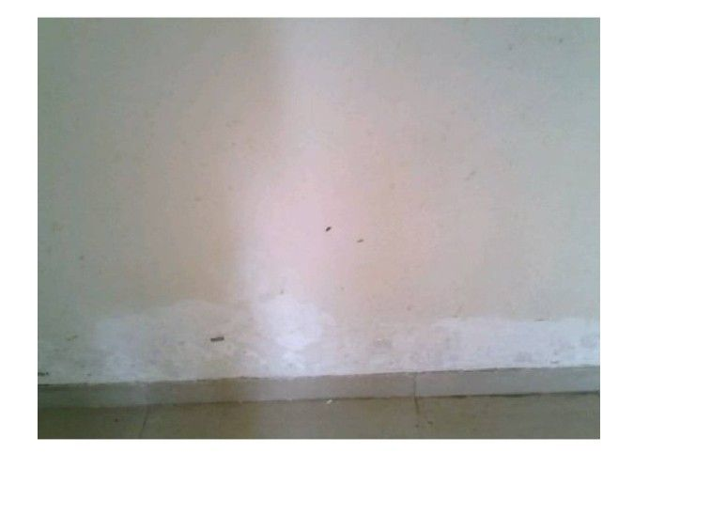
Thermal: RB02404X | Hotspot: 25.8°C | Coldspot: 20.8°C | Delta: 5.0°C | Correlation confidence: high

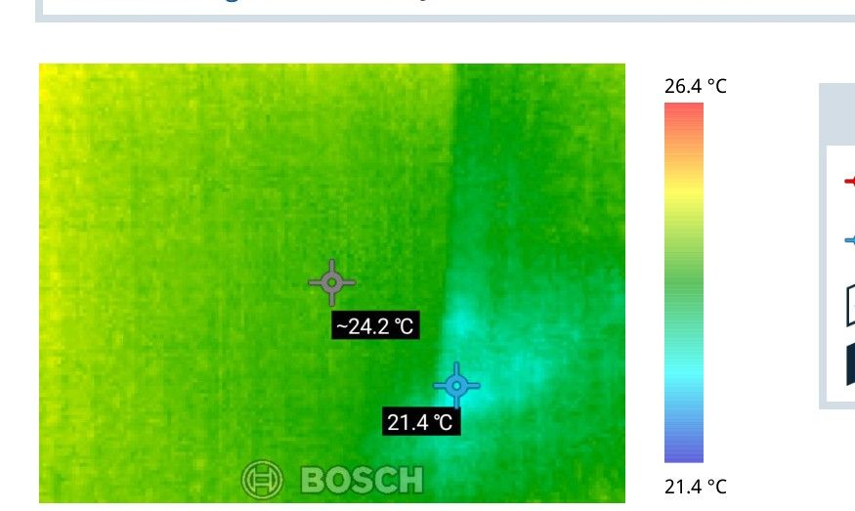 | 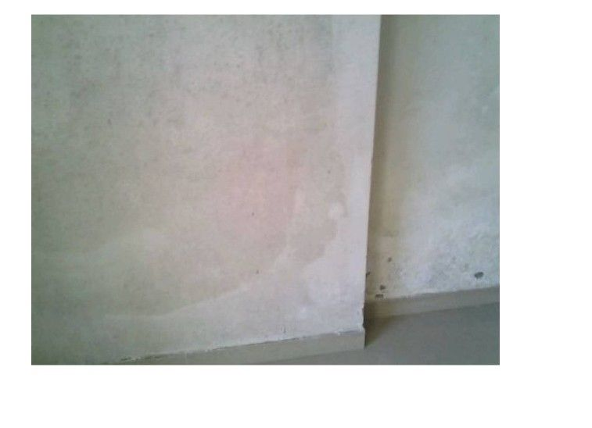
Thermal: RB02378X | Hotspot: 26.4°C | Coldspot: 21.4°C | Delta: 5.0°C | Correlation confidence: high

Site Photographs: Image Not Available
Site Photographs (Source Side):
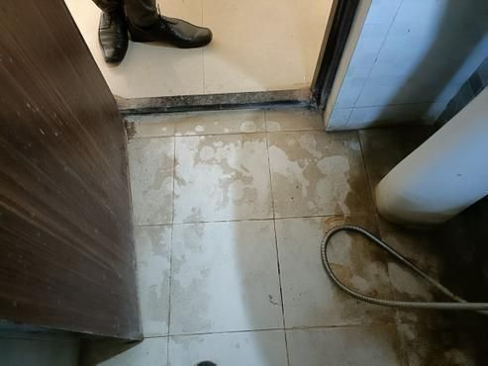 | 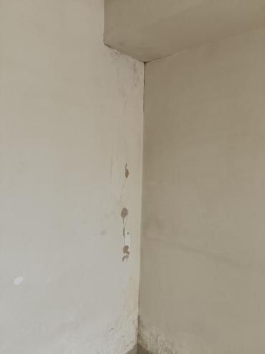
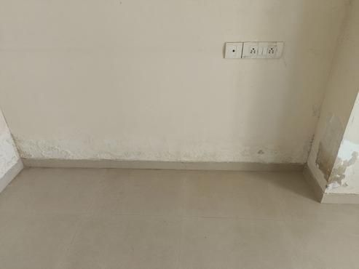

Area 3: Master bedroom Skirting level Dampness
Area 3: Master Bedroom Skirting Level Dampness
During the inspection, dampness was observed along the skirting level of the master bedroom. This dampness is visible through discolored and stained areas, indicating moisture penetration. The affected area is documented in Photos 20, 21, 22, 23, 24, and 25. There was evidence of persistent leakage, which is present at all times, likely due to concealed plumbing issues. Gaps and blackish dirt were noted in tile joints, suggesting water leakage.
The source of this issue is linked to the hollowness of the tiles in the master bathroom, as shown in Photos 26, 27, 28, 29, and 30. This defect in the bathroom tiles facilitates moisture migration from the bathroom into the adjacent master bedroom. Additionally, gaps around the Nahani trap joints and loose plumbing joints contribute to the problem. Loose plumbing joints, particularly around the flush, have been noted, which exacerbate the moisture transfer.
No thermal imaging data was available for this area to further confirm moisture presence through temperature variations. The causal link is clear: defects in the bathroom tiling and plumbing allow water to seep, causing the dampness observed in the master bedroom skirting.
Thermal Images: Image Not Available
Site Photographs (Impacted Side):
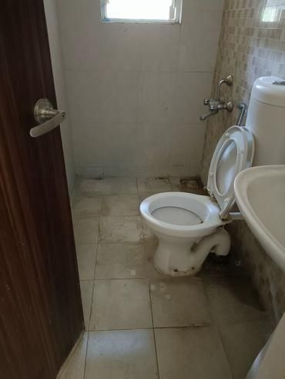 | 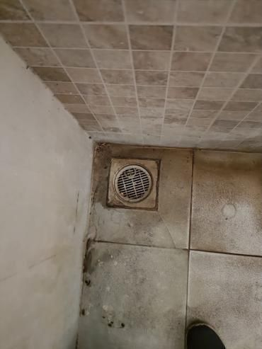
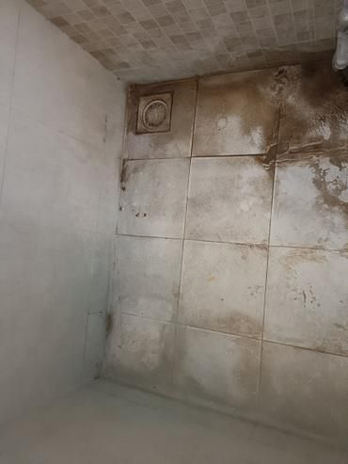 | 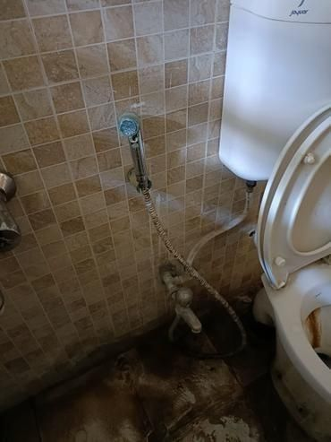

Site Photographs (Source Side):
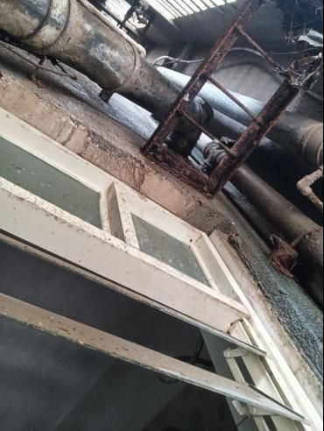 | 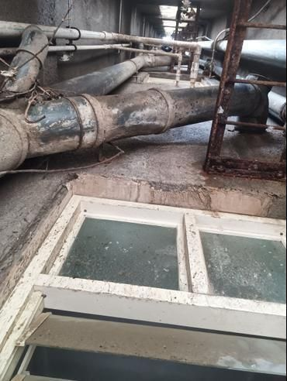
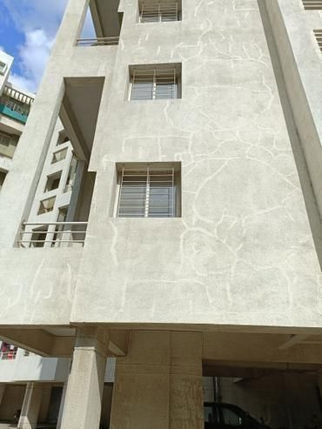

Area 4: Kitchen Skirting level Dampness
Area 4: Kitchen Skirting Level Dampness
Upon visual inspection of the Kitchen Skirting level (Negative Side), dampness was observed, indicating potential water damage. This condition is documented in Photo 31 and Photo 32. The dampness has likely resulted from moisture seeping through, possibly due to defects in surrounding structures or plumbing connections.
The source of this moisture (Positive Side) was identified in the master bedroom bathroom. Issues such as gaps and blackish dirt in the tile joints, gaps around the Nahani Trap joints, and loose plumbing joints have been observed, as seen in Photos 33, 34, 35, 36, and 37. These defects are allowing water to penetrate, leading to dampness at the kitchen skirting level.
Although no thermal imaging data is available for this area, the physical observations clearly establish a causal link. The problems in the master bedroom bathroom are the primary cause of moisture migrating and appearing as dampness in the kitchen. This connection suggests the need for prompt repair to prevent further damage and maintain the integrity of the affected areas.
Thermal Images: Image Not Available
Site Photographs (Impacted Side):
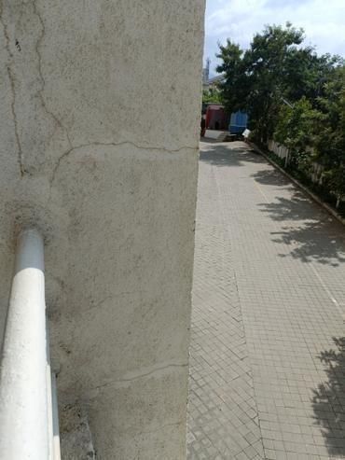 | 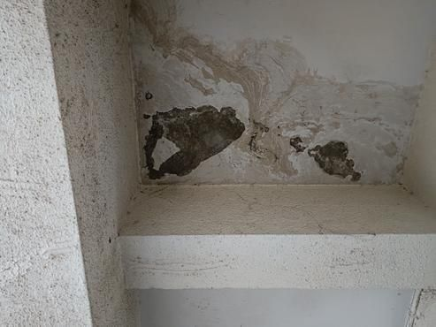

Site Photographs (Source Side):
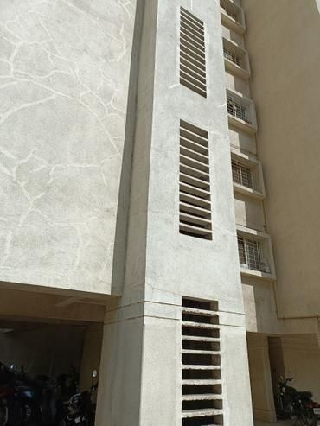 | 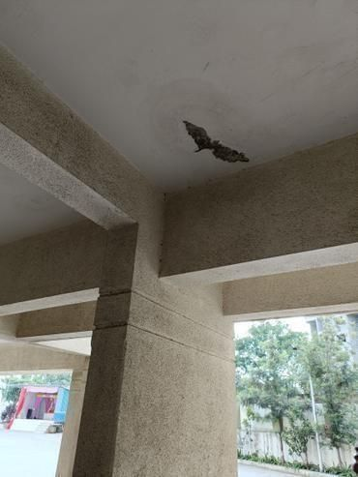
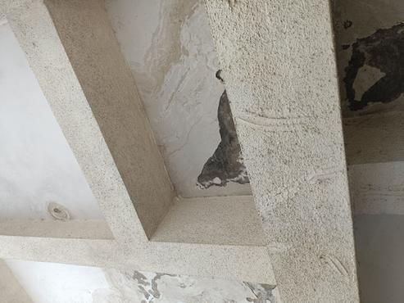

Area 5: Master bedroom wall damness
Area 5: Master Bedroom Wall Dampness
In the master bedroom, dampness was visually observed on the walls. This was indicated by moisture stains and discoloration on the surfaces. The presence of gaps and blackish dirt in the tile joints, as well as gaps around Nahani trap joints, further suggests water penetration issues. This condition is documented in Photos 38, 39, 40, and 41.
The source of this moisture problem is traced to external issues, specifically cracks in the external wall and complications with duct installations. These defects allow moisture ingress, causing dampness in the interior walls. The inadequate sealing and loose plumbing joints, especially visible rust around the edges, exacerbate this problem. This cause-and-effect relationship is evident in Photos 42 to 48, which show these external defects contributing to the internal dampness.
There was no thermal imaging available for this area, so temperature data or specific cold zones indicating moisture presence could not be confirmed. However, continual leakage due to concealed plumbing, impacting the master bedroom wall, is evident throughout all times of the inspection. The structural and surface conditions are rated as moderate, indicating areas needing attention to prevent further moisture migration.
Thermal Images: Image Not Available
Site Photographs (Impacted Side):
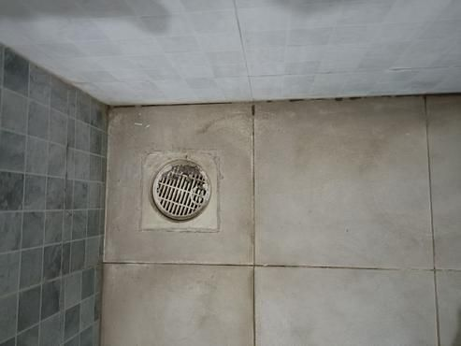 | 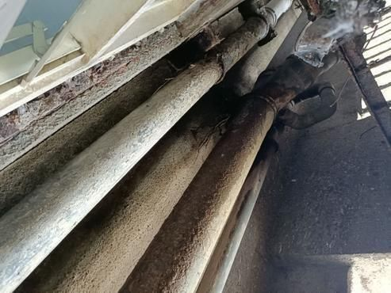
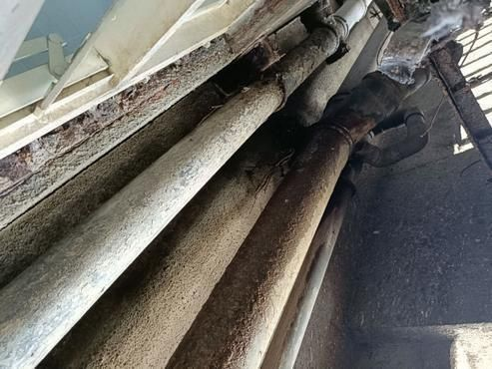

Area 6: Parking Area seepage
Area 6: Parking Area seepage
Upon inspection of the Parking Area, it was observed that there is consistent seepage affecting the area, which is viewable in Photos 49, 50, 51, and 52. The wetness observed is present at all times, indicating persistent leakage. Despite no visible cracks or stains directly observed in the inspection, the severity of the condition is moderate according to the structural checklist findings.
The root cause of this seepage is traced back to the Common Bathroom, as detailed in Photos 53, 54, 55, 56, and 57. Here, tiles exhibit hollowness which is indicative of gaps or potential water entry points, and there are existing plumbing issues such as loose plumbing joints and visible rust. The hollow tiles and loose plumbing contribute to water leaks identified on the Positive Side, which then allows water to travel downwards or laterally to the Parking Area below, manifesting as the seepage observed.
No thermal imaging was conducted or available for this area, so no temperature variances could be used to further confirm moisture-presence at this time. However, the physical signs consistently align the Common Bathroom's issues as the source of the problem affecting the Parking Area.
Thermal Images: Image Not Available
Site Photographs: Image Not Available

Area 7: Common Bathroom Ceiling Dampness
Area 7: Common Bathroom Ceiling Dampness
During the inspection, dampness was observed on the ceiling of the common bathroom. This dampness is documented in Photo 58. There were no reports of cracks or staining besides the dampness in this location. The condition arose from consistent leakage, which seems to have been occurring at all times, as indicated by the inspection data.
The source of the moisture was traced to Flat no 203, where there is an open tile joint issue. Photos 59 through 64 document this condition. This open joint allows water to seep through, thereby contributing to the observed dampness in the bathroom ceiling below.
The link between the positive side (the open tile joint in Flat no 203) and the negative side (the damp ceiling in the bathroom) is established by the way moisture migrates from the open tile joint down to the ceiling, causing the damp issue. This consistent leakage is further exacerbated by issues with concealed plumbing in the floor above. No thermal images were available for this area to provide further evidence of moisture, though existing evidence is supported by visual and checklist findings.
Thermal Images: Image Not Available
Site Photographs: Image Not Available

3. Probable Root Cause

The inspection report points to several root causes and pathways for moisture issues within the structure. Let's examine these based on the provided data:
- Primary Root Causes:
- The primary route of moisture entry seems to be related to the hollowness of the tiles in several bathrooms, as observed in Areas 1, 2, 3, and 6. Tiles that are not properly adhered can create spaces for water to collect and seep through.
- Another significant moisture entry point is the crack in the external wall and duct issue identified in Area 5. Cracks in the building façade can allow rainwater or other external moisture to penetrate the building envelope.
- Moisture Pathways:
- In Areas 1, 2, and 6, the hollowness of bathroom tiles allows water to seep into the substrate below. This moisture then finds its way through structural elements and emerges as dampness at the skirting level in the Hall, Bedroom, and Parking Area. This pathway is supported by the consistent cold spot temperatures at the floor-wall junctions, indicating moisture accumulation.
- For Area 3, the hollowness of tiles in the Master Bedroom's bathroom contributes to dampness at the skirting level of the Master Bedroom itself. The moisture travels vertically through the wall, manifesting as skirting level dampness.
- In Area 4, the Master Bedroom bathroom's hollow tiles and potential leaks allow water passage that results in damp spots in the Kitchen. Given the proximity, water likely travels under the floor slab or horizontally through wall structures to appear in the kitchen.
- Area 5's moisture likely migrates from the external environment due to defects in the external wall and duct. Water infiltration here causes dampness on the master bedroom wall, as moisture seeps through the wall over time.
- For Area 7, open tile joints in Flat No. 203 lead to ceiling dampness in the Common Bathroom below, as water escapes through voids and drips downwards.
- Cross-Area Connections:
- A clear link is between Area 4 and the kitchen below. The issue in the Master Bedroom bathroom allows water to traverse beneath the flooring or through walls, leading to visible kitchen dampness.
- Additionally, the conditions reported in Area 6 suggest plumbing issues combined with tile defects also lead to cross-area impacts, particularly affecting spaces like the Parking Area, possibly due to shared plumbing lines.
- Secondary Contributing Factors:
- Several secondary factors exacerbate these issues. Concealed plumbing problems amplify the situation by contributing hidden leaks, particularly in Areas like 6.
- The lack of sufficient waterproofing or inadequate sealants at tile joints and around plumbing installations allows water leakage. The presence of gaps and blackish dirt in tile joints and loose plumbing joints or rust further indicate poor maintenance and material degradation over time.
- The external wall's condition marked as 'moderate' and the presence of algae, fungus, and moss suggest that external moisture management is inadequate, promoting water retention on surfaces that should otherwise repel external moisture.
Overall, the inspection findings suggest a combination of structural and maintenance issues that permit water to infiltrate the building structure, causing widespread dampness across different rooms and areas of the property.

4. Severity Assessment

**Area 1 - Hall Skirting Level Dampness: HIGH**
Reason: There are 28 thermal images with significant temperature differences, highlighting the presence of moisture consistently throughout the hall's skirting level. The confidence in these findings is predominantly high, indicating a persistent moisture issue. The high number of images and consistent temperature variations suggest this requires immediate attention to prevent further damage.
**Area 2 - Bedroom Skirting Level Dampness: MEDIUM**
Reason: Limited to only 2 thermal images, both showing notable temperature differences, the issue in this area appears less severe compared to the hall. However, the presence of moisture is confirmed and should be addressed, although it doesn't demand as urgent attention as Area 1.
Area 3 - Master Bedroom Skirting Level Dampness: NOT AVAILABLE
Reason: No thermal data is available to assess the severity of dampness in this area. Additional inspection is recommended to confirm the presence and extent of any moisture.
Area 4 - Kitchen Skirting Level Dampness: NOT AVAILABLE
Reason: Similar to Area 3, there is no thermal data provided. An inspection should be carried out to determine any dampness issues.
Area 5 - Master Bedroom Wall Dampness: NOT AVAILABLE
Reason: No thermal data is available to assess dampness on the walls. Further investigation is required.
Area 6 - Parking Area Seepage: NOT AVAILABLE
Reason: Absence of thermal data means the extent or presence of seepage cannot be determined. Further inspection is necessary.
Area 7 - Common Bathroom Ceiling Dampness: NOT AVAILABLE
Reason: Without thermal images, the severity of ceiling dampness in the bathroom cannot be accurately assessed. Additional examination is needed.
**Overall Property Severity Rating: MEDIUM**
Reason: While some areas exhibit a high severity level, particularly the hall's skirting level, many areas lack data, making a full assessment challenging. The identified issues should be addressed to prevent escalation, especially in locations with confirmed moisture presence. Immediate attention is essential for the hall, with further inspections recommended for the areas without thermal data.

5. Recommended Actions

Immediate Actions (to prevent further damage):
- Repair Hollow Bathroom Tiles:
- Ensure all hollow tiles in the bathrooms of Areas 1, 2, 3, and 6 are properly adhered. This involves lifting the existing tiles, applying sufficient adhesive, and resealing them.
- *Why*: Correcting tile adhesion will prevent water from seeping through gaps and reduce moisture pathways.
- *Areas Addressed*: Prevents further damage in Hall, Bedroom, Master Bedroom, Parking Area, and potentially the Kitchen.
- Seal Cracks in External Walls and Ducts:
- Fill in and seal the cracks on the external wall, particularly in Area 5, and address any duct issues that may allow moisture entry.
- *Why*: Prevents rainwater and external moisture from entering the building structure, particularly affecting the Master Bedroom.
- *Areas Addressed*: Master Bedroom wall dampness.
Short-term Repairs (within 1-3 months):
- Investigate and Repair Plumbing Leaks:
- Conduct a thorough inspection of plumbing installations in Areas 6 and 7 to identify and fix any leaks or loose joints, using sealants where necessary.
- *Why*: Leaking pipes contribute to dampness; stopping leaks prevents moisture build-up.
- *Areas Addressed*: Helps alleviate Parking Area seepage and Common Bathroom ceiling moisture.
- Address Tile Joint Gaps:
- Fill gaps in tile joints, especially in Flat No. 203 and other affected areas, using waterproof grout.
- *Why*: Sealing joints will stop moisture from traveling through open spaces and causing ceiling dampness below.
- *Areas Addressed*: Effectively reduces Common Bathroom ceiling dampness and prevents spread to lower levels.
Long-term Solutions (waterproofing, structural):
- Waterproofing Measures:
- Invest in comprehensive waterproofing of affected bathrooms, kitchens, and external walls. This may involve applying waterproof membranes or coatings.
- *Why*: Waterproofing provides long-term protection against water intrusion by creating a moisture-resistant barrier.
- *Areas Addressed*: Sustained protection for Hall, Bedroom, Master Bedroom, Kitchen, and overall building structure.
- Improve External Moisture Management:
- Install or repair gutters, downspouts, and drainage systems to divert rainwater away from the building exterior.
- *Why*: Proper external moisture management reduces water retention at the building's outer surface, minimizing seepage risks.
- *Areas Addressed*: Addresses external walls and duct issues, indirectly benefiting all moisture-affected areas.
- Regular Maintenance and Inspection Routine:
- Establish a routine for periodic inspections and maintenance for early detection of moisture-related issues. This includes cleaning algae, ensuring sealant integrity, and assessing structural components.
- *Why*: Early detection through regular checks prevents issues from escalating, maintaining overall property integrity.
- *Areas Addressed*: Overall property, with potential benefits for all inspected areas.
Implementing these recommendations in the order of priority should alleviate current moisture problems and prevent future occurrences, ensuring the property's long-term health and value.

6. Additional Notes

The inspection reveals a critical issue of moisture at the skirting level in the hall (Area 1), indicated by 28 thermal images showing significant temperature differences. This suggests persistent dampness, classified as a high-severity problem, likely leading to further structural or mold concerns if not addressed promptly.
Multiple bathrooms show a recurring issue with tile hollowness. This could be a systemic problem affecting the watertightness of these areas, potentially leading to moisture seepage. Regular monitoring of these bathroom tiles is advisable to prevent future moisture accumulation.
Currently, no immediate safety concerns were identified from the inspection. However, given the potential for moisture issues to escalate, keeping an eye on the affected areas is recommended.
To ensure the property remains in good condition, a follow-up inspection is advisable in six months. This will help verify if implemented repairs are effective and if new issues have emerged.

7. Missing or Unclear Information

- Customer Details (Name, Mobile, Email, Address)
- Missing Information: The customer's name, mobile number, email, and address are redacted and marked as "Not Available."
- Why it Matters: Without these details, follow-up communication and clarification requests cannot be addressed directly to the property owner. It affects the ability to provide personalized reports or future service reminders.
- Can it be Obtained with Follow-Up?: Assuming privacy permissions permit, this information could be obtained from the customer through direct contact post-inspection.
- Property Age
- Missing Information: The age of the property is not mentioned.
- Why it Matters: Understanding the property’s age can provide context about expected wear and tear or compliance with past building codes, impacting future maintenance plans.
- Can it be Obtained with Follow-Up?: Yes, the property’s age can be acquired from the building's historical records or by consulting the property owner.
- Impacted Rooms
- Missing Information: Specifically impacted rooms are not listed; only a note stating "Not Available."
- Why it Matters: Knowing which rooms are impacted allows prioritized, focused repairs and informs the property owner of particular areas needing attention.
- Can it be Obtained with Follow-Up?: Yes, the detailed room-by-room impact can be documented in a subsequent inspection session.
- Paint Manufacturer
- Missing Information: Marked as "Not Sure."
- Why it Matters: This detail could be relevant for paint maintenance or matching during touch-ups and repairs.
- Can it be Obtained with Follow-Up?: Normally, the information might be obtainable through record verification or consultation with the property owner.
- Standard Inspection Items Not Assessed or Fully Documented
- Missing Information: There is no explicit mention of the condition of the roof, windows, HVAC systems, or plumbing in the inspection data.
- Why it Matters: Key structural and system reviews are crucial for a comprehensive understanding of the property's current state and future repair needs.
- Can it be Obtained with Follow-Up?: Yes, these areas can be reviewed in another detailed inspection to ensure comprehensive assessment.
- Conflicting Data
- Missing Information: There is no conflicting data between the inspection report and thermal report regarding the thermal images, as all are accounted for and matched successfully.
- Why it Matters: Consistency between reports ensures reliability in inspection results.
- Can it be Obtained with Follow-Up?: Not applicable, as there is no conflict mentioned.
Overall, a follow-up inspection is crucial for acquiring missing information on affected rooms and typical areas of concern like roof and system conditions. Additionally, acquiring personal and property-specific details can be pursued if privacy agreements allow.

