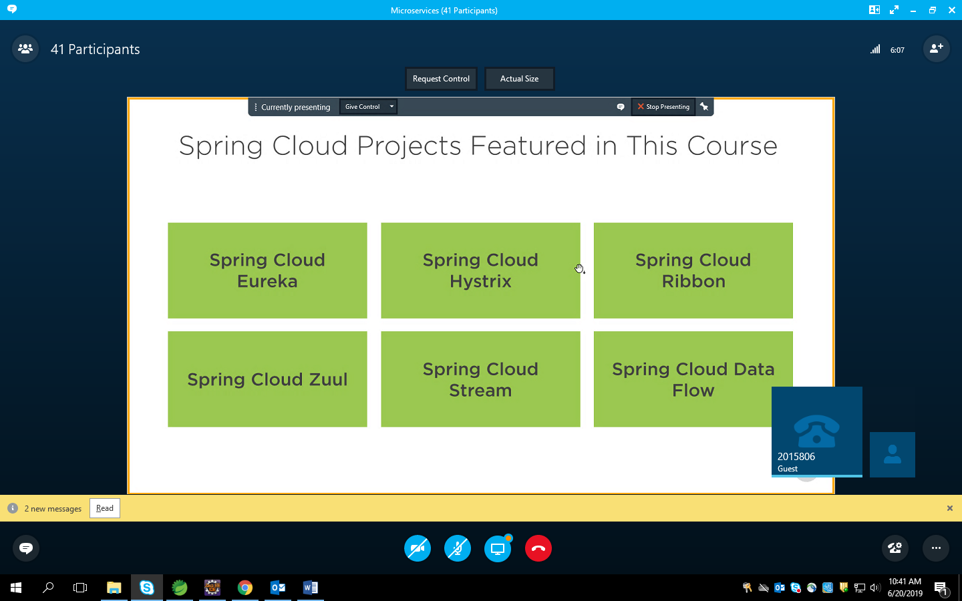

By Netflix

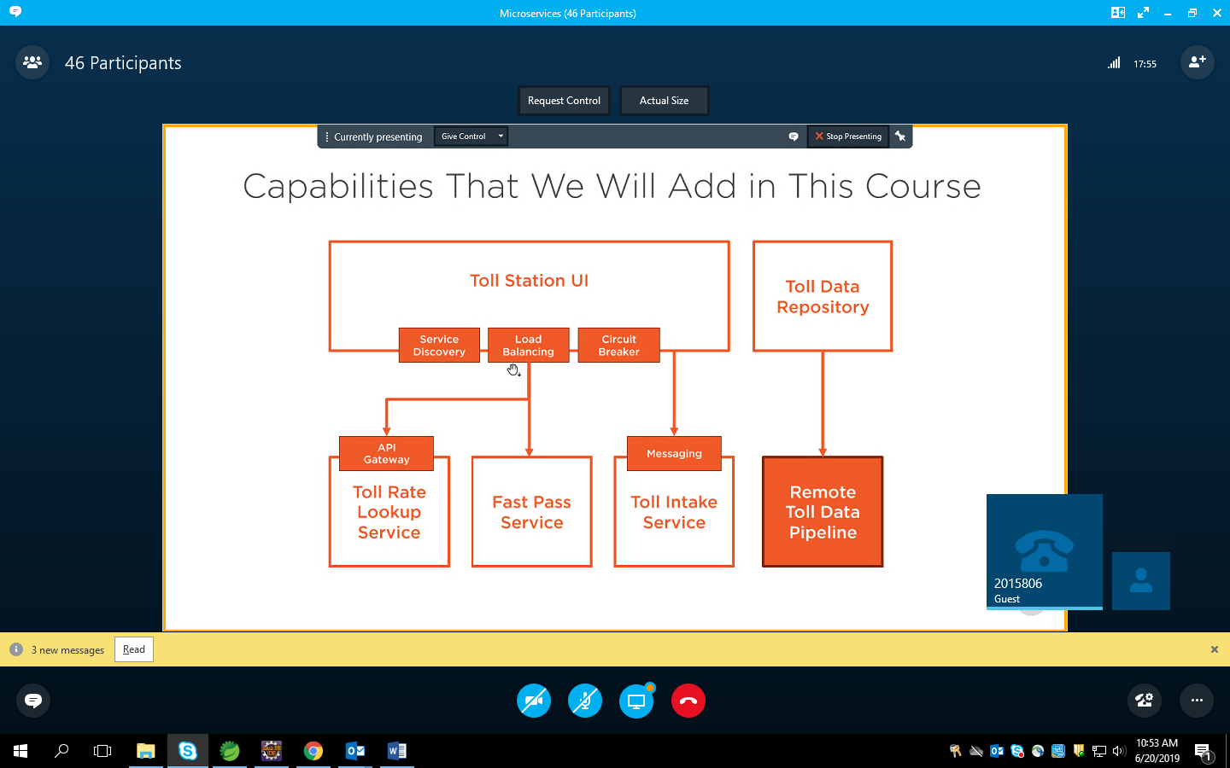

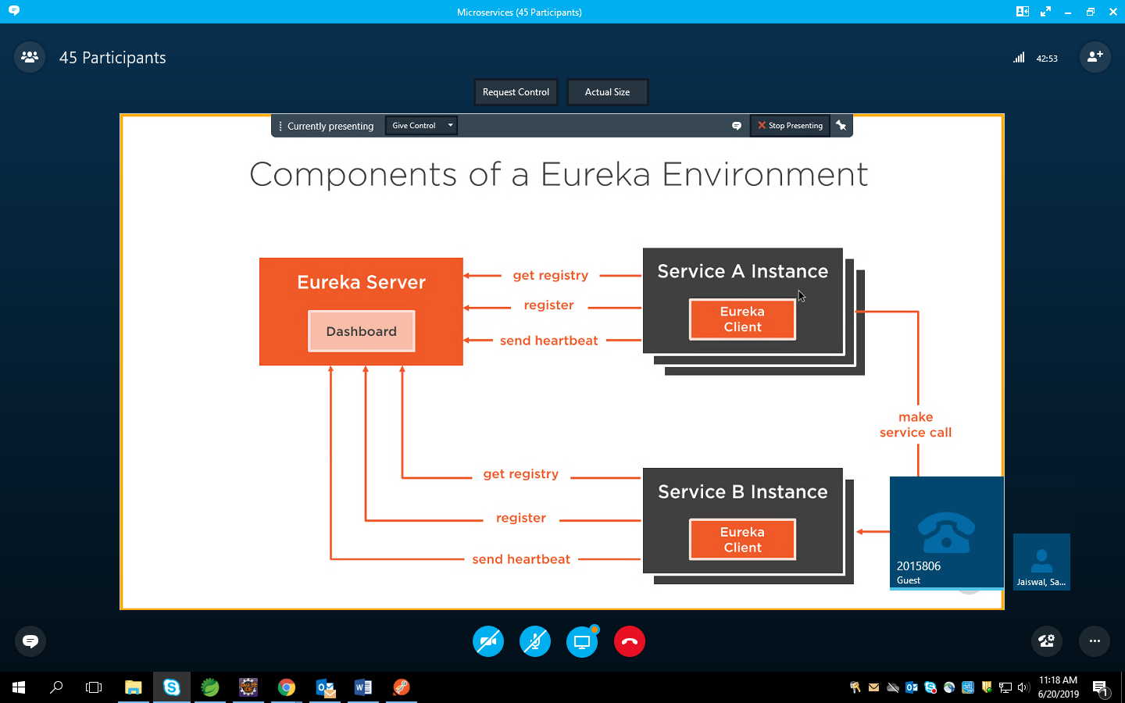

Service a is client for service B

Heatbeat & get registry -> polling

Register -> one –time

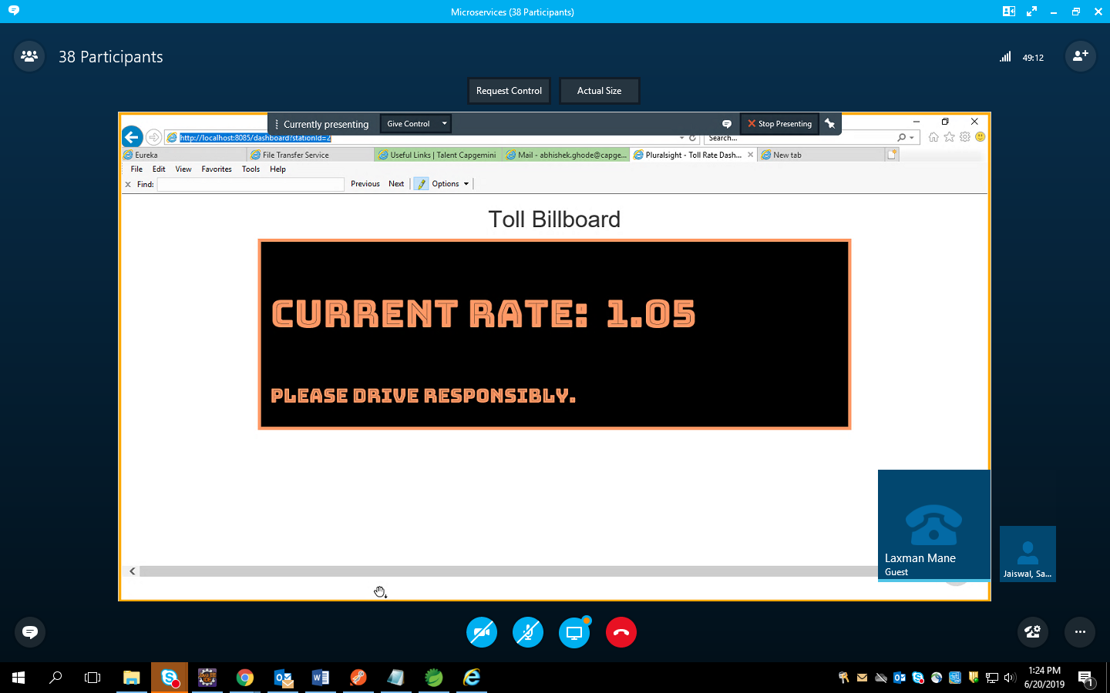

<http://localhost:8085/dashboard?stationId=2>

access dashboard

-Dorg.eclipse.ecf.provider.filetransfer.excludeContributors=org.eclipse.ecf.provider.filetransfer.httpclient4   
-Dorg.eclipse.ecf.provider.filetransfer.retrieve.closeTimeout=3000   
-Dorg.eclipse.ecf.provider.filetransfer.retrieve.readTimeout=3000

Localhost:8761

Anindya Chandra