Cf push <app-name> -p <warfile> -m <memorylimit> -n <hostname> -I <number_of_instance>

Domains available: 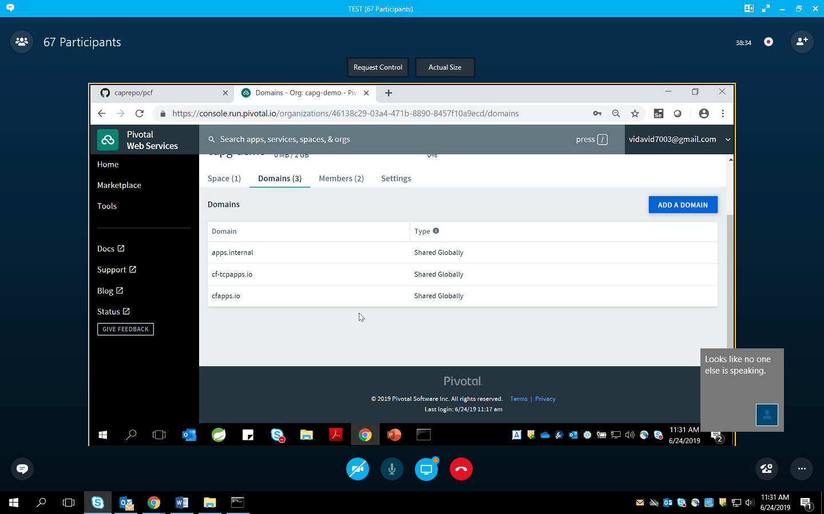

Cf push spring-music-capg –p spring-music.war –m 1024m –n spring-music-capg123 –I 1

Cf apps  
=> show apps running and deleting  
  
cf delete –f <app-name>  
=> force delete (path & all everything gets deleted)

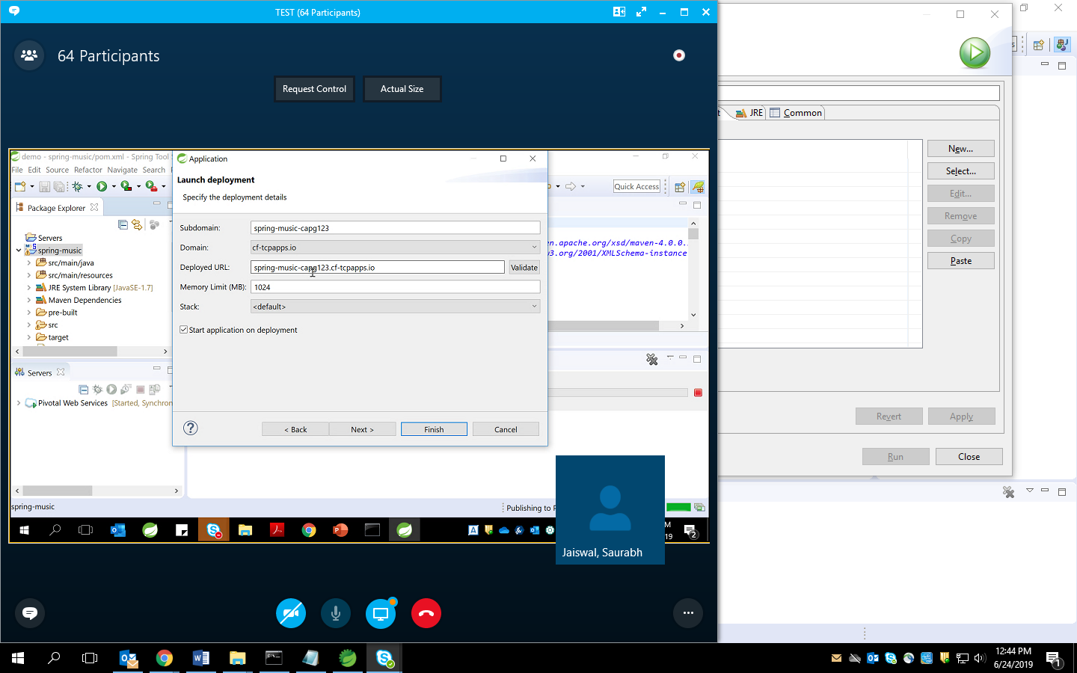

What happen when we push (cf push):

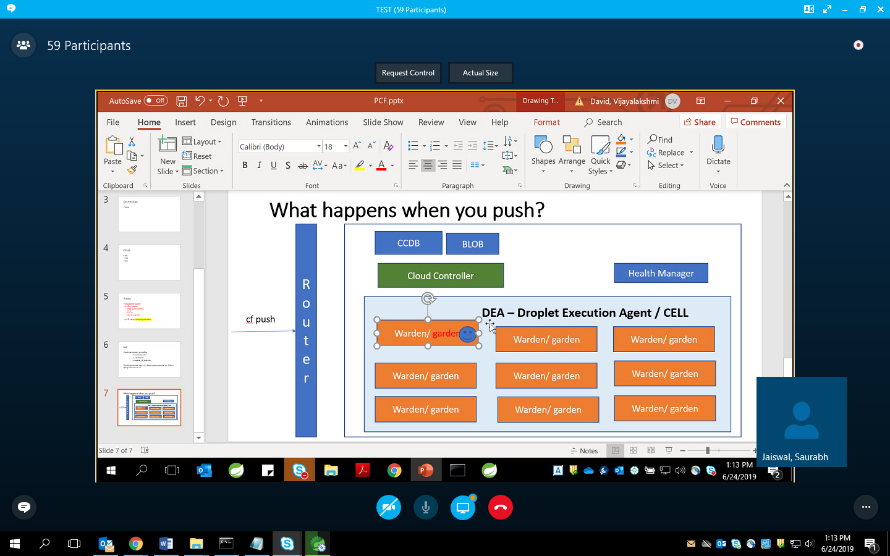

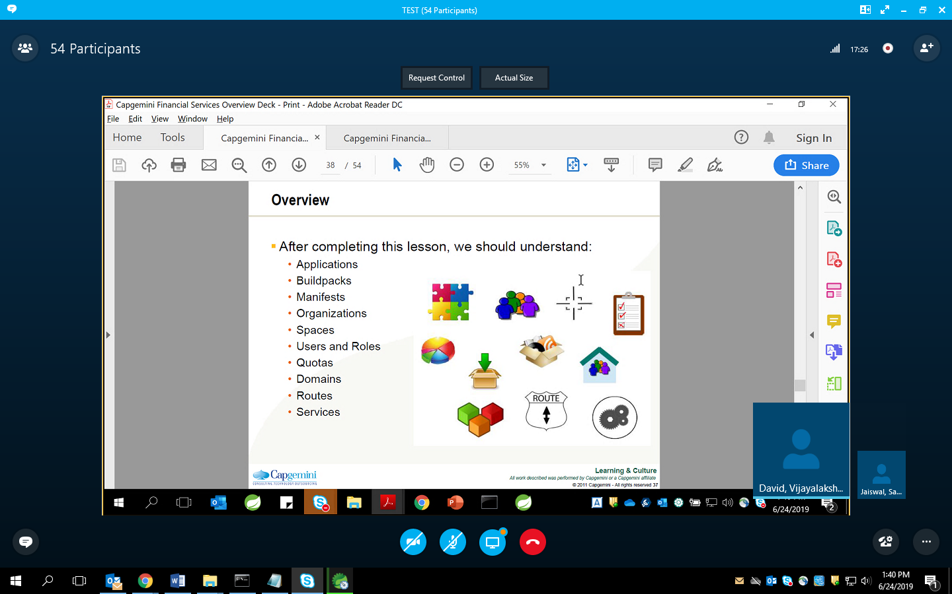

Buildpack -> language independent (9 different types)

Manifests -> a deployment “blueprint” for an application.

Org -> create multiple space  
 difrrentiate people on basis of org  
  
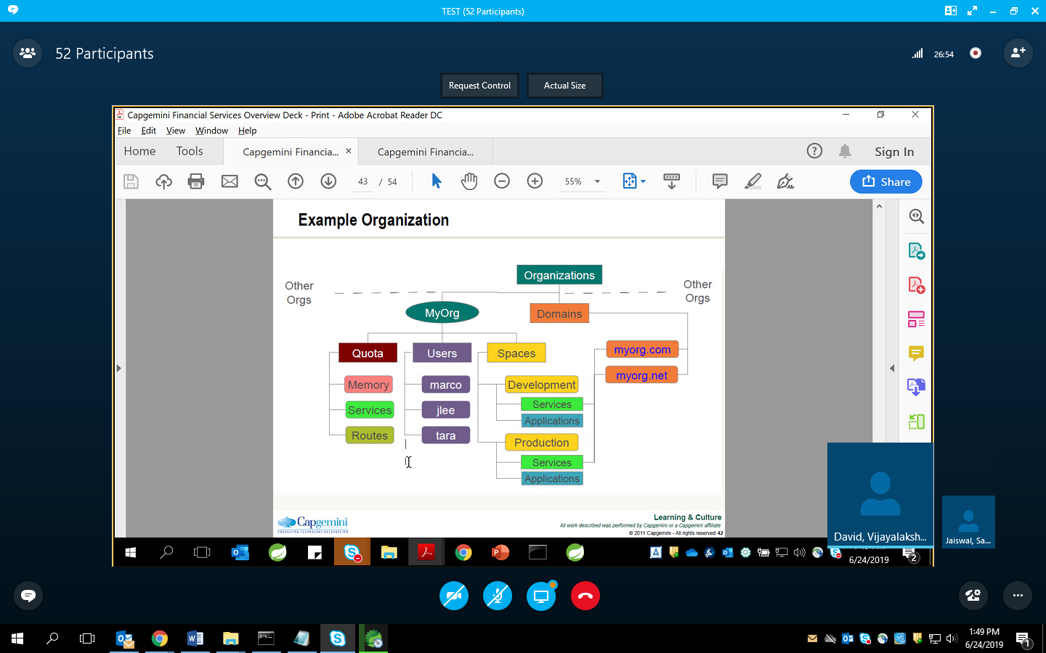

Space->