Cf target –**s** testing

Change **space**

Cf apps  
 see details of PCF running

Cf target –**o** samerra-123

Change **org**

2 type of service:

* CF Managed
* User Managed

Cf services

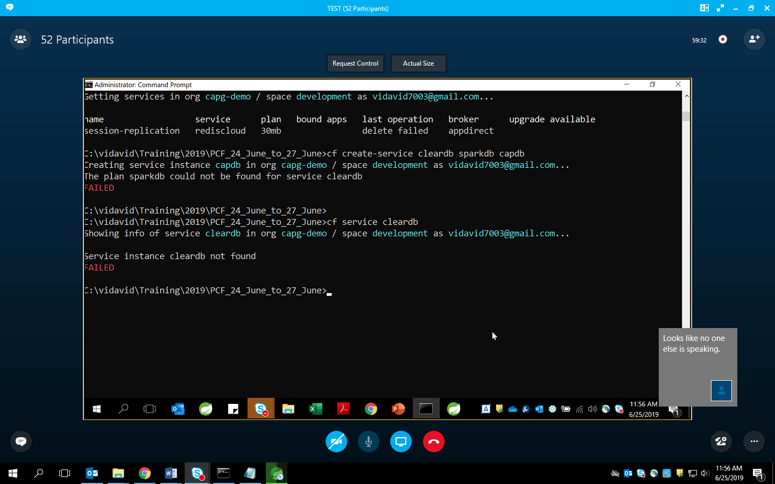

Cf create-service cleardb sparkdb capdb

Cf bind-service spring-music capdb

Bind- > restage -> new droplets & metadata has to be taken/updated

<https://github.com/caprepo/pcf>

Service Broker:  
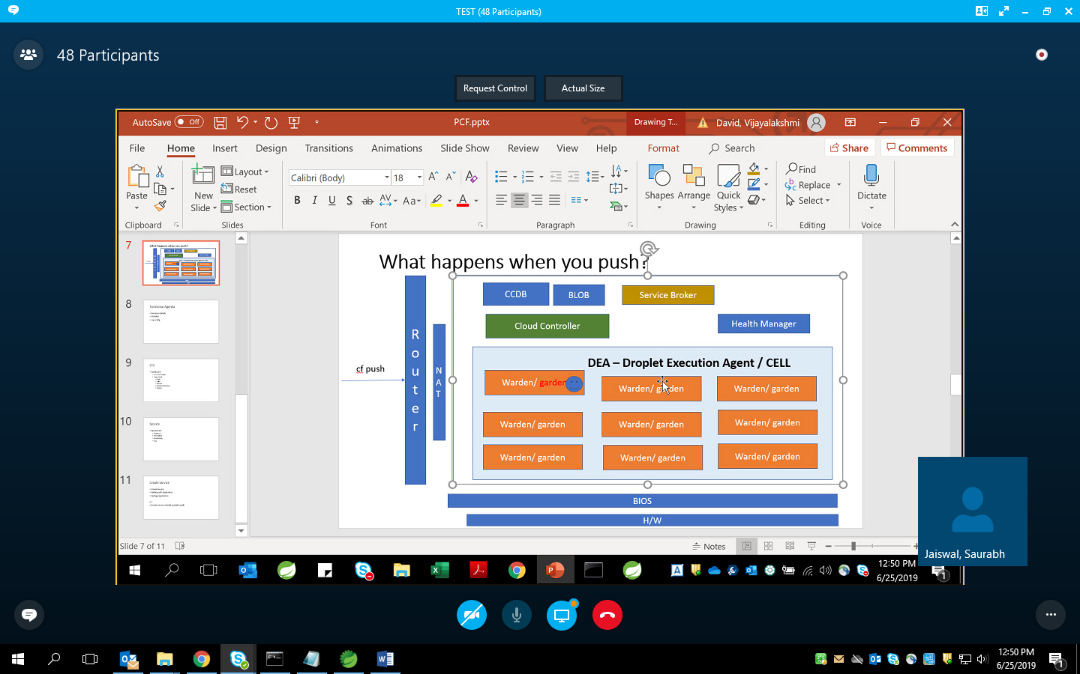

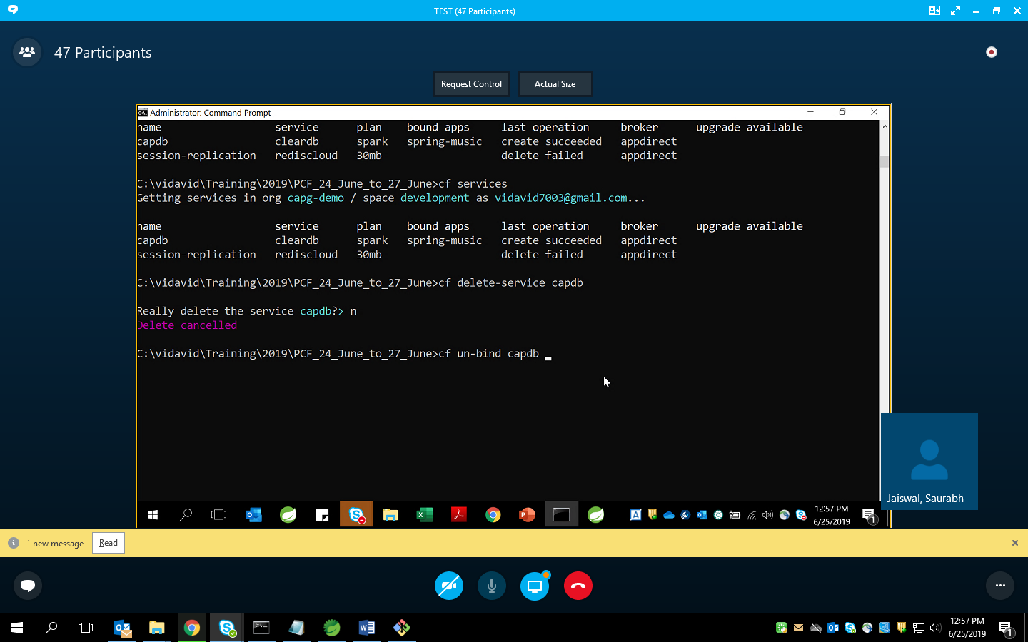

**DAY-3:**

[**https://github.com/cloudfoundry-community/staticfile-buildpack.git**](https://github.com/cloudfoundry-community/staticfile-buildpack.git)

Fork “<https://github.com/cloudfoundry/java-buildpack/blob/master/config/open_jdk_jre.yml>”

And then edit for java version

Cf push <> -p <> -I –m <> -b <forked github link>