1.What are the two values of the Boolean data type? How do you write them?
Ans: True and False. bool() function is used to get a Boolean value
Eg: x = 5
y = 10
print(bool(x==y))
Which returns false as a result

2. What are the three different types of Boolean operators?
Ans: Boolean operators are: and, or & not

3. Make a list of each Boolean operator's truth tables (i.e., every possible combination of Boolean values for the operator and what it evaluates).
Ans:
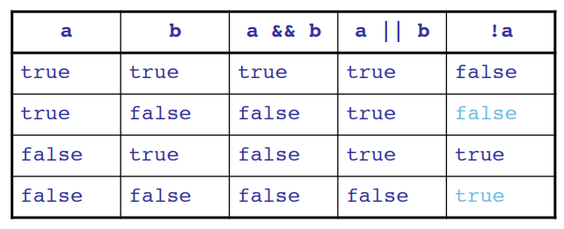

4. What are the values of the following expressions?
(5 > 4) and (3 == 5) => False
not (5 > 4) => False
(5 > 4) or (3 == 5) => True
not ((5 > 4) or (3 == 5)) => False
(True and True) and (True == False) => False
(not False) or (not True) => True

5. What are the six comparison operators?
Ans: Less than (<), Greater than (>), Less than or equal to (<=), Greater than or equal to (>=),
Equal to (==) and Not equal to (!=)

6. How do you tell the difference between the equal to and assignment operators? Describe a condition and when you would use one.
Ans: Assignment operator uses single equals to symbol while comparison operator has double equals to symbol in use.
Eg: a= 10, b = 15 / / Assignment operator
a==b // Comparison operator

7. Identify the three blocks in this code:
spam = 0
if spam == 10:
print('eggs')
if spam > 5:
print('bacon')
else:
print('ham')
print('spam')
print('spam')

Ans: Block of code means the lines of code written in same indentation, the code given here doesn’t have proper indentation, so will fix the indentations and re-write the question with the answer as shown below in the image.
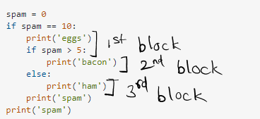
8. Write code that prints Hello if 1 is stored in spam, prints Howdy if 2 is stored in spam, and prints Greetings! if anything else is stored in spam.
Ans:
spam = input()
if spam == 1:
print('Hello')
elif spam == 2:
print('Howdy')
else:
print('Greetings!')

9. If your programme is stuck in an endless loop, what keys you’ll press?
Ans: To stop or break out of endless loop interrupt the kernel or kill the programme.
press I twice to interrupt the kernel (only works if you're in Command mode. If not already enabled, press Esc to enable it.)

10. How can you tell the difference between break and continue?
Ans: Break statement terminates the loop when provided conditions are satisfied.
Continue statement skips the rest of the loop statement and starts the next iteration of the loop to take place.

11. In a for loop, what is the difference between range(10), range(0, 10), and range(0, 10, 1)?
Ans: The resulting output of the given three statements are the same. The only difference are :-
range(10) : here only stop value is given
range(0, 10) : here start and stop value are given
range(0, 10, 1) : here start and stop value are given with the jump or step size

12. Write a short program that prints the numbers 1 to 10 using a for loop. Then write an equivalent program that prints the numbers 1 to 10 using a while loop.
Ans:
Using for loop: -
for i in range(1, 11):
print(i)

Using while loop: -
i = 1
while(i<=10):
print(i)
i += 1

13. If you had a function named bacon() inside a module named spam, how would you call it after importing spam?
Ans: spam.bacon()

