

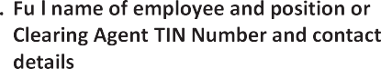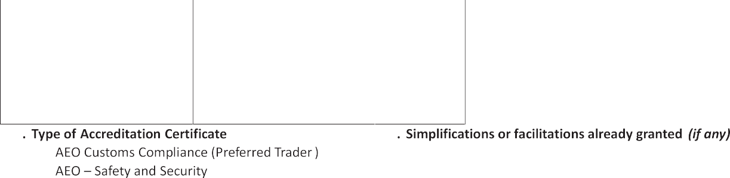









*Explanatory notes:*

1. **Applicant:** Enter the full name of the company / economic operator.
2. **Taxpayer Identification Number:** Enter the TIN as issued upon registration with ERS.
3. Legal status: Enter the legal status as mentioned in the document of establishment.
4. **Date of establishment:** Enter the day, month and year of establishment.
5. **Address of establishment:** Enter the full address of the place where your entity was established, including the country.
6. **Location of main place of business:** Enter the full address of the place of your business where the main activities are carried out.
7. **Website:** enter website of your company
8. **Contact person:** Indicate the full name, phone and fax numbers, and e-mail address of the contact person designated by you within your company to be contacted by the customs authorities when examining the application.
9. **Correspondence address:** Fill in only in case it differs from your address of establishment.
10. **Legal registration numbers:** The registration number issued by the company registration Ministry / administration in Eswatini.
11. **Management of Customs Clearances:** Indicate whether the company self- manages Customs clearances through an employee (i e. clearance is done in-house) or it uses a clearing agent for its customs declarations and if in-house, provide names of personnel responsible for customs clearance.
12. Employee name and position of the person responsible for in- house clearances or where customs clearing is outsourced provide the name and contact details of the clearing agent.
13. **Type of accreditation certificate:** Mark in the relevant box. AEO — Customs Compliance is equivalent to the Preferred Trader Program. (NB. Currently the ERS is implementing only the Customs Compliance accreditation program, AEO — Safety and Security is not yet operational)
14. **Simplifications or facilitations already granted:** Indicate the type of simplification / facilitative procedures already granted. Please include the relevant customs procedure/ the accreditation number.
15. **Name, date and signature of the applicant:**
    1. *Signature:* the signatory should add his capacity. The signatory should always be the person who represents the applicant as a whole.
    2. *Name: name of the applicant and the stamp of the applicant.*
    3. *Date: the date on which the application is signed and submitted for consideration to ERS*
    4. *Number of annexes: the applicant shall give the following general information:*
       * *Appendix 1 - Organizational chart of the Company*
       * *Appendix 2 - List of executive management and board members, stating names, roles, addresses and passport number.*
       * *Appendix 3 - List of principle shareholders / owners including percentage of shareholding / ownership and stating names, addresses and passport number.*

**Page 2 of 2**