ACKNOWLEDGEMENT

A very sincere and honest acknowledgement to Mr. Dhananjay V. Gadre, Assistant Professor, Electronics and Communication Engineering Division, NSIT, Delhi for providing us with an opportunity to work with him and undertake a project of such importance. Working under him has not only enriched us with technical knowledge but has also imparted the maturity of thought and vision, the attributes required to be a successful professional.
We are grateful to all our friends for providing critical feedback & support whenever required.
We regret any inadvertent omissions.

SAURABH GUPTA VIJAY MAJUMDAR
81-EC-05 97-EC-05

TABLE OF CONTENTS

- Table of Figures………………………………………………………………………………6
- Abstract………………………………………………………………………………………7
- Introduction…………………………………………………………………………………..8
  - Data Acquisition System……………………………………………………………………..8
  - Need for data acquisition system……………………………………………………………. 9
  - DAS IN NSIT……………………………………………………………………………….10
  - Objectives…………………………………………………………………………………...12
- Literature Overview…………………………………………………………………………13
  - WiFi (Wireless Fidelity)…………………………………………………………………….14
    - How a WiFi Network Works……………………………………………………………14
    - The Elements of a WiFi Network……………………………………………………….14
    - Protocols………………………………………………………………………………...14
    - FHSS……………………………………………………………………………………15
    - DSSS……………………………………………………………………………………16
    - Infrared Technology…………………………………………………………………….16
    - Orthogonal Frequency Division Multiplexing………………………………………….17
    - Transmitter……………………………………………………………………………...17
    - Reciever………………………………………………………………………………...18
    - Channels and International Compatibility……………………………………………...19
    - WiFi Network Topologies………………………………………………………………20
    - Network security………………………………………………………………………..20
    - Advantages Of a Wireless Network…………………………………………………….24
    - Disadvantages Of a Wireless Network…………………………………………………25
4.2 OpenmokoArchitecture…………………………………………………………………….26
4.2.1 Software Framework……………………………………………………………………..26
4.2.1.1 GTK+…………………………………………………………………………………..27
4.2.1.2 Qt toolkit……………………………………………………………………………….28
4.2.2 Hardware Framework……………………………………………………………………28
4.2.3 Openmoko Tools for development………………………………………………………30
4.2.4 Why Openmoko is used………………………………………………………………….31
4.3 Socket Programming………………………………………………………………………32
4.3.1 Berkeley Socket Interface………………………………………………………………..32
4.3.2 Socket API Functions……………………………………………………………………32
4.4 DATABASE MANAGEMENT SYSTEM………………………………………………...33
4.4.1 DBMS Building Blocks………………………………………………………………….34
4.4.2 Keys……………………………………………………………………………………...34
4.5 GRAPHICAL USER INTERFACE………………………………………………………..35
4.5.1 GTK+, GIMP Toolkit…………………………………………………………………….35
4.5.2 Architecture………………………………………………………………………………35
5. Design and Implementation…………………………………………………………………37
5.1 Client Model………………………………………………………………………………..37
5.2 Communication Model……………………………………………………………………..41
5.3 Server Model……………………………………………………………………………….43
6 Deployment of DAS in NSIT………………………………………………………………...49
7 CONCLUSIONS AND FUTURE SCOPE…………………………………………………...52
7.1 CONCLUSION…………………………………………………………………………….52
7.2 FUTURE SCOPE…………………………………………………………………………..53
7.2.1 . Speech Recognition API………………………………………………………………53
7.2..2 Image Processing API………………………………………………………………….53
8. References and Bibliography………………………………………………………………54
9. APPENDIX...........................................................................................................................55
Appendix A..........................................................................................................................55
Appendix B..........................................................................................................................56
Appendix C..........................................................................................................................59
Appendix D..........................................................................................................................62

1. LIST OF FIGURES

Figure # | Title | Page #
1. | Module present in DASO | 8
2. | WiFi Adhoc Network | 14
3. | OFDM Transmitter | 18
4. | OFDM Receiver | 18
5. | Frequency Spectrum | 19
6. | WiFi LAN | 20
7. | Security in WiFi | 23
8. | Software Stack of OpenMoko | 26
9. | Hardware model of OpenMoko | 29
10. | An EMP table (Database) | 32
11. | Beginning Window of the application | 37
12 | Class Selection Window | 38
13. | Attendance List Window | 39
14. | Notes List Window | 40
15. | Individual Note Sheet | 40
16 | Pending data sending Window | 41
17. | Topic Page : Website | 45
18. | Class Performance Page : Website | 46
19. | Attendance Statistics Page : Website | 48
20. | Individual Student Statistics Page : Website | 49

- Abstract

Our project implements Data acquisition system on Openmoko (DASO) for NSIT in which we acquire data manually on a device called Openmoko and process it on a central remote server. The data is sent in encrypted format using Wireless mode. Encryption provides a high level of data security and minimizes the risk of data disclosure. The wireless communication is done via Wi-Fi from client (openmoko) to server. Redundancy has been implemented in data sending to avoid any data loss. A complete database has been implemented to store data on server side in an organized way.

This paper shows how the different kind of data can be acquired in an easy and organized way and processed on a computationally efficient machine. This system aims at implementing a complete automated data processing system.

This project deals on the 4th and upper layer of OSI networking model. From a practical perspective, this system removes all the overhead of manual storage and processing of different type of data acquired and provides a consistent and secure facility. The processed data can be viewed by the intra college website available through the LAN available in NSIT. Currently the project handles the data for attendance and remarks about class and students.

3. Introduction

3.1 Data Acquisition System (DAS)

Data acquisition is the sampling of the real world to generate data that can be manipulated by a computer. Acquired data are displayed, analyzed, and stored on a computer, either using custom made software, or custom displays and control can be developed using various general purpose programming languages such as C, C++, Python, PHP and the database can be handled using standard structured query language (SQL).

In a data acquisition system, there are several components which are integrated together and proper interface between these sub modules is necessary. The main parts of it are data acquiring unit, communication interface and data processing unit. In this project, communication is done wirelessly and data acquiring unit is a portable hand held embedded device. The following figure shows the main component of a data acquisition system.

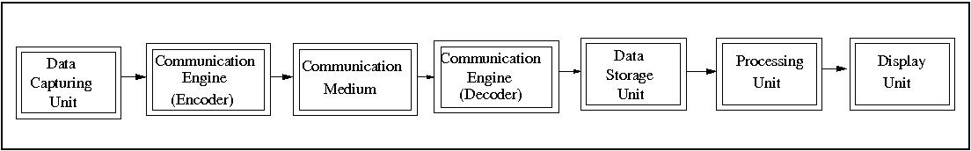

Figure 1: Modules present in a data acquisition system

3.2 Need for data acquisition system

Collecting and reporting of data have become increasingly complex tasks for the analysts now a day. With growing complexity and huge data set, the need for an automated data capturing and processing unit arises. Now a days, in every field from experimentation to process testing, set of data and records are required which need processing on large scale. Such calculation is not advisable to be done manually and hence data acquisition system tools and systems are developed.

In disaster management systems, DAS is used extensively which retrieves data from various sensors and report to the control team automatically. Now a days, in weather forecasting, DAS is used extensively to predict the weather using various sensors.

In education system also, data processing is required. One such example is the student’s attendance records and their performance analysis. Often, remarks are given to students based on their performance by teachers but these are difficult to handle. Also, the attendance statistics are quite cumbersome to calculate. In such cases, data acquisition tool for handling all these information become a necessary thing.

3.3 DASO IN NSIT

This project aims to implement data acquisition system for acquisition of data on an hand held portable device. The data can be of any form. In this project, the application is built to facilitate teachers to take attendance, notes and other student's data and sending it wirelessly to a central server where data processing takes place and result can be viewed on an intra-college website. The various modules for data acquisition system in this project are:

Data Capturing Unit: It captures the data from the real world in digital form. This will be a portable touch sensitive embedded device called Neo Freerunner using software stack named Openmoko. The device consists of ARM 16/32 processor with 250/400 MHz frequency. However, the application is developed in a way that it can be ported on any portable device provided it has a linux kernel running on it.

Communication Engine: This works to set up the communication and to encode/decode the acquired data in proper format. The communication is done to transfer the data from Data capturing unit and Data storage unit. In this project, this is a program written in C++ which works on the network layer to create a socket connection with the central server.

Communication Medium: The medium is Wireless communication using Wi-Fi protocol.

Data Storage Unit: This is a server with enough memory (more than 40GB) to store data in the form of databases which can be read using SQL.

Processing Unit: This is a computer which sufficient processing resource. It interfaces with the data storage unit and processes the data.

Display Unit: The processed data can be seen in form of tables and graphical user interface through an intra-college website. Every teacher has an account on the website and the result can be seen after logging in with the password set by user (teachers here).

3.4 Objectives

The major objectives of this project are:

- Application for data capturing on Openmoko – To record various information, a proper GUI is made for client device. The application uses gtk+ library to build the GUI.

- Setting up a communication mode – The transfer of data from client to serve will be done through a communication engine which uses college Wi-Fi.

- Setting up a server using LAMP – a server which receives data from remote client is set up using Linux – Apache – MYSQL – PHP. The server uses the socket crates a socket connect at a fixed IP and port number through which client communicates.

- Setting up an intra college website – An intra college website is setup using glfusion as the platform. All kind of data statistics are available on it and can be accesses via any computer in NSIT.

4. Literature Overview
4.1 WiFi (Wireless Fidelity)

WiFi (Wireless Fidelity) is a generic term that refers to the IEEE 802.11 set of standards for wireless local area networks (WLANs). The WiFi Alliance tests the wireless components to their own terms of reference. Products that pass become WiFi certified and may carry the WiFi logo. WiFi certification is provided for technology used in home networks, mobile phones, video games, and other devices that require wireless networking.

4.1.1 How a WiFi Network Works

WiFi is supported by most personal computer operating systems, many game consoles, laptops, smart-phones, printers, and other peripherals. The basic principle behind WiFi is almost the same as a walkie talkie. A WiFi hotspot is created by installing an access point to an internet connection. An access point acts as a base station. When a WiFi enabled device encounters a hotspot the device can then connect to that network wirelessly.
A single access point can support up to 30 users and can function within a range of 100-150 feet indoors and up to 300 feet outdoors. Many access points can be connected to each other via ethernet cables to create a single large network.

4.1.2 The Elements of a WiFi Network

A WiFi network is composed of the following main 3 components -
1. Access Point (AP) – The AP is a wireless LAN transceiver or “base station” that can connect one or many wireless devices simultaneously to the internet.

- WiFi Cards – They accept the wireless signal and relay information. They can be internal and external.(eg. PCMCIA card for laptop and PCI card for desktop PC).
- Safeguards – Firewalls and anti- virus software protect networks from unauthorized access and keep information safe and secure.

The WiFi Technology
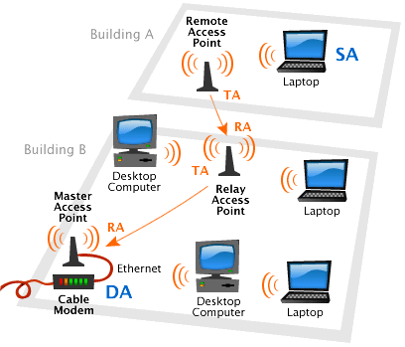

Fig 2. WiFi Adhoc Network

Wi Fi networks use the IEEE 802.11 technology standards for WLAN.
IEEE 802.11 is a set of standards carrying out wireless local area network (WLAN) computer communication in the 2.4, 3.6 and 5 GHz frequency bands. They are implemented by the IEEE LAN/MAN Standards Committee (IEEE 802).

4.1.3 Protocols

802.11-1997 (802.11 legacy)
It specified two net bit rates of 1 or 2 megabits per second (Mbit/s), plus forward

error correction code. It specifed three alternative physical layer technologies: diffuse infrared operating at 1 Mbit/s; frequency-hopping spread spectrum operating at 1 Mbit/s or 2 Mbit/s; and direct-sequence spread spectrum operating at 1 Mbit/s or 2 Mbit/s.
4.1.4 FHSS
Frequency-hopping spread spectrum (FHSS) is a method of transmitting radio signals by rapidly switching a carrier among many frequency channels, using a pseudorandom sequence known to both transmitter and receiver. It is utilized as a multiple access method in the frequency-hopping code division multiple access (FH-CDMA) scheme.
A spread-spectrum transmission offers three main advantages over a fixed-frequency transmission:
- Spread-spectrum signals are highly resistant to narrowband interference. The process of re-collecting a spread signal spreads out the interfering signal, causing it to recede into the background.
- Spread-spectrum signals are difficult to intercept. An FHSS signal simply appears as an increase in the background noise to a narrowband receiver. An eavesdropper would only be able to intercept the transmission if they knew the pseudorandom sequence.
- Spread-spectrum transmissions can share a frequency band with many types of conventional transmissions with minimal interference. The spread-spectrum signals add minimal noise to the narrow-frequency communications, and vice versa. As a result, bandwidth can be utilized more efficiently.

4.1.5 DSSS
In telecommunications, direct-sequence spread spectrum (DSSS) is a modulation technique. The name 'spread spectrum' comes from the fact that the carrier signals occur over the full bandwidth (spectrum) of a device's transmitting frequency.
1. It phase-modulates a sine wave pseudo randomly with a continuous string of pseudo noise (PN) code symbols called "chips", each of which has a much shorter duration than an information bit. That is, each information bit is modulated by a sequence of much faster chips. Therefore, the chip rate is much higher than the information signal bit rate.
2. It uses a signal structure in which the sequence of chips produced by the transmitter is known a priori by the receiver. The receiver can then use the same PN sequence to counteract the effect of the PN sequence on the received signal in order to reconstruct the information signal.

4.1.6 Infrared Technology
The IEEE 802.11 standard also provides for an alternative to radio waves: infrared light. The primary feature of infrared technology is the use of a light wave to transmit data. These transmissions travel mono-directionally, whether by using a direct line of sight or reflected off a surface. The non-diffuse nature of light waves offers a higher level of security. With infrared technology, it is possible to send data at 1 to 2 Mbits/sec per second by using a kind of modulation called PPM

4.1.7 Orthogonal Frequency Division Multiplexing
Orthogonal frequency division multiplexing (OFDM) essentially identical to Coded OFDM (COFDM) and Discrete multi-tone modulation (DMT) is a frequency division multiplexing (FDM) scheme utilized as a digital multi-carrier modulation method. A large number of closely-spaced orthogonal sub-carriers are used to carry data. The data is divided into several parallel data streams or channels, one for each sub-carrier. Each sub-carrier is modulated with a conventional modulation scheme at a low symbol rate, maintaining total data rates similar to conventional single-carrier modulation schemes in the same bandwidth.
OFDM has developed into a popular scheme for wideband digital communication, whether wireless or over copper wires, used in applications such as digital television and audio broadcasting, wireless networking and broadband internet access.
4.1.8 Transmitter
An OFDM carrier signal is the sum of a number of orthogonal sub-carriers, with baseband data on each sub-carrier being independently modulated commonly using some type of quadrature amplitude modulation (QAM) or phase-shift keying (PSK). This composite baseband signal is typically used to modulate a main RF carrier.

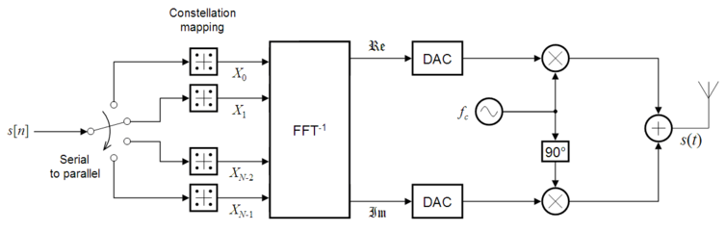
Figure 3: OFDM Transmitter
s[n] is a serial stream of binary digits. By inverse multiplexing, these are first demultiplexed into N parallel streams, and each one mapped to a (possibly complex) symbol stream using some modulation constellation (QAM, PSK, etc.).
An inverse FFT is computed on each set of symbols, giving a set of complex time-domain samples. These samples are then quadrature-mixed to passband in the standard way. The real and imaginary components are first converted to the analogue domain using digital-to-analogue converters (DACs); the analogue signals are then used to modulate cosine and sine waves at the carrier frequency, fc, respectively. These signals are then summed to give the transmission signal, s(t).

4.1.9 Receiver
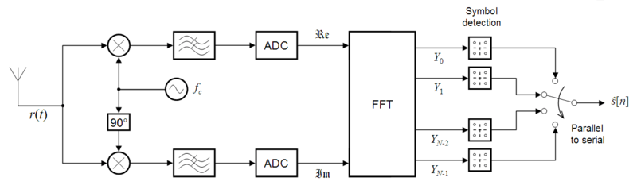
Figure 4: OFDM Receiver
The receiver picks up the signal r(t), which is then quadrature-mixed down to baseband using cosine and sine waves at the carrier frequency. This also creates

signals centered on 2*fc, so low-pass filters are used to reject these. The baseband signals are then sampled and digitised using analogue-to-digital converters (ADCs), and a forward FFT is used to convert back to the frequency domain.
This returns N parallel streams, each of which is converted to a binary stream using an appropriate symbol detector. These streams are then re-combined into a serial stream, which is an estimate of the original binary stream at the transmitter.

4.1.10 Channels and International Compatibility

802.11 divides each of the above-described bands into channels, analogously to how radio and TV broadcast bands are carved up but with greater channel width and overlap. For example the 2.4000–2.4835 GHz band is divided into 13 channels each of width 22 MHz but spaced only 5 MHz apart, with channel 1 centred on 2.412 GHz and 13 on 2.472 GHz to which Japan adds a 14th channel 12 MHz above channel 13.
Availability of channels is regulated by country, constrained in part by how each country allocates radio spectrum to various services.

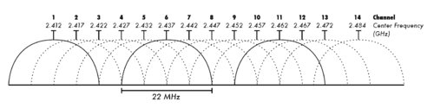
Figure 5: Frequency spectrum

4.1.11 WiFi Network Topologies

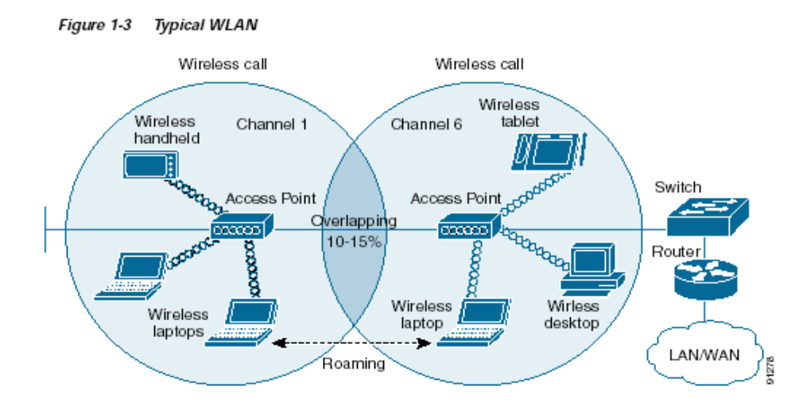
- AP based topology – The client communicates through access point. BSA – RF coverage is provided by an AP. The ESA consists of 2 or more BSA and includes 10-15% overlap to allow roaming.
Figure 6: Wi-Fi LAN

- Peer to Peer topology – AP is not required and client devices within a cell can communicate directly with each other. It is useful for setting up of a wireless network quickly and easily.
- Point to Point multipoint bridge topology – This is used to connect a LAN in one building to LANs in other buildings even if the buildings are miles apart. These conditions recieve a clear line of sight between buildings. The line of sight varies based on the type of wireless bridge and antennae used as well as the environmental conditions.

4.1.12 Network security
The main issue with wireless network security is its simplified access to the network compared to traditional wired networks such as ethernet. With wired networking it is necessary to get past either gain access to a building, physically connecting into the internal network or break through an external firewall. With wireless it is necessary only to get reception and spend as long as you want snooping without alerting the network owner.
Attackers who have gained access to a WiFi network can use DNS spoofing attacks very effectively against any other user of the network, because they can see the DNS requests made, and often respond with a spoofed answer before the queried DNS server has a chance to reply.
Threats To The Network
- Eavesdropping – Eavesdropping is an easy to perform and almost impossible to detect technique. By default, everything is transmitted in clear text usernames, passwords etc.. and no security is offered by the transmission medium. Different tools are available to cause eavesdropping, network sniffers, protocol analyzers and
password collectors etc.
- MITM attack – Attacker spoofs a disassociate message from the victim and the victim starts to look for a new access point, and the attacker advertises his own AP on a different channel, using the real AP's MAC address. The attacker connects to the real AP using victim's MAC address.
- Denial Of Service – This is an attack on the transmission frequency used and causes frequency jamming. Attacks on MAC layer causes spoofed de-authentication/disassociation messages and can target one specific user.
Requirements for WiFi security
The requirements for Wi Fi security can be broken down into two primary components-

- Authentication
  - User Authentication
  - Server Authentication
- Privacy
Authentication requires maintaining a record of the users that have secure access to the system and keeps unauthorized users off the network.
For User authentication an authentication server is used which asks for a password and a username whenever a user desires to login to the network.
The risk involved in this is the fact that the data (username and password) are sent before secure transmission path is established. It is also prone to passive eavesdropping by the attacker.
The solution to this problem is to establish an encrypted channel before sending username and password.
The next level of authentication is the – Server Authentication for which a digital certificate is used and validation of the digital certificate occurs automatically within the client software.
Security Techniques
Service Set Identifier – SSID is used to identify an 802.11 network and it can be preconfigured or advertised in beacon broadcast. It is transmitted in clear text and thus provides very little security.

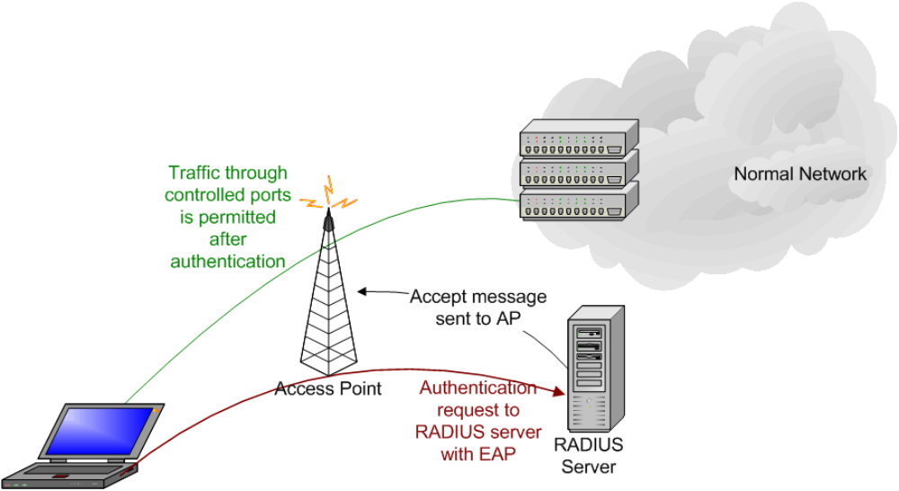
Wired Equivalent Privacy (WEP) – WEP was included as the privacy of the

Figure 7: Security in Wi-Fi
original IEEE 802.11 standard ratified in September 1999. WEP uses the stream cipher RC4 for confidentiality, and the CRC-32 checksum for integrity. It was deprecated as a wireless privacy mechanism in 2004, but for legacy purposes is still documented in the current standard.

- 802.1x Access Control – This is designated as a general purpose network access control mechanism and isn't Wifi specific. Authentication of each client connected to an AP is done with a radius server (for Ethernet). The RADIUS server, which “tells” the access point whether access to controlled ports should be allowed or not.
- Wi-Fi Protected Access (WPA and WPA2) – It is a certification program created by the WiFi alliance to indicate compliance with the security protocol created by the WiFi Alliance to secure wireless computer networks. This protocol was created in

response to several serious weaknesses researchers had found in the previous system, Wired Equivalent Privacy (WEP). The protocol implements the majority of the IEEE 802.11i standard, and was intended as an intermediate measure to take the place of WEP.
WPA comes in two flavours
WPA-PSK
    - Uses a pre shared key
    - For SOHO environments
    - Single master key used for all users
WPA Enterprise
    - For large organizations
    - Most secure method
    - Unique keys for each user
    - Separate username & password for each user
Data is encrypted and protection against eavesdropping and man in the middle

4.1.13 Advantages Of a Wireless Network
- Mobility
- Ease of installation
- Flexibility
- Cost
- Reliability

- Security
- Speed
4.1.14 Disadvantages Of a Wireless Network
- Interference
- Degradation in performance
- High power consumption
- Limited range

4.2 OpenmokoArchitecture
Openmoko is a project dedicated to delivering mobile phones with an open software stack. Openmoko is a project driven by a community of passionate and intelligent volunteers. Openmoko, born as an Open Source project under GPL and LGPL license, is dedicated to deliver an open software stack on mobile platforms.

4.2.1 Software Framework

The framework consists of many cross compilers for C, C++, python and many more. All libraries support for building applications can be found here. The software architecture of Openmoko is given in the next figure.

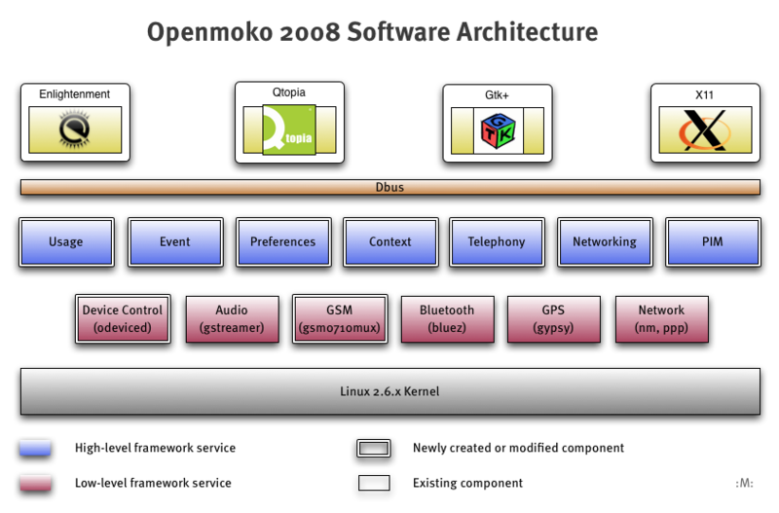

Figure 8 : Software Stack of Openmoko

Unlike most other mobile phone platforms, the phones on which Openmoko Linux runs are designed to provide end users with the ability to modify the operating system and software stack. The platform is also supported by other mobile phones.

Openmoko Linux uses the Linux kernel, GNU libc, the X. Org server plus their own graphical user environment built using the EFL toolkit, GTK+ toolkit, Qt toolkit and the illume window manager (previously Matchbox window manager) . The Open Embedded build framework and a modified version of ipkg package system, called Opkg, are used to create and maintain software packages.

4.2.1.1 GTK+
GTK+, or The GIMP Toolkit, is a cross-platform widget toolkit for creating graphical user interfaces. It is one of the most popular toolkits for the X Window System, along with Qt.
GTK+ was initially created for the GNU Image Manipulation Program (GIMP), a raster graphics editor, in 1997 by Spencer Kimball and Peter Mattis, members of eXperimental Computing Facility (XCF) at UC Berkeley.
Licensed under the LGPL, GTK+ is free software and is part of the GNU Project.
GTK+ is written in the C programming language, and its design uses the GObject object system. The GNOME platform provides language bindings for:

* C
* C++ (gtkmm)
* Perl (Gtk2-perl)
* Ruby (ruby-gtk2)
* Python (PyGTK)
* Java (java-gnome) (not available for Microsoft Windows)

4.2.1.2 Qt toolkit
Qt (pronounced as the English word "cute") is a cross-platform application development framework, widely used for the development of GUI programs (in which case it is known as a widget toolkit), and also used for developing non-GUI programs such as console tools and servers.
Qt uses C++ with several non-standard extensions implemented by an additional pre-processor that generates standard C++ code before compilation. Qt can also be used in several other programming languages; via language bindings. It runs on all major platforms, and has extensive internationalization support. Non-GUI features include SQL database access, XML parsing, thread management, network support and a unified cross-platform API for file handling.

4.2.2 Hardware Framework
The device is a portable touch sensitive mobile phone which has the following hardware specifications and supports the following with software also.

Hardware Electrical

- 400/500 MHz Samsung 2442B Processor/SOC (400 minimum, ARM920T core, ARMv4T)
- Boot code in NAND FLASH or 2MB NOR FLASH (optional design)
- 128 MB SDRAM total, 64 MB CPU internal, 64 MB external
- 256MB NAND Flash MCP package.

Display

- Topploy VGA, 16 bit color depth
- resolution: 480 x 640 pixels
- size: 43mm x 58mm (1.7” x 2.27”)

- White LED backlight. Required brightness is 200 NIT minimum.
WiFi 802.11 b/g transceiver

- TX power at 11 Mbps: 13 dBm minimum
- RX sensitiveity at 11 Mbps: -89 dBm desired, -83 dBm minimum

Serial interfaces (UART)

- A-GPS or GPS
- GSM/GPRS
Accelerometer

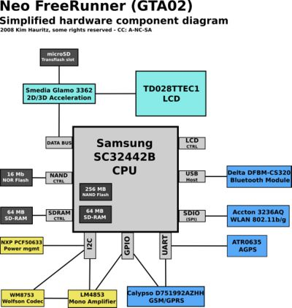
- 2x accelerometer required

Figure 9 : Hardware model of OpenMoko

GPS and AGPS

- GPS chipset receiver and antenna
- Sensitivity at Antenna port: -157 dBm tracking on chipset specification

4.2.3 Openmoko Tools for development

There are a lot of tools available for developing application on the Openmoko platform.

- Openmoko toolchain: A prebuilt toolchain is available for directly developing applications for Openmoko and cross compilation. The speech recognition project is developed using this toolchain. It is available for i686 and x86_64 hardware platforms.

- Openembedded: The popular openembedded and bitbake platform is also available for compiling and building applications on Openmoko platform. The whole distribution image can be compiled using bitbake utility.

- Emulator: Applications developed for Openmoko can be tested and emulated using the qemu emulator available for Openmoko. Qemu loads the available Openmoko distribution image and then emulates the device and is used for testing purposes.

4.2.4 Why Openmoko is used
Openmoko is a project that combines the true essence of open source with a rich application-programming interface. Openmoko is a true conversion of the desktop Linux into mobile Linux, which doesn’t bring in any non-standard or hidden aspects. It was built using standard X-server, GTK, ALSA, Dbus and so on. The beauty is that even the hardware platform is as open as the software platform. Openmoko makes use of a standard platform to make the mobile environment complete. With rich libraries and APIs available for openmoko, application development is so easy. Also, the availability of phones along with cost effectiveness and good performance adds up the reason for using openmoko in this project.

4.3 Socket Programming

4.3.1 Berkeley Socket Interface

The Berkeley socket interface, an API, allows communications between hosts or between processes on one computer, using the concept of an Internet socket. It can work with many different I/O devices and drivers, although support for these depends on the operating-system implementation. This interface implementation is implicit forTCP/IP, and it is therefore one of the fundamental technologies underlying the Internet. The Berkeley sockets application programming interface (API) comprises a library for developing applications in the C programming language that perform inter-process communication, most commonly across a computer network.

4.3.2 Socket API Functions
- socket () creates a new socket of a certain socket type, identified by an integer number, and allocates system resources to it.
- bind () is typically used on the server side, and associates a socket with a socket address structure, i.e. a specified local port number and IP address.
- listen () is used on the server side, and causes a bound TCP socket to enter listening state.
- connect () is used on the client side, and assigns a free local port number to a socket. In case of a TCP socket, it causes an attempt to establish a new TCP connection.

4.4 DATABASE MANAGEMENT SYSTEM

A database management system (DBMS) is computer software that manages databases. DBMSes may use any of a variety of database models, such as the network model or relational model. In large systems, a DBMS allows users and other software to store and retrieve data in a structured way.

DBMS are categorized according to their data structures or types. It is a set of prewritten programs that are used to store, update and retrieve a Database. The DBMS accepts requests for data from the application program and instructs the operating system to transfer the appropriate data.

Database servers are computers that hold the actual databases and run only the DBMS and related software. Database servers are usually multiprocessor computers, with generous memory and RAID disk arrays used for stable storage. Connected to one or more servers via a high-speed channel, hardware database accelerators are also used in large volume transaction processing environments. DBMSs are found at the heart of most database applications.

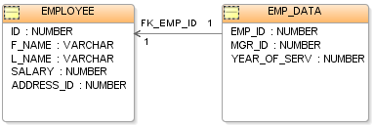

Fig. An EMP Table(Database)

4.4.1 DBMS Building Blocks

A DBMS includes four main parts: modeling language, data structure, database query language, and transaction mechanisms.
4.4.2 Keys

A primary key is a column or set of columns that uniquely identifies the rest of the data in any given row.
A foreign key is a column in a table where that column is a primary key of another table, which means that any data in a foreign key column must have corresponding data in the other table where that column is the primary key. In DBMS-speak, this correspondence is known as referential integrity.

4.5 GRAPHICAL USER INTERFACE
A Graphical User Interface is a type of user interface which allows people to interact with electronic devices such as computers; hand-held devices.

4.5.1 GTK+, GIMP Toolkit
It is a cross-platform widget toolkit for creating graphical user interfaces. GTK+ is written in the C programming language, and its design uses the GObject object system.
GTK+ is a highly usable, feature rich toolkit for creating graphical user interfaces which boasts cross platform compatibility and an easy to use API. GTK+ it is written in C, but has bindings to many other popular programming languages such as C++, Python and C# among others. GTK+ is licensed under the GNU LGPL 2.1 allowing development of both free and proprietary software with GTK+ without any license fees or royalties.

    - Architecture
Over time GTK+ has been built up to be based on four libraries, also developed by the GTK+ team:
- Glib: A low-level core library that forms the basis of GTK+. It provides data structure handling for C, portability wrappers and interfaces for such run-time functionality as an event loop, threads, dynamic loading and an object system.
- Pango: A library for layout and rendering of text with an emphasis on internationalization. It forms the core of text and font handling for GTK+ 2.0.
- Cairo: A library for 2D graphics with support for multiple output devices
- (including the X Window System, Win32) while producing a consistent output on all media while taking advantage of display hardware acceleration when available.
- ATK: A library for a set of interfaces providing accessibility. By supporting the ATK interfaces, an application or toolkit can be used with tools such as screen readers, magnifiers, and alternative input devices.

5 Design and Implementation

The design model of this project mainly uses three parts – client side, communication model and server side. These are discussed in detail in the following parts.

5.1 Client Model

Client side system completely runs on the OpenMoko side. Its does the following important tasks:
Providing GUI for taking attendance, notes & sending pending data:
When the client program is initiated then a GUI is run which provides the user with the option, whether he wants to take Attendance, Notes or send pending data.
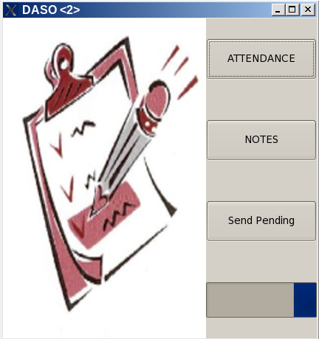
Fig 11. Beginning Window of the application

  - Take Attendance:
If attendance is selected then a combo box appears which lets the user to select a class from the list of classes in the database. This leads to a window with the list of student of the class selected. The teacher can take attendance on this window. The attendance is saved locally on OpenMoko & is sent via Communication Engine running in the background. The file sent is received & parsed at the sever side which is discussed in the Server Model.

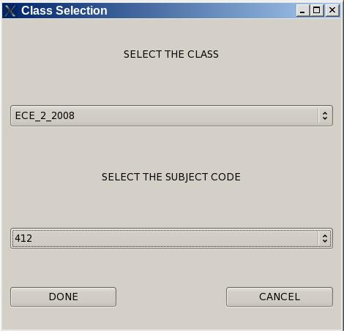
Fig 12. Class Selection Window

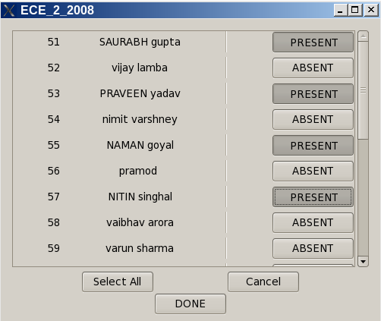
Fig 13. Attendance List Window
  - Take Notes:
If notes is selected then a combo box appears which lets the user to select a class from the list of classes in the database. This leads to a window with the list of student of the class selected. The teacher can take notes on this window. The notes is saved locally on OpenMoko & is sent via Communication Engine running in the background. The file sent is received & parsed at the sever side which is discussed in the Server Model.

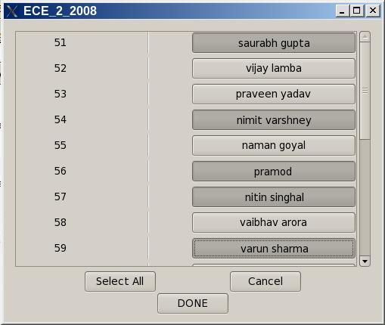
Fig 14. Notes List Window
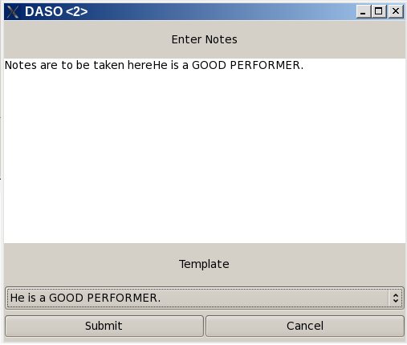
Fig 15. Individual Note Sheet
  - SEND PENDING DATA:
When send pending data is selected then a window appears that asks if you want to send the pending data Via WiFi or Via Wired connection. Then the list of files pending is sent to server via Communication engine which runs a script on the server to download all the files pending to be sent to the server.

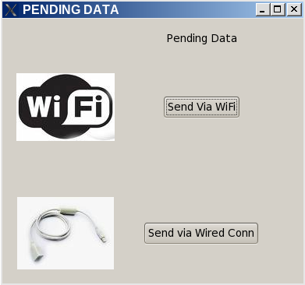
Fig 16. Pending data sending window

5.2 Communication Model

This part is a separate process which works with the GUI. GUI part and communication engine communicate with each other through IPC (inter process communication). This engine is responsible for sending and retrieval of data from the Central Database. The main features of communication engine are:

- Wireless communication
- Encryption of data transferred
- Redundancy for data sending and acknowledgement
- Local data backup in case of communication failure
The communication is done on the network layer implemented in C++ and PHP. Socket programming is used extensively to bind the socket with an available network. On Openmoko side, communication protocol is written in C++ and data is transferred through TCP/IP protocol. On server, a similar application is running which receives/sends data on a pre defined port and IP.
If the connection cannot be built at the time attendance is taken, the output file is stored locally. Next time, whenever a communication is made through WiFi, all pending files will be sent and database will be updated. A provision is also made by which the the data stored on Openmoko can be sent to database server by attaching it with PC and a proper GUI will be made for that. This feature is helpful in case wi-fi connection is not working in the college.
Data sent is encrypted with a hashing algorithm developed as explained in appendix. This ensures data security and minimizes the risk of data disclosure. Redundancy has been for file transfer so that no data packet is lost and a proper acknowledgement is sent back to client to confirm the receipt of data packet.

5.3 Server Model

Server side system has mainly three jobs which it performs over its whole life time. These are:

- Communication with remote client :
Server always remain in listening state to receive data from remote client. The communication is done by the same model as described in communication model. The data received is decrypted and acknowledgement is sent back to client. A socket is created by the server and resources are alloted to it. Whenever any data file is received, it is sent for parsing and the next job is performed.

- Processing the data:
This is one of the major work to be done by server model. The received data is parsed and and then stored in the database system set at server side. The database used is MYSQL and model used is referential. The following figure shows the basic data table used in the MYSQL database for storing the stduent's data. Here, attendance and remarks are to be stored along with proper time stamp and other information.
The database is queried from time to time to retrieve the stored records. Currently, the processing is done for the following statistics:

- Maintaining the attendance record for every student and each class:
The processing is done so that the attendance record for every stduent and every class for every month or for over a period of several months is calculated.

- Viewing the percentage of attendance and distribution of attendance according to days and months of a given period:

This result is calculated and displayed in the form of pie charts, line graphs and histograms. User can choose any duration for which he/she wants to view the attendance distribution.

- View Class performance:
The overall class performance in terms of attendance and any remarks given is calculated and processed. The list of stduents less than 75% attendance is also displayed.

- View remarks about the whole class or particular students
The remarks written by teacher about the whole class or some stduents are stored in the database with proper time stamp and subject code.

- Displaying the result:
All the processed result is stored in the database and is available to users via NSIT's intra college website which is developed on the platform of glfusion. Every teacher will be given an account name and password which is required to avail the site. A student can also view some limited result on the website also. An overview of the site is as:

Fig. 17. Topic Page : Website
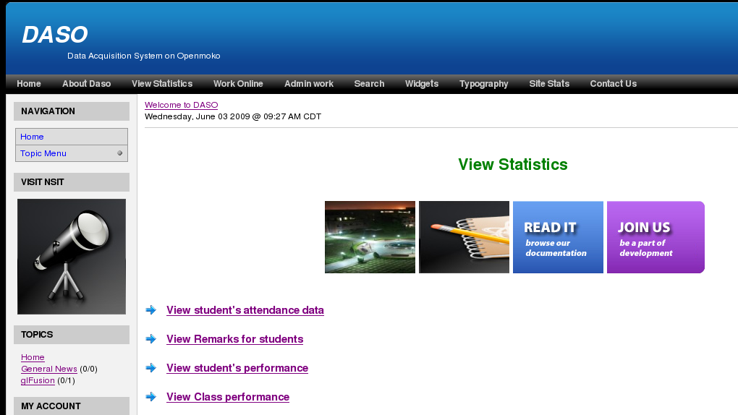

The website running on server will be using the LAMP (linux apache mysql php) technology. A static IP and domain name is set for the website through which it can be accessed from any room in NSIT.

The different results for the student's performance and statistics are displayed in the following formats:

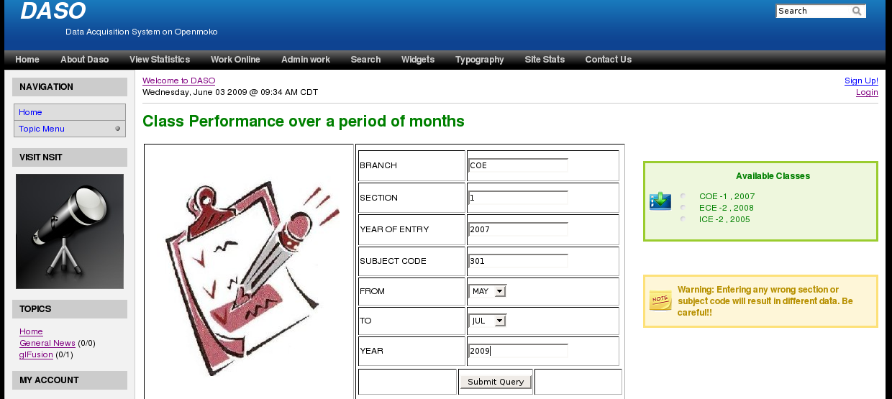
- Viewing the class performance:

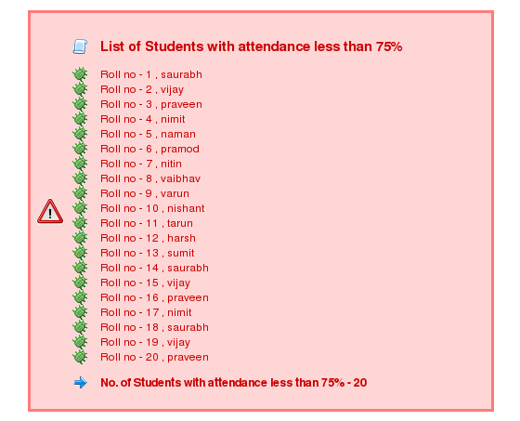

- Viewing attendance statistics:

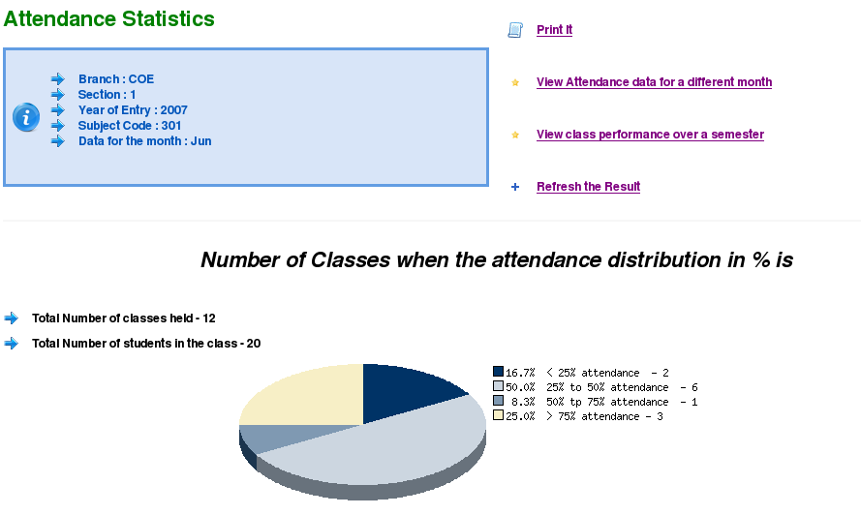

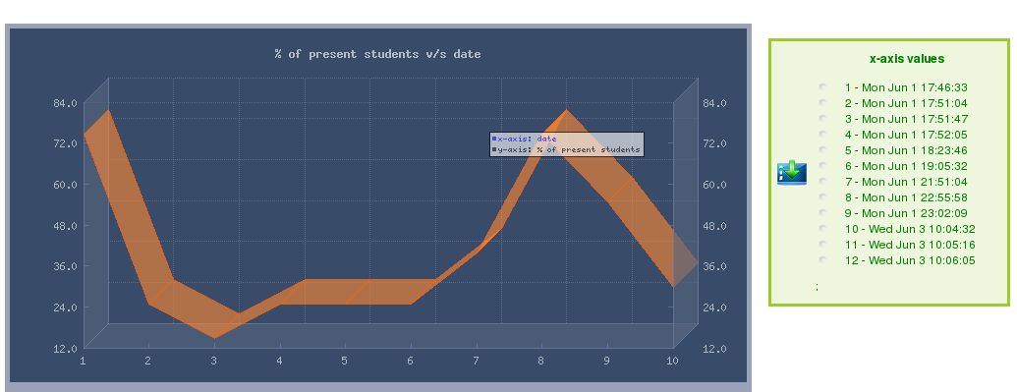

Fig 18. Class Performance Page : Website

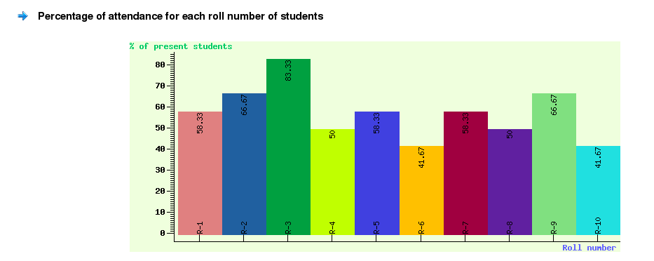

Fig 19. Attendance Statistics Page : Website

- View Remarks about a student

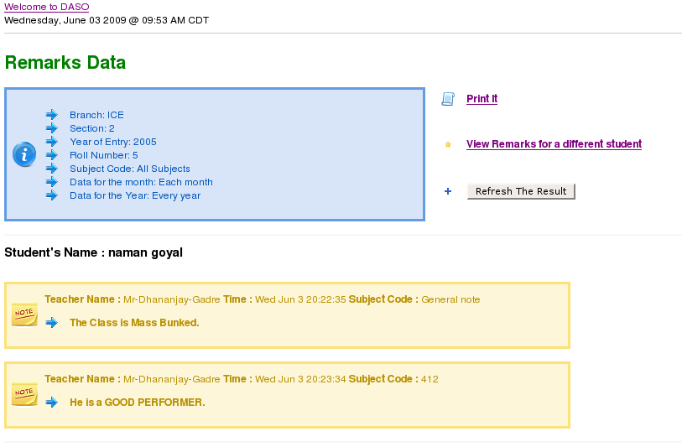
Fig 20. Individual Student Statistics Page : Website

Along with viewing results online through website, facility is made so that attendance and remarks can be added for a class or student through website directly. This feature is available under the tag of “work online”. Here teacher can choose the class and then record the data online. This feature is provided in case the openmoko device for data acquiring is not working.

6. Deployment of DAS in NSIT
This will include the deployment of:

- WiFi system in NSIT:
A WiFi system with enough range and payload capacity is setup is the college. Each OpenMoko will be provided with a unique ID & IP. In this LAN technology a Server setup will be employed with Static IP, the underlying technology will be LAMP on a Linux system, which will operate 24x7 with proper battery backup.

- LAMP Server:
LAMP (LINUX- Apache – PHP - My SQL) Server will be setup in the Lab which will run 24x7 listening to the client request sent by the OpenMoko to register attendance, notes or to send pending data.

- Availability of OpenMoko:
Each faculty member will be provided with an OpenMoko with a fixed IP & ID and this application installed on it with pre stored data about the classes. The faculty member will be also provided with the documentation of the same, so that he can use the application properly.

- Intracollege Website:
An Intranet Website is formed so that teacher can view statistics about the attendance of the class, about an individual student from his class or about any student from the college. The teacher will be provided with the facility, that he can view the profile of any student for his complete college duration containing information about his attendance, notes, marks and awards.

  - Teacher Account:
Every teacher will be provided with a unique account & password for this intranet website. So that he can login in the site, he can also modify the attendance or notes of his class once he is logged in.

  - Student Account:
Every student will also be provided with a unique account & password for the website. So that he can view his past performance, attendance & other personal information about him.

7 CONCLUSIONS AND FUTURE SCOPE

7.1 CONCLUSION

The project results in a very useful application which allows data recording in a more automated, secured and comfortable way. The teacher’s task of taking attendance is simplified as no manual work is involved in maintaining the attendance statistics.
In addition, the presence of a central database obviates the need for regular submitting of attendance to the administration, which is itself taken care of. Time, is automatically saved as any data can be retrieved within no time. Besides having the facility for marking attendance and notes, this system can be extended to any activity in the college work e.g. data acquisition system and automatic storage in library related activities etc.

7.2 FUTURE SCOPE
Besides recording data manually, more advanced features can be integrated with this project. For example:

7.2.1. Speech Recognition API: Speech Recognition API can be integrated with it and then attendance can be marked just by speaking the roll numbers of the present students. In speech recognition, teacher voice and words are pre stored in the device and it will be recognized as “PRESENT” or “ABSENT” and attendance will be marked.

7.2.2. Image Processing API: Another possibility is to integrate the system with image processing API. A camera can be integrated with the device and it will capture the image of the whole class. Face recognition software will run on the device and mark the attendance of the present students. The current target device Openmoko’s hardware supports the facility for camera.

8. References and Bibliography

- www.openmoko.org
- http://wiki.openmoko.org/wiki/Neo_FreeRunner_Wifi#Using_WPA_and_.2Fetc.2Fnetwork.2Finterfaces
- http://wiki.openmoko.org/wiki/Toolchain
- http://zetcode.com/tutorials/gtktutorial/
- http://www.micahcarrick.com/12-24-2007/gtk-glade-tutorial-part-1.html
- http://www.w3schools.com/PHP/php_operators.asp

9. APPENDIX

Appendix A

ENCRYPTION

Encryption is the process of transforming information (referred to as plaintext) using an algorithm (called cipher) to make it unreadable to anyone except those possessing special knowledge, usually referred to as a key. The result of the process is encrypted information (in cryptography, referred to as cipher text). In many contexts, the word encryption also implicitly refers to the reverse process, decryption (e.g. “software for encryption” can typically also perform decryption), to make the encrypted information readable again (i.e. to make it unencrypted).

Encryption is also used to protect data in transit, for example data being transferred via networks (e.g. the Internet, e-commerce), mobile telephones, wireless microphones, wireless intercom systems, Bluetooth devices and bank automatic teller machines.

There are two common approaches to network encryption:
- Encrypting at the network link layer (layer 3), which is typically carried out using an encryption option in a router, for example a Cisco router

- Encrypting at the data link layer (layer 2), which is typically implemented using a pair of stand alone encryption devices.

Each approach has advantages. Layer 3 encryption can be implemented without requiring additional devices, but introduces additional latency, reduces throughput, and can be complex to administer.
Layer 2 encryption is typically easier to install and supports all protocols, but requires an additional device at each network interface.

Few Simple Hash Function

CRC variant:
Do a 5-bit left circular shift of ‘h’. Then XOR in ‘ki’. Here ‘ki’ is the ith bit of the input to be encrypted. ‘h’ is the output value
Specifically:
highorder = h & 0xf8000000 // representation
h = h << 5
h = h ^ (highorder >> 27)
h = h ^ ki

PJW hash:
Left shift h by 4 bits. Add in ‘ki’. Move the top 4 bits of ‘h’ to the bottom. Specifically:
h = (h << 4) + ki
g = h & 0xf0000000
if (g != 0)
h = h ^ (g >> 24)
h = h ^ g

Appendix B

GLFusion

glFusion is a content publishing system. It has been called a blog, content management system, and even an application development framework. Regardless what it is called, glFusion provides all the tools necessary to quickly create and maintain a content driven web site. glFusion also provides a rich application development environment.

A summary of glFusion’s features are:

Blog/CMS Features
• Create, Schedule, Post and Edit articles in multiple topics.
• Save story drafts until they are ready for publishing.
• Control over formatting used in articles (HTML white lists).
• Control over acceptable content (filtering of offensive language).
• Embed images or other content in articles.
• Submissions from users.
• Support for comments, trackbacks and pingbacks.
• Export and import in all common syndication formats (RSS/RDF/Atom etc).
• Calendar functions with support for personalized calendars.
• Extendible via numerous plugins.

Administration Features
• User accounts and access controls.
• Robust security model for all objects which can be extended for use in plugins.
• All passwords are stored encrypted.
• All admin access is logged.
• All errors are logged.
• Complete error logging on all forms and SQL calls.

Developer Features
• Plugin support with Application Program Interfaces (API) for developers.
• A fully configurable block system, with php-in-block support.
• Well organized code base, use of PHP's Object-Oriented features.
• Thin database abstraction layer allowing glFusion to be ported to DBMS's other than the default (MySQL is the only database currently supported by glFusion).

APPENDIX C

OSI MODEL

The Open Systems Interconnection Reference Model (OSI Reference Model or OSI Model) is an abstract description for layered communications and computer network protocol design. It was developed as part of the Open Systems Interconnection (OSI) initiative.^{[1]} In its most basic form, it divides network architecture into seven layers which, from top to bottom, are the Application, Presentation, Session, Transport, Network, Data-Link, and Physical Layers. It is therefore often referred to as the OSI Seven Layer Model.

A layer is a collection of conceptually similar functions that provide services to the layer above it and receives service from the layer below it. On each layer an instance provides services to the instances at the layer above and requests service from the layer below. For example, a layer that provides error-free communications across a network provides the path needed by applications above it, while it calls the next lower layer to send and receive packets that make up the contents of the path. Conceptionally two instances at one layer are connected by a horizontal protocol connection on that layer.

Description of OSI layers
Physical Layer
The Physical Layer defines the electrical and physical specifications for devices. In particular, it defines the relationship between a device and a physical medium.

Data Link Layer
The Data Link Layer provides the functional and procedural means to transfer data between network entities and to detect and possibly correct errors that may occur in the Physical Layer. Originally, this layer was intended for point-to-point and point-to-multipoint media, characteristic of wide area media in the telephone system.
Network Layer
The Network Layer provides the functional and procedural means of transferring variable length data sequences from a source to a destination via one or more networks, while maintaining the quality of service requested by the Transport Layer. The Network Layer performs network routing functions, and might also perform fragmentation and reassembly, and report delivery errors.
Transport Layer
The Transport Layer provides transparent transfer of data between end users, providing reliable data transfer services to the upper layers. The Transport Layer controls the reliability of a given link through flow control, segmentation/desegmentation, and error control.
Session Layer
The Session Layer controls the dialogues (connections) between computers. It establishes, manages and terminates the connections between the local and remote application. It provides for full-duplex, half-duplex, or simplex operation, and establishes checkpointing, adjournment, termination, and restart procedures. The OSI model made this layer responsible for graceful close of sessions, which is a property of the Transmission Control Protocol.
Presentation Layer
The Presentation Layer establishes a context between Application Layer entities, in which the higher-layer entities can use different syntax and semantics, as long as the Presentation Service understands both and the mapping between them. The presentation service data units are then encapsulated into Session Protocol Data Units, and moved down the stack.
Application Layer
The application layer is the OSI layer closest to the end user, which means that both the OSI application layer and the user, interact directly with the software application. This layer interacts with software applications that implement a communicating component. Such application programs fall outside the scope of the OSI model. Some examples of application layer implementations include Telnet, Hypertext Transfer Protocol (HTTP), File Transfer Protocol (FTP), and Simple Mail Transfer Protocol (SMTP).

Appendix D

Availability of Codes and Licensing

The project is done as a final year project for the award of B.E. in Electronics and Communication Engineering degree from Delhi University. The codes developed under this project will be released under the GNU Lesser General Public License (http://www.gnu.org/licenses/lgpl-3.0.txt) and are uploaded at http://attendance-on-openmoko.googlecode.com/svn/trunk/ . The codes can be either browsed or downloaded as a set using subversion tool.

