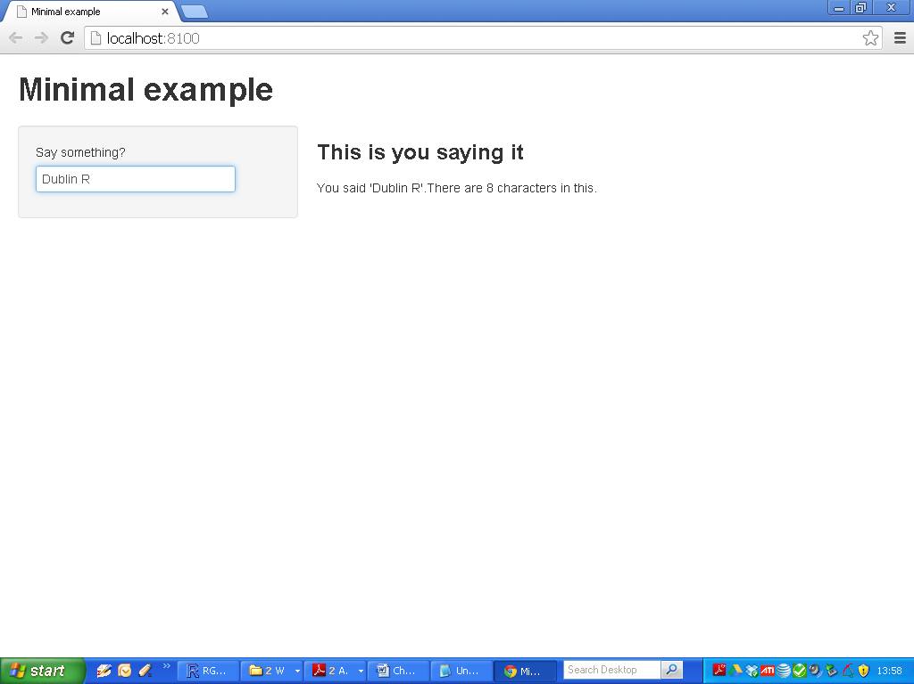

|  |
| --- |
| minimal example – ui.R (1) |
| library(shiny)  shinyUI(pageWithSidebar(  headerPanel("Minimal example"),  sidebarPanel(  textInput(inputId = "comment",  label = "Say something?",  value = ""  )  ),  mainPanel(  h3("This is you saying it"),  textOutput("textDisplay")  )  )) |

|  |
| --- |
| minimal example – ui.R (2) |
| library(shiny)  shinyUI(pageWithSidebar(  headerPanel("Minimal example"),  sidebarPanel(  textInput(inputId = "comment",  label = "Say something?",  value = ""  )  ),  mainPanel(  h3("This is you saying it"),  textOutput("textDisplay")  )  )) |

|  |
| --- |
| minimal example – ui.R (3) |
| library(shiny)  shinyUI(pageWithSidebar(  headerPanel("Minimal example"),  sidebarPanel(  **# Shiny input function – Widgets Sliders etc**  **# full list on CRAN pdf**  **textInput**(inputId = "comment",  label = "Say something?",  value = ""  )  ),  mainPanel(  **h3**("This is you saying it"), **#HTML FUNCTION**  **# Shiny output function**  **textOutput**("textDisplay")  )  )) |

|  |
| --- |
| minimal example – server.R (1) |
| library(shiny)  shinyServer(function(input, output) {  output$textDisplay <- renderText({  paste0("You said '", input$comment,  "'.There are ",  nchar(input$comment),  " characters in this.")  })  }) |

|  |
| --- |
| minimal example – server.R (2) |
| library(shiny)  **# load shiny at beginning at both scripts**  shinyServer(function(input, output) {  output$textDisplay <- renderText({    **#Normal R Code here**  paste0("You said '", input$comment,  "'.There are ",  nchar(input$comment),  " characters in this.")  })  }) |

|  |
| --- |
| minimal example – server.R (3) |
| library(shiny)  shinyServer(function(input, output) {  **# Shiny rendering function – renderText**  output$textDisplay <- renderText({**#here**  **# mark function as “reactive” and assign to**  **# output$textDisplay for passing to ui.R**  paste0("You said '", input$comment,  "'.There are ",  nchar(input$comment),  " characters in this.")  })**# and here**  }) |

|  |
| --- |
| minimal example – server.R (3) |
| library(shiny)  shinyServer(function(input, output) {  output$textDisplay <- renderText({  paste0("You said '", input$comment,  "'.There are ",  nchar(input$comment),  " characters in this.")  })  }) |
| ***from ui.R***  sidebarPanel(  textInput(inputId = "comment",  label = "Say something?",  value = ""  ) |