**Chris Beeley :** Demo to show widget types, return values and data types in Shiny

* <http://chrisbeeley.net/>
* <https://gist.github.com/ChrisBeeley/6571951>
* Inputs in the Side Panel
* Inputs and Class of Inputs returned in Table on Main Panel

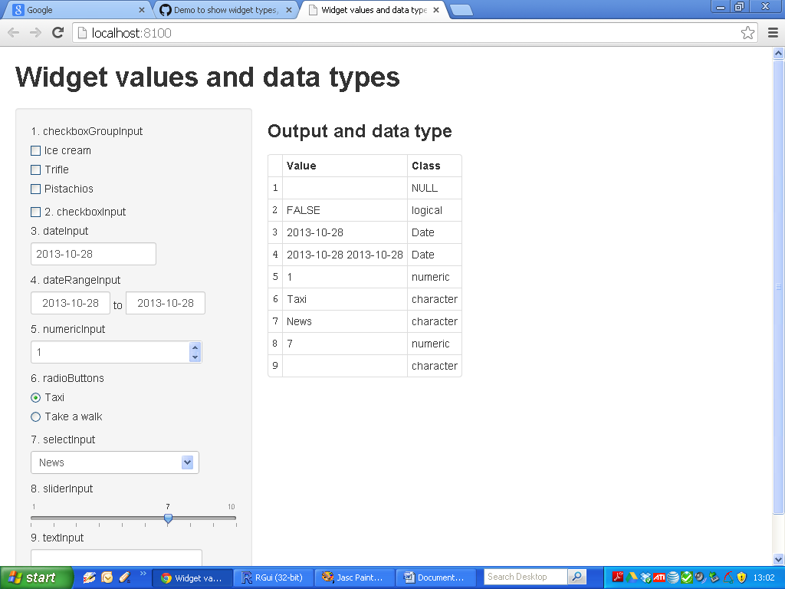

|  |
| --- |
| Widgets - ui.R (1) |
| library(shiny)    shinyUI(pageWithSidebar(    headerPanel("Widget values and data types"),    sidebarPanel(    checkboxGroupInput(inputId = "checkGroup",  label = "1. checkboxGroupInput",  choices = list("Ice cream" = "IC", "Trifle" = "Trifle",  "Pistachios" = "Pist")),    checkboxInput(inputId = "boxInput",  label = "2. checkboxInput"),    dateInput(inputId = "theDate",  label = "3. dateInput"),    dateRangeInput(inputId = "dateRange",  label = "4. dateRangeInput"),    numericInput(inputId = "pickNumber",  label = "5. numericInput",  min = 1, max = 10, value = 1),    radioButtons(inputId = "pickRadio",  label = "6. radioButtons",  choices = list("Taxi" = "Taxi",  "Take a walk" = "Walk")),    selectInput(inputId = "comboBox",  label = "7. selectInput",  choices = list("News" = "News",  "Situation comedy" = "Sitcom",  "Film" = "Film")),    sliderInput(inputId = "slider",  label = "8. sliderInput",  min = 1, max = 10, value = 7, step = 1),    textInput(inputId = "comment",  label = "9. textInput",  value = "")    ),    mainPanel(  h3("Output and data type"),  tableOutput("textDisplay")  )  )) |

|  |
| --- |
| ui.R (2) |
| library(shiny)    shinyUI(pageWithSidebar(    headerPanel("Widget values and data types"),    sidebarPanel(    checkboxGroupInput(inputId = "checkGroup",  label = "1. checkboxGroupInput",  choices = list("Ice cream" = "IC", "Trifle" = "Trifle",  "Pistachios" = "Pist")),    checkboxInput(inputId = "boxInput",  label = "2. checkboxInput"),    dateInput(inputId = "theDate",  label = "3. dateInput"),    dateRangeInput(inputId = "dateRange",  label = "4. dateRangeInput"),    numericInput(inputId = "pickNumber",  label = "5. numericInput",  min = 1, max = 10, value = 1),    radioButtons(inputId = "pickRadio",  label = "6. radioButtons",  choices = list("Taxi" = "Taxi",  "Take a walk" = "Walk")),    selectInput(inputId = "comboBox",  label = "7. selectInput",  choices = list("News" = "News",  "Situation comedy" = "Sitcom",  "Film" = "Film")),    sliderInput(inputId = "slider",  label = "8. sliderInput",  min = 1, max = 10, value = 7, step = 1),    textInput(inputId = "comment",  label = "9. textInput",  value = "")    ),    mainPanel(  h3("Output and data type"),  tableOutput("textDisplay")  )  )) |

|  |
| --- |
| server.R (1) |
| library(shiny)    shinyServer(function(input, output) {    output$textDisplay <- renderTable({    getMat = matrix(c(paste(  #-----------------------------------#  #Input 1 and 2  input$checkGroup, collapse=','),  class(input$checkGroup),  input$boxInput, class(input$boxInput),  #-----------------------------------#  # Input 3 and 4  as.character(as.Date(input$theDate,  origin = "1970-01- 01")), class(input$theDate),  paste(as.character(as.Date(input$dateRange[1],  origin = "1970-01-01")),  as.character(as.Date(input$dateRange[2],  origin = "1970- 01-01")), collapse = ','),  class(input$dateRange),  #-----------------------------------#  # Inputs 5 to 9  input$pickNumber, class(input$pickNumber),  input$pickRadio, class(input$pickRadio),  input$comboBox, class(input$comboBox),  input$slider, class(input$slider),  input$comment, class(input$comment)  ), ncol=2, byrow = TRUE)    colnames(getMat) = c("Value", "Class")    getMat    })  }) |

|  |
| --- |
| server.R (2) |
| library(shiny)    shinyServer(function(input, output) {  **# renderTable command used to construct output table**  output$textDisplay <- renderTable({    **# Normal R Code – just setting up a “data frame” style matrix**  getMat = matrix(c(paste(#-----------------------------------#  #Input 1 and 2  input$checkGroup, collapse=','),  class(input$checkGroup),  input$boxInput, class(input$boxInput),  #-----------------------------------#  # Input 3 and 4  as.character(as.Date(input$theDate,  origin = "1970-01- 01")), class(input$theDate),  paste(as.character(as.Date(input$dateRange[1],  origin = "1970-01-01")),  as.character(as.Date(input$dateRange[2],  origin = "1970- 01-01")), collapse = ','),  class(input$dateRange),  #-----------------------------------#  # Inputs 5 to 9  input$pickNumber, class(input$pickNumber),  input$pickRadio, class(input$pickRadio),  input$comboBox, class(input$comboBox),  input$slider, class(input$slider),  input$comment, class(input$comment)  ), ncol=2, byrow = TRUE)    colnames(getMat) = c("Value", "Class")    getMat    })  }) |

|  |
| --- |
| server.R (2) |
| library(shiny)    shinyServer(function(input, output) {    output$textDisplay <- renderTable({    getMat = matrix(c(paste(  input$checkGroup, collapse=','),  class(input$checkGroup),  input$boxInput, class(input$boxInput),  as.character(as.Date(input$theDate,  origin = "1970-01- 01")), class(input$theDate),  paste(as.character(as.Date(input$dateRange[1],  origin = "1970-01-01")),  as.character(as.Date(input$dateRange[2],  origin = "1970- 01-01")), collapse = ','),  class(input$dateRange),  input$pickNumber, class(input$pickNumber),  input$pickRadio, class(input$pickRadio),  input$comboBox, class(input$comboBox),  input$slider, class(input$slider),  input$comment, class(input$comment)  ), ncol=2, byrow = TRUE)    colnames(getMat) = c("Value", "Class")    getMat    })  }) |