Problem Statement
  - An organization is interested in managing their Vechicle Inventory Management System as a web application. The different use cases of this system are as shown below

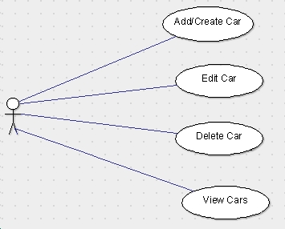

  - This system should be designed and implemented by taking into consideration some of the following points
    - The system should be adaptable to new environment
    - The system should be extensible
    - The system should be maintainable
    - The system should be designed by following standard design principles
    - The system should be implemented by following best practices.
  - Taken into consideration above requirements we will go for the MVC design principle, which is as shown below
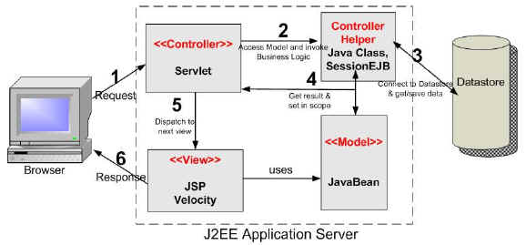
- Activity 1
- The Database details are as given below
  - username="VIM" password=" "
  - url="jdbc:oracle:thin:@localhost:1521:XE
- A DataSource using above Database will have following details
  - resource name="jdbc/VIMDataSource"
  - Max Active Connections = 100
  - Max Idle Connections = 30
  - Max waiting interval = 10000ms
- Action Item 1 :-
  - Taken into consideration above Database and DataSource details take appropriate actions
  - The databse script file database_ora.sql will be provided to participants
- Activity 2
- Taken into consideration above design create a Servlet as shown below
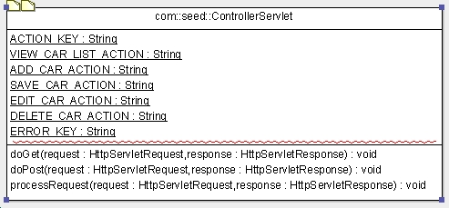
The details of the servlet are as given below
  - Logical name of the servlet in DD is Controller
  - Mapping url for above servlet in DD is /controller/*
  - Every action on the UI (Create, Edit, Delete, View) is mapped in the servlet using constants as shown above
  - The Get or Post HTTP requests should be routed to processRequest
  - The processRequest API is going to abstract the controlling behavior of this controller
- Action Item 2 :-
  - Taken into consideration above servlet details implement the Controller
  - Get the information of <load-on-startup> tag and use it in DD
- Activity 3
- All the database related activities will be abstracted using Data Access Object (DAO) pattern
- This pattern is as shown below
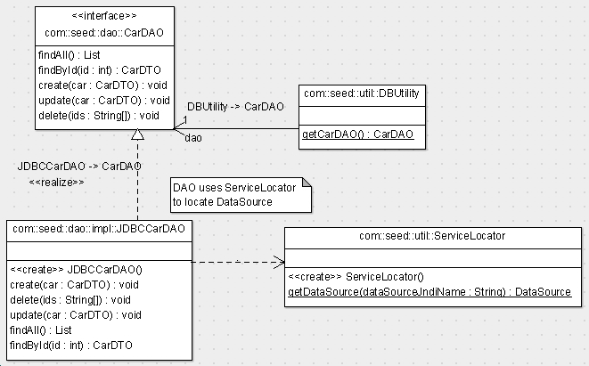

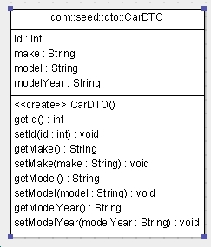

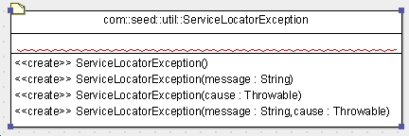
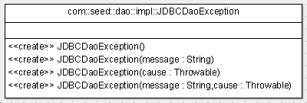

- Each action on View is mapped to corresponding API of DAO by the Controller
- The DAO Takes the help of ServiceLocator to get the DataSource
- DBUtility acts as a Static Factory of DAO
- Each record from database will be represented by a DTO. Most of the DAO APIs uses DTO
- ServiceLocatorException is an unchecked exception abstracting the error in locating the DataSource service
- JDBCDaoException is an unchecked exception abstracting the error in locating the database related service
- Action Item 3 :-
  - Based on Activity 3 details implement the TODOs of all above classes in following sequence
    - DBUtility
    - ServiceLocator
    - ServiceLocatorException
    - JDBCDaoException
    - CarDTO
  - The stub classes will be provided to participants
- Activity 4

- Action Item 4 :-
  - Implement the JDBCCarDAO
  - The stub classes will be provided to participants
- Activity 5
- Action Item 5 :-
  - Implement the ControllerServlet
  - The stub classe will be provided to participants

- Activity 6
- Action Item 6 :-
  - Study all .jsp files and perform the action based on jsp comments
  - The stub jsps will be provided to participants

- Activity 7
  - Action Item 7 :-
    - Handle following error conditions in a declarative fashion
      - For page not found error (Status code 404) show WEB-INF/unavailable.jsp
      - Server error (Status code 500) WEB-INF/unavailable.jsp
      - Map the exception JDBCDaoException to WEB-INF/showErrorMessage.jsp



