**STEP 1**: You can download Tomcat from[Apache Tomcat 8](https://tomcat.apache.org/download-80.cgi" \t "_blank)**and**[Tomcat 9](https://tomcat.apache.org/download-90.cgi" \t "_blank) website pages. Go for Binary Installable versions like**32-bit/64-bit Windows /Linux**

**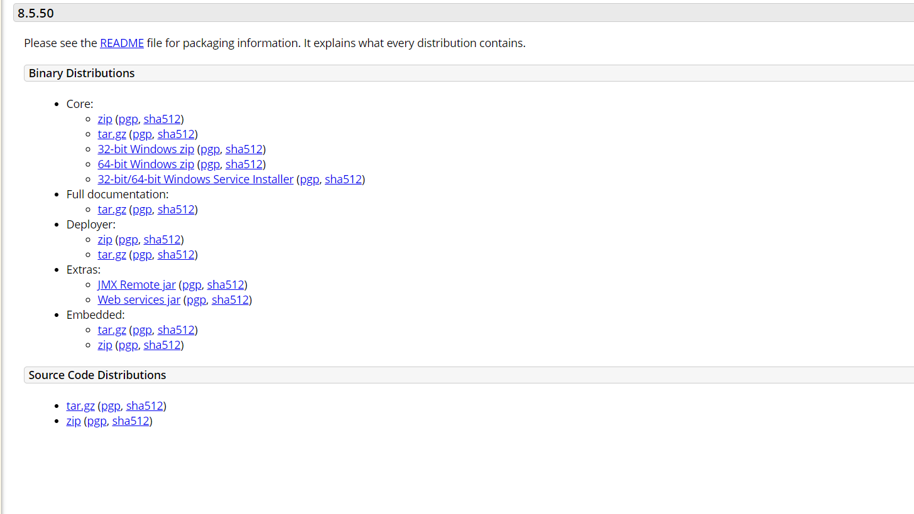**

**STEP 2:**Install the downloaded file, pass all the setup until reaching **Configuration Options**

**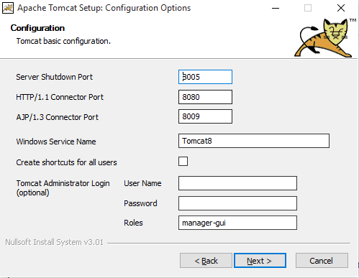**

**STEP 3:**

Next, you will choose the location where you want to install the [Tomcat](https://www.liquidweb.com/kb/how-to-install-oracle-java-8-on-ubuntu-12-04-lts/" \t "_blank) 9 service. Click Next.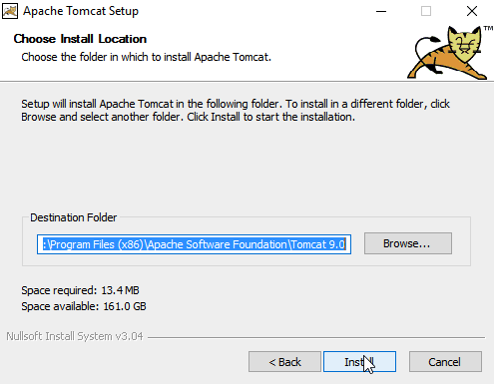

**Step 4:** To correctly install Tomcat 9 on your server, the Wizard will want you to choose the location of any other Java related software on your server.

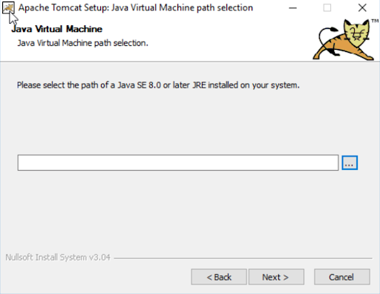

**STEP 5:** Once the install is complete, click Next. Lastly,uncheck the Readme checkbox.  
If you prefer to start Apache [Tomcat 9](https://www.liquidweb.com/kb/how-to-install-apache-tomcat-9-on-ubuntu-18-04/" \t "_blank) after the install, leave the checkbox marked. If not, then you will want to uncheck that checkbox.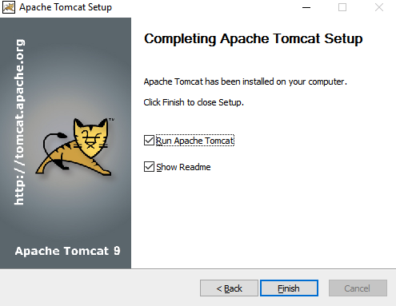

**STEP 6:**To test the Tomcat 9 install and verify it is running on your server, open and point your browser to localhost.

