SubmitBridge
Product Requirements Document
A trust layer for digital assignment submission

College Minor Project – BCA Final Year
Document Version 2.0 (Detailed)

1. Problem Statement
College faculty routinely require handwritten submissions for assignments even in computer science subjects, despite the coursework itself being computer-based. This creates unnecessary friction for students and does not reflect how the subject is actually practiced.
The underlying reason teachers resist digital submissions is trust, not technology: a digital file is trivially easy to copy-paste from an AI tool, and teachers currently have no reliable way to gauge how much of a submission reflects a student's own work. Handwriting is treated as a weak proxy for authenticity.
Core pitch: “digital submission can still be trusted.” SubmitBridge does not try to fully automate grading or policing — it gives teachers visibility (an AI-generated-content flag and an AI-assisted grading estimate) while keeping the teacher as the final decision-maker at every step.

2. Objective
- Replace handwritten submission with a simple digital workflow (shareable link + QR code) that a teacher can set up in minutes.
- Make the shared link a full, absolute web address (http/https), not a local or relative path — so a student can open it from any device, any network, at any time, without being on the same Wi-Fi or machine as the teacher.
- Reduce a teacher's manual grading effort by offering an AI-generated mark estimate and summary per submission — as a suggestion, never a final grade.
- Give teachers a visible AI-content-likelihood flag per submission to support (not replace) their own judgment on authenticity.
- Keep the system explainable and simple enough to walk a professor through, file by file, during a viva.

3. User Personas
 | Teacher | Student
Goal | Accept digital submissions with confidence, without extra reading burden | Submit assignments digitally instead of handwriting them
Key need | Assurance that a PDF isn't just copy-pasted AI output; final say on grading | A fast, low-friction way to submit via a link or QR code, from any device
Pain today | No trust signal for digital work → defaults to requiring handwriting | Forced to handwrite CS assignments on a computer-based course
Interaction | Creates assignments with full context, shares link/QR, reviews submissions + AI flags | Opens link/QR from anywhere, fills details, uploads file

4. Scope & Constraints
This is a college minor project built for a viva demonstration, not a production SaaS product. All design and implementation decisions below are made to keep the codebase simple, explainable, and free of unnecessary engineering complexity.

4.1 Tech Stack
- Frontend: React.js — functional components and hooks only (no Redux, no Context API)
- Backend: Node.js + Express.js
- Database: Supabase (PostgreSQL) via @supabase/supabase-js
- File Storage: Supabase Storage (PDF/DOCX uploads)
- Auth: JWT-based login (or Supabase Auth if simpler)
- AI Grading (Phase 2): gpt-5-mini via Azure OpenAI Service (Azure for Students credits)
- AI Detection (Phase 3): Sapling AI Detector API
Azure OpenAI Configuration (Phase 2)
The originally planned gpt-4o-mini deployment was not available on the Azure for Students subscription, so the project uses gpt-5-mini instead. Same integration pattern (Azure OpenAI SDK, chat-completions call, structured JSON response) — only the endpoint/deployment values change:
endpoint = "https://submitbridge.openai.azure.com/"
model_name = "gpt-5-mini"
deployment = "gpt-5-mini"
These three values go in .env (AZURE_OPENAI_ENDPOINT, AZURE_OPENAI_MODEL, AZURE_OPENAI_DEPLOYMENT) alongside the API key — never hardcoded in source, per the hard constraints below.

4.2 Hard Constraints
- Code must be simple and beginner-friendly enough to explain line by line to a professor.
- No over-engineering: no queues, no complex state machines, no design patterns, no advanced retry/backoff logic.
- Minimal file count — avoid splitting logic into many tiny files unnecessarily.
- Plain CSS or inline styles only — no Tailwind or heavy UI libraries.
- All secrets in .env (never hardcoded); .env.example provided with placeholders; .env gitignored.
- Any repeating logic (e.g. API key rotation) implemented as a simple first-year-level for-loop — nothing clever or hard to explain.
- Submission links and QR codes must always resolve to a full, public, absolute URL (http/https) — never localhost or a private-network address — so any student can use them from anywhere.

5. System Architecture
A straightforward three-tier architecture, deliberately kept flat so each layer maps to a small, explainable set of files.
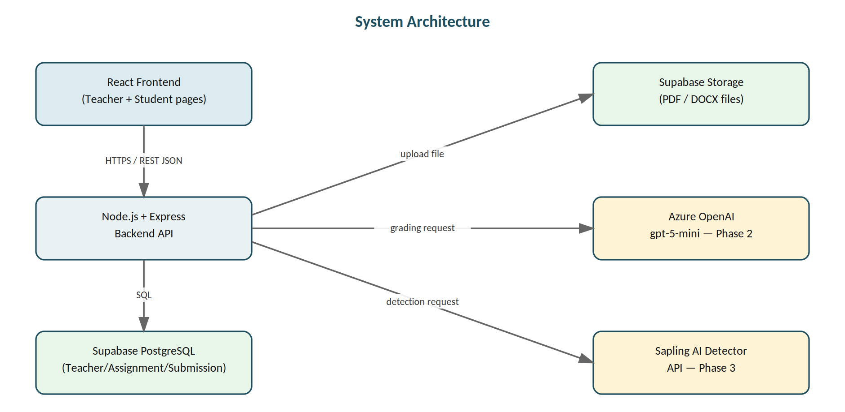
Figure 1 — Overall system architecture
Client (React)
Functional components + hooks only. Pages: Teacher Login, Teacher Dashboard, Create Assignment, Assignment Detail, Student Submission. Plain CSS or inline styles.
Server (Node.js + Express)
Route handlers for auth, assignments, and submissions. On submission: uploads file to Supabase Storage, extracts text (pdf-parse / mammoth), runs the Phase 2 grading call and the Phase 3 detection call, and writes results back to the Submission row.
Data & External Services
- Supabase (PostgreSQL) — Teacher, Assignment, Submission tables.
- Supabase Storage — uploaded PDF/DOCX files.
- Azure OpenAI (gpt-5-mini) — grading estimate + summary (Phase 2).
- Sapling AI Detector API — AI-likelihood score (Phase 3), called with simple round-robin key rotation across 3 free-tier keys.
This flow is intentionally linear — no background job queue, no message broker, no async worker pool. Each submission request extracts text, calls the two external APIs in sequence (or skips them per the rules below), and saves the result, all within the same request/response cycle.

6. Phase-wise Feature Breakdown

Phase 1 — Core Submission Flow (no AI yet)
Establishes the basic digital submission loop: teacher creates an assignment with full context, shares a permanent public link/QR, and students submit files against it from anywhere.
1. Teacher Login
- Email + password authentication using JWT.
- Single Teacher table/model — no role hierarchy needed.
2. Teacher Dashboard
- Lists assignments created by the logged-in teacher: subject, created date, submission count.
- “Create New Assignment” button.
3. Create Assignment Page — expanded field set
The original scope only listed Subject name, Questions, and Max marks. In practice a teacher needs more context up front so the generated submission page is self-explanatory to students without any extra back-and-forth. The full field list:
Field | Input type | Why it's needed
College / Institute name | Text | Printed on the submission page so students confirm they're on the right assignment; useful if the teacher teaches at more than one institute
Department (optional) | Text | e.g. “BCA”, “BSc IT” — helpful when a college runs multiple programs
Teacher name | Text | Auto-filled from the logged-in teacher's profile, shown on the submission page
Subject name | Text | e.g. “Operating Systems”
Subject code (optional) | Text | College-assigned code, if the institute uses one
Assignment title | Text | Short title distinct from the subject, e.g. “Assignment 3 — Process Scheduling”
Instructions | Textarea | General submission instructions — formatting rules, page limits, what to include on the cover section, academic-integrity note, etc.
Questions | Textarea | The actual assignment questions students must answer
Max marks | Number | Used later for the Phase 2 AI grading estimate
Due date & time | Date/time picker | Shown to students on the submission page; used to decide whether a resubmission is still allowed
Allowed file types | Checkbox (PDF / DOCX) | Phase 1 launches with PDF only; DOCX is added once the extraction pipeline (Phase 2) supports it
Late submission allowed? | Toggle (Yes/No) | Simple flag — if off, the submission form hides after the due date

On submit: the form data is saved to the Assignment table, and the backend generates (a) a unique assignment ID, (b) a full absolute shareable link built from the deployed domain — e.g. https://submitbridge.vercel.app/submit/:assignmentId, never a relative path or localhost address — and (c) a QR code image encoding that same absolute link, using the “qrcode” npm package. Both the link and QR are shown to the teacher immediately after creation, and remain valid indefinitely (or until the due date, if late submissions are disabled) so students can use them from any device or network at any time.
4. Assignment Detail Page (teacher view)
- Re-displays the link/QR.
- Table of submissions: Student Name, Roll Number, Submission Timestamp, link to view the uploaded file, plus AI grading/detection columns once Phases 2 and 3 are live.
5. Student Submission Page (via link/QR)
- Read-only display of: college/institute name, department, teacher name, subject name and code, assignment title, instructions, questions, max marks, and due date.
- Form fields: Student Name, Roll Number, file upload (PDF, later DOCX).
- On submit: file uploaded to Supabase Storage, submission record saved, success message shown.
Resubmission rule: if the same student (matched by roll number) submits again for the same assignment, the previous submission is overwritten — the old file is replaced and the existing DB record is updated, rather than creating a duplicate entry.
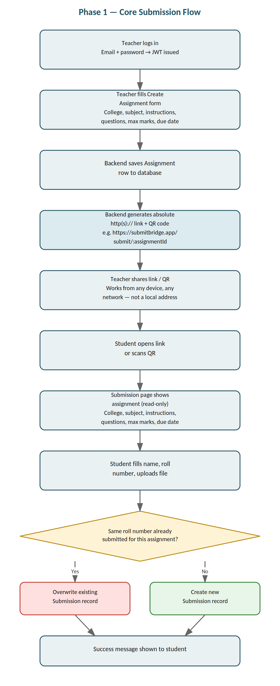
Figure 2 — Phase 1 submission flow, including the resubmission (overwrite) decision

Phase 2 — AI-Assisted Grading
Goal: AI reads each submission independently and produces an estimated mark and short summary so the teacher doesn't need to read every submission in full — but the AI never has final authority; the teacher always makes the final call.
Model: gpt-5-mini via Azure OpenAI Service (Azure for Students credits). The originally planned gpt-4o-mini deployment was not available on the student subscription, so gpt-5-mini is used instead — the integration code is identical, only the endpoint and deployment name differ (see §4.1).
Flow
- Teacher supplies assignment questions, instructions, and max marks up front, as part of the Phase 1 Create Assignment form.
- On submission, extract text from the file: PDF via pdf-parse, DOCX via mammoth (extractRawText).
- Clean/preprocess the extracted text to save API quota: strip repetitive headers/metadata (“Name:”, “Roll No:”, “Page:”, date lines), normalize whitespace, truncate to ~4000 characters, and skip AI processing entirely if the cleaned text is under ~100 characters.
- Send the cleaned text plus assignment questions/max marks to gpt-5-mini with a prompt that explicitly instructs it to grade only this submission in isolation, with no comparison to other students, to keep grading unbiased per student.
- Request a structured JSON response: estimated mark (out of max marks), a short summary of what the student wrote, and brief reasoning for the mark.
- Store the AI's mark, summary, and reasoning against the submission record.
- On the dashboard, show the AI estimate per submission with an ACCEPT or EDIT/override control — the teacher's decision is always final; AI marks are never auto-published as final grades.
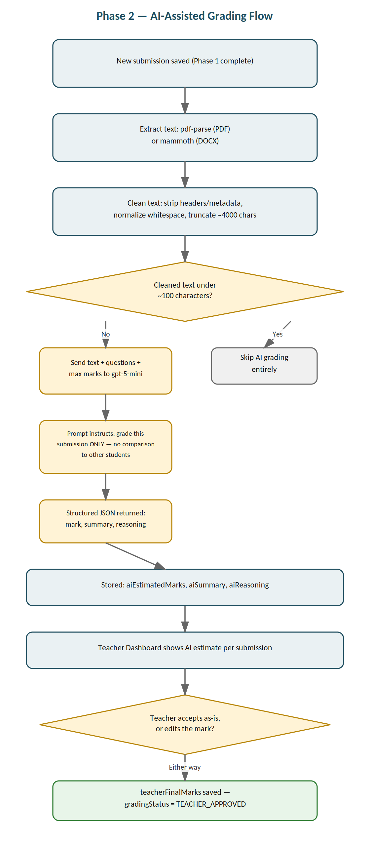
Figure 3 — Phase 2 AI-assisted grading flow
Additional fields — Phase 2
Field | Type | Notes
aiEstimatedMarks | number | AI's suggested mark, out of maxMarks
aiSummary | text | Short AI-generated summary of the submission
aiReasoning | text | Brief AI justification for the estimated mark
teacherFinalMarks | number | Set once the teacher accepts or overrides
gradingStatus | text | e.g. "AI_ESTIMATED", "TEACHER_APPROVED"

Phase 3 — AI-Generated-Content Detection
Goal: flag the probability that a submission was AI-generated, without automatically rejecting it. AI detectors are not reliable enough to be a final decision-maker on their own — a 2026 benchmark found even a strong detector like Sapling has a false-positive rate of close to 19% on genuinely human-written text, so hard-blocking on this signal would unfairly punish real students.
Flow
- Reuses the Phase 2 text extraction and cleaning pipeline — no separate pipeline is built.
- Sends the cleaned text to the Sapling AI Detector API (POST https://api.sapling.ai/api/v1/aidetect with { key, text }); the response's score field (0–1) is multiplied by 100 for a percentage AI-likelihood score.
API key handling (kept intentionally simple)
- Three free-tier API keys stored as SAPLING_API_KEYS=key1,key2,key3 in .env.
- Simple round-robin loop: request 1 uses key1, request 2 uses key2, request 3 uses key3, request 4 wraps back to key1, and so on — spreading load evenly instead of exhausting one key.
- If the current key in rotation fails (e.g. quota exceeded), a small fallback loop tries the next key within the same request — not a retry queue or backoff system.
- If all keys fail, the submission is still accepted normally; the system stores aiScore = null and aiStatus = "FAILED" or "QUOTA_EXHAUSTED" rather than rejecting anything.
Display
- Teacher's dashboard shows the AI likelihood percentage next to each submission (e.g. “AI likelihood: 42%”) as a flag, not a rejection.
- If a submission is flagged above a threshold, the student sees this on their confirmation view and can choose to resubmit a revised version before the assignment's final due date; the final accept/reject decision still rests with the teacher.
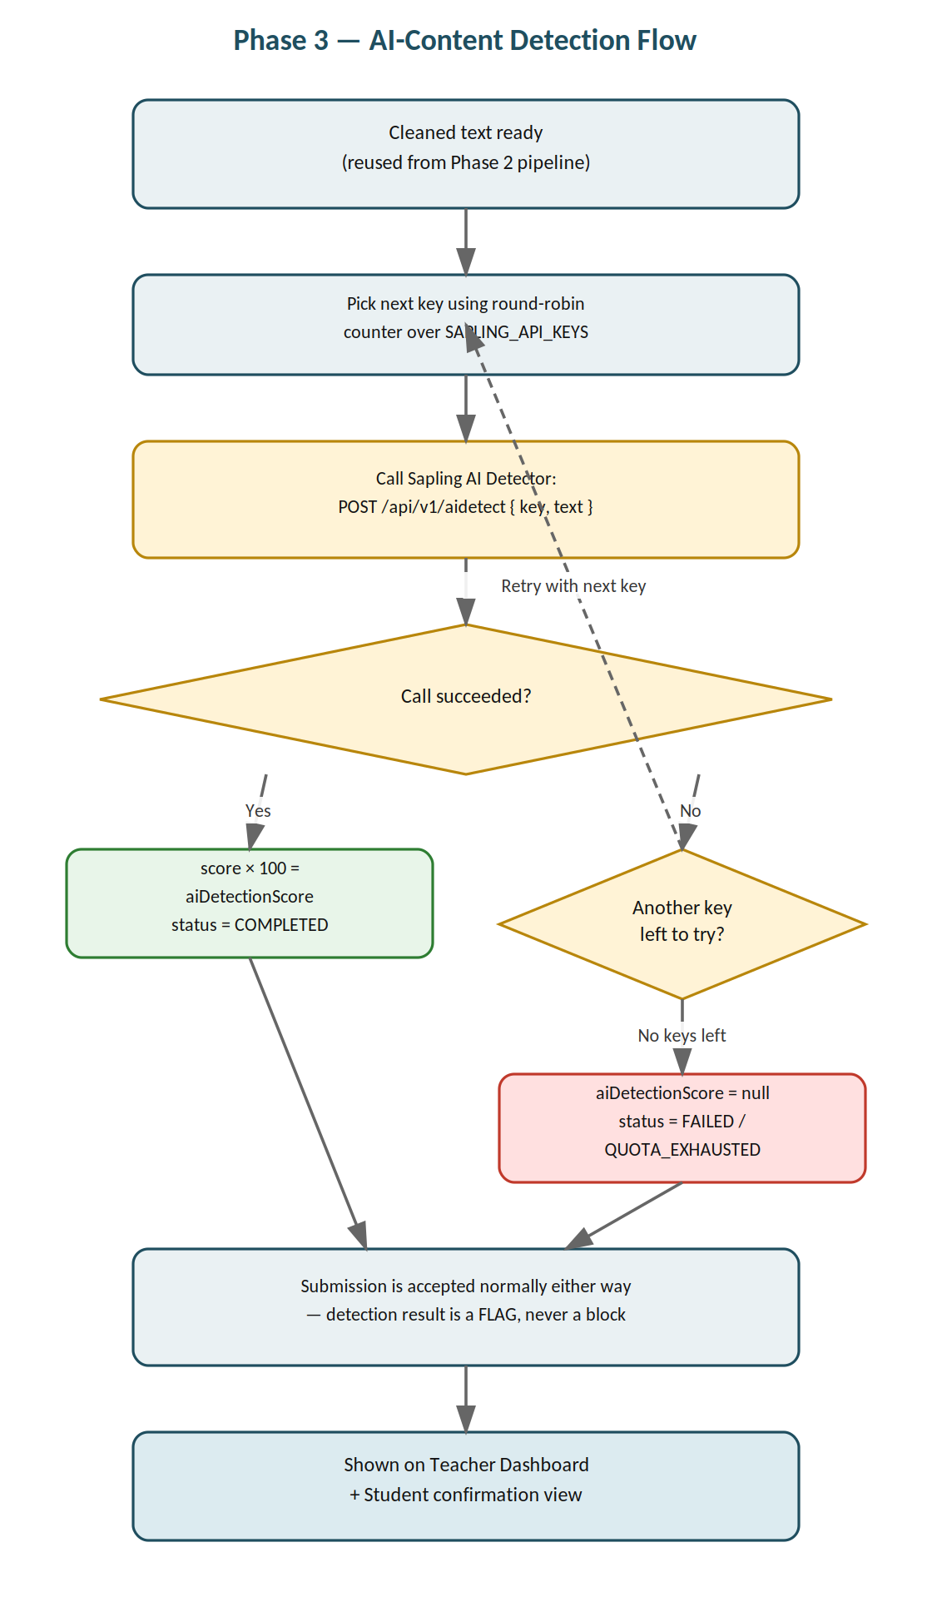
Figure 4 — Phase 3 AI-content detection flow, including key rotation and fallback
Additional fields — Phase 3
Field | Type | Notes
aiDetectionScore | number (0–100) | Percentage AI-likelihood, or null on failure
aiDetectionStatus | text | "COMPLETED" / "SKIPPED" / "FAILED"

7. Data Models (Consolidated)
Consolidated view of all fields across all three phases. Phase 1 fields form the base; Phase 2 and Phase 3 fields are added to the Submission table as those phases are built.
Teacher
Field | Type | Notes
name | text | Teacher's display name
email | text | Login identifier, unique
password | text (hashed) | Never stored in plain text
collegeName | text | Default college/institute name, pre-filled into new assignments
Assignment
Field | Type | Notes
collegeName | text | Institute name shown on the submission page
department | text (optional) | e.g. “BCA”, “BSc IT”
subject | text | Subject name
subjectCode | text (optional) | College-assigned subject code
title | text | Assignment title, distinct from subject
instructions | text | Submission/formatting instructions
questions | text | Assignment questions, entered as free text
maxMarks | number | Used for the Phase 2 AI grading estimate
dueDate | timestamp | Shown to students; governs late-submission behaviour
allowLateSubmission | boolean | If false, submission form closes after dueDate
allowedFileTypes | text | e.g. "pdf" or "pdf,docx"
shareableLink | text | Full absolute http(s):// URL — never localhost or relative
teacherId | reference → Teacher | Owner of the assignment
createdAt | timestamp | Auto-set on creation
Submission (Phase 1 base + later additions)
Field | Type | Notes
assignmentId | reference → Assignment | Which assignment this belongs to
studentName | text | Entered by student at submission time
rollNumber | text | Used to detect and overwrite resubmissions
fileUrl | text | Supabase Storage URL of the uploaded file
submittedAt | timestamp | Updated on resubmission, not duplicated
aiEstimatedMarks / aiSummary / aiReasoning | — | Added in Phase 2
teacherFinalMarks / gradingStatus | — | Added in Phase 2
aiDetectionScore / aiDetectionStatus | — | Added in Phase 3

8. Success Criteria
- A teacher can log in, fill in full assignment context (college, subject, instructions, questions, due date, etc.), and receive a working absolute shareable link and QR code within the same flow.
- The generated link is always a full http(s):// URL that opens correctly from a different device on a different network — confirming it is not tied to localhost or the teacher's local machine.
- A student can open the link/QR, see all assignment context, submit a PDF, and get a success confirmation; a second submission with the same roll number overwrites the first rather than duplicating it.
- Phase 2: submissions receive an AI-estimated mark and summary, and the teacher can accept or override it before it becomes final.
- Phase 3: submissions receive an AI-likelihood percentage flag, key rotation continues to function even if one Sapling key is exhausted, and a failed detection never blocks a submission from being accepted.
- The full codebase can be explained file-by-file and function-by-function in a viva, with no component the student cannot justify or walk through.
- No secrets appear in source code; .env.example is present and .env is gitignored.

