**Intelligent Driver Assistance with Accident-Prone Zone and Weather Alerts**

Prof. Dr. Asma shaikh[1], Sanika Mohite[2], Prem Kadam [3],Saurabh Mali[4] , Mugdha Patil[5]

*Annasaheb Dange College Of Engineering and Technology , Ashta*

***Abstract:*** ***Due in large part to drivers' ignorance of accident-prone areas, abrupt weather changes, and unforeseen road hazards, traffic accidents continue to rank among the world's leading causes of death. The proposed Intelligent Driver Assistance System (IDAS) uses GPS, GIS data, and real-time sensor inputs to provide real-time alerts about hazardous road segments, high-risk areas, and unfavorable weather conditions. The system uses user-reported hazards, live weather APIs, and historical accident data to dynamically evaluate route safety and alert drivers via haptic, visual, and voice cues. Constructed with mobile technologies like MapKit, Firebase, and Core Location, it guarantees data-driven and responsive safety feedback while protecting user privacy through on-device processing. This solution seeks to improve situational awareness, decrease traffic accidents, and encourage safer driving practices by integrating machine learning, geospatial analysis, and community-driven data—especially in high-risk areas like India.***

***Keyword:*** Intelligent Driver Assistance, Road Safety, Accident-Prone Zone Detection, GPS, Weather Alerts, Machine Learning, GIS

1. **INTRODUCTION**

Road safety is one of the most pressing global challenges today. According to the World Health Organization (WHO), nearly 1.3 million people die each year due to road traffic accidents, and millions more suffer injuries or long-term disabilities. A major contributing factor to these accidents is the lack of timely awareness about accident-prone areas (blackspots), poor weather conditions, and unexpected road hazards such as potholes or sharp curves. With the rising number of vehicles and rapid urbanization, traditional road signs and static warnings are not sufficient to address real-time driving risks.The Accidental Intelligence Navigator (AIN) has been designed as an iOS-based mobile application that enhances road safety by providing real-time, proactive alerts to drivers. Unlike conventional navigation apps that only focus on shortest or fastest routes, AIN integrates multiple data streams such as GIS accident blackspot data, live weather updates, GPS tracking, and crowdsourced hazard reports to dynamically assess the risk on a driver’s route. By doing so, the system not only navigates but also acts as an intelligent co-driver that helps prevent accidents before they occur.AIN leverages the full capabilities of modern smartphones—Core Location (GPS), MapKit, Core Motion sensors, and Firebase backend services—to deliver timely safety notifications through visual banners, voice prompts, and haptic feedback. For example, if a user is approaching a curve where multiple accidents have historically occurred, or if sudden rainfall is detected on their route, the system immediately issues an alert with enough lead time for corrective driving. These reports are validated, aggregated, and shared with other drivers in real-time, making the system self-improving and community-driven. Privacy is also a key focus; sensitive data is minimized, with most processing handled on-device, ensuring user trust and compliance with privacy standards. By blending machine learning models, GIS analysis, and smartphone sensor fusion, AIN represents a significant step towards next-generation road safety systems. Its potential lies in reducing the number of accidents, minimizing traffic delays, and ultimately saving lives. The system can be scaled globally, but the MVP rollout will focus on India, where road accident rates are among the highest in the world, thereby addressing a highly relevant and impactful problem.

**Objectives:**

1. Detect accident‑prone and recently reported accident locations using real‑time GPS and historical incident data.
2. Alert users via push notifications, voice, and haptics when approaching hazardous zones.
3. Provide early warnings for weather‑related risks (e.g., rain) and road geometry risks
4. Reduce accident risk and traffic delays through timely, contextual alerts and safer rerouting.
5. Deliver a user‑friendly, privacy‑preserving iOS app for real‑time safety notifications.
6. **LITERATURE REVIEW**

**[1]A Smart GPS-Based IoT System for Blackspot Notification**

Billy Owire ,etl, written that suggests an Internet of Things (IoT)-based system that employs GPS and GSM modules to send out audio alerts to drivers about accident blackspots. The system provides real-time driver notifications by integrating Arduino microcontrollers with GPS coordinates of known blackspots. tested with successful detection and alerts on well-known blackspots in Kenya, such as Mombasa Road and Salgaa.

**[2]Investigation of Road Accident Zone and Suggestion for Preventive Measures by Using GPS and GIS Technology in Thanjavur, Tamil Nadu, India**

M. Kannan ,etl. written that Using GPS and GIS technology, the study looks into Thanjavur's road accident zones in order to identify hotspots and take preventative action. Police station-by-police station, vehicle type, time, road type, and location are among the parameters used to analyze accident data. Based on speeding and inadequate infrastructure, hotspots were identified, including the Kulichapatu cut road, Echankottai, and the Soorakottai bus stop.

**[3]AI Enabled Accident Black Spot Alerting Mobile System to Enhance Road Safety Using GMM-SVM**

M. Sobhana ,etl. Written that In order to predict the severity of traffic accidents and pinpoint blackspots in Tamil Nadu, India, the study uses machine learning models (Decision Tree, Random Forest, Gradient Boosting, and XGBoost). Five years' worth of accident records (2017–2021) are included in the dataset, along with variables like time, weather, vehicle category, and type of road. When it came to predicting accident severity and blackspot locations, XGBoost had the best accuracy (98.3%).

**[4]Identification and Mitigation of Road Accident Black Spots Using Data Analytics and Machine Learning**

R. Bhuvaneshwari ,etl. written that In order to pinpoint accident-prone areas and recommend preventative measures, the study combines data analytics with machine learning models (Logistic Regression, Random Forest, and Gradient Boosting). Three years' worth of accident data from Tamil Nadu, India's highways, covering variables like time, weather, and driving habits, are included in the dataset. Compared to other models, Random Forest demonstrated strong predictive performance in identifying high-risk zones.

**[5]Prediction and Identification of Black Spots to Reduce the Severity of Accidents Using Machine Learning Algorithms**

Arun Kannan ,etl. written that In order to predict the severity of traffic accidents and pinpoint blackspots in Tamil Nadu, India, the study uses machine learning models (Decision Tree, Random Forest, Gradient Boosting, and XGBoost). Five years' worth of accident records (2017–2021) are included in the dataset, along with variables like time, weather, vehicle category, and type of road. When it came to predicting accident severity and blackspot locations, XGBoost had the best accuracy (98.3%).

**[6]Smart Vehicle Assistance and Accident Prevention System**

Dr. I. Jeya Daisy ,etl. written that In order to decrease traffic accidents and enhance driver safety, the paper "Smart Vehicle Assistance and Accident Prevention System" presents an AI-powered framework that integrates IoT, Machine Learning, and Computer Vision. SVAAPS, the suggested system, uses sensors and cameras to continuously monitor environmental conditions, driver behavior, and vehicle parameters. While ML algorithms forecast accident risks based on historical and real-time data, deep learning models such as YOLO and Faster R-CNN are utilized for real-time object detection. Better decision-making is made possible by an interactive dashboard that shows risk factors and accident-prone areas. All things considered, the study shows that incorporating AI-driven technologies can greatly improve traffic safety, lower the number of fatalities, and open the door for intelligent, networked transportation systems.

**[7]Navigational Intelligence for Accident Prevention and Real Time Road Safety**

Dr M Sindhana Devi ,etl. written that In order to increase road safety, the paper "Navigational Intelligence for Accident Prevention and Real-Time Road Safety" describes an AI-powered navigation and accident prevention system that combines Internet of Things (IoT), Inertial Navigation Systems (INS), and Global Navigation Satellite Systems (GNSS). It analyzes real-time data from vehicles, road sensors, and environmental inputs using machine learning and deep learning models (CNN-GRU, logistic regression, and MLP), allowing for adaptive route optimization and predictive accident risk assessment. The results of the experiment demonstrate effective real-time routing, quick alert response, and high navigation (98.7%) and accident prediction (96%). The study shows that incorporating AI, IoT, and predictive analytics into navigation systems can greatly increase traffic safety, lower accident rates, and boost the effectiveness of transportation on highways and in urban networks.

1. **METHODOLOGY:**

This project aims to enhance road safety by providing real-time alerts about nearby accident-prone or hazardous areas. Using GPS and live data, the app detects recent accidents, sharp turns, and bad weather like rain. It notifies users through push notifications and maps to help them avoid risky zones and take safer routes. The Android/iOS app ensures timely awareness, reducing the chances of accidents, traffic delays, and emergency response issues.

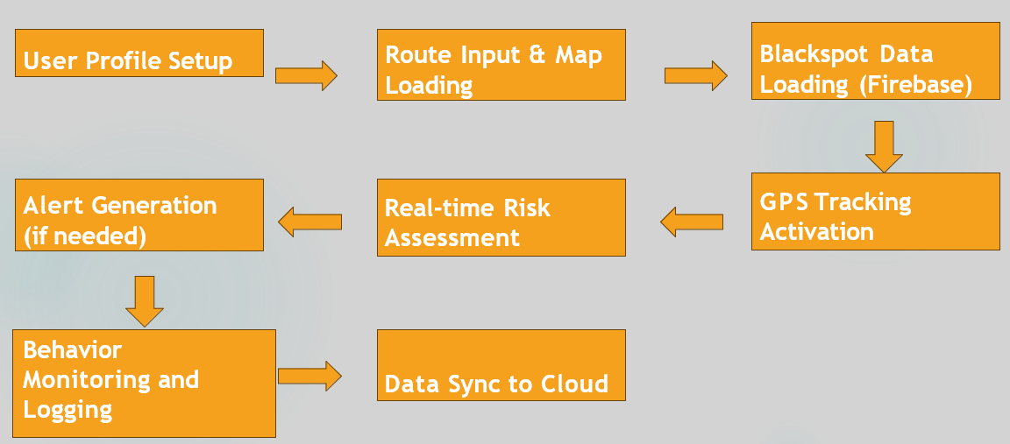

*Fig. 1 - System Flow*

An actual work of this project is as follows:

The driver registers and customizes the app during the system's initial user profile setup. Blackspot data is then loaded from Firebase after route input and map loading. To continuously track the location of the vehicle, the app turns on GPS tracking. To determine whether the driver is approaching a dangerous area, a real-time risk assessment is conducted using this data. The system warns the driver with alerts if necessary. Lastly, all data is synced to the cloud for analysis and future enhancements, and driver behavior is tracked and recorded.

**Data Collection & Preparation**

Gathering and Preparing Data  
The system gathers information from a variety of sources, including user-reported hazards, weather APIs, blackspot (danger zone) maps, real-time GPS data from drivers, and government accident records. Firestore is where all of this data is kept. Old reports are automatically deleted when they are no longer valid, and hazard reports are validated and assigned confidence scores.

**Route Segmentation & Feature Extraction**

The app divides the road into manageable chunks when a driver chooses a route. Road curvature, weather, previous accident history, and distance from accident-prone areas are all taken into consideration when analyzing each segment. Additionally taken into account are GPS speed and braking patterns.

**Risk Scoring & Alerts**

A risk engine (ML model) is used to score each segment. The app instantly issues a warning via voice, vibration, and notifications if the driver is about to enter a segment where there is a high risk. By doing this, the driver can remain vigilant before approaching a hazardous area.

**Crowdsourcing & Continuous Improvement**

Real-time reporting of potholes, accidents, and other road hazards is possible. After verification, these reports are entered into the system. New data is used to retrain the model over time, improving the system's intelligence and dependability. Accuracy is increased and false alerts are decreased through field testing and user feedback.

**System Architecture**

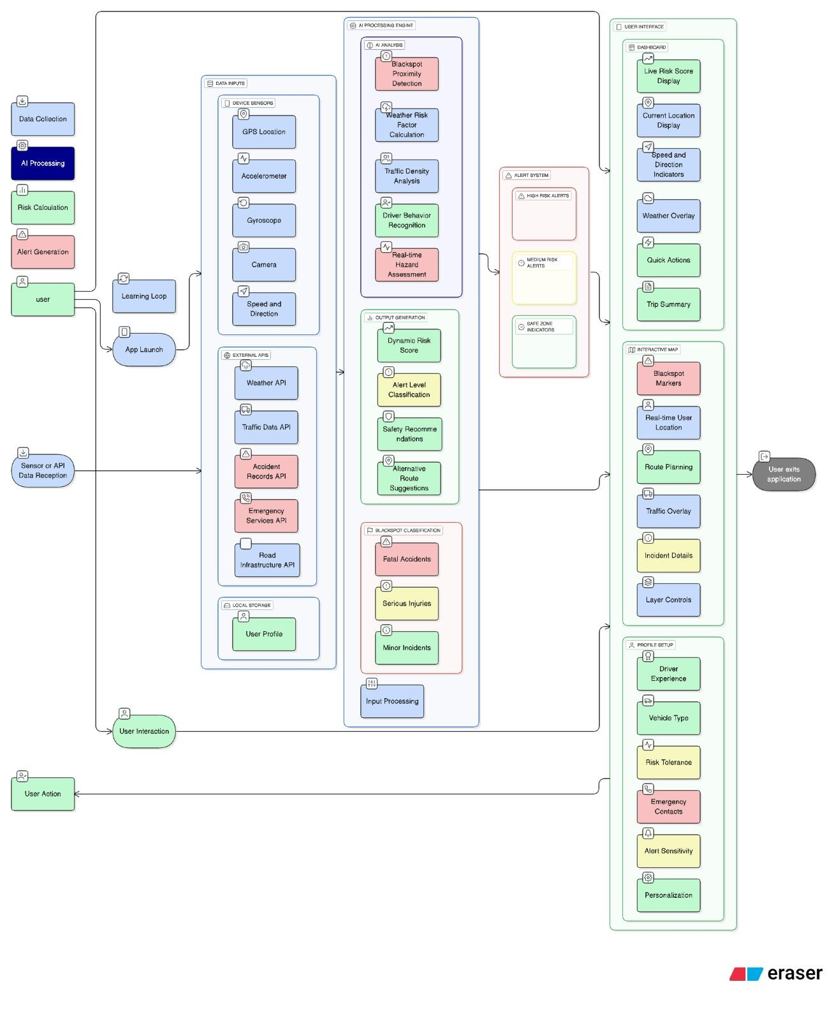*Fig. 2 - System Architecture*

**Data Collection & Integration**

The system gathers real-time data from GPS, accelerometer, gyroscope, camera, and speed sensors, along with external sources like weather, traffic, and accident APIs. All data is securely stored in Firestore, where outdated or invalid entries are automatically removed.

**AI Processing & Behavior Analysis**

Collected data is analyzed using AI models to detect driving patterns such as overspeeding, harsh braking, and distraction. External factors like weather, traffic, and blackspot proximity are also evaluated to assess real-time driving risk.

**Risk Evaluation & Alerts**

A dynamic risk engine scores each road segment based on environmental and behavioral factors. When high-risk conditions are detected, the system issues instant alerts via voice, vibration, and on-screen notifications to warn the driver.

**Learning & Improvement**

Drivers can report hazards like potholes or accidents, which are verified and added to the database. This crowdsourced data helps retrain the AI model, improving accuracy and reducing false alerts over time.

**Security & Privacy**

All data is encrypted and handled according to privacy standards like GDPR and CCPA, ensuring user safety and data protection.

1. **RESULT AND DISCUSSION**
2. **CONCLUSION**

The suggested system effectively combines real-time risk assessment, GPS tracking, and blackspot data to give drivers timely warnings about areas that are prone to accidents. It guarantees quick responses while preserving data reliability by fusing on-device processing with cloud-based data storage. The system can be tailored to various driving habits and road conditions thanks to the addition of user profiles and behavior monitoring.

All things considered, this solution not only increases road safety by alerting drivers ahead of time, but it also creates an ever-expanding knowledge base by utilizing cloud synchronization and crowdsourced reports. The system's scalable architecture and machine learning integration allow it to develop over time, assisting in the decrease of accidents and encouraging safer driving techniques.

**Future Work:**

**Integration with IoT Sensors:**

To improve risk prediction, link the system to vehicle sensors (braking, speed, and tire pressure).

**AI Model Enhancement:**

To increase the accuracy of identifying accident-prone areas, enhance machine learning models**.  
  
Offline Functionality:**

To assist regions with inadequate network connectivity, create offline risk prediction using models and cached maps. **Scalability & Expansion:**

For broader adoption, expand the system to include rural and highway roads and integrate it with government traffic databases.

We can improve this system's features and benefits by expanding and improving it further, which will make it a useful and more reliable to the users.

1. **ACKNOWLEDGEMENT**

We would like to express our sincere gratitude to my guide, Prof. Dr. Asma Shaikh, for her help and advice in completing the project.

1. **REFERENCES**

[1]“A Smart GPS-Based IoT System for Blackspot Notification” ,“Billy Owire, Bernard Shibwabo Kasamani” , IEEE ,(2021).

[2]“Investigation of Road Accident Zone and Suggestion for Preventive Measures by Using GPS and GIS Technology in Thanjavur, Tamil Nadu, India” , “M. Kannan, G. Aakash” , ResearchGate(2024).

[3] “AI Enabled Accident Black Spot Alerting Mobile System to Enhance Road Safety Using GMM-SVM” , “M. Sobhana, V. Krishna Rohith” ,IEEE(2023).

[4]“Identification and Mitigation of Road Accident Black Spots Using Data Analytics and Machine Learning”,“R. Bhuvaneshwari, Sathesh Kumar” ,ScienceDirect (2023).

[5] “Prediction and Identification of Black Spots to Reduce the Severity of Accidents Using Machine Learning Algorithms” , “Arun Kannan, M. Sivaprakash” ,IEEE(2024).