1) Clone the Repo

git clone https://github.com/saurabh916/GCP_Projects.git

cd AppEngine/GCPAPPEngineIAP_Auth

2) gcloud app deploy

gcloud app browse

3) Click on the URL of the deployed app and you should get a page as below

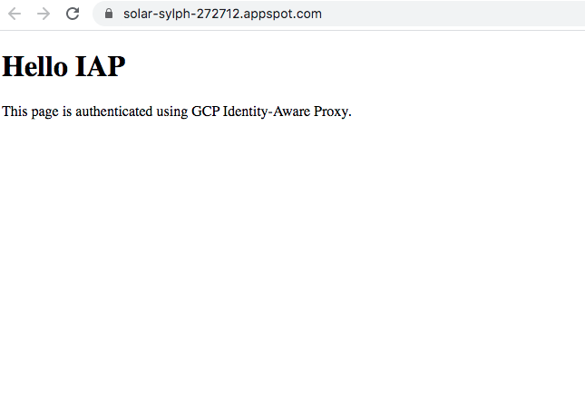

4) Go to your GCP Console and go to the tab App Engine. You should see the application deployed

5)Click on Security > Identity-Aware Proxy. Go to the Configure Consent Screen tab and do the configurations as below and click save

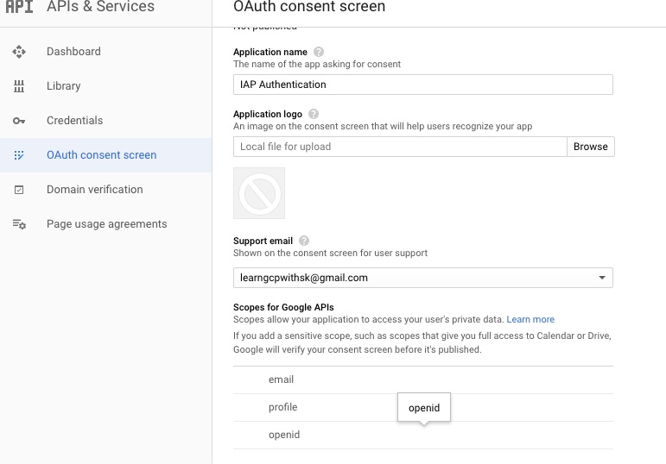

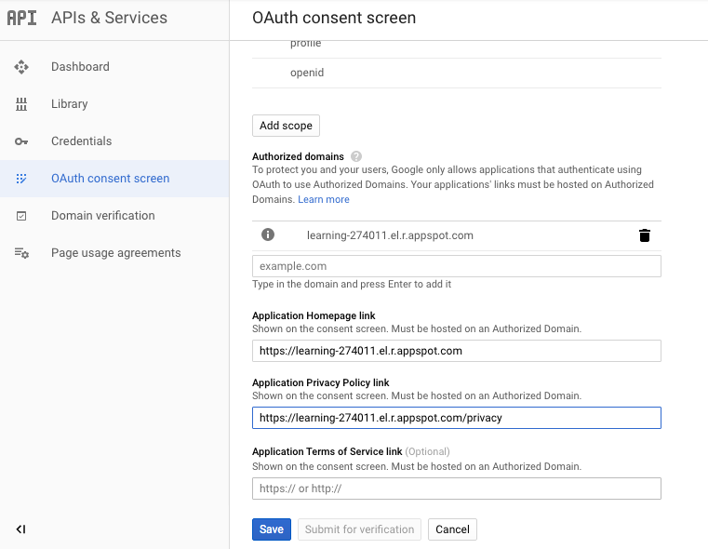

6)

6) Close the configuration screen and refresh the Identity-Aware Proxy screen. You should see screen like below with resource as your App Engine.

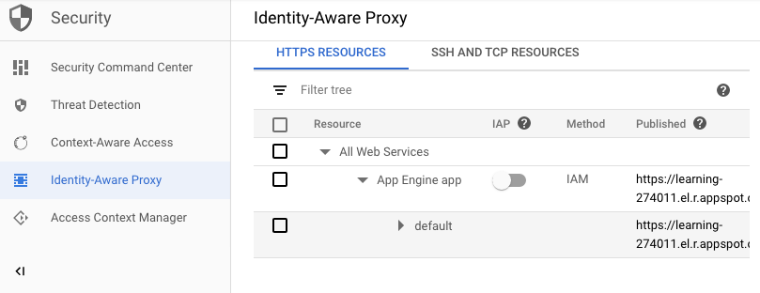

7) Turn on the IAP toggle and on the right hand panel of the screen click on Add Member button. Provide the email address for which you need access and also select the role as **Cloud IAP/IAP-Secured Web App User** as below

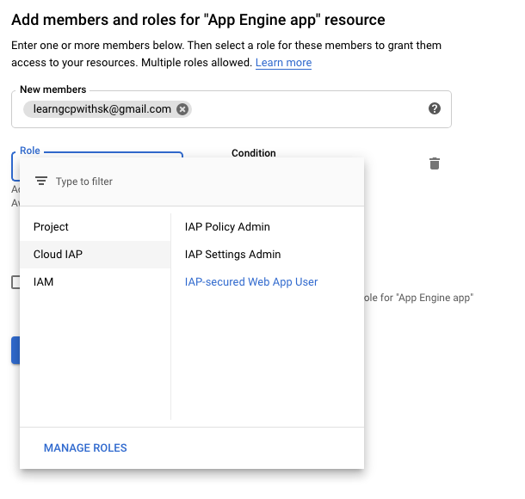

8) Now try to access your App engine URL, ie: [https://learning-274011.el.r.appspot.com](https://learning-274011.el.r.appspot.com/). You can add /_gcp_iap/clear_login_cookie at the end of the URL to clear the previous stored credentials and refresh the browser. For example <https://learning-274011.el.r.appspot.com/_gcp_iap/clear_login_cookie>. Now the application will redirect you to authentication screen of google for sign in. It uses OAuth 2.0 to provide access token for the resource. The authentication screen should look as below.

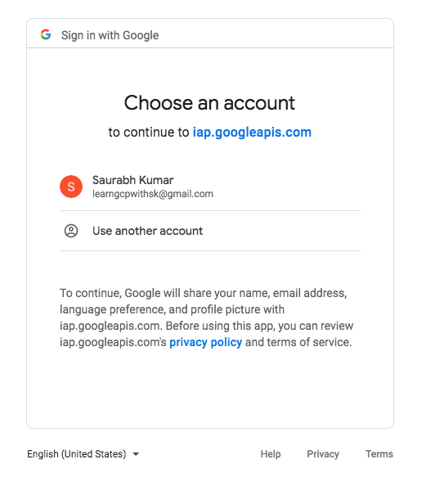

9) On successful authentication, you should see the below page of your App Engine deployed application other wise error screen.

