Software Engineering Tools Lab

Assignment No-1

Module 1- Introduction to OSS

Name: Saurabh Ashok Tribhuvan

Prn No.2019BTECS00108

Batch:T5

1.Weka is a GUI workbench that empowers data wranglers to assemble machine learning pipelines, train models, and run predictions without having to write code. Using Weka tool perform below tasks such as data preprocessing, data classification (use any appropriate ML algorithm) and data visualization efficiently on given dataset.

Use the Iris dataset given:

https://drive.google.com/file/d/1A3Fxsfzm6BSfhFZGDrjI47RTe45bSgYP/view

Note-provide screen shots for every task Create a report which will illustrate the details of tasks performed (for e.g to perform preprocessing of data provide details of navigation and selection of appropriate parameters)

Used Dataset: form weka proived

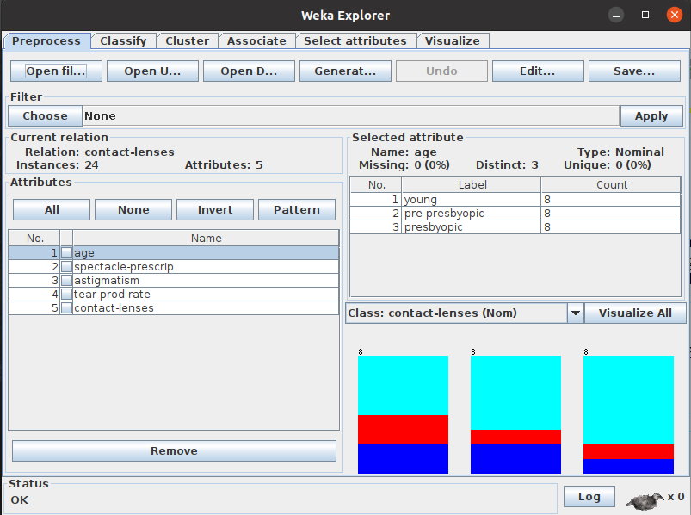

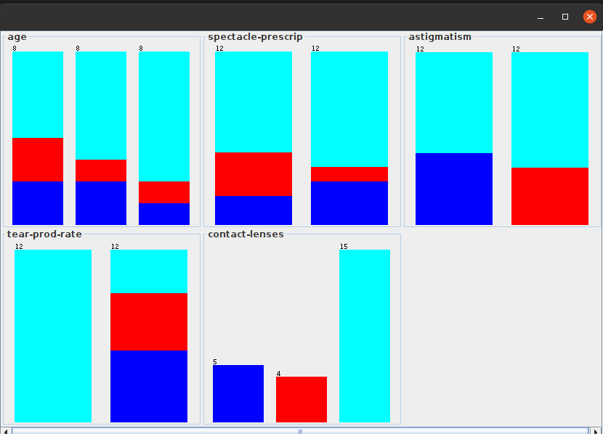

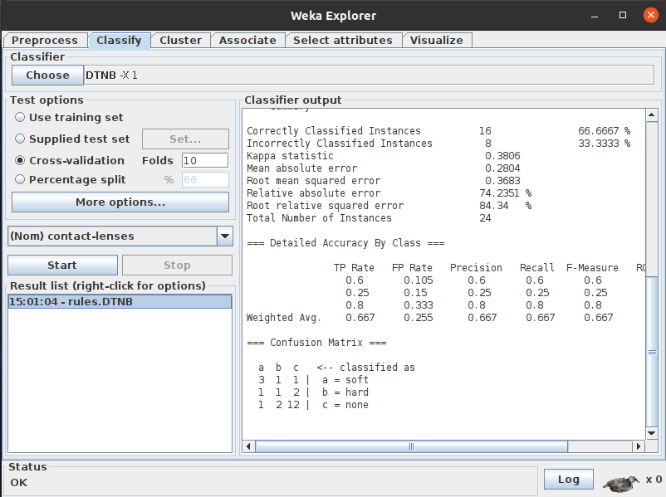

2.Orange is an easy to use data visualization tool with a large toolkit. In spite of being a GUI-based beginner-friendly tool, you mustn’t mistake it for a light-weight one. It can do statistical distributions and box plots as well as decision trees, hierarchical clustering and linear projections.

a. Install orange

b. Show data distribution

c. Show linear projection

d. Show FreeViz

Use dataset:

https://drive.google.com/file/d/1m6sKI1Dap0XK6Bw1edUd5PohwpPwXnd9/view

Create a report for this task and upload screenshots for the same.

Installation of ornage :

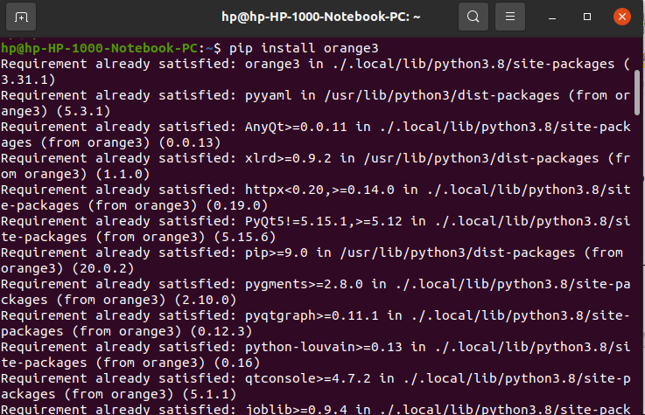

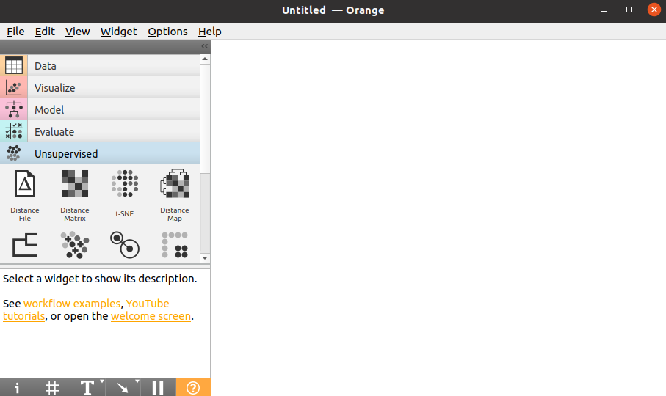

Loading provided data set:

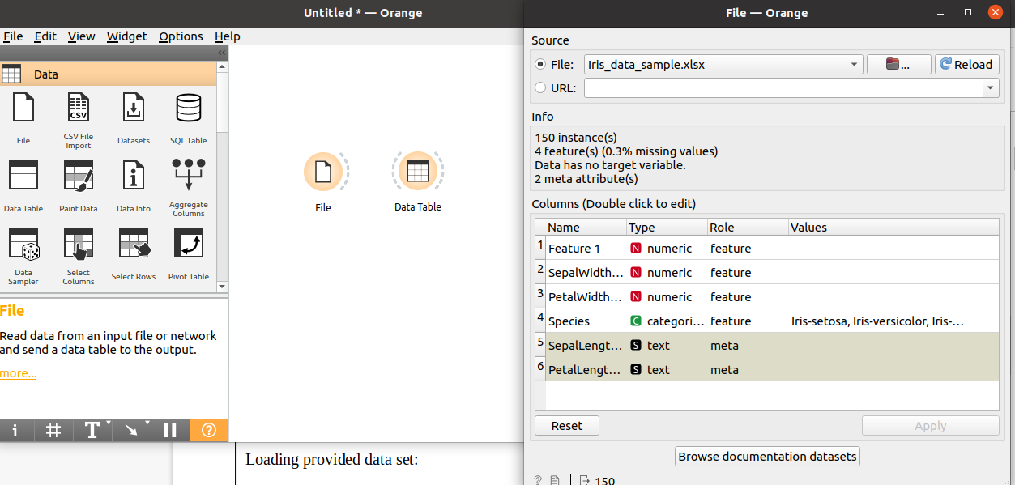

Data Distribution

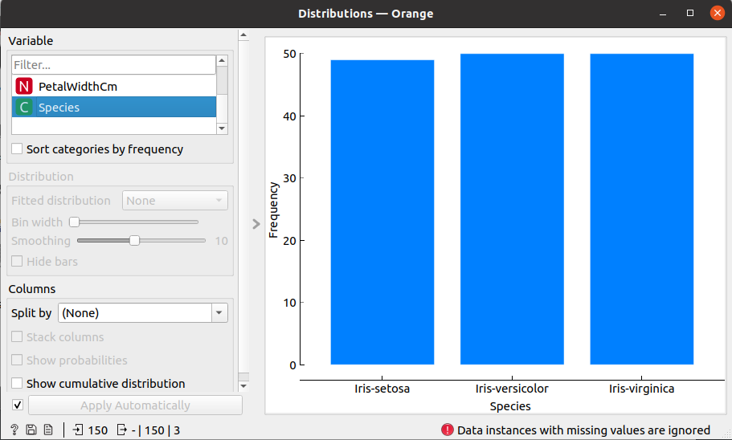

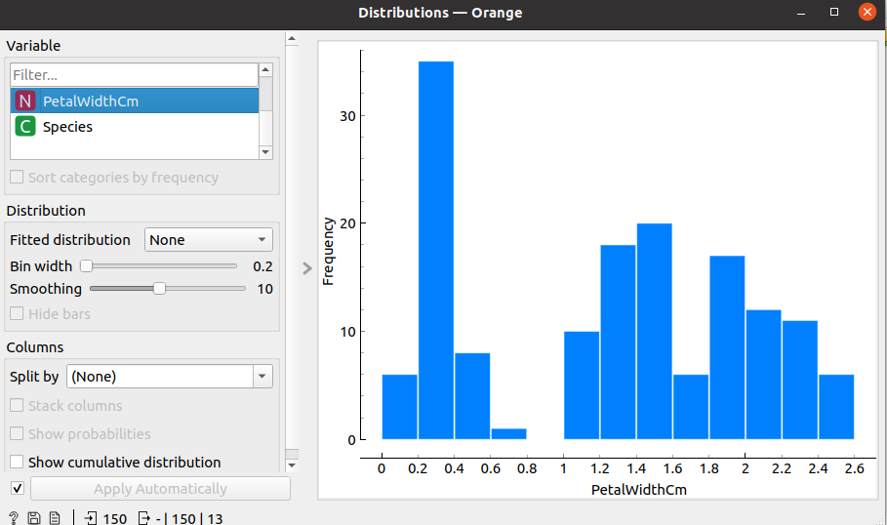

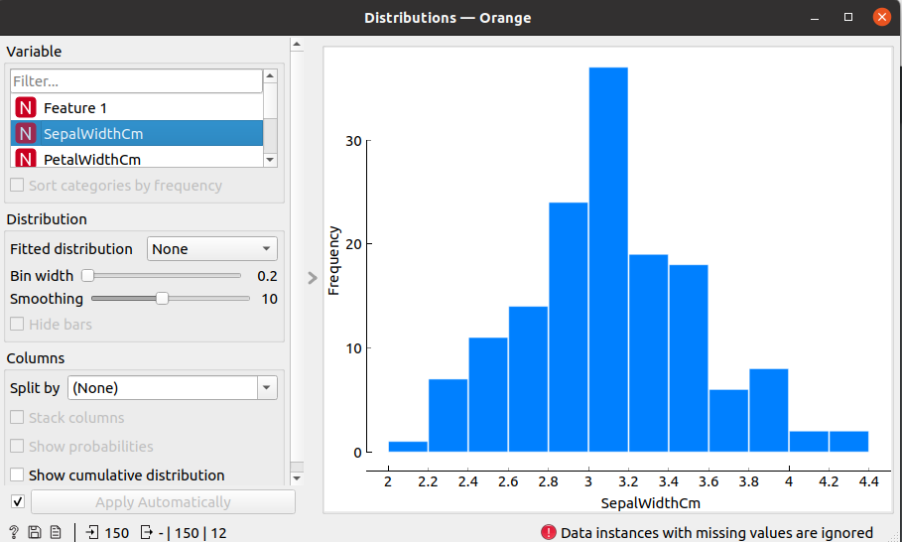

Linear Projection:

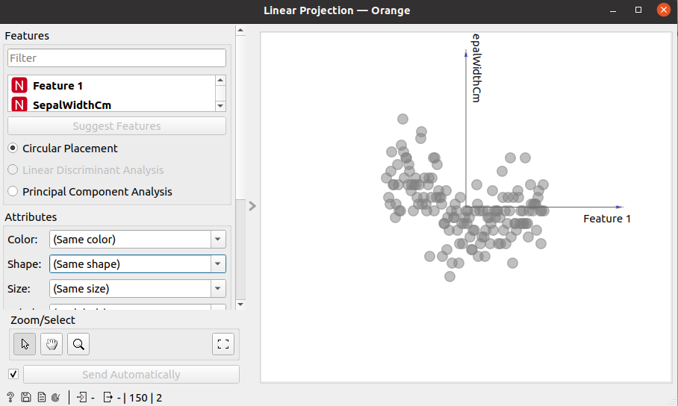

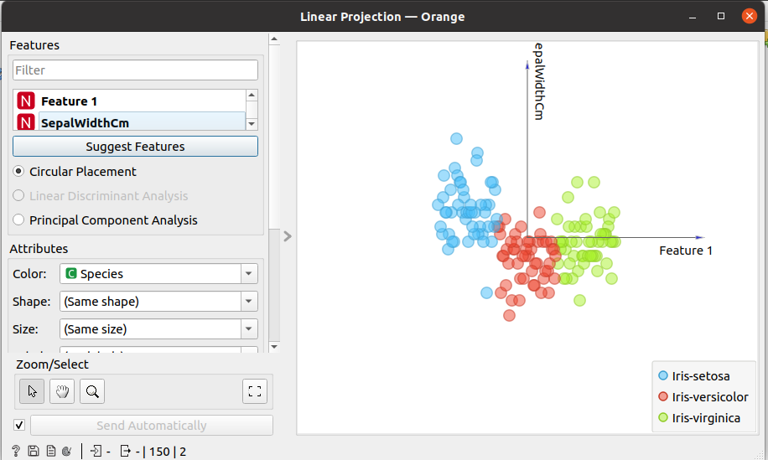

Freefiz

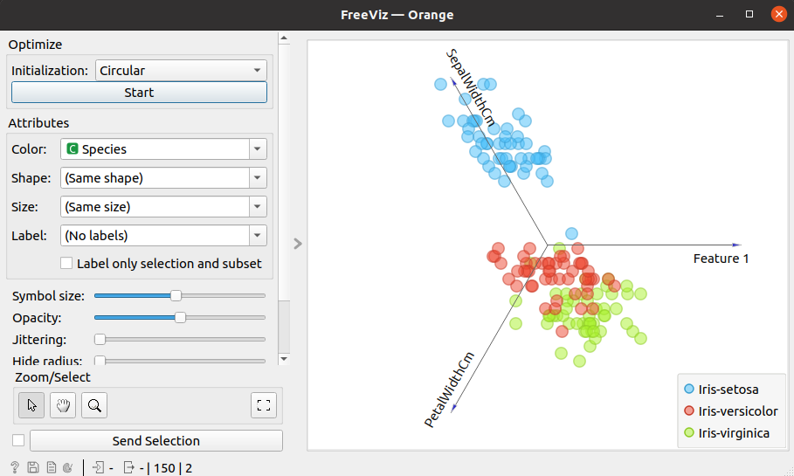

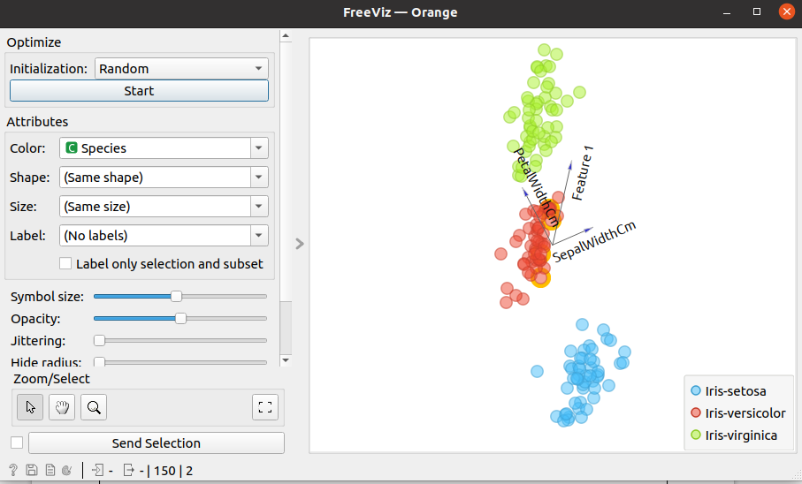

3. Differentiate in between free software, Open source software and

proprietary software with respect to its properties.

Free Software:

“Free software” means software that respects users’ freedom and community. Roughly, it means that the users have the freedom to run, copy, distribute, study, change and improve the software.

The term “free software” is sometimes misunderstood—it has nothing to do with price. It is about freedom.

Open Source Software :

Open Source Software is something which you can modify as per your needs, share with others without any licensing violation burden. When we say Open Source, source code of software is available publicly with Open Source licenses.

Proprietary Software :

Proprietary software is a computer software where the source codes are not publicly not available only the company which has created can modify it. Here the software is developed and tested by the individual or organization by which it is owned not by public. This software is managed by an closed team of individuals or groups that developed it. We have to pay to get this software and it commercial support if available for maintenance. The company gives a valid and authenticated license to the users to use this software.

4. Using Anaconda Python create Histogram, Scatter plot and Bar plot for the dataset given below.

Dataset- https://drive.google.com/file/d/1i11BZFe8Xj9kNq7eeE9KOa_Iz1KhEdXJ/view

a. Scatter plot- Scatter plot of Price Vs Age

b. Histogram- for Kilometer and CC

c. Bar plot- Bar plot for different fuel types

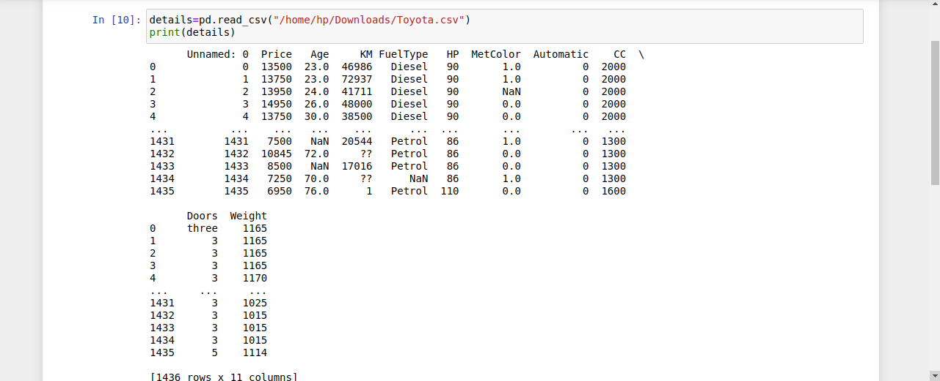

a.Scatter plot- Scatter plot of Price Vs Age

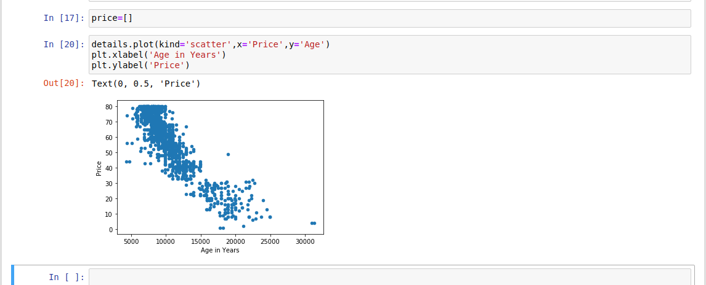

b.Histogram- for Kilometer and CC

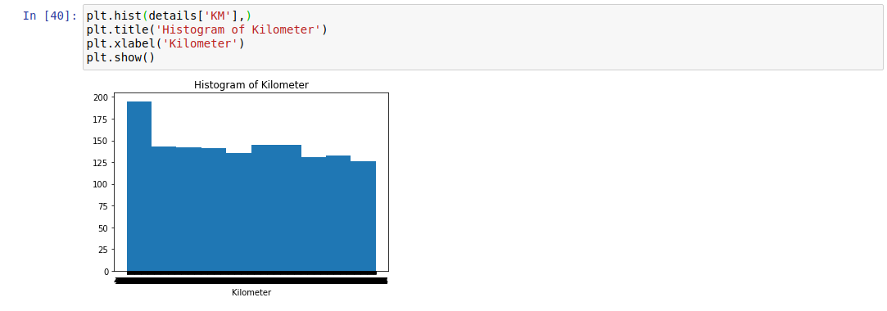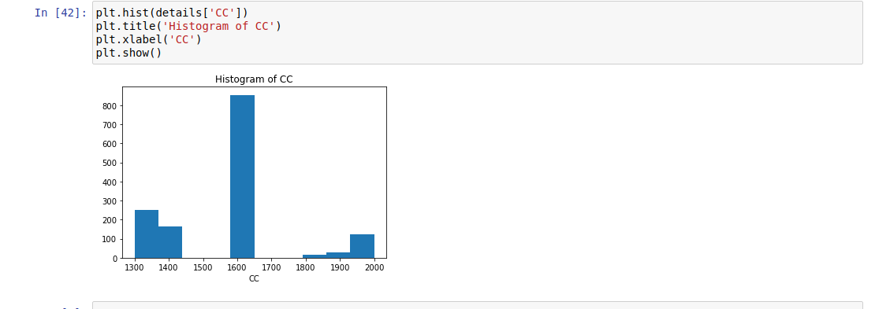

c. Bar plot- Bar plot for different fuel types

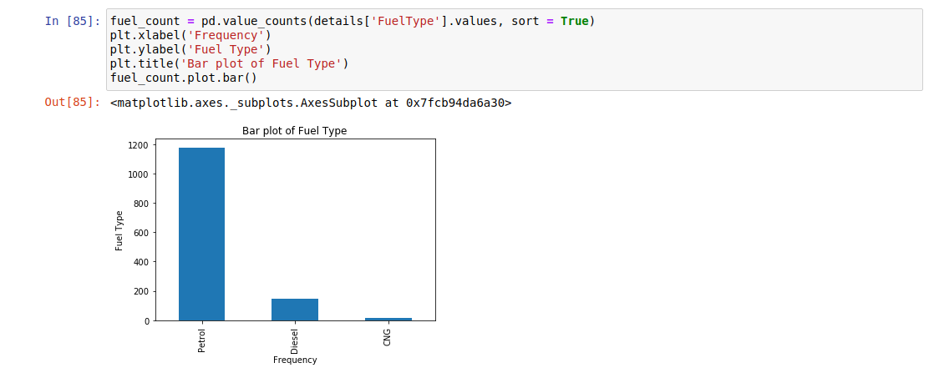

5. Enlist some examples along with its purpose and properties (at least 10) of

FOSS and proprietary software with respect to database.

1.Open Source (Database) :  
An open source database is a database that anyone can easily view the source code and this is open and free to download. Also for community version some small additional and affordable cost are imposed. Open Source Database provide Limited technical support to end users. Here Installation and updates are administered by user. For examples: MYSQL, PostgreSQL, MongoDB etc.

2. Proprietary (Database) :  
Commercial database are that which has been created for Commercial Purpose only. They are premium and are not free like Open Source Database. In Commercial Database it is guaranteed that technical support is provided. In this Installation and updates are Administrated by software Vendor. For examples: Oracle, IBM DB2 etc.