**Assignment – 1**

1.Create a remote git hub repository using Git Hub.

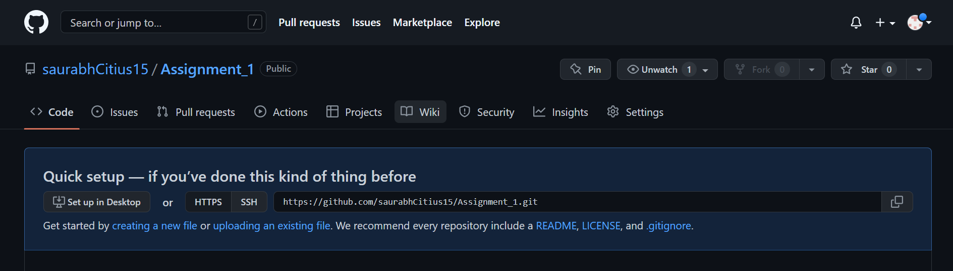

2. Clone the repository on your local machine.

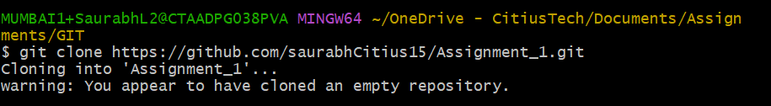

3. Using git config, set the username & email to your name and your CT email id respectively.

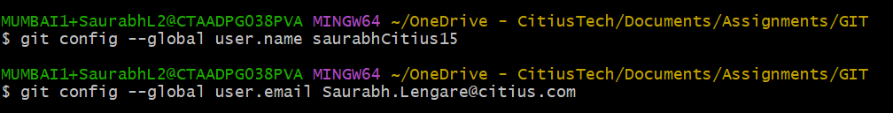

4. Create two empty text files named f1.txt and f2.txt inside the cloned repository.



5. Commit and push the changes to the remote repository

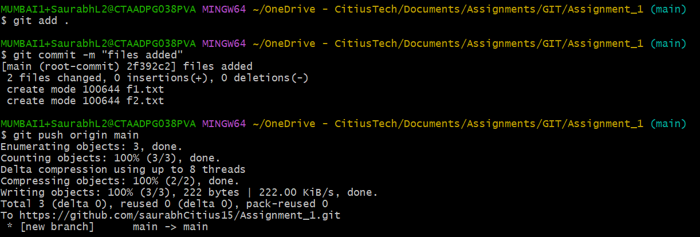

6. Check the status of the local repo.

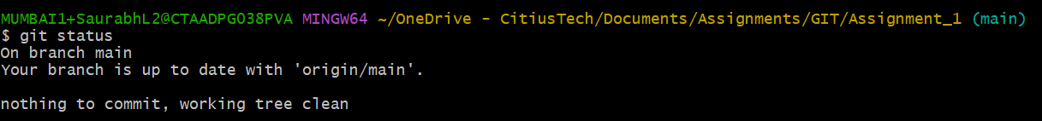

7. Go to the remote repository & check what files are present

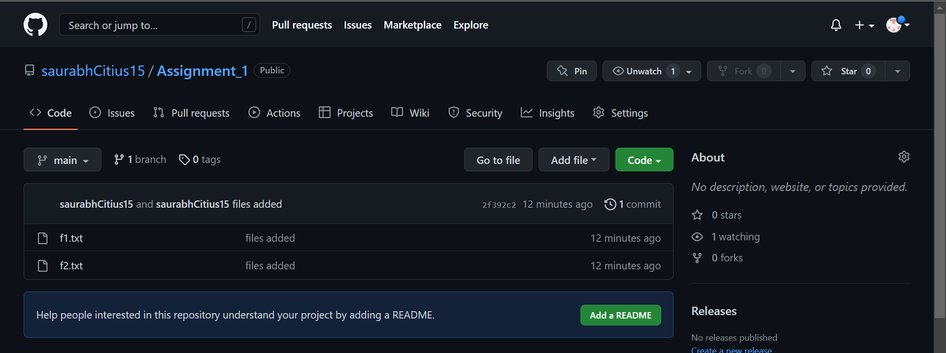

8. Add some text in f2.txt and save the changes.

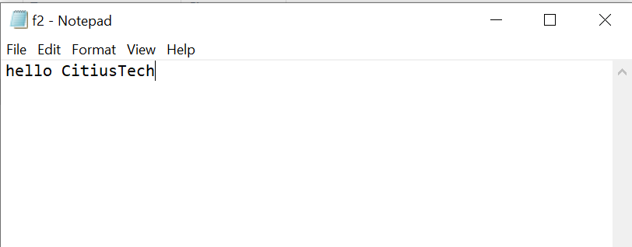

9. Check the status of the local repo.

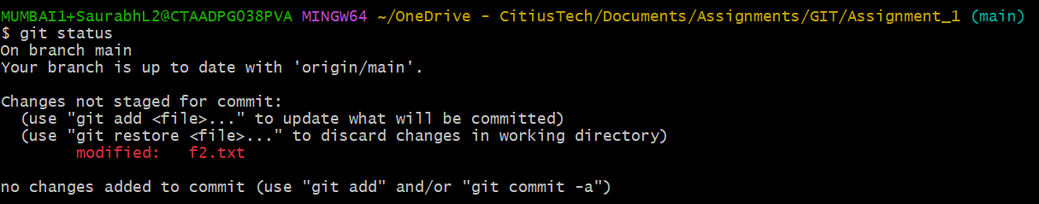

10. Go to the remote repository & check the contents of f2.txt. What do you see and why?

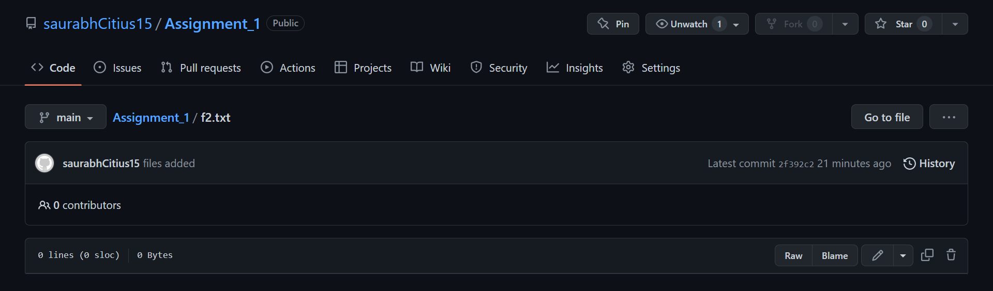

As we do not have committed and pushed the file to our remote repository the saved changes in the local repository are not reflected.

11. Add the file f2.txt into staging.



12. Check the status of the local repo.

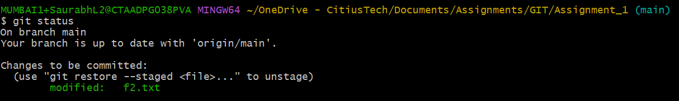

13. Go to the remote repository & check the contents of f2.txt. What do you see and why?



The file in remote repository is still empty as we did not committed and pushed the file.

14. Use appropriate Git commands to push the changes to the remote repository.

