**Assignment – 2**

1. Continuing from the previous assignment, make sure that there are no files in the staging area & that the remote repository contains files f1.txt and f2.txt with some content.

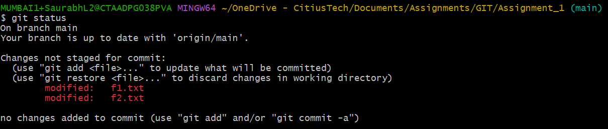

2. Create 3 new files named f3.txt, f4.txt and f5.txt respectively.

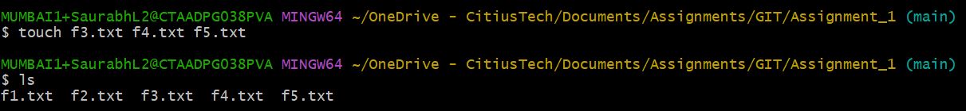

3. Commit the changes.

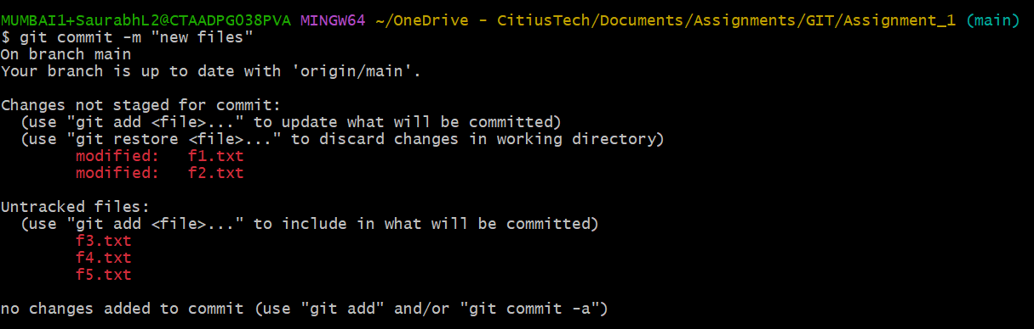

4. Add some text again in f1.txt and save the changes

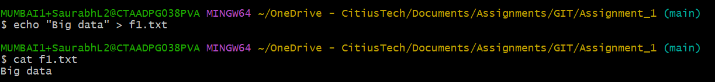

5. Stage the changes made to f1.txt.

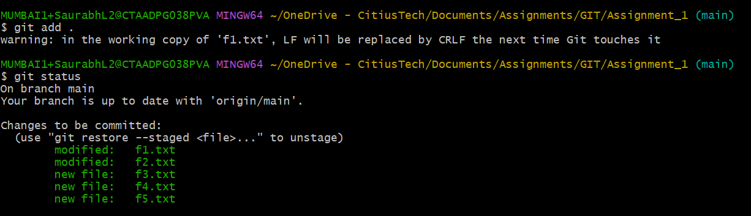

6. Use the commit –amend command to undo the last commit.

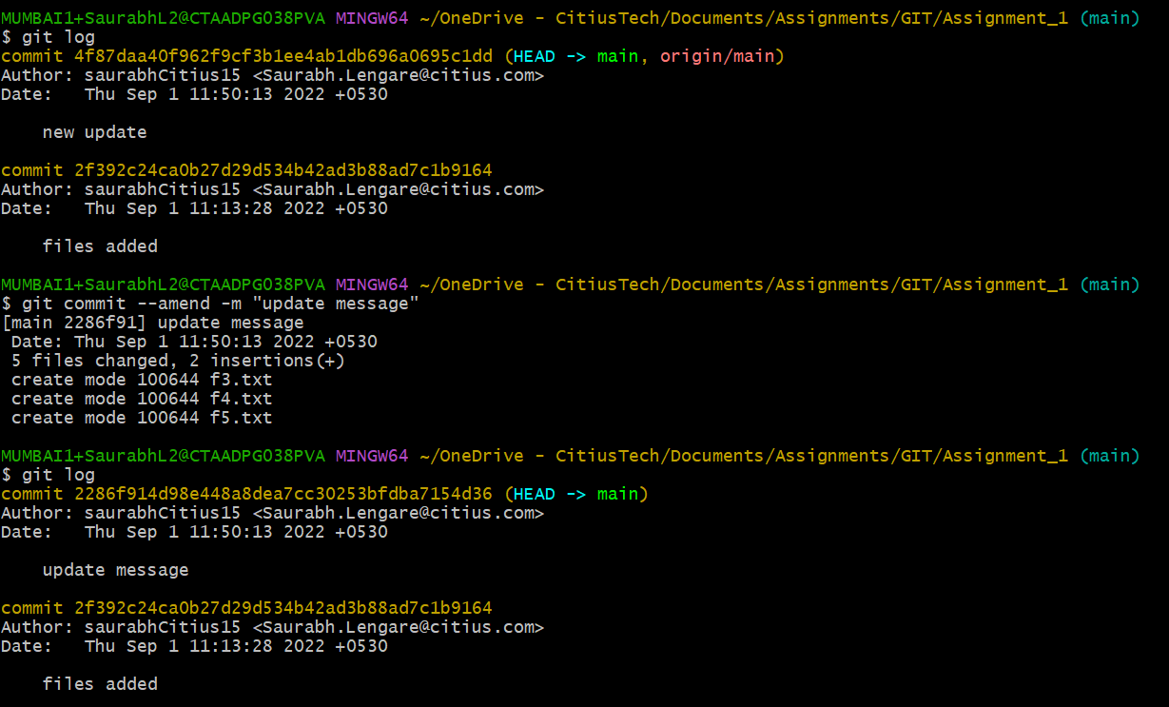

7. Push the changes to the remote repo finally. Go to the remote repo and check the results.