First Stage Project Report
On

Novel REMOTE SENSING PLATFORM FOR ACRE AND SUB-ACRE AGRICULTURAL FIELD
Submitted in the partial fulfilment of the requirement for the Degree of

MASTERS OF TECHNOLOGY

by
Vinay Verma (Roll Number: 123316001)

Under the supervision of

Prof. Surya S. Durbha

Centre of Studies in Resource Engineering
INDIAN INSTITUTE OF TECHNOLOGY BOMBAY
October 2014

Approval Sheet
This first stage project report entitled “A Novel Remote Sensing Platform for Acre and Sub-Acre Agricultural Field” prepared by Vinay Verma (123316001) is hereby approved for submission.

Date: Prof. Surya S. Durbha
Place:

DECLARATION
I declare that this written submission represents my ideas in my own words and where others' ideas or words have been included, I have adequately cited and referenced the original sources. I also declare that I have adhered to all principles of academic honesty and integrity and have not misrepresented or fabricated or falsified any idea/data/fact/source in my submission. I understand that any violation of the above will be cause for disciplinary action by the Institute and can also evoke penal action from the sources which have thus not been properly cited or from whom proper permission has not been taken when needed.

Signature

Vinay Verma

Date: (123316001)

ABSTRACT
Agriculture is an economically growing industry as number of consumers is increasing rapidly, but the suitable land for farming/cultivating crops is not considerably enough to match the growing demand. One effective way of increase the productivity is through remote sensing based precision farming techniques, but currently available platforms for remote sensing are not very cost effective and easy to operate. Indian agriculture is very big industry with large land cover, but this large land cover is mainly comprises of small agricultural lands with different owner for each. We need a cost effective, easy to operate and assemble platform which can be used for precision farming to extract different parameters for these small lands. Based on these parameter farmers can take real time decisions for their crops. An integrated remote sensing platform, based on rope-pulley assembly, open source hardware like arduino and raspberry pi, IoT, WSN and SOS is proposed here to overcome the issues with previous and available remote sensing platforms.
Keywords: IoT, remote sensing, precision agriculture, WSN, SOS, arduino

Contents
Approval Sheet ii
DECLARATION iii
ABSTRACT iv
Contents v
Acronym vi
List of Figures vii
Chapter 1 : INTRODUCTION 1
1.1 Remote Sensing 1
1.1.1 Remote Sensing in Agriculture 2
1.1.2 Available Remote sensing platforms 3
1.2 Core Objective 5
1.2.1 Introduction 5
1.2.2 Integrated Technologies and Concepts covered 6
1.2.3 Final Words 8
Chapter 2 : LITERATURE REVIEW 9
2.1 Vegetation Indices in Agriculture 9
2.2 Remote Sensing Platforms 10
Chapter 3 : METHODOLOGY AND ARCHITECTURE 16
3.1 Proposed Design 16
3.1.1 Cement block as base, pole and cable 17
3.1.2 Testing of design 18
3.2 System Architecture 19
3.2.1 Client- Server Architecture 19
3.2.2 Base station and WSN Architecture 20
3.2.3 Sensing System Architecture 21
3.2.4 Complete system Architecture 22
3.3 Hardware involved 22
3.3.1 Arduino Uno 23
3.3.2 Raspberry Pi 24
3.3.3 Zigbee / Xbee module and Programmer 24
3.3.4 Camera stabilizer Gimbal 25
3.4 Software Involved 26
Chapter 4 : SUMMARY AND FUTURE WORK 27
4.1 Summary 27
4.2 Future Work 27
REFERENCES 28
ACKNOWLEDGEMENT 31

Acronym
Lidar | Light detection and ranging
NDVI | Normalized difference Vegetation Index
CWR | Crop Water Requirement
NIR | Near Infrared Region
$$ρ_{NIR}$$ | Reflectance in NIR
$$ρ_{RED}$$ | Reflectance in red band
RVI | Ratio Vegetation Index
HTTP | Hyper Text Transfer Protocol
SAVI | Soil Adjusted Vegetation Index
UAV | Unmanned Aerial Vehicle
GIS | Geographic Information System
NRSC | National Remote Sensing System
IEEE | Institute of Electrical & Electronics Engineers
IoT | Internet of Things
OGC | Open Geospatial Consortium
LAI | Leaf Area Index
DVI | Difference Vegetation Index
WDVI | Weight Difference Vegetation Index
PVI | Perpendicular Vegetation Index
PC | Personal Computer
DIA | Digital Image Analysis
WP | Water Productivity
ASP | Aerial Sensor Platform
SOS | Sensor Observation Service
LNA | Leaf Nitrogen Accumulation
SQL | Structured Query Language
PCA | Principal Component Analysis
ADC | Agricultural Digital Camera
WSN | Wireless Sensor Network
CCD | Canopy Chlorophyll Density
USB | Universal Serial Bus
SWE | Sensor Web Enablement
GNDVI | Green Normalized Difference Vegetation Index
GLAI | Green Leaf Area Index
PAR | Photosynthesis Active Radiation

List of Figures
Figure No. | Description of Figure | Page No.
1.1 | Remote sensing architecture | 02
1.2 | Spectral distribution of plant reflectance | 02
1.3 | Tea gardens from bhuvan | 04
1.4 | Different UAVs used in farming | 05
1.5 | Architecture of WSN | 06
1.6 | IoT middleware | 07
1.7 | SOS request – response scheme | 08
3.1 | Proposed design for remote sensing platform | 16
3.2 | Base and pole assembly | 17
3.3 | Multi strand cable | 18
3.4 | Testing model | 18
3.5 | Images of testing model | 19
3.6 | Client-server architecture | 20
3.7 | Base station – WSN architecture | 20
3.8 | Sensing system architecture | 21
3.9 | Complete system architecture | 22
3.10 | Arduino uno | 23
3.11 | Raspberry pi | 24
3.12 | Zigbee module and programming board | 25
3.13 | Basic gimbal model | 26

: INTRODUCTION
Agriculture or farming is defined as cultivation of soil, plants and live stocks. It is backbone of human food and some other major products. Agriculture is still an economically growing industry as number of consumers is increasing rapidly, but the suitable land for farming/cultivating crops is not considerably enough to match the growing demand. Many government and non-government researches are subjected to match the graph between supplies and demand for that several conventional and non-conventional techniques are available. One effective way of doing this is through remote sensing based precision farming technique, where we can have information in form of Vegetation Indices. Vegetation Indices are very helpful in crop deficiency detection and yield monitoring. For remote sensing based precision farming, cost effective and easy to use system are needed, which can fulfil the requirement at most. To make system more efficient, interactive and interoperable we can integrate concepts of Internet of Things (IoT), Wireless Sensor Network (WSN) and Sensor Observation System (SOS) in it.

Remote Sensing
Remote sensing is science and art of obtaining information about a subject through the data obtained by a device that is not in contact with that, collected data is then analysed for generating information about subject. We basically collect data based on electromagnetic energy distributions; in this we gather data in several electromagnetic wavelengths like visual band (0.4-0.7µm), near infrared band (0.7-3µm), thermal infrared band (3-14µm). Wavelength ranging from 0.3 to 14 µm can be detected using multispectral sensors, also called as multispectral imagery. Figure 1.1 shows a typical architecture of remote sensing.
Remote Sensing may further categorised as
- Passive Remote Sensing: do not have their own source of radiation
- Active Remote Sensing: uses their own source of radiation like Light Detection and Ranging (Lidar)
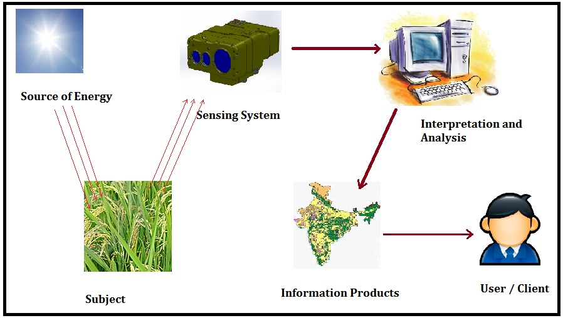
Figure 1.1 Remote Sensing Architecture

Remote Sensing in Agriculture
Remote sensing proved to be very effective for precision agriculture. Application of remote sensing in farming is based on the reflectance characteristics of plants and soil. Figure 1.2 describes the spectral distribution of plant reflectance.
Figure 1.2 spectral distribution of plant reflectance [3]
Reflectance characteristics can be used to monitor some major parameters in farming like
- Spatial distribution of crop yield
- Water stress
- Nitrogen biomass, diseases and weed prediction
- Yield forecasting

Looking into spectrum behaviour different Vegetation Indices are defined that are used for extraction of these parameters, some of them are
- Normalized Difference Vegetation Index (NDVI)
Its most widely used Vegetation Index and represented as a normalized ratio of Near Infrared Region (NIR) and red band
$$NDVI= \frac{ρ_{NIR}-ρ_{RED}}{ρ_{NIR}+ρ_{RED}}$$

- Ratio Vegetation Index (RVI)
$$RVI= \frac{ρ_{NIR}}{ρ_{RED}}$$

- Soil Adjusted Vegetation Index (SAVI)
$$SAVI=(1+L)\frac{ρ_{NIR}-ρ_{RED}}{ρ_{NIR}-ρ_{RED}+L}$$

Available Remote sensing platforms
There is a variety in remote sensing platforms being used for farming purpose; some platforms are satellite, Unmanned Arial Vehicle (UAV), hot air balloon, hand held multispectral radiometer.
Satellite Imagery and Geographic Information System (GIS) are very important system for acquiring and generating agricultural maps. It provides a very bigger picture of any agricultural land as it covers very large area on ground. Satellite data provides several type of land/soil classification, crop classification, change detection, environmental forecasting related to agriculture and an overall map for state or country with acceptable resolution. But working on satellite data generation and interpretation is very costly, whole satellite data generation, analysis, interpretation and then generating information generation from that data takes too much of effort, money and most important time. It has a very poor temporal resolution and monitoring a single field using satellite is not an advisable thing but doing well for large area monitoring and classification. Figure 1.3 shows how National Remote Sensing Centre (NRSC) is using satellite data and GIS for specifying tea gardens in India.
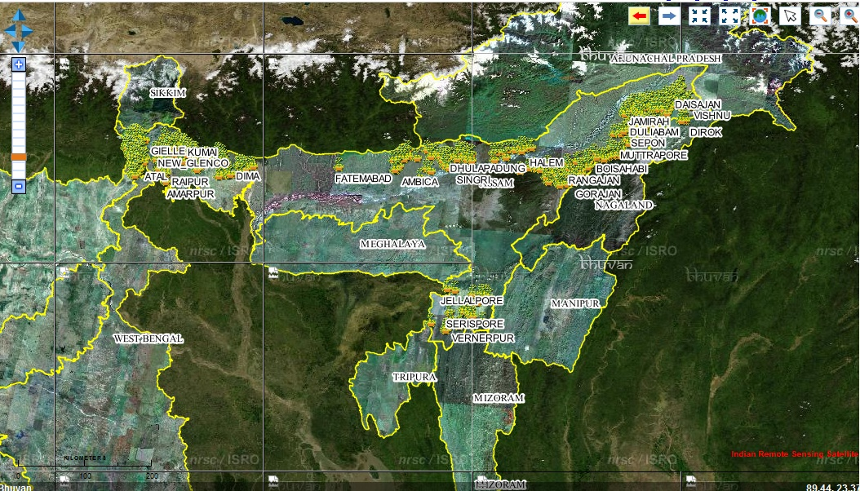 Figure 1.3 Tea Garden Image from Bhuvan [28]
UAVs have the upper edge from Satellite in monitoring targeted agricultural field, as UAVs are capable of scan small fields. Use of UAVs, drones in agriculture is increasing continuously and researches are going on to make it more purposeful and profitable. UAVs are much cheaper than satellite and have a user dependent temporal resolution. Figure 1.4 shows some UAVs being used now a days.
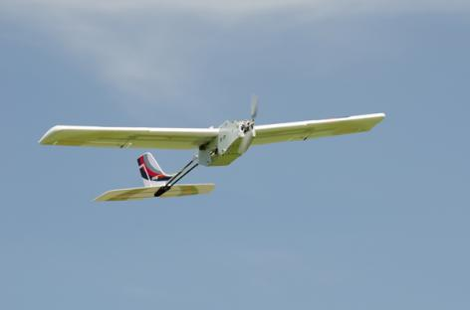 | 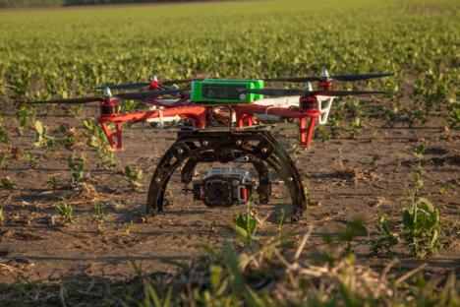
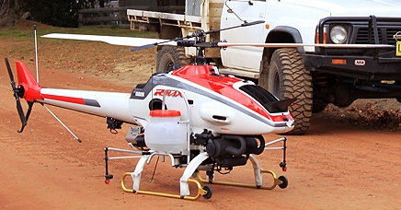 | 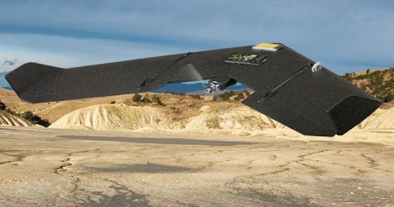
Figure 1.4 Different UAVs used in farming
UAVs have several sensors mounted on that to work as a better platform for farming purpose; most significant sensor is multispectral camera which is mainly responsible for the parameter extraction and map generation of an agriculture field. UAVs also have some limitations like power supply issue, limited flight time, low payload capacity and complexity of operation.

Core Objective

Introduction
There are different kinds of systems with distinct platforms available for precision/better farming, each having its own benefits and drawbacks. In country like India agriculture is very big industry with large land cover, but this large land cover is mainly comprises of small agricultural lands with different owner for each. So total income from this large agriculture industry divides in number of people and that’s why everyone get very small share. Indian farming has two issues, first to match the production and consumption graphs, second is cost and easiness of use. To overcome these issues farming needs a system which can provide precision farming facility with minimal effort and money.
UAVs are very good platform for remote sensing in farming but they seem to be very costly and required lots of technical supervision for operation. Objective of this project is to overcome these issues and provide a “Novel Remote Sensing Platform for Agricultural Field”. Instead of UAVs we are using a stationary (partially) platform based on rope – pulley assembly used in cable cars and rope ways, that might cover acre and sub-acre area at once. This architecture would be able to provide a very good multispectral imagery system which can be easily installed and operated. This system has integration of Wireless Sensor Network (WSN) and Internet of Tings (IoT) with interoperability via Sensor Observations Service (SOS). Idea is to demonstrate a simple remote sensing platform with initial capability of capturing multispectral images and then that data can be used for further applications after processing. Grain crops are main targets of this system i.e. system is initially cover some of the crops like rice, wheat, chana and other small height crops which are being harvested in large amount in India by small farmers. These crops are also have a very large demand in market as these are the basic crop which serve as food, so the production need to be very high and efficient.

Integrated Technologies and Concepts covered
To achieve the complete architecture of proposed platform these technologies and concepts were also integrated with it.

Wireless Sensor Network
Wireless sensor network is network system of spatially distributed sensors with a particular communication protocol or scheme. All detector station are called sensor node and every sensor node is the fundamental unit of WSN and may have transducer, microcontroller and power source. Wireless Sensor networks are highly recommended for application like surveillance, monitoring, detection and communication due to the robustness of system. For WSN communication protocols like ZigBee or Bluetooth may be used. A simple architecture for WSN is shown in figure 1.5
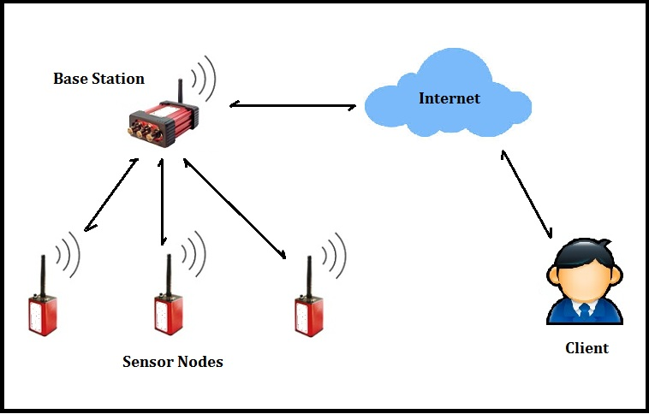
Figure 1.5 Architecture of WSN
For our purpose WSN using ZigBee and Arduino will work sufficiently to communicate between base station and sensor nodes.

Internet of Things
Internet of things is basically connecting/operating the things (heterogeneous sensors or physical objects) through internet using a software platform termed as middleware. Figure .6 IoT middleware structure with fundamental components.
Figure 1.6 IoT Middleware [29]
IoTs Architecture has three fundamental layers as
- Sensor Layer or Physical Layer: It may consist WSN with some protocol like ZigBee
- Network Layer: This layer have all web and server side tools and this layer serves as bridge between device and the application by providing benefits of IoT middleware
- Application Layer: this layer deal with client side functionalities like user based applications and logics, user interface
IoT in this project will be implemented as a liaison between remote sensing platform and client side applications processing.

Sensor Observation Service
For providing interoperability and standardization sensor observation services is needed. As project include sensor web enablement so there should be some standard to be followed. SOS is based on Open Geo-spatial Consortium (OGC) standards or sensor web framework. SOS uses a semantic architecture based on XML called SensorML, which is a machine interpretable model of sensor. Like all services SOS also has in own request and response schemas based on which we can easily achieve goal of semantic sensor web enablement. Some of the requests are, GetCapabilities, Describe Sensor and Get Observations. Figure 1.7 shows a request – respose scheme for SOS.
Figure 1.7 SOS request – response scheme [30]

Final Words
Integration of these cutting edge technologies with a platform based on a simple, low cast and open source hardware will provide a good solution for monitoring and mapping of agricultural parameters which will be very helpful for farmers to achieve the precision agricultural benefits in minimum effort, time and cost.

: LITERATURE REVIEW
As agriculture is one of the major factors in any countries economy and sustainability, lots of efforts and research is going on worldwide in this domain. Remote sensing in agriculture is considered as one of the milestone in these researches, that’s why it’s catching eyes of lots of researchers in precision farming. This chapter briefs about some researches about remote sensing in precision farming and some fundamental about technologies involved.

Vegetation Indices in Agriculture
Most important data from remote sensing in agriculture is Vegetation Index, some detail about vegetation indices and their extraction are also covered in literature review part.
A very early analysis on comparison of vegetation indices are studied in [1], it describes the visible and near infrared spectral analysis and crops covered are wheat, cotton, corn and soybean. Two vegetation indices RVI and NDVI are tested with incident Photo synthetically Active Radiation (PAR). This paper gives information about the relation between vegetation indices, Leaf Area Index (LAI), biomass, photosynthesis and daily mean PAR with mathematical modelling and field data. Those relationships can be used for homogeneous vegetated surface of grass and agricultural crops.
[2] Propose and discuss about Soil-Adjusted Vegetation Index (SAVI). Dealt with red and NIR spectrum and covered vegetation indices are RVI and NDVI. Paper also discussed about influence of soil characteristics on vegetation indices in light-colored soil and dark-colored soil.
In [3], a detail about remote sensing in farming and use of vegetation indices are discussed. It also tells about parameter extraction using vegetation index using regression and modelling approaches. Vegetation indices covered are RVI, NDVI, Weighted Difference Vegetation Index (WDVI), SAVI, Green Normalised Difference Vegetation Index (GNDVI), Difference Vegetation Index (DVI), Transformed Adjusted Vegetation Index (TSAVI), Perpendicular Vegetation Index (PVI), Modified Soil Adjusted Vegetation Index (MSAVI), Stress Related Vegetation Index (STVI) and Cubed Ration Vegetation Index (CRVI). Paper also gives some light on remote sensing application in extraction of evapotranspiration, soil salinity, crop growth, nutrient/pest management and yield estimation.
Some details about calculation of Leaf Area Index (LAI) of rice crop has given in [4], paper also enlighten about drawbacks of NDVI. This paper proposed a new vegetation index with combination of red, green and blue bands to calculate LAI of rice and discussed about correlation analysis and sensitivity analysis between indices, including validation of results.
In [5], a comparative analysis of different vegetation indices for estimating Green Leaf Area Index (GLAI) is discussed to find out suitability of vegetation indices for the same. Study area was research facility in Nebraska-Lincoln Agricultural Research and Development Centre (UNL-ARDC) U.S.A. Vegetation indices covered are Normalized Difference Vegetation Index, Enhanced Vegetation Index, Green Atmospherically Resistant Vegetation Index, Wide-Dynamic Range Vegetation Index, Green Chlorophyll Index, Red-edge Chlorophyll Index, and MERIS Terrestrial Chlorophyll Index.

Remote Sensing Platforms
Remote sensing in precision farming proved to be very beneficial, different type of architectures with different techniques involved are available and researches for new platforms are going on. Some of the current techniques are discussed below
Study [6] is centred on damage assessment of wheat from green bug (Hemitera: Aphididae), using Digital Image Analysis (DIA) of data captured by remote sensing of field using an Ocean Optics hyperspectral hand-held spectrometer (cost around $2000) and fields are located in Texas and Oklahoma. Study demonstrates the use of hand held remote sensing device in precision agriculture.
Study [7], discuss about weed detection and management in crops via remote sensing by comparing textures of soil, weed, crops. Two categories where this study looks after were weed against bare soil and weed against vegetative background. Told about use of satellite imagery on weed detection and then had a compare about weed detection using airborne platforms and found airborne have more flexibility and resolution than satellite. Some cons. of airborne imagery like high cost, processing discussed with common errors occurred in imagery techniques. Study concluded as airborne imagery may be economical only on large scale not in small scale farming, but may have more low cost multispectral cameras to reduce cost.
Application of remote sensing in precision farming with requirement of less technical knowledge from farmers use point of view is discussed in study [8], a learning community approach which connects farmers and researcher is covered and led by Upper Midwest Aerospace Consortium (UMAC). Data taken from AVHRR, MODIS, ETM+, IKONOS and wheat monitoring using NDVI had done with area selection for sugar beet by drainage deficiency. In conclusion several drawbacks of satellite remote sensing were proposed.
In study [9], several comparisons between hyper spectral and multi spectral imagery in precision agriculture were stated. Imagery sources were ETM+, MODIS, AVIRIS and parameter discussed are NDVI and LAI. In result correlation between LAI and spectral reflectance, correlation between NDVI and LAI and canonical correlation analysis were shown.
Rice yield, water consumption and Water Productivity(WP) in Indo-Gangetic river basin using remote sensing is studied in [10], they have used integration of remote sensing, census data and weather data for this purpose. Crop coefficients were derived from multispectral imagery and Evapotranspiration (ET) was calculated from meteorological data. Based on these extracted parameters several maps like ET map, yield map, WP map for that region prepared and concluded the relation between all these.
Study [11], discussed about remote sensing through UAV for agricultural surveillance and decision support for coffee including aspects like weed detection, water and nutrient requirement and yield maintenance. This study also discussed about some benefits of UAV in precision farming over satellite and airborne imagery system. Study area was Kauai Coffee Company at Hawaii, USA and platform used was NASA’s pathfinder-plus UAV which was very costly solar powered light weight aircraft with a wing span of 36.3 meter and payload capacity of 67.5 kg. Aircraft equipped with two cameras one for hyper spectral imagery (Hasselblad 555ELD) and another for multispectral imagery (DuncanTech MS3100). Detailed operational and processing specifications were included in this study.
A low altitude remote sensing platform designed using helium balloon is proposed and used for parameter extraction from wheat crop in study [12]. Crop yield and crop protein level in grain crops were mapped. Instrument used were Kodak DC3200 and a small (25mm*25mm) black and white analogue camera. Balloon’s diameter was 1.8 meter and study area was southeasten Queensland Australia. Geo referencing of images was done with help of 20 ground control points and ground resolution was around 0.25 meter. Parameters extracted were NDVI, DVI, GNDVI, RVI and Correlation between these parameters was studied to estimate yield and protein.
In study [13], an ASP (Aerial Sensor Platform) was tested and evaluated concerning its suitability to follow a given route within a field, and to collect georeferenced multispectral data which can be used for deriving management decisions (as fertilizer application) in precision farming. The ASP was equipped with the spectrometer (MMS1) in the underside of the fuselage and autopilot MP2028g, and a PDA on top of the ASP for collection of multispectral sensor and GPS data. The ASP has a wing span of 1.4 m and a maximum take-off weight of 4.2 kg. Multispectral data was collected with a spatial resolution of 8m. Since the payload capacity was limited to 1kg, reference measurements were not possible, thus limiting the suitability of multispectral data.
In article [14], authors have proposed the use of common spectra wavebands and vegetation indices (VI) for identification of leaf nitrogen accumulation (LNA). Ratio vegetation index (RVI), Differential vegetation index (DVI), and NDVI are used for identifying the correlation. Also, quantitative relation between LNA and canopy reflectance spectra, are determined for wheat and rice. The experiment was carried out at Nanjing Agricultural University, China for a single season from 2001 to 2002. Spectral reflectance was measured using MSR16 radiometer (wavelength range 447-1752nm and 16 specific wavebands). Results show that RVI (870,660) and RVI (810,660) are highly correlated to LNA.
In [15], the authors have developed a method to determine the status of Nitrogen and Chlorophyll content of rice leaf by using all visible bands, derived from images captured using conventional digital camera. Test area was at University of Putra Malaysia, Serdang, Malaysia. Authors used ExG (Excessive green index), ExR (Excessive red index) along with other indices and applied Principal Component analysis (PCA) to generate the results. Results suggest that Low Altitude Remote Sensing (LARS) platform attached to a UAV can provide a low cost, high spatial and temporal resolution system as compared to airborne or satellite systems.
Study [16] provides a comparative analysis of vegetation indices (VIs) developed based on narrowband and broadband spectral data for calculation of Leaf Area Index (LAI) and Canopy chlorophyll density (CCD) for cotton. For the experiment, hyperspectral reflectance was measured at 2.3m above the cotton canopy along with LAI and CCD (field data). NDVI and RVI (Ratio vegetation index) were used to generate a linear and exponential regression analysis against LAI and CCD values. Also, traditional broadband vegetation indices based on simulated spectra are compared with their narrowband versions in predicting LAI and CCD. Authors present the following comparison: VIs based on different red-NIR bands; Optimum red-NIR bands; broadband VIs and hyper spectral VIs.
In [17] authors have proposed architecture for precision agriculture monitoring with real time remote sensing. Basic GIS layers are prepared using ground mapping and ground data collection. Aerial data is collected using a still infrared camera (500-900nm and spatial resolution of 50cm) and a digital camera (450-680nm spectral range and spatial resolution of 50cm). Objective of work was to determine the amount of nitrogen supplied to the plants and weekly water requirement of plants for regulating the growth.
Article [18] gives an insight into design and development of Hyperspectral and Multispectral Cameras for airborne mapping (HAMCAM). The system integrates a hyperspectral sensor with four multispectral cameras, an Inertial Navigation System (INS), a Wide Area Augmentation System (WAAS)-capable Global Positioning System (GPS), a data acquisition computer, and custom software for running the sensors in a variety of different modes. It provides full details on camera used, calibrations, airborne system, data collection and processing. Although it is not a novel approach, it gives a good idea about the state-of-art techniques used for spectra based sensing and mapping.
Study [19] also explores the use of standard digital cameras for monitoring crop growth change in open fields. Authors have developed a Crop Phenology Recording System (CPRS) for monitoring rice growth. Digital camera driven vegetation indices like visible atmospherically resistant index (VARI, based on daytime normal colour images) and night time relative brightness index (NRBINIR, based on night time near infrared images) are used. Apart from this authors also include agronomic data such as plant length, LAI, and above ground dry matter weight to generate temporal relation between VIs and biophysical parameters. Results show the brightness of the night time NIR images had spatial heterogeneity when a point light source is used. It also shows that ISO sensitivity and calibrated digital number of the NIR have significant effect on NRBI_{NIR}.
Study [20] also helps in predicting nitrogen status of rice at different growth stages with help of multispectral data. It shows that nitrogen status is related to reflectance in visible and NIR region. Canopy reflectance measurements are converted to ratio vegetation index (RVI) and NDVI. Results show that precision of regression models using above indices are very high.
Article [21] promotes the use of Earth Observation Systems (EOS), for development of policy based remote sensing applications. It refers to the NASA funded Synergy program and shows some potential applications in field of agriculture, range management and water resource management. Qualitative and Quantitative metrics are estimated along with importance of user involvement, data accessibility and sustainability study. It overall highlights the potential of remotely sensed data in decision and policy making.
In [22], authors have used an unmanned helicopter for vegetation monitoring through remote sensing. A real-time kinematic global positioning system was adopted and an inertial sensor was used to control the posture of helicopter. Results are generated from images captured from UAV with a spatial error of 38cm. Images were taken at three channels with central wavelength at 550, 650 and 800nm. These images are then used for nitrogen and chlorophyll content detection.
Study [23] shows the use of an unmanned aerial vehicle for agricultural remote sensing. UAV is designed to be less than 14kgs and is equipped with a multispectral camera. Authors have designed and extended Kalman filter (EKF) based UAV navigation system using sensor fusion techniques. It gives a full outline of techniques used for UAV design, stabilization, communication, flight planning, data capture and calibration. It also gives a complete performance evaluation of the proposed system.
Study [24] gives an overview of different multispectral imaging systems for airborne remote sensing systems for agricultural applications. First being a low cost Agricultural Digital Camera (ADC). Second is a relatively expensive multispectral camera and third is a high cost custom made multispectral camera (like Texas Tech Airborne Multispectral Remote Sensing System). These systems vary in terms of cost, specifications, ease of operation, quality of output, speed of operation, extent and usability. It also presents a trade-off between space-borne, air-borne and ground based imaging systems.
Study [25] shows the use of thermal and narrowband multispectral remote sensing for vegetation monitoring using UAV. For this thermal imagery in 7.5-13µm region (resolution 40cm) and narrowband multispectral imagery in 400-800nm (resolution 20cm) was obtained. Through this surface reflectance and temperature imagery are obtained. This helps in calculation of NDVI, transformed chlorophyll absorption in reflectance, soil adjusted vegetation index and photochemical reflectance index are calculated.
In study [26], authors have used a blimp based remote sensing system for low altitude sensing for agricultural applications. The blimp was a helium filled envelope which was 23m long and with a maximum diameter of 7m. It was designed to fly at an altitude ranging from 30 to 400m with a payload of approximately 100kg. Blimp was also equipped with four monochromatic CCD video cameras. This was used to calculate the LAI (Leaf area index) with spatial variability between and within fields.

: METHODOLOGY AND ARCHITECTURE
Hardware needed, software used and all other supportive materials and technologies implimented for remote sensing platform architecture, are discussed in this chapter. Here some concept about communication architecture between client-server, sensors and base station are also covered.

Proposed Design
Prototype design comprises of a four pole - four wire assembly as shown in figure 3.1. We tried to create a rover-rail assembly which is mounted on parallel cables at a particular height.
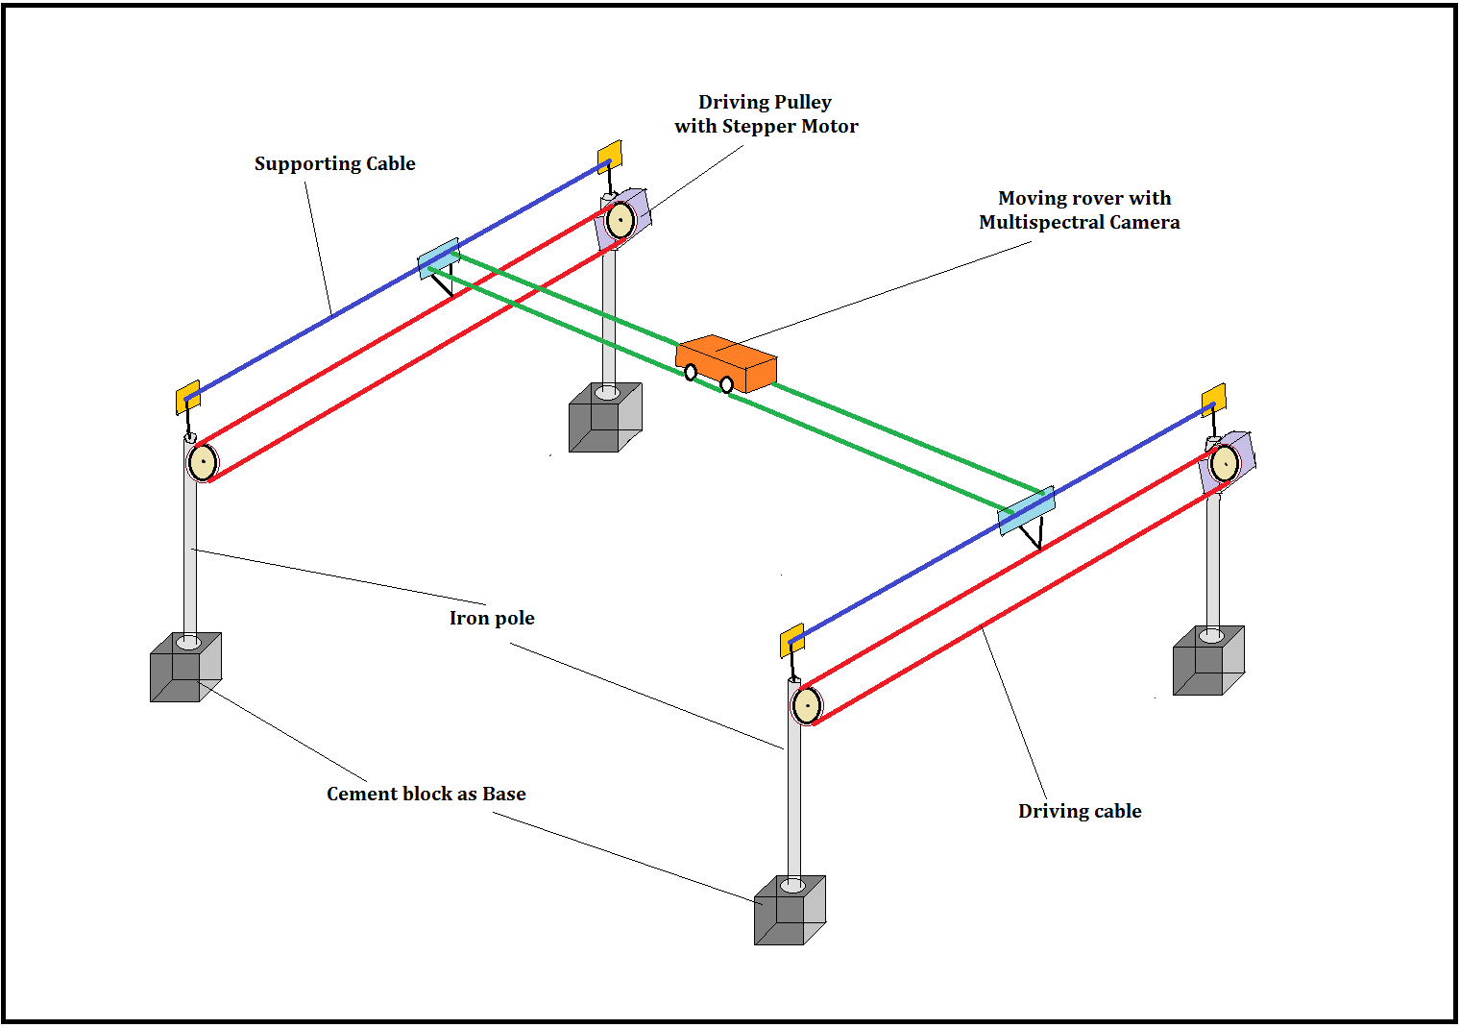
Figure 3.1 Proposed Design for remote sensing platform
Rope cable are driven by geared assembly of stepper motor, steps of motor can be controlled and defined either manually or hardcoded in controller. For prototyping a remote control for manually controlling the step size is there. Steps of motor eventually control the movement of rope cable and rover, that will define systems temporal resolution and number of images taken on one go. For purpose of using open source hard ware arduino uno is considered as it’s a very compatible and easy to use controller board having open source feature. For base station also use of open source hardware raspberry pi is proposed to work as single board computer. Multispectral camera will be connected to rover moving on the rails which will take images after every step to cover the field defined by the total are of square made by four poles. Initial area cover is targeted to be a sub acre field on ground but can be extended further.
This design is a very simple architecture with simple hardware and easy to operate which will can be operated and assembled by farmers also.

Cement block as base, pole and cable
Base of prototype is considered to be a cement block with some movement arrangement with it, which will make it easy to operate in field. This base will supress the requirement of digging the field every time for mounting the pole, base also has burial and anchor type mounting for pole, to provide it better stability. Pole can be a wooden/bamboo one or an iron pole which one is suitable and less costly, for prototype design iron pole is proposed. Rope-cable will be multi strand metal cable to provide better strength and less shagging. Figure 3.2 shows pole and base assembly and figure 3.3 shows a multi strand cable design.
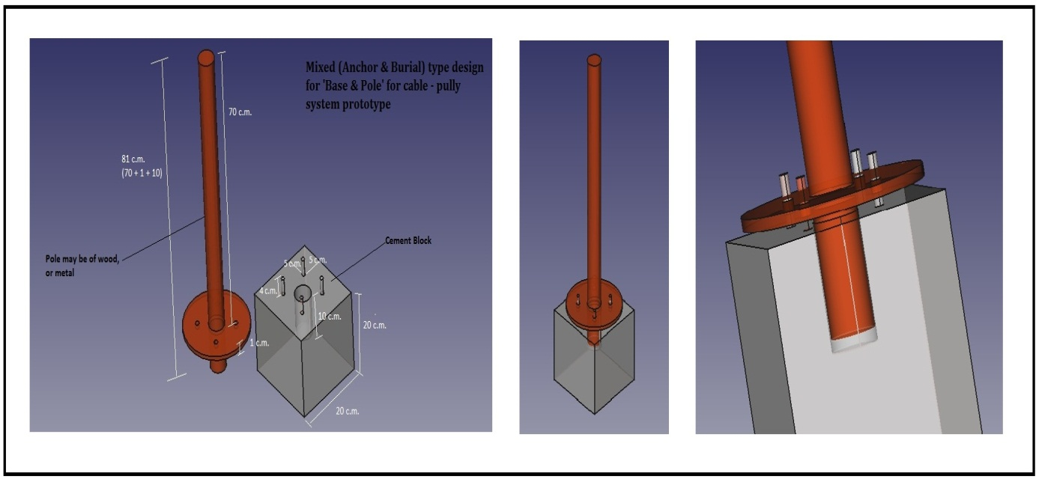
Figure 3.2 Base and pole assembly

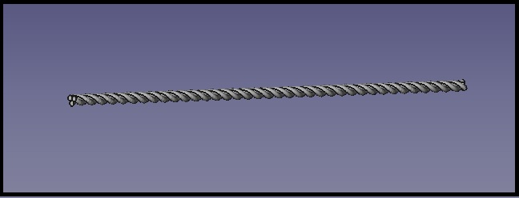
Figure 3.3 Multi strand cable

Testing of design
Before building the prototype for validation of design a miniature model is prepared. This model also helped in modification of design for better operation of whole system. Figure 3.4 shows image of complete assembly of testing model. As proposed design it has four poles – four wire assembly mounted on a base. Driver cable and supporting cable are mention in figure. Driver cable moved through a geared assembly of stepper motor which is operating through arduino uno. A four wheel rover is mounted on the parallel wire arrangement and operated by another stepper motor. This testing model successfully demonstrates the working of prototype up to certain level as camera and other things are not mounted here. Figure 3.5 shows some images of testing model.
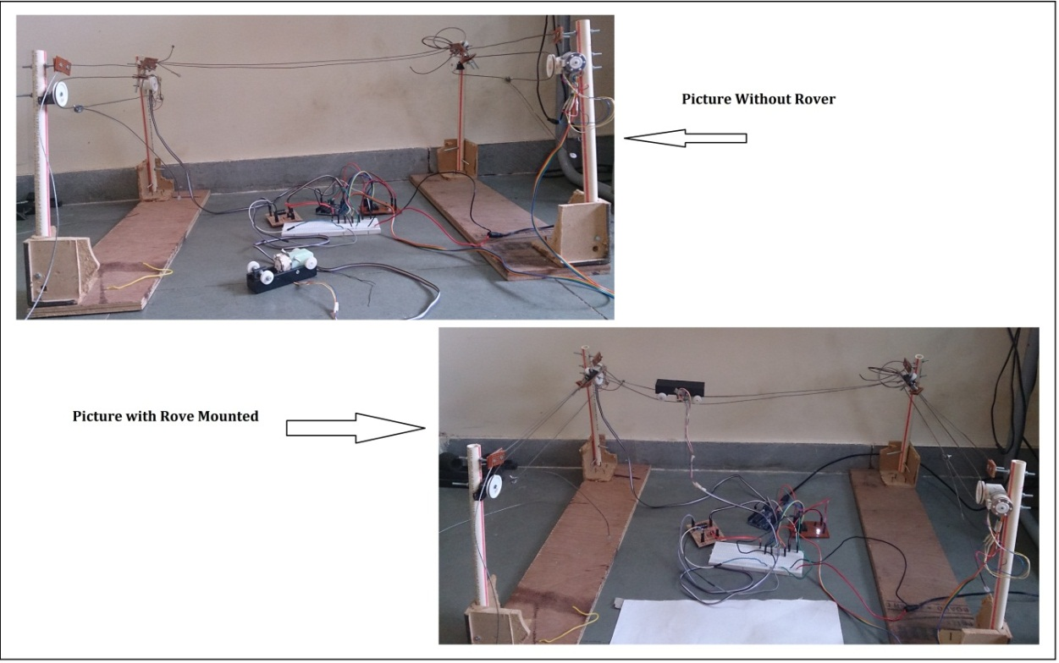
Figure 3.4 Testing Model
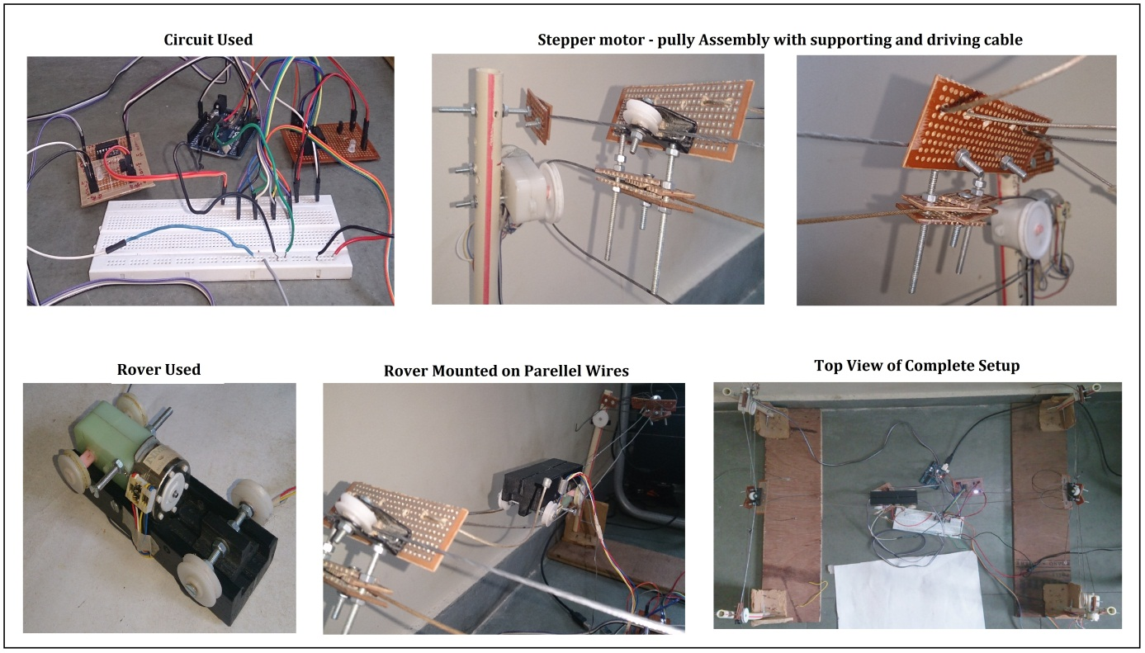
Figure 3.5 Images of Testing Model

System Architecture
Three type of System architectures are proposed and discussed here for this remote sensing platform, these architectures explains the working of the system at different layers.

Client- Server Architecture
Figure 3.6 shows client - server architecture of system, it illustrate the flow of tasks or requests between the request generator (client) and request handler (server). Client interface may be based on an android application or a simple web page that will provide accessing the information and data stored on server using sensor observation service (SOS) and http protocol.
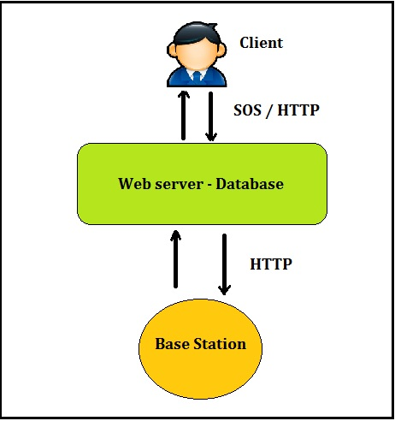
Figure 3.6 Client – server architecture
For making this system more dynamic concepts of interoperability is integrated with it. Sensor observation Service is a service provided by Open Geospatial Consortium (OGC) to establish interoperability between different systems. It also incorporates the fundamentals of Sensor Web Enablement (SWE) in a sophisticated manner. Web server is there between client and base station to handle requests and processing part.

Base station and WSN Architecture
Base station architecture for any system illustrates how a base station is connected and configured with other system entities like sensor node. Figure 3.7 shows base station architecture for this system, where a raspberry pi could be as base station which is connected to arduino based sensor node through Zigbee protocol.
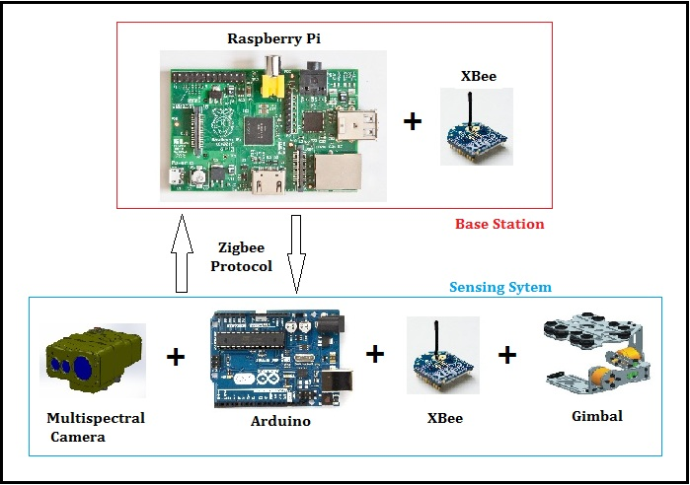
Figure 3.7 Base Station – WSN architecture
Scanning system in this case is mounting on rover and have a multispectral camera connected with it, gimbal assembly is used to stabilize the camera or make the system damp free in case of any vibrations. Here WSN integrated with Zigbee protocol between base station and scanning system to have communication and transferring the collected data.

Sensing System Architecture
Sensing system architecture is main operational part of this remote sensing platform. It defines how all hardware components are integrated in this platform and how they are working with each other. Figure 3.8 shows sensing system architecture for this system.
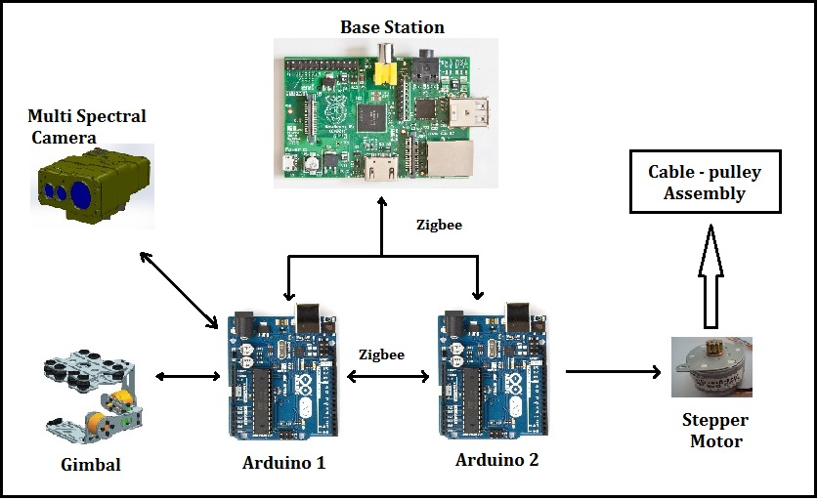
Figure 3.8 Sensing system architecture
Here two arduino used, one is connected to stepper motor to drive the cable-pulley assembly which respectively drive the rover rail of parallel cables and second arduino is responsible for working of multispectral camera and gimbal. These two arduino are communicated with each other via Zigbee protocol as they need to maintain synchronization with each other, and at the end both are also connected with base station for further operation and control.

Complete system Architecture
This architecture explains all components of the system, how they are connected to each other and how they are operating communicating with each other. This also includes client side operation and communication part with protocols and services.
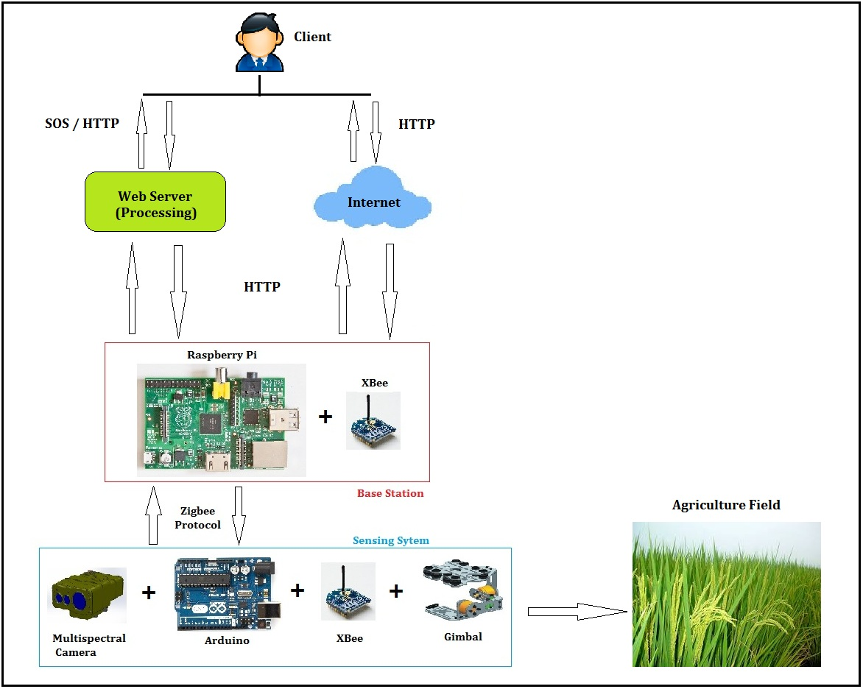
Figure 3.9 Complete system architecture

Hardware involved
In this section some details about involved hardware tools and equipment are discussed.

Arduino Uno
Arduino uno is an open source microcontroller board which can be easily programmed and used for several general purpose uses. This board has sufficient capabilities to match requirement of this system. Figure 3.10 shows board image and with details.
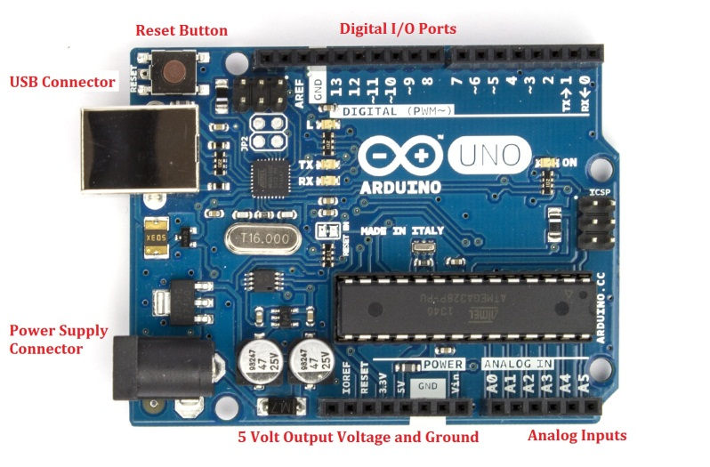
Figure 3.10 Arduino uno [31]
Specifications of this board are listed below [31],
Microcontroller | ATmega328
Operating Voltage | 5V
Input Voltage (recommended) | 7-12V
Input Voltage (limits) | 6-20V
Digital I/O Pins | 14 (of which 6 provide PWM output)
Analog Input Pins | 6
DC Current per I/O Pin | 40 mA
DC Current for 3.3V Pin | 50 mA
Flash Memory | 32 KB (ATmega328) of which 0.5 KB used by boot loader
SRAM | 2 KB (ATmega328)
EEPROM | 1 KB (ATmega328)
Clock Speed | 16 MHz

Raspberry Pi
Raspberry pi is very small single board computer which can be configured through python. Raspberry pi has sufficient hardware and software support to configure a base station. Figure 3.11 shows image of raspberry pi with some specifications [32].
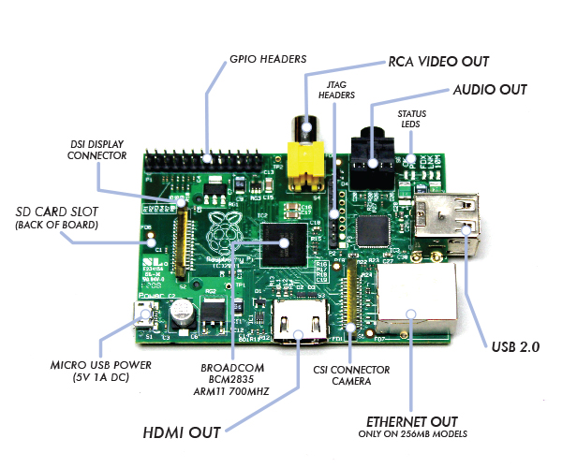
Figure 3.11 Raspberry pi [32]
Some specifications of raspberry pi are listed below,
Developer | Raspberry pi foundation
Operating System | Linux
Power | 2.5 W – 3.5 W
Memory | 256 MB – 512 MB
System on Chip (SoC) | Broadcom BCM2835
Processor | ARM1176JZF – S
Storage | SD card
Graphics | Broadcom video core

Zigbee / Xbee module and Programmer
Zigbee protocol is designed to communicate through hostile RF environment and Zigbee standards operates on the IEEE 802.15.4 physical radio specification with band specification of 2.5 GHz, 900 MHz and 868 MHz. It has several benefits like Low Latency, Low duty cycle so low power consumption, data encryption [33].
Zigbee modules are trans-receivers based on Zigbee protocol and are easy to use with microcontroller board like arduino. These modules are programmable as a transmitter or receiver, based on the purpose using Universal Serial Bus (USB) programmer board. They can also be connected to PCs via this programmer board. Figure 3.12 shows a zigbee module and programmer board.
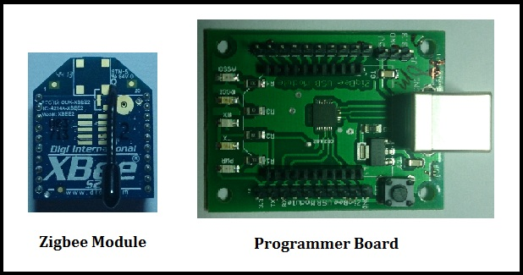
Figure 3.12 Zigbee module and programmer board

Camera stabilizer Gimbal
For stabilizing the camera a gimbal design will be used that will prevent the camera from any external movement hence giving stable image. Basic gimbal is a support that prevents the rotation of any object along a single axis. Two different type of gimbal being used in low cost remote sensing platform like UAVs are servo based and brushless motor based. For designing gimbal for our platform we need brushless motors, gyroscope circuit board and a controller board, proposed gyroscope circuit board based on MPU6050 IC is shown in figure 3.13 along with a gimbal model with two axis stabilization using brushless motors.
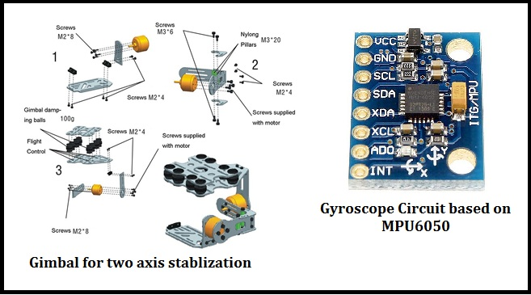
Figure 3.13 Basic gimbal models

Software Involved
This system has invoplved various software platforms and programing languages to achieve the objectives mentioned. Some are useful for building the structure and some may be use used for developing a client side application and processing. Some of the key software tools and programming languages are mentioned here,
- Arduino Sketch : used to write, compile and burn the assembly program to arduino board
- Xbee programmer : used to program the check and program the xbee module
- PostgreSQL and PostGIS : Spatial database, for managing and storing spatial data
- Linux : for configuring base station
- Python: used as scripting language
- Hypertext Markup Language (HTML), php, CSS : for server/client side programming
- JAVA, C++, XML, AJAX : for configuring base station and achieving interoperability with SOS
- Geoserver and 52⁰ North : for deploying an interoperable web – server
- Free CAD : a Computer Added Design tool used for drawing mechanical profile of the platform

: SUMMARY AND FUTURE WORK

Summary
This system is an initiative for low cast remote sensing platform using rope and pulleys for small farming lands in India and some key factors about projects are mentioned below,
- Low cost and easy to install remote sensing platform
- Not much technical knowledge required to operate this system from formers side
- Not much complicated hardware tool and equipment needed to construct
- Implementation of open source technologies and an interoperable system architecture
- Can be constructed easily with some basic knowledge and one of its kind architecture
- Provide better spatial and temporal resolution for field scanning
- Farmer can have a real time analysis of their crops and have a better decision support
- Can be used by administrative body to collect real time information in precision farming for small sized crop like wheat, rice, channa etc.

Future Work
Some future work scope with this proposed architecture are discussed below,
- Prototype construction of proposed system and deployment in field
- Demonstration of remote sensing platform with a client - server based architecture
- Involvement of processing and extracting information from collected data
- Integrate Global Positioning System (GPS) with this system
- Assign the architecture some post processing tasks also

REFERENCES
[1] Bhaskar J. Chaudhury; Relationships Between Vegetation Indices, Radiation Absorption, and Net Photosynthesis Evaluated by a Sensitivity Analysis; REMOTE SENSING OF ENVIRONMENT 22:209-233 (1987)
[2] A. R. HUETE; A Soil-Adjusted Vegetation Index (SAVI); REMOTE SENSING OF ENVIRONMENT 25:295-309 (1988)
[3] Bruno Basso, Davide Cammarano, Pasquale De Vita; REMOTELY SENSED VEGETATION INDICES: THEORY AND APPLICATIONS FOR CROP MANAGEMENT; B. Basso et al. - Rivista Italiana di Agrometeorologia 36-53 (1) 2004
[4] WANG Fu-min, HUANG Jing-feng, TANG Yan-lin, WANG Xiu-zhen; New Vegetation Index and Its Application in Estimating Leaf Area Index of Rice; Rice Science, 2007, 14(3): 195-203
[5] Andrés Viña, Anatoly A. Gitelson, Anthony L. Nguy-Robertson, Yi Peng; Comparison of different vegetation indices for the remote assessment of green leaf area index of crops; Remote Sensing of Environment 115 (2011) 3468–3478
[6] M. Mirik, G.J. Michels Jr., S. Kassymzhanova-N.C. Elliott, Mirik, V. Catana, D.B. Jones, R. Bowling; Using digital image analysis and spectral reflectance data to quantify damage by greenbug (Hemitera: Aphididae) in winter wheat; Computers and Electronics in Agriculture 51 (2006) 86–98
[7] D. W. Lamb, R. B. Brown; Remote-Sensing and Mapping of Weeds in Crops; J. agric. Engng Res. (2001) 78 (2), 117}125
[8] Santhosh K. Seelan, Soizik Laguette, Grant M. Casady, George A. Seielstad; Remote sensing applications for precision agriculture: A learning community approach; Remote Sensing of Environment 88 (2003) 157–169
[9] Kyu-Sung Lee, Warren B. Cohen, Robert E. Kennedy, Thomas K. Maiersperger, Stith T. Gower; Hyperspectral versus multispectral data for estimating leaf area index in four different biomes; Remote Sensing of Environment 91 (2004) 508–520
[10] X.L. Cai, B.R. Sharma; Integrating remote sensing, census and weather data for an assessment of rice yield, water consumption and water productivity in the Indo-Gangetic river basin; Agricultural Water Management 97 (2010) 309–316
[11] S.R. Herwitz, L.F. Johnson, S.E. Dunagan, R.G. Higgins, D.V. Sullivan, J. Zheng, B.M. Lobitz, J.G. Leung, B.A. Gallmeyer, M. Aoyagi, R.E. Slye, J.A. Brass; Imaging from an unmanned aerial vehicle: agricultural surveillance and decision support; Computers and Electronics in Agriculture 44 (2004) 49–61
[12] T. Jensen, A. Apan, F. Young, L. Zeller, Detecting the attributes of a wheat crop using digital imagery acquired from a low-altitude platform; Computers and Electronics in Agriculture 59 (2007) 66–77
[13] J. Link, D.Senner,W.Claupein; Developing and evaluating an aerial sensor platform (ASP)tocollect multispectral data for deriving management decisions in precision farming; Computers and Electronics inAgriculture 94(2013)20–28
[14] Yan Zhu, Xia Yao, YongChao Tian, XiaoJun Liu, WeiXing Cao; Analysis of common canopy vegetation indices for indicating leaf nitrogen accumulations in wheat and rice; International Journal of Applied Earth Observation and Geoinformation 10 (2008) 1–10
[15] M.M. Saberioon, M.S.M. Amin, A.R. Anuar, A. Gholizadeh, A. Wayayok,S. Khairunniza-Bejo; Assessment of rice leaf chlorophyll content using visible bands atdifferent growth stages at both the leaf and canopy scale; International Journal of Applied Earth Observation and Geoinformation 32 (2014) 35–45
[16] Dehua Zhao, Liangmei Huang, Jianlong Li,Jiaguo Qi; A comparative analysis of broadband and narrowband derived vegetation indices in predicting LAI and CCD of a cotton canopy; ISPRS Journal of Photogrammetry & Remote Sensing 62 (2007) 25–33
[17] O. Beeri, A. Peled; Geographical model for precise agriculture monitoring with real-time remote sensing; ISPRS Journal of Photogrammetry and Remote Sensing 64 (2009) 4754
[18] Pece V. Gorsevski, Paul E. Gessler; The design and the development of a hyperspectral and multispectral airborne mapping system; ISPRS Journal of Photogrammetry and Remote Sensing 64 (2009) 184192
[19] Toshihiro Sakamoto, Michio Shibayama, Akihiko Kimura,Eiji Takada; Assessment of digital camera-derived vegetation indices in quantitative monitoring of seasonal rice growth; ISPRS Journal of Photogrammetry and Remote Sensing 66 (2011) 872–882
[20] Zhang Jin-Heng, Wang Ke, J. S. Bailey, Wang Ren-Chao; Predicting Nitrogen Status of Rice Using Multispectral Data at Canopy Scale; Pedosphere 16(1): 108-117, 2006
[21] S. Kalluri, P. Gilruth, R. Bergman; The potential of remote sensing data for decision makers at the state, local and tribal level: experiences from NASA’s Synergy program; Environmental Science & Policy 6 (2003) 487–500
[22] Ryo Sugiura, Noboru Noguchi, Kazunobu Ishii; Remote-sensing Technology forVegetation Monitoring using an Unmanned Helicopter; Biosystems Engineering (2005) 90 (4), 369–379
[23] Haitao Xiang, Lei Tian; Development of a low-cost agricultural remote sensing system based on an autonomous unmanned aerial vehicle (UAV); BIOSYSTEMS ENGINEERING 108(2011) 174-190
[24] Yanbo Huang, Steven J. Thomson, Yubin Lan, Stephan J. Maas; Multispectral imaging systems for airborne remote sensing to support agricultural production management; March, 2010 Int J Agric & Biol Eng Vol. 3 No.1
[25] Jose A. J. Berni, Student Member, IEEE, Pablo J. Zarco-Tejada, Lola Suárez, and Elias Fereres; Thermal and Narrowband Multispectral Remote Sensing for Vegetation Monitoring From an Unmanned Aerial Vehicle; IEEE TRANSACTIONS ON GEOSCIENCE AND REMOTE SENSING, VOL. 47, NO. 3, MARCH 2009
[26] Y. Inoue, S. Morinaga & A. Tomita (2000) A blimp-based remote sensing system for low-altitude monitoring of plant variables: A preliminary experiment for agricultural and ecological applications, International Journal of Remote Sensing, 21:2, 379-385
[27] Soma Bandyopadhyay, Munmun Sengupta, Souvik Maiti and Subhajit Dutta; Role of Middleware for Internet Of Things: A Study; International Journal of Computer Science & Engineering Survey (IJCSES) Vol.2, No.3, August 2011
[28] http://bhuvan.nrsc.gov.in/bhuvan_links.php
[29] Soma Bandyopadhyay, Munmun Sengupta, Souvik Maiti and Subhajit Dutta; Role of Middleware for Internet of Thing: A Study; International Journal of Computer Science & Engineering Survey (IJCSES) Vol.2, No.3, August 2011
[30] Surya S. Durbha, Roger L. King, Senior Member, IEEE, Santhosh K. Amanchi, Shruthi Bheemireddy, and Nicolas H. Younan, Senior Member, IEEE; Standards-Based Middleware and Tools for Coastal Sensor Web Applications; IEEE JOURNAL OF SELECTED TOPICS IN APPLIED EARTH OBSERVATIONS AND REMOTE SENSING, VOL. 3, NO. 4, DECEMBER 2010
[31] http://arduino.cc/
[32] http://www.raspberrypi.org/
[33] http://www.digi.com/technology/rf-articles/wireless-zigbee
[34]http://www.unmannedtech.co.uk/manualsguides/fiberglass-brushless-gimbal-assembly-guide
[35] F. L. Lewis; Wireless Sensor Networks1; Smart Environments: Technologies, Protocols, and Applications ed. D.J. Cook and S.K. Das, John Wiley, New York, 2004.

ACKNOWLEDGEMENT

With great pleasure and gratitude I record my thankfulness and indebtedness to my esteemed supervisor Prof. Surya S. Durbha for his invaluable guidance and constant supervision. I also express my sincere regards to him for their encouragement and blessings.

Vinay Verma

(123316001)
IIT Bombay

