EMPLOYEE TABLE:



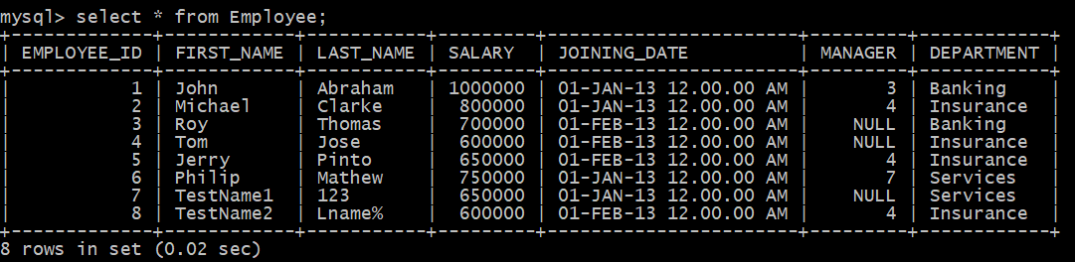

1. Write a query to print the number of employees per department in the organization

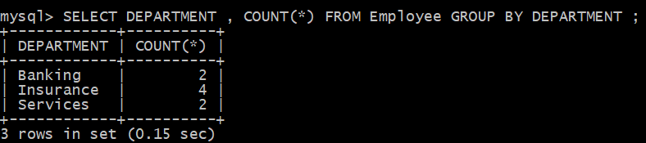> SELECT DEPARTMENT , COUNT(*) FROM Employee GROUP BY DEPARTMENT ;

1. Write an SQL query to find the name of the top-level manager of each department

>SELECT * FROM EMPLOYEE WHERE MANAGER IS NULL;





1. 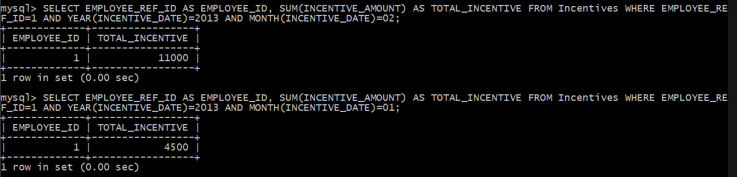Write a query to find the total incentive received by a given employee in a given month.

>SELECT EMPLOYEE_REF_ID AS EMPLOYEE_ID, SUM(INCENTIVE_AMOUNT) AS TOTAL_INCENTIVE FROM Incentives WHERE EMPLOYEE_REF_ID=1 AND YEAR(INCENTIVE_DATE)=2013 AND MONTH(INCENTIVE_DATE)=01;

1. Write a query to find the month where employees got maximum incentive

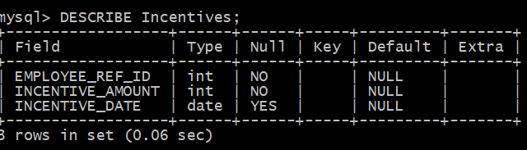

1. You have two sand timers, which can show 4 minutes and 7 minutes respectively. Use both the sand timers (at a time or one after other or any other combination) and measure a time of 9 minutes.

**ANSWER:**

1. Start the 7 minutes sand timer and the 4 minutes sand timer.

2. Once the 4 minutes sand timer ends turn it upside down instantly.

Time Elapsed: 4 minutes. At this moment, 3 minutes of sand is left in the 7 minutes sand timer.

3. Once the 7 minutes sand timer ends turn it upside down instantly.

Time Elapsed: 7 minutes. At this moment, 1 minutes of sand is left in the 4 minutes sand timer.

4. After the 4 minutes sand timer ends, only 1 minute is elapsed in 7 minutes sand timer, therefore for another minute turn the 7 minutes sand timer upside down.

Time Elapsed: 8 minutes.

5. When the 7 minutes sand timer ends, total time elapsed is 9 minutes.

So effectively 8 + 1 = 9.

1. John and Mary are a married couple. They have two kids, one of them is a girl. Assume safely that the probability of each gender is 1/2. What is the probability that the other kid is also a girl?

**Answer:** As we know that one of the kids is girl child. So there can be three possibilities:

**<Girl, Girl>**

<Boy, Girl>

<Girl, Boy>

We will use the conditional probability:

P(Both girl | At least one girl) = P(both girl) / P(at least one girl)

P(both girls) = 0.5 * 0.5 = 0.25

P(at least one girl) = 1 – P(no girl)

P(no girl) = P(both boys) = 0.5 * 0.5 = 0.25

P(at least one girl) = 1 – 0.25 = 0.75

P(Both girl | At least one girl) = 0.25/0.75 = 1/3

Thus, our answer will be **1/3.**

1. The following appeared as part of a campaign to sell advertising time on a local radio station to local businesses.

Ron’s Cafe began advertising on our local radio station this year and was delighted to see its business increase by 10 percent over last year's totals. Their success shows you how you can use radio advertising to make your business more profitable.

Discuss how well reasoned you find this argument. In your discussion be sure to analyse the line of reasoning and the use of evidence in the argument. For example, you may need to consider what questionable assumptions underline the thinking and what alternative explanations or counterexamples might weaken the conclusion. You can also discuss what sort of evidence would strengthen or refute the argument, what changes in the argument would make it more logically sound and what, if anything, would help you better evaluate in conclusion.

**Answer**:

The above paragraph shows how the radio station helped the Ron’s Café to increase its business by 10%. The success that the Ron’s Café got can be achieved by other businesses.

But the above paragraph doesn’t clearly specify the increment on the last year total is more than including the advertisement price on radio. There can be better approach to make the success of the Ron’s Café.