Q.1 created iam user with policy ec2full access.

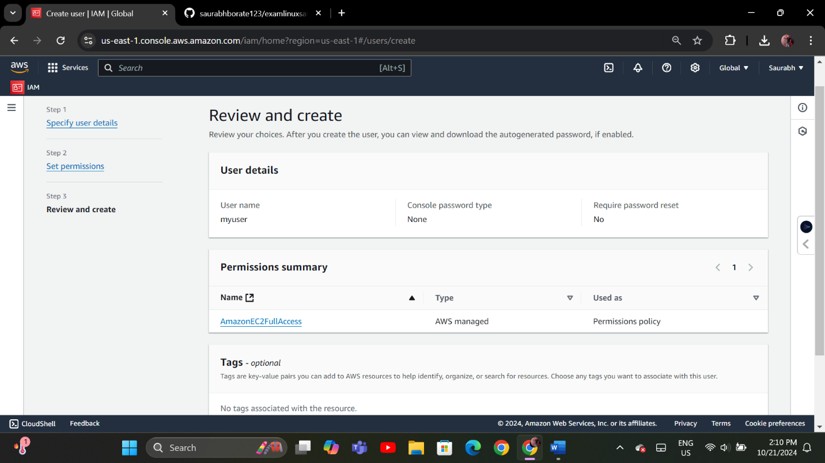

Q.2 Created s3 bucket with uniquebucket1306 name and static website hosted with message “Hello,welcome to my page,”.

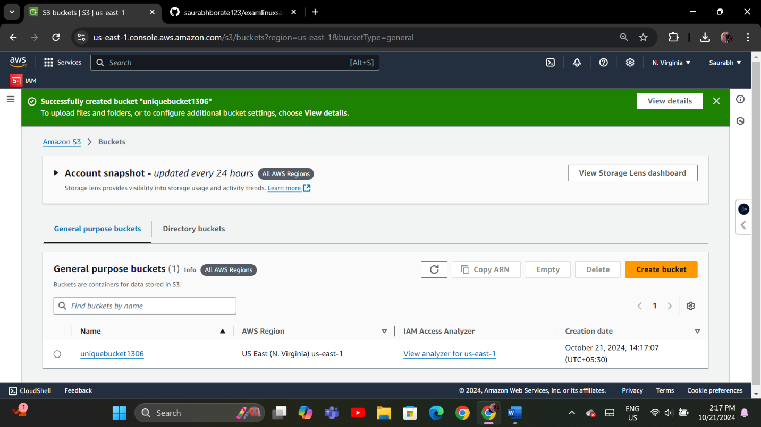

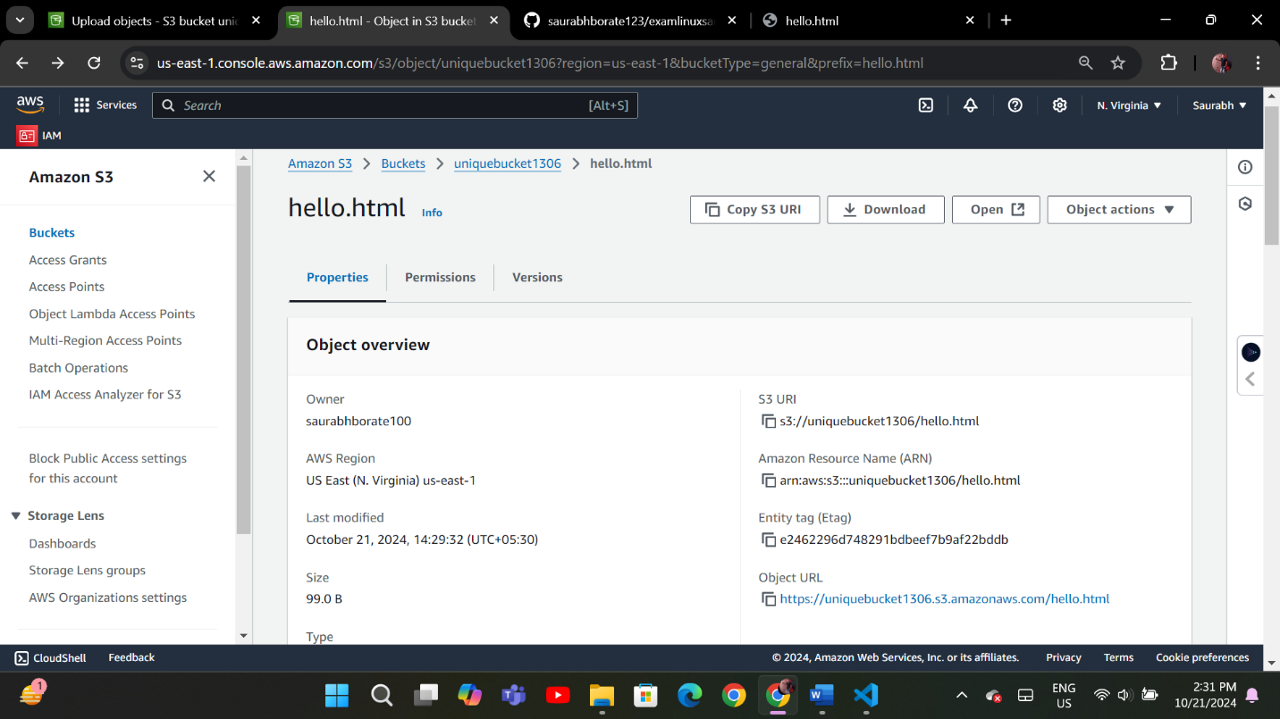

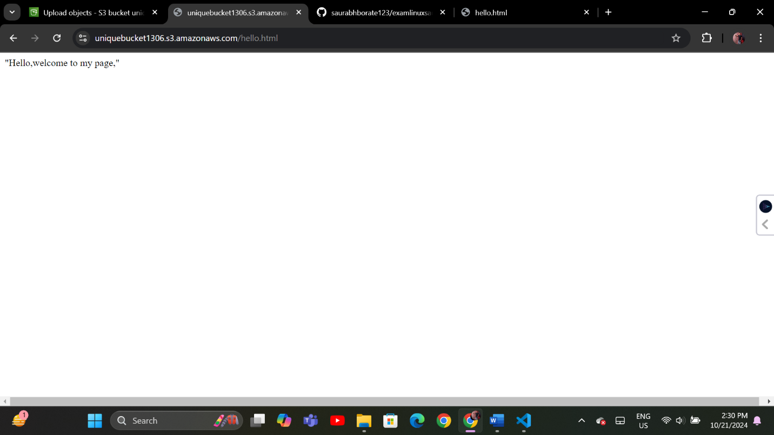

Q. File is publicly accessible though all by the object URL .

<https://uniquebucket1306.s3.amazonaws.com/hello.html>

Q.Successfully created IAM users credential and listed all instances of root users .

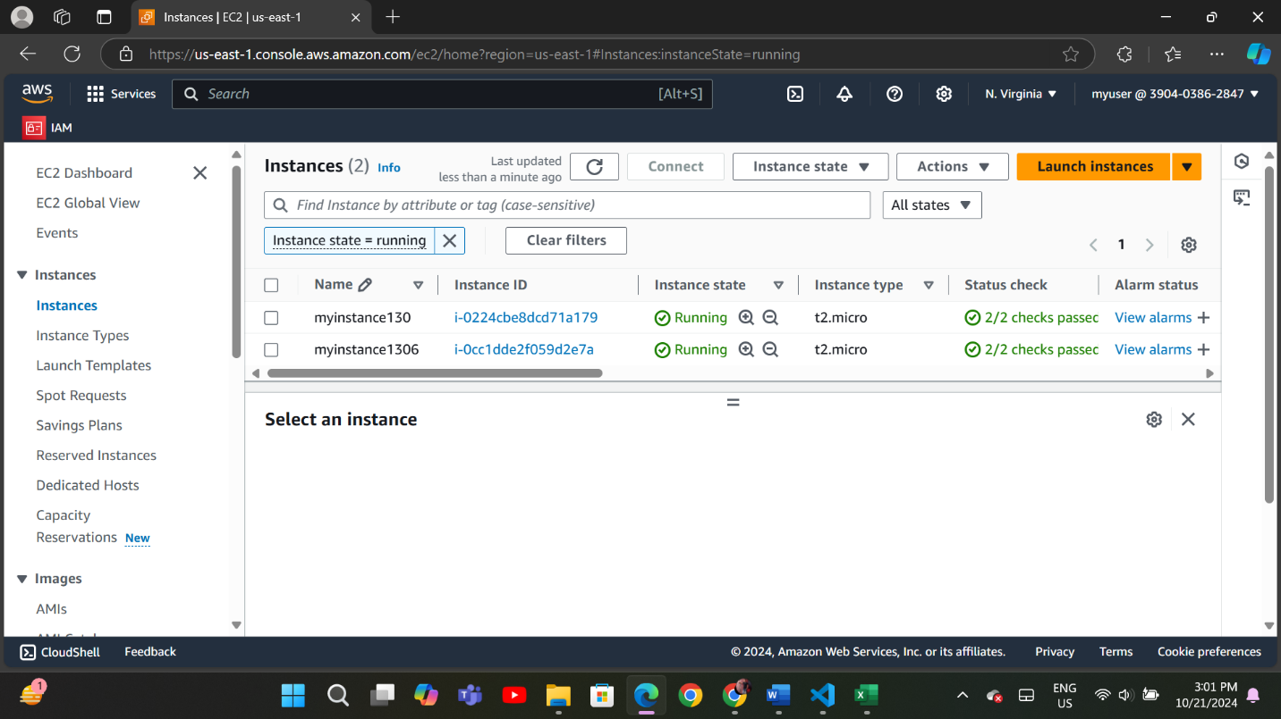

############ LINUX ######################

Q.2—1

Created new directory with name newdir.

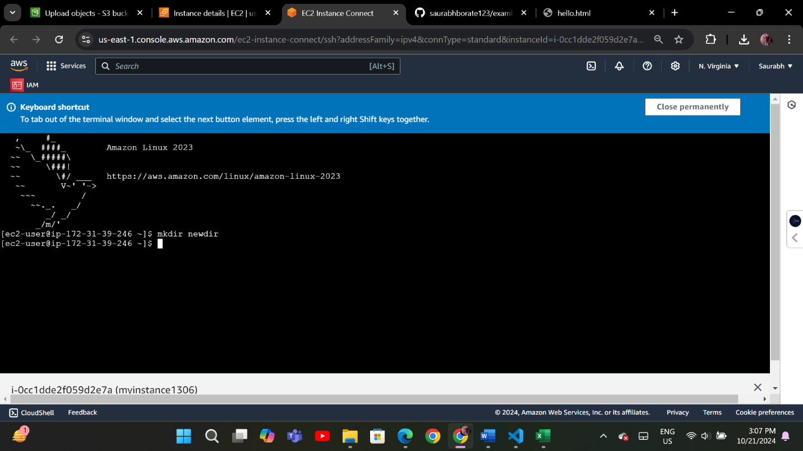

Q.2-5 created file in directory and given permissions.

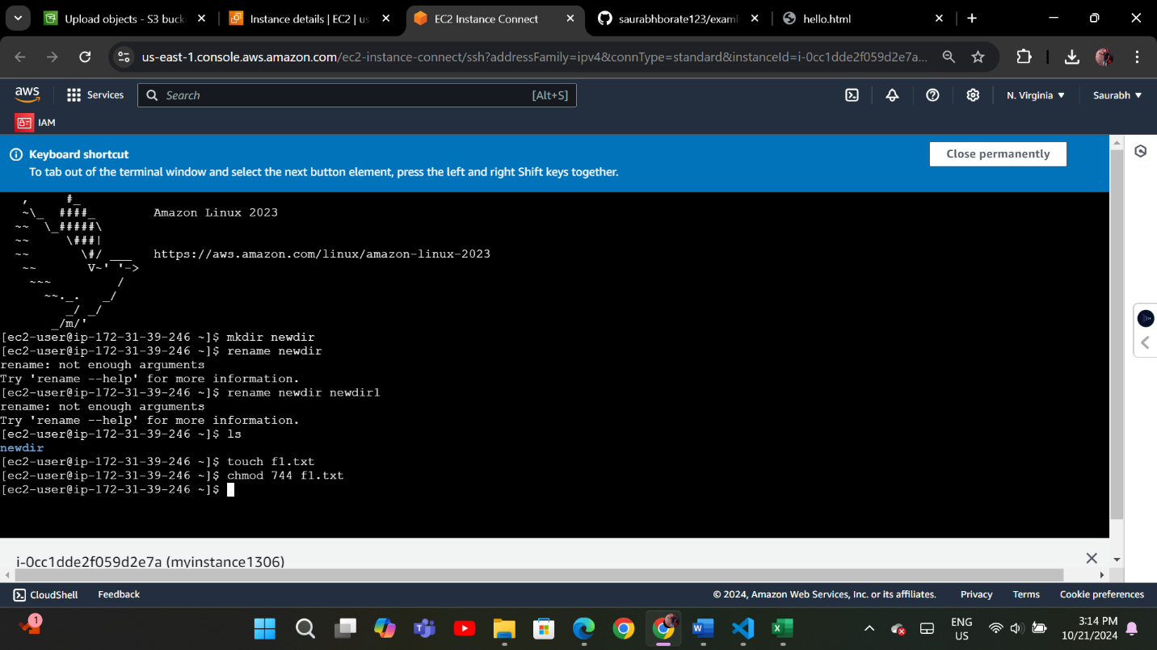

Q.2-4

Deleted an existing directory named newdir

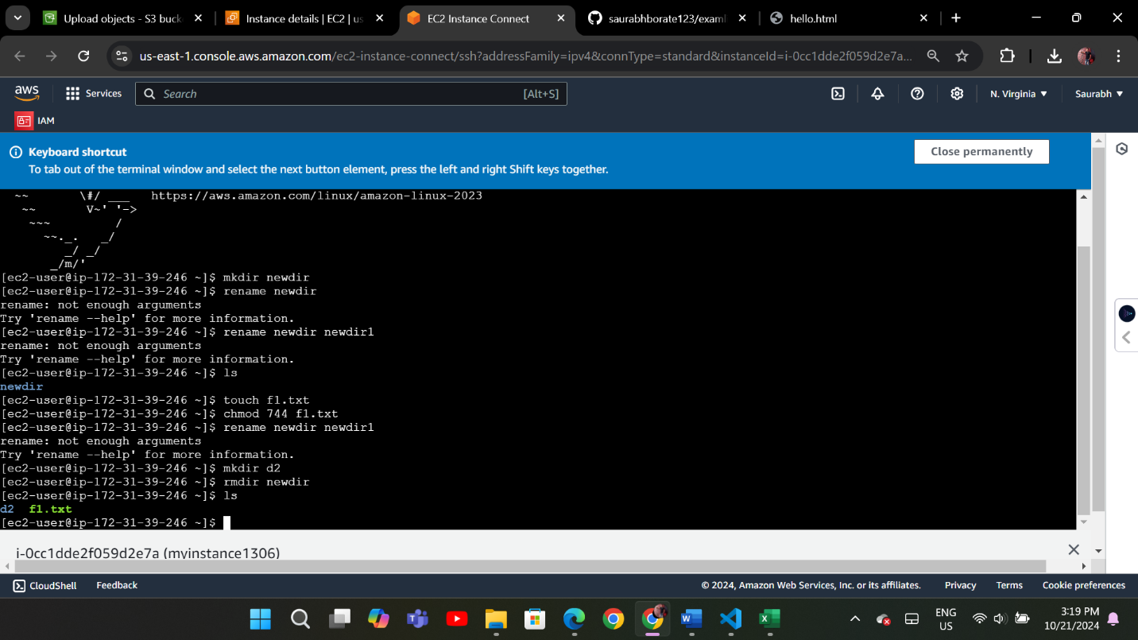

Q.1-1

