Saurabh Chalke

You Need to do the following things in your database assignment:

- Create Entity - Relation Diagram for the restaurants management system. (20 marks)

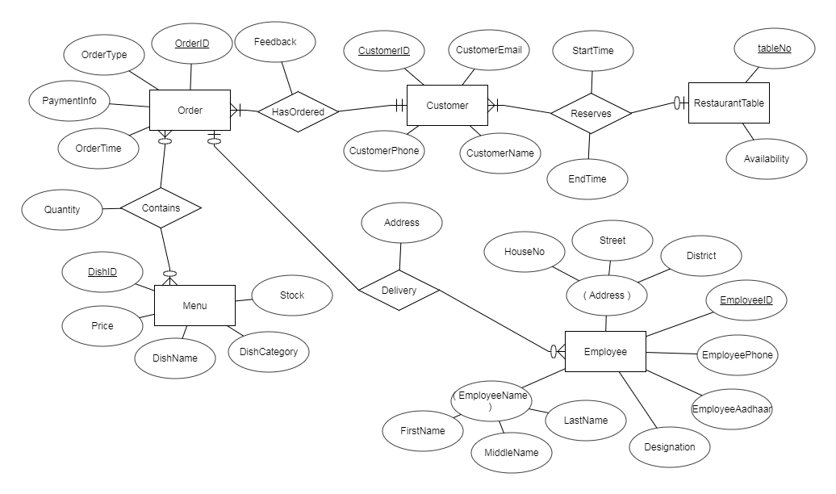

2. Pick Customers module of the ER Diagram and created the Tables with Proper relationships. (30 marks)
Module details: Restaurant's Customers including order, menu(including price). Billing.

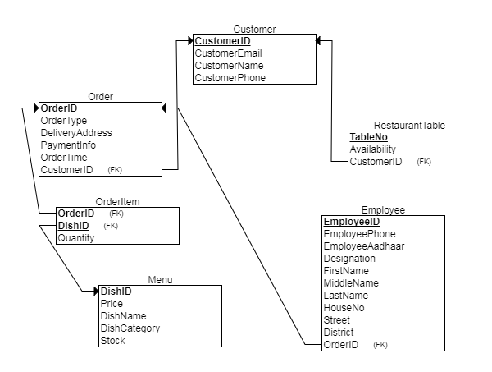

CREATE TABLE `customer` (
`customerid` int(10) NOT NULL AUTO_INCREMENT,
`customeremail` varchar(30) DEFAULT NULL,
`customername` varchar(30) DEFAULT NULL,
`customerphone` varchar(30) DEFAULT NULL,
PRIMARY KEY (`customerid`)
) ENGINE=InnoDB AUTO_INCREMENT=6 DEFAULT CHARSET=latin1;

CREATE TABLE `employee` (
`employeeid` int(10) NOT NULL AUTO_INCREMENT,
`employeephone` varchar(30) NOT NULL,
`employeeaadhaar` varchar(30) NOT NULL,
`designation` varchar(30) NOT NULL,
`firstname` varchar(30) NOT NULL,
`middlename` varchar(30) NOT NULL,
`lastname` varchar(30) NOT NULL,
`houseno` varchar(30) NOT NULL,
`street` varchar(30) NOT NULL,
`district` varchar(30) NOT NULL,
`orderid` int(10) DEFAULT NULL,
PRIMARY KEY (`employeeid`),
KEY `employee` (`orderid`),
CONSTRAINT `employee` FOREIGN KEY (`orderid`) REFERENCES `order1` (`orderid`)
) ENGINE=InnoDB AUTO_INCREMENT=4 DEFAULT CHARSET=latin1 ;

CREATE TABLE `menu` (
`dishid` int(10) NOT NULL AUTO_INCREMENT,
`price` decimal(7,2) NOT NULL,
`dishname` varchar(30) NOT NULL,
`dishcategory` varchar(30) NOT NULL,
`stock` int(5) NOT NULL DEFAULT '100',
PRIMARY KEY (`dishid`)
) ENGINE=InnoDB AUTO_INCREMENT=7 DEFAULT CHARSET=latin1;

CREATE TABLE `order1` (
`orderid` int(10) NOT NULL AUTO_INCREMENT,
`ordertype` varchar(30) NOT NULL,
`deliveryaddress` varchar(60) DEFAULT NULL,
`customerid` int(10) NOT NULL,
`paymentinfo` varchar(30) NOT NULL,
`OrderTime` timestamp NOT NULL DEFAULT CURRENT_TIMESTAMP,
PRIMARY KEY (`orderid`),
KEY `order1` (`customerid`),
CONSTRAINT `order1` FOREIGN KEY (`customerid`) REFERENCES `customer` (`customerid`)
) ENGINE=InnoDB AUTO_INCREMENT=6 DEFAULT CHARSET=latin1 ;

CREATE TABLE `orderitem` (
`orderid` int(10) NOT NULL,
`dishid` int(10) NOT NULL,
`quantity` int(5) DEFAULT '1',
PRIMARY KEY (`orderid`,`dishid`),
KEY `dishid` (`dishid`),
CONSTRAINT `orderitem_ibfk_1` FOREIGN KEY (`orderid`) REFERENCES `order1` (`orderid`),
CONSTRAINT `orderitem_ibfk_2` FOREIGN KEY (`dishid`) REFERENCES `menu` (`dishid`)
) ENGINE=InnoDB DEFAULT CHARSET=latin1;

CREATE TABLE `restauranttable` (
`tableno` int(5) NOT NULL AUTO_INCREMENT,
`availability` tinyint(1) DEFAULT '1',
`customerid` int(10) NOT NULL,
PRIMARY KEY (`tableno`),
KEY `restauranttable` (`customerid`),
CONSTRAINT `restauranttable` FOREIGN KEY (`customerid`) REFERENCES `customer` (`customerid`)
) ENGINE=InnoDB AUTO_INCREMENT=4 DEFAULT CHARSET=latin1;

- Insert some data.
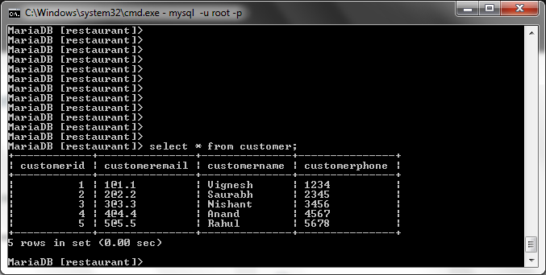
Customer Table

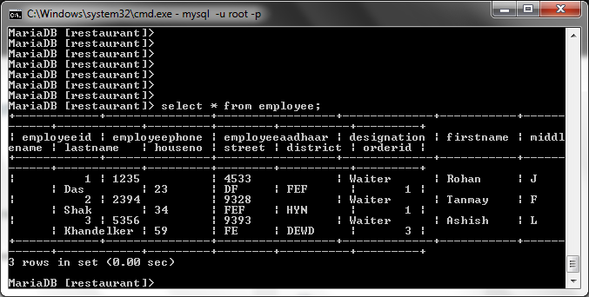
Employee Table

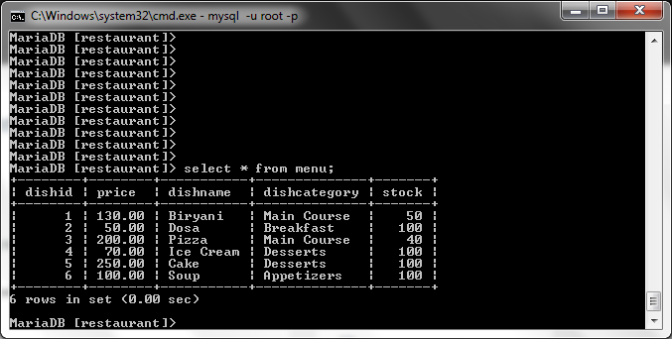
Menu Table

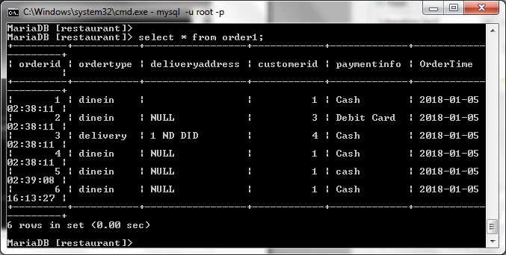
Order1 Table

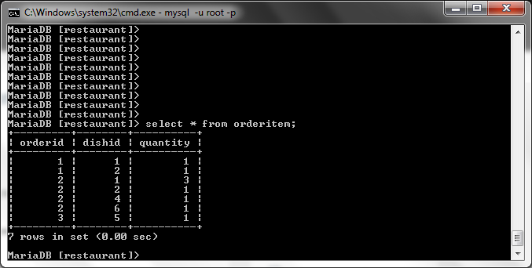
Orderitem Table

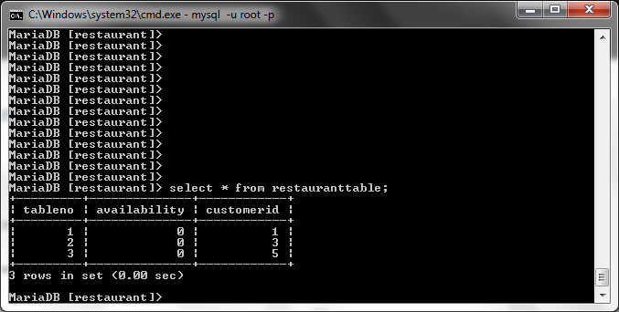
Restauranttable Table

For the below things you can assume your own business requirement and do the followings things.

5. Create following Views: (10 marks)
vw_customerSnapshot : To show customer with most visits, and customer Details.

Query:
create view vw_customerSnapshot as
select distinct c.customername as `Customer Name`, c.customeremail as `Customer Email`, c.customerphone as `Customer Phone` from customer as c, order1 as o
where c.customerid = o.customerid and o.customerid = (select customerid from order1 group by customerid order by count(*) desc limit 1);

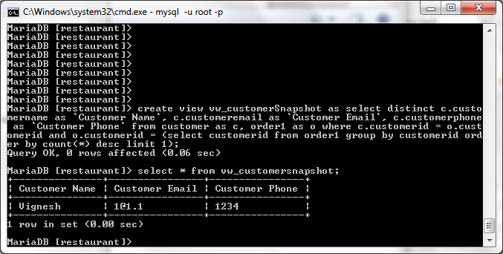

vw_OrderSnapshot: To show Most Ordered Item, and item details.

Query:
create view vw_OrderSnapshot as
select distinct m.dishname as `Dish Name`, m.price as `Dish Price`, m.dishcategory as `Dish Category` from menu as m, orderitem as o
where m.dishid = o.dishid and o.dishid = (select dishid from orderitem group by dishid order by sum(quantity) desc limit 1);

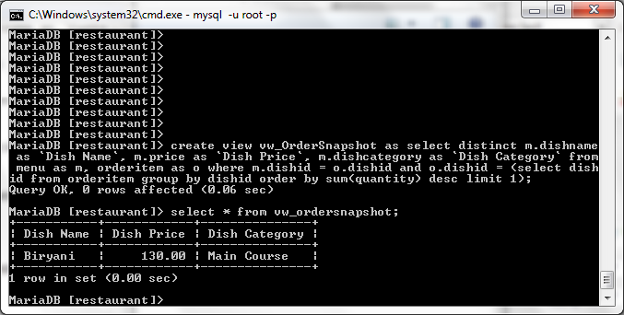

6. Create a function to fetch the time since order was placed by a customer. (10 marks)
fn_GetOrderTimeElapsed(CustomerID)

Query:
delimiter $$
drop function if exists fn_GetOrderTimeElapsed$$
create function fn_GetOrderTimeElapsed(customerid int(10)) returns int
deterministic
begin
declare lasttime timestamp; declare elapsedtime int(10);
select ordertime into lasttime from order1
order by ordertime desc limit 1;
set elapsedtime = time_to_sec(timediff(now(), lasttime))/60;
return elapsedtime;
end $$
delimiter ;
select fn_GetOrderTimeElapsed(1);

(This shows the number of minutes elapsed)
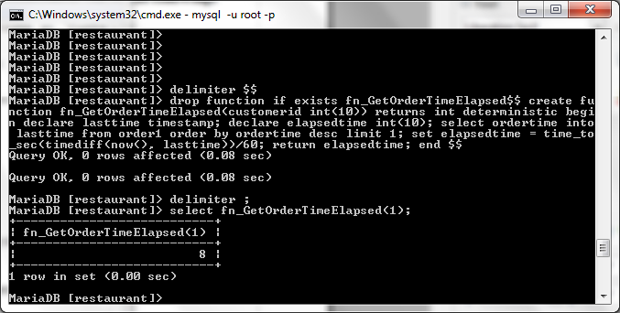

7. Create a Procedure to get Order for a customer (15 marks)
sp_GetOrder(IN CustomerID) (Returns Order Details as a Table)

Query:
delimiter $$
drop procedure if exists sp_GetOrder$$
create procedure sp_GetOrder(IN customeridin int(10))
begin
select * from order1 where customeridin = customerID;
END $$
delimiter ;
call sp_GetOrder(1);

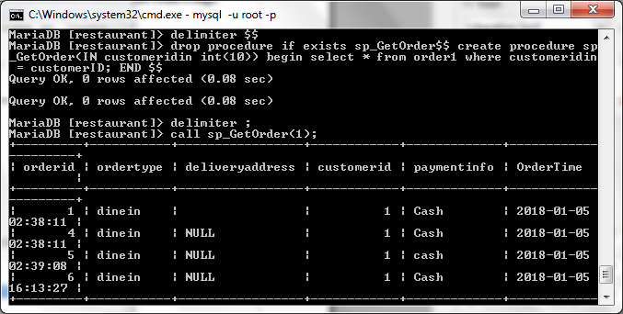

8. Create a Procedure to Generate bill for an order. (15 marks)
sp_GenerateBill(IN OrderID, OUT BillAMT)

Query:
delimiter $$
drop procedure if exists sp_GenerateBill$$
create procedure sp_GenerateBill(IN orderidin int(10), OUT billamt decimal(10,2))
begin
select sum(price * quantity) into billamt from orderitem as o, menu as m
where o.dishid = m.dishid and orderid = orderidin;
END$$
delimiter ;
call sp_GenerateBill(1, @outputbill);
select @outputbill;

