# KUBERNETES NOTES

<https://kubernetes.io/docs/concepts/overview/what-is-kubernetes/>

<https://itsfoss.com/install-bash-on-windows/>

If you have docker desktop for windows running you can activate kubernetes as below

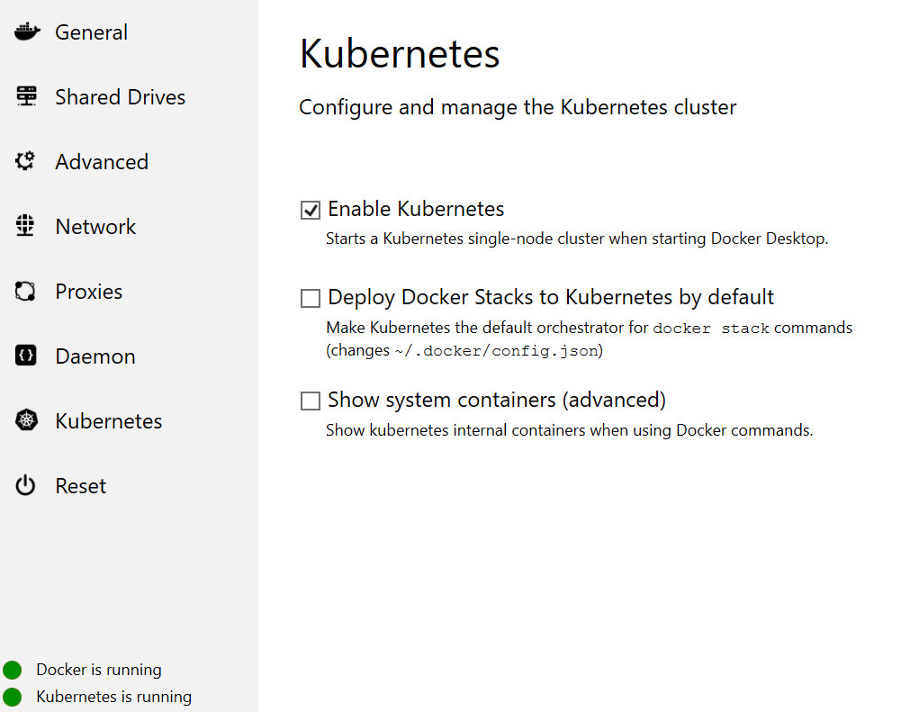

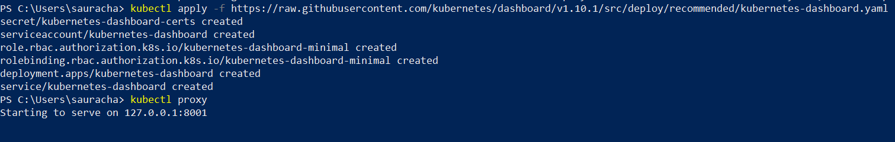

<https://github.com/kubernetes/dashboard> Kubernetes Dashboard

To deploy dashboard execute following :

kubectl apply -f <https://raw.githubusercontent.com/kubernetes/dashboard/v1.10.1/src/deploy/recommended/kubernetes-dashboard.yaml>

To access Dashboard from your local workstation you must create a secure channel to your Kubernetes cluster. Run the following command:

$ kubectl proxy

Now access Dashboard at:

<http://localhost:8001/api/v1/namespaces/kube-system/services/https:kubernetes-dashboard:/proxy/>

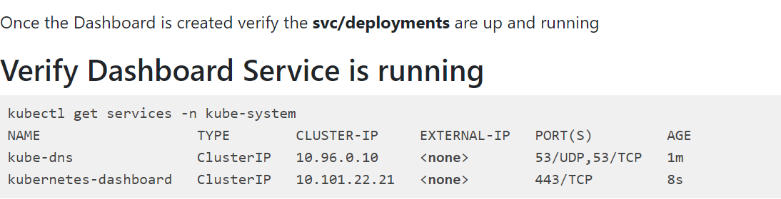

Kubernetes ask for authentication locally

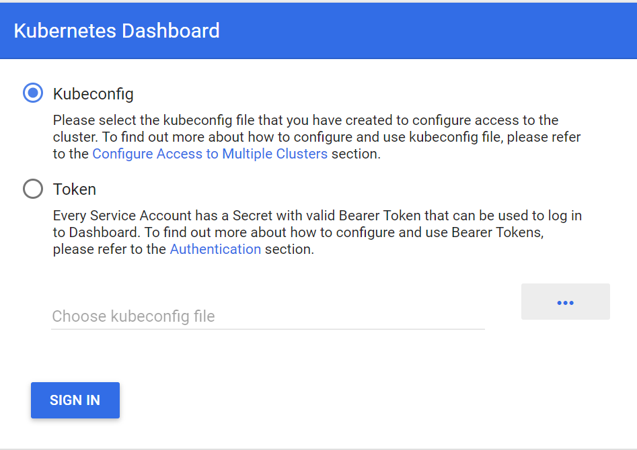

<https://8gwifi.org/docs/kube-dash.jsp> Login By Token

<http://docs.shippable.com/deploy/tutorial/create-kubeconfig-for-self-hosted-kubernetes-cluster/> Login by KubeConfig File

apiVersion: v1

kind: ServiceAccount

metadata:

name: svcs-acct-dply *#any name you'd like*

### **Create the service account**

You can create a service account by running the following command:

kubectl create -f sa.yaml

This will use your personal account to create the service account. Make sure your personal account has permissions to do this.

### **Fetch the name of the secrets**

### **Fetch the name of the secrets used by the service account**

This can be found by running the following command:

kubectl describe serviceAccounts svcs-acct-dply

**output**

Name: svcs-acct-dply

Namespace: default

Labels: <none>

Annotations: <none>

Image pull secrets: <none>

Mountable secrets: svcs-acct-dply-token-h6pdj

Tokens: svcs-acct-dply-token-h6pdj

Note down the Mountable secrets information which has the name of the secret that holds the token

### **Fetch the token from the secret**

Using the Mountable secrets value, you can get the token used by the service account. Run the following command to extract this information:

kubectl describe secrets svcs-acct-dply-token-h6pdj

This will output the token information that looks something like above. Note down the token value

### **Get the certificate info for the cluster**

Every cluster has a certificate that clients can use to encryt traffic. Fetch the certificate and write to a file by running this command. In this case, we are using a file name cluster-cert.txt

kubectl config view --flatten --minify > cluster-cert.txt

cat cluster-cert.txt

# CORRECT WAY TO LOGIN INTO LOCAL KUBERNETES DASHBOARD ARTICLE

After the Kubernetes cluster is up via docker-desktop options

Run commands in following sequence :

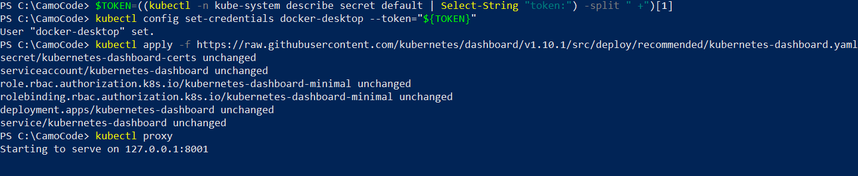

$TOKEN=((kubectl -n kube-system describe secret default | Select-String "token:") -split " +")[1]

**kubectl config set-credentials docker-desktop --token="${TOKEN}"**

**Then**

kubectl apply -f <https://raw.githubusercontent.com/kubernetes/dashboard/v1.10.1/src/deploy/recommended/kubernetes-dashboard.yaml>

kubectl proxy

**Kubernetes is UP locally !**

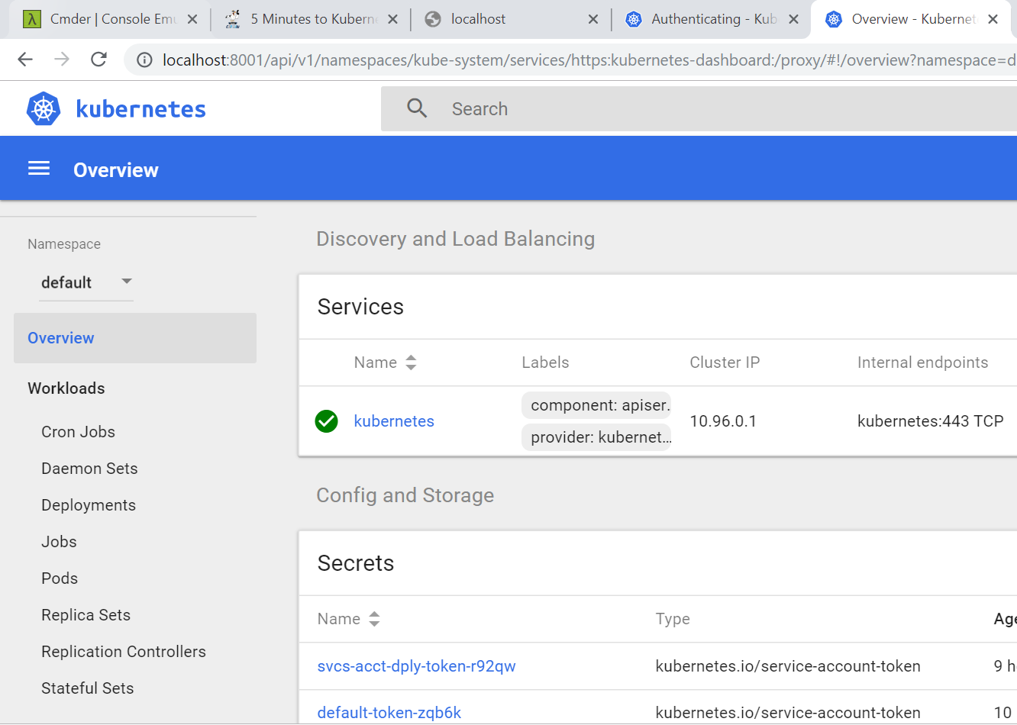

**REF ARTICLE :**

<http://collabnix.com/kubernetes-dashboard-on-docker-desktop-for-windows-2-0-0-3-in-2-minutes/>

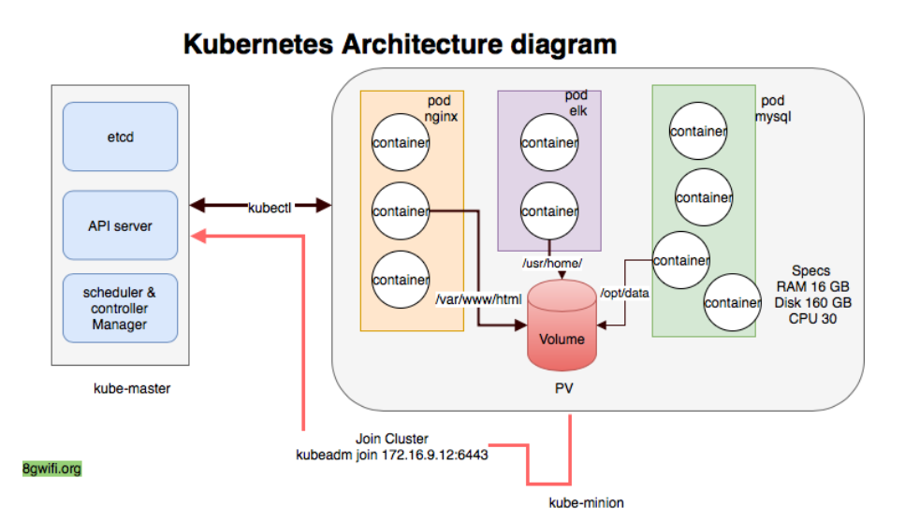

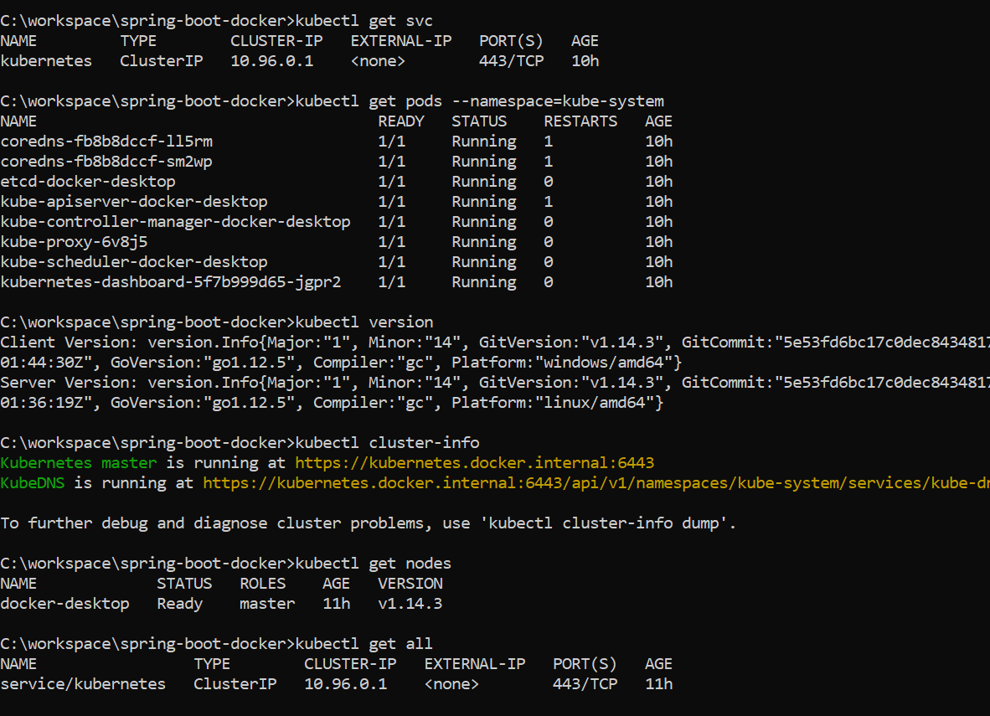

Start a single instance of **nginx** with one **replicaset**

root@kube-master:$ kubectl run nginx --image=nginx --replicas=1

The output will be deployment.apps/nginx created



<https://kubectl.docs.kubernetes.io/pages/kubectl_book/resources_and_controllers.html>

**Kubectl Book**

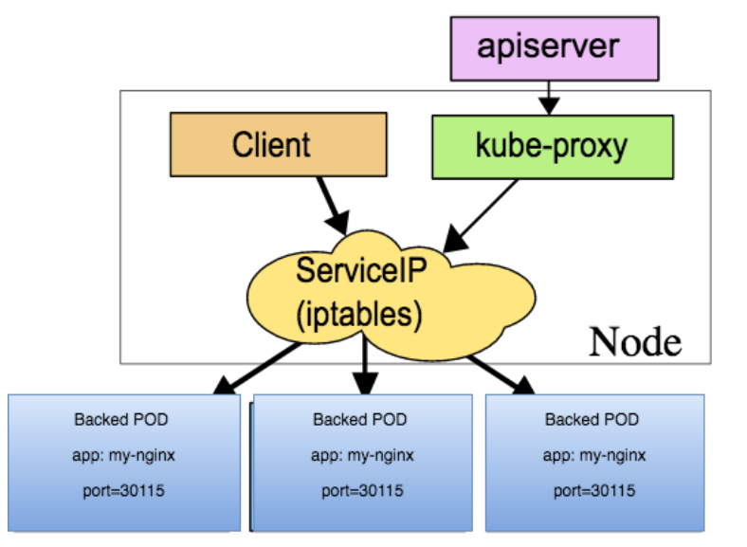

curl https://raw.githubusercontent.com/kubernetes/helm/master/scripts/get | bash

<https://www.mirantis.com/blog/introduction-to-yaml-creating-a-kubernetes-deployment/?utm_campaign=blog&utm_content=yaml&utm_medium=website&utm_source=quora>

<https://javagyanmantra.wixsite.com/website/single-post/2018/06/29/Why-GitHub-GitHub-vs-SVN>

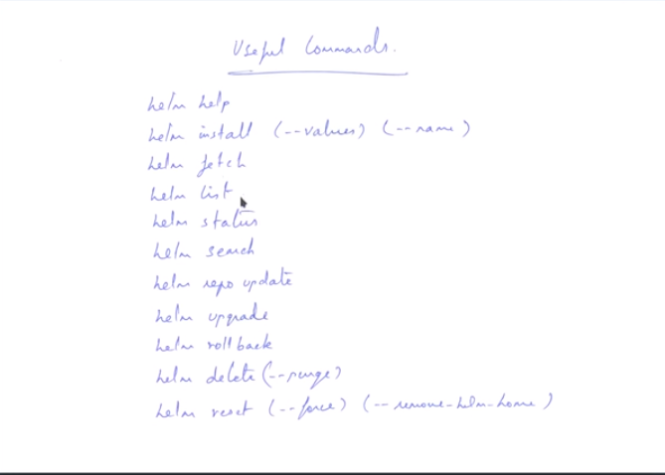

**Helm has a Client Side Component and a server side Component .**

**Client component can be downloaded or be installed via kubectl .**

**kubectl -n kube-system create serviceaccount tiller**

**helm fetch {packageName}**

**helm reset – deletes helm home directory**

**only removes the deployment , as replica set exists .**

<https://www.youtube.com/watch?v=eHvKc6hNmhI>

**Deploy docker container to kubernetes using YAML files .**

# **Introduction to Microservices, Docker, and Kubernetes**

<https://www.youtube.com/watch?v=1xo-0gCVhTU>

<https://static.brandonpotter.com/kubernetes/DeploymentBuilder.html>

Deployment builder for Kubernetes

<https://www.mirantis.com/blog/multi-container-pods-and-container-communication-in-kubernetes/>

<https://github.com/janakiramm/Kubernetes-multi-container-pod>

contRol5plane Oracle Account Password

<https://www.youtube.com/watch?v=GN6eMwsNkds&list=PL6XT0grm_TfgP3OlZzmGh4Cq_rHtX8z7e>

Gaurav Sharma Ansible/Docker tutorials

kubectl scale deploy my-awesome-deployment --replicas=0

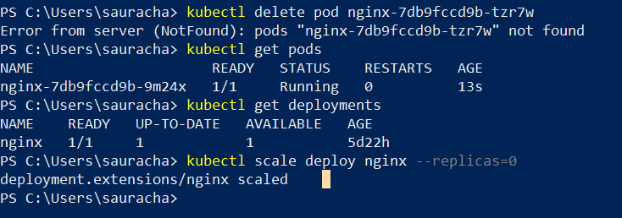

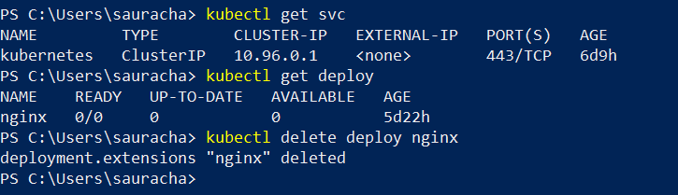

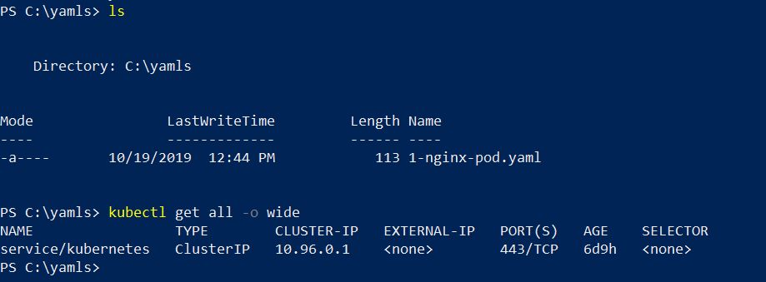

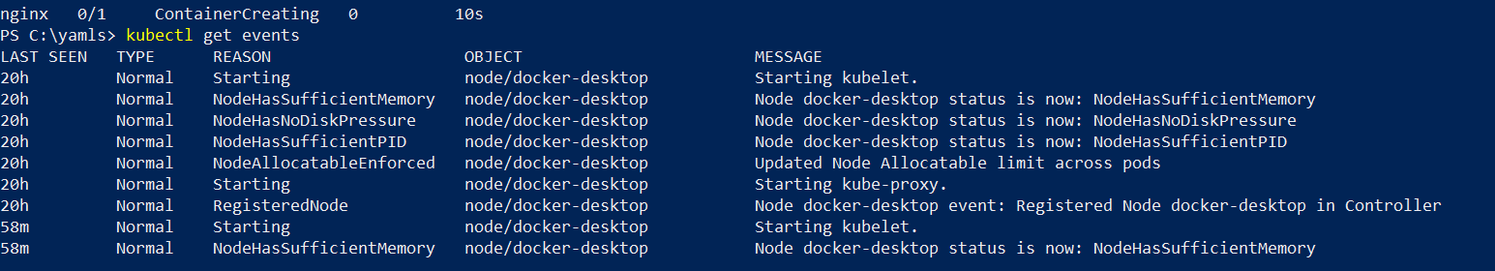

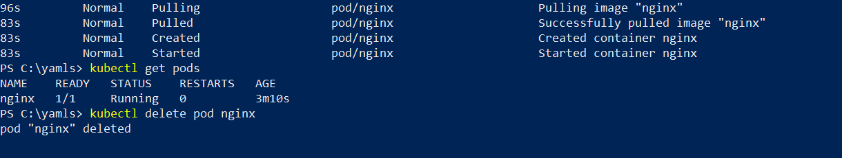

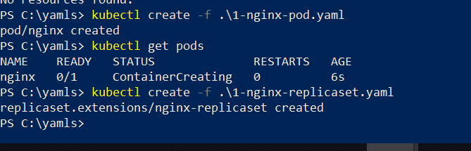

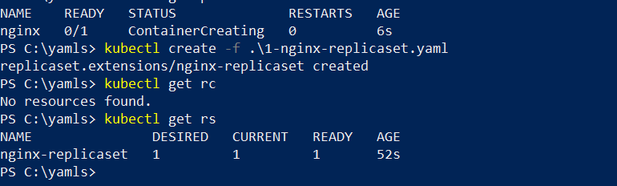

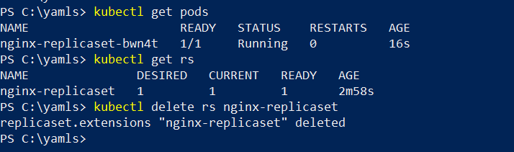

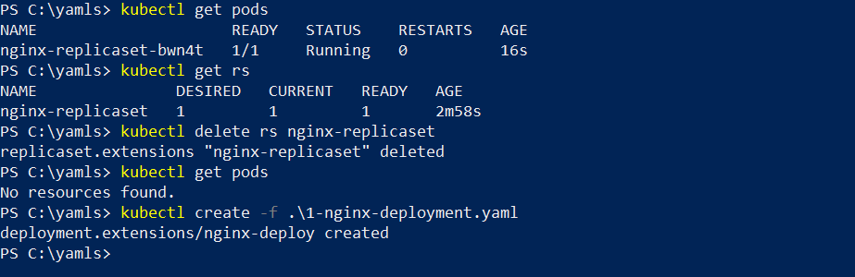

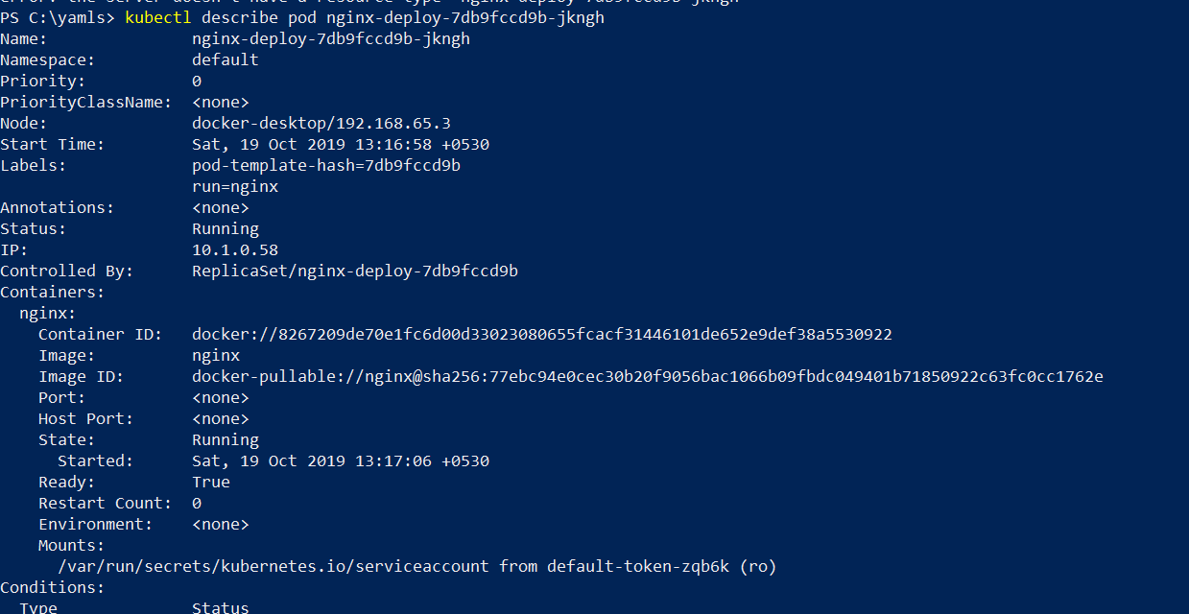

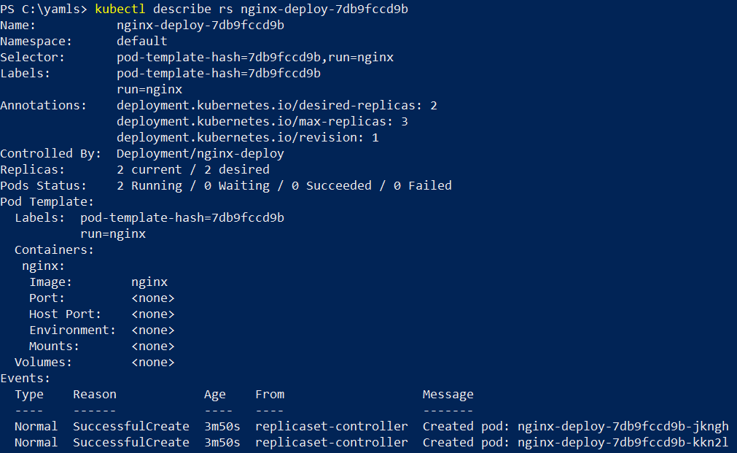

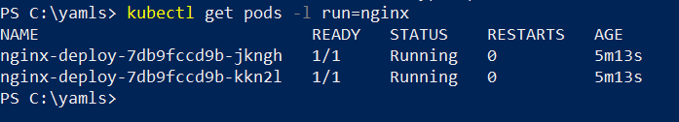

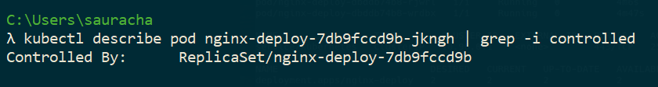

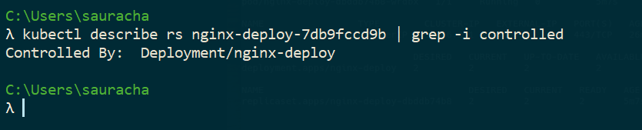

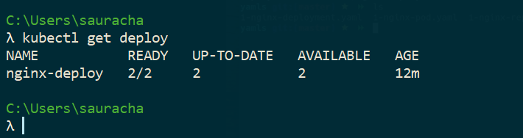

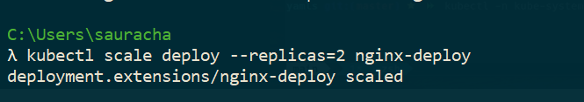

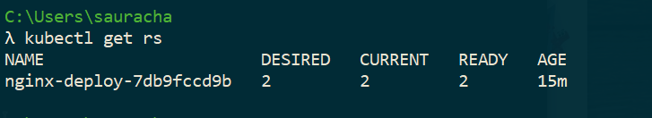

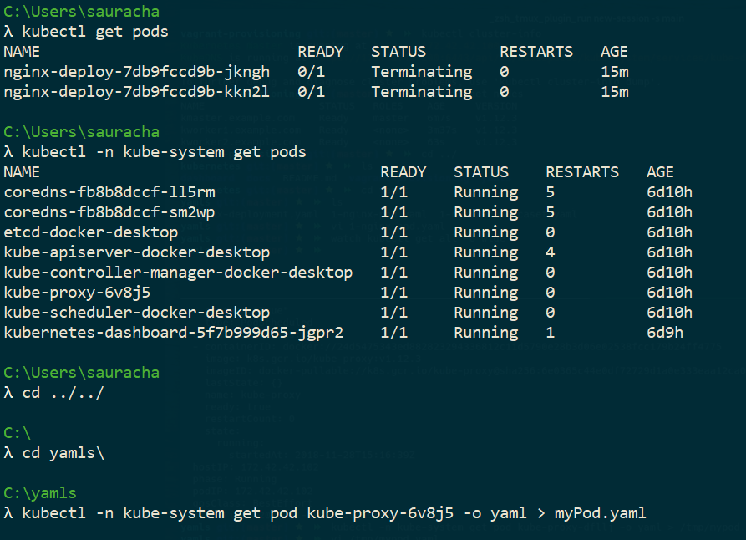

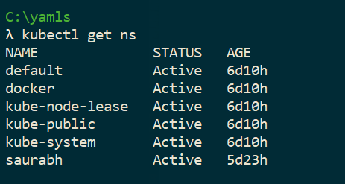

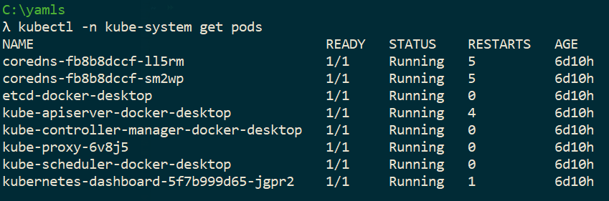

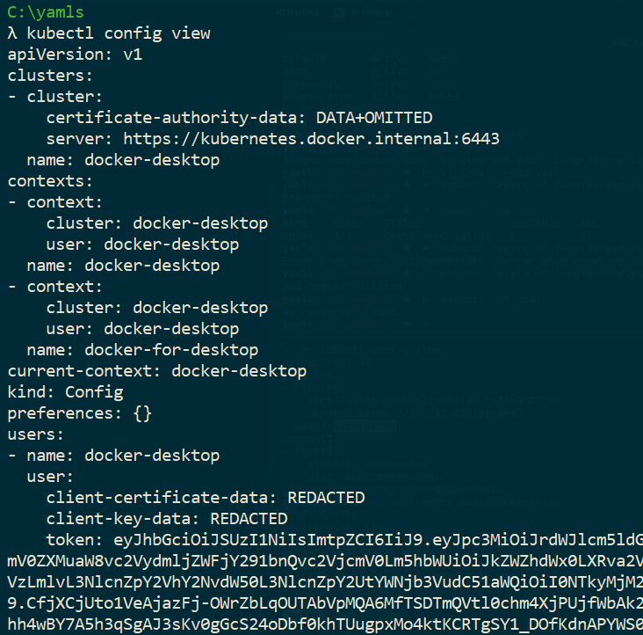

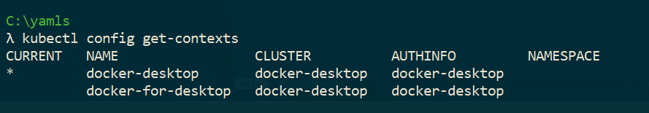

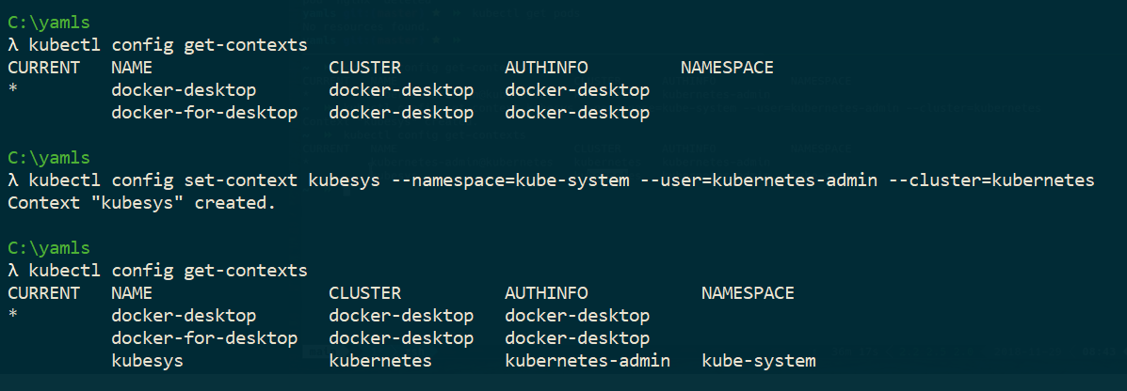

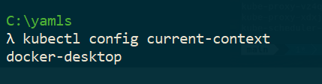

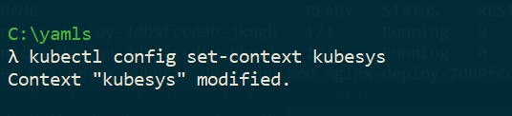

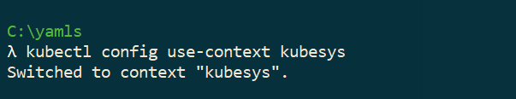

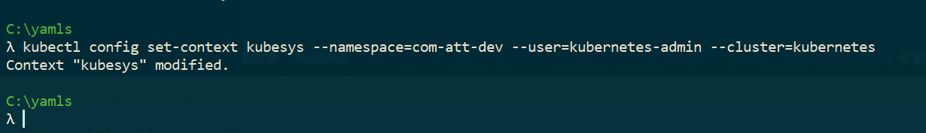

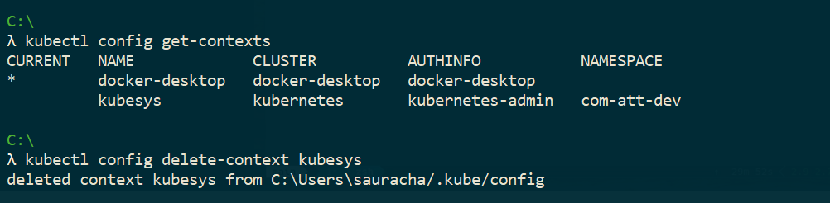

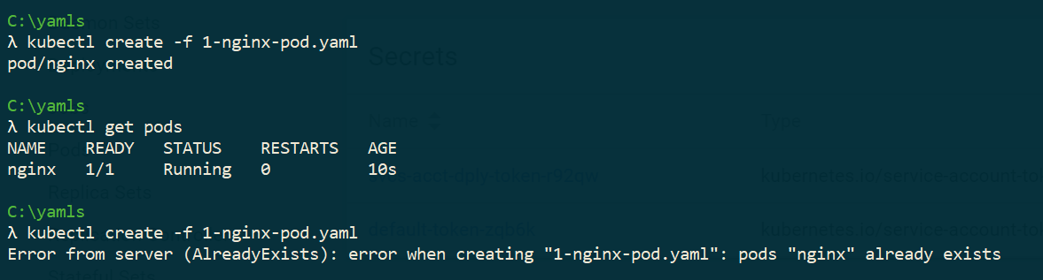

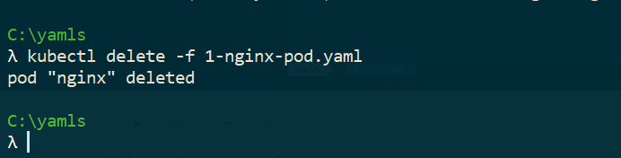

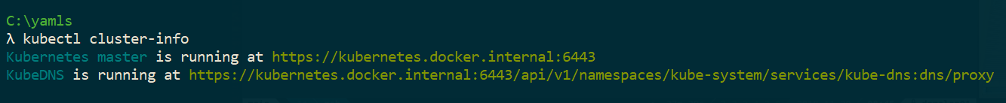

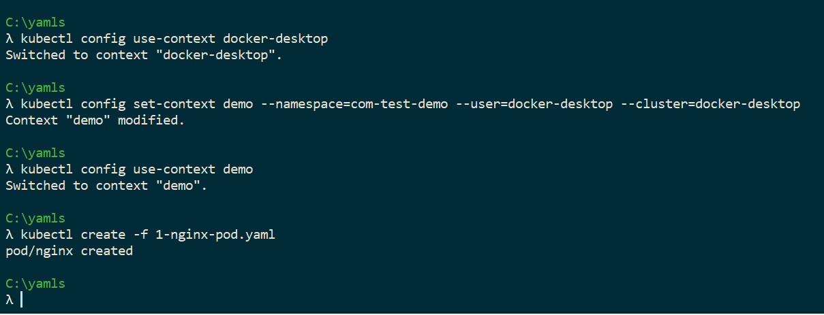

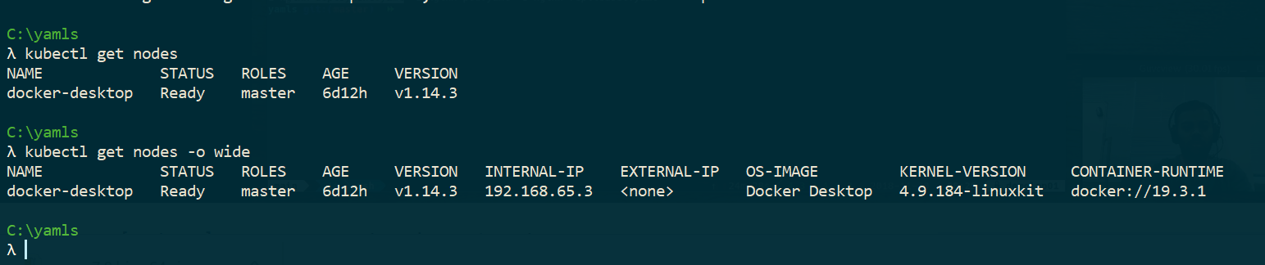

# KUBERNETES ADDING A LABEL SELECTOR TO THE NODES

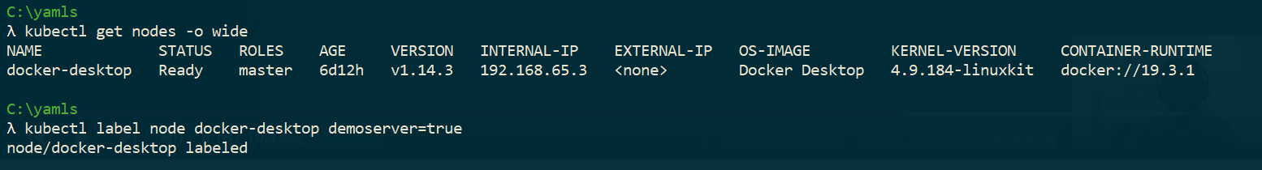

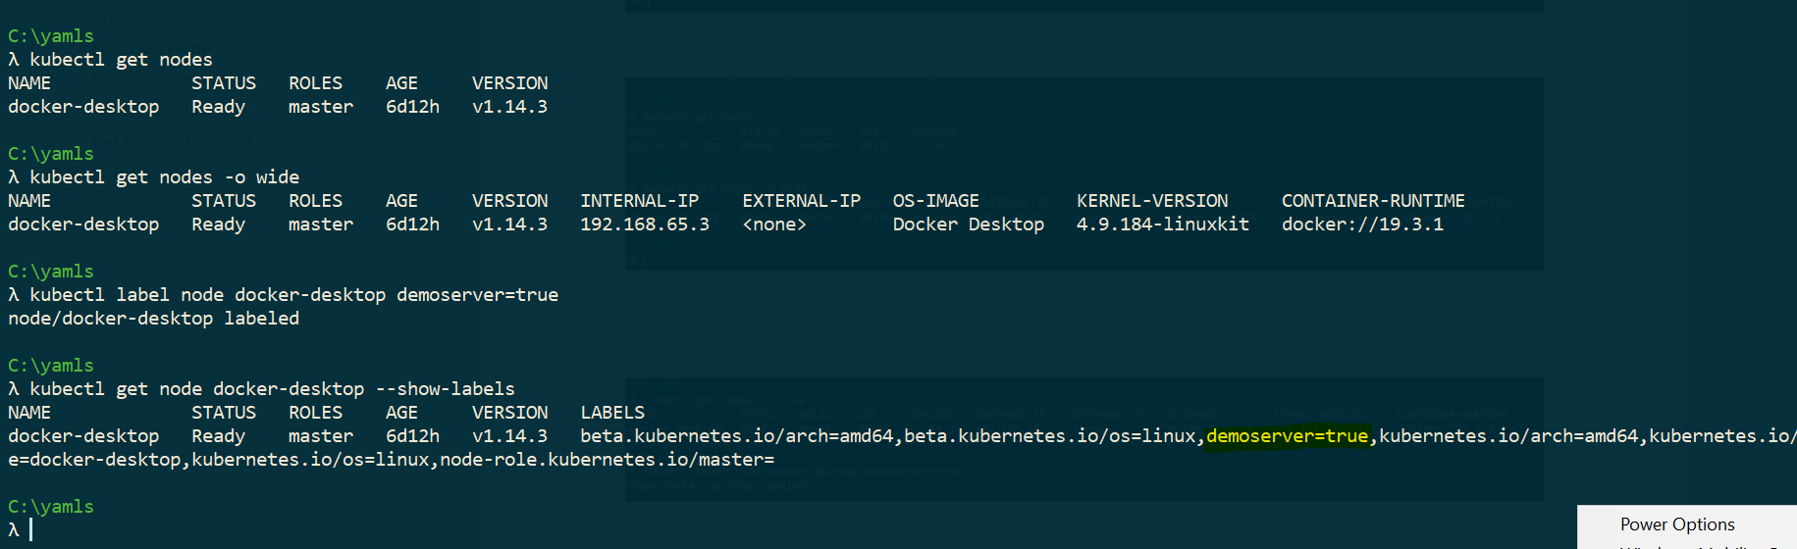

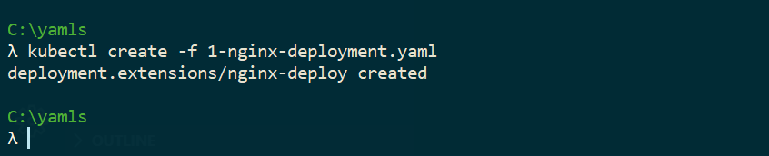

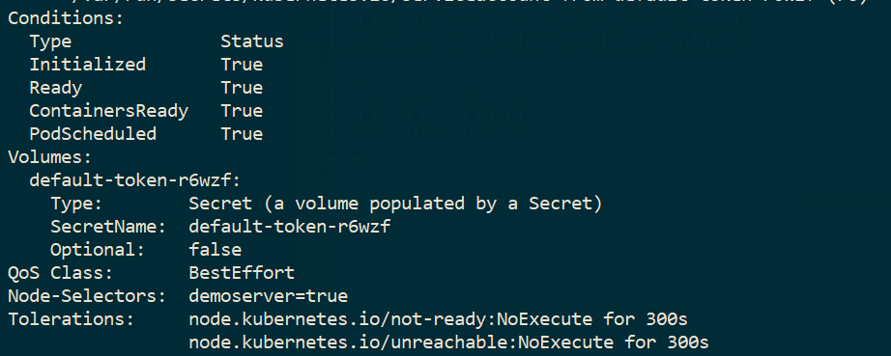

# KUBERNETES DAEMON SETS

A daemon set is a POD gets deployed on all the nodes .

A daemon set deployment on a set of pods can be controlled via use of Labels .

<https://www.bogotobogo.com/DevOps/DevOps_Jenkins_Chef_Puppet_Graphite_Logstash.php>

Good DevOps Content

<https://www.bogotobogo.com/Algorithms/algorithms.php>

<https://www.freecodecamp.org/news/setting-up-go-programming-language-on-windows-f02c8c14e2f/>

<https://kind.sigs.k8s.io/>

<https://www.bogotobogo.com/DevOps/Docker/Docker-Kubernetes-Multi-Node-Local-Clusters-kind.php>

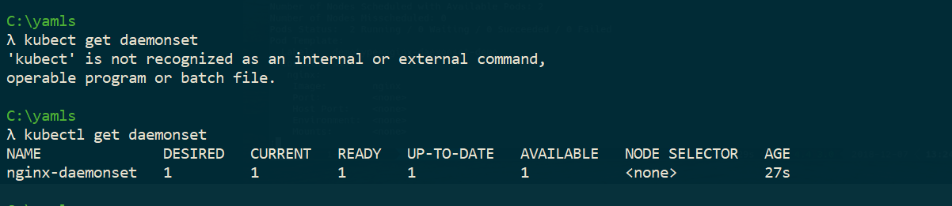

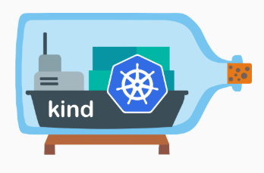

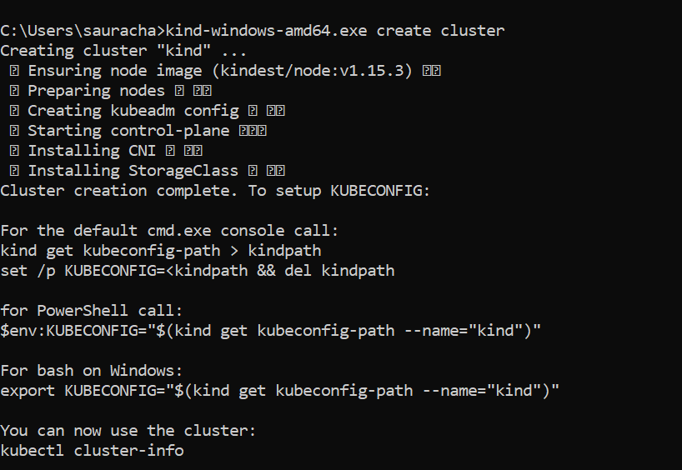

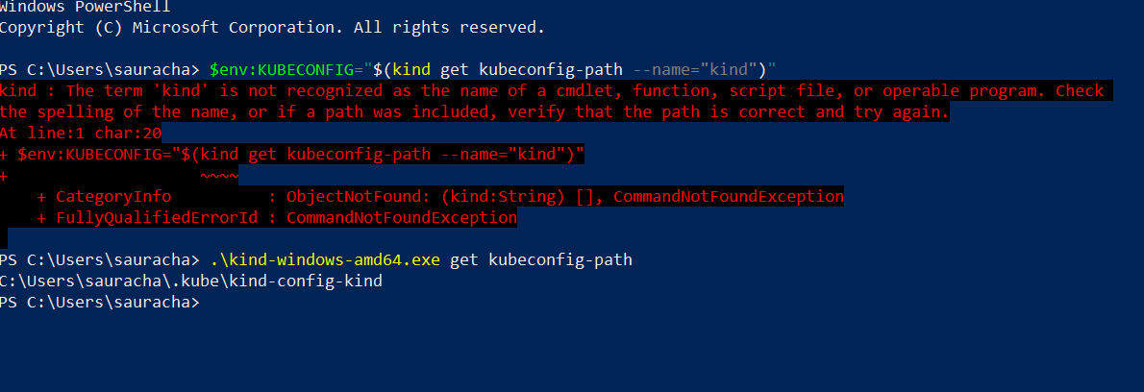

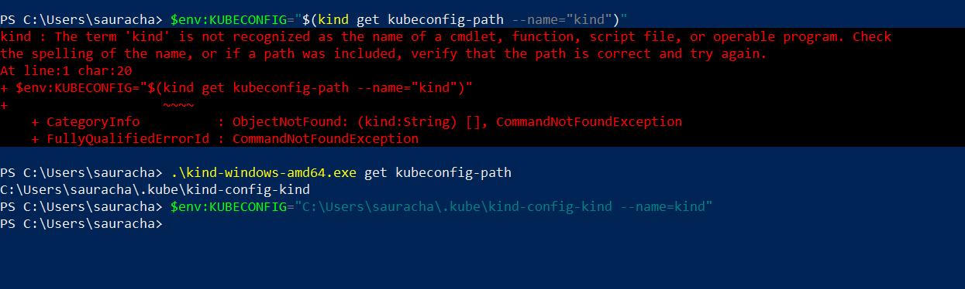

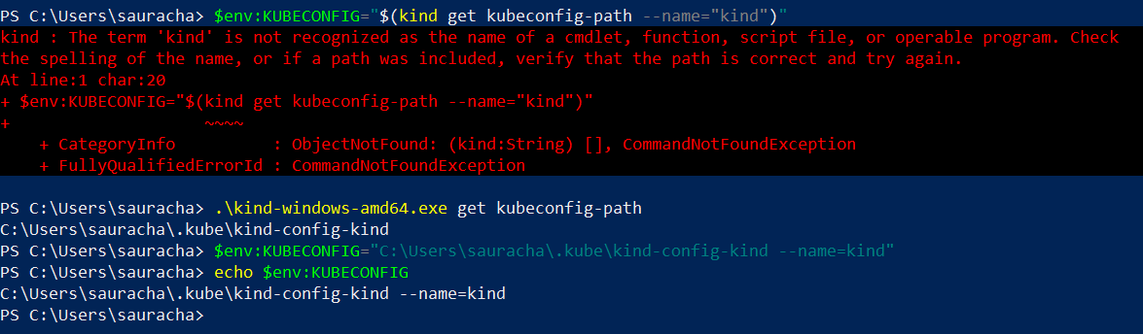

# KUBERNETES JOBS

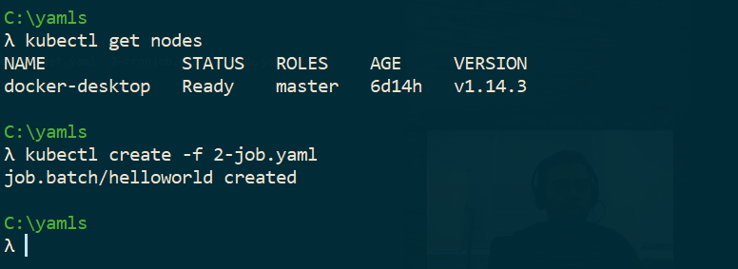

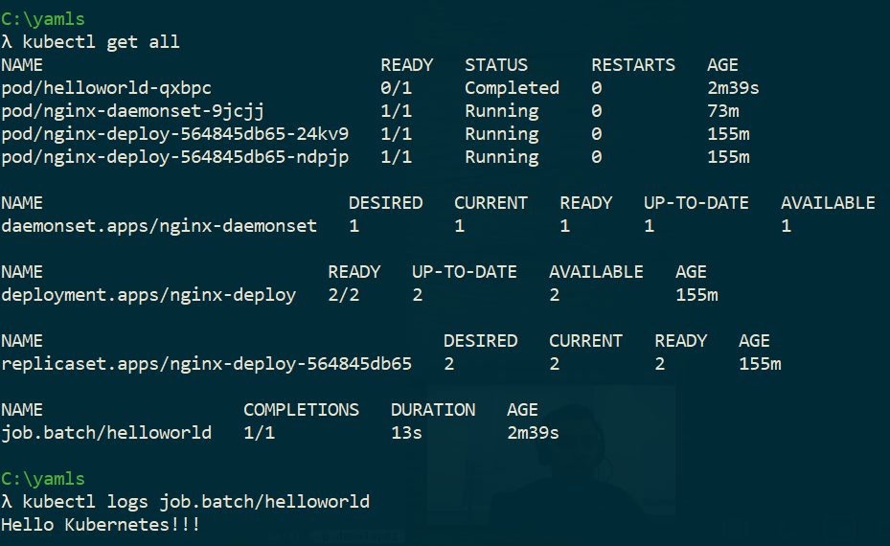

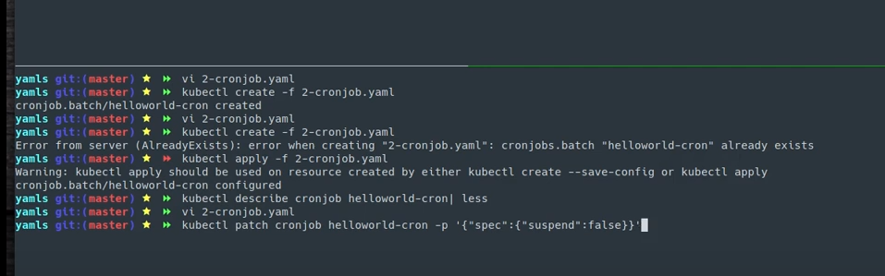

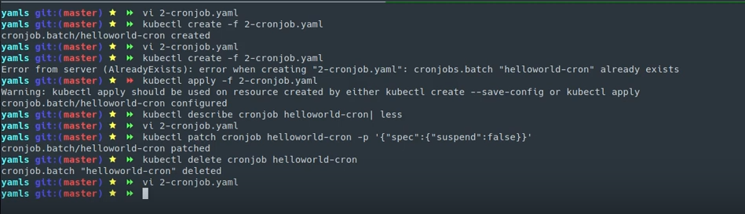

# RUNNING DOCKER CONTAINERS IN KUBERNETES

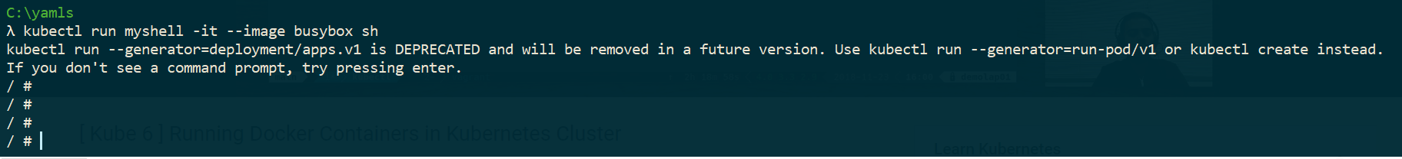

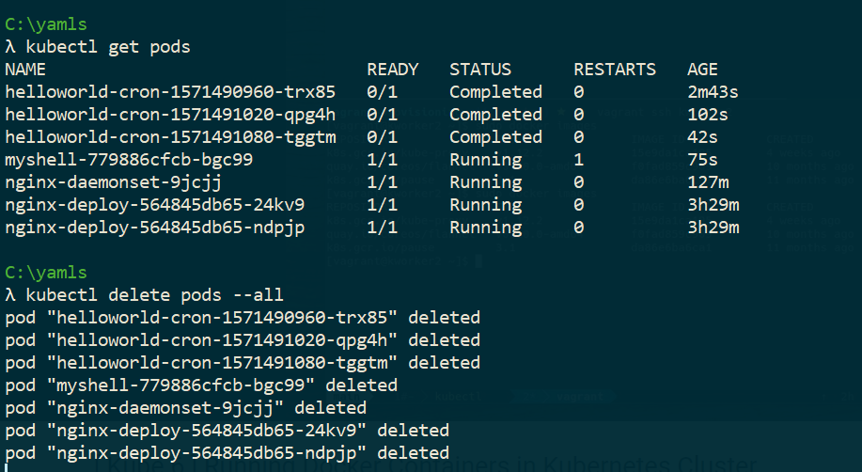

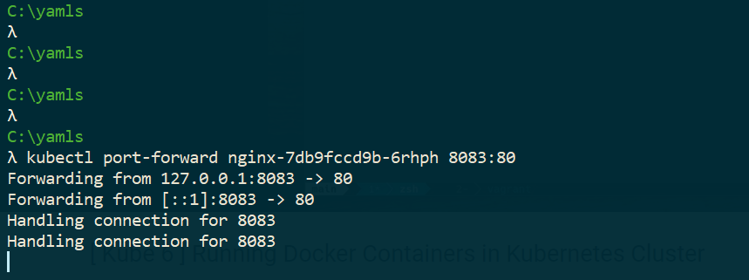

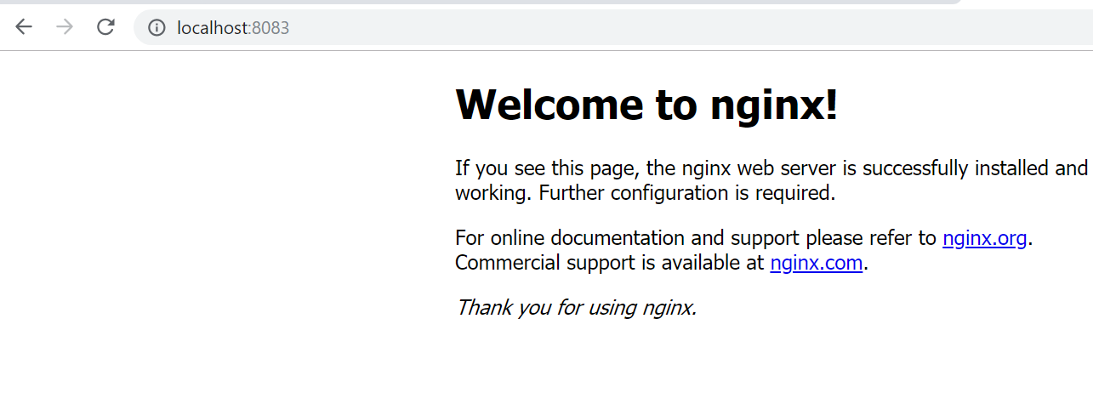

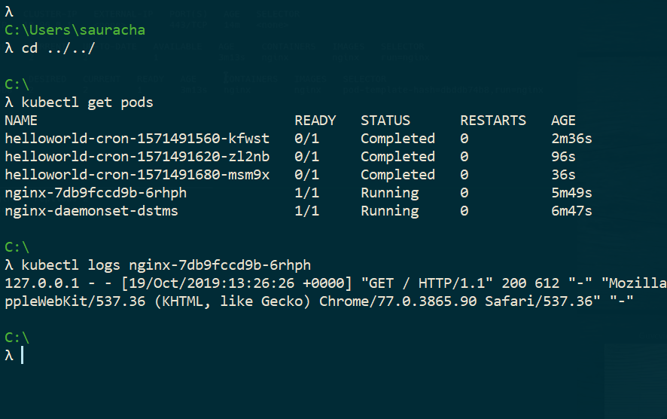

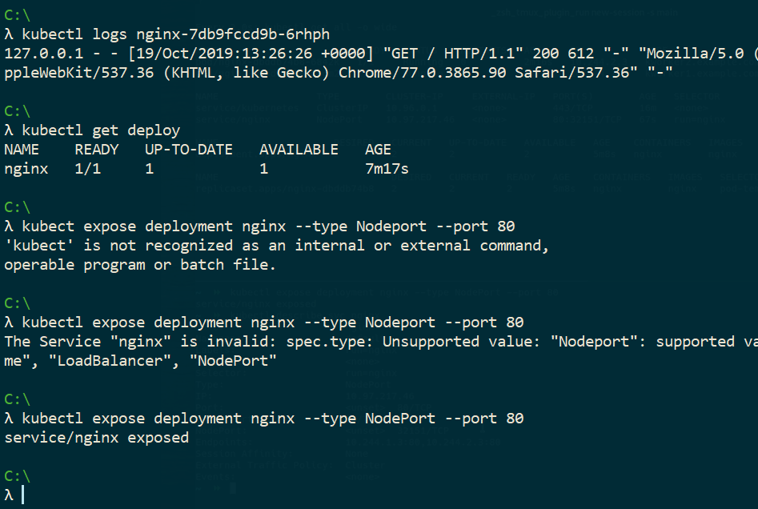

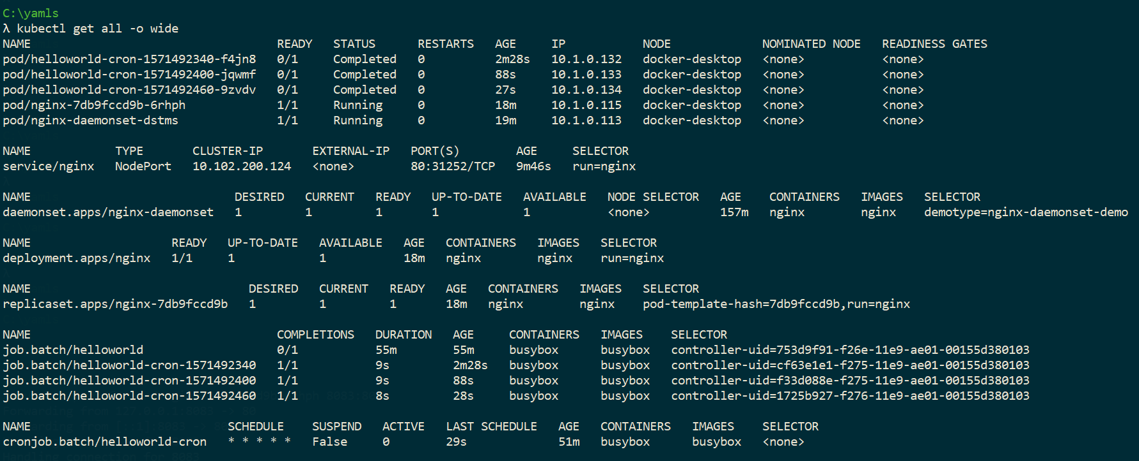

<https://medium.com/better-programming/build-your-own-multi-node-kubernetes-cluster-with-monitoring-346a7e2ef6e2>

<http://fullbit.ca/kubernetes-setting-up-a-cluster-locally-on-windows-10/>

<https://wiki.web.att.com/display/MessageRouter/DMaaP+Message+Router+Home>