**SPRING DATA JPA**

**A General Spring Data JPA Layer Should have**

1. **A Model to Store Data values .**
2. **An Interface ModelRepository that extends JPARepository<T,Serializable>**
3. **A ModelService class that provides methods that return data from database by injecting**

**@Autowired the ModelRepository , and provides data from database .**

**First of all , Spring Data JPA Provides a set of default methods in the DAO Layer .**

**findAll() --- return all records**

**saveAll() --- saveAllRecords**

**save ---- saves a single Record**

**Syntax for custom queries**

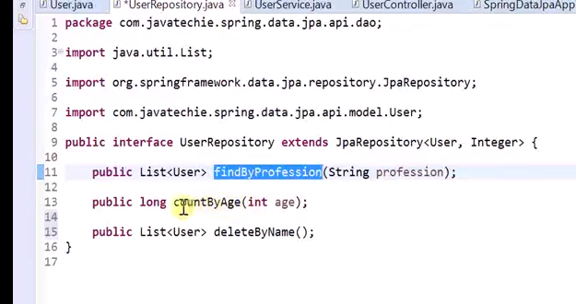

**More Examples :**

