Oracle Account Password === PS;w9>T#8K#9:%W]

tTWrVMk1FcPuCKroCd9E

<http://candidjava.com/tutorial/spring-boot-interview-questions/>

Omelette

Salt , Turmeric , Onion , Chllies , Black pepper , Coriander

<https://github.com/sivajavatechie/DemoDocuments/tree/master/datastructures%20and%20algorithms/src/com/sivajavatechie/datastructure>

<http://web.archive.org/web/20170908035416/stackoverflow.com/documentation>

<https://www.youtube.com/watch?v=bI-9epPq_Eg&list=PLFGoYjJG_fqr84PKCp88iPkQDWJSfzaqz&index=23> Null related facts

<https://www.youtube.com/watch?v=pkkFqlG0Hds&list=PL2_aWCzGMAwKedT2KfDMB9YA5DgASZb3U>

Sorting algorithms

<http://javabypatel.blogspot.com/2016/09/java-multithreading-interview-questions-answers.html>

Multithreading questions

<http://javabypatel.blogspot.com/2016/05/exception-handling-interview-questions.html>

Exception Handling

<http://javabypatel.blogspot.com/2016/04/java-interview-questions.html>

Overriding Questions

<http://javabypatel.blogspot.com/2016/07/type-casting-interview-questions-in-java.html>

Type-Casting questions

<http://javabypatel.blogspot.com/2016/05/ambiguous-method-overloading.html>

Method Overloading questions

<http://javabypatel.blogspot.com/2016/09/concurrenthashmap-interview-questions.html>

Concurrent Hash Map questions

<http://javabypatel.blogspot.com/2016/09/java-interface-interview-questions-in-java.html>

Java Interface questions

<https://javabypatel.blogspot.com/2016/04/java-interview-questions.html>

General JI Questions

<https://www.deadcoderising.com/2015-05-19-java-8-replace-traditional-for-loops-with-intstreams/>

IntStream Explaination

<https://www.java67.com/2018/06/data-structure-and-algorithm-interview-questions-programmers.html>

100 data structure questions

<https://www.hackerearth.com/practice/algorithms/sorting/merge-sort/visualize/>

Java Hungry

<https://www.youtube.com/channel/UCORuRdpN2QTCKnsuEaeK-kQ/playlists>

Java Techie

<https://www.youtube.com/channel/UCwgYv9lmioF0uR7dnsINFKw>

<https://www.youtube.com/watch?v=CYrCW1SjpOI>

<https://www.concretepage.com/java/java-8/> Good Java 8

<https://javaranch.com/journal/2003/04/immutable.htm>

<https://javaranch.com/campfire/StoryPassBy.jsp> pass by value

<https://www.baeldung.com/java-concurrency-interview-questions>

<https://www.baeldung.com/java-classes-initialization-questions>

<https://www.baeldung.com/java-8-interview-questions>

<https://www.baeldung.com/java-memory-management-interview-questions>

<https://www.baeldung.com/java-generics-interview-questions>

<https://www.baeldung.com/java-flow-control-interview-questions>

<https://www.baeldung.com/java-exceptions-interview-questions>

<https://www.baeldung.com/java-annotations-interview-questions>

<https://www.baeldung.com/spring-interview-questions>

<https://www.baeldung.com/java-collections-interview-questions>

<https://www.baeldung.com/java-executor-wait-for-threads>

<https://www.youtube.com/channel/UCaH2MTg94hrJZTolW01a3ZA/playlists> Green Java

<https://docs.spring.io/spring-boot/docs/current/reference/html/common-application-properties.html>

Common application.properties values

<http://blog.hampisoftware.com/index.php/2016/01/20/apache-kafka-differences-from-jms/>

<https://www.youtube.com/watch?v=0grCtFI5pKE&list=PL3GCZkoyKK4diXXSF2idbJFRGKe1VVR_6&index=12> Maven Snapshot

<https://www.aquasec.com/wiki/display/containers/70+Best+Kubernetes+Tutorials>

<https://codelabs.developers.google.com/codelabs/cloud-springboot-kubernetes/#10>

<https://technology.amis.nl/2018/08/13/running-kubernetes-1-10-using-minikube-on-windows-10-adding-kubectl-and-helm-tiller/>

<https://www.youtube.com/channel/UC_evcfxhjjui5hChhLE08tQ/playlists>

**DevOps Tutorial Links**

<https://www.youtube.com/watch?v=-PbnWGddmcM&list=PLTyWtrsGknYd0JgqeARypdRy-SX1ORYhs>

**Microservices Design Patterns**

<https://university.mongodb.com/certification/developer/about#schedule>

**MongoDB Learning Path**

<https://www.youtube.com/watch?v=hwrnmQumtPw&list=PLGLfVvz_LVvSX7fVd4OUFp_ODd86H0ZIY&index=39>

**Derek Banas Tutorials**

<https://jayvilalta.com/blog/>

<https://www.youtube.com/watch?v=YdAMoN1ZsXw>

<https://www.youtube.com/watch?v=OZEGnam2M9s&list=PLu-nSsOS6FRIg52MWrd7C_qSnQp3ZoHwW>

**Best GIT PlayList**

<https://codenotfound.com/best-spring-blogs.html>

<http://roufid.com/no-compiler-is-provided-in-this-environment/>

<https://www.youtube.com/channel/UCRPMAqdtSgd0Ipeef7iFsKw/playlists> Gaurav Sen Playlist

PostGreSQL port : 5432

<https://github.com/sdmg15/Best-websites-a-programmer-should-visit>

<https://github.com/clarketm/java-design-patterns>

<https://github.com/HugoMatilla/Effective-JAVA-Summary>

<https://www.youtube.com/watch?v=mOIRNSdar54> tricky java questions

<http://www.thejavageek.com/design-patterns/> **Java Design Patterns**

<https://www.youtube.com/watch?v=vOEN65nm4YU&list=PLG6ePePp5vvYVEjRanyndt7ZSqTzillom>

Algorithms

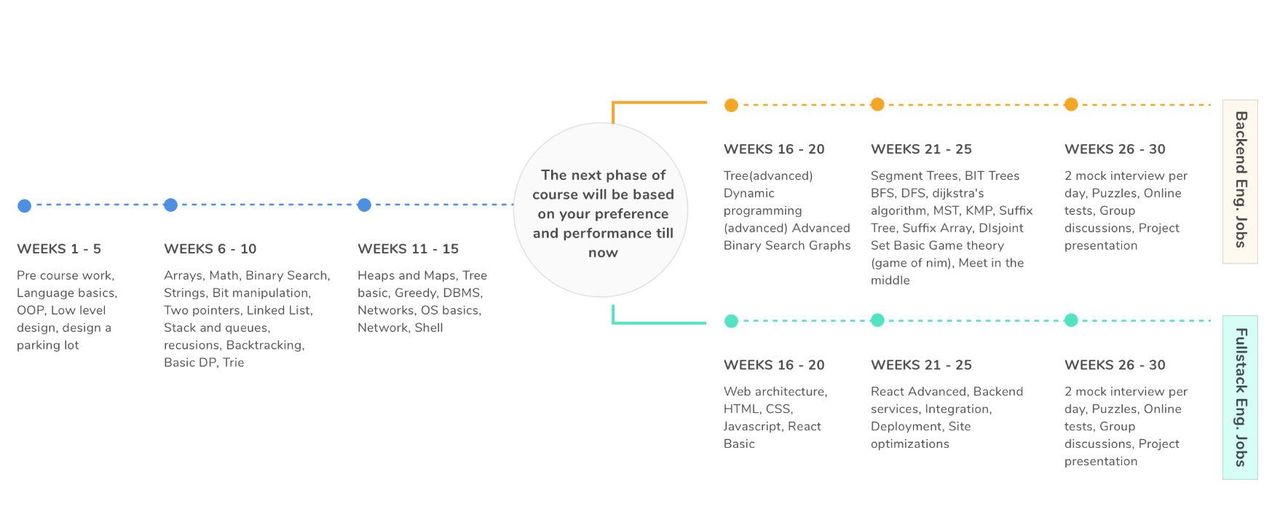

<https://www.algoexpert.io/questions>

<https://blog.pramp.com/how-to-succeed-in-a-system-design-interview-27b35de0df26>

<https://codepumpkin.com/use-private-constructor-java/>

CODE PUMPKIN TUTORIALS

<https://engineering.videoblocks.com/web-architecture-101-a3224e126947>

<https://www.geeksforgeeks.org/amazon-sde-interview-experience-july20-2019/>

<https://www.guru99.com/payment-gateway-testing-tutorial-with-sample-test-cases.html>