MTH302- Business Mathematics & Statistics
Paper Year Session
Paper # 01 2008 (session-02)
Paper # 02 2009 (session-02)
Paper # 03 2009 (session-03)
Paper # 04 2009 (session-04)
Paper # 05 2010 (unknown)
Paper # 06 2010 (unknown)
Paper # 07 2011 (session-02)
Paper # 08 2011 (session-03)
Paper # 09 2011 (session-04)

Paper # 01
Fall 2008
(Session - 2)

Question No: 1 ( Marks: 1 ) - Please choose one
Store A marked down a $ 50 perfume to $ 40 with markdown of $10 . The % Markdown is
► 10%
► 20%
► 30%
► 40%

Question No: 2 ( Marks: 1 ) - Please choose one
Given Net price of shirt = $20 , Discount = 10% ,List price will

► $22
► $24
► $26
► $30

Question No: 3 ( Marks: 1 ) - Please choose one
Which is the correct syntax for the determinant of a matrix given by the following array
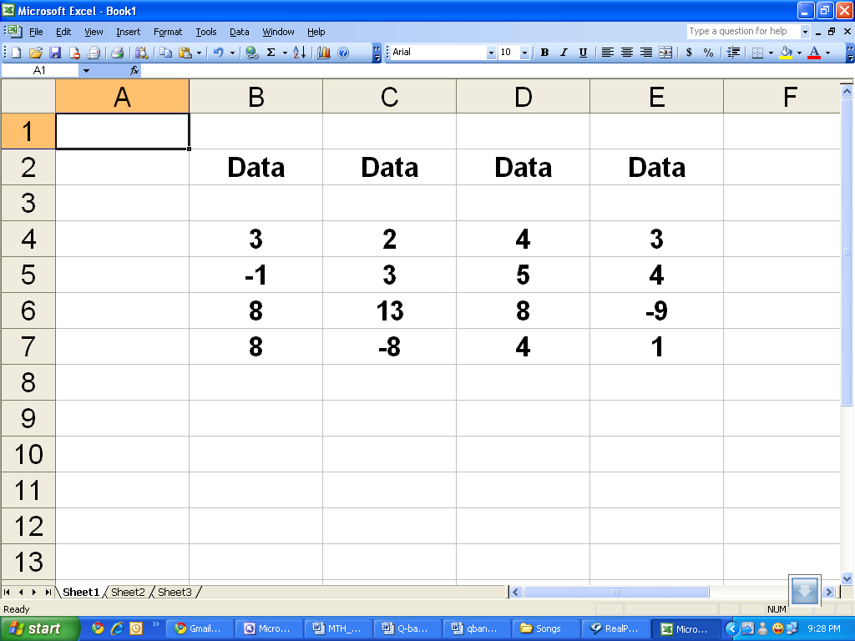

► =DETERM (B4:E7)

► =MDTERM (B4:E7)

► =MDETERM (B4:E7)

► =MDETERM (B4;E7)

Question No: 4 ( Marks: 1 ) - Please choose one
VDB returns the depreciation of an asset for

► Zero period

► One period

► Two periods

► Any arbitrary period

Question No: 5 ( Marks: 1 ) - Please choose one
If the cost & selling price of a pen are Rs.12 & Rs.15 respectively, profit percentage is:

► 33.33%

► 25%

► 20%

► 10%

Question No: 6 ( Marks: 1 ) - Please choose one
This example returns the depreciation for an asset that costs Rs. 10,000, with a salvage value of $8,000. The useful life of the asset is 5 years. The depreciation is being calculated for the third year, and there are 10 months in the first year.

► =DB (10000, 5, 8000, 3, 10)
► =DB (10000, 8000, 5, 10, 3)
► =DB (10000, 8000, 5, 3, 10)
► =DB (10000, 8000, 10, 3, 5)

Question No: 7 ( Marks: 1 ) - Please choose one
Which of the following functions is not related to financial analysis?

► AMORDEGRC
► AMORLINC
► CUMIPMT
► MDETERM

Question No: 8 ( Marks: 1 ) - Please choose one
(2) ^ -2 = ) 0.25……..

► 
► 
► 
► 

Question No: 9 ( Marks: 1 ) - Please choose one
 Dimension of a matrix means

       ► Column space

       ► Row space

       ► Order of the matrix

       ► None of these

Question No: 10 ( Marks: 1 ) - Please choose one
 If there is a -30% change in the price of an item, what does the negative sign show?
       
► The price is increasing.
       ► The price is decreasing.
       ► The price has low rate of change.
       ► None of the above.

Question No: 11 ( Marks: 1 ) - Please choose one
 According to taxation rules; the amount of allowances is treated tax free if it is upto 50% of the basic salary.

       ►
       ►
       ► 
       ►

Question No: 12 ( Marks: 1 ) - Please choose one
 Write a formula to find the simple interest (I) if $5000 is invested at 4% for 2 years.
       ► I=PRT
       ► I=P+R+T
       ► I=PT
       ► I=P(R+T)

Question No: 13 ( Marks: 1 ) - Please choose one
 Every percentage can be converted into:

► Decimal
► Ratio
► Proportion
► Both decimal & ratio

Question No: 14 ( Marks: 1 ) - Please choose one
Monthly installments of a leased car are calculated by using the techniques of:

► Simple interest method

► Compound interest method

► Annuity
► Hit & trial method

Question No: 15 ( Marks: 1 ) - Please choose one
Suppose that you are spending 1500 dollars in an investment and Accumulated factor is 15 then Accumulated Value will be

► 22550
► 22500
► 21000
► 22510

Question No: 16 ( Marks: 1 ) - Please choose one
What is the interest on Rs. 1600 for one year at the rate 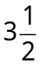%?

► 65
► 56
► 75
► 90

Question No: 17 ( Marks: 2 )
A man borrows $39000 for 1and half year at a rate of 1.65%. What is the simple interest he has to pay?

Simple interest is given by
I= P*R*T/100
P= principal = $39000
R= interest rate= 1.65%
T= 1.5 year
Interest, I =(39000 * 1.65 *1.5)/100 = Rs 965.25

Question No: 18 ( Marks: 2 )
If
Cost price = 2000Rs
Selling price = 6500Rs
Then what will be %Markup on cost?

MUC= S- C (Rs markup on cost = selling price- cost price)
= 6500-2000 = Rs 4500
% markup on cost = (MuC/cost price) * 100 = (4500/2000) *100= 225%

Question No: 19 ( Marks: 3 )

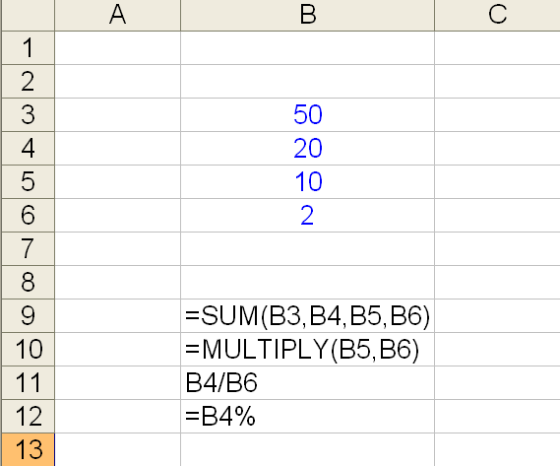

Write the output of B9, B10, B11 and B12. If you think the formula is incorrect write "Error" in output.

ANSWER:
The output of =sum(B3,B4,B5,B6) = 82

=multiply(B5,B6) will not give result because multiply is not a excel function

B4/B6 is not a formula because in excel formula must start with "="

=B4% will return 0.2

Question No: 20 ( Marks: 5 )
A gold chain is sold for Rs. 6500 at a gain of 25%. Find the profit.

Selling price = 6500
Profit = 25%
Profit in Rs= (6500*25)/100= Rs 1625

Question No: 21 ( Marks: 10 )
For the following matrices perform the indicated operation, if possible.
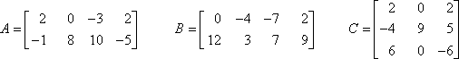
(a)
(b)
(c)
a)
A = 2 0 -3 2 + B = 0 -4 -7 2
-1 8 10 -5 12 3 7 9

A+B= 2+0 0-4 -3-7 2+2
-1+12 8+3 10+7 -5+9

A+B = 2 -4 -10 4
11 11 17 4

b)
B-A= 0-2 -4-0 -7-(-3) 2-2
12-(-1) 3-8 7-10 9-(-5)

B-A= -2 -4 -4 0
13 -5 -3 14
c) A+C is not conformable for addition because for addition number of rows and columns of A must be equal to number of rows and columns of C

Paper # 02
Fall 2009 (Session - 2)
Time: 60 min
Marks: 42

Question No: 1 ( Marks: 1 ) - Please choose one
45% of what is 9?

► 20
► 40
► 30
► 10

Question No: 2 ( Marks: 1 ) - Please choose one
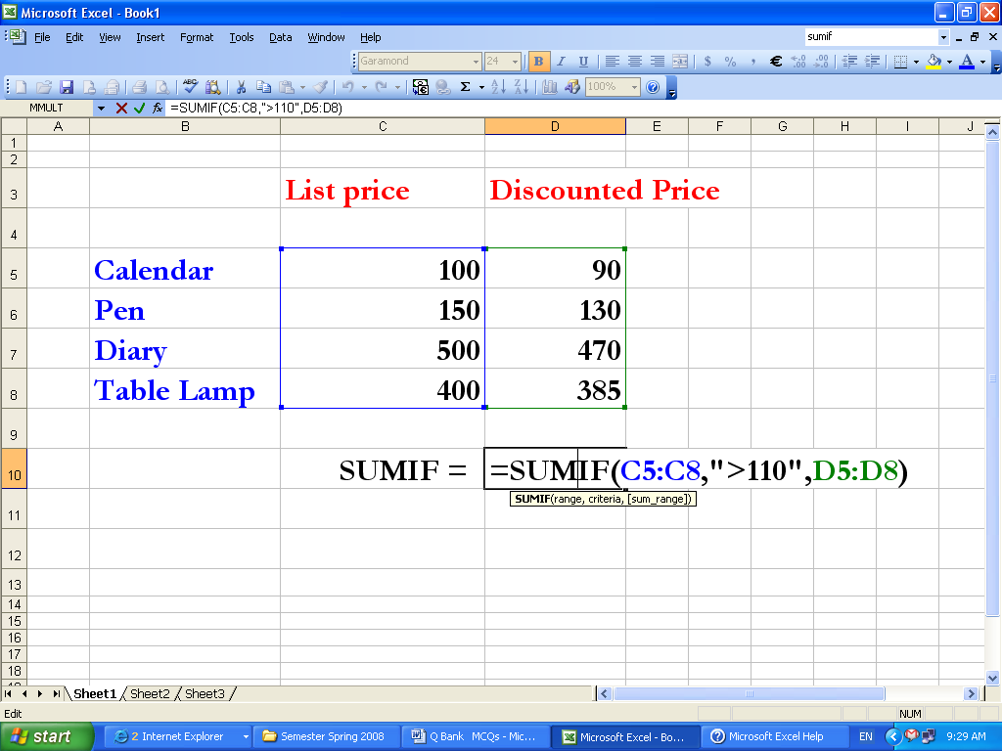

What will be the answer of the SUMIF formula?

       ► 1075
       ► 985
       ► 855
       ► 130

Question No: 3 ( Marks: 1 ) - Please choose one
After the merchant buys merchandise, it is sold at a higher price called the _______

► Sale price
► Revenue discount
► Selling price
► Cost price

Question No: 4 ( Marks: 1 ) - Please choose one
In the case of partial payments, the _______ is the partial payment plus the partial cash discount

► Amount received
► Amount returned

► Amount credited
► Amount displaced

Question No: 5 ( Marks: 1 ) - Please choose one
In a friendly cricket between India and Pakistan, Pakistan is scoring at a rate 7% more than India in 35 overs. If the India’s score after 35 overs was 230 what’s Pakistan score now?
► 250
► 235
► 246
► 240

Question No: 6 ( Marks: 1 ) - Please choose one
0.20% = ------------
       
► 0.2
► 0.02
► 0.002
► 0.0002

Question No: 7 ( Marks: 1 ) - Please choose one
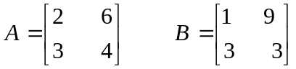, then AB is --------------------------

► 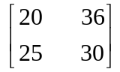
► 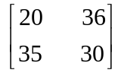
► 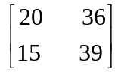
► 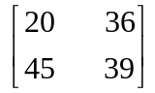

Question No: 8 ( Marks: 1 ) - Please choose one
What will be the base of 25% rate and percentage is 65?

► 216
► 250
► 260
► None of these

Question No: 9 ( Marks: 1 ) - Please choose one
The formula for compound interest for n number of periods is

       ► S = P(1 + r/100)* n

       ► S = P(1 + n/100)^ r

       ► S = P(1 + r/100)^ n

       ► S = P(1 + r/100)/ n

Question No: 10 ( Marks: 1 ) - Please choose one
According to the local laws, the allowances are considered tax free if they are up to

► half of the basic salary
► one fourth of the basic salary
► one third of the basic salary
► 55% of the basic salary

Question No: 11 ( Marks: 1 ) - Please choose one
Amount of discount is obtained as

       ► Percentage of Discount x List Price
► Percentage of Discount / List Price
► Percentage of Discount - List Price
► None of these

Question No: 12 ( Marks: 1 ) - Please choose one
In which Trust Fund, the company does not deduct, but only contribute 1/11th of Basic Salary of the employee per month?

► Provident Fund
► Gratuity Fund
► Stock yield
► Interest

Question No: 13 ( Marks: 1 ) - Please choose one
The value of x for the equation -(-x - 5) = x – 2 is ------------------

► no solutions
► -5
► 3
► 1 / 2

Question No: 14 ( Marks: 1 ) - Please choose one
What will be the simple interest earned on an amount of Rs. 16,800 in 9 months at the rate of 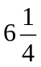% p.a?

       ► Rs. 787.50
       ► Rs. 812.50
       ► Rs 860
       ► Rs. 887.50

Question No: 15 ( Marks: 1 ) - Please choose one
This example returns the present value of an investment that pays Rs. 250 at the end of every month for 2 years. The money paid out will earn 7.5% annually.

       ► =PV (7.5%/12, 2*12, 250, 1)
       ► =PV (7.5%/12, 2*12, 250, 0)
       ► =PV (7.5%/12, 2, 250, 0)
       ► =PV (7.5%, 2*12, 250, 1)

Question No: 16 ( Marks: 1 ) - Please choose one
All formula in Excel start with
       ► +
       ► =
       ►  -
       ► %

Question No: 17 ( Marks: 1 ) - Please choose one
A percentage is a way of expressing a number as
       
► a fraction of 100 .
       ► sum of number with 100.

       ► multiplication of number with 100.

       ► average of number with 100.

Question No: 18 ( Marks: 1 ) - Please choose one
Given : List Price =5500Rs , Discount = 850Rs, then Net Cost Price will be
       ► 6350 Rs
6350 Rs

       ► 5508 Rs
5508 Rs

       ► 5585 Rs

       ► 4650 Rs

Question No: 19 ( Marks: 1 ) - Please choose one
If C = Cost price, S = Selling Price then the margin on the cost is equal to

       ► 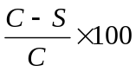
       ► 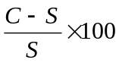
       ► 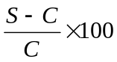
       ► 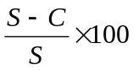

Question No: 20 ( Marks: 1 ) - Please choose one
In 2 years you are to receive $10,000. If the interest rate were to suddenly decrease, the present value of that future amount to you would

► Fall
► Rise
► remain unchanged
► The correct answer cannot be determined without more information

Question No: 21 ( Marks: 1 ) - Please choose one
The net price of a computer table is 2500 and list price 3000. The trade discount will be

► 13%

► 17%
► 21%
► 25%

Question No: 22 ( Marks: 1 ) - Please choose one
Store A marked down a $ 50 perfume to $ 40 with markdown of $10
The % Markdown is

► 10%
► 20%
► 30%
► 40%

Question No: 23 ( Marks: 1 ) - Please choose one
Given for a product selling price = $45 and unit variable cost= $30 then Unit contribution margin will be

► $15
► $75
► $1.5
► Can not be found from given values.

Question No: 24 ( Marks: 1 ) - Please choose one
3x² ⁺ 5x – 7 is --------------- expression.

► Monomial
► Binomial
► Trinomial
► Linear

Question No: 25 ( Marks: 3 )
The mean of the numbers 10, 7, 9, 2 and x is 11; find the value of x.

Solution
total = 5*11 =55
total =10+7+9+2+x=55
28+x=55
x=55-28
x=27
Question No: 26 ( Marks: 5 )
The salary of an employee is as follows:
Basic salary = 50,000 Rs.
What is the amount of allowances if House Rent = 45 %, Conveyance allowance = 2.5 % and Utilities allowance = 2.5 %?

Solution
House Rent = 50000*45/100 =22500
Conveyance Allowance = 50000*2.5/100 = 1250
Utilities Allowance = 50000*2.5/100 = 1250

Question No: 27 ( Marks: 10 )
If the price of 16 dozen of eggs and 10 breads of large size is 332.The price of 10 dozen of eggs and 8 breads of large size is 225.Find the prices of per dozen eggs and per bread.
(Solve this question by using matrices only)

Solution
192X+10y=332
120x+8y=225
from 2
8y=225-120x
y=(225-120x)/8
put in 1
192x+10(225-120x)/8=332
192x+281.25-150x=332
(192-150)x=332-281.25
42x=50.75
x=1.21
y=(225-120*1.21)/8
y=10

Paper # 03
Fall 2009 (Session - 3)
Time: 60 min
Marks: 42

Question No: 1 ( Marks: 1 ) - Please choose one
The Basic salary of an employee is Rs 7,000. What is the contribution of the company on account of gratuity to the Gratuity Trust Fund?

► Rs 636.36
► Rs 6363.6
► Rs 63.636
► Rs 6363

Question No: 2 ( Marks: 1 ) - Please choose one
The monthly incomes of A and B are in the ratio 4 : 5, their expenses are in the ratio 5 : 6. If 'A' saves Rs.25 per month and 'B' saves Rs.50 per month, what are their respective incomes?

       ► Rs.400 and Rs.500
       ► Rs.240 and Rs.300
       ► Rs.320 and Rs.400
       ► Rs.440 and Rs.550

Question No: 3 ( Marks: 1 ) - Please choose one
Sum of annuity is always

► Present value

► Future value

► Net present value

► Current value

Question No: 4 ( Marks: 1 ) - Please choose one
In annuity interest is charged by the:
► Simple interest method

► Compound interest method
► Both simple and compound interest method

► Accumulated method

Question No: 5 ( Marks: 1 ) - Please choose one
Find x if 3(x + 2) - 7 = 11.
► 2
► -4
► 6
► 4

Question No: 6 ( Marks: 1 ) - Please choose one
The value of x after solving the following linear equation is
-2x + 6 = 4x - 2

► 0
► 3
► 1/2
► 4/3

Question No: 7 ( Marks: 1 ) - Please choose one
The sequence of payments at equal interval of time is called

► Annuity

► Accumulated value

► Discounted value

► None of these

Question No: 8 ( Marks: 1 ) - Please choose one
Ali has improved his typing speed from 40w/m to 60w/m.The percentage improvement is

► 20%
► 150%
► 50%
► 30%

Question No: 9 ( Marks: 1 ) - Please choose one
Markdown means a reduction from the

► Original cost price

► Original sale price

► Original Net price

► None of these

Question No: 10 ( Marks: 1 ) - Please choose one
Markup is an amount added to ----------------------------------------

► get accumulated interest
► a cost price while calculating a selling price.
► The principal amount of the loan.
► Accumulation factor.

Question No: 11 ( Marks: 1 ) - Please choose one
Interest calculated upon the principal amount added to the interest on it is called ……

► Simple interest
► Compound interest
► Annual interest per year
► Semi annual interest

Question No: 12 ( Marks: 1 ) - Please choose one
Contribution Margin is the Rs. amount that is equal to ----------------------

► S – VC
► VC – S
► FC – VC
► VC – FC

Question No: 13 ( Marks: 1 ) - Please choose one
Reduction from original selling Price is called ………

► Loss
► List price
► Profit
► Markdown

Question No: 14 ( Marks: 1 ) - Please choose one
What will be the simple interest earned on an amount of Rs. 16,800 in 9 months at the rate of % p.a?

► Rs. 787.50
► Rs. 812.50
► Rs 860
► Rs. 887.50

Question No: 15 ( Marks: 1 ) - Please choose one
A percentage is a way of expressing a number as
       
► a fraction of 100 .
       ► sum of number with 100.

       ► multiplication of number with 100.

       ► average of number with 100.

Question No: 16 ( Marks: 1 ) - Please choose one
12.5% of a circular plot as a fraction is expressed as 1/8

       ► 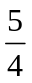
       ► 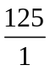
       ► 
       ► 

Question No: 17 ( Marks: 1 ) - Please choose one
To convert a number in percent (%) from a fraction, we do which of the following operation:

       ► add by 100

       ► subtract by 100

       ► multiply by 100

       ► divide by 100

Question No: 18 ( Marks: 1 ) - Please choose one

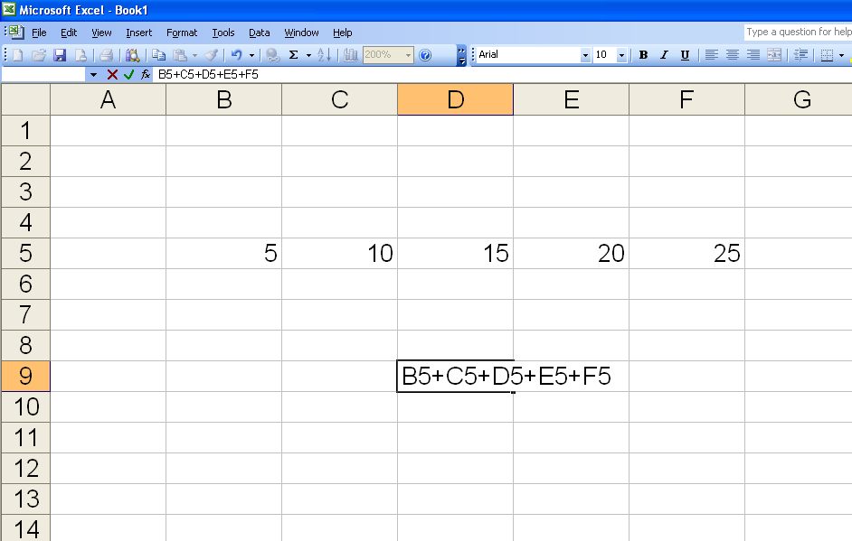

What result will I get when press enter in cell D9?

       ► 75
       ► B5+C5+D5+E5+F5
       ► Error
       ► Cannot be determine

Question No: 19 ( Marks: 1 ) - Please choose one
Interest paid (earned) on only the original principal borrowed (lent) is often referred to as

► simple interest
► present value
► future value
► compound interest

Question No: 20 ( Marks: 1 ) - Please choose one

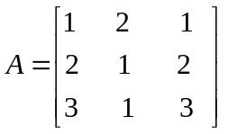 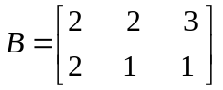
By multiplying the above two matrices we get the following result
► 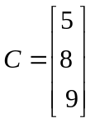
► 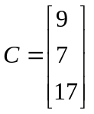
► 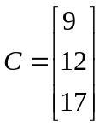
► Given matrices cannot be multiplied

Question No: 21 ( Marks: 1 ) - Please choose one
The formula for finding BEP in units is given by

► FC/VC
► FC/(S-VC)
► CM/FC
► CM/VC

Question No: 22 ( Marks: 1 ) - Please choose one
If A is a matrix whose determinant is zero then its inverse is given by:

► zero
► product of its diagonal entries
► infinite
► cannot be determined

Question No: 23 ( Marks: 1 ) - Please choose one
which of the following is linear equation

► 2x-3y=-6

► x+x+x

► 520x²y²

► y^2 -3=0

Question No: 24 ( Marks: 1 ) - Please choose one
percentage of ratio of given number with standard number is.......
       
► 100
       ► Same number
       ► 1000
       ► 10

Question No: 25 ( Marks: 3 )
Find the single discount rate that is equivalent to the series18%, 12%, 9%.
Solution:

Let list price = 100

Series trade discount: Netprice = List price(1-d1)(1-d2)…..(1-dn)
= 100 (1 - .18)(1 - .12)(1 - .09)
= 100(.82)(.88)(.91)
=100(.657)
=65.7
Single discount rate = 100 – 65.7
= 34.3%

Question No: 26 ( Marks: 5 )
Compute the amount of compound interest for Rs 3500 at 6% per annum for 2 years.
Solution:

S = P(1+R/100)^n
S= Money accrued after n years also called compound amount
P= Principle amount
R= Rate of interest
n= number of periods

S= 3500 (1 + 6/100)^2
=3500 (1 + .06)^2
=3500(1.06)^2
= 3500(1.1236)
S=3933

Compound interest = S – P
= 3933 – 3500
= 433

Question No: 27 ( Marks: 10 )
It is advised by the exam department of an institute to the assistant to develop a structure of marks obtained by three students in three different subjects for very quick view & analysis with the following instructions to be followed strictly as;
- marks obtained by EACH student in EVERY subject
- marks in EACH subject be obtained by EVERY student.

Also describe & justify the optimality of the structure. If such model is possible then suggest its further extension for numerous numbers of students.

Solution: The optimal method to solve this problem is by using matrices

Let the student names be:
- Ahmed
- Shahzad
- Amjad
Let the subjects be:
- Math
- Chemistry
- Physics

 | Math | Chemistry | Physics
Ahmed | 10 | 20 | 30
Shahzad | 15 | 25 | 35
Amjad | 20 | 25 | 45

Now let’s convert the above table into a matrix:

10 20 30
A = 15 25 35
20 25 45

BENEFITS OF MATRICES: The below benefits can help in further extension
- Can handle large amount of data:
So w.r.t to the above question you can increase the no. of students & subjects as per your requirement and a
- Analysis of data:
By using different matrix functions you can easily find out the respective averages and the grades of students.
- Simple & Easy:
The above mentioned matix structure is simple and easy to understand and the data can be easily converted from table to matrix
- Easy to evaluate performance:
Its easy to find each students performance in a specific subject
- Easy extension:
As matrices can handle large amounts of data so you just need to enter the data rest is done by matrices functions.

Paper # 04
Spring 2009 (session-4)

Time: 60 min
Marks: 40

Question No: 1 ( Marks: 1 ) - Please choose one
A, B and C play cricket. A's runs are to B's runs and B's runs are to C's as 3:2. They get altogether 342 runs.
How many runs did A make?

► 162
► 108
► 72
► 112

Question No: 2 ( Marks: 1 ) - Please choose one
The price of a P4 computer was $12000 last year. What is the price of the computer for this year if the price is decreased by 10%?
► $12000

► $12500

► $10800

► $9000

Question No: 3 ( Marks: 1 ) - Please choose one
Four friends take an IQ test. Their scores are 96, 100, 106, 114. Which of the following statements is true?

► The mean is 103.
► The mean is 104.
► The median is 100.
► The median is 106.

Question No: 4 ( Marks: 1 ) - Please choose one
Percentage is a ratio of given number with standard number:

► 100
► Same number

► 1000
► 10

Question No: 5 ( Marks: 1 ) - Please choose one
The Virtual University of Pakistan is a growing distant learning university of Pakistan. The number of students in the university is increasing each year. The number of registered students in a course related to business math last year was 7113 and it is increased up to 9242 this year. What is the percentage increase in the number of students?

► 23%
► 30%
► 18%
► 42%

Question No: 6 ( Marks: 1 ) - Please choose one
If A and B are any two matrices of order and 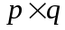 respectively and m>n and p<q. What should be the condition on m, n, p, q for the product AB to hold?

► n>p
► m<=q
► q=p
► n=p

Question No: 7 ( Marks: 1 ) - Please choose one
The price at which investors buy or sell a share of stock at a given time is referred as

► Face value
► Market value
► Accumulated value
► Earning value

Question No: 8 ( Marks: 1 ) - Please choose one
Gross salary is also called Net salary
► True
► False

Question No: 9 ( Marks: 1 ) - Please choose one
Can we subtract a positive integer k from the identity matrix?
► Yes
► No

Question No: 10 ( Marks: 1 ) - Please choose one
Net price =
► List price +trade discount

► List price - trade discount

► List price /trade discount

► List price * trade discount

Question No: 11 ( Marks: 1 ) - Please choose one
Division. Symbol: / is a type of
► Comparison operators

► Concatenation operator

► Reference operators

► Arithmetic operators

Question No: 12 ( Marks: 1 ) - Please choose one
Given : List Price =5500Rs , Discount = 850Rs, then Net Cost Price will be
► 6350 Rs
6350 Rs

► 5508 Rs
5508 Rs

► 5585 Rs

► 4650 Rs

Question No: 13 ( Marks: 1 ) - Please choose one
To convert a number in percent (%) from a fraction, we do which of the following operation:

► add by 100

► subtract by 100

► multiply by 100

► divide by 100

Question No: 14 ( Marks: 1 ) - Please choose one
If is the matrix of dimension 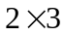 and is the identity matrix of dimension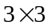. Then which of the following is true

► AI = I

► AI = A
► A + I = A

► A + I = I

Question No: 15 ( Marks: 1 ) - Please choose one
If ratio of boys and girls in a class is 7: 5, which of the following can’t be the total number of the students in the class?

► 36
► 50
► 60
► 120
Question No: 16 ( Marks: 1 ) - Please choose one
SLN returns the straight-line depreciation of an asset for

► Zero period

► One period
► Two periods

► Three periods

Question No: 17 ( Marks: 1 ) - Please choose one
Assume you will work for the next 20 years and at the end of each year you will deposit $20,000 into a savings account. At the end of that 20 year period you will start withdrawing your retirement living expenses from that account at the beginning of every year. This financial plan involves a _____ problem while you are working and a _____ problem while you are in retirement.

► a present value of a dollar, future value of a dollar
► a future value of an annuity due, a present value of an annuity due
► a future value of an annuity due, a present value of an ordinary annuity
► a future value of an ordinary annuity, a present value of an annuity due
► a future value of an ordinary annuity, a present value of an ordinary annuity

Question No: 18 ( Marks: 1 ) - Please choose one

By multiplying the above two matrices we get the following result
►
►
►
► Given matrices cannot be multiplied

Question No: 19 ( Marks: 1 ) - Please choose one
which of the following is linear equation

► 2x-3y=-6

► x+x+x

► 520x²y²

► y^2 -3=0

Question No: 20 ( Marks: 1 ) - Please choose one
Given FC = Rs.5000 ,CM= Rs. 30 ,VC= Rs. 150 , Capacity = 320units then BEP in units =

       ► 4500 units
       ► 167 units
       ► 33 units
       ► 16 units

Question No: 21 ( Marks: 2 )
Find the Discount where price is 2000 and discount rate is 12%.

Solution:

Price = 2000
Discount rate = 12%

Discount = Price * rate
Discount = 2000*12/100
Discount = 240

Question No: 22 ( Marks: 3 )
Calculate compound interest earned on Rs. 2250 invested at 8% per annum for 6 years

Solution

compound interest = (1-((1.08)^6))*2250=1320

Question No: 23 ( Marks: 5 )
If the Basic salary of an employee is Rs 8000 and Allowances are Rs 4,000 . What are the cost on account of 20 casual and 10 sick leaves per year if normal working days per month are 26?

Solution:

Cost of casual leaves per year = {18 / (26 x 12)} x 12000 x 12 = 8307.7 Rs
Cost of Sick leaves per year = {12 / (26 x 12) x 12000 x 12 = 5538.5 Rs.

Question No: 24 ( Marks: 10 )
The price of medicine inventory is Rs. 500,000.
The series discounts are 20%, 10%, 5%.
What is the single equivalent discount rate?
if Invoice was dated May 1st and 10% discount is offered if invoice is paid up to 10thMay. What will be net payment for invoice value of Rs. 500,000 if paid up to 10th May.

Solution

List Price=500,000
D1=20%
D2=10%
D3=5%
Net price=N= L (1-d1)(1-d2)(1-d3)
= 500,000(1-0.20)(1-0.10)(1-0.05)
= 342,000
Single discounted rate is given by
Here we see N=L(1-d)
=500000(1-31.6%)
=342000
So we can say that …..31.6% is a single discounted rate

Payment over 10th of may= 500,000(1- 10%)
= 450,000

Paper # 05
Spring 2010 (unknown)

Time: 60 min
Marks: 40

Q1
: In which Trust Fund, the company does not deduct, but only contribute 1/11th of Basic Salary of the employee per month?
- Provident Fund
- Gratuity Fund
- Charity Fund
- None of the above
Q2

What will be the answer of the SUMIF formula?

- 1075
- 985
- 855
- 130
Q3
If Cost = Rs. 7060 and Markup Rate = 46.7% then Selling price equal to --------------
- Rs. 11253.05
- Rs. 32970.2
- Rs. 10357.02
- Rs. 9046.7
Q4
Find x if 2x + 6 = 10.
- 8
- 2
- -2
- –8
Q5
Which statement is true?
- Social charges comprise the leaves, group insurance and medical.
- Social charges comprise House rent and conveyance allowance.
- Social charges comprise gratuity and provident funds.
- Social charges comprise employee’s children’s education, club membership only.
Q6
0.20% = ------------
- 0.2
- 0.02
- 0.002
- 0.0002
Q7
0^1=?
- 0
- 1
- Undefined
- Infinity
Q8
Net Cost Price =
- List price – Discount.
- Discount - List price
- Discount x List price
- List price / Discount
Q9
If a speed of a car is changed from 25km/h to 40km/h then the percentage change in its speed is?
- 15%
- 50%
- 40%
- 60%
Q10
Ali has improved his typing speed from 40w/m to 60w/m.The percentage improvement is
- 20%
- 150%
- 50%
- 30%
Q11
Amount of discount is obtained as
- Percentage of Discount x List Price
- Percentage of Discount / List Price
- Percentage of Discount - List Price
- None of these
Q12
If an asset is purchased at Rs 3000 on the date 6/29/2008 and the first depreication period ends on 11/29/2008, where salvage value is 300 and period is taken as 1 on 20% interest rate where basis =1, then which of the following function Returns the depreciation for given accounting period
- =AMORLINC(3000, 6/29/2008, 11/29/2008, 300, 1*12, 20%, 1)
- =AMORLINC(3000, 6/29/2008, 11/29/2008, 300, 1, 20% / 12 , 1)
- =AMORLINC(3000, 6/29/2008, 11/29/2008, 300, 1, 20%, 1)
- =AMORLINC(3000, 6/29/2008, 11/29/2008, 300, 1*12 , 20%/12, 1)
- None of these
Q13
Net loss = Number of unit’s sale below BEP in unit’s × ……………per unit.
- FC
- vC
- CM
- S
Q14.
Given list price of shirt = $20 , Discount = 10% ,Net price will be
- $ 16
- $ 18
- $ 20
- $ 22
Q15
Given Old Sale price = $1.95 , Markdown rate =13.6% ,then $Mark down will be

- $ 0.27
- $ 0.72
- $ 0.66
- $ 0.92
Q16
The Break Even Point in units is 64 and Production Capacity = 320 units per period, then The break Even point as a % of capacity will be

- 35%
- 30%
- 25%
- 20%
Q17
The Basic salary of an employee is Rs 17, 000.
What is the contribution of the company on account of gratuity?

Q18
Given FC = Rs. 8000 , VC = Rs.200, S= Rs.190 , CM =Rs. 10 , NI = Rs 8000.
Find units over BEP
Q19
Store A marked down $ 20.64 an item to $ 14.29
What is the $. Markdown?
What is the %markdown
Q20
The matrix G represents the average score for each student on tests, quizzes, and homework. Tests are 50% of the grade, quizzes are 30% and homework is 20%.
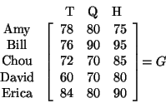

- Write the vector P expressing the percentages that would be used to find the final grade for each student.
- Would GP or PG produce a matrix of the final grades? Also using matrices, determine the final grade for each student.

Q21
Write which of the given function is used for which of the below given tasks.
Functions:

RATE(total number of payment periods, payment made each period,pv,fv,type,guess)

PPMT(interest rate, period, total number of payment periods, pv, fv, type)

Paper # 06
Spring 2010 (unknown)
MTH302- Business Mathematics &amp; Statistics

Time: 60 min
Marks: 40

Q1
Solve x – 16 = 12 for x.

- 4
- 28
- –4
- –28
Q2
The Virtual University of Pakistan is a growing distant learning university of Pakistan. The number of students in the university is increasing each year. The number of registered students in a course related to business math last year was 7113 and it is increased up to 9242 this year. What is the percentage increase in the number of students?

- 23%
- 30%
- 18%
- 42%
Q3
Ali has bought his new motorcycle on installments. He will pay Rs. 2000 for 30 months. If the bike currently cost Rs. 54000 what percent of current cost he will pay more after 30 months.
- 6%
- 15%
- 11.2%
- 10%
Q4
If the salary of an employee is 10,000 and his allowances are 5,000 then what is the taxable income of the employee?
- 5,000
- 10,000
- zero
- 15,000
Q5
The Basic salary of an employee is Rs 7,000 and the allowances are Rs 3000. Then the social charges will be ------------------------------------.
- Rs 2030
- Rs 2900
- Rs 2500
- Rs 2150
Q6
0^1=?
- 0
- 1
- Undefined
- Infinity
Q7
If a and b are any two integers such that a>b then a-b is

- positive
- negative
- zero
- cannot be told
Q8
If a birthday cake is cut into eight equal parts then what percent of the cake is a single pie?
- 20%
- 15.75%
- 12.5%
- 11%
Q9
A Matrix is a ……………. of numbers

- Rectangular array
- Triangular array
- Linear array
- None of these
Q10
If a matrix has four column and 5 rows then its dimensions are
- 20
- 4x5
- 5x4
- 5x5
Q11
Markup is an amount added to ----------------------------------------

- get accumulated interest
- a cost price while calculating a selling price.
- The principal amount of the loan.
- Accumulation factor.
Q12
In Excel there different types of operators are

- 3
- 4
- 5
- 12
Q13
Assume you will work for the next 20 years and at the end of each year you will deposit $20,000 into a savings account. At the end of that 20 year period you will start withdrawing your retirement living expenses from that account at the beginning of every year. This financial plan involves a _____ problem while you are working and a _____ problem while you are in retirement.

- a present value of a dollar, future value of a dollar
- a future value of an annuity due, a present value of an annuity due
- a future value of an annuity due, a present value of an ordinary annuity
- a future value of an ordinary annuity, a present value of an annuity due
- a future value of an ordinary annuity, a present value of an ordinary annuity

Q14
Which function calculates your monthly payment?
- PMT
- NPER
- PV
- all of these choices
Q15
which of the following is linear equation

- 2x-3y=-6
- x+x+x
- 520x²y²
- y^2 -3=0
Q16
The point at which no profit is made and no losses are incurred is said to be

- Fixed Cost point
- Contribution Margin
- Break even point
- Contribution Rate
Q17
If Variable Cost = Rs.157 and Sale= Rs.185, then find the value of contribution margin
Q18
If the basic salary of an employee Rs. 14,000 and allowances are Rs. 9,000 then what is the taxable income of employee?
Q19
Given the matrices
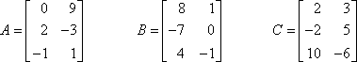
Compute
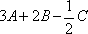.
Q20
At what rate Rs. 4000 double it in 4 year.
Q21
A 50-inch segment is divided into three parts whose lengths have the ratio 2 : 3 : 5. What is the length of the longest part?.

Paper # 07
Spring 2011
MTH302- Business Mathematics & Statistics (Session - 2)

Question No: 1 ( Marks: 1 ) - Please choose one
Principal remains constant through out the agreement period in:

Compound interest
Annuity
Simple interest
Nominal interest

Question No: 2 ( Marks: 1 ) - Please choose one
A square matrix A, has an inverse if,
A
= 0
A
= 0
A
0
A
= 0

Question No: 3 ( Marks: 1 ) - Please choose one
Write a formula to find the simple interest (I) if $5000 is invested at 4% for 2 years.

I=PRT
I=P+R+T
I=PT
I=P(R+T)

Question No: 4 ( Marks: 1 ) - Please choose one
If A and B are any two matrices of order m n and p q respectively and m>n and p<q
What should be the condition on m, n, p, q for the product AB to hold?

n>p
m<=q
q=p
n=p

Question No: 5 ( Marks: 1 ) - Please choose one
Total Provident Fund added to the employee’s fund is ----------------- of the basic salary.

1 / 11 th
2 / 11 th
9.09 %
9.99%

Question No: 6 ( Marks: 1 ) - Please choose one
2 6 1 9
A B 3 4 3 3, then AB is --------------------------

20 36
25 30

20 36
35 30
20 36
15 39

20 36
45 39

Question No: 7 ( Marks: 1 ) - Please choose one
The negative of the negative of an odd number is

negative
positive
the odd number
does not exist

Question No: 8 ( Marks: 1 ) - Please choose one
The correct relation among the %markup on cost, cost price and selling price is

Selling Price = Cost price + (Cost price × %Markup on sale)
Selling Price = Cost price + (Cost price × %Markup on cost)
Cost Price = selling price + (Cost price × %Markup on cost)
None of these

Question No: 9 ( Marks: 1 ) - Please choose one
If I is an identity matrix then it must also be a

rectangular matrix
row matrix
column matrix
scalar matrix

Question No: 10 ( Marks: 1 ) - Please choose one
The determinant of a square matrix is ----------------

Matrix
Number
Only a positive number
Only a negative number

Question No: 11 ( Marks: 1 ) - Please choose one
In which Trust Fund, the company does not deduct, but only contribute 1/11th of
Basic Salary of the employee per month?

Provident Fund
Gratuity Fund
Stock yield
Interest

Question No: 12 ( Marks: 1 ) - Please choose one
Returns the cumulative interest paid on a loan between start period and end period
is ………
CUMIPMT
CUMPRINC
FV
PV

Question No: 13 ( Marks: 1 ) - Please choose one
In Excel there different types of operators are
3
4
5
12

Question No: 14 ( Marks: 1 ) - Please choose one
The text concatenation operator is used to

include “:” and “,”
calculate exponentiation: ^
combine two text strings
make comparisons.

Question No: 15 ( Marks: 1 ) - Please choose one
Division. Symbol: / is a type of

Comparison operators
Concatenation operator
Reference operators
Arithmetic operators

Question No: 16 ( Marks: 1 ) - Please choose one
12.5% of a circular plot as a fraction is expressed as
5
4

125
1

8
1

1
8

Question No: 17 ( Marks: 1 ) - Please choose one
Assume you will work for the next 20 years and at the end of each year you will deposit
$20,000 into a savings account. At the end of that 20 year period you will start
withdrawing your retirement living expenses from that account at the beginning of every
year. This financial plan involves a _____ problem while you are working and a _____
problem while you are in retirement.

a present value of a dollar, future value of a dollar
a future value of an annuity due, a present value of an annuity due
a future value of an annuity due, a present value of an ordinary annuity
a future value of an ordinary annuity, a present value of an annuity due
a future value of an ordinary annuity, a present value of an ordinary annuity

Question No: 18 ( Marks: 1 ) - Please choose one
Which of the following is the correct formula for calculating the contribution margin

S-VC
VC-S
S-FC
FC-S

Question No: 19 ( Marks: 1 ) - Please choose one
Which is the correct syntax for the determinant of a matrix given by the following
Array

=DETERM(B4:E7)
=MDTERM(B4:E7)
=MDETERM(B4:E7)
=MDETERM(B4;E7)

Question No: 20 ( Marks: 1 ) - Please choose one
Which function calculates depreciation at the same amount each year over an asset’s
useful life?

DB
SLN
DDB
All of above

Question No: 21 ( Marks: 2 )
An article is sold for Rs.990 causes 10% loss on the selling price, find its cost price.
Answer
1089

Question No: 22 ( Marks: 3 )
After a markup of 30% on sales a watch sells for Rs. 225. What is its cost price?
Answer
29.25

Question No: 23 ( Marks: 5 )
Cindy used part of an insurance settlement to purchase an ordinary annuity that
would pay her $5,000 each six months for 10 years. How much did the annuity
cost if the interest rate is 10% compounded semiannually?(discounted value)

Question No: 24 ( Marks: 10 )
A stylish pencils that was bought for Rs. 200 was marked up 16% of the sale price.
When the pencils went out of production, they were marked down 14%.
What was the sale price after the 14% markdown?

Paper # 08
Spring 2011
MTH302- Business Mathematics & Statistics (Session - 3)

Question No: 1 ( Marks: 1 ) - Please choose one
What will be the answer of the SUMIF formula?

1075
985
855
130

Question No: 2 ( Marks: 1 ) - Please choose one
If you invest some amount at an interest rate of 8%, then at the end of 9 years.
What will be the value of Accumulation Factor?

12.736
12.487
12.965
12.856

Question No: 3 ( Marks: 1 ) - Please choose one
If Cost = Rs. 7060 and Markup Rate = 46.7% then Selling price equal to -----------
---
Rs. 11253.05
Rs. 32970.2
Rs. 10357.02
Rs. 9046.7

Question No: 4 ( Marks: 1 ) - Please choose one
The margin is the difference between the selling price and the _____.
Profit
Revenue
Cost
tax
Question No: 5 ( Marks: 1 ) - Please choose one
Sale price is the selling price less the ________
Markdown
Revenue
Cost
Profit

Question No: 6 ( Marks: 1 ) - Please choose one
Principal remains constant through out the agreement period in:

Compound interest
Annuity
Simple interest
Nominal interest

Question No: 7 ( Marks: 1 ) - Please choose one
Monthly installments of a leased car are calculated by using the
techniques of:
Simple interest method
Compound interest method
Annuity
Hit & trial method

Question No: 8 ( Marks: 1 ) - Please choose one
Sum of annuity is an accumulated amount of:
Original payments and discount
Original payments and interest
Interest and the payment yet not paid
Compound interest

Question No: 9 ( Marks: 1 ) - Please choose one
Find x if 3x + 7 – x = 17.
5
4
12
-5

Question No: 10 ( Marks: 1 ) - Please choose one
If
Original Price
= Rs. 3120 and
Markdown Rate = 6.3 %
then the
Sale Price
is equal
to
2933.44
3033.2
2910.4
3316.56

Question No: 11 ( Marks: 1 ) - Please choose one
Which statement is true?
Social charges comprise the leaves, group insurance and medical.
Social charges comprise House rent and conveyance allowance.
Social charges comprise gratuity and provident funds.
Social charges comprise employee’s children’s education, club membership only.

Question No: 12 ( Marks: 1 ) - Please choose one
Witch of the following percent is
of the basic salary?
Conveyance Allowance
2.5%
45%
5%
None of these

Question No: 13 ( Marks: 1 ) - Please choose one
If a and b are any two integers such that a>b then a-b is
positive
negative
zero
cannot be told

Question No: 14 ( Marks: 1 ) - Please choose one
The short cut method of showing a number is multiplied by itself is called
Superscript
Subscript
Exponent
None of these

Question No: 15 ( Marks: 1 ) - Please choose one
Dimension of a matrix means
Column space
Row space
Order of the matrix
None of these

Question No: 16 ( Marks: 1 ) - Please choose one
In which Trust Fund, the company does not deduct, but only contribute 1/11th of
Basic Salary of the employee per month?
Provident Fund
Gratuity Fund
Stock yield
Interest
Question No: 17 ( Marks: 1 ) - Please choose one
If x: y = y: 1, then
X = y
X = y^2
X = y / x
X = -y

Question No: 18 ( Marks: 1 ) - Please choose one
If the basic salary of an employee is 8, 000 Rs. allowances are 6000 Rs. and total cost of
leaves per year is equal to 28280 Rs. then the cost of leaves as percent of gross salary is
29.46%
16.83%
22.23%
28.28%

Question No: 19 ( Marks: 1 ) - Please choose one
Given FC = Rs.5000 ,CM= Rs. 30 ,VC= Rs. 150 , Capacity = 320units then BEP in units
=
4500 units
167 units
33 units
16 units

Question No: 20 ( Marks: 1 ) - Please choose one
The Break Even Point in units is 64 and Production Capacity = 320 units
per period, then The break Even point as a % of capacity will be
35%
30%
25%
20%

Question No: 21 ( Marks: 2 )
If a company is currently trading at Rs. 300 a share and earnings over the last 12 months
were Rs. 10.5 per share, then find the price earning ratio for the stock

Question No: 22 ( Marks: 3 )
Given the matrices
Compute
A Matrix is a rectangular array of numbers. The plural of matrix is matrices.
Matrices are usually represented with capital letters such as Matrix A, B, C.
For example .

Question No: 23 ( Marks: 5 )
Find the interest earned on an annuity due if payments of $2,000 per year are
made for 15 years into an account paying 5% compounded
annually.(Accumulated Value)

Question No: 24 ( Marks: 10 )
A,B and C, each of them working alone can complete a job in 6, 8 and 12 days
respectively. If all three of them work together to complete a job and earn $ 2340, what
ill be share of each earnings?
Join:

Paper # 09
Spring 2011
MTH302- Business Mathematics & Statistics (Session - 4)

Question No: 1 ( Marks: 1 ) - Please choose one
If the basic salary is Rs 6500 and the social charges are Rs 1820, what percentage of basic salary are the social charges?

► 27 %
► 28 %
► 29 %
► 30 %

Question No: 2 ( Marks: 1 ) - Please choose one
The price at which a business purchases merchandise is called the
► List
► Cost
► Investment
► Exchange rate

Question No: 3 ( Marks: 1 ) - Please choose one
A reduction of the amount due on an invoice is called a _______ .

► Trade discount
► Net discount
► Cash discount
► Unearned discount

Question No: 4 ( Marks: 1 ) - Please choose one
If Selling Price = Rs. 5890 and Markup Rate = 59.5 % then the Cost Price is equal to

► Rs. 3229.70
► 3692.79
► 2385.45
► 3504.55

Question No: 5 ( Marks: 1 ) - Please choose one
0.20% = ------------

► 0.2
► 0.02
► 0.002
► 0.0002

Question No: 6 ( Marks: 1 ) - Please choose one
What percentage is 10% of 85?

► 
► 
► 
► None of these

Question No: 7 ( Marks: 1 ) - Please choose one
If a matrix has four column and 5 rows then its dimensions are

       ► 
       ► 
       ► 
       ► 

Question No: 8 ( Marks: 1 ) - Please choose one
If an asset is purchased at Rs 3000 on the date 6/29/2008 and the first depreication period ends on 11/29/2008, where salvage value is 300 and period is taken as 1 on 20% interest rate where basis =1, then which of the following function Returns the depreciation for given accounting period

       ► =AMORLINC(3000, 6/29/2008, 11/29/2008, 300, 1*12, 20%, 1)
       ► =AMORLINC(3000, 6/29/2008, 11/29/2008, 300, 1, 20% / 12 , 1)
       ► =AMORLINC(3000, 6/29/2008, 11/29/2008, 300, 1, 20%, 1)
       ► =AMORLINC(3000, 6/29/2008, 11/29/2008, 300, 1*12 , 20%/12, 1)
       ► None of these

Question No: 9 ( Marks: 1 ) - Please choose one
The break even point is a point when ----------------------

► Revenue is greater than cost.
► Revenue is less than cost.
► Revenue is exactly equal to cost.
► None of the above.

Question No: 10 ( Marks: 1 ) - Please choose one
This example returns the depreciation for an asset that costs Rs. 10,000, with a salvage value of $6,000. The useful life of the asset is 4 years. The depreciation is being calculated for the first year, and there are 12 months in the first year.

► =DB (10000, 6000, 4, 1, 12)
► =DB (10000, 6000, 4, 12, 1)
► =DB (6000, 10000, 4, 12, 1)
► =DB (10000, 6000, 4, 1, 1)

Question No: 11 ( Marks: 1 ) - Please choose one
The text concatenation operator is used to

► include “:” and “,”
► calculate exponentiation: ^
► combine two text strings
► make comparisons.

Question No: 12 ( Marks: 1 ) - Please choose one
Which of the following formulas is the correct formula for calculating selling price

► Cost price (1+Cost price × %Markup on cost)

► Cost price (1+ %Markup on cost)

► Cost price (Cost price × %Markup on cost)

► Cost price (Cost price + Cost price × %Markup on cost)

Question No: 13 ( Marks: 1 ) - Please choose one
If the cost & selling price of a pen are Rs.12 & Rs.15 respectively, profit percentage is:

► 33.33%

► 25%

► 20%

► 10%

Question No: 14 ( Marks: 1 ) - Please choose one
Given FC = Rs.5000 ,CM= Rs. 30 ,VC= Rs. 150 , Capacity = 320units then BEP in units =

► 4500 units
► 167 units
► 33 units
► 16 units

Question No: 15 ( Marks: 1 ) - Please choose one
3x² ⁺ 5x – 7 is --------------- expression.

► Monomial
► Binomial
► Trinomial
► Linear

Question No: 16 ( Marks: 1 ) - Please choose one
If there is a change of -30% in the price of an item, what does the negative sign show?

► The price is decreasing.
► The price has low rate of change.
► None of the above.
► The price is increasing.

Question No: 17 ( Marks: 1 ) - Please choose one
The price-earning ratio is calculated as…………..

► Market value per share/Earning per share (EPS)

► Earning per share (EPS)/Market value per share

► Market value per share+Earning per share (EPS)

► Market value per share-Earning per share (EPS)

Question No: 18 ( Marks: 1 ) - Please choose one
Net current asset value per share (NCAVPS) is calculated as………

► No. of shares outstanding/(Current assets-total liabilities)

► (Current assets-total liabilities)/No. of shares outstanding

► No. of shares outstanding+(Current assets-total liabilities)

► No. of shares outstanding-(Current assets-total liabilities)

Question No: 19 ( Marks: 1 ) - Please choose one
What shall be contribution margin if sale price is Rs.50 and variable cost is
Rs.30?

► Rs.80
► Rs.20
► Rs.30
► none of these

Question No: 20 ( Marks: 1 ) - Please choose one
For multiplication of two matrices A and B

► The no. of rows of A must be equal to columns of B

► The no. of rows of B must be equal to no. columns of A

► The no. of columns of A must be equal to no. rows of B

► None of these

Question No: 21 ( Marks: 2 )
The price of a sandwich maker is Rs 2000. The company offers a 25% trade discount. Find trade discount amount.

Solution

Sandwich Price Rs.2, 000
Trade Discount Rate 25%
Trade Discount Amount =2,000*25/100

=Rs.500

Question No: 22 ( Marks: 2 )
A firm sells its new product at Rs. 65 per unit. If the variable cost is Rs 40, find the contribution margin.

Solution

Sale Price Per Unit Rs.65
Variable Cost Rs.40
Contribution Margin =S-VC
=65-40

= Rs.25 per unit

Question No: 23 ( Marks: 3 )
Ratio of sales of Product X to sales of Product Y is 5:4. The sales of product X is forecasted at Rs. 200,000. What should be the Sales of product Y to maintain the ratio of sales between the two products?

Solution

Ratio x to y 5:4
Sale of Product x Rs.200, 000
Sale of product of y =200,000 * 4/5

=Rs.160, 000

Question No: 24 ( Marks: 3 )
A company sells its item at Rs. 125 per unit. If the variable cost is Rs 80, find the contribution rate.

Solution
Sale Price per unit Rs.125
Variable Cost Rs.80
Contribution margin =S-VC
=125-80
=Rs.45
Contribution Rate =CM/S*100
=45/125*100

=36%

Question No: 25 (Marks: 5)
Ahmed buys 10 apples for $1. At what price should he sell a dozen apples if he wishes to make a profit of 25%?

Solution

Cost price =$1 for 10 Apples
Cost price per apple =1/10
=$0.1
Cost price of dozen apples =0.1*12
=$1.2
Profit Margin 25%
Sale price =1.2*125/100

=$1.5

Question No: 26 ( Marks: 5 )
Evaluate the sum of the years digits depreciation of an asset having the cost of Rs.10, 000 for a period of 5 years such that salvage value after 7 years is Rs.5000.

Solution

Cost Price Rs.10, 000
Salvage value after 7 years Rs.5, 000
Depreciable Value =Cost Price – Salvage value
=10,000-5,000
=5,000
Sum of Years digit depreciation. =7+6+5+4+3+2+1
=28

1st year depreciation =7/28*5000 =Rs.1, 250
2nd year depreciation =6/28*5000 =Rs.1, 071
3rd year depreciation =5/28*5000 =Rs.893
4th year depreciation =4/28*5000 =Rs.714
5th year depreciation =3/28*5000 =Rs.536

